Parabuild manual

Table of contents
Introduction 22
CAD Interface 23
BIM - Building Information Modeling 26
The Coordinate System 29
User Guide 31
User Interface 32
Toolbars 32
Ribbon 36
Model Lines 36
Using the Context Modeler 39
Connections 44
Workshop Drawings 60
Reference Guide 67
License management 68
Parabuild Settings 72
Global settings 76
Library Localization 84
Bolt Parts Database 86
Bolt Assemblies 87
Variables of Macros 90
Material / Finishing 93
Threaded Holes 95
DSTV WeldPoints 96
Clash Control 99
Object Filters 100
Structural types 104
Classify parts 108
CNC contour and matchline settings 109
Check CNC contours when numbering parts 132
3D Model settings 135
Dynamic Data 136
Viewing Parabuild drawings without Parabuild 137
The Properties Panel 139
Dynamic Properties 140
Arc 140
Line 142
Coordinate System 143
Member 143
Macro 152
Plate 153
Pattern 160
Bolt 160
Structure 166
Array 173
View 174
Camera 177
Annotation 178
3D Weld 182
Main - Library 189
Draw Profiles 189
Editing the Profile Library 195
Floors 201
Custom Shapes 203
Elements Library 205
Plate with PolyLine 206
Lowering a Member 206
Corrugated Sheet Sections 208
Miscellaneous 209
Add to Elements Library 211
Add to Custom Shapes Library 211
Main - 3D Modeling 212
Context Modeling 212
Draw Framing 216
Draw Sub-Profiles 218
Draw Plates 220
Draw welds 223
Context Buttons 226
Rotate Profile 230
Levels 230
Mass Creation 230
View - Visibility 231
Visibility Manager 231
Saved Views 235
View Angle 236
Quick select 237
Search for Objects 238
Isolate Objects 239
Isolate a Selection 240
Hide Objects Entirely 240
Volumes -> Axes 241
Axes -> Volumes 241
Show / Hide Cameras 242
Assembly / Single Object Selection 242
Weld Check 243
Clash Check 243
General - Grids 244
Draw Grid 245
Convert Line to Grid-Line 246
Modify Levels 247
Model Lines 248
2D Line 248
3D Line 248
Vertical Line 249
3D PolyLine 249
Portal Frame 249
Tower 249
Pyramid 250
Ladder 250
Constrained Profiles 250
Column with Point 251
Columns with Grid Lines 252
Beam with Points 253
Beam between Columns 254
Beams with Grid Lines 255
Apex between Columns 257
Apex with Grid Lines 258
Free Member 260
Modify Levels 261
Bolts / Holes 262
Bolt Standards 262
Shop Bolts 263
Draw Bolt 265
Bolts on a Plane 267
Bolts on Touching Surfaces 268
Galvanizing Holes 270
Check for New Holes 271
Remove Holes and Cuts 272
Slotted Hole 273
Hole <-> Threaded Hole 274
Hole <-> C/Sunk Hole 275
Hole <-> Blind Hole 276
Cutting 278
Cut by a Line 279
Cut by a PolyLine 282
Cut against a part (shorten only) 283
Cut against a part (shorten and extend) 284
Cut out with a part 286
Miter cuts 287
Break Profile 288
Hex Holes (Castellated) 289
Edit a Profile's Cuts 290
Add Cut to Macro 291
Modify Profiles and Plates 294
Chamfer 295
Fillet 296
Modify Plate Vertices 297
Convert Strip or Plate 297
Hex Holes (Castellations) 301
Correct Twist of Helix 301
Modify Axis of Profile 302
Modify Surface Treatment 303
Edit Entity 304
Tools 305
Move / Rotate 306
Copy / 3D Rotate 309
Show / Modify Properties 310
Move along a Line 311
Draw Line on an Edge 312
Create Structure 313
Draw a Body 314
Manipulate a Body 315
Web Stiffeners 316
Flange Stiffeners 322
Stairs 324
Stair 324
Railing 330
Ladder 338
Spiral Stair 341
Correct Twist of Helix 342
Railing End Connections 343
Railing Intersection Conns. 346
Connect Post 347
Connect Post to Handrail - 2 Base 349
Connect Post to Handrail - 3 Base 350
Weld Connections 350
Draw Grating 351
Modify Macros 354
Review Macro 354
Delete Macro 369
Smart Copy 370
Erase Macro 374
Erase Objects and dep. Macros 375
Smart Copy Settings 375
Merge Macros 375
Copy a Macro manually 376
Connection Components Library 376
Connections 377
Standards for Connections 378
Applying Connections 379
Propagate 382
Haunch 385
Apex 386
Apex with Column 388
Column under Beam 389
Beam Offset to Column 390
Beam to Column 392
Adjacent Beams to Column 393
Purlin on top of Beam 394
Purlin Brackets 396
Purlins on Beam / 3-bases 397
Purlin / Rail supports 399
Beam to Beam 401
Beam / Column Splice 402
Connect Post 404
Connect Post to Handrail - 2 Base 404
Connect Post to Handrail - 3 Base 405
Connections for 1 PEB member 405
Connections for 2 PEB members 406
Connections for 1 PEB member and 1 regular member 407
Weld Connections 408
New Connection from Group 409
Web Stiffeners 410
Flange Stiffeners 410
Connection Components Library 410
Miscellaneous ending connections 411
End / Base-Plates 413
Bracing 417
Bracing 417
Gusset Plate - 2 Base 424
Gusset Plate - 3 Base 426
Trusses 428
Truss 428
Truss between Columns 433
Truss for Portal Frame 435
Truss Strut 436
Truss Haunch Connection 438
2 Trusses v Column 440
Truss Apex 442
Truss to Truss 443
Framework 444
Frames 445
Stair 454
Railing 454
Ladder 455
Spiral Stair 455
Cladding 455
PEB member 465
Feeding excel values to macros and arrays 467
Draw a Body 479
Manipulate a Body 480
Pre-engineered buildings (PEB) 480
Main - Output 483
Assemblies / Groups 483
Assembly / Object Selection 484
Add parts to assembly 484
Remove parts from assembly 485
Set as End-Plate 486
Switch Profile Triangle Direction 487
Restore Group Selections 487
Welds 488
The 3D Weld object 491
AutoWeld 493
Reviewing and modifying welds 522
Delete welds 525
Remove weld segment 526
Split/Merge welds 527
Number welds 529
Weld symbols on shop drawings 530
Weld Symbol 532
ISO Weld Symbol 534
AWS Weld Symbol 539
Edit Weld Symbol 541
Numbering / Revisions 541
Numbering 542
Revisions manager 545
Standard Parts Library 547
Unfolding 548
Enabling unfolding for Dstv and shop drawings 555
Testing unfold in 3D 556
Document generation : Sheets, BOM, CNC 558
Sheets Manager 559
Generate Part and Assembly shop drawings 563
Generate DXF Files 567
Generate DSTV NC Files 568
Generate WrapAround for Pipes 569
Pipe Wraparound Options 571
Generate STEP Files 572
Generate Bills 573
Slideshow of sheets 574
Print all sheets 574
Export sheets as DWG files 575
Add New Plan Views 575
Right Click on a 2D sheet 579
Right Click on a Part number 582
Right Click on a BOM Item 583
Left or Right Click on the list headers 583
Refresh Views 585
Document generation Settings 587
General 589
DXF Settings 592
DSTV NC Settings 596
DSTV WeldPoints 610
Bills of Material 613
Bill Formatting Options 615
Plates / Members / Assemblies / GA Views 618
Sheet properties 620
Template settings 623
Other sheet settings 629
Settings for automatic generation of sheets 631
Where to change the contents of annotations on shop drawings 634
Part 637
Assembly-specific settings 638
Views 640
Pre-configure View Arrangement 641
Modify View Settings 642
Configure View Directions 644
Annotations and dimensions 646
Objects to be copied from 3D to 2D views 648
Change Existing View Settings 650
Default Dimensions 652
Plate Dimension Settings 652
Side View Dimension Settings 653
Section View Dimension Settings 654
Advanced Dimension Settings 655
Bill of materials 656
Profile Length Optimization 659
Erase Position or Assembly history 662
Tools for 2D Drawings 663
Position Number Tag 663
Assembly Number Tag 664
Part Name 665
Comment 665
Other Annotations 666
Level 667
Weld Symbol 667
Edit Weld Symbol 668
Automatic annotations and dimensions on View 668
Label templates 670
Annotation styles 672
Draw Section 680
Detail in G.A. Drawing 682
Properties to be used in annotations and bills 684
Dimensioning 702
Chain Dimension 703
Ordinate Dimension 703
Chain + Ordinate Dimension 704
Aligned Dimension 705
Angular Dimension 705
Radius Dimension 706
Diameter Dimension 706
Arc Length Dimension 707
Measure distance between 2 sub-geometries 707
Measure 710
Modifying Dimensions 711
Add Ext. Line to Chain Dim. 711
Remove Ext. Line from Chain Dim 712
Change Origin of Ordinate Dim. 712
Search for Dims. and Merge 713
Manually Merge into Chain Dim. 713
Disconnect Dims. from Chain 714
Modify Settings of Chain Dim. 715
Parabuild General 716
Help 716
Exercises 716
Allow Remote Control 717
Parabuild Information 718
Settings 718
Import BIM from File 718
Export BIM to File 720
Project Data 723
Miscellaneous 724
Various commands without icons 724
Phases 730
Erection Sequence 731
Advanced - Producing Intelligent objects 731
Macros and Modules 733
Geometric Rules 734
Create Geometric Rules 737
Degrees of Freedom 738
Create New Macro 739
Create an Array of Macros 739
Set Macro as Current 743
Calculate all Macros 743
Edit Macro 744
The Rules Tab 746
The Geometries Tab 751
The Variables Tab 752
The Commands Tab 755
General macro settings 755
Creating smart structure objects 758
Automatically changing section sizes 762
Automatically changing structure sizes 764
Smart Copy Settings 765
Edit Macro Groups 771
Create Dialog Boxes 773
Automatic Text Translation 774
Manually copy a Macro 776
Manually copy a Macro with more control 777
Create Bolts Pattern 777
Create Coordinate System 778
Create Plane Help Geometry 778
Release Notes 781
Version 5.1 781
Version 6.0 795
Version 7.0 820
Version 8.0 835
Versie 8.0 - Nederlands 847
Versie 7.0 - Nederlands 860
Version 7.0 - Français 877
Version 8.0 - Migration guide for users 895
Versie 8.0 - Migratie gids voor gebruikers 950
Version 7.0 - Migration guide for users 1007
Versie 7.0 - Migratie gids voor gebruikers 1037
Version 7.0 - Guide de migration pour les utilisateurs 1066

Introduction

Parabuild runs on both AutoCAD and BricsCAD platforms. Structural steel objects can be modified through the standard AutoCAD and BricsCAD commands or using the Object Property Manager.
All Parabuild objects are integrated as if they are native AutoCAD/BricsCAD objects.

Fast and intuitive modeling
For easy detailing of structural steel - small parts or frame elements such as beams, columns, girders, struts, joists, purlins - use the Context Modeler for maximum productivity. Move the cursor around and solutions are offered in real time based on cursor location, nearby members and other context. The new element is automatically linked to the nearby members or to the grid.

Connections
Parabuild has a library of hundreds of standard steel connections. Detailing connections is easy; select the members and only valid types are proposed for that situation. The connection is immediately drawn and any changes made are shown instantly on the 3D model. Easily turn unconnected members into fully connected structural steel.

User-defined connections
Every single standard connection was created using tools that are available to any detailer, without programming a single line of code. This was done by using simple geometric rules on members and parts inside template drawings, which means you can create your own connections! They are integrated with the existing connection system for easy re-use in all your projects.

Geometric constraints
Parabuild is the only structural steel detailing software that allows fully constrained structures. Connections and macros can be constrained in template drawings and re-used in any project. That includes whole structures, trusses, wind bracing, cladding, stairs, … This means it is possible to customize Parabuild without hiring a programmer or writing any code.

Clash detection
Parabuild will automatically detect any collision between parts and show it on the screen. Bolt clearance and hole to edge/hole to hole distances are checked as well.

Numbering of identical parts
Parabuild automatically recognizes identical parts in the model, with the purpose of making the Bill of Materials shorter and for needing less shop drawings.

CNC file generation
Parabuild can write DXF, Dstv, Sat and Step files automatically for the purpose of using them for CNC machines.

Shop drawing generation
Parabuild will generate clear and readable shop drawings for the fabrication of all the parts in the drawing.
It supports 'Position' drawings, which are 'per part' drawings containing dimensions for holes and cuts.
It also support assembly drawings, which contain the dimensions for welding multiple single parts.

General Arrangement Drawings
Parabuild has many tools that allow you to quickly create GA drawings. It will also help with updating the existing GA drawings after changes have been made to the 3D model.


CAD Interface
AutoCAD / BricsCAD
AutoCAD is the most widely used CAD software in the world. It is easy to use, there is a large community behind it, a lot of documentation, and a lot of training material. Most drafters are familiar with AutoCAD and new detailers can be trained to master it with ease.
BricsCAD is very similar to AutoCAD in many ways, it uses the same file format, and is only a fraction of the price. Because each has its own advantages we feel the choice should be up to the detailer, so we are committed to supporting both platforms. Scroll down to read more about these two excellent programs.
The combination of AutoCAD and BricsCAD, with Parabuild’s unique features results in an easy to use yet powerful solution for drawing 3D structural models. For steel detailing Parabuild benefits even more because of the extensive 2D and dimensioning tools in both applications

Complete integration
Parabuild was completely integrated with both platforms. Here are some examples of this:

Osnap interface
You can use the powerful object snapping tools on any of the Parabuild entities and sub-entities.
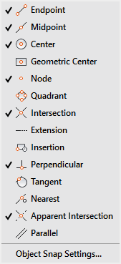

Object Property Manager (OPM)
Parabuild objects can be modified, searched and filtered through the powerful OPM interface. This helps you make changes to many objects at the same time with minimal effort.
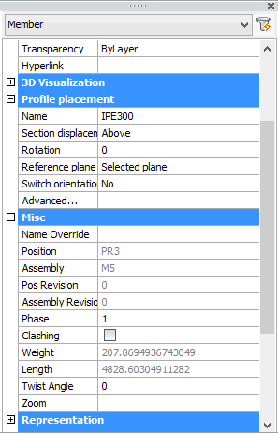

Standard commands
The standard commands can be used on Parabuild objects. That includes stretch, move, copy, array, mirror, …

DWG file format
Parabuild drawing information is entirely contained in the .dwg file, the most pervasive CAD file standard. The same drawing file is used in both AutoCAD and BricsCAD, so there is no need to convert drawings and you can freely switch between both platforms at any time.

Easy to learn
Both platforms are easy to learn and if you are familiar with one of them, using the other will feel quite natural. Combined with the intuitive and efficient features of Parabuild this results in an environment that gets you to productivity quickly.

Extensive dimensioning tools
AutoCAD 2D sketching and dimensioning tools are popular and refined through decades. BricsCAD works similarly and has tools that are just as powerful and easy to use. Parabuild takes full advantage by drawing all automatic dimensions as native AutoCAD/BricsCAD dimensions making it easy for the detailer to make changes when needed.
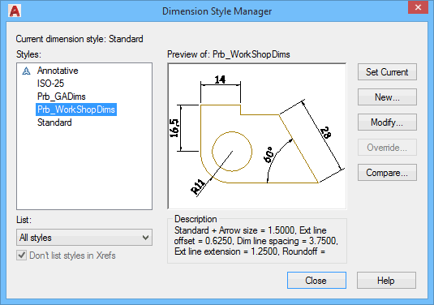

3rd party applications
Both platforms are open development platforms. That means 3rd party applications are available for a wide variety of CAD sectors, and these apps can be used simultaneously in the same drawing. The fact that all 3rd party apps work inside the same CAD environment and on the same drawing, is a unique environment that gives the draftsperson the freedom to combine many different disciplines within the same CAD environment. AutoCAD and BricsCAD are very popular development platforms, which has resulted in the availability of thousands of 3rd party applications on these platforms.

Additional visibility tools with Parabuild
AutoCAD and BricsCAD have many powerful functions that allow you to visualize your 3D model : visual styles, slices, view limitations, object hiding, transparency, etc… Parabuild adds extra visibility tools that are specific for structural steel detailing and they allow you to save time while modeling, or provide you with a better insight in the model.
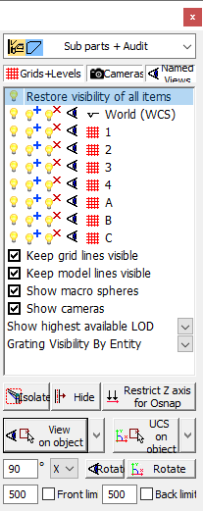

AutoCAD or BricsCAD: two good choices
The choice between AutoCAD and BricsCAD is mostly one of preference. Both are good platforms and will help you get the job done efficiently. Parabuild is equally powerful on both platforms and we aim to keep it that way.
AutoCAD is the industry standard DWG platform. In development since 1980 and with millions of users, AutoCAD is a CAD environment that has been refined for decades. It is the current market leader for general CAD software. There are thousands of 3rd party applications based on the platform, whatever you need it will for sure exist as a 3rd party app on AutoCAD. We have been a Autodesk Developer Network (ADN) member for over 20 years, and we consider it an excellent CAD application.

BricsCAD is fully compatible with the DWG format. BricsCAD offers the same features as AutoCAD, and in some cases more. BricsCAD costs only a fraction of the price of AutoCAD. While there are currently less 3rd party apps on BricsCAD, this is rapidly changing. Some unique features in the premium versions of BricsCAD are direct modeling, an impressive sheet metal module and improved AEC tools. The team working on BricsCAD is very open and dynamic and is supportive and responsive to us as developers. This makes it a joy to have them as a partner and a very good choice as a CAD platform.

BIM - Building Information Modeling

About BIM
The key idea behind BIM (Building Information Modeling) is to have all information related to a facility organized in one application-independent model. Ideally, this model is started at concept stage and expanded during each phase of construction and operation of the facility.
While BIM is centered around a 3D model, it is not limited to geometry. Other possibilities are costs, maintenance information, manufacturers, materials, names, dates and times, position and assembly numbers, phases, revisions, and so on.
While any application storing these properties with the 3D model often claims to be BIM software, for it to have practical benefit the software should support the free exchange of data with other applications. While there are several formats available, in the last few years the IFC file format has emerged as the best way to exchange BIM models. IFC stands for Industry Foundation Classes; it is an open-source file format developed by the independent organisation buildingSMART, and it is supported by all the major CAD vendors.

Why is BIM so important?
Information management is key to completing a project on time and within budget. Yet it is information that poses a recurring problem in the construction industry. Throughout all stages of a project a wide variety of different document types are generated by different tools and different teams, and at each stage the data is being manually reworked to fit the task at hand. Challenges include incompatible file formats, 2D/3D conversions, communication problems, limited transparency and more. This results in more errors and inefficiencies, ultimately increasing costs and causing delays.
Instead of moving and mutating data throughout the process, BIM methodology proposes that all teams work off the same data from start to finish, regardless of which BIM software is used. This not only facilitates communication and collaboration, but allows information to flow between the various tools used by the construction industry.

What are the main BIM benefits?
While the initial effort to set up a BIM model can be a bit bigger, there are benefits at each stage of a construction project. Even at the concept and design stage, the 3D aspect can help with visualization and communication with the client. Different variations can be more efficiently explored, and even at this early stage the client will have an increased understanding of what the end result will be.
This improved insight will also support better decision making early on, which helps the project progress smoothly.
The resulting model is an excellent communication tool for the next phases – either in-house or for external contractors. In addition to re-use of data and visual checking, the BIM model can be used for early-stage collision detection when data from different applications is combined.
The rich data model is also an excellent base for improved cost estimation for pricing, bidding or planning.
Model-based communication means improved collaboration and results in less friction and mistakes. Because some types of errors are avoided and some are detected sooner, fewer changes and revisions will be needed. The same 3D BIM model can be accessed on the field – by tablet or laptop – eliminating all doubts should any issues arise.
All of these result in better time and cost estimations, faster project completion, faster delivery and better business relationships.

Avoid vendor lock-in with IFC
A major benefit not often talked about is avoiding of CAD vendor lock-in. Most vendors use proprietary file formats, limiting data exchange between your preferred applications, and ensuring you would need to keep licenses of their software just so you could still access your own data.
If you design your BIM strategy around the widely used and open-source file format IFC then you escape this kind of vendor lock-in. Not only can you choose which application is best for each aspect of your project, you are free to change your mind in the future, switch to a different application and still maintain access to the BIM models of your older projects.
This freedom of choice is especially important when outsourcing parts of a project. No longer is a specific application a job requirement – BIM is the requirement and that greatly expands the number of parties you can work with.

What BIM means for steel detailers
These days BIM is increasingly becoming a requirement for many jobs. Not only are companies realizing the benefits but some governments have mandated the use of BIM in public projects in order to speed up adoption. It is advisable to plan accordingly in order to remain competitive in the future. Getting on board sooner will help you get more jobs and finish them more efficiently.
Detailers that are still working in 2D or using a generalized 3D modeling application (without BIM information) will have a steeper learning curve because switching to a 3D steel detailing solution is a requirement, but they also have the most to gain. A specialized steel detailing application can save a lot of time and money over manual methods.
You certainly should not fear 3D. While some 3D applications are certainly very complex to use, Parabuild was designed to be intuitive and it may be a lot easier to pick up then you think. A lot of your repetitive work will become automated, allowing you more time to focus on the important things.
For detailers that are already using specialized 3D steel detailing software, changing to a BIM mindset will not be difficult. Most modern 3D steel detailing software already have all the required BIM data in a proprietary file format, and should support IFC import/export so the detailer's work can integrate with the rest of the data. There are also free tools available to help you combine, visualize, check and manage BIM models.
You will be able to use BIM data from Revit Structure and most structural analysis software, and once detailed the model will serve for collision detection with HVAC, piping, mechanical objects among other things.
On a side note; a format other then IFC used to be more popular in the steel industry – CIS/2- but that format was deemed too specific to structural steel and did not support enough of the other aspects of construction. Currently it looks likely that IFC will remain the dominant BIM file format for a very long time.

The LOD of steel detailing
When you're getting involved with BIM you will hear about LOD: Level Of Development (or a while ago Level Of Detail – which was deemed not adequately generalized). LOD describes the amount of information in a BIM model. It goes from LOD100 (conceptual data) to LOD500.
Steel detailers work at nearly the final level of development; LOD 400. That means the structural steel model is fully specified down to the nuts and bolts, and it is ready for fabrication and construction. This is just a matter of terminology – detailers have been documenting at this level for a long time. Now this work is defined and stored as LOD400 within the BIM model. The next level LOD500 is for use during and post-construction, it specifies data on the state of the project as it was built.

BIM in Parabuild
Parabuild has been an information-rich application right from the start, long before BIM/IFC was around. By working with Parabuild, you are automatically constructing your BIM model! We are proponents of keeping your data freely accessible and easily shared, so we support the best BIM file format IFC for both import and export. Try the free Parabuild trial to experience it first-hand!

The Coordinate System
Every point in an CAD drawing file can be identified by its X,Y,Z coordinates. When viewed in plan, the X axis will pass from left to right, with movement to the right given as a positive (+) value, and to the left, a negative (-) value.
The Y axis will pass from top to bottom, with movement up given as a positive (+) value, and down as a negative (-) value.
The Z coordinate value will be 0.0 This system of coordinates is referred to as the World Coordinate System, or WCS.
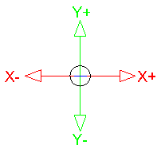 | 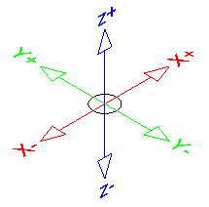
2D Coordinate system | 3D Coordinate system

Coordinate input
The most direct way to enter points precisely is to type numbers with the keyboard. CAD uses these keyboard coordinate entry formats:
  - Absolute Cartesian: e.g. 20,40,60
Values:
X = 20
Y = 40
Z = 60
  - Relative X,Y,Z coordinates e.g. @37,-25,50 (The @ character defines coordinates relative to the last point (x = 20, Y = 40, Z = 60))
Values:
X = 37
Y = -25
Z = 50
  - Relative polar coordinates e.g. @25<45 = (@distance<angle)
Values:
@25 = distance from the last point
<45 = Angle

User Coordinate Systems
You can define an additional coordinate system to more easily create drawings. This Non-World coordinate system, known as a User Coordinate System or UCS.
Why would you want to diverge from the standard WCS? Well, the most common reason is that its much easier to calculate and enter coordinates if they're based on the plane you want to work on in 3D.
Suppose that you're modeling an old-fashioned, wedge-shaped rubber doorstop and you want to add the manufacturer's logo to the sloping surface of the wedge. It isn't easy if you stay in the WCS, but AutoCAD lets you set a new UCS based on that sloping surface. After the UCS is made current, you draw in it just as you draw in the WCS.
Although originally intended for 3D work, a UCS can be useful on either two dimensions or three. The WCS assumes that the north direction is straight up, but you may be working on a building layout where one wing is at a 37.8 degree angle to the other.
No problem: Simply create a UCS thats aligned appropriately. You can look up this process in the on-line help system, but heres a quick hint: Click the UCS icon in the lower-left corner of the screen to make “grips” appear at the origin and the ends of the axis indicators. Then drag the icon by its grips to set a new UCS.

DRAW BY NUMBERS
You're CAD system will locate absolute X,Y coordinates with respect to the 0,0 point of the drawing — usually, its lower-left corner. AutoCAD or BricsCad locates relative X,Y coordinates and relative polar coordinates with respect to the previous point you picked or typed.
You will see how CAD uses all three coordinate formats to draw a pair of line segments that start at the absolute coordinates 2,1, and then move to the right 2 units and up 1 unit (@2,1) relative to the first point, and then (relative to that point) move 2 units at an angle of 60 degrees (@2<60).
Note in particular how the first two coordinate pairs use the same numbers (2,1) but the second pair defines a different point because of the leading @ symbol.
You can find out the X,Y location of the cross-hairs by moving them around in the drawing area and reading the coordinate values at the left end of the status bar. The X,Y coordinates should change as you move the cross-hairs. If the coordinates don't change, click the drawing coordinates area until you see Coordinates on in the command line.
If you're using the full version of AutoCAD, you may have noticed that three numbers are at the left end of the status bar. AutoCAD is showing you the X,Y coordinates of the cross-hairs and the current elevation. However, in 2D drafting, the Z value is 0, so you can continue calling them X,Y coordinates.
Although it isn't apparent at first, AutoCAD has, in fact, four coordinate display modes. Clicking the coordinates readout cycles through these modes:
- Off - (<Coords off>): The status bar coordinate readout is dimmed, and the coordinate values don't update until you pick a point.
- On - showing X,Y coordinates (<Coords on>): The coordinate readout appears black, and the absolute X,Y coordinates update continuously as you move the cross-hairs. If no command is active, clicking the coordinates readout alternates between this mode and <Coords off>.
- On - showing polar coordinates (<Coords on>): This mode, which displays distance and angle relative to the last point picked rather than absolute X,Y values, appears if a command is active and AutoCAD is waiting for you to pick a point.
- On - showing geographic coordinates (<Coords on>): This mode displays coordinates as latitude and longitude values, but it can be used only after you set the drawing's geographic location with the GeographicLocation command.
If you start a command such as Line, pick a point, and then click the Coordinates area a few times, the display changes from coordinates Off to live absolute coordinates to live polar coordinates. Displaying live polar coordinates is the most informative mode most of the time.
If you're working in AutoCAD’s architectural or engineering units, the default unit of entry is inches, not feet. Here are some guidelines for entering numeric values when you work with feet and inches:
- To specify feet, you must enter the apostrophe (′) symbol for feet after the number:
6′ is 6 feet.
- To separate feet from inches, enter a dash:
6′-6″ is 6 feet, 6 inches.
- When you enter coordinates and distances, both the dash and the inch mark are optional:
6′6″ and 6′6 are the same as 6′-6″.
- To type a coordinate or distance that contains fractional inches, you must enter a dash — not a space — between the whole number of inches and the fraction:
6′6-1/2 (or 6′-6-1/2) represents 6 feet, 6-1/2 inches.
- To enter partial inches, use decimals instead:
6′6.5 is the same as 6′6-1/2″ to AutoCAD, whether you're working in architectural or engineering units.

User Guide

User Guide

User Guide - Getting Started
This section is to provide a brief introduction to Parabuild and get familiar with its basic features - for this initial exercise, we'll be constructing a simple post and beam structure (Below)
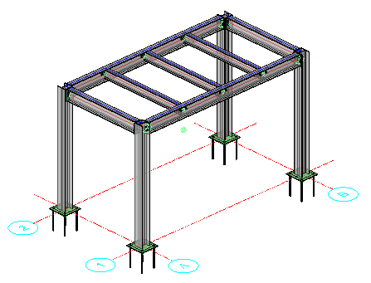
We will explain the basic principles of constructing the skeletal frame using both Model lines and Parabuild's Context modeler
Once the skeletal frame is built, we will apply base plates and connections
From here, we will create 2D general arrangement drawings, bills-of-material, and all associated fabrication drawings and NC files.
To further explain these basic features, we will add a stairway and ladder with flooring.

User Interface

User Interface
This chapter covers the Parabuild user interface, and includes an explanation of:
- ToolBars - Main and FlyOut
- Ribbons

Toolbars

Main ToolBars
Parabuild comes with 3 main ToolBars.
Dock the ToolBar by dragging it by the title bar to one of the edges of the application window.

Main - Library
Main - 3D Modeling
Main - Output

ToolBar FlyOuts
On some tool buttons a small black arrow at the bottom right corner of the icon indicates a FlyOut is available. A FlyOut holds a group of related tools. Press and hold the left mouse button to expand the FlyOut and choose one of the FlyOut tools. The tool that was last chosen remains visible in the collapsed ToolBar.
Each of the FlyOuts can be opened as a separate ToolBar. Drag the button of a ToolBar FlyOut into the drawing area to open it as a floating ToolBar.

Parent |  | FlyOut
Main - 3D Library
 |  | Draw Profiles
 |  | See Draw Profiles
Main - 3D Modeling
 |  | Context Modeling
 |  | View - Visibility
 |  | General
 |  | Model Lines
 |  | Constrained Profiles
 |  | Bolts - Holes
 |  | Cutting
 |  | Modify Profiles and Plates
 |  | Tools
 |  | Stairs
 |  | Review Macro
 |  | Erase Macro
 |  | Modify Macros
 |  | Connections
 |  | Bracing
 |  | Trusses
 |  | Framework
Main Output
 |  | Welding / Numbering
 |  | Sheets Manager
 |  | Tools for 2D Drawings
 |  | Dimensioning
 |  | Modifying Dimensions
 |  | Parabuild General

Ribbon

Ribbon
Almost all Parabuild commands may be accessed from the ribbon at the top of the application window. This ribbon may be displayed or hidden by typing 'ribbon' in the command line window.
Parabuild has 2 main tabs - Parabuild modeling, which contains all the 3D modeling commands, and Parabuild output, which contains all 2D commands including generation of 2D sheets and dimensioning.
The Icons are as per the Toolbars

Parabuild Modeling

Parabuild Output

Model Lines

Using Model Lines
There are 2 ways to construct a 3D steel structure in Parabuild: A wireFrame from Model lines, and using Parabuild's unique Context Modeler. They may be used exclusively, or in tandem with one another.
Here we will look at creating a simple WireFrame model to represent a simple post and beam structure in order to demonstrate the basic principles of Parabuild.
Before constructing the WireFrame model, we should first establish a Grid and Levels. These are important to take advantage of the View functions, and more importantly, in the generation of the 2D arrangement and detail drawings.

Grid
Being a very simple structure we'll establish a 2 x 2 grid, which is 4000 in the X direction, and 2500 in the Y direction - It will be drawn on the datum level WCS 0 (See The Coordinate System)
Click on the Grid icon to open the grid dialog.

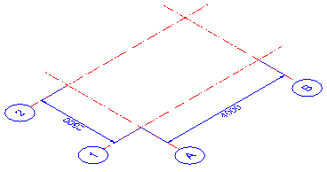

Levels
This will be a single level structure at 2750 high sitting on a foundation 200 mm above the datum, allowing for a leveling grout of 25 mm.
Therefore, we will establish 3 levels above datum = 0 (WCS), the first will be to the top of foundation = (TOC = 200). The second will be to the underside of the base plate (TOC + 25) = 225. The third will be to the top of the structure = 2750
It is possible to draw the grid using model lines, and afterwards use the Convert line to Grid line command, but Parabuild's Grid function is far simpler, quicker, and more efficient.
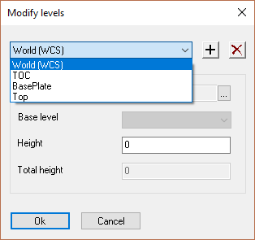

Draw the WireFrame
Place a vertical line to represent the columns beginning at A1 - 2750 high, (to coincide with the already established level) - repeat this process for the other 3 columns at A2, B1, and B2.
Draw horizontal lines between the 4 columns at the +2750 level to represent the outer beams
Draw 2 horizontal lines along the Y axis at 1000, 2000, 1000 - and 2 lines along the X axis between the 2 inner lines at 750, 1000, 750 - to represent the inner beams
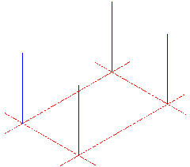 | 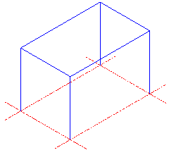 | 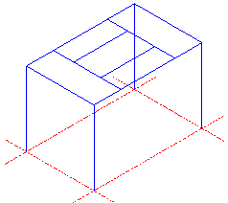 | 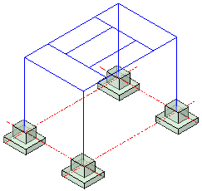
Draw vertical lines (Columns) | Draw horizontal lines (Outer beams) | Draw horizontal lines (Inner beams) | Show Foundations (Reference)

The next step is to draw the skeletal structure based on the WireFrame:
For the purposes of this exercise, we will be using UC profiles for the Columns, and UB profiles for the beams.

Draw the Columns
Open Draw Profiles, select I Profiles from the group / activate the UB from the group list / and select 254x146x31 from the value tables.
Scroll to the bottom of the Draw Profiles dialog and select On Model line
You will the be prompted to: Select the lines for placing the profiles : indicate the 4 column lines and press <Enter> The columns will be automatically drawn accompanied by the Profile placement dialog. Maintain the profile placement at Middle to ensure the center of the column is aligned with the model line. If necessary, Rotate the columns through 90° so that the flanges face along the Y axis. Notice that the columns are extended through the foundation to intersect with the grid line at the WCS - don't worry about this at this stage - it will be corrected when we place the base plates.

Draw the Outer Beams (Beams to Column)
Open Draw Profiles again and select I Profiles from the group / activate the UB from the group list / and select 203x133x25 from the value tables, and select and the On model line option - select the 2 outer model lines on the Y axis (Short side). Press <Enter> and the beams will be automatically drawn accompanied by the Profile placement dialog. Maintain the profile placement at Above to ensure the horizontal center of the beam is in line with the column, and the top flange is at the top of the column (2750 level). Press Close.
Repeat the process for the beams on the X axis, selecting UB from the group list and 254x102x25 from the value tables

Draw the Inner Beams (Beams to Beam)
Open Draw Profiles again and select C Profiles from the group / activate the UPN from the group list / and select UPN 200 from the value tables. Select the 2 model lines on the Y axis, press <Enter>. From the Profile placement dialog select Up left to ensure the heel of the channel is on the model line, and the top flange is in line with the top flange of the outer beams.
Open Draw Profiles again and select C Profiles from the group / activate the UPN from the group list / and select UPN 200 from the value tables. Select the 2 model lines on the X axis, press <Enter> Repeat the process above.

Note on placing Channel sections:
When placing Channels on multiple model lines, the toes of the channels may be found to point in the same direction. It may be necessary to manually mirror the profiles to change the orientation of selected profiles. Do this using the CAD 2D or 3D mirror commands.
At any time, the profiles may be edited by double-clicking on the selected profile to open the The Properties Panel.
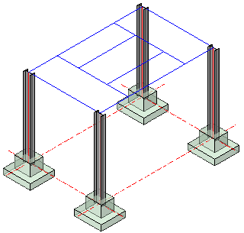 | 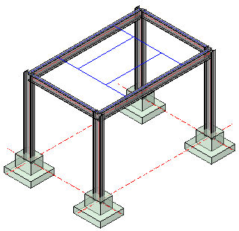 | 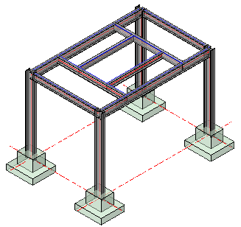
Place columns | Place outer beams | Place inner beams

This completes the skeletal structure using model lines- next, is to look at the various connections, but first we will draw this same structure using the Context Modeler.

Using the Context Modeler

Using The Context Modeler
The Context Modeler is unique to Parabuild, and will allow you to do far more than setting out a simple post and beam structure as demonstrated in this exercise - we will be looking at these additional functions in more detail later in this user guide.
As with the WireFrame model, we should first begin with establishing a Grid and Levels. These are important to take advantage of the View functions, and more importantly, in the generation of the 2D arrangement and detail drawings.
Grid
Being a very simple structure we'll establish a 2 x 2 grid, which is 4000 in the X direction, and 2500 in the Y direction - It will be drawn on the datum level WCS 0 (See The Coordinate System)
Levels
Levels may be established directly from the Context Modeler
This will be a single level structure at 2750 high sitting on a foundation 200 mm above the datum, allowing for a leveling grout of 25 mm.
Therefore, we will establish 3 levels above datum = 0 (WCS), the first will be to the top of foundation = (TOC = 200). The second will be to the underside of the base plate (TOC + 25) = 225. The third will be to the top of the structure = 2750

Draw the Columns
Open the Context Modeler dialog and set the Top level to Top and set the Bottom to BasePlate - These level names will coincide with those established and can be viewed and selected from the drop down options.
At any time the levels may be revised by selecting the level by name, and editing the value from the drop-down options menu. The model will reflect the changes immediately.
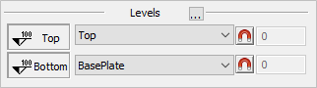
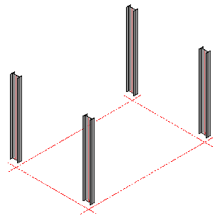

From the Context Modeler dialog, select the column profile type from the Selection options in this case we'll be using UB - 254x146x31, press the button Draw Framing. The column will hang from the mouse pointer, which should be placed on the grid line intersection (A1). Manipulate the mouse pointer so that the column is orientated correctly (The column flanges should face along the Y axis, or alternatively set the Rotation Angle while the column is still suspended. Once the column is orientated properly, press <Enter>, the selected orientation will remain while you click and <Enter> the remaining (3) column positions. Note that the selected levels will be taken into account.

Draw the Outer Beams
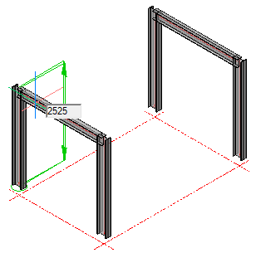
From the Context Modeler dialog, select the beam profile type from the Selection options in this case we'll be using UB - 203x133x25. Select the option, Draw a beam between columns 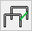 and select Draw Framing. Place the mouse pointer between the columns on the Y axis - the column will be shown hanging from the pointer between the columns - when satisfied with the positioning press the left mouse button to confirm the selection. The beam height may be adjusted by moving the mouse pointer or editing the dimension shown in the edit box. You may re-visit the positioning at any time by selecting the beam and editing the edit box.
Using the same method, select UB - 254x102x25 from the Selection options and place them between the columns on the X axis.

Draw the inner beams
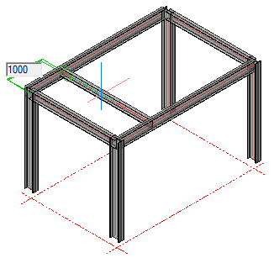
From the Context Modeler dialog, select the beam profile type from the Selection options in this case we'll be using UPN - 200. Select the option, Draw a beam between beams 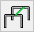and select Draw Framing. Place the mouse pointer between the outer beams on the X axis - the beam will be shown hanging from the pointer between the outer beams - moving the mouse pointer will display the current position from its grid reference point. Set the position at 1000 mm from the A grid line.
when satisfied with the positioning press the left mouse button to confirm the selection. You may re-visit the positioning at any time by selecting the beam and editing the edit box.
Repeat the process by placing a beam 1000 mm from the B grid.
Finally, From the Context Modeler dialog, select the beam profile type from the Selection options in this case we'll be using UPN - 180 and place them between the last 2 beams at 750 mm from the 1 and 2 grid lines using the same procedure.
In this example, ensure that the toes of the channels face outwards by using the Rotate Profile command, and that the dimension is placed to the heel of the channel. This can be done by Editing the profiles.

Completed Skeletal Frame
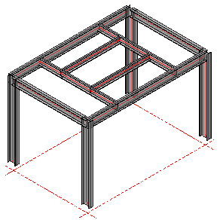

Editing Profiles:
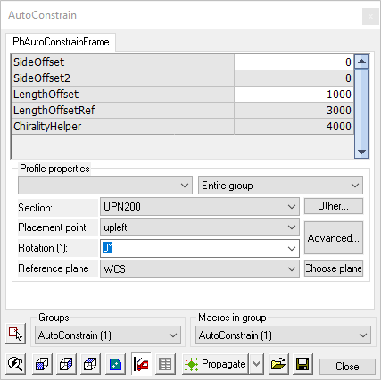
At any time, profiles placed using the Context modeler may be edited - this includes the profile type and size, its location, and its orientation. This is done by double-clicking the selected profile to open the Auto Constrain dialog.
To ensure channels are placed at the heel of the channel, set the placement point to up left

This completes the skeletal structure using the Context Modeler- next, is to look at the various connections.

Connections

Connections
To complete this very simple structure, we'll now add some connections, beginning with the base plates
Base Plates
Select Connections - End / Base Plates from the main menu and following the command line prompt Select Entities - indicate the base of the column - The base plate selection dialog will appear.
Select I BasePlate from the dialog and press <Enter> - the default Base plate will be drawn. You will notice that the base plate has been drawn at the WCS (0) and the column extended - this will be corrected in the customization dialog.
Press <Enter> again to open the Customization dialog. Here you are able to set the plate size and thickness, bolt pattern, and relationship to the column

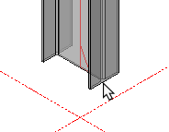
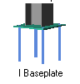
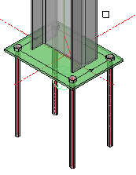

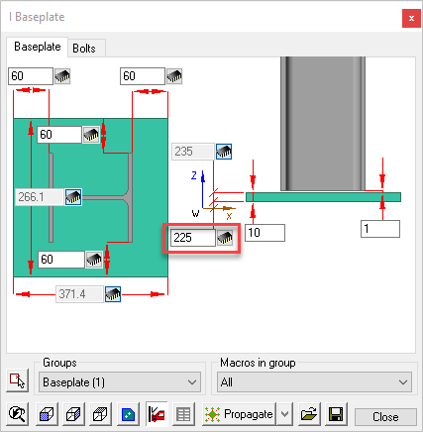

Editing the Base Plate Dialog
The dialog as 2 tabs - BasePlate - where you may edit the plate size and thickness, and Bolts - where you may edit the bolts pattern.
(For more information about the editing dialog boxes see Review Macro)
In this instance, as we noted, the base plate was re-situated at the WCS, to correct this, edit the dimension from the WCS from 0 to 225. This will bring the base plate back to its intended position.
Notice also, that the base plate is colored green - to indicate it is a base plate welded to the column - doing this will ensure the base plate will get an additional view on the workshop drawings.
Copy the Base Plates to the other columns
Once the base plate has been customized to suit, this may be copied by using the Smart Copy command, or alternatively, use the Propagate command
Warnings / Clash Detection
Parabuild has recognized that we are placing connections and has changed the color of the structure to yellow - this is to serve as a warning that there are clashes between the elements. This is normal, because at this stage the elements of the structure are intersecting due to the lack of any connections.
Bolts are also colored yellow when they are too close to a plate or beam. Bolts will be colored red if they are drawn in the air or if they are too close to the edge of a beam or plate that they are connecting.
The maximum distance between a bolt and the edge of a beam or plate can be set in the Global settings / Clash control dialog.
As the connections are resolved and clashes removed, the model will revert to its default Grey color. When the entire model is grey, indicating there are no further clashes, its safe to proceed with he preparation of workshop drawings.
You may also manually check for clashes using the Clash check command
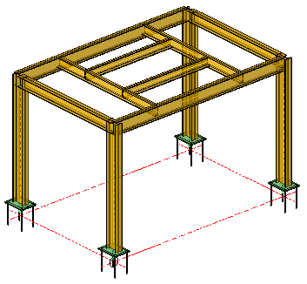
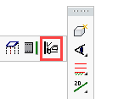

Beam to Column Connections - (Beam to column flange)
Select Connections / Beam to Column Connections from the main menu and following the command line prompt, Select the continuous column - followed by Select the beam. Note - Always select the column first - followed by the beam. Reversing the order will cause unpredictable results - if you make this mistake, correct it using the Back button.
The Beam to continuous column selection dialog will appear. Parabuild has recognized that the intended connection is connecting an I-Profile beam to the Flange of the column and has automatically filtered the options to reflect this particular configuration. This filtering mechanism simplifies the selection process.
Select I EndPlate Medium Moment from the dialog and press <Ok> - the default End plate will be drawn.
Press <Enter> to open the Customization dialog. Here you are able to set the plate size and thickness, bolt pattern, and relationship with the beam.

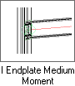
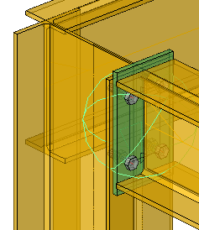
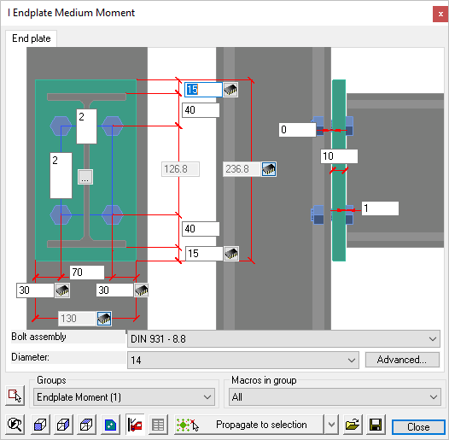

It's clear from this example, that the end plate will require some editing. The bolt diameter is too small, and the end plate protrudes above and below the beam - for a medium moment connection connecting anywhere but the top of the column, this would be OK, but in this particular instance it's not a good idea.
Editing the dialog
The first thing to change is that end plate protrusion, so we'll change the dimension (Top and Bottom) from 15 to -6 - this will allow for a 6 mm fillet weld. Next we'll change the weld gap from 1 to 0, and increase the clearance between end plate and column from 0 to 2 mm.
Next, we'll change the vertical bolt pitch to 70 / 70 measured from the top of the beam flange - leaving the horizontal gauge at 70 mm with an edge distance of 30 mm.
Finally, we'll increase the bolt diameter from 14 to 16
Press Close when complete
See the edited dialog and connection below.
(For more information about these editing dialog boxes see Review Macro)

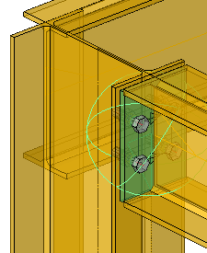
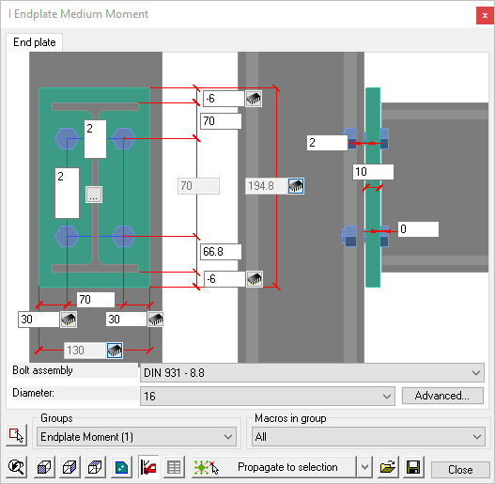
Copy the End Plate to the other connections
Once the end plate has been customized to suit, it may be copied by using the Smart Copy command, or alternatively, use the Propagate command.

Beam to Column Connections - (Beam to column Web)
Select Connections / Beam to Column Connections from the main menu and following the command line prompt, Select the continuous column - followed by Select the beam. Note! - Always select the column first - followed by the beam. Reversing the order will cause unpredictable results - if you make this mistake, correct it using the Back button.
The Beam to continuous column selection dialog will appear. Parabuild has again recognized that the intended connection is connecting an I-Profile beam to the Web of the column and has automatically filtered the options to reflect this particular configuration..
Select I EndPlate Medium Moment again from the dialog and press <Ok> - the default End plate will be drawn.
Press <Enter> to open the Customization dialog. Here you are able to set the plate size and thickness, bolt pattern, and relationship with the beam.
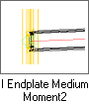
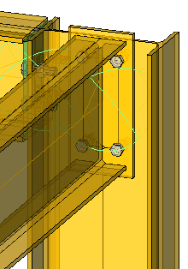
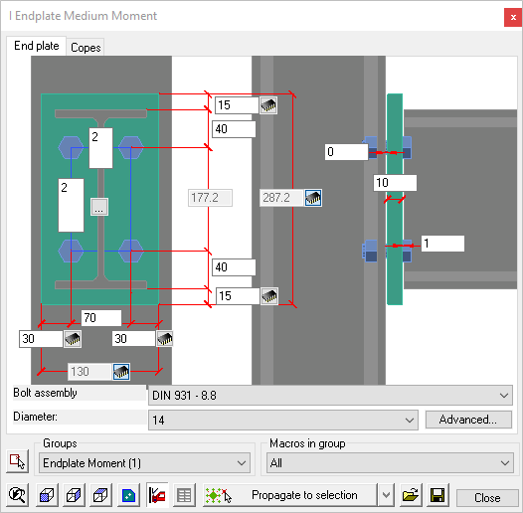

As before, the end plate will require some editing. The comments that apply to the beam to column flange connection, apply here.
Editing the dialog
we'll again change the dimension (Top and Bottom) from 15 to -6. Next we'll change the weld gap from 1 to 0, and increase the clearance between end plate and column from 0 to 2 mm.
As before, we'll change the vertical bolt pitch to 70 / 70 measured from the top of the beam flange - we'll leave the horizontal gauge from 70 to 90 mm with an edge distance of 30 mm.
Finally, we'll again increase the bolt diameter from 14 to 16
Press Close when complete
See the edited dialog and connection below.
(For more information about the editing dialog boxes see Review Macro)
Note! When detailing end-plates, it's always a good idea to round-off the overall dimensions when possible. In this example, the plate depth has worked out to 242.2 mm and though this is strictly correct, it would be better to round it off to a round figure and compensate the difference by revising the lower end-plate dimension to -6.2. which is effectively a reference dimension.

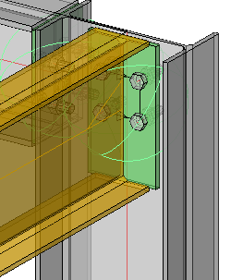
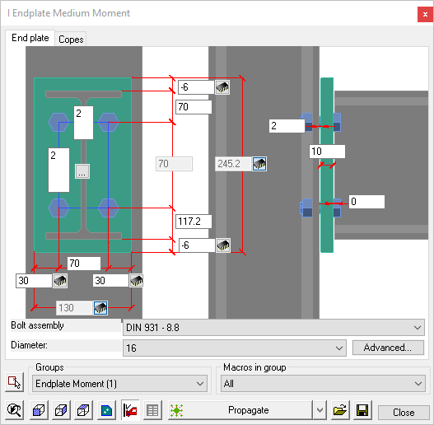

Beam to Beam Connections
Select Connections / Beam vs beam from the main menu and following the command line prompt Select the continuous beam (Supporting beam) - followed by Select the 2nd beam (Connecting beam) - The Beam vs beam selection dialog will appear.
Select U EndPlate from the dialog and press <Enter> - the default End plate will be drawn.
Press <Enter> again to open the Customization dialog. Here you are able to set the plate size and thickness, bolt pattern, and relationship to the column.
Note that Parabuild has recognized that the connection is a Channel section to an I beam - and automatically selected the appropriate dialog.

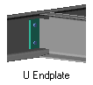
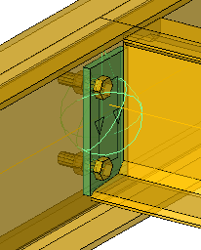

The default connection is 2 bolts situated vertically. We will change this to a 4 bolt connection with the bolts placed horizontally equally about the heel of the channel, with a vertical pitch of 70 / 70.
Being a beam-to-beam connection Parabuild has recognized that a top flange cope is necessary.
Editing the dialog
This dialog has 3 tabs - End Plate / Bolts / Copes
The Copes tab
First, we'll check the Copes - the default depth is 30 mm - we can check this by looking at the reference of 21.6 mm which should be greater than the root radius of the beam. In this case, it is.
Next is the clearance of 10 mm between the toe of the supporting beam and the flange of the connecting beam - in all but the largest beams, this will be OK.
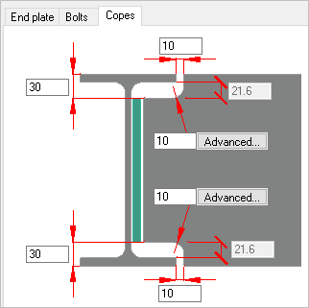
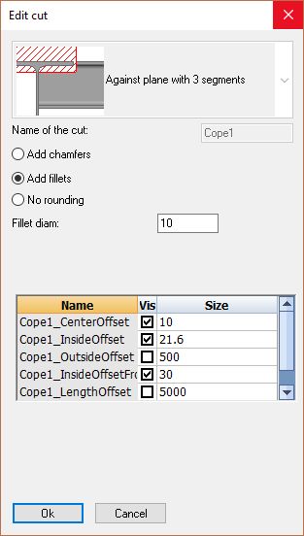
The default fillet radius for the notch is set at 10 mm - which is good practice - selecting the advanced button will open the Edit Cut dialog where you have the option of changing the fillet radius, making it a chamfer, or leaving it out altogether.
Additionally, you may edit all the other cope properties.

The end plate tab
Next we'll open at the end plate tab. General practice is to set the top of the end plate equal to the depth of the cope, which in this case is 30 mm.
As we are making a 4 bolt connection, we'll increase the end plate width from 80 to 150, and to center the plate about the heel of the channel, we'll set a dimension of 75.
Next we'll change the weld gap from 1 to 0, and increase the clearance between end plate and column from 0 to 2 mm.
The depth of the end plate we'll set at 150 - the reason for doing this will be explained when we look at the bolts.
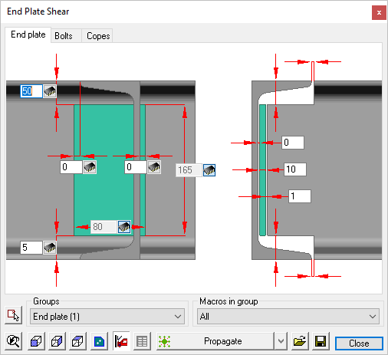 | 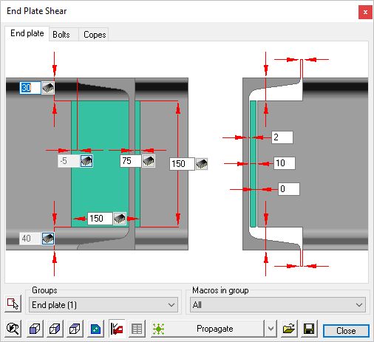
Before Editing | After Editing

The bolts tab
As mentioned earlier - this will be a 4-bolt connection with the vertical pitch of 70 / 70 mm. measured from the top of the incoming beam, and a horizontal gauge of 90 mm.
Here we will change the horizontal number of bolts from 1 to 2, Edit the horizontal gauge from 40 to 90, leaving a horizontal edge distance of 30 mm.
In order to maintain the 70 / 70 vertical bolt pitch, edit the dimension from the top of the end plate to the first row of bolts from 30 to 40 mm. This, added to 30 mm from the top of the beam (Depth of cope) = 70 mm.
Edit the vertical bolt pitch from 105 to 70 mm.
(For more information about the editing dialog boxes see Review Macro)
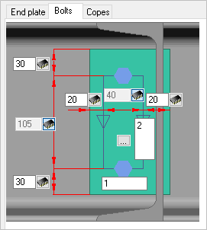 | 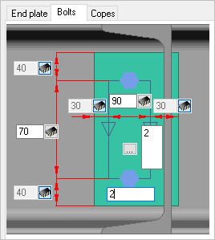 | 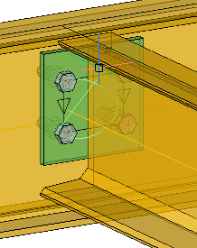
Before Editing | After Editing | The Completed Connection

Next, we'll connect the inner beams to each other using another variation of the end plate. As with the previous connection, select the supporting beam, followed by the connecting or incoming beam. From the connection selection dialog select U EndPlate - The default connection will be drawn - Press <Enter> to open the U EndPlate edit dialog.
Note that Parabuild has again recognized the orientation of the connection and presented options compatible with the configuration. Once selected, the edit dialog likewise, reflects the particular configuration.
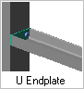

Editing the dialog
This dialog has tabs - End Plate / Bolts
The editing procedure is exactly the same as the previous connection. In this case, we'll provide a 2-bolt connection at a horizontal pitch of 90 mm

The end plate tab
As we are making a 2 bolt connection aligned horizontally, we'll increase the end plate width from 70 to 150, and to center the plate about the heel of the channel, we'll set a dimension of 75. The depth of the end plate will be set at 80 mm.
Next we'll change the weld gap from 1 to 0, and increase the clearance between end plate and column from 0 to 2 mm.
The depth of the end plate we'll set at 80 - again, this will be to accommodate the bolts at the bolts.
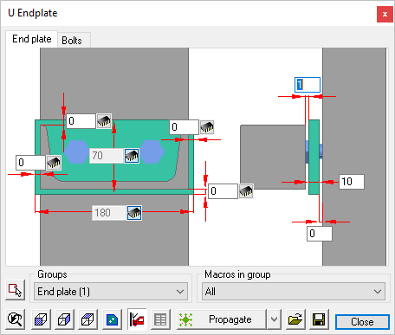 | 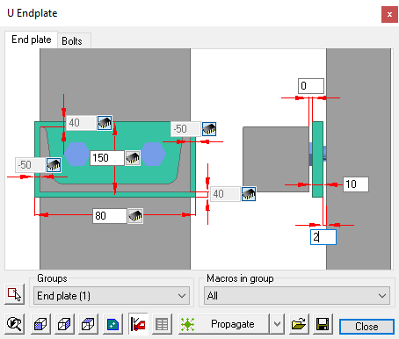
Before Editing | After Editing

The bolts tab
As this will be a 2-bolt connection, the vertical pitch will be set at 70 mm to the row of bolts measured from the top of the incoming beam, and a horizontal gauge of 90 mm.
Here we will change the vertical number of bolts from 2 to 1, Edit the horizontal gauge from 14 to 90, leaving a horizontal edge distance of 30 mm.
Edit the dimension from the top of the end plate to the row of bolts from 28 to 40 mm. This, added to 30 mm from the top of the beam (Depth of cope) = 70 mm.
Edit the vertical bolt pitch from 124 to 0 mm.
(For more information about the editing dialog boxes see Review Macro)
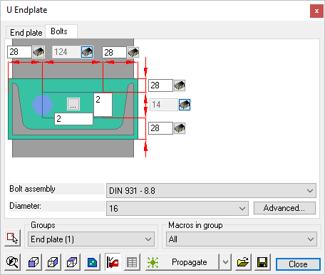 | 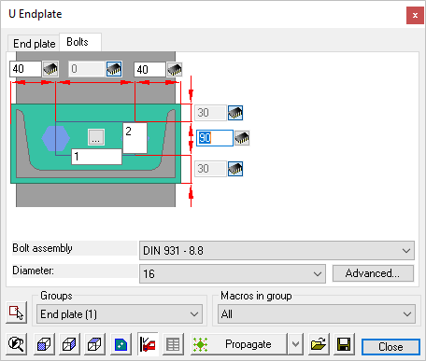
Before Editing | After Editing
Once the base plate has been customized to suit, it may be copied by using the Smart Copy command, or alternatively, use the Propagate command
Below is the completed connection
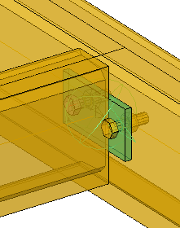

The Completed structure
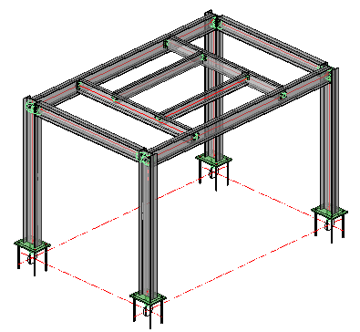

Workshop Drawings

Workshop Drawings
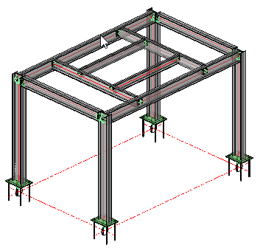
From the simple model just created we will now produce the workshop drawings which will include:
Position and assembly sheets - which are piece by piece workshop details of all the component parts of the structure, together with assembly details, detailing how the component parts fit together to form the assembly - an example would be a beam with end plates welded to one, or both ends. Each part will be automatically given a part number, and each assembly will be automatically numbered, referencing the individual part numbers.
Parabuild allows you to edit and customize each of these functions - which we will look at as this chapter progresses.
Generate DXF files - which are AutoCad Data Exchange Files. These files may be read by virtually all CAD formats. Parabuild produces DXF files for all workshop drawings by default. (For more details on Generating DXf Files go to Generate DXF files)
DSTV NC files - to be read by most cutting- and drilling CNC (Computer Numerically Controlled) machines. Also some plate machines (laser, plasma) (For more details on generating DSTV NC files go to Generate DSTV NC files)
Generate WrapAround for pipes - this function will provide numeric details for the cutting of pipes or circular hollow sections which a welded together to form a joint - this is useful when detailing hollow section girders or trusses. (For more information on this go to Generate WrapAround for pipes)
Generate STEP files - which is a CAD file format, usually used to share 3D models between users with different CAD systems (For more information on this go to Generate STEP fies)
Generate Bills - which include comprehensive bills of material, bolt lists, washers etc.
General arrangement Drawings - where you are able to produce 2D plan and elevation views of the structure. These will be based on the already established grid-line formation and set levels.

Position and Assembly Sheets
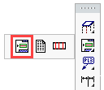
We begin by opening the Sheets manager from the Main - Output menu. Press the Generate button to open the drop-down options, and select Generate Position+Assembly Sheets
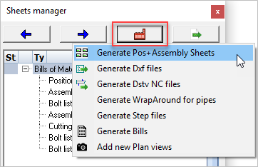

Following the procedure given in Generate Position+Assembly Sheets the sheets will be prepared and stored (In DXF format) in the same folder as the model.
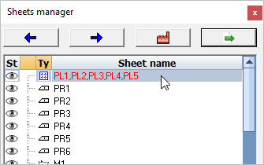
The Position and assembly sheets may be reviewed by double clicking the item in the top list of the Sheets Manager, or alternatively, you may use the left / right arrows to scroll though the drawings.
As can be seen from the examples below, Items and assemblies are automatically fully dimensioned and marked.
The drawing sheets contain a schedule of materials and title block - all of which can be modified and customized to suit your particular requirements. The examples shown below have been prepared according to the default values determined by the Settings. We'll look at reviewing these settings and making some changes:

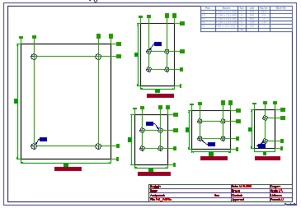 | 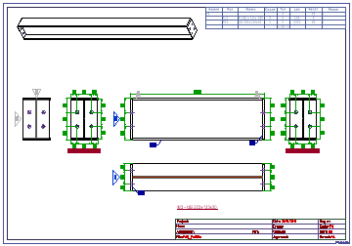
Typical Detail Drawing | Typical Assembly Drawing

Dimensions and Annotations
Setting values for automatic dimensioning is in 2 parts:
Part 1 includes setting the Sheet properties, where you may set (among other things) the dimension and text styles
Part 2 includes setting the format of the dimensions, where you may establish whether the dimensions are Ordinate (as above) or Chained - you may also set the dimension positions relative to the object. These Default Dimension values are set separately by means of interactive dialogs for Plates, Side views, and Sections
Modify Frame templates
Here you may select and/or modify the drawing frame template (Sheet size) by selecting from any of the ISO or US frame templates. Go to Modify Frame Templates
Modify Title Block template
Here you may edit the title block by adding Project titles, signatures, etc. You may also edit the title block to show your, or your company's logo and information. Go to Modify Title Templates
Modify Bill of Material Template
Here you may edit the Bill of material template by adding or deleting columns, rearranging them, and inserting additional data. You may also change its position in the drawing sheet. Go to Modify Bill Templates
Manually Editing the Drawings
Parabuild has many functions for manually adding additional information to the assembly drawings - these include Weld symbols, Levels, Comments, Additional annotations, Part names etc. These options can be found at Tools for 2D Drawings
General Notes
Here you can add generic General Notes to drawings. Parabuild has a built-in General Notes template which you may complete and add to the drawing frame. For more information go to the General Notes Template

General Arrangement Drawings
We begin by opening the Sheets manager from the Main - Output menu. Press the Generate button to open the drop-down options, and select Add new Plan views
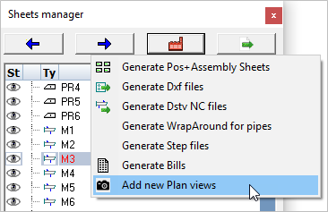

Follow the procedure given in Add new Plan Views
For the purposes of this exercise, select plan views for: World (WCS) and Top. In the following Format and scale dialog, select the drawing format to A1 and the scale to 1:20.
Finally activate all the Annotations in the Format and scale checkboxes and press Ok
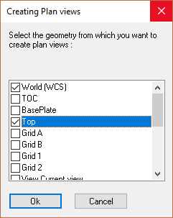
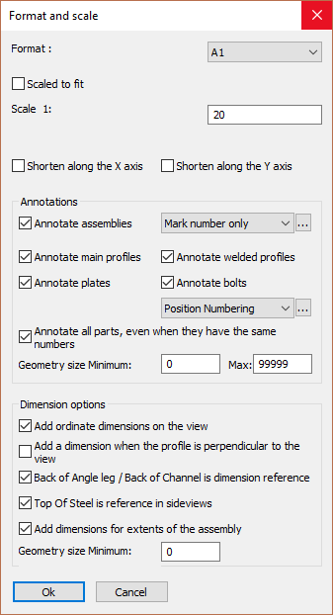

As we are placing multiple plan views, follow the command line prompt and Select the location where the view is to be drawn - World - indicate a place on the drawing sheet and press the left mouse button to confirm. Following the command line prompt again, indicate a position to place the view Top. Don't worry if the positions are a bit random at this stage - just try to ensure that the views don't overlap on the drawing.
Next we'll place some elevations on the drawing - Repeat the Add new plan views process and select Grid 1 - follow the command line prompt and place it on the drawing sheet. Repeat this process for Grid A.
At this stage, it's good practice to align the views so that they project along common lines - in other words, align the plans horizontally, with the elevations or sections aligned with the plans. This is done using the built-in CAD move / copy commands. See example below.
In Europe (and most of the world) Third angle orthographic projection is used whereby the plan views are placed above the elevations, in the US, First angle projection is used whereby the plans and elevations are switched.
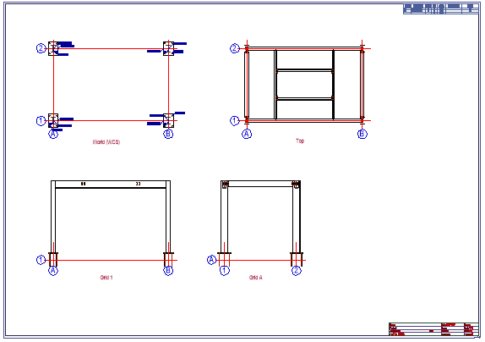

Manually editing the drawing
Often it's necessary to manually edit parts of the drawing - usually to make things clearer and easier to read, an example of which, in this instance, are the text and labels around the base plates.
To move text and labels, indicate the text or label to be moved with the left mouse button, and holding the text grips, relocate it.
To change the appearance of the object (The grid line notation in this case) double click the item and modify its Properties.
Do not modify the Values!

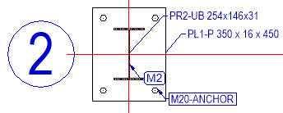 | 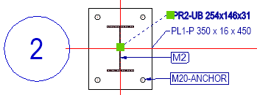
Before Editing | After Editing

Adding Dimensions
Parabuild has a full range of dimension commands derived from the regular CAD properties. The options for dimensioning are full explained in Dimensioning.
Adding Levels Notation
Levels notation may be added to Elevations and Sections using the Levels command
The options available for editing the Drawing frame, Title Block, Bill of Materials, and General notes templates are as noted for Position and Assembly Sheets
General Plate Settings
Parabuild has the facility to change the appearance of the plate notation on the drawing, where you can add spaces to the name, alter the order in which the plates are noted etc. This facility is available from Global Settings
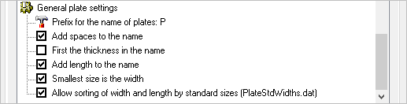

Bills of Material / Bolt Lists
To generate all bills, open the Sheets manager from the Main - Output menu. Press the Generate button to open the drop-down options, and select Generate Bills you will be prompted to update the revision from the Revision manager or Continue without locking. In this case Continue
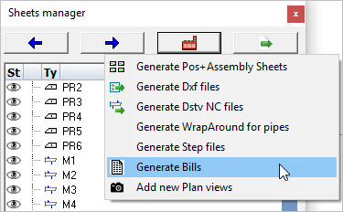
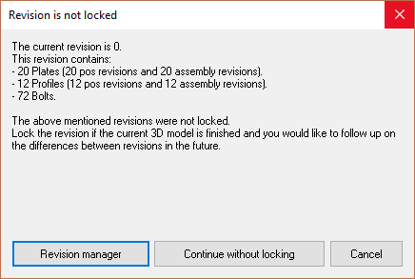
The Bills will be automatically generated and then immediately opened in Excel, Open Office or the Parabuild spreadsheet. The format used depends on the output setting in the bill's Settings. The file will be stored in the same folder as the 3D DWG files.
Settings for bills of material
There are numerous option available for the presentation of bills of material contained in Document generation Settings / Bills of Material here you can create, save, and load Bills.
Bills can be customized to suit by accessing the Bills of material / Formatting options, where you can edit the Bill type and format, You can also adjust the column type, column order, and sub-total columns. You can also add filters to aid in the sorting.

This completes the first exercise, at this point we have produced a working model of a simple post and beam structure using both Model Lines and Parabuild's Context Modeler. In preparing this model, we have added base plates and connections, providing and introduction into the use of Parabuild's macro edit dialog system.
We have produced Detail and Assembly drawings, together with Bills-of-material, Bolt-Lists, and General Arrangement drawings, each of which were automatically derived from the model.
We have also seen how we can modify and customize the drawing sheets and bills of materials to suit requirements in order to present accurate and professional documents.
At this point, you should repeat these exercises using different profiles and section sizes, use different connection options, and adjust the settings for dimensions and bills.
Mastery of this simple exercise will provide you with an in-depth insight into the workings of Parabuild so that you may confidently approach the next steps.

Reference Guide
This section covers all the commands listed in the 3 main toolbars and the ribbon, together with the Parabuild Settings and the Properties panel.
- Parabuild Settings
- The Properties Panel
- Main - Library
- Main - 3D Modeling
- Main - Output

License management
Command - PrB_Info
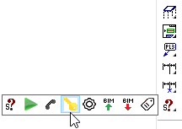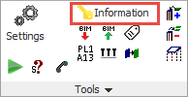

This dialog box allows you to see information about the version and license of Parabuild.
You can also activate and deactivate the license here.

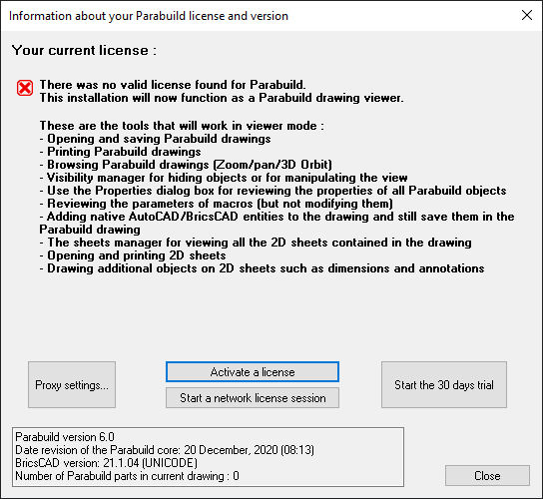

The items in the dialog are explored below :

Activate a license
This button allows us to activate a normal perpetual or rental license. When we activate a license from this dialog box, Parabuild will request a license activation from the internet server.
The server will only grant an activation if the license is not already activated on another computer.

Deactivate this license
By deactivating the license, you will free up the license on the server again.
This makes the license available again for activation on another computer.

Deactivating frequently
For managing licenses we use a third party service. Deactivation and Activation of the license is taxing on the servers. For this reason, we are charged per activation by the third party.
To avoid excessive costs, you are allowed to activate Parabuild for a maximum of 50 times per year if you have a maintenance contract for the license, or 10 activations per year if you do not have active maintenance for the license.
We will monitor the activation usage periodically to find the licenses that have surpassed this limitation.
If this happens we will then contact the customer to find a solution, which may include billing for excess activations.

Activation fails and you can't use Parabuild anymore
This can happen when a system crash has occurred on a system that had a Parabuild activation.
To fix this, we can reset the activations of your license on the server.

You can ask your reseller to help you with this problem.
For a quicker response, you can create a support ticket by sending an email to : support@parabuild.com
You can also contact customer relations to help you with this problem. You can email them at : contact@parabuild.com
Do not forget to mention your license ID and company name.

If you need very urgent assistance with this problem, you can call Parabuild directly at :
+32 3 216 49 66
This phone number will be answered during business hours in time zone GMT+1/CET.

Proxy settings
This is only needed in very rare occasions.
If your network requires you to use a proxy server, then enter the proxy information here.
Parabuild will then go through this proxy server to contact the Parabuild server.

Check validity online
Parabuild will periodically connect to a license server to verify the status of your license.
This check happens in the background, unless the server could not be reached for several days.
If this happens, the user will be notified and still has 3 days to connect to the internet.

If you expect to be working offline for a few days, you can prepare by pressing the Check validity online button.
If it is not yet visible then it means the license was recently verified and there is no need for a new check.

Element count
At the bottom of the dialog, we can see this line :
Number of Parabuild parts in current drawing
This shows the total amount of 3D parts as it would be counted for the licensing.
This number can be used to see how close the current drawing is to hitting the maximum amount of parts in the current drawing.
Only the LT versions of Parabuild have a limit on the number of parts in the drawing.
Only plates, profiles, structures and volumes are counted as 3D parts. Bolts are counted as well but the total number of bolts is divided by 4.
Once the maximum has been reached, the commands for drawing new 3D parts will stop working.
Parabuild will start to function as a viewer from this point on, or until enough 3D parts have been removed from the drawing.

Floating network licenses
A floating Parabuild license can easily move from one user to another user over the internet. The floating license is only available for Full versions of Parabuild and comes at an additional cost.
In Parabuild, a floating network license does not require the installation of a network server.
This service is provided by Parabuild directly over the internet.
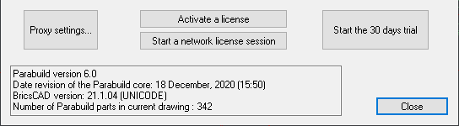
Normal license
For activating a normal perpetual or rental license, use the Activate a license button.
This license type will stay active on your computer until you've released it.
A network license can't be activated through this button.
Network license
Use the Start a network license session to use a floating network license.
A normal license can't be activated through this button.
Upon clicking this button, you will get this dialog box :
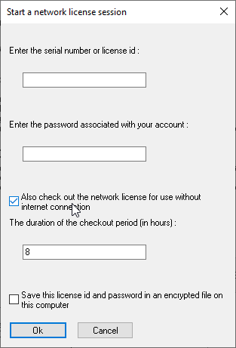
Besides entering the license Id and password, there are more options to choose from :
Also check out the network license for use without internet connection - Use this tool when you are planning to use the license while on the move. The license can then be used without an internet connection. However, nobody else will be able to check out the license during this period.
The duration of the checkout period - The number of hours that the license needs to be checked out. During this period, the license will be locked to the computer. When this time has elapsed, the license will become available for checking out again, even if the computer to which it was checked out to has no internet connection.
Save this license id and password - When activating this, the data will not need to be entered daily when using a network license.
This will save the license id and password in an encrypted file in the parabuild folder : \Parabuild\LicensePassword.dat
After successfully checking out the network session, the following information is displayed :
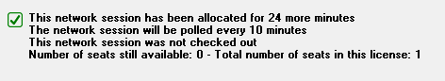
This network session has been allocated for xx minutes - The amount of time that this session was allocated to this computer.
This is simply informative, because a request to extend this session will be done automatically in the background before this time expires
The network session will be polled every xx minutes - This is the time between each polling action. A polling action is done in the background while your are working in Parabuild. When the server has not received any recent polling request for the session, and if all polling retry timeouts have also expired, then the seat will become available for a new session.
This mechanism is important to automatically release the license seat when the user that had the active session has lost their internet connection, for example.
This network session was (not) checked out - Whether the license was checked out for offline use for a certain period of time.
Number of seats still available - The number of seats that are not in use in this license
Total number of seats in this license - The total number of seats that have been purchased on this license
When you close Parabuild, the license will be released automatically to the server, so that another user can start a network session immediately after that.
A network session is only active in one Parabuild instance.
In order to start Parabuild multiple times, the session should be checked out for a certain period. Otherwise, multiple network sessions would have to be opened : one for each Parabuild instance.

Parabuild Settings
Command: PrB_Settings
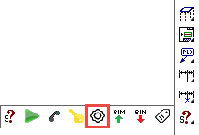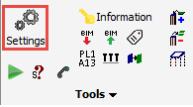
The Parabuild settings window has 3 main tabs:
Global - Where you can preset global standards and settings - these settings will override all AutoCAD and BricsCAD settings
The bottom buttons allow you to edit the various libraries and filters, and clash control settings
3D Model - These settings will determine how the model is presented and viewed
Dynamic data - This allows additional properties to be created to supplement the properties already offered by Parabuild
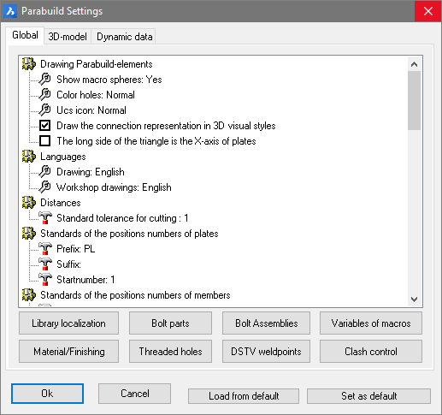

Where are the values of these settings stored?
Most of the setting values on the tabs Global and 3D-model are stored in the 3D drawing (.dwg file).
So if you make another 3D drawing active, then you might see different values in the tabs Global and 3D-model.

Where are the library settings stored?
All the settings behind the below 7 buttons are stored in the Parabuild library (fe c:\Parabuild\Pb_Lib)
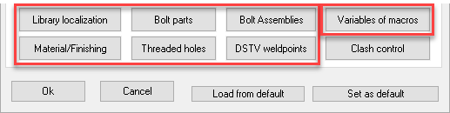
The library folder can be switched to a different location with the help of the Parabuild Startup settings tool.

The purpose of this would be to let several Parabuild users share the same library within the same company.
If one of the users adds a new profile or a new material, then all the users will automatically get access to the new profile and material.
The procedure to do this is to first copy the Pb_Lib folder of one of the users to the shared location and then use the Startup settings tool on all of the Parabuild installations to switch the library to the shared location.
A condition for doing this set-up is that all the Parabuild installations should work with the same version of Parabuild.

We recommend to use one of the cloud drive services as the location for the shared Parabuild library folder (DropBox, Microsoft OneDrive or Google Drive).
These cloud drives will store a local copy of the library, which ensures maximum speed while using Parabuild commands.
But still if the user is disconnect from the internet such as with a laptop, he/she will still have access to the local Parabuild library to continue working with Parabuild.
The cloud drive's synchronization tool will update the local library with changes from the cloud and will upload your changes to the cloud drive in the background when there is an internet connection.

The Startup settings tool can be found in the Windows start widget :
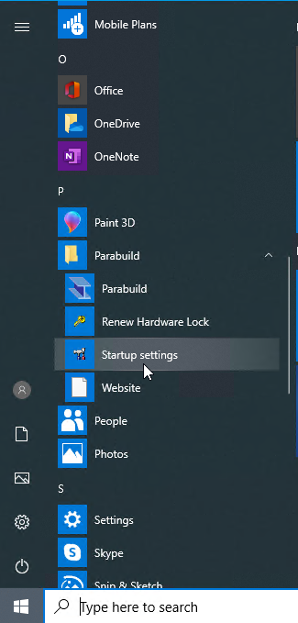

How to change these values for existing parts?
This dialog box will not modify the settings of existing parts in the drawing.
The settings in this dialog box only applies to new parts that will be drawn.
If you want to change the settings of existing parts, then use the Properties panel to change the settings of a single part or several parts at the same time.

How to store these settings?
You can use the Load/Set from default buttons at the bottom of the dialog box to store or retrieve the setting values in the dialog box.
This refers only to the settings on the Global and 3D-model tabs.
- Set as default will store all of the settings in a file in your Parabuild installation folder (\Parabuild\defset.dat).
All new 3D drawings that you create starting from a template drawing will assume these defaults.
- Load from default will read the defaults that have been stored in \Parabuild\defset.dat and will apply all the values to the current 3D drawing.

Global settings
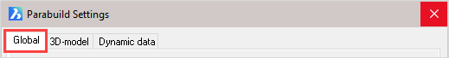
The global settings are divided into the following categories:
- Drawing parabuild elements
- Languages
- Standard tolerances for cutting
- Distances
- Standards of the position numbers of plates
- Standards of the position numbers of members
- Standards of the position numbers of structures
- Standards of assembly numbers
- Global settings
- Standard values for newly drawn members and plates
- General plate settings

The buttons at the bottom of the dialog are referenced here:
- Library Localization
- Bolt Parts database
- Bolt Assemblies
- Variables of Macros
- Material / Finishing
- Threaded Holes
- DSTV WeldPoints
- Clash Control
- Object Filters
- Structural types
- CNC contour settings
- Modify K-Factor tables - This button allows modification and creation of new K-factor tables

Drawing Parabuild Elements
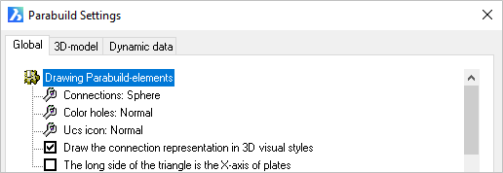
Connections: Refers to the macro indicator - Options = Not / Sphere / Triangle
Color Holes: Hole color - Options = Normal / Red
UCS icon: This refers to the coordinates system of plates and profiles. Options = Normal, which draws a triangle at the origin / Detail, which draws a UCS icon at the origin.
Draw the connection representation in 3D visual styles: A switch, which when checked will show the macro spheres when one of the 3D visual styles are active. When unchecked all spheres will be hidden.
The long side of the triangle is the X axis of the plates: The origin triangle direction may be switched from the Y axis (checkbox UnChecked) to the X axis (Checked). This option will only come into effect when the UCS icon is set to Normal

Languages
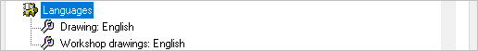
The language option for Drawing refers to the language of the user interface in Parabuild. That means all the dialog boxes, command line prompts and toolbars.
The language option for Workshop drawings refers to the language of the automatically generated workshop drawings and GA drawings only. More specifically the title block and Bill of Material on these drawings.
The available languages include:
  - English
  - Dutch
  - French
  - German
  - Korean
  - Traditional Chinese

Distances
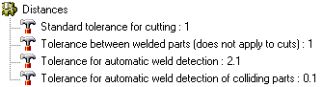
Standard tolerance for cutting: Commands for adding cuts to parts will follow this default value. Default value = 1 mm.
Tolerance between welded parts (does not apply to cuts): The distance (gap) that should be generally applied between welded parts.
This applies to all welded parts except in case a cut is touching one of the parts. In case of a cut, the above tolerance counts.
Tolerance for automatic weld detection: This tolerance is used by the Workshop Drawings generation command, and by the DSTV and DXF export commands.
When parts are not touching but within this tolerance, then Parabuild will assume that the parts are touching and need to be welded. The touching status will determine whether the welded part will get certain dimension on the shop drawing or CNC contours or matchlines in the CNC files.
Tolerance for automatic weld detection of colliding parts: This tolerance is used by the Workshop Drawings generation command, and by the DSTV and DXF export commands.
When parts are not touching but colliding with each other but within this tolerance, then Parabuild will assume that the parts are touching and need to be welded. The touching status will determine whether the welded part will get certain dimension on the shop drawing or CNC contours or matchlines in the CNC files.

Standards for the position numbers of plates
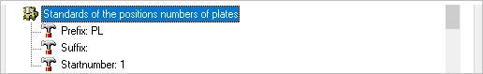
Prefix: Is the prefix given to plate numbers i.e. PL 1 - this may be edited to suit
Suffix: Is the suffix given to plate numbers i.e. PL 1 01 - this is optional
Start number: Is the first number given to the plate i.e. PL500. This number will be automatically incremented if the given start number is already occupied.

Standards for the position numbers of members
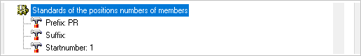
Prefix: Is the prefix given to member numbers i.e. PR 1 - this may be edited to suit
Suffix: Is the suffix given to member numbers i.e. PR 1 01 - this is optional
Start number: Is the first number given to the member i.e. PR500. This number will be automatically incremented if the given start number is already occupied.

Standards for the position numbers of structures
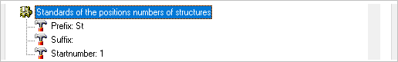
Prefix: Is the prefix given to structure numbers i.e. ST 1 - this may be edited to suit
Suffix: Is the suffix given to structure numbers i.e. ST 1 01 - this is optional
Start number: Is the first number given to the structure i.e. ST500. This number will be automatically incremented if the given start number is already occupied.

Standards of the assembly numbers
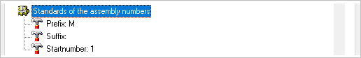
Prefix: Is the prefix given to assembly numbers i.e. M 1 - this may be edited to suit
Suffix: Is the suffix given to assembly numbers i.e. M 1 01 - this is optional
Start number: Is the first number given to the assembly i.e. M500. This number will be automatically incremented if the given start number is already occupied.

Global Settings
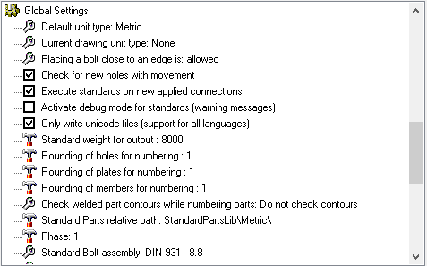
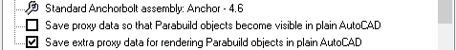
Default unit type: Use None if you want to work in both Metric and Imperial projects. Choosing Metric will cause Parabuild to assume Metric in drawings with conflicting units variables. The same applies to the Inches option. Options = None / Metric / Inches
Current drawing unit type: Change this option only when Parabuild has assumed the wrong units for the current 3D drawing. Options = None / Metric / Inches
The following variables are used by Parabuild to conclude whether a dwg file is Metric or Imperial :
Variable name | Variable value
Measurement | 0 for Imperial  1 for Metric
LUnits | 2 for decimal metric  3 or higher for imperial  (4 for fractions notation)
InsUnits | 1 for Imperial  4 for millimeters
The setting Current drawing unit type in this dialog box will be set to what could be derived from these 3 variables. You can change the setting in this dialog to correct it if needed.
AutoCAD and BricsCAD also have the following variables that may interest you especially when working with Imperial units:
Variable name | Variable value
Dimzin | Controls the suppression of zeros in the primary unit value in dimensions.  0-7 for Imperial  8 for Metric
Dimtzin | Controls the suppression of zeros in tolerance values in dimensions.  0-3 for Imperial  4, 8 and 12 for Metric
DimFrac | Sets the fraction format when DIMLUNIT is set to 4 (Architectural) or 5 (Fractional).  0 : Horizontal stacking  1 : Diagonal stacking  2 : Not stacked (for example : 1/2)
DIMTFac | Scale factor for fractions
DimLUnit | Sets units for all dimension types except Angular.  1 : Scientific  2 : Decimal  3 : Engineering  4 : Architectural (always displayed stacked)  5 : Fractional (always displayed stacked)  6 : Microsoft Windows Desktop (decimal format using Control Panel settings for decimal separator and number grouping symbols)
DimPost | Specifies a text prefix or suffix (or both) to the dimension measurement.
luprec | Sets the display precision for linear units and coordinates.
unitmode | Controls the display format for units.  0 : Displays fractional, feet-and-inches, and surveyor's angles in "report" format using spaces as delimiters  1 : Displays fractional, feet-and-inches, and surveyor's angles in "input" format without including spaces and, in some cases, substituting dashes for spaces
InsunitsDefSource / InsUnitsDefTarget | These are only used when the source or target drawings of an insert operation don't have the InsUnits variable set

Placing bolt close to an edge: Options = Not allowed / Allowed
(The minimum distance between a bolt and the edge of a beam or plate can be set in the Clash Control dialog)
Check for new holes with movement: Options = Off / On
(When a bolt is moved, the corresponding holes are moved with it. You can switch this off)
Execute standards on new applied connections: Options = On / Off (Refer to Standards for Connections)
Activate debug mode for standards (Warning messages): Options - On / Off
Only write Unicode files (Support for all languages): Options - On / Off
Standard weight for output: This value is the default weight that Parabuild should assume for objects that have no material assigned. The default value is set at 8000 kg/m³ - which is the approximate value for 1m3 of steel (7860 kg/m³).
Rounding of holes for numbering: This is the tolerance that Parabuild should use when searching for identical parts and assigning numbers to them.
In practice, Parabuild will assume half of this tolerance when comparing 2 parts. This means that the total maximum difference between 3 parts will be the full tolerance.
The below illustration shows the difference between the tolerance of 2 parts and the total tolerance of 3 parts or more.
It shows 3 plates on top of each other, but with slightly offset hole positions.
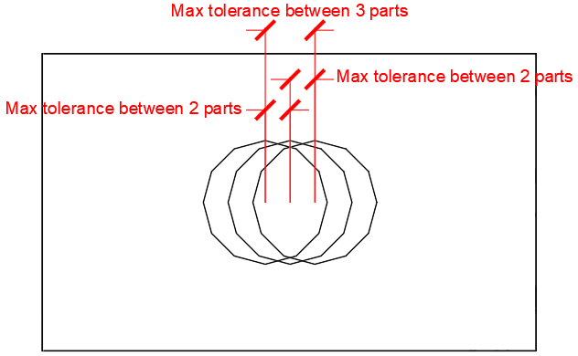
Rounding of plates for numbering: Same as above, but this refers to the tolerance of plate edges for number assignment.
Rounding of members for numbering: Same as above, but this refers to the tolerance of member edges and cuts for number assignment.
Check welded part contours while numbering parts - This option is explained in detail in the Check contours when numbering parts topic.
Standard parts relative path: This value should point to a folder inside the Parabuild library (the full path is by default c:\Parabuild\Pb_Lib\StandardPartsLib\Metric\ or \Imperial\).
The purpose of this tool is to assign predetermined part numbers to "off the shelf" parts so that those parts can simply be taken out of storage instead of produced.
For more information about this tool see the Standard Parts Library topic.
K-factor table to be used when parts are unfolded - The table allows you to assign K-factors based on material, part name, plate thickness, bend radius, and bend angle.
During the unfolding process, this table will only be consulted if the K-factor was not found in the part's advanced properties, nor in the K-Factor and BendRadius columns of the section table, nor in the more options dialog of the section table.
At the bottom of this dialog you can also find the Modify K-factor tables button which allows you to modify or create a new K-factor table.
Phase: Sets the phase that all newly drawn objects should receive.
Standard bolt assembly: The default bolt assembly that connections and bolt tools should use by default. (See Bolt Assemblies)
Standard anchor bolt assembly: The default bolt assembly that anchor plate macros should use by default. (See Bolt Assemblies)
Save proxy data so that Parabuild objects become visible in plain AutoCAD/BricsCAD: This option allows the 'Proxy' details of a 3D-drawing to be saved.
Parabuild creates its own objects (profiles, plates, bolts ...) which means that without Parabuild, AutoCAD will not recognize these objects and therefore will not display the profiles. This is solved by the 'proxy' details, details on the appearance of the objects, which is saved within the drawing. One disadvantage of this is that the drawing becomes 2 to 3 times larger. However, this does not result in any great delay when opening or editing the drawing, as these details are not actively used, and is therefore not loaded into memory when working with Parabuild. Remember that when this option is turned on within an existing drawing and then saved normally, the details are not yet saved. This can be solved by either setting the variable 'ISAVEPERCENT' to 0, or by saving the drawing under another name.
One final requirement is that the proxy details on the computer without Parabuild is set to display. This can be set up in AutoCAD as follows: Tools > Options > Open And Save > Proxy Images for custom objects should be set to Show proxy graphics.
Save extra proxy data for rendering Parabuild objects in plain AutoCAD/BricsCAD: this is a sub-set of the previous option.
This will add additional proxy data for rendering of faces with 3D objects. Note that this option will not work independently as the edges are still needed to determine the faces. Therefore, both check boxes must be active if you want the rendering data to be written to file.

Standard values for newly drawn beams and plates
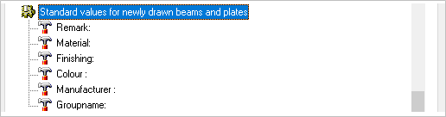
Remark: Here you may enter a standard Remark for newly drawn parts
Material: Here you may enter a standard material for newly drawn parts
Finishing: Here you may enter a standard Finishing for newly drawn parts
Color: Here you may enter a standard Color for newly drawn parts
Manufacturer: Here you may enter a nominated Manufacturer for newly drawn parts
Group name: This property is not actively used by Parabuild, so it can be considered a free to be used "User property".

General plate settings
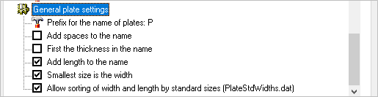
Prefix for the name of plates: The default value is PL - this may be changed to suit preference (i.e. PL8x100)
Add spaces to the name: Will add spaces between the characters (i.e. PL 8 x 100)
First the thickness in the name: Will place the plate thickness before the plate size (PL8x100 vs PL100x8)
Add length to the name: Will add the plate length to the plate name (i.e. PL8x100x190)
Smallest size is the width: Will assume the smallest size is the plate width (i.e. PL8x135x200 vs PL8x200x135)
Allow sorting of width and length by standard sizes (PlateStdWidths.dat): If enabled, Parabuild will use this file to determine what the standard plate widths are : c:\Parabuild\Pb_Lib\PlateStdWidths.dat.

Library Localization
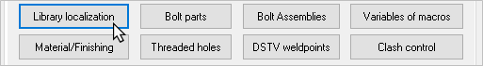
This is the same dialog box that is shown when starting Parabuild for the first time.
First you will be prompted to select the preferred drawing units:
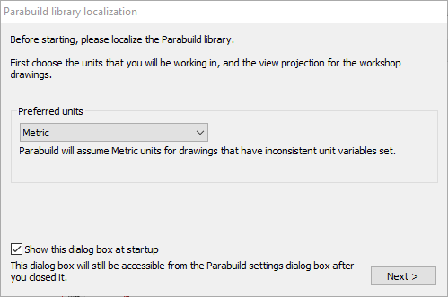
The options include: None / Metric / Inches
Choosing None would suggest that the user may sometimes work on metric drawings, and at other times on Imperial drawings.
Choosing for Metric or Inches will often solve issues that can arise when the user has mistakenly started drawing with a template of the wrong units.
Choosing Metric or Inches will also cause less options to be proposed in the next steps.
Click Next to open the Parabuild Profile library localization.
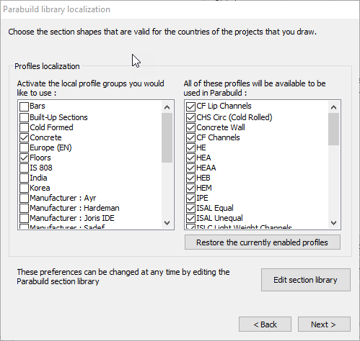
Step 2 of the process allows you to select the desired profiles. The window on the left is essentially a keyword filter allowing you to select profiles and shapes according to their generic group which includes - shapes, country of origin, profiles, and manufacturer specific profiles. Activating the checkbox will display the options contained within that generic group in the right hand window. These preferences may be changed at any time by Editing the Profile Library
Restore the currently enabled profiles - will restore the state of the profiles to how it was before opening this dialog box.
Edit the profile library - allows you to edit the profile library
Click Next to open the bolt library localization
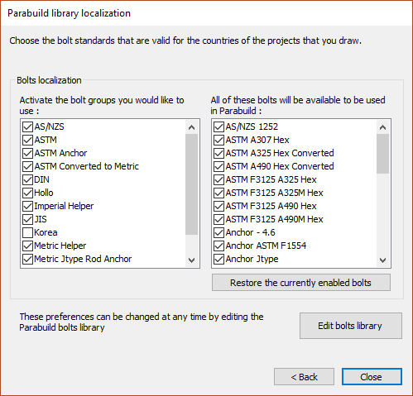

Step 3 of the process allows you to select the desired bolts. As with profile selection above, the window on the left is a keyword filter allowing you to select bolt assemblies according to their generic group which includes - types, standards, country of origin, and manufacturer specific bolts. Activating the checkbox will display the options contained within that generic group in the right hand window. These preferences may be changed at any time by editing the Bolt parts database
Restore the currently enabled bolts - will restore the state of the bolts to how it was before opening this dialog box
Edit the bolts library - allows you to edit the bolts library

Bolt Parts Database
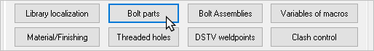
All bolts, nuts and washers to be drawn come directly from this database.
This database contains every bolt with its exact dimensions (diameter, length, thread length, ...).
This enables Parabuild to select a bolt from the list that the user makes available, and draws them exactly.
Every part has a checkbox in front of its name. If the box is not checked, Parabuild will never use the part. This allows parts to be turned on without having to delete them. This feature can prove very useful if a part with a certain diameter, length and standard is never used or is not in stock, in which case it can be turned off.
All parts in the available lengths and diameters for the respective standards have already been entered.
Because the number of parts can total more than 1000, a filter can be applied. Type in DIN933 in the box in the top right-hand corner, and only the parts with DIN933 will be displayed. Click on the adjacent button and all except those with DIN933 will be displayed.
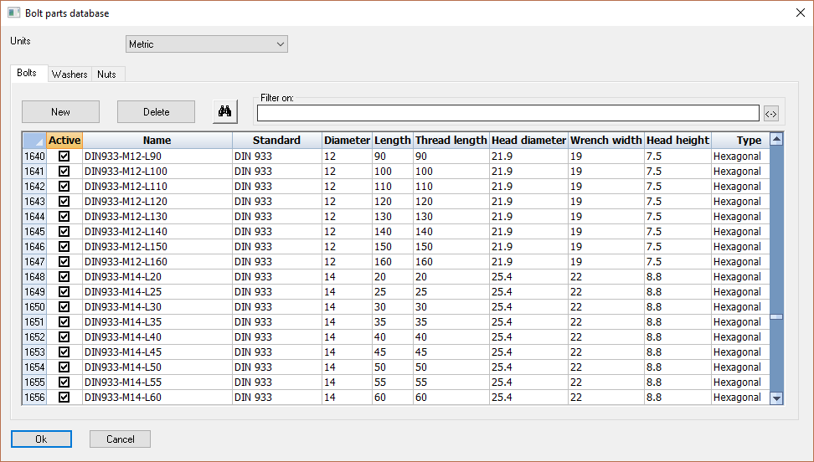

Bolt Assemblies
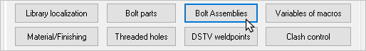
The assembly of a bolt determines the standards of the bolt, washers and nuts. We can also determine the default tolerance of the holes in the assembly.
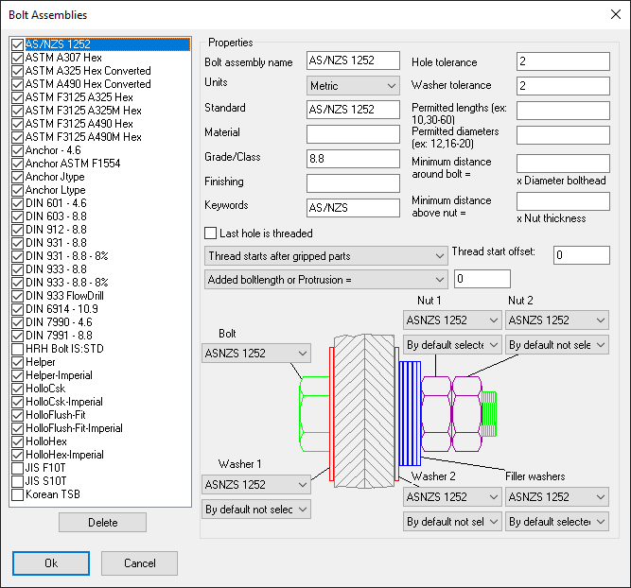
A summary of all existing assemblies is shown in the top left-hand side of the dialog window. Clicking on one of the assemblies will display all of its settings. These settings can be changed on the directly. Activating another assembly will save all the changes that you made to the current assembly. If another assembly name is assigned to the assembly then a new assembly with that name will be created.
The standards of the bolts, nuts and washers that are presented in the dropdown boxes are retrieved directly from the Bolt parts database.
With the nuts and washers a selection may be made between not, yes, never or always. When you choose yes or not, you effectively determine whether a new bolt drawn in 3D will have the nuts/washers enabled/disabled by default. When you choose always or never, you will not be able to disable/enable them after drawing the bolt.
The added length can be made diameter dependent. The added length is to make the bolt longer than is actually necessary. A good example of this is the anchor bolt: which only needs to pass through a footplate, but must actually be much longer.
The added length and the hole-tolerance can still be changed after the bolt was drawn.
The settings Permitted lengths and Permitted diameters are useful quick filters. As the bolt standard contains many bolt diameters and lengths, but in practice most of these bolts are not used. The diameters and lengths that you enter here should match the bolts that the erectors bring to the site. This way, the Parabuild bolts list will accurately match the bolts that the erectors will need on site.
This is the sequence that Parabuild uses when a new bolt is drawn :
  - Parabuild searches within the selected assembly for the standard for the new bolt, washers and nuts that should be used.
  - Using this standard, Parabuild refers to the bolt parts database and selects a bolt using the following details: Standard, diameter and length (length = penetration length + washers + nuts + added length).
  - Only the bolt parts that fall within the above Permitted lengths and Permitted diameters filters are used by Parabuild

The Thread start type option offers the following choices :
  - Thread starts anywhere - This is typically used for standards with full threads
  - Thread starts after shear plane - The bolt length will be changed to make sure that the thread does not pass through the shear plane. See below for more information about the shear plane.
  - Thread starts after shear plane (ignore runout) - Same as above, but the runout distance is ignored. The runout is calculated based on the diameter of the bolt (see table below)
  - Thread starts after gripped parts - The bolt length will be changed to make sure that the thread does not pass through gripped parts. See below for more information about the gripped parts plane.
  - Thread starts after gripped parts (ignore runout) - Same as above, but the runout distance is ignored. The runout is calculated based on the diameter of the bolt (see table below)
Thread start offset - This option works in conjunction with the thread start option : Enter an additional offset to be added to the thread length of the bolt.

The runout is the transition area between the thread and the shank.
The runout is calculated based on the diameter of the bolt using the following rules :
Metric runout rules |  |  | Imperial runout rules
Diameter | Runout (mm) |  | Diameter | Runout (inches)
<= 4 | 1.5 |  | <= 1/2 | 0.19
<= 7 | 2.5 |  | <= 5/8 | 0.22
<= 12 | 4.0 |  | <= 3/4 | 0.25
<= 16 | 5.0 |  | <= 7/8 | 0.28
<= 22 | 6.0 |  | <= 1 | 0.31
<= 27 | 7.0 |  | <= 9/8 | 0.34
<= 33 | 8.0 |  | <= 10/8 | 0.38

To further explain these options, consider the following 3 situations of the position of the bolt shank and thread relative to the shear plane or gripped parts :
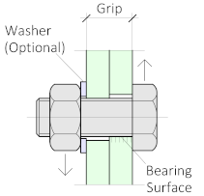 | 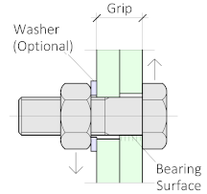 | 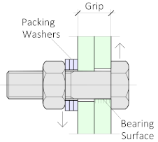
Thread starts anywhere, it passes through the shear plane in this case | Thread starts after the shear plane | Thread starts after the gripped parts
The first situation occurs with certain fully threaded standards such as DIN933, but usually also when bolts are > M16 and their length is <= 45.
The second situation is the most commonly preferred; namely where the thread of the bolt does not pass through the shear plane.
The third and last situation is where the thread does not pass through the gripped parts. Filler washers will be needed to make sure that the nut can be tightened, as the thread runout will be positioned outside of the gripped material.
Filler washers can be enabled by default in the bolt assembly, and also individually per bolt in the properties. When enabled, Parabuild will automatically calculate the number of filler washers that are needed.

Variables of Macros
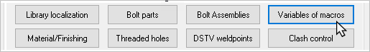
In this dialog box we can influence the variables that are used by the Macro standards.
The purpose of the macro standards is to change the macros default values to some sensible values that are dependent on the base profiles of the macro.
The Macro standards is a tool that is run automatically on each macro that is inserted from the library using any of these commands :
It is also possible to run the standards on a macro manually, with this button in any macro dialog box :
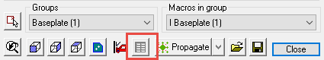

You can influence the standards by changing the value of a variable in the below dialog box. The changes you make to the lower list of variables apply to the system, so they apply to all projects you draw.
However do not remove variables; this is preserved for people who extend the standards.
Each variable points to a specific setting in one or more connections. It is possible that a variable has an effect on one connection, on a group of connections or on all connections.
We cannot explain all the available variables in this manual, but we will explain a select few as examples:
gen_StdWeldOffset : Determines the distance that is kept between two welded objects. This setting applies to all connections.
gen_StdBoltOffset : Determines the distance that is kept between two bolted objects. This setting applies to all connections that contain bolts.
gen_StdHoleOffsetFile : This variable contains a filename as its value. In the file itself you can make changes to influence the hole tolerance. See the next chapter for more information.
gen_StdHoleOffset : The (radius) tolerance of the hole of a bolt. This setting has an effect on all connections that contain bolts. However it only applies when the variable gen_StdHoleOffsetFile does not contain hole tolerance information for a certain diameter.
gen_StiffenerThicknessesFile : The variable refers to a special file that contains multiple plate thicknesses and widths. From this file a plate thickness will be chosen for the stiffener.
If you the file "\Pb_Lib\PlateStdWidths.dat", then you can determine the available plate thicknesses and widths. This will not only be used by the standards, but also to assign names to plates, for example:
If P10x160 is a standard size, then Parabuild will automatically choose P10x160-143 for the name of a plate that measures 143 to 160.
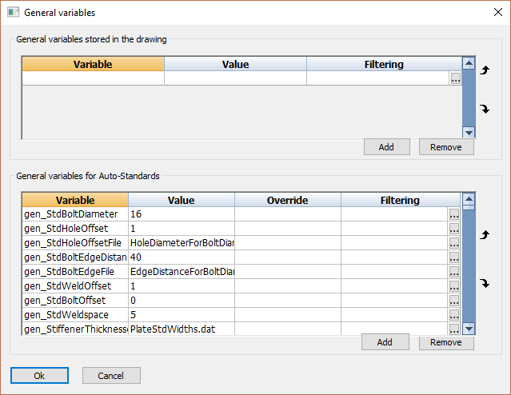

Files
A part of the standards variables refer to a file. You will find these files in the following location on your computer:
\Parabuilld\Pb_Lib\Connection Standards\Data\
The .dat files you find here can be modified using Notepad.
The contents of the file HoleDiameterForBoltDiameter.dat looks like this:
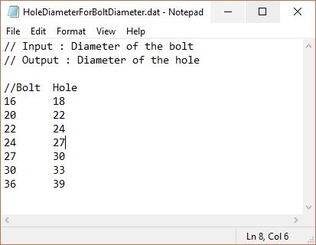
The lines that start with “//” are comments. They have no effect on the workings of Parabuild.
The purpose of each file is explained in these comment lines.
The purpose of HoleDiameterForBoltDiameter.dat is to choose a hole diameter for each bolt diameter.
If you want to add a new diameter M12, then you would add the following line:
12 14
Between the numbers 12 and 14 you should type a TAB character. Columns are separated this way.

Material / Finishing
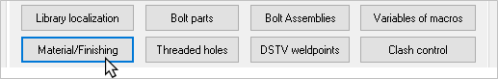
The following dialog appears - The configuration options include:
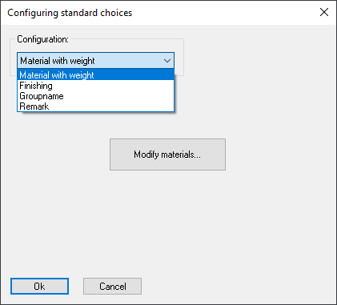
Material with weight - Clicking here will direct you to the materials dialog box, see below
Finishing - Here you may enter a list of default finishings in the list. The list that you provide here will be presented in the properties panel or in the Draw Profiles dialog box.
GroupName - Here you may enter a list of default groupnames in the list. The list that you provide here will be presented in the properties panel or in the Draw Profiles dialog box.
Remark - Here you may enter a list of default remarks in the list. The list that you provide here will be presented in the properties panel or in the Draw Profiles dialog box.

Materials table
This table is used by Parabuild to find out what the weight factor of the materials are.
It also allows us to automatically assign certain properties at the time when a material is assigned to a part.
Each row in the table represents a material.
The grade is combined with the material, that is why we have several different entries for steel in this table.
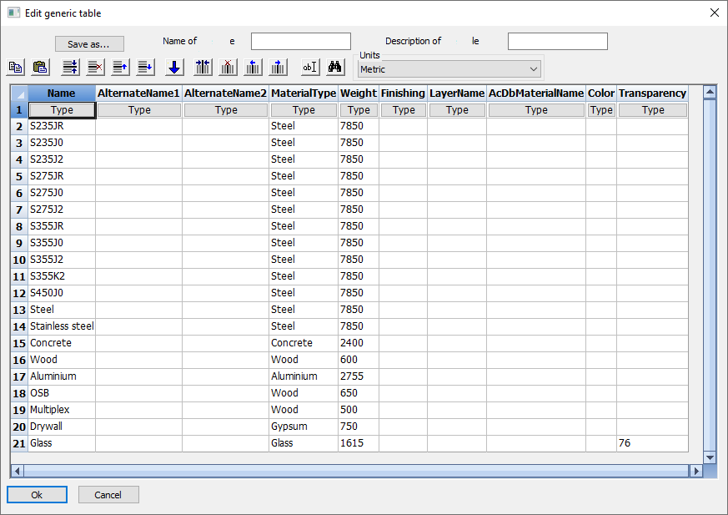
The materials table has the following columns :
Name - This is the main name by which this material will be identified. It is also the name that will be visible in the properties for selecting the material of a part. This name should make it clear what the material and the grade are.
AlternateName1 - This option makes it possible to match the material with a slightly different name, for example when importing files (currently not implemented)
AlternateName2 - This option makes it possible to match the material with a slightly different name, for example when importing files (currently not implemented)
Material type - This is the general type of the material without grade nor modifications
Weight - The weight factor that Parabuild should use when calculating the weight of parts with this material. In Metric this is in kg/m³. In Imperial this is in lb/ft³.
Finishing - Enter the finishing property text here that should be assigned to the parts that get this material assigned. If you want the finishing property of the part to remain intact, then leave this field empty.
LayerName - Enter the layer name here that should be assigned to the parts that get this material assigned. If you want the layer property of the part to remain intact, then leave this field empty.
AcDbMaterialName - Enter the material visual style name here that should be assigned to the parts that get this material assigned.
It may become confusing as the material property also exists in AutoCAD and BricsCAD.
However the AutoCAD/BricsCAD material is only used to change the visual representation of the object.
The Parabuild material is used mainly for assigning the grade and the weight factor to the object.
So even though they carry the same name in the properties, they have a different purpose.
You can use the MATERIALS command to manage the AutoCAD/BricsCAD materials in the drawing.
Use the properties panel for assigning visual style materials to objects.
If you want the material style property of the part to remain intact, then leave this field empty.
Color - Enter the color property here that should be assigned to the parts that get this material assigned.
This refers to the AutoCAD/BricsCAD color property.
Enter the color in RGB format, which is 3 numbers separated by a comma.
For example : 255,0,0 is Red.
To find out the RGB color codes for a specific color, type in the COLOR command in AutoCAD or BricsCAD.
If you want the color property of the part to remain intact, then leave this field empty.
Transparency - Enter the transparency value here that should be assigned to the parts that get this material assigned.
This refers to the AutoCAD/BricsCAD transparency property.
Use a value from 0 to 100 : 0 is no transparency, 100 is full transparency.
If you want the transparency property of the part to remain intact, then leave this field empty.

Threaded Holes
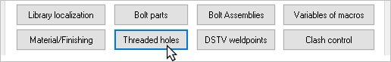
In this dialog box you can determine which drill diameter the shop drawings should use for threaded holes. For illustration purpose threaded holes have some extra lines in 3D similarly to the thread of a real hole.
If you convert a regular hole into a threaded hole, the diameter of that hole will be set to match the diameter of the bolt.
Here you can adjust for each threaded hole diameter the drill diameter that the annotation on the shop drawing should contain.
By default the annotation of a threaded hole will look like this : Drill ø10.2 Tap M12
The annotations in workshop drawings that contain the variable %PbColCommentForHoleDriller% will contain this string.
Parabuild uses the first 2 columns to compose this string.

The column Text for annotations is a separate string that will be used instead of the above string, but only if the last column Is a persistent override is active for the row.

The column Filter by standard applies an extra filter for the entire row. Just enter the standard of the bolt here, and the row will only be applied to those bolt standards.
Thanks to this we filter can create multiple rows for the same diameter, but with different drill diameters. This is useful when different tapping tools are used in the same 3D drawing.

A threaded hole is different from a regular hole, even when Parabuild numbers your elements.
If there are 2 identical plates with the same number of holes at the same location, but one plate has one of its holes threaded and the other does not, Parabuild would assign these two plates a different position number.
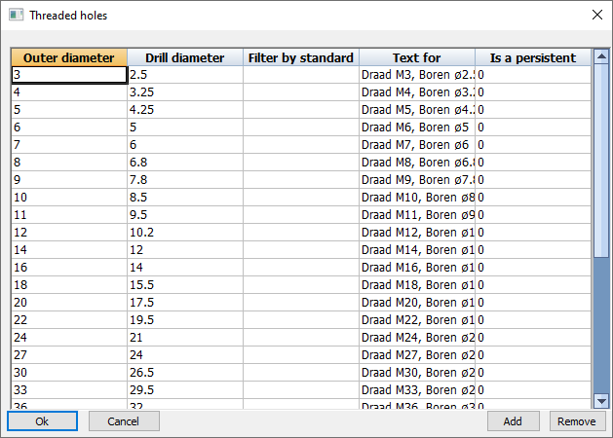

DSTV WeldPoints
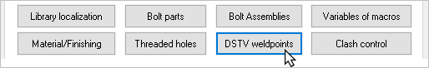
DSTV weld points are points that are placed in the automatically produced DSTV NC-files.
A point indicates on which spot an element must be welded on the profile. Because the CNC-machine can drill these points automatically, it can result in gaining time because one has to measure less when welding.
The points will normally be made by the machine with the tip of the (currently present) drill.
Because of the flexibility of the numbering of profiles and plates the program must place the points automatically. With some general options you can influence the placement of the point for each element.
Related Articles:
DSTV Weld Points
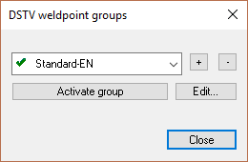
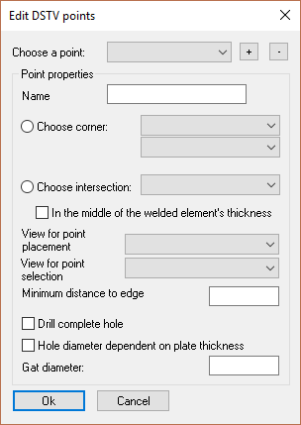

Creating a points list
First of all we have to make some DSTV points that we will later use for each element.
When you open the Dstv Weldpoints button you will see a small dialog box with a list of WeldPoint groups.
Here you have to set one group as current in order for the DSTV weld points to work. The points in the current group will be used for this drawing (the current group can be established separately for each drawing).
The purpose of several groups is that one can create a different set of weld points for a certain project, and thereby can keep the normal weld points intact.
Creating a point
When you click on Edit…, a new dialog box will appear.
At the top of the dialog you see all points in the group. You can create new points or remove points with the buttons next to the list.
If you select a point from the list then the options for that point will be visible beneath it and you can modify these.
Properties of a point
Name: The name for the point. We will later use this name if we want to use this point for a welded element.
Choose corner: You choose the corner where the weld point should be positioned on the welded element.
We illustrate all possible choices with an example:
Corner left under.
Corner left above. The point will only be placed where there is material, in this case below but the upper part of the angle bracket.
Corner right under.
Corner right above. The point was not placed entirely at the top because the drill head cannot come this close to the flange. This clearance space is adjustable, see further in the manual.
Choose intersection: To understand this option we must imagine that a line is drawn through the welded element (on the weld plane). The weld point is placed on the first point where the line intersects the welded element. With this option you choose where this intersection line should be placed.
We illustrate all possible choices with an example:
Intersection left.
Intersection Right.
Intersection Above
Intersection under + middle. With this example not only the option Intersection under was enabled but also the option In the middle of the welded element's thickness. The result is that the point will be placed in the middle of the bracket’s thickness.
In the middle of the welded element's thickness: If this is activated then the point will be placed in the middle of the thickness at the local intersection.
Choose view: If this is set to Automatic then the software will always use the view that directly looks at the welding plane. However you can choose to manually set another view, in those cases where the automatic view is not desired (for example for brackets that are welded against the flanges of an I profile).
Minimum distance to edge: The machine can’t move its drill too close to obstacles. If there is a point on the web of an I profile, then the weld point should keep clear a distance from the flange. Otherwise the drill would collide against the flange and cnc machine refuses to create the point.
The value you enter here is the clearance Parabuild will use automatically to avoid these occurrences.
Drill complete hole: If you activate this option, a complete hole will then be drilled instead of a point. This hole will never be visible in the 3D drawing. It will still be treated as if it is a weld point. Only during the communication with the CNC-machine a complete hole will be passed on instead of a point.
This hole can be useful, for example for stiffeners: we only have to drill one hole for both stiffeners and the hole is also more visible while welding.
Hole diameter dependent on plate thickness: If you activate this, you do not have to enter a diameter for the hole, but how much larger than the thickness the hole has to be (offset).
The points we just looked at have to be set up just once.
Coupling weld points to elements (you have to do this for each project)
Now you have to give each welded element that needs it a weld point.
This is possible using the AutoCAD Properties (see group ‘Output’).
In the field DSTV WeldpPoint of the properties you enter the name of the weld point.
This property is of course only useful for welded elements.
This property exists both for plates and profiles.
You can give one element multiple WeldPoints.
When the above options were completed successfully, then you will see crosses on the mark (assembly) drawings. These are the weld points that will be passed on to the machine. The crosses were added to the assembly for the convenience of the welder. This way one can see more easily on which spot the welded element and the weld point must match.
Assembly drawings and DSTV files will also get different names. Normally you have one DSTV file for each position number, but that is no longer possible when that profile has weld points. In that case the file name of the assembly drawing and the DSTV file will contain both the mark number and the position number. The result is more files and drawings, but it is an inevitable disadvantage.

Clash Control
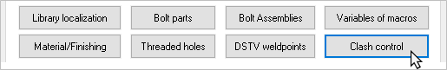
The default settings may be revised to suit user preferences.
Values greater than the maximum, or less than the minimum will be marked on the drawing as 'Clashing'

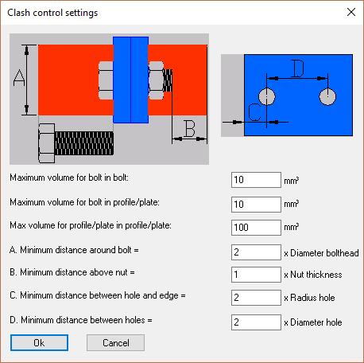

Object Filters
The purpose of filters is to identify specific objects in the model based on a set of rules.
The structural types rely on these filters to classify objects, but that is not the only use case for filters.
Filters can also be used in general to find certain types of parts.
The CNC contour settings for example also use filters to assign different contour options to the type of part.
Filters can use the part properties and even geometrical traits as condition for passing the filter.

The filters modification dialog can be accessed from the Parabuild Settings command.
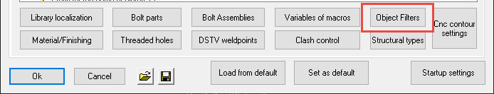
We will explore all the different options in this dialog box :
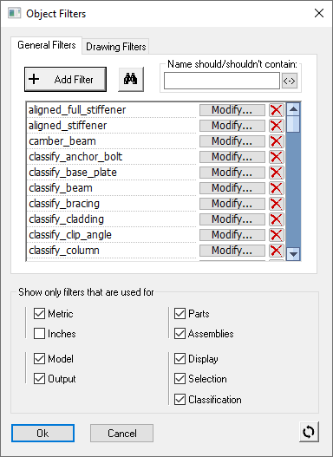
General Filters -
Drawing Filters -
Add filters - Click this button to add a new filter to the list
Name should/shouldn't contain - Start type letters or words, and the list of filter will be reduced. Only those filters that contains (or do not contain) your text string will be shown
Listbox that lists all the filters - Each row contains a filter. Use the modify and delete button to apply a change to the filter
Show only filters that are used for - Use these check-boxes to reduce the number of filters on the list, by only showing the filters with a particular purpose.
This button will reset all of the filters to the Parabuild 'factory defaults'

Configuring a filter
This dialog is accessible from the Filters dialog, when modifying a single filter.
We will explore all the different options in this dialog box :
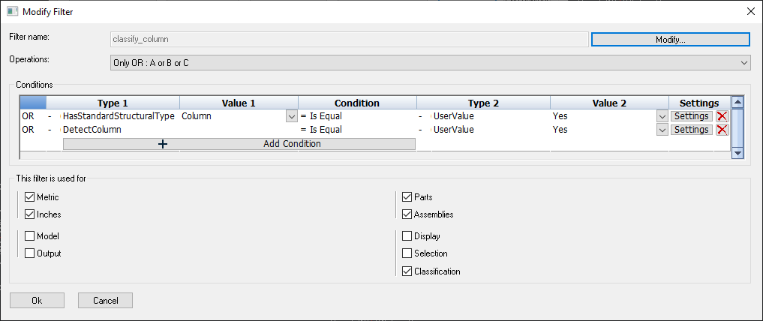
Filter name - This is the unique name for the filter, which is used throughout Parabuild to identify this filter

Operations - This option has an influence on the conditions in the dialog. It has the following options
- Only OR - If any of the conditions match, then the filter passes
- Only AND - If all of the conditions match, then the filter passes
- Primary OR - The matching principle of the conditions can be arranged in groups. An example of this operation type is :
A OR (B AND C), where A, B and C are conditions. Once this option is enabled, the condition list below changes so that you can add or remove conditions to each group, or add groups.
- Primary AND - The matching principle of the conditions can be arranged in groups. An example of this operation type is :
A AND (B OR C), where A, B and C are conditions. Once this option is enabled, the condition list below changes so that you can add or remove conditions to each group, or add groups.
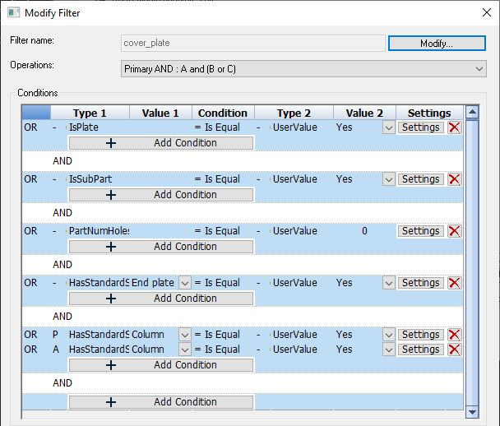
An example filter that uses the more advanced condition arrangement

Conditions - This list contains a row per condition. It lists the conditions that need to pass in order for the filter to pass. Use the Add condition button below each group to add conditions.
- Operator (First nameless column) - This column shows what the operator is within the group of the condition. It is informative but it can be changed by changing the operations (explained above).
- Redirection 1 (Second nameless column) - This column is the redirection of the property that is being queried by the columns Type 1 and Value 1. You can change the value of this setting by clicking on it. The following different values are available for redirection :
  - None - This is the default redirection. The property value will be retrieved directly from the part that is being iterated.
  - Main Part - The property value will be retrieved from the main part of the assembly of which the part is a part of.
  - Assembly - The property value will be retrieved directly from the assembly of which the part is a part of. This redirection type will only appear when the property on this row is a valid property of an assembly.
- Type 1 - The condition type can be anything from a property, a geometrical trait, a formula or another filter.
This column also contains the Redirection (None/Main Part/Assembly) just before the type itself. By specifying the redirection, we can better target the type of value that needs to be retrieved.
To better explain the redirection consider the following example : When the condition type is Weight, should that be the weight of the main part or the weight of the entire assembly?
- Value 1 - This is used in some cases in addition to the condition type.
This value will be adjustable only when the property needs an additional value.
The type HasStandardStructuralType is such a type that needs an additional value :
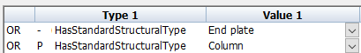
- Condition - The condition is the comparison that needs to be performed between the value of Type 1 and the value of Type 2.
For many condition types this can only be equal or not equal.
But for a condition type such as Weight, this can also be Larger than or Smaller than.
For condition types that can contain strings such as Material, other comparisons become useful such as Starts with, Ends with, Contains or Does not contain.
Only the comparisons that are compatible with Type 1 will be shown.
- Redirection 2 (Fifth nameless column) - This column is the same as column Redirection 1, but it applies to the columns Type 2 and Value 2.
- Type 2 - This condition type is very much dependent on the type that was set in Type 1.
When Type 1 is IsPlate, then the available options in Type 2 will only be UserValue.
However when Type 1 is Material, then the Type 2 is not limited, because the Material is a string that can be compared to any other type.
The redirection is also available for Type 2, see Type 1 to learn what it does.
- Value 2 - The availability of this value field depends on both Type 1 and Type 2.
When Type 1 is IsPlate, then the available options in Value 2 will only be Yes or No.
However when Type 2 is Formula, then you can enter the actual formula here.
- Settings - The settings of a condition allows you to change the following options for the condition :
Case sensitive for strings - whether string comparisons should be case sensitive or not
Tolerance for decimal value - the tolerance to be used when comparing 2 decimal values

This filter is used for - By enabling or disabling these check-boxes, you can influence in which circumstances the filter will be used throughout Parabuild and the user interface of Parabuild.
- Metric / Inches - Use the filter on drawings in Metric, in Inches or both units.
- Model / Output - Whether the filter should be used for 3D modeling and/or output generation
- Parts / Assemblies - Whether the filter should be used on single parts, assemblies or both
- Display / Selection / Classification - Whether the filter should be for user interface display tools, for the section of objects, or for the classification of structural types (or a combination of these)

Note : For very complex filters it is recommended to split them up into multiple sub-filters and then combine them into the final filter.
This will improve readability and the re-use of filters.

Structural types
The purpose of structural types is to assign type names to parts and assemblies so that those types can be used to automatically assign properties, define behavior specific to that type, or select objects based on their type.
The most obvious examples of structural types are columns and beams.
During or after the structural types are assigned to parts, we can use several tools on these parts, such as :
- Automatically assigning properties to the part. For example, assigning numbering prefix B for Beams and C for columns.
- Automatic selection of all the parts with a particular structural type
- Define a CNC scribing style specific to a structural type
- In the near future, many more applications for structural types will be implemented
Assigning structural types can be done in a number of ways :
1) Assigning automatically during numbering
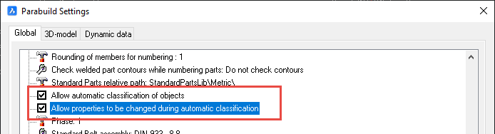
When this option is enabled in the Parabuild Settings, Parabuild will automatically assign structural types to all parts when the model is numbered.
This value is enabled by default when you install Parabuild.
However, if you have updated Parabuild from an older version to v6, or if you open a drawing that was saved with a Parabuild version older than v6, then this setting will be disabled. By disabling it in older projects we can ensure that the numbering of older projects will not have a mix of old and new numbering prefixes.
If the numbering was done premature before the project was finished (for example a bill was generated), then the assigned structural types might not always be the best.
To solve this either run Classify parts on those objects, or disable automatic classification and run Classify parts when the model is (mostly) ready.

2) Assigning automatically on demand
You can use the Classify parts command to purge the previous classification of parts and automatically classify them again.

3) Assigning manually
You can use the Properties panel to assign structural types to parts.

Many Structural types can be detected and assigned automatically.
However, for most structural types the connections between the different members are used to determine the type of the parts.
The structural type detection uses the connected bolts, welds and macros to learn more about the part.
For example for a profile to be classified as a beam, it will need an end-connection on both sides.
Columns on the other hand are more quickly classified as such because their upright position alone is enough to distinguish them from all the other structural types.
Therefore it is best to automatically classify the parts when the 3D model is (largely) finished.
Once a structural type is assigned (manually or automatically), then the numbering will not try to classify the part anymore.
If you want to re-assign the structural type of parts that already have a structural type, then use the Classify parts command.
Structural types can be modified or added to from the structural types modification dialog, which can be accessed from the Parabuild Settings command.
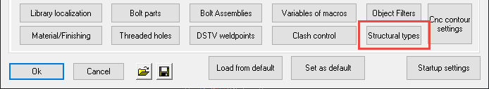
We will explore all the available options in the structural types dialog :
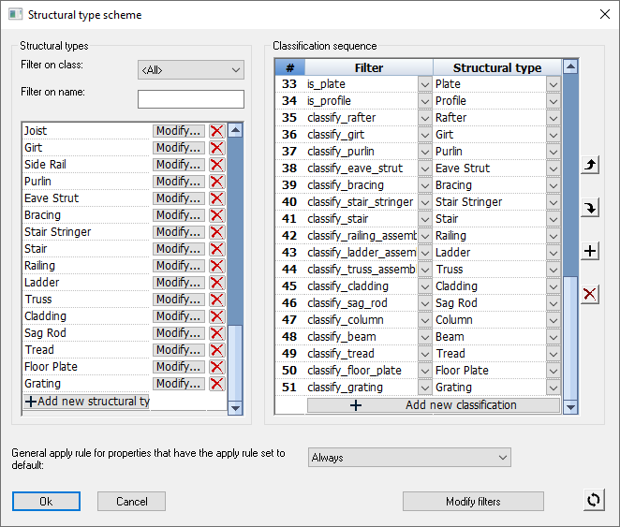
Structural types
Filter on class - Use this option to only show structural types for parts or only for assemblies
Filter on name - Use this option to filter the list of structural types on particular letters or words in their name
Listbox of structural types - Each row contains a structural type. Use the modify and delete button to change a particular structural type.
Add new structural type - You can add new structural types by clicking the button on the last item in this list.

Classification sequence
Listbox of classification sequences - This listbox allows you to change the priority in which structural types are assigned.
Each row represents a structural type and a filter that should be used for that structural type to be used.
When assigning structural types automatically, Parabuild will look at the first entry in this list, and will check whether the part passes through the filter. If the part passes the filter, then the part will receive the structural type and the classification of that part is done. If it does not pass the filter, then the next item on the list is attempted until it finds a match (or none).
For more information about filter, see the Object Filters topic.
Add new classification - You can add new classifications by clicking the button on the last item in this list.
General apply rule for properties that have the apply rule set to default - General apply rule for properties that have the apply rule set to Default - When a property inside a structural type has the apply rule set to Default then this apply rule will be used. The apply rule specifies when to assign properties to parts: 'Never', 'Always', or 'If not set'. The last choice will only set properties that were not already set.
This button will reset all of the structural types to the Parabuild 'factory defaults'

When you click on Ok to save your changes, you will be prompted to save the changes to the defaults.
We recommend that you do, and always work with the same structural types on all your projects.
Not doing so can have unintended consequences, because the numbering of parts can be influenced by the structural types.
If you open and modify a drawing with different structural types, then the numbering prefixes may now be assigned differently for the modified parts. So the modified parts may then get different numbering prefixes than the unmodified parts.

Configuring a structural type
This dialog is accessible from the Structural types dialog, when modifying a single structural type.
We will explore all the different options in this dialog box :
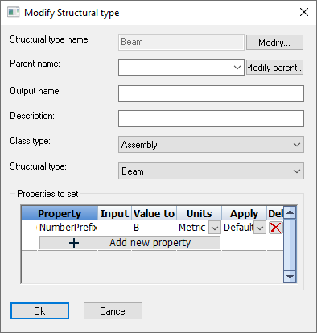
Structural type name - This is the unique name of the structural type that will be used throughout Parabuild to identify the structural type.
Parent name - The parent of this structural type. This structural type will recursively inherit all the parent's properties.
Output name - Not yet in use
Description - A description for this structural type.
Class type - Use this option to limit the applicability of the structural type to the type of object.
Structural type - If the structural type matches one of the standard built-in structural types, then it is best to choose it here. Set this to Undefined in case you are creating a new non-standard structural type.

Properties to set - Lists all of the properties that should be applied to parts when they get this structural type assigned
Each row in the list represents a property that needs to be set.
The columns in this list are explained hereafter :
- Redirection (First nameless column) - The first small column is the redirection of the property. You can change the value of this setting by clicking on it. The following different values are available for redirection :
  - None - This is the default redirection. The property will be applied to the part that gets this structural type assigned.
  - Main Part - When this option is used then the main part of the assembly will receive the property change on this row.
  - Assembly - The property will be applied to the assembly of which the part is a part of. This redirection type will only appear when the property on this row is a valid property of an assembly.
- Property - Specifies the property that should be modified
- Input value - This is used in some cases in addition to the above property. It will be adjustable only when the property needs an additional value.
- Value to set - The actual value that should be set in the property
- Units - Set this to the units of the value that was set in the Value to set field.
- Apply - When should the value be set. Set this to If not set if you do not want the structural type to override the property of the part. When it is set to Default, then the apply option in the Modify structural types dialog will be used.

Classify parts
Command : PrB_Classify
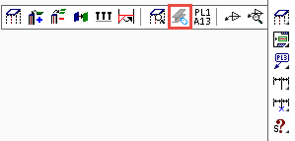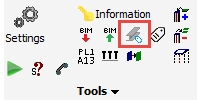
This command can automatically classify all parts or a portion of the parts.
For more information about classification of structural types, see the Structural types topic.
Many Structural types can be detected and assigned automatically.
However, for most structural types the connections between the different members are used to determine the type of the parts.
The structural type detection uses the connected bolts, welds and macros to learn more about the part.
For example for a profile to be classified as a beam, it will need an end-connection on both sides.
Columns on the other hand are more quickly classified as such because their upright position alone is enough to distinguish them from all the other structural types.
Therefore it is best to automatically classify the parts when the 3D model is (largely) finished.
This command can re-assign all parts, or only assign parts that do not have a structural type yet.
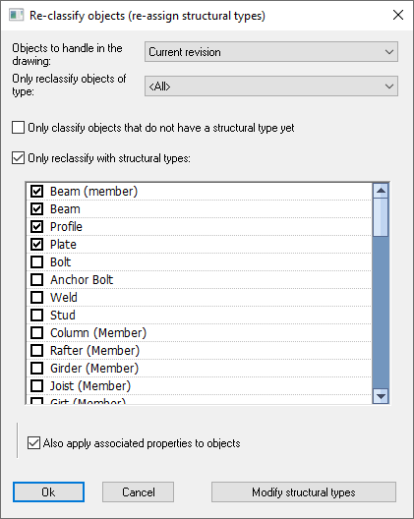
We will explore all of the options in this dialog :
Objects to handle in the drawing - As a first filter, you could only classify all the parts on the current revision.
If you would re-assign parts on an older revision, and if the below option Also apply associated properties to objects is active, then this command may cause those part numbers to be modified, and those parts may then also move from their old revision to the current revision.
Only reclassify objects of type - An extra filter on what type of objects that may be classified (parts/assemblies/bolt assemblies/welds)
Only classify objects that do not have a structural type yet - An extra filter for leaving untouched all parts that already have a structural type assigned to them. Use this in case you have already manually assigned structural types to parts
Only reclassify parts with structural types - An extra filter that allows you to only re-assign parts that have one of the selected structural types. This option is useful in case some parts have received generic structural types, such as beam, profile or plate. This situation may occur when the first automatic classifications have been done too early - before all the connections were drawn.
Also apply associated properties to objects - When this option is active, and when parts get new structural types assigned by this command, then those parts will also receive the properties that are part of the structural type (for example numbering prefixes)

CNC contour and matchline settings

Match lines and contours
Match lines and contours can be modified from the Global settings tab :
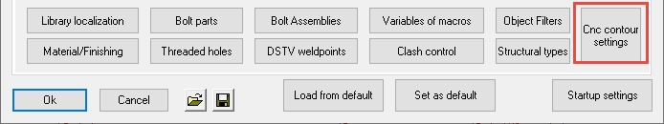
Match lines allow you to scribe short lines or punch marks on the main parts as well as the sub parts, causing them to match.
The hole axis is projected, and here both the main member and the sub-part can be marked with a short line or a punch mark. Those matching lines/marks can then be simply matched up in the shop to position the parts on the assembly.
The sub part that should be welded has a short line on it's side, and the part to which it needs to be welded also has a short line.
These 2 short lines will match up so that the part can be positioned by the welder without any many measuring involved.
At most the welder will need a square to make the lines (or dots) match.
When the to be welded part has holes, the holes are projected and used for the match lines.
The part number of the part that needs to be welded can be added close to the match lines, but this is optional.
The match lines can be replaced for single punch marks that are done with the drill. This is useful in case the machine can't scribe, or the scribing takes too much time.
The match lines can still be combined with the classic contour scribing.

These capabilities will offer the draftsperson and the workshop the following advantages :
- These advanced scribing options replace the manual scratching/marking when laying out the steel, saving significant man hours in the shop.
- Contours, punch marks and hole matching lines are generated directly from the 3D model and can reduce mistakes on the shop floor.
- The capability to use punch marks on some types of parts coupled with scribing on other types can save time on the beamline by using punch marks there, while still having the option to use full or corner contours and scribed hole matching lines on plates.
- Scribing contour and/or part numbers can be skipped entirely for specified situations. This offers further opportunities for optimizing the utilization of the machines in the shop.
- Automatic scribing options can be configured based on the type of part. These settings only need to be configured once, and after that CNC files for the whole model can be generated automatically. This will save the draftsperson time in not having to do changes manually.
All together these features will increase productivity of the drafters, shop floor staff, and machines in the shop.

Here are some examples of what is possible with contours and match lines in different situations.
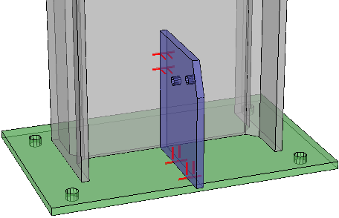
An example baseplate and gusset plate where only match lines were enabled
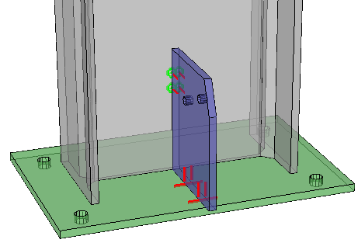
An example with match lines on the plates, and punch marks on the profiles
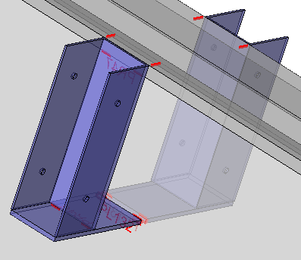
An example of brackets where match lines are transferred to the top flange automatically. There are also sub parts that have contours for other sub parts, this is optional and can be turned off.
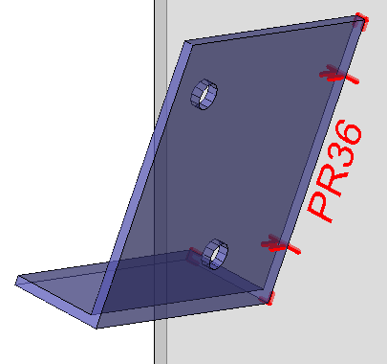
An example of corner contours combined with hole match lines
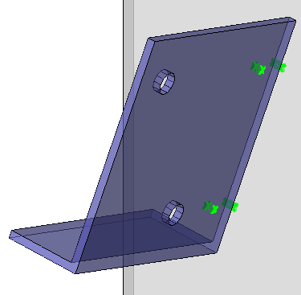
The same example as above, but with punch marks on both the main part and on the attached part, no contours and no part numbers
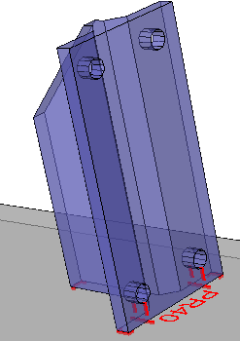
Another example of corner contours combined with hole match lines
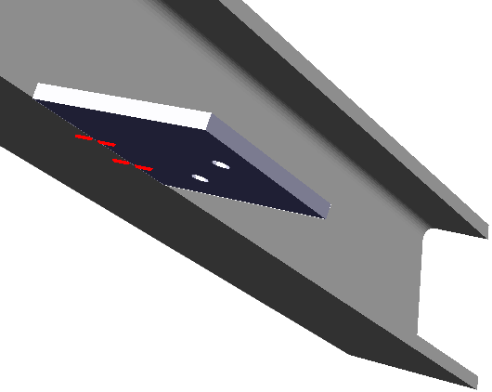
Hole match lines were transferred to the flange automatically
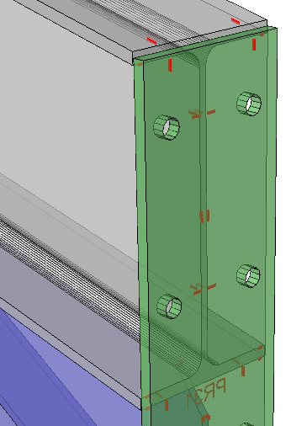
Example of a haunch connection end-plate, with it's hole match lines transferred to the flange. The scribing on the outside of the end-plate can be turned off
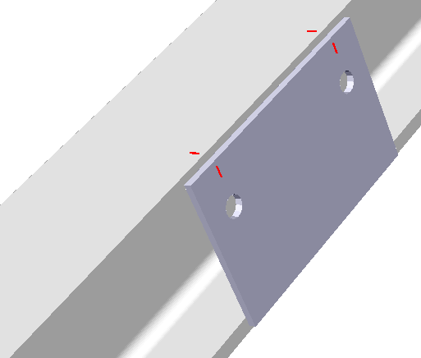
Example of a toe plate where the hole match lines were transferred to the flange
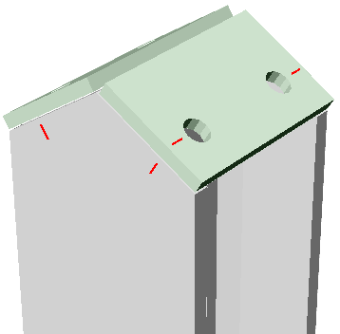
Example of double end plates where hole match lines are transferred to the flange

To configure the match lines and contours, use this button from within the DSTV NC Settings dialog :
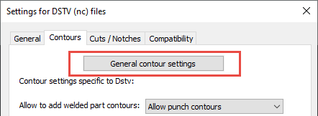

Or, from the Parabuild Global settings dialog box :
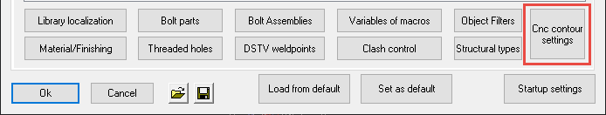

We will explore all of the options in the contours dialog :
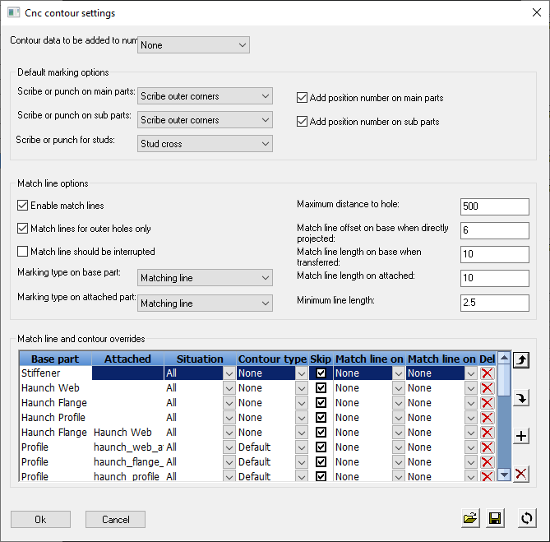

Contour data to be added to numbering - This is the same option that can also be changed in the Parabuild general settings.
This option is explained in detail in the Check contours when numbering parts topic.

Default marking options
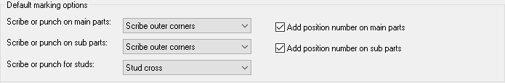
Scribe or punch on main parts - This option allows to add a marking for the position of parts that need to be welded.
You can change here what type of markings should be added on main parts.
This setting has the following options :
Each option is illustrated with an example of the results. These are graphical representations drawn by Parabuild on the 3D model, for verification of the chosen Dstv options. We can have a better preview of the scribing and punching results without having to open the dxf or dstv files individually. You can enable this option in the DSTV NC Settings.
- None - This disables the option
- Punch mark at corners - A single punch mark will be added on all the corners of the contour
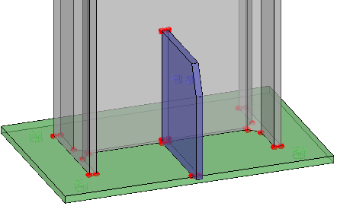
- Punch mark at outer corners - A single punch mark will be added on only the outer corners of the contour
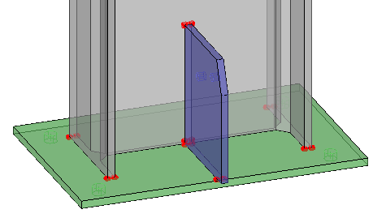
- Punch mark at outer extent corners - A single punch mark will be added on only the outer extent corners of the contour. So the maximum amount of punches will be 4 per contour
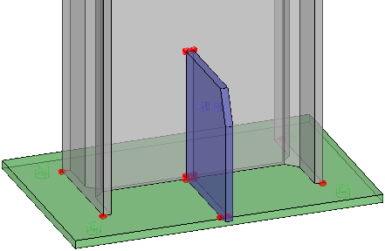
- Punch mark at plate edge in the middle - Instead of the corners, the edges of the plates will each get 1 punch mark, in the middle of the edge
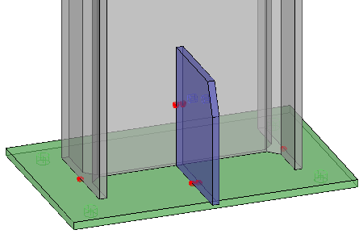 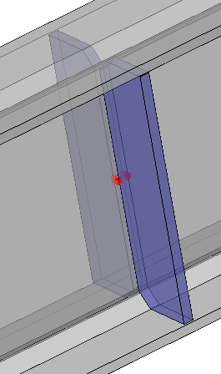
- Scribe contour - Scribes the entire contour
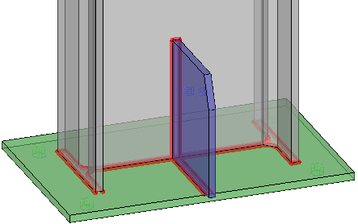
- Scribe corners - Scribes each corner of the contour
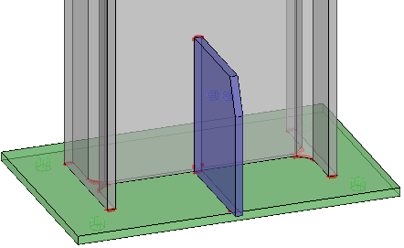
- Scribe outer corners - Scribes only the outer corners of the contour
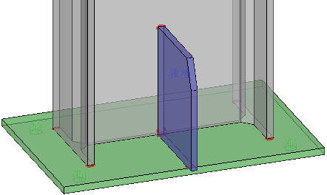
- Scribe outer extent corners - Scribes only the outer extent corners of the contour. So the maximum amount of corners will be 4 per contour
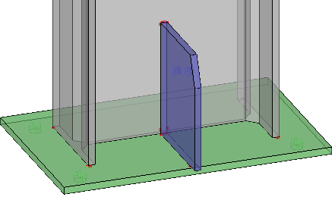
- Scribe outer curves - This will scribe all the outer edges, so inner edges will be skipped
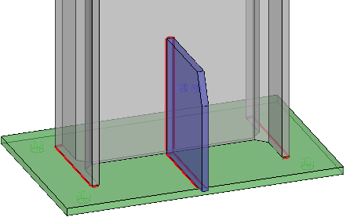
- Scribe a line in the middle of the plate edges - The edges of the plates will each get 1 short line scribed, in the middle of the edge
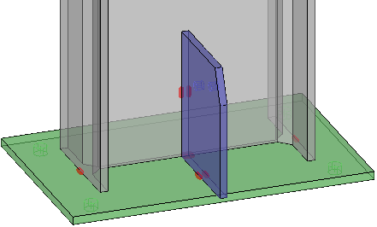
Scribe or punch on sub parts - This option allows to add a marking for the position of parts that need to be welded.
You can change here what type of markings should be added on sub parts.
See above for an explanation of the available options
Scribe or punch on studs - This option allows to add a marking for the position of parts that need to be welded.
You can change here what type of markings should be added for studs.
This setting has the following options :
- None - This disables the option
- Stud center punch - A single punch mark in the middle of the stud's position
- Stud cross - Will scribe a cross that is comprised of 2 lines
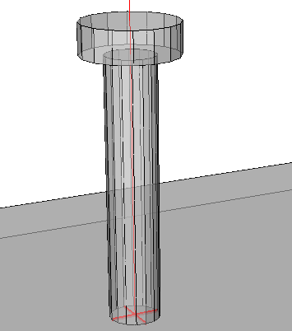
- Stud linked cross - Will scribe a cross that is comprised of only 1 line
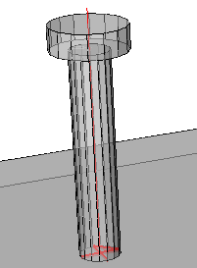
- Stud circle - Scribes a single circle in the middle of the stud's position
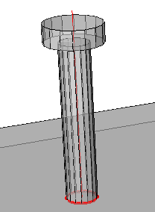
- Stud center corner - Scribes a corner in the middle of the stud's position
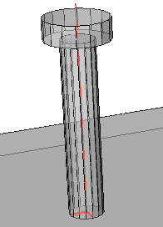
- Stud bottom left corner - Scribes a corner in the bottom left corner of the stud's position
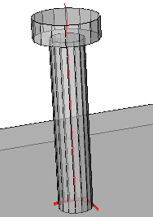

Add position number on main parts - When enabled, the punch marks or scribings on the main parts will be accompanied by a text of the part's position number that should be welded there
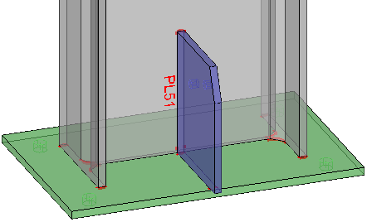
Add position number on sub parts - When enabled, the punch marks or scribings on the sub parts will be accompanied by a text of the part's position number that should be welded there
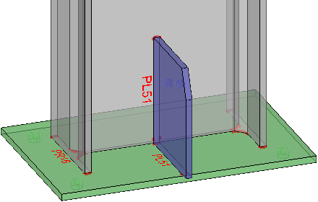

Match line options
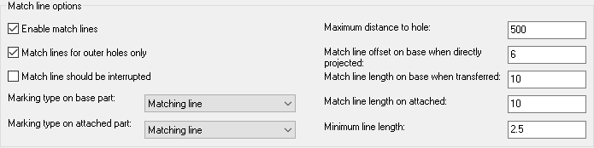
Match lines allows you to scribe short lines or punch marks on the main parts as well as the sub parts, causing them to match.
With only minimal scribing or punching, parts can be positioned accurately with just a square, at the position of the holes.
These match lines can be used in combination with contours or separately.
Enable match lines - Enables or disables this feature
Match lines for outer holes only - When a part has more than 2 holes, only the 2 outer holes will get match lines
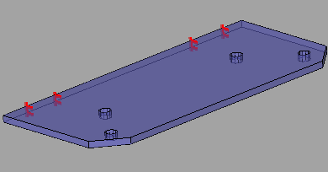 | 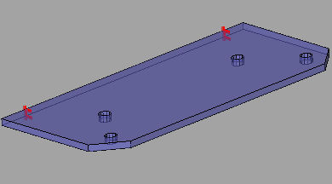
Example with Outer holes only disabled | Example with Outer holes only enabled

Match lines should be interrupted - Match lines that are destined for the same hole can be optionally interrupted where the part intersects the match line.
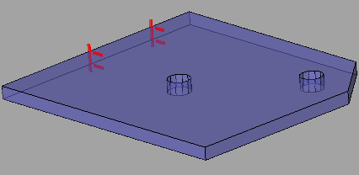 | 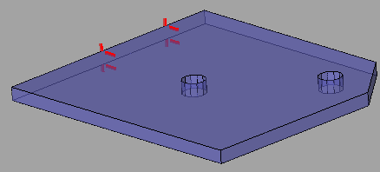
Example with Interrupted disabled | Example with Interrupted enabled
Marking type on base part - Specifies what type of marking should be done on the base parts
This setting has the following options :
- None - Disables the marking on base parts
- Matching line - A line will be added that will match up with another line or punch mark
- Matching punch mark - A punch mark will be added that will match up with another line or punch mark
Marking type on attached part - Specifies what type of marking should be done on the attached parts (the part with the holes)
See above for an explanation of the available options
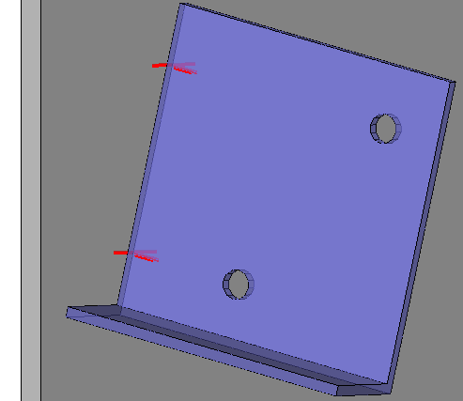
An example with the match lines enabled on the base part and the sub part

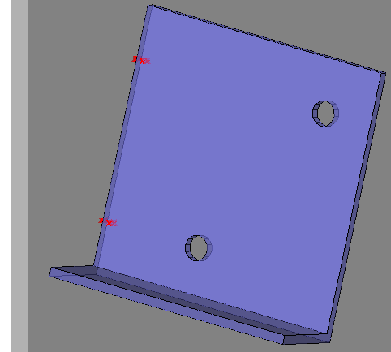
An example with the match punch marks enabled on the base part and the sub part

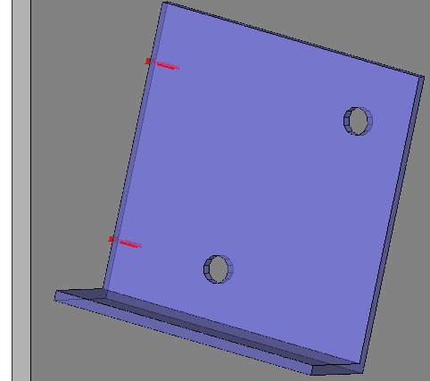
An example with the match punch mark enabled on the base part,
and the match line enabled on the sub part
Maximum distance to hole - The maximum distance of the hole to the edge where the objects meet. Holes farther than this will not get match lines or punch marks
Match line offset on base when directly projected - If this is a direct projection of the hole line; how far should the line extend on each side?
The actual line length will be : plate thickness + (offset x 2)
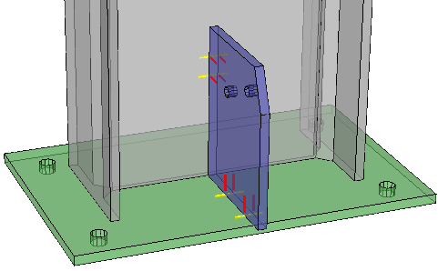
In this example, the directly projected match lines on base are shown in yellow
The attached lines are shown in red
Match line length on base when transferred - How long should lines be when they were not directly projected, but transferred to another surface.
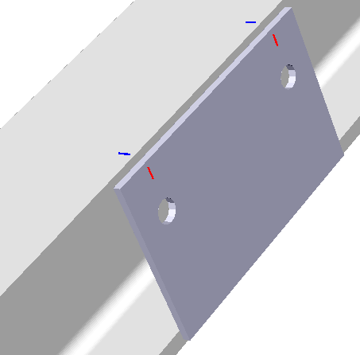
In this example, the transferred match lines on the base are shown in blue
The attached lines are shown in red
Match line length on attached - How long should the lines on the part with the hole be. See above for 2 examples of this line type.

Minimum line length - Skip the line if it goes under this length (When part of the line can't be scribed and it was shortened)

Match line overrides
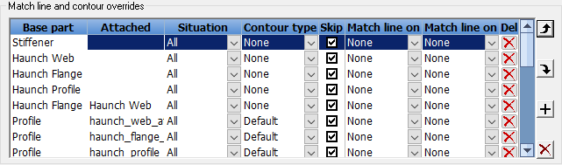
Filters and structural parts can be used to configure which situations should get certain types of scribing. This allows for great user control in the fully automatic scribing system.
For example : Stiffeners are usually generic parts. Even for stiffeners that have parts welded to them it could be beneficial to disable contours, as they could be located with markings on the main instead.
Another example: when scribing position numbers on the material it could be useful to skip the scribing of the position number if it will already be scribed on another part. One such occurrence is when a gusset plate is also welded to an endplate: the position number of the gusset on the endplate is usually plenty and can be skipped on the main.

In this list, each row is an override of the match line and/or contour settings.
The order of the rows in this list does matter : The items will be looped from top to bottom, and the first row that matches the filter ans the situation type will be used.
We will explore all the columns and their meaning :
Base part filter - The criteria to which the base part needs to comply to determine when the override will be activated
Filter names or a structural type can be used. Structural types are checked only if no filter by that name was found.
Attached part filter - The criteria to which the attached part needs to comply to determine when the override will be activated
Filter names or a structural type can be used. Structural types are checked only if no filter by that name was found.
Situation type - Specifies the type of matching line situation this override applies to. The setting has the following options :
  - All - The override applies to all contours and matchlines
  - Contour - The override applies only to the contour
  - Stud - The override applies only to studs
  - Matchline - The override applies only to the matchline
  - End plate inside - The override applies only to end plates on the inside (the welded side)
  - End plate outside - The override applies only to end plates on the outside (the side that is not welded)
  - Toe plate holes - The override applies only to the holes of toe plates
  - Toe plate extent - The override applies only to the extents of toe plates
Contour type - Enter a contour type that should be used when this override is activated
This setting has the following options :
- None - Disables the contour when this override is activated
- Default - Refer to the general default - this override does no contour override when it is activated
- Undefined - Undefined means that this override says nothing about that contour type so that Parabuild knows to keep going down the list to find it
- All the other options are explained above in the standard matching settings
Skip label? - When this checkbox is active, the match lines or contours will not be accompanied by the position number of the part that needs to be welded
Match line on base part - What type of marking should be used on the base part?
This setting has the following options :
- None - Disables the matching line when this override is activated
- Default - Refer to the general default - this override does no matching line override when it is activated
- Undefined - Undefined means that this override says nothing about that match line type so that Parabuild knows to keep going down the list to find it
- Matching line - Adds a matching line to the base part when this override is activated
- Matching punch mark - Adds a matching punch mark to the base part when this override is activated
Match line on attached part - What type of marking should be used on the attached part? (the part with the hole)
The available options for this settings are explained above in the Match line on base part settings
TIP - If the override only applies to the base part OR the attached part, then set the other to either Default or Undefined.
The last row in the list allows us to add more entries to the list.

Check CNC contours when numbering parts
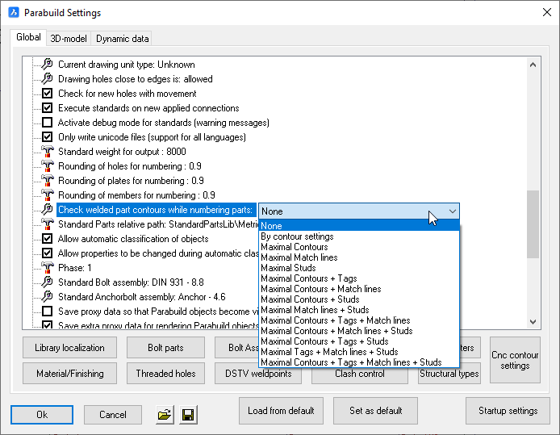
This option can be accessed from the Parabuild Global settings.
There are a number of available options, each of them adding more or less contour and matchline data to the numbering.
When contours and/or matchlines are checked while numbering, then the location of a part relative to the attached parts in that assembly may influence its part number.
When tags are added to the numbering, then the part number of each attached part is also considered by the numbering and may also cause a different part number if it differs.

The advantages of enabling this option are :
- Less complexity in the naming of DSTV and DXF files, because the part number will not have to be combined with the assembly number anymore.
- The assembly numbers will not have to be scribed on the part in order to uniquely identify the part.
- There is less potential for confusion when each part with different scribing has a different part number
- Some MIS/MRP/ERP solutions do not support the combination of the part number and assembly number for the CNC files. This issue can be avoided by enabling this option.

One minor disadvantage of this option is that it may result in more part numbers and thus more shop drawings for single parts. The amount of assembly numbers/drawings will remain the same.
Parabuild ensures you will get different NC files (DXF & DSTV) for parts with different contours, whether the option to consider contours in numbering is enabled or not.
When the contour/matchline is not checked during numbering, then Parabuild will add the assembly number to the NC file, but only if necessary.
This is important because if detailing software generates only a single file for parts that may have different contours, this can result in loss of material and errors on the shop floor if the situation is not discovered before welding.

The following illustrations show the difference in numbering when the contours in numbering are activated or deactivated. This example mentions DSTV filenames, but the same goes for DXF.
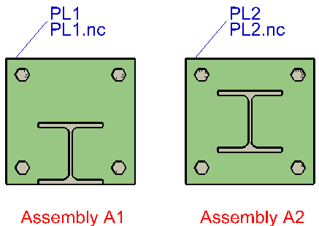
Baseplate and column with checking contours in numbering enabled: the baseplates are equal but have different scribing so they get a different number and a simple NC file name

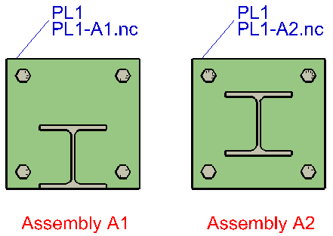
Baseplate and column without checking contours in numbering: the parts are equal and get the same number. Because the scribing differs, the assembly number is included in the NC filename and will be scribed on the baseplates

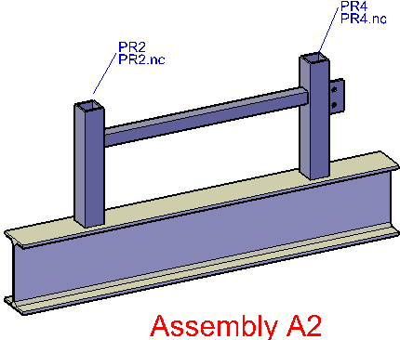
Assembly with checking contours in numbering enabled: two attached parts in the same assembly have the same geometry but different scribing so get a different number and simple NC filename

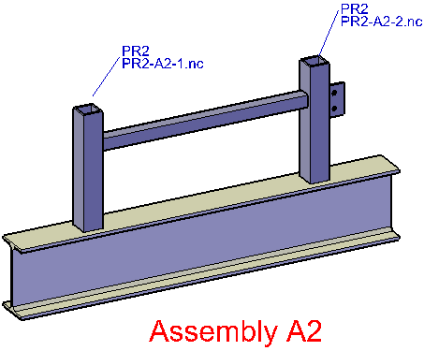
Assembly without checking contours in numbering: the geometry of both parts is equal so they get the same number. Because the scribing differs, the assembly number and an additional incremental number is included in the NC filename and will be scribed on the attached parts. The additional assembly- and incremental number are only used when needed to uniquely identify two equal-number parts with different scribing.

3D Model settings
These settings determine how the 3D models are presented.
All of the settings in this list will apply to newly drawn objects - they do not affect existing objects.
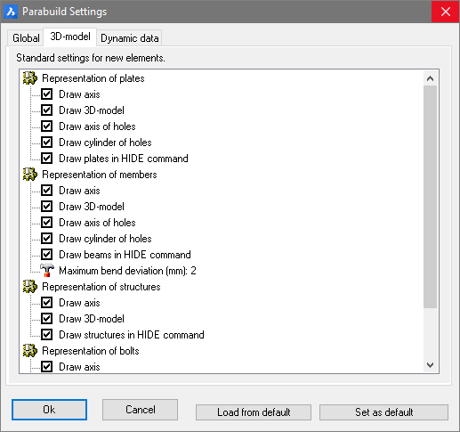

Dynamic Data
Dynamic properties are custom properties that the user can assign to Parabuild objects.
This allows additional properties to be created to supplement the properties already offered by Parabuild.
Additional properties can be created using the Global settings dialog window. All properties shown here are also available and adaptable in the Properties panel. Every dynamic property can also be activated as a column in the parts list (also on workshop drawings).
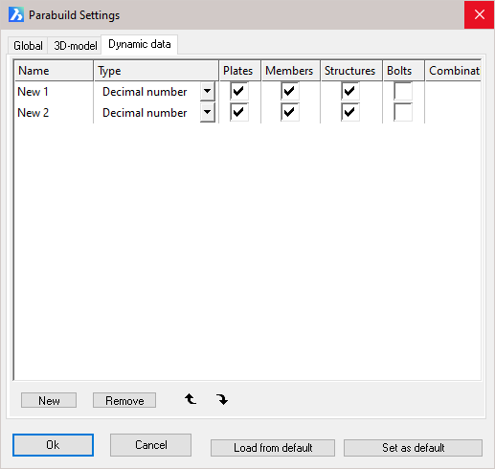

Name:- Click the button 'New' to add a new property. The name may be edited to suit.
Type:- Is the determined value of the property. From the drop-down menus select either:
Decimal number - e.g. 00
Comma delimited number - e.g. 00.0
Text - e.g. Stock No. 5
Combination-text - This can be used to contain a fixed number of predetermined texts. These texts should be entered in the last column
Plates:- Tick the checkbox to apply the property to plates
Members:- Tick the checkbox to apply the property to members
Structures:- Tick the checkbox to apply the property to structures
Bolts:- Tick the checkbox to apply the property to bolts
Combination text:- The texts should be separated with a comma. E.g. “steel,concrete,aluminum” will allow you to make a selection of these three materials.

Viewing Parabuild drawings without Parabuild
When a dwg file written with Parabuild is opened in an application without Parabuild then the Parabuild parts will not be visible.
This will happen with AutoCAD, BricsCAD, Trueview, and online viewer tools.

There are 2 possible solutions to this problem :

Enabling proxy data
When we enable proxy data in Parabuild then the dwg file written by Parabuild will also contain appearance information of all the Parabuild parts.
This appearance information is then used by AutoCAD, BricsCAD, and Trueview to display the Parabuild parts even though these software programs have no knowledge of the parts.
Proxy data can be enabled in Parabuild in the Global settings :
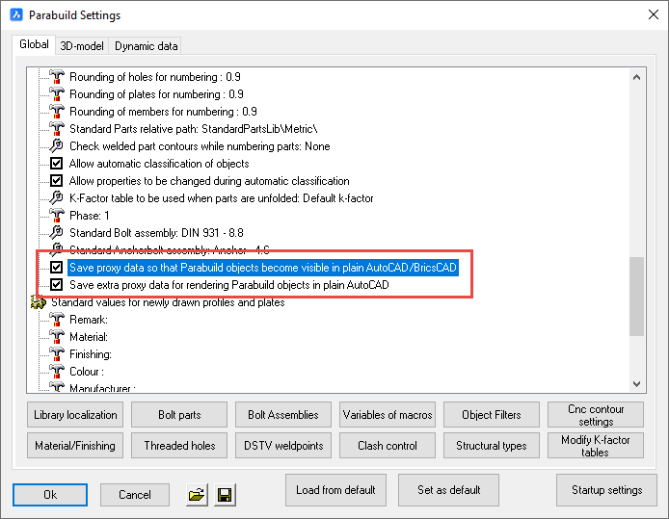

Using Parabuild as a viewer
It is required to have AutoCAD Full or BricsCAD Pro installed for this solution to work.
With this solution we would install Parabuild without an active license.
When you do not activate a license in Parabuild, Parabuild will work as a viewer.
The viewer mode of Parabuild still has the following capabilities :
- Opening and saving Parabuild drawings
- Printing Parabuild drawings
- Browsing Parabuild drawings (Zoom/pan/3D Orbit)
- Visibility manager for hiding objects or for manipulating the view
- Use quick select to find parts in the drawing
- Use the Properties dialog box for reviewing the properties of all Parabuild objects
- Reviewing the parameters of macros (but not modifying them)
- Adding native AutoCAD/BricsCAD entities to the drawing and still save them in the Parabuild drawing
- The sheets manager for viewing all the 2D sheets contained in the drawing
- Opening and printing 2D sheets
- Drawing additional objects on 2D sheets such as dimensions and annotations

The above capabilities are not possible with the proxy data solution (except for the viewing/browsing of Parabuild drawings).

The Properties Panel
The Properties of all Parabuild objects can be changed using the Properties window. This window can be started in one of 4 ways:
- From the top (CAD) menu, select Modify > Properties
- At the command line, enter Properties
- Select an object using the left mouse button, click on the object with the right mouse button, and select Properties from the drop-down menu
- Double click the object using the left mouse button (this will only work on some objects such as lines)
The properties window can be resized to suit, and docked at the top, bottom, left, or right sides of the viewing area. When the dialog window is open, all commands are still accessible without affecting the Properties window.
Just as with AutoCAD or BricsCAD objects, Parabuild objects can also be edited in the same properties window. When the properties window is displayed, one or multiple objects can be selected and the common properties of the selected objects will be displayed immediately. These properties can then be changed as required.
Note that editing an object from the Properties panel will only affect the selected object(s) and will have no impact on the default settings.
Just a note of caution, that when selecting multiple objects with different properties, for example 2 members of different sections, the ‘Properties’ value will, in most cases, be read as ‘Varies’. Editing this value, will change both members. At any time, these changes may be reversed by clicking on the Edit > Undo button from the top (CAD) menu.
Note! The default values visible in the Properties panel are set by the AutoCAD or BricsCAD settings – these values may be overridden by the Parabuild Global Settings. The Parabuild settings will take precedence over all CAD settings.
This dialog window can also be used to view and change dynamic properties. Dynamic properties are properties applied by the user. For further explanation see the chapter Dynamic properties
Types of objects
Each object type has its own distinctive properties.
The following object types are explained in more detail :
- Arc
- Line
- Coordinate system
- Annotation
- Member
- Macro
- Plate
- Pattern
- Bolt
- Structure
- Array
- View
- Camera
- Annotation
- 3D Weld

Dynamic Properties
All Parabuild parts can have an unlimited number of user properties.
These are shown at the bottom of the properties list.
To create these user properties, see the topic See Dynamic data.

Arc
The 'Arc' object type has the following headings:
General
3D Visualization
Geometry
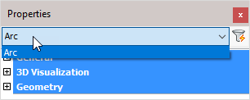

General: Is common to all object types, and covers general AutoCAD and BricsCAD settings, including: Color / Layer / Linetype / Linetype scale / Plot style / Lineweight / Transparency / Hyperlink / Handle /

3D Visualization: Is also common to all object types and includes: Material.
The material that is referred to here is only the visual representation material. For changing the actual material of parts, see the Additional Data section of plates, profiles or structures.

Geometry:
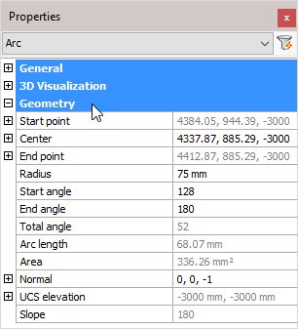
Note! - * indicates that the given value is a resultant of the sum of other values in the panel - and cannot be individually edited.
Start point: * Start point of the arc – expressed as the X, Y, and Z coordinates
Center: The geometric center of the arc – expressed as the X, Y, and Z coordinates
End point: * End point of the arc – expressed as the X, Y, and Z coordinates
Radius: Arc radius
Start angle: Measured from the horizontal plane
End angle: Measured from the horizontal plane
Total angle: * = (End angle - start angle)
Arc Length: * Calculated arc length
Area: * calculated area
Normal: Determines the 3D unit normal vector of a selected circle, arc, or PolyLine arc segment. This normal vector is the Z coordinate of the object coordinate system (OCS) of the selected object.
UCS elevation: * UCS elevation (Reference)
Slope: * Slope angle relative to the horizontal plane (Reference)

Line
The 'Line' object type has the following headings:
General
3D Visualization
Geometry
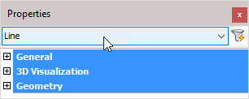

General: Is common to all object types, and covers general AutoCAD and BricsCAD settings, including: Color / Layer / Linetype / Linetype scale / Plot style / Lineweight / Transparency / Hyperlink / Handle /

3D Visualization: Is also common to all object types and includes: Material.
The material that is referred to here is only the visual representation material. For changing the actual material of parts, see the Additional Data section of plates, profiles or structures.

Geometry
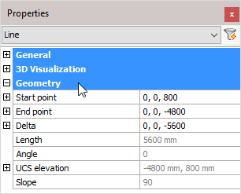
Note! - * indicates that the given value is a resultant of the sum of other values in the panel - and cannot be individually edited.
Start point: Line start point (X, Y, Z coordinates)
End point: Line end point (X, Y, Z coordinates)
Delta: Delta (X, Y, Z coordinates)
Length: * Calculated line length
Angle: * calculated line angle
UCS elevation: * UCS elevation (Reference)
Slope: * Slope angle relative to the horizontal plane (Reference)

Coordinate System
The 'Coordinate system' object type has the following headings:
General
3D Visualization
Misc

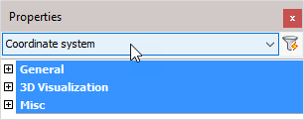

General: Is common to all object types, and covers general AutoCAD and BricsCAD settings, including: Color / Layer / Linetype / Linetype scale / Plot style / Lineweight / Transparency / Hyperlink / Handle /

3D Visualization: Is also common to all object types and includes: Material.
The material that is referred to here is only the visual representation material. For changing the actual material of parts, see the Additional Data section of plates, profiles or structures.

Misc:
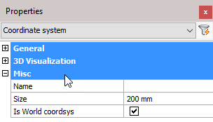
Name: User coordinate system name
Size: User coordinate system Icon size
Is World coordsys: This value can't be changed as there is always 1 World coordinate system in the drawing. Parabuild creates this coordinate system automatically.

Member
The 'Member' object type has the following headings:
General
3D Visualization
Profile placement
Misc
Representation
Additional Data
Number Settings
Output

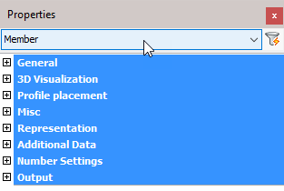

General: Is common to all object types, and covers general AutoCAD and BricsCAD settings, including: Color / Layer / Linetype / Linetype scale / Plot style / Lineweight / Transparency / Hyperlink / Handle /

3D Visualization: Is also common to all object types and includes: Material.
The material that is referred to here is only the visual representation material. For changing the actual material of parts, see the Additional Data section of plates, profiles or structures.

Profile placement
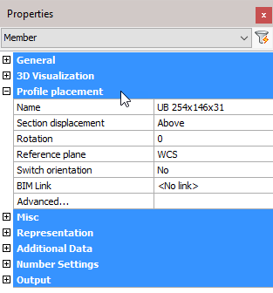

Name: Clicking the button will open the Select Profile dialog where you can select a different profile from any of the groups. Changing the profile will reflect immediately on the drawing.
Section displacement: Select a new section displacement point from the drop-down menu (This value will be Unavailable when the member is not determined by a macro)
Rotation: Enter a new value for the rotation of the profile (This value will be Unavailable when the member is not determined by a macro)
Reference plane: Select a Reference plane from the drop-down menu (This value will be Unavailable when the member is not determined by a macro)
Switch orientation: Enables you to switch the orientation of the profile. For more information, refer to Switch Profile Triangle Direction (This value will be Unavailable when the member is not determined by a macro)
BIM link: Select options from the drop-down menu (This value will be Unavailable when the member is not determined by a macro)
All placement options: This will open the Profile Placement dialog
This value will be Unavailable when the member is not determined by a macro
However, it is possible to automatically create a placement macro for a member when the placement options are set to Unavailable.
Just click on the All placement options button, then the macro will be created automatically.
A model line will be searched for near the profile. If no model line was found, then a new model line will be drawn on the axis of the profile.
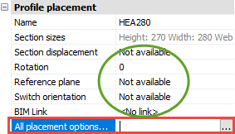
This will give you more flexibility : you can use the placement tools to rotate or displace a profile, even after the original macro was already deleted.

Misc
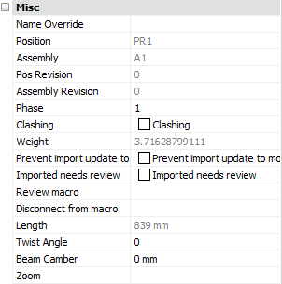
Note! - * indicates that the given value is a resultant of the sum of other values in the panel - and cannot be individually edited.
Name override: The replacement of the normal profile name. This replacement name will be used in all part lists and workshop drawings.
Position: * The number automatically given to elements by Parabuild. Elements that are the same, (same dimensions, holes, sections) are given the same position number. These positions are partially adaptable with prefixes and suffixes, see Number settings.
Assembly: * The Assembly number automatically given to elements by Parabuild
Pos revision: This value is automatically assigned by Parabuild. Whenever the part is created or modified, then it will get the current revision that is currently active in the Revisions manager.
Assembly revision: This value is automatically assigned by Parabuild. Whenever the assembly's parts or the distance between the parts has modified, then it will get the current revision that is currently active in the Revisions manager.
Phase: Change the project phase of the selected element
Clashing: This is set to yes or no and refers to whether the profile is currently clashing with other elements or not. This property is automatically set by the clash control, and is primarily included in properties for search objectives. For more information read the chapter Clash Check
Weight: * Calculated weight of the selected member
Prevent import update to model: Activating the checkbox will prevent any import update to the model. This refers to CIS/2 or Ifc incremental imports.
Imported needs review: This value will be set automatically for parts that were updated after an incremental CIS/2 or Ifc import.
Review macro: Will open the macro edit dialog, where the macro may be viewed and/or edited
Length: * Calculated member length
Twist angle: The angle that the profile has to turn over the length of the profile. This should only be used for profiles on a spiral path or other special 3D-forms.
Beam camber: The camber (distance) to be used for the beam. This value influences the position number of the beam. This value is exported to KISS files.
Zoom: Zoom to the extents of the selected member

Representation
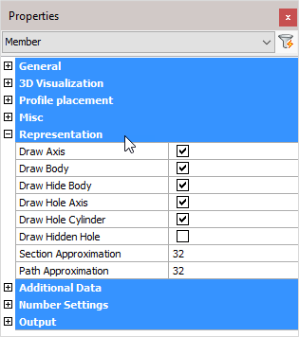
Draw Axis: Draws the Axis of a profile
Draw Body: Draws the complete 3D-model of the profile in 2D wireframe
Draw Hide Body: Draws the complete 3D-model of the profile in 3D visual styles
Draw Hole Axis: Draws the axis of every hole in the profile
Draw Hole Cylinder: Draws the cylindrical path of all holes in the profile in 2D wireframe
Draw Hidden Hole: Draws the cylindrical path of all holes in the profile in 3D visual styles.
One can activate the hole subtraction here for a better visual representation, but do note that when a bolt is drawn through this hole, you would not see the difference. On top of that, the subtraction is heavy on resources. This is the reason why this option is disabled by default.
The edges of the hole are always drawn independently of this setting.
Section Approximation: Determines how accurately the cross section of a profile should be drawn. This has a particular influence over curves in a cross section, for example when the rounding between a beam web and flange is applied.
Path Approximation: Determines how accurately the profile is drawn over its path. This has a particular influence on curved profiles

Additional data
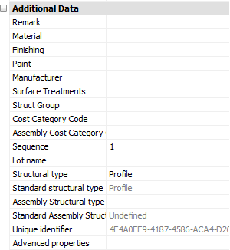
Remark: Can be used in a variety of ways. This field is maintained for every element. It has its own column in the part lists, and can be used for sorting part lists and workshop drawings. This property has no further influence
Material: This field also has its own column in the part lists and can be used for sorting, but this has a direct influence on the position number (and consequently the mark/assembly number). Two elements that are identical, but have another material assigned to, will be given another position number. This enables a total categorization of different materials in part lists and workshop drawings.
The weight factor of every material can be changed in the Parabuild Properties - Global - Material/Finishing. Parabuild will use this weight factor to calculate the weight in the part lists.
Finishing: Same as Remark
Paint: Same as Remark
Manufacturer: Same as Remark
Surface Treatments: This will open the Surface Treatments dialog. It allows you to add new surface treatments or modify existing surface treatments.
Struct Group: This property can be freely used for the user's own purpose.
Cost category Code: These codes are usually determined while a quote for the project is made. This code can then later be assigned to the 3D model when the project was ordered. This way the parts can be traced from estimation to production and to completion inside ERP/MIS software. This value is exported to KISS files.
Assembly Cost category Code: See ‘Cost category Code’
Sequence: The erection sequence of the part. The sequence of a part has the following capabilities:
  - The reference assembly of a bolt can be determined by the sequence number of the assemblies
  - The sequence is exported to KISS file
  - It should be available in bills when you make the columns : %PbColSequence%
  - A planning tool for erection is a future addition
Lot Name: The lot that the part belongs to. This value is exported to KISS files
Structural Type: For example: Bracing/Rafter/Stringer/Handrail/Post/etc.... You can use the variable %PbColStructuralType% to use this property in Bill of materials or annotations
Assembly Structural Type: For example: Stair/Railing/etc.... You can use the variable %PbColAssemblyStructuralType% to use this property in Bill of materials or annotations
Unique Identifier: The Unique identifier is allocated by Parabuild, or received from a CIS/2 or Ifc file import.
Advanced properties - Clicking on this button will open the advanced properties dialog, which contains the following properties for profiles :
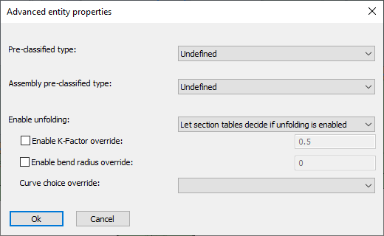
  - Pre-classified type and Assembly pre-classified type - This property is only useful for template drawings of connections/macros.
This setting is a good alternative way to automatically assign structural types when it is too difficult or impossible to create filters that detect the type of part automatically.
To make this work, you first have to set the pre-classified structural type here, and then save the template drawing in the library. Then the next time when the template drawing is used and inserted into the drawing, then this pre-classified structural type will be set in the structural type property of the part upon insertion.
The purpose of this is to have an influence on the automatic assignment of the structural part type property, without having to rely on the automatic Structural types assignments through Object Filters.
The unfolding options in the advanced properties of a part take precedence over all other unfolding settings (that may have been set in the section table for example).
  - Enable unfolding - This dropdown has the following choices :
    - Disable folding - Use this option if you don't want the unfold operation to happen on this part
    - Enable unfolding - Use this option if you always want the unfold operation to happen on this part
    - Let section tables decide if unfolding is enabled - Use this option if you want the section table settings to decide whether the part should be unfolded. This is the default setting.
  - Enable K-Factor override - Enter a value here if you want to specify a different K-Factor for this part
  - Enable bend radius override - Enter a value here if you want to specify a specific bend radius for this part. This bend radius will only be used on sharp edges.
  - Curve choice override - When unfolding, the bends are not only neutralized from the part, but also the part is flattened to a 2D plate. As a consequence, there are multiple ways in which the flattening can be done. These are the available options for the flattening :
    - Minimum material - Always assume the minimum amount of material
    - Maximum material - Always assume the maximum amount of material
The difference between minimum and maximum material is most easily explained with an example :
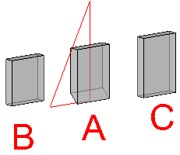
A. is the part being flattened to 2D
B. is the resulting plate after choosing the minimum material option.
C. is the resulting plate after choosing the maximum material option.
    - Top surface of the unfolded part - Always assume the top surface of the part
    - Bottom surface of the unfolded part - Always assume the bottom surface of the part

Number settings
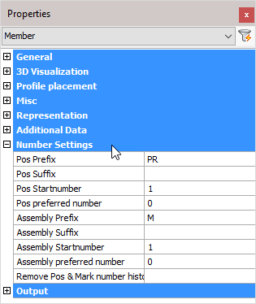
Pos Prefix: Determines the prefix of the position number.
Pos Suffix: Determines the suffix of the position number.
Pos Start number: Determines the start number of the position number.
Pos preferred number: Forces Parabuild to use the preferred number as position number. Parabuild will comply if this number is not already in use by a different part.
Assembly Prefix: Determines the prefix of the Assembly number
Assembly Suffix: Determines the prefix of the Assembly number
Assembly Start number: Determines the start number of the Assembly number
Assembly preferred number: Forces Parabuild to use the preferred number as assembly/mark number. Parabuild will comply if this number is not already in use by a different part.
Remove Pos & Mark number history: Lets Parabuild forget the preferred numbers and also the previous numbers that the part had.
Note! For more information on any of these items, refer to Numbering of elements

Output
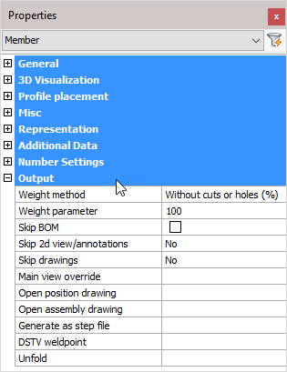
Weight method:
- Without cuts or holes (%): The weight of the complete length of the profile will be calculated, without subtracting the holes and cuts. In the next property you can adjust the percentage of this value that should be used.
- Cut: The cuts in the profiles are subtracted to calculate the weight.
- Cut and drilled: The cuts and the holes are subtracted to calculate the weight
- Fixed value: The value you enter in the next property will be used as the weight for this element in kg or lbs (This value will be taken over in the BOMs without any adjustments).
Weight parameter: This property is being used in combination with the above properties ‘Default’ and ‘Fixed value’
Skip BOM: If this property to ‘Yes’, this element will not appear in the BOMs
Skip 2D view/annotations: Adjust this to skip this element for the 3D annotations or the 3D annotations + 2D view
Skip drawings: You can skip only the Position drawings, only the mark/assembly drawings, or both the Position and Mark drawings
Main view override: Select a plane that determines the main view's direction
Open position drawing: Will open the position drawing of the selected part
Open assembly drawing: Will open the assembly drawing of the selected assembly
Generate as a STEP file: STEP file is a CAD file format, usually used to share 3D models between users with different CAD systems. Note! This command will only work in BricsCAD and when the Communicator module is installed and licensed. For more information, refer to Document generation Settings > Generate STEP Files
DSTV weld point: DSTV weld points are points that are placed in the automatically produced DSTV NC-files. A point indicates on which spot an element must be welded on the profile. For more information, refer to parabuild Settings > Global > DSTV Weld points
Unfold: Will unfold or develop a sheet metal object. Note! This command will only work in BricsCAD and when you have an active sheet metal license.
This tool does the following actions sequentially :
  - Convert the profile to a 3D Solid
  - Convert the solid to a sheet metal object
  - Repair the sheet metal
  - Create bends automatically
  - Unfold the sheet and write the result as a DXF file in the 3D model's directory and that carries the part number of the strip as name.

Macro
The 'Macro' object type has the following headings:
General
3D Visualization
Misc

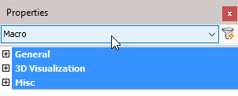

General: Is common to all object types, and covers general AutoCAD and BricsCAD settings, including: Color / Layer / Linetype / Linetype scale / Plot style / Lineweight / Transparency / Hyperlink / Handle /

3D Visualization: Is also common to all object types and includes: Material.
The material that is referred to here is only the visual representation material. For changing the actual material of parts, see the Additional Data section of plates, profiles or structures.

Misc
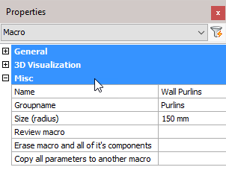
Name: The name of the macro – this may be edited and will reflect in the macro dialog box
Group name: The group name of the macro – this value is used for grouping together similar macros in the macro dialog box
Size (radius): Adjust the size of the macro sphere
Review macro: Activating this button will open the macro edit dialog box for the selected object
Erase macro and all of its components: Will Erase macro and all of its components
Copy all parameters to another macro: Will Copy all parameters to another macro

Plate
The 'Plate' object type has the following headings:
General
3D Visualization
Misc
Representation
Additional Data
Number Settings
Output

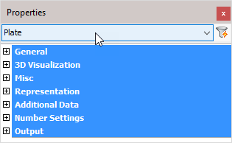

General: Is common to all object types, and covers general AutoCAD and BricsCAD settings, including: Color / Layer / Linetype / Linetype scale / Plot style / Lineweight / Transparency / Hyperlink / Handle /

3D Visualization: Is also common to all object types and includes: Material.
The material that is referred to here is only the visual representation material. For changing the actual material of parts, see the Additional Data section of plates, profiles or structures.

Misc
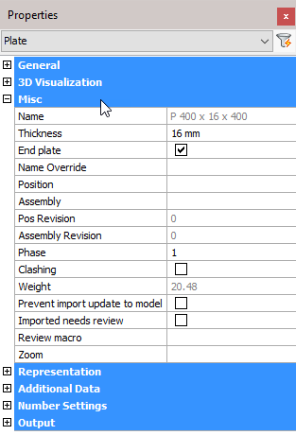
Note! - * indicates that the given value is a resultant of the sum of other values in the panel - and cannot be individually edited.
Name: * This is the plate size, also shown in the BOM. Refer to the Settings dialog box for influencing this name
Thickness: Plate thickness - editing this value will immediately reflect on the model
End Plate: A plate, designated as an 'End plate' will receive an additional view on the assembly drawing
Name Override: The replacement of the normal plate name. This replacement name will be used in all part lists and workshop drawings.
Position: * The number automatically given to elements by Parabuild. Elements that are the same, (same dimensions, holes, sections) are given the same position number. These positions are partially adaptable with prefixes and suffixes, see Number settings.
Assembly: * Assembly number
Pos Revision: This value is automatically assigned by Parabuild. Whenever the part is created or modified, then it will get the current revision that is currently active in the Revisions manager.
Assembly Revision: This value is automatically assigned by Parabuild. Whenever the assembly's parts or the distance between the parts has modified, then it will get the current revision that is currently active in the Revisions manager.
Phase: Change the project phase of the selected element
Clashing: This is set to yes or no and refers to whether the profile is currently clashing with other elements or not. This property is automatically set by the clash control, and is primarily included in properties for search objectives. For more information read the chapter Clash Check
Weight: * Calculated weight of the selected member
Prevent import update to model: Activating the checkbox will prevent any import update to the model. This refers to CIS/2 or Ifc incremental imports.
Imported needs review: This value will be set automatically for parts that were updated after an incremental CIS/2 or Ifc import.
Review macro: Will open the macro edit dialog, where the macro may be viewed and/or edited
Zoom: Pressing the button will zoom to the extents of the selected plate

Representation
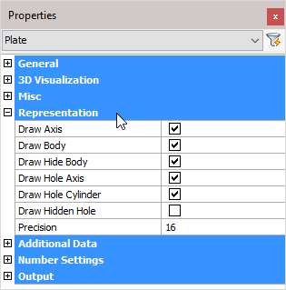
Draw Axis: Draws the Axis of a profile
Draw Body: Draws the complete 3D-model of the profile in 2D wireframe
Draw Hide Body: Draws the complete 3D-model of the profile in 3D visual styles
Draw Hole Axis: Draws the axis of every hole in the plate
Draw Hole Cylinder: Draws the cylindrical path of all holes in the plate in 2D wireframe
Draw Hidden Hole: Draws the cylindrical path of all holes in the plate in 3D visual styles.
One can activate the hole subtraction here for a better visual representation, but do note that when a bolt is drawn through this hole, you would not see the difference. On top of that, the subtraction is heavy on resources. This is the reason why this option is disabled by default.
The edges of the hole are always drawn independently of this setting.
Precision: This value applies to the precision of curves in the plate's internal or external contours.

Additional Data
Remark: Can be used in a variety of ways. This field is maintained for every element. It has its own column in the part lists, and can be used for sorting part lists and workshop drawings. This property has no further influence
Material: This field also has its own column in the part lists and can be used for sorting, but this has a direct influence on the position number (and consequently the mark number). Two elements that are identical, but have another material assigned to, will be given another position number. This enables a total categorization of different materials in part lists and workshop drawings.
The weight factor of every material can be changed in the Parabuild Properties > Global > Material/Finishing. Parabuild will use this weight factor to calculate the weight in the part lists.
Finishing: Same as Remark
Paint: Same as Remark
Manufacturer: Same as Remark
Surface Treatments: Will open the Surface Treatments dialog
Struct Group: This property can be freely used for the user's own purpose.
Cost category Code: These codes are usually determined while a quote for the project is made. This code can then later be assigned to the 3D model when the project was ordered. This way the parts can be traced from estimation to production and to completion inside ERP/MIS software. This value is exported to KISS files.
Assembly Cost category Code: See ‘Cost category Code’
Sequence: The erection sequence of the part. This value is exported to KISS files
Lot Name: The lot that the part belongs to. This value is exported to KISS files
Structural Type: For example: Bracing/Rafter/Stringer/Handrail/Post/etc.... You can use the variable %PbColStructuralType% to use this property in Bill of materials or annotations
Assembly Structural Type: For example: Stair/Railing/etc.... You can use the variable %PbColAssemblyStructuralType% to use this property in Bill of materials or annotations
Unique Identifier: The Unique identifier is allocated by Parabuild, or received from a CIS/2 or Ifc file import.
Advanced properties - Clicking on this button will open the advanced properties dialog, which contains the following properties for plates :
  - Pre-classified type and Assembly pre-classified type - This property is only useful for template drawings of connections/macros.
This setting is a good alternative way to automatically assign structural types when it is too difficult or impossible to create filters that detect the type of part automatically.
To make this work, you first have to set the pre-classified structural type here, and then save the template drawing in the library. Then the next time when the template drawing is used and inserted into the drawing, then this pre-classified structural type will be set in the structural type property of the part upon insertion.
The purpose of this is to have an influence on the automatic assignment of the structural part type property, without having to rely on the automatic Structural types assignments through Object Filters.

Number Settings
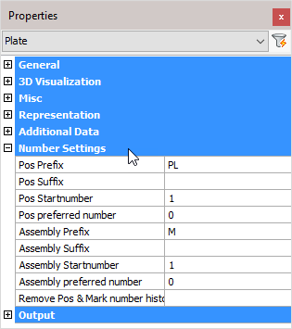
Pos Prefix: Determines the prefix of the position number.
Pos Suffix: Determines the suffix of the position number.
Pos Start number: Determines the start number of the position number.
Pos preferred number: Forces Parabuild to use the preferred number as position number. Parabuild will comply if this number is not already in use by a different part.
Assembly Prefix: Determines the prefix of the Assembly/Mark number.
Assembly Suffix: Determines the prefix of the Assembly/Mark number.
Assembly Start number: Determines the start number of the Assembly/Mark number.
Assembly preferred number: Forces Parabuild to use the preferred number as assembly/mark number. Parabuild will comply if this number is not already in use by a different part.
Remove Pos & Mark number history: Lets Parabuild forget the preferred numbers and also the previous numbers that the part had.
Note! For more information on any of these items, refer to Numbering of elements

Output
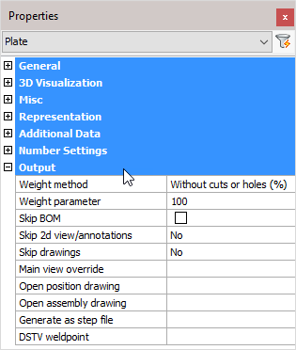

Weight method:
- Without cuts or holes (%): The weight of the complete length of the profile will be calculated, without subtracting the holes and cuts. In the next property you can adjust the percentage of this value that should be used.
- Cut: The cuts in the profiles are subtracted to calculate the weight.
- Cut and drilled: The cuts and the holes are subtracted to calculate the weight
- Fixed value: The value you enter in the next property will be used as the weight for this element in kg or lbs (This value will be taken over in the BOMs without any adjustments).
Weight parameter: This property is being used in combination with the above properties ‘Default’ and ‘Fixed value’
Skip BOM: If this property to ‘Yes’, this element will not appear in the BOMs
Skip 2D view/annotations: Adjust this to skip this element for the 3D annotations or the 3D annotations + 2D view
Skip drawings: You can skip only the Pos drawings, only the mark drawings, or both the Pos and Mark drawings
Main view override: Select a plane that determines the main view's direction
Open position drawing: Will open the position drawing of the selected part
Open assembly drawing: Will open the assembly drawing of the selected assembly
Generate as a STEP file: STEP file is a CAD file format, usually used to share 3D models between users with different CAD systems. Note! This command will only work in BricsCAD and when the Communicator module is installed and licensed. For more information, refer to Document generation Settings > Generate STEP Files
DSTV weld point: DSTV weld points are points that are placed in the automatically produced DSTV NC-files. A point indicates on which spot an element must be welded on the profile. For more information, refer to parabuild Settings > Global > DSTV Weld points

Pattern
The 'Pattern' object type is used by macros to draw and manage a range of bolts. It has the following headings:
General
3D Visualization
Misc

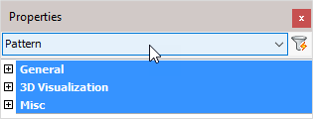

General: Is common to all object types, and covers general AutoCAD and BricsCAD settings, including: Color / Layer / Linetype / Linetype scale / Plot style / Lineweight / Transparency / Hyperlink / Handle /

3D Visualization: Is also common to all object types and includes: Material.
The material that is referred to here is only the visual representation material. For changing the actual material of parts, see the Additional Data section of plates, profiles or structures.

Misc
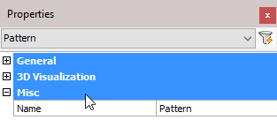
Name: Will show the pattern name

Bolt
The 'Bolt' object type has the following headings:
General
3D Visualization
Geometry
Misc
Representation
Parts
Output

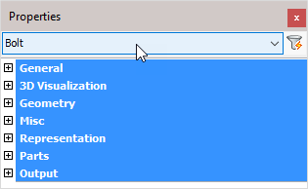

General: Is common to all object types, and covers general AutoCAD and BricsCAD settings, including: Color / Layer / Linetype / Linetype scale / Plot style / Lineweight / Transparency / Hyperlink / Handle /

3D Visualization: Is also common to all object types and includes: Material.
The material that is referred to here is only the visual representation material. For changing the actual material of parts, see the Additional Data section of plates, profiles or structures.

Geometry
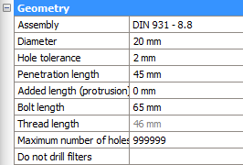
Assembly: Select a Bolt assembly from the drop-down menu. For more information refer to Bolt Assemblies
Diameter: Edits the bolt diameter
Hole tolerance: The diameter of the bolt's hole = diameter of the bolt + hole tolerance
Penetration length: This is the combination of the thickness of all the drilled part(s)
Added length: Minimum length of the bolt = net length (material length) + nut thickness + thickness of all washers + added length. This minimum length will be used to extract the actual bolt length from the part database. The actual bolt length shall be equal to, or longer than the minimum length of the bolt
Bolt length: The effective length of the bolt taken from the Bolt parts database. The length of the bolt can be changed temporarily for drilling extra holes. Method: Bolt penetrates one flange of a tube; it needs to penetrate both tube flanges. Increase the bolt length enough to pass completely through the tube. Now use the command Check for new holes on the tube and the bolt. The bolt will be given the correct length and the second hole will be drawn.
Thread length: The thread length is taken from the Bolt parts database
Maximum number of holes: You can enter a limit on the number of holes that this bolt can have. Parts will get holes starting from the bolt head until the maximum number of holes limit has been reached.
Do not drill filters - With this property, it is possible to have the bolt not add any holes to certain objects
This is done with the help of multiple filters that can be entered per bolt.
In the value field of this property, you have to enter all the filter values separated by a semicolon ;
The bolt will not create any holes in parts that match one of the values you have entered here in the following properties :
- Material
- Phase
- Remark
- Structural type
- Struct group

Misc
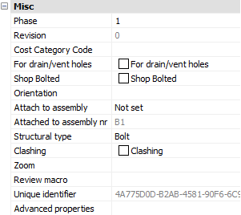
Phase: Changes the project phase of the selected element
Revision: This value is automatically assigned by Parabuild. Whenever the part is create or modified, then it will get the current revision that is currently active in the Revisions manager.
Cost category code: These codes are usually determined while a quote for the project is made. This code can then later be assigned to the 3D model when the project was ordered. This way the parts can be traced from estimation to production and to completion inside ERP/MIS software. This value is exported to KISS files.
For drain/vent holes - When this property is enabled, then all of the holes drawn by this bolt will also get this drain/vent holes property enabled. Drain/vent holes will get no dimensioning on the assembly drawings at all, contrary to regular holes.
Shop Bolted: Activating the checkbox will set the bolt to shop-bolted - See Bolts/Holes > Shop Bolts
Orientation: Clicking on the button will switch the orientation of the bolt
Attach to assembly: From the drop-down menu, select which element the bolt should be attached to. Options include 'Closest to bolt head' or 'Closest to bolt end'
Attached to assembly nr: This will indicate which assembly number the bolt is currently attached to. It is assigned automatically based on the above property.
Structural type: ** For example: Bolt or Anchor bolt **
Clashing: This is set to yes or no and refers to whether the profile is currently clashing with other elements or not. This property is automatically set by the clash control, and is only included in properties for search objectives. For more information read the chapter Clash Check
Zoom: Zoom to the extents of the selected bolt(s)
Review macro: Will open the Macro Edit dialog, where the macro that owns this bolt may be viewed and/or edited
Unique identifier: Unique identifier allocated by Parabuild, or received from a CIS/2 or Ifc file import.
Advanced properties - Clicking on this button will open the advanced properties dialog, which contains the following properties for bolts :
  - Pre-classified type - This property is only useful for template drawings of connections/macros.
This setting is a good alternative way to automatically assign structural types when it is too difficult or impossible to create filters that detect the type of part automatically.
To make this work, you first have to set the pre-classified structural type here, and then save the template drawing in the library. Then the next time when the template drawing is used and inserted into the drawing, then this pre-classified structural type will be set in the structural type property of the part upon insertion.
The purpose of this is to have an influence on the automatic assignment of the structural part type property, without having to rely on the automatic Structural types assignments through Object Filters.
  - Only draw holes in parts that are used by the macro that draws the bolt - This option can help when bolts should be refrained from drawing too many holes.
Normally, bolts in Parabuild will automatically add holes whenever they collide with a part.
This is the design intent of Parabuild to make drawing parts fast and easy and reduce the amount of mistakes that can be made.
But in some special cases, this feature is not desired.
In this example of purlins or side rails/girts, it is the constructor's desire to have as many purlins with the same part number as possible.
This can be achieved by adding holes at pre-determined fixed locations at offset from the start and end of the purlins.
With the help of macros, these holes can be drawn automatically using helper bolts.
But when the purlins are overlapping (Z shapes), these helper bolts may inadvertently cause holes to be drawn in the overlapping purlin.
And that in turn will cause the parts to get different part numbers.
When enabling this option for the helper bolt, the macro that draws the bolts will be used to decide which purlin/rail is drilled and which one is not (the purlin/rail on which the bolt is drawn will get a hole, the others won't).
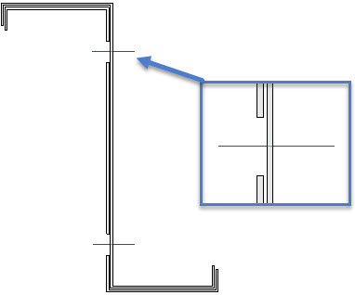
An example of helper bolts that add holes in one part, but purposefully does not add holes in the other part

Representation
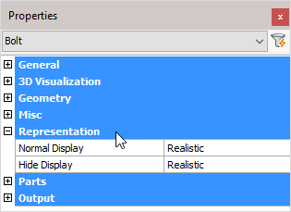
Normal Display: Selects the bolt display style in 2D wireframe
Hide Display: Selects the bolt display style in 3D Visual styles

Parts
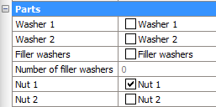
Washer 1: Enables or disables washer 1. The standards used for these parts are recorded in Bolt Assemblies
Washer 2: Enables or disables washer 2. The standards used for these parts are recorded in Bolt Assemblies
Filling washers: Enables or disables filling washers. The standards used for these parts are recorded in Bolt Assemblies
If the length of the bolt thread is not long enough (according to the standard) then it will not be possible to tighten the nut onto the work. This will also be visible in your drawing. Turning on filling washers will add sufficient washers enabling the bolt to be completely tightened
Number of filler washers - When the Filler washers (Packing washers) option of the bolt is enabled, and the shank of the bolt extends beyond the Grip (see illustration), then Parabuild will automatically add as many washers as necessary to make sure that the nut does not touch the thread runout or shank.
This property shows the number of filler washers that were applied on this bolt for this purpose.
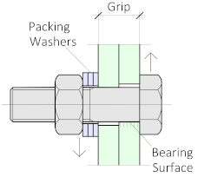
Nut 1: Enables or disables nut 1. The standards used for these parts are recorded in Bolt Assemblies
Nut 2: Enables or disables nut 2. The standards used for these parts are recorded in Bolt Assemblies

Output
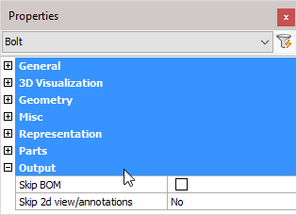
Skip BOM: If this property to ‘Yes’, this element will not appear in the BOMs
Skip 2D view/annotations: Adjust this to skip this element for the 3D annotations or the 3D annotations + 2D view

Holes
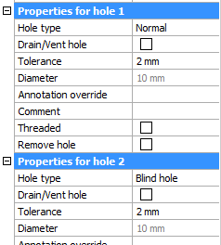
The last properties of the bolt are always the holes that the bolt may have.
All holes will be shown here separately, starting from the bolt's head the first hole will get number 1 and so on.
These are the properties for holes.
Hole type : Normal, Slotted, Counter sunk or Blind. For more information about the hole types, see their respective topics.
Drain/Vent hole : All the holes that are designated as 'drain / vent' holes will not receive any dimensions on the assembly shop drawings.
Tolerance : The tolerance for the hole in relation with the bolt.
Diameter : This value is only informative because it is derived from the bolt diameter and the tolerance.
Annotation override : When you enter a text in this field, this text will always be shown in the annotation of this hole on the position shop drawing. It will override the default text which would be the diameter, slotted, countersunk and thread information if it is such a hole type.
Comment : Feel free to use this field to add comment to the hole. It will only have an effect if the variable %PbColHoleComment% is used in an annotation or in a parts list.
Threaded : See the threaded hole topic for more info about this.
Remove hole : This is an action. Clicking on the button will erase this hole.

Structure
The 'Structure' object type has the following headings:
General
3D Visualization
Geometry
Misc
Representation
Additional Data
Number Settings
Output

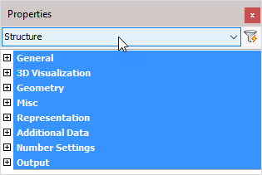

General: Is common to all object types, and covers general AutoCAD and BricsCAD settings, including: Color / Layer / Linetype / Linetype scale / Plot style / Lineweight / Transparency / Hyperlink / Handle /

3D Visualization: Is also common to all object types and includes: Material.
The material that is referred to here is only the visual representation material. For changing the actual material of parts, see the Additional Data section of plates, profiles or structures.

Geometry
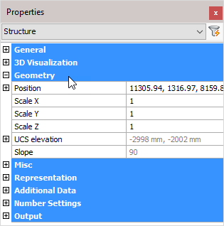
Note! - * indicates that the given value is a resultant of the sum of other values in the panel - and cannot be individually edited.
Position: Position of the structure (X, Y, and Z) relative to the UCS coordinates
Scale X: Scale factor X
Scale Y: Scale factor Y
Scale Z: Scale factor Z
UCS elevation: * UCS elevation (Reference)
Slope: * Slope angle relative to the horizontal plane (Reference)

Misc
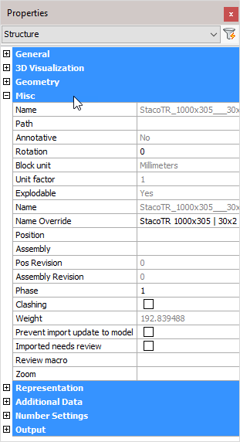
Note! - * indicates that the given value is a resultant of the sum of other values in the panel - and cannot be individually edited.
Name: * This is an AutoCAD and BricsCAD setting
Path: This is an AutoCAD and BricsCAD setting
Annotative: * This is an AutoCAD and BricsCAD setting
Rotation: This is an AutoCAD and BricsCAD setting
Block unit: * This is a AutoCAD / BricsCAD function. set block units to meters / mm / inches / etc.
Unit factor: * This is a AutoCAD / BricsCAD function. set block unit factor
Explodable: * Structure is explodable
Name: * Structure name used in the parts lists and workshop drawings
Name override: The replacement of the normal structure name. This replacement name will be used in all part lists and workshop drawings.
Position: * The number automatically given to elements by Parabuild. Elements that are the same, (same dimensions, holes, sections) are given the same position number. These positions are partially adaptable with prefixes and suffixes, see Number settings.
Assembly: * Assembly number
Pos revision: This value is automatically assigned by Parabuild. Whenever the part is created or modified, then it will get the current revision that is currently active in the Revisions manager.
Assembly revision: This value is automatically assigned by Parabuild. Whenever the assembly's parts or the distance between the parts has modified, then it will get the current revision that is currently active in the Revisions manager.
Phase: The project phase of the selected element.
Clashing: This is set to yes or no and refers to whether the profile is currently clashing with other elements or not. This property is automatically set by the clash control, and is only included in properties for search objectives. For more information read the chapter Clash Check
Weight: * Calculated weight of the selected member
Prevent import update to model: Activating the checkbox will prevent any import update to the model. This refers to CIS/2 or Ifc incremental imports.
Imported needs review: This value will be set automatically for parts that were updated after an incremental CIS/2 or Ifc import.
Review macro: Will open the macro edit dialog, where the macro may be viewed and/or edited
Zoom: Zoom to the extents of the selected structure

Representation
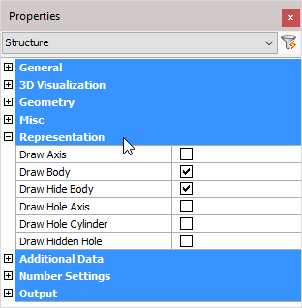
Draw Axis: Draws the Axis of a profile
Draw Body: Draws the complete 3D-model of the profile in 2D wireframe
Draw Hide Body: Draws the complete 3D-model of the profile in 3D visual styles
Draw Hole Axis: Draws the axis of every hole in the structure
Draw Hole Cylinder: Draws the cylindrical path of all holes in the structure in 2D wireframe
Draw Hidden Hole: Draws the cylindrical path of all holes in the structure in 3D visual styles.
One can activate the hole subtraction here for a better visual representation, but do note that when a bolt is drawn through this hole, you would not see the difference. On top of that, the subtraction is heavy on resources. This is the reason why this option is disabled by default.
The edges of the hole are always drawn independently of this setting.

Additional Data
Remark: Can be used in a variety of ways. This field is maintained for every element. It has its own column in the part lists, and can be used for sorting part lists and workshop drawings. This property has no further influence
Material: This field also has its own column in the part lists and can be used for sorting, but this has a direct influence on the position number (and consequently the mark number). Two elements that are identical, but have another material assigned to, will be given another position number. This enables a total categorization of different materials in part lists and workshop drawings.
The weight factor of every material can be changed in Parabuild Properties - Global - Material/Finishing . Parabuild will use this weight factor to calculate the weight in the part lists.
Finishing: Same as Remark
Paint: Same as Remark
Manufacturer: Same as Remark
Surface Treatments: Will open the Surface Treatments dialog
Struct Group: This property can be freely used for the user's own purpose.
Cost category Code: These codes are usually determined while a quote for the project is made. This code can then later be assigned to the 3D model when the project was ordered. This way the parts can be traced from estimation to production and to completion inside ERP/MIS software. This value is exported to KISS files.
Assembly Cost category Code: See ‘Cost category Code’
Sequence: The erection sequence of the part. This value is exported to KISS files
Lot Name: The lot that the part belongs to. This value is exported to KISS files
Structural Type: For example: Bracing/Rafter/Stringer/Handrail/Post/etc.... You can use the variable %PbColStructuralType% to use this property in Bill of materials or annotations
Assembly Structural Type: For example: Stair/Railing/etc.... You can use the variable %PbColAssemblyStructuralType% to use this property in Bill of materials or annotations
Unique Identifier: The Unique identifier is allocated by Parabuild, or received from a CIS/2 or Ifc file import.
Advanced properties - Clicking on this button will open the advanced properties dialog, which contains the following properties for structures :
  - Pre-classified type and Assembly pre-classified type - This property is only useful for template drawings of connections/macros.
This setting is a good alternative way to automatically assign structural types when it is too difficult or impossible to create filters that detect the type of part automatically.
To make this work, you first have to set the pre-classified structural type here, and then save the template drawing in the library. Then the next time when the template drawing is used and inserted into the drawing, then this pre-classified structural type will be set in the structural type property of the part upon insertion.
The purpose of this is to have an influence on the automatic assignment of the structural part type property, without having to rely on the automatic Structural types assignments through Object Filters.

Number Settings
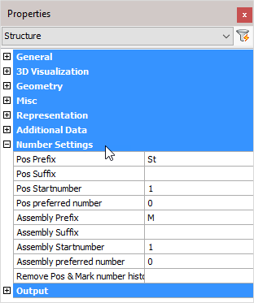
Pos Prefix: Determines the prefix of the position number.
Pos Suffix: Determines the suffix of the position number.
Pos Start number: Determines the start number of the position number.
Pos preferred number: Forces Parabuild to use the preferred number as position number. Parabuild will comply if this number is not already in use by a different part.
Assembly Prefix: Determines the prefix of the assembly/mark number.
Assembly Suffix: Determines the prefix of the assembly/mark number.
Assembly Start number: Determines the start number of the assembly/mark number.
Assembly preferred number: Forces Parabuild to use the preferred number as assembly/mark number. Parabuild will comply if this number is not already in use by a different part.
Remove Pos & Mark number history: Lets Parabuild forget the preferred numbers and also the previous numbers that the part had.
Note! For more information on any of these items, refer to Numbering of elements

Output
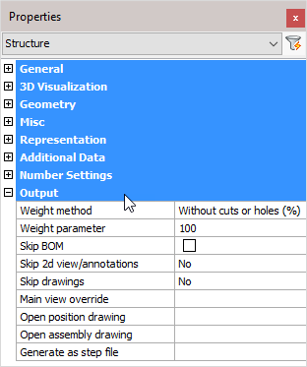
Weight method:
- Without cuts or holes (%): The weight of the complete length of the profile will be calculated, without subtracting the holes and cuts. In the next property you can adjust the percentage of this value that should be used.
- Cut: The cuts in the profiles are subtracted to calculate the weight.
- Cut and drilled: The cuts and the holes are subtracted to calculate the weight
- Fixed value: The value you enter in the next property will be used as the weight for this element in kg or lbs (This value will be taken over in the BOMs without any adjustments).
Weight parameter: This property is being used in combination with the above properties ‘Default’ and ‘Fixed value’
Skip BOM: If this property to ‘Yes’, this element will not appear in the BOMs
Skip 2D view/annotations: Adjust this to skip this element for the 3D annotations or the 3D annotations + 2D view
Skip drawings: You can skip only the Position drawings, only the mark drawings, or both the Position and Mark drawings
Main view override: Select a plane that determines the main view's direction
Open position drawing: Will open the position drawing of the selected part
Open assembly drawing: Will open the assembly/mark drawing of the selected assembly
Generate as a STEP file: STEP file is a CAD file format, usually used to share 3D models between users with different CAD systems. Note! This command will only work in BricsCAD and when the Communicator module is installed and licensed. For more information, refer to Document generation Settings > Generate STEP Files

Array
The 'Array' object type is used for creating and updating arrays of macros. It has the following headings:
General
3D Visualization
Misc

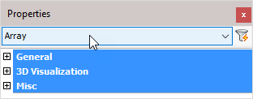

General: Is common to all object types, and covers general AutoCAD and BricsCAD settings, including: Color / Layer / Linetype / Linetype scale / Plot style / Lineweight / Transparency / Hyperlink / Handle /

3D Visualization: Is also common to all object types and includes: Material.
The material that is referred to here is only the visual representation material. For changing the actual material of parts, see the Additional Data section of plates, profiles or structures.

Misc
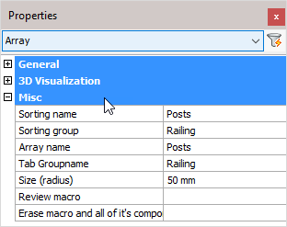
The name of the macro – this may be edited and will reflect in the macro dialog box
Group name:

Sorting name: The macro name to which the array should belong to in the macro edit dialog box
Sorting group: The group name to which the array should belong to in the macro edit dialog box
Array name: The name of this array
Tab Groupname: The name of the tab to which this array should be assigned to in the macro edit dialog box
Size (radius): The size of the triangle shown in the 3D model
Review macro: Will open the macro edit dialog, where the macro may be viewed and/or edited
Erase macro and all of its components: Will erase the array, all of its subject macros and all of the parts owned by these macros

View
The View object type is used in workshop drawings and on GA plans for showing a 2D representation of the 3D model or a part of it.
A view is a collection of 2D lines that are connected to their 3D model counterparts.
The view has the following headings :
General
3D Visualization
Misc
Model appearance
Camera options

General: Is common to all object types, and covers general AutoCAD and BricsCAD settings, including: Color / Layer / Linetype / Linetype scale / Plot style / Lineweight / Transparency / Hyperlink / Handle /

3D Visualization: Is also common to all object types and includes: Material.
The material that is referred to here is only the visual representation material. For changing the actual material of parts, see the Additional Data section of plates, profiles or structures.

Misc
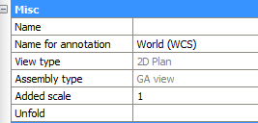
Name - The name view for description purpose
Name for annotation - The short name of the view, as it will be shown in annotations
View type - The main purpose of this type is for Parabuild so that it know whether this is a side view, an endplate view or something else
Assembly type - This relates more to the type of sheet on which the view is located (plate, member, assembly or GA)
Added scale - This scaling property is used to enlarge or shrink the view relative to the sheet scale. The sheet scale is always 0. Setting this to smaller than 1 will shrink the view. Setting it to larger than 1 will enlarge the view.
Dimensions and annotations that are connected to the view will be adapted but not scaled.
Unfold - Clicking on this button will generate an unfold of the part that is displayed by the view.
This button will only work on supported plates/strips. It is supposed to be used on the views of workshop drawings.
This option currently only works when Parabuild is run inside BricsCAD Mechanical.

Model appearance
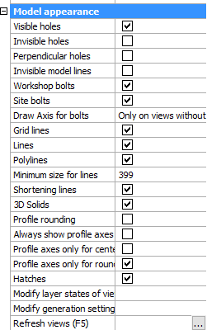
Practically all of the properties in this section are already explained in the topic.
But these 3 properties do need some more explanation :
Modify layer states of view - This button will open up a dialog where you can disable or enable layers. The 3D objects that are on the enabled layers will be shown in the view. All the other 3D objects will be ignored.
Modify generation settings - This is a link to the Modify view Settings dialog of this view
Refresh views - This will refresh this view only. See note.

Note!
After applying a change to any of the properties in the Model appearance section, you will need to refresh the view in order to see the changes on the view.
You can refresh views with any of these 3 methods :
- The function key <F5> will refresh all the sheets that are currently visible on your screen
- The refresh views button of the view itself
- You can right-click on a sheet in the sheets manager to refresh all the views on the sheet

Camera options
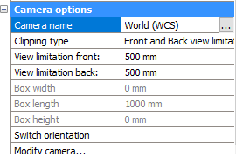
Camera name - Shows the camera name to which this view is currently connected.
Use the button to link the view to a different camera. This can be useful when a view has lost its link to a camera after a delete or a copy/paste operation.
All the other options here refer to the linked camera.
Changing an option here will change the camera to which the view is linked
All of these properties are already explained in the camera topic.

Camera
The camera is used as the driver for views.
It is always located in the 3D model, and determines :
- The viewing direction in 3D
- View clippings
- Additional filters on 3D model selection
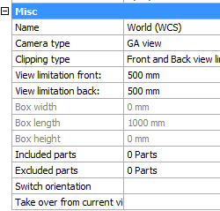
The camera has the following properties :
Name - The name of the camera, as it will be shown in the Sheets Manager
Camera type - This relates more to the type of sheet on which the view is located (plate, member, assembly or GA)
Clipping type - Clipping is used to filter out unwanted 3D models from the view, as they would obstruct the view on the subject models that we want to show on the view.
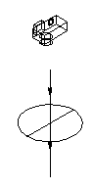 | 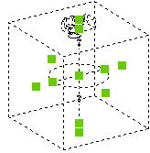
A camera with Front/Back limitation | A camera with Box limitation
View limitation front/back - This will only work the Front/Back clipping type is enabled.
Front limitation is measured from the circle of the camera (see illustration) to the camera symbol. Back limitation is measured from the circle to the opposite side.
Box Width/Length/Height - This will only work the Box clipping type is enabled.
The grip points can be used to stretch the box. The grip points are shown when you select the camera in 3D (they are shown as green squares in the illustration).
Included parts - With this button you can force the view and camera to only show a certain selection set of 3D models on the view.
Excluded parts - With this button you can force the view and camera to never show a certain selection set of 3D models on the view.
Switch orientation - This button will switch the orientation of the camera in 3D.
Take over from current view - This button will rotate the camera as such that it matches the current 3D view you are currently using.

Note!
After applying a change to any of the properties in the camera, you will need to refresh the view in order to see the changes on the view.
You can refresh views with any of these 3 methods :
- The function key <F5> will refresh the visible views on a sheet
- The view has a refresh property button
- You can right-click on a sheet in the sheets manager to refresh all the views on the sheet

Annotation
The 'Annotation' object type has the following headings:
General
3D Visualization
Misc
Text
Frame
Leader
Level
Section Arrow

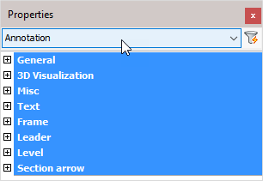

General: Is common to all object types, and covers general AutoCAD and BricsCAD settings, including: Color / Layer / Linetype / Linetype scale / Plot style / Lineweight / Transparency / Hyperlink / Handle /

3D Visualization: Is also common to all object types and includes: Material.
The material that is referred to here is only the visual representation material. For changing the actual material of parts, see the Additional Data section of plates, profiles or structures.

Misc
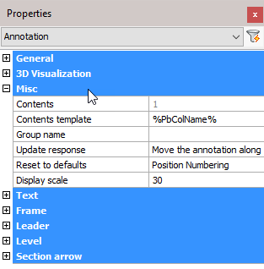
Note! - * indicates that the given value is a resultant of the sum of other values in the panel - and cannot be individually edited.
Contents: * Displays the text string
Contents template: determines the contents template
Group name: Add a group name
Update response: Options include:
Move the annotation along
Stretch the arrow
Reset to defaults: Press the button to open the ‘Reset settings to the default values’ dialog, and choose the annotation style you want to reset from the drop-down menu
Display scale: Set the annotation scale

Text
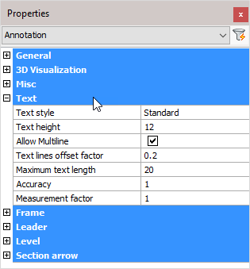
Text style: Set the text style
Text height: Set the text height
Allow Multi line: Activate the checkbox to allow multi line text
Text lines offset factor: Change the masking around the text – the value given is a percentage of the text height
Maximum text length: Set the maximum text length
Accuracy: Set the numerical text accuracy factor
Measurement factor: Set the numerical text measurement factor

Frame (If applicable)
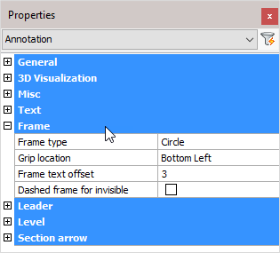
Frame type: Select the frame type from the drop-down menu
Grip location: Select the grip location from the drop-down menu
Frame text offset: Reset the offset (Padding) between the text and frame (mm)
Dashed frame for invisible: Activating the checkbox will make the frame invisible

Leader (If applicable)
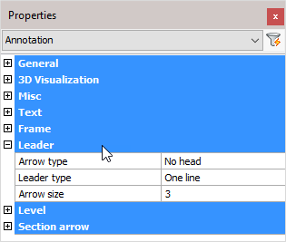
Arrow type: Select the Arrow type from the drop-down menu
Leader type: Select the Leader type from the drop-down menu
Arrow size: Set the arrow size (mm)

Level
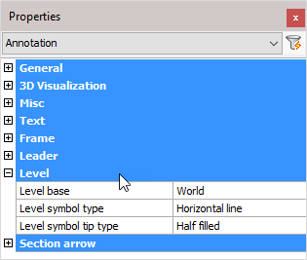
Level base: Enter the base level (datum) – all levels are measured from this value
Level symbol type: Select Level symbol type from the drop-down menu
Level symbol tip type: Select Level symbol tip type from the drop-down menu

Section arrow
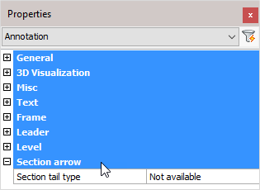

Section tail type: Select Tail type from the drop-down menu

3D Weld
The 3D weld object has the following property categories:
Arrow side / back side
Miscellaneous

Arrow side / Back side

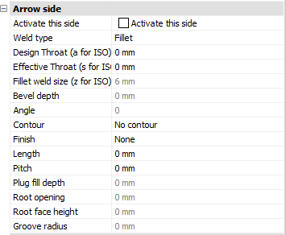
Both sides of the weld tag have the same properties, so they are listed just once.
Activate this side - When this side is active, the weld will be drawn on this side of the material.

Weld type - These are all the available weld types. Not all have 3D volume representations:
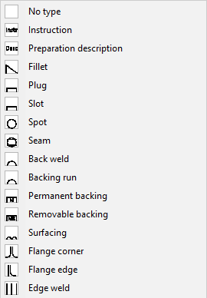 | 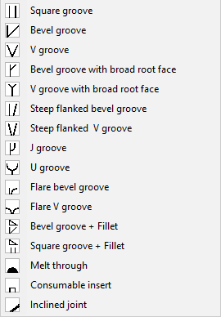

Design throat (a for ISO) - This option only applies to Tee joints. It is the distance from root edge to the weld surface.
Design throat is the same as nominal throat size (a for ISO).
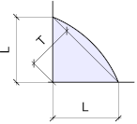
The design throat size is T on this illustration

Effective throat (s for ISO) - The effective throat is only a setting that is stored and shown in the weld symbol and/or reports. Parabuild does not use this value during the modeling process.
Fillet weld size (z for ISO) - This size only applies to fillet welds. In skewed joints this is not the same as the leg length. Measurement is similar to the use of a fillet gauge:
 | 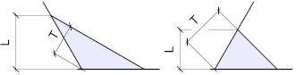
L on this image is the weld size for a square joint (it is the same as the leg size in this case) | L on this image is the weld size for skewed joints (obtuse and acute)

Bevel depth - This option only works on these weld types : Bevel grooves, V Grooves, J Grooves, U grooves and Bevel Groove with Fillet.
The default is to set the bevel depth, but you can also set the bevel depth to 0 and then set the Root face height instead. Then Parabuild will use the Root face height size to calculate the bevel depth automatically.
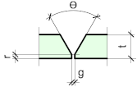 | 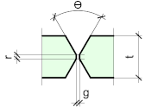
Bevel depth is t-r in this single V weld | Bevel depth is (t-r)/2in this double V weld

Angle - For groove welds, this is the groove angle.
For plug welds, this is the countersunk angle.
Contour - The contour can be flush, convex or concave :
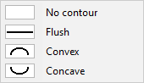
Finish - The finish option is only available when the AWS standard was chosen as the standard for the weld.
These finishing types are available :
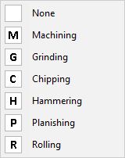
Length - This option will only work when the Length type property was set. When the length is not set, the weld length will be the distance between 'abrupt ends' of the weld edge.
Pitch - For AWS : This is the center-to-center spacing of welds for intermittent welds
For ISO : This is the offset spacing between welds for intermittent welds
Plug fill depth - This option only works on slot and plug welds. It is the depth of the weld material that should be filled in the slot.
Root opening - The root gap is not set by the 3D weld itself. It is retrieved from the parts that are to be welded together.
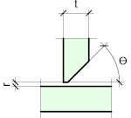
'r' is the root gap in this tee joint | 'g' is the root gap in this butt joint
Root face height - The is also called the 'landing'. It is the height of the face that is at the narrowest part between the welded elements. It is not drawn on the weld annotation and is only for reporting, weldprep, etc...
This value can also be extracted from the bevel depth. The default is to set the bevel depth, but you can also set the bevel depth to 0 and then set the Root face height here. Then Parabuild will use this size to calculate the bevel depth.
'r' is the root face height in this single V weld | 'r' is the root face height in this double V weld

Groove radius - This is the root radius and only applies to J-Groove and U-Groove welds.

Miscellaneous
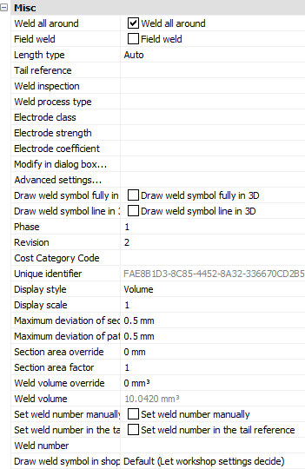
Weld all around - When you enable this property, then the weld all around symbol will be shown on the weld annotation on the shop drawing.
If you enable this option on a 3D weld, then the welded segments will be expanded automatically to make the weld all-around :
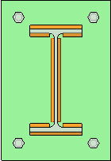 | 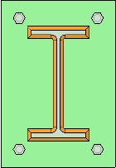
A weld with Weld all around disabled | A weld with Weld all around enabled

Field weld - This setting determines if the weld is a site or shop weld.
Length type - By default, the weld length is automatically determined. But you can enable a fixed weld length, an intermittent weld or a staggered weld here.
Tail reference - The text to be shown in the tail of the weld symbol
Weld inspection, Weld process type, Electrode class, Electrode strength, Electrode coefficient - These are information fields about the weld for tracing and to show in reports.
Modify in dialog box - This will open the weld in a dialog box that visually represents the weld symbol
Advanced settings - This will open the advanced visual settings for the weld, which are text height, arrow size, tail size, etc...
Draw weld symbol fully in 3D - Adds the full weld symbol to the 3D representation
Draw weld symbol line in 3D - Adds a weld line and type symbol to the 3D representation of the weld
Phase - The phase in which this weld needs to be produced
Revision - The revision of the weld - currently not in use
Cost Category code - These codes are usually determined while a quote for the project is made. This code can then later be assigned to the 3D model when the project was ordered. This way the parts can be traced from estimation to production and to completion inside ERP/MIS software.
Unique identifier - Each weld object will receive a unique number during numbering, this number can be used to track welds.
Display style - Choose one of the display styles for the 3D weld : None, Axis, Wireframe or Volume. Axis or none is the least taxing on computer resources, volume will be the most taxing for large projects.
Display scale - When the weld symbol is also drawn in 3D (see 6 properties higher), then this display scale will determine the size of the weld symbol.
Maximum deviation for section - Curved geometries are therefore drawn segmented to reduce graphics overhead. Enlarging this number will decrease the accuracy of the drawn weld but may result in faster graphics for large projects.
Maximum deviation for path - Curved geometries are therefore drawn segmented to reduce graphics overhead. Enlarging this number will decrease the accuracy of the drawn weld but may result in faster graphics for large projects.
Section area override - Enter a value here if you want to specify a different section area for the weld than the one calculated by Parabuild. The section area influences the weld volume and weight calculations.
Section area factor - Allows you to increase or decrease the section area calculated by Parabuild. Enter for example 2 if you want to double it, or 0.5 if you want to halve the calculated area. The section area influences the weld volume and weight calculations.
Weld volume override - Enter a value here if you want to specify a different volume than the one calculated by Parabuild. This may be useful for weld types that have no 3D representation.
Weld volume - The weld volume as calculated by Parabuild.
Set weld number manually - To specify the number manually instead of having it automatically assigned by weld numbering
Set weld number in the tail reference - This will cause the weld number to be displayed in the tail of the weld symbol
Weld number - This field can be filled automatically by the Number welds command
Draw weld symbol in shop drawing - This property will determine whether this weld will get a weld symbol drawn for it in the assembly shop drawing.
It has the following options :
  - Default (Let workshop settings decide) - The workshop drawing settings will determine whether this weld receives a weld symbol You can learn more about these settings in the Weld symbols on shop drawings topic
  - Never skip, regardless of workshop settings - The workshop drawing settings will be ignored for this weld
  - Always skip - The weld will never receive a weld symbol in the shop drawing

Main - Library
This chapter covers the commands in the Main Library toolbar, and includes:
- Draw Profiles
  - Editing the Profile Libraries
- Custom Shapes
- Elements Library

Draw Profiles
These are all the different section shapes that can be used to draw profiles :
I - Profiles
C - Profiles (Channels)
L - Profiles (Angles)
T - Profiles (Tees)
Built-Up Profiles (Plate Girders)
Hollow Sections ( Circular, Square, Rectangular)
Flats / Bars / Rounds
Cold Formed Profiles(Purlins and Side-Rails)
Floors (Plate and Grating)
Others
Custom Shapes - User Defined
Elements Library
Plate with PolyLine , Lowering a Member, Corrugated Sheet Sections, Miscellaneous, Add to Elements Library, Add to Custom Shapes Library
Selecting any of the above will bring up the Select profile dialog, but based on the icon that you selected a different tab will be pre-selected.

There are 3 ways to draw profiles in Parabuild :
- On model line with this dialog - Simply select all of the model lines on which you want to draw profiles.
With the model line option, profiles can be drawn on the following line types:
  - Line
  - Arc
  - 2D PolyLine
  - 3D PolyLine
  - Spline
  - Parabuild helix - Command : PrB_Helix
  - Parabuild 3D polyline, which has a bit more flexibility with regards to arcs in 3D than the AutoCAD/BricsCAD 3D polyline. Command : PrB_3dPoly
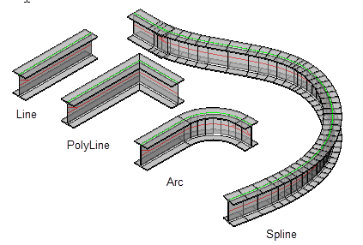
Note that Polylines, Arcs, and Splines should be 'open-ended'. This command will not work with circles or rectangles. Also the model lines should never be self-intersecting.
- Choose 2 points with this dialog - The user is prompted for the first and second points, after which the above dialog and options are displayed. The points may be placed anywhere on the drawing.
- Alternatively, using a different tool entirely called the Context Modeler

Select Profile
We will explore all of the options in this dialog :
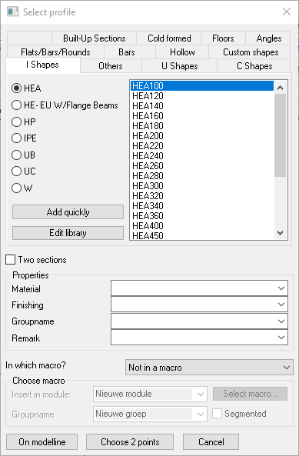

The top of this dialog lists the profile Groups, which correspond with the toolbar icons.
The left side column lists the Types contained within the specified group - the radio button, when activated, will display the available sections of the specified type.

There are options to add to, or edit the library. See Editing the Profile Library
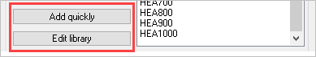

Morph 2 Sections
With the Two sections checkbox checked, you may morph 2 Profile sections.
To do this, you must begin by drawing the profile the normal way - once the selected profile has been drawn, the Profile placement dialog will appear enabling you to enter the second profile.
A prerequisite for this function is that the two sections have the same number of segments. Otherwise, a logical sequence cannot be created; The transition is being made from segment to segment (a segment is a section of straight line or curve section of a PolyLine)

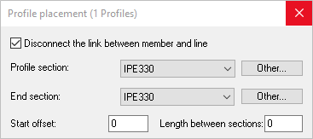

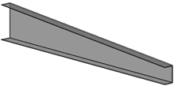

Profile Properties
Below the profile section you may enter 4 properties that the new profiles will receive. To avoid typing these values each time, they may be entered as standards by using the Parabuild settings > Global tab
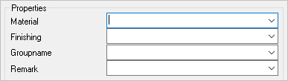

Add new profiles to a macro
These settings are relevant if you wish to add the new profiles to a macro. This is useful if you wish that the profile stays dependent on the model line with which it was drawn. If the model line changes, the profile will modify automatically. It is the macro that keeps the link between the line and the profile intact.
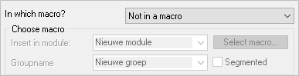

After the profile is drawn, the following dialog will appear, offering the following options:
Profile placement
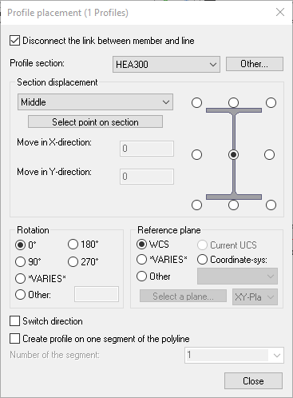
- Disconnect the link between the member and line - With the checkbox Unchecked, the profile will be constrained to the line. That is to say, the member cannot be moved independently of the line. See Constrained Profiles
With the checkbox activated, the member may be moved independently of the line - but only after closing this dialog, at which time the disconnect will happen.
- With the Profile section DropDown menu, the user is able to change the profile section - while selecting Other, the user is able to select a profile from another group.
- The Section displacement enables the user to select the appropriate displacement point on the member, this may be done by activating the appropriate radio button, or selecting an option from the drop-down menu.
- It is possible to match the rotation of the member to another part by manually selecting a reference plane
- The Current UCS option allows you to let the profile follow the current UCS's inclination.
To make this feature possible, Parabuild draws a new coordinate system object on the current UCS location.
The macro will link the profile(s) rotation to this coordinate system. The coordinate system object should only be deleted when the macro that links the 2 objects is deleted, otherwise the profile placement rules inside the macro are broken.
- With the checkbox 'Switch direction' activated, the user is able to switch the direction of the member on its axis.
- With the checkbox 'Create profile on one segment of the PolyLine, the user is able to select the applicable segment.
- Use the Select point on section button to choose an endpoint or midpoint on the section directly :
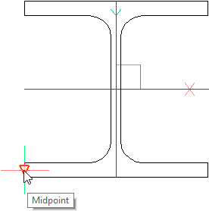
This method is based on the segment number of the section.
So when you change the size of the section from HEA200 to IPE300, the displacement stays valid and will be updated for the section's new sizes.
However when a new section is chosen with a different shape, then the segment number will point towards a different edge. This will happen when you change an I shape to a channel shape, for example.

Editing the Profile Library
Add a Profile to the Profile Library
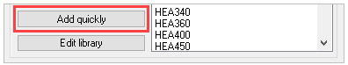
The Add quickly button will add a new profile to the active Value Table.
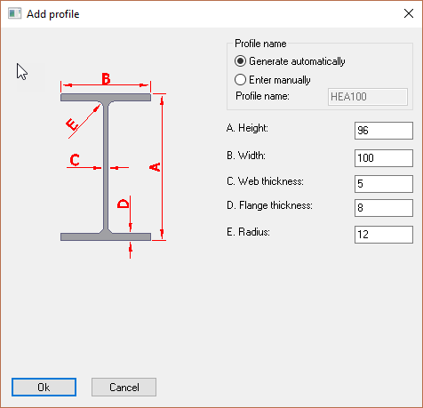

Profile name
The options are to Generate automatically or Enter manually.
Selecting 'Generate automatically' will automatically add the Type to the profile i.e. IPE. In this mode the Profile name window will be grayed out.
Selecting 'Enter manually' will allow the user to change the profile name manually.
By adding the relevant dimensions the new profile will be added to the active Value table.

Edit the Profile Library
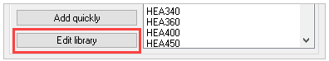
Selecting this tool will bring up the Edit profile library dialog. At the top left of the dialog there are 2 tabs: Overview and Value tables
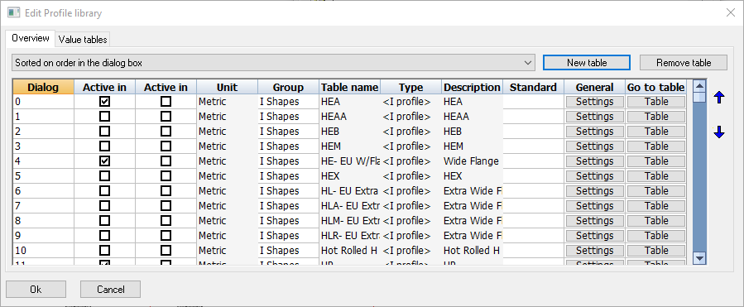

Overview tab
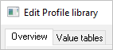
Selecting the Overview tab will show a table, wherein each row represents a profile table.
The purpose of each columns are explained below:
- Dialog priority - which establishes the order of the profile table in the Draw profiles dialog box. The lower the is value, the higher it will be listed in the Select profile dialog box.
- Active in Metric - If you are working on a Metric 3D drawing and this checkbox is activated, then this profile table which will become visible in the Select Profile dialog.
- Active in Imperial - If you are working on a Imperial 3D drawing and this checkbox is activated, then this profile table which will become visible in the Select Profile dialog.
- Units - Indicates whether the contents of the profiles table is in millimeters or in inches
- Group name - Indicates which Group the row belongs to. Each group name represents a tab in the Select profile dialog box
- Table name - The table filename this profile group is linked to. You can find this filename in the folder : \Parabuild\Pb_Lib\Prof\
- Type - Refers to the section type that the profile table is using
- Description - Provides a description of the profile. This description is the name of the table as it is shown in the Select profile dialog box.
- Standard - Describes the international standards for the selected profile table
- General settings - Will bring up the Section Table Options dialog, whereby the user may modify general settings of the profile table.
- Go to Table - will take the user to the Value tables tab dialog, where all the contents and options of the table can be modified. See below.

Value tables tab
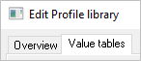
The Value tables will vary according to the profile Type, however, the first 4 columns are consistent for all Types:
- File name - is the file name for the table which has the suffix .pr which is stored in the folder : c:\parabuild\Pb_Lib\Prof\
- Sysname - The system name of the profile that Parabuild needs internally for the unique recognition of the profile. The value must not be one already used by another profile in the table. The prefix (name of the table) is put before this text to obtain the complete system name. This system name is usually not used in the bills of materials or dialog boxes: Parabuild uses this name internally only. This system name is required because Parabuild needs to have a unique name that is independent of the name of the profile in other languages.
- I/O - You can deactivate the individual profile so that it becomes invisible in the Select profile dialog box without having to remove it. Parabuild will nevertheless recognize the profile if it was drawn in a drawing. Therefore if you deactivate the profile here it only has influence on the Select profile dialog box.
- Name - The name of the profile that Parabuild uses everywhere for identification (dialog boxes, bill of materials, shop drawings …)
All columns that follow hereafter are columns that define the dimensions of the profile (height, width, thickness,…). These columns can differ depending on the type of section that was chosen for the table.

Section table options
With the More options button on the Value tables tab, we can access more advanced options of the current table :
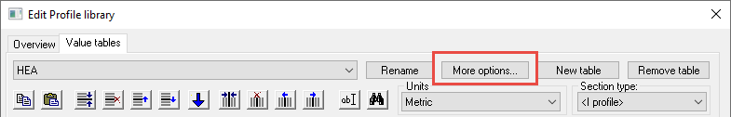

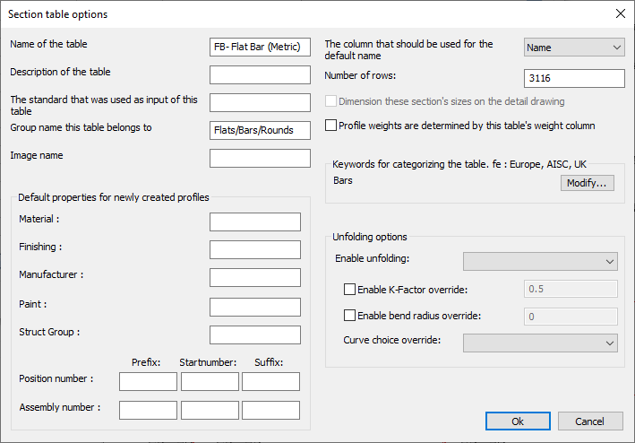

We will explore all of the options in this dialog box :
Name of the table - This is the name of the table as it should appear in the profile selection dialog box :
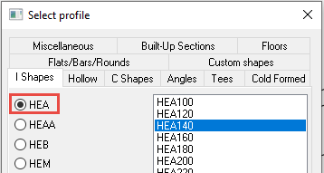
Description of the table - Use this to give a more full description of the table (this text is currently not shown in any other dialog boxes)
The standard that was used as input for this table - This text is currently not shown in any other dialog boxes)
Group name this table belongs to - This text string will determine in which tab the table will appear in the profile selection dialog box :
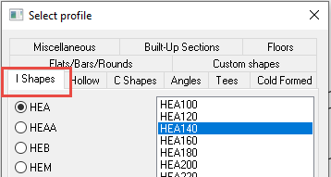
Use the English group names that are already in use.
Translation of this text to other languages is done at run-time using Automatic Text Translation.
Enter a new groupname only in case you want to create a new tab in the profile selection dialog box.
Image name - Currently not implemented
The column that should be used for the default name - Select the column here that should be used for the name of the sections inside the Bill of materials and shop drawings. This is especially important when the same section can have a different name in other languages.
Number of rows - Use this setting to quickly add or remove many rows at once
Profile weights are determined by this table's weight column - When enabled, Parabuild will use the weight column in this table to determine the part's weight. When disabled, Parabuild will use the geometric area of the section in combination with the material to calculate the part's weight.
Keywords - Enter keywords here that are related to the table, such as AISC or Europe. The Library Localization tool uses the keywords to allow the user to quickly enable section shapes that have a certain topic or that are for a certain area.
Default properties for newly created profiles - When any of these values are used, the new profiles that are drawn with this table will automatically receive the properties. A practical example for use of this feature is grating : all Grating panels will receive the part number prefix GRTG because it was set in the Grating tables.

Unfolding options
The section tables is usually the best location to activate the unfolding of parts.
The section table settings can be overridden in the Advanced properties of each individual part though.
This is a breakdown of all the unfolding options in the section table :
Enable unfolding - This dropdown has the following choices :
  - Disable folding - Use this option if you don't want the unfold operation to be activated on profiles drawn with this section table
  - Enable unfolding - Use this option if you want the unfold operation to be activated on profiles drawn with this section table
Enable K-Factor override - Enter a value here if you want to specify a specific K-Factor for this section table
Enable default bend radius override - Enter a value here if you want to specify a bend radius for this section table. This bend radius will only be used on sharp edges.
Curve choice override - When unfolding, the bends are not only neutralized from the part, but also the part is flattened to a 2D plate. As a consequence, there are multiple ways in which the flattening can be done. These are the available options for the flattening :
  - Minimum material - Always assume the minimum amount of material
  - Maximum material - Always assume the maximum amount of material
The difference between minimum and maximum material is most easily explained with an example :
A. is the part being flattened to 2D
B. is the resulting plate after choosing the minimum material option.
C. is the resulting plate after choosing the maximum material option.
  - Top surface of the unfolded part - Always assume the top surface of the part
  - Bottom surface of the unfolded part - Always assume the bottom surface of the part

Floors
Command - Prb_CreateProfFloors
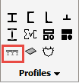
Activating this command will open the Select profile dialog - where you will be prompted to select a flooring profile.
Floor types are divided into 4 groups:
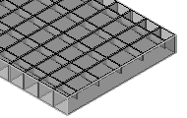 | 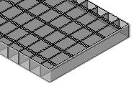 | 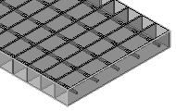 | 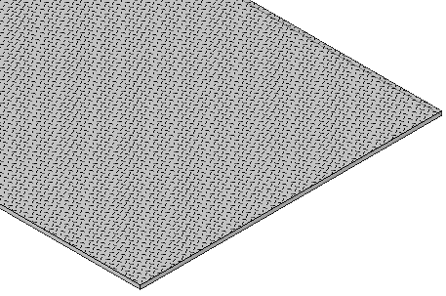
Press Lock Bar Grating | Welded Bar Grating | Swage Lock bar Grating | Raised Pattern Floor Plates

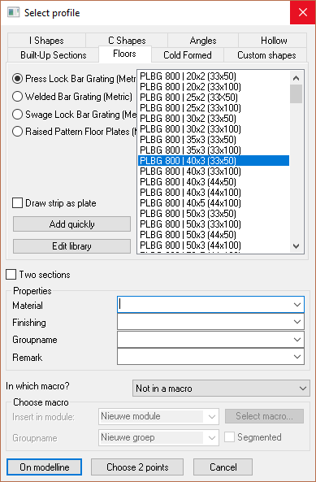

From this dialog you may select the required flooring type by selecting the appropriate radio button - the column to the right will display the value tables applicable to the selected floor type.
The value table will display the floor panel characteristics which may be interpreted thus:
PLBG 800 | 40x3 (33x50)
PLBG = Floor panel type - in this instance, Press Lock Bar Grating
800 = Standard panel width
40x3 = The bearing bar size
(33x50) = the grating opening size. 33 = the bearing bar centers, while the 50 = the transversal bar spacing
Draw Strip as plate - activating this checkbox will draw the floor panel as a plate (see Convert strip / plate)
Adding and Editing floor panels in the library
Custom Floor panels may be added to the library by clicking the Add quickly button in the Select Profile dialog which will open the Add profile dialog
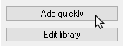
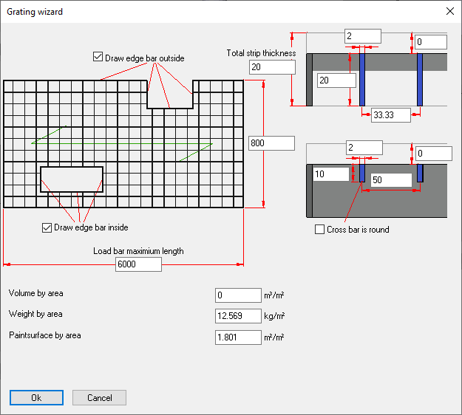

This function will add a new profile to the active Value Table.

Edit Library
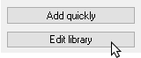
This function will open the Edit profile library dialog where the properties of specific floor panels may be edited.
For more information on editing the library, you can read the Editing the profile library topic.

Custom Shapes
Command - Prb_CustomProf
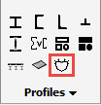
Custom shapes are user-defined shapes which are not contained within the standard profiles library.
Activating this command will bring up the Select profile dialog with the Custom shapes tab open.
Select the profile by selecting the title or the icon - the profile is drawn in the same manner as all profiles.
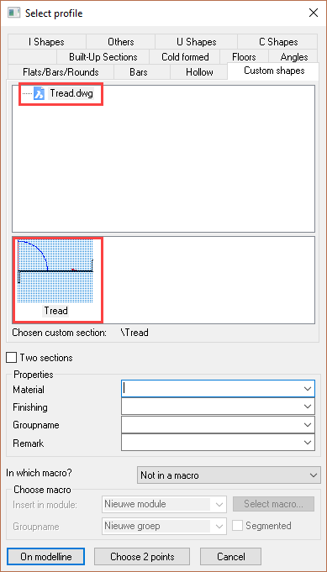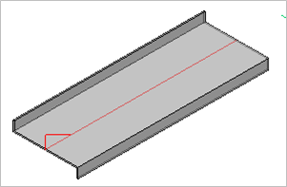
New custom shapes can be added using the Create new custom shape command.

Elements Library
This system is similar to Custom shapes
There is a command to add new elements to the library, and a command to extract an element from the library and add it to the current drawing.

Creating a new library element
Command : PrB_NewElementLib
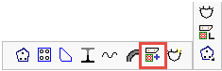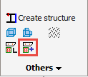
First take a good (3D) view, and zoom in, A small preview will be captured using this view.
Start the command to create a new library element.
Select the location in the dialog window and the name of the new library element and click on Ok.
Now give the insertion point that will be used later to insert the profile into the drawing.
The elements to be added to the library may now be selected. These can be any types of elements: plates, profiles, bolts, structures, lines, texts, dimensions, solids, ...

Adding a library element to the current drawing
Command : PrB_ElementLib
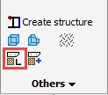
To use this tool, simply select the element to be inserted.
If the elements are to be inserted into the drawing as separate normal elements, then select Insert as regular elements at the bottom
If the elements are to be added to the drawing as one structure, then select Insert as one structure. The structure will be given the name of the library-element. You can find more information about Structures in the Structures topic.

Plate with PolyLine
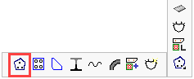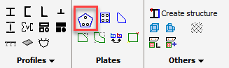
The PolyLine must at least have 3 vertices, i.e. a Square, Rectangle, Triangle. An exception to this is a circle, which is also allowed.
- At the command prompt, indicate the PolyLine shape and press <Enter>
- At the command line prompt enter the plate thickness, press <Enter>
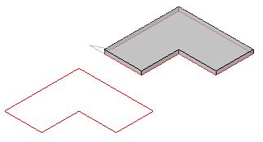

Lowering a Member
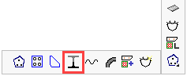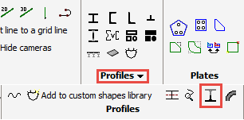
This command will create a Tee section from a standard profile.
Starting this command will bring up the Lowering dialog where the appropriate icon should be selected
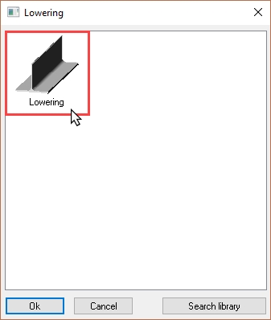

Selecting the profile top-flange will trim the lower half of the profile, while selecting the bottom flange will trim the upper half.
By default, the profile will be trimmed at the vertical center on the profile. By editing the zero value on the customization dialog the profile web will be modified accordingly.
A plus value will shorten the web, while a negative value will lengthen the web
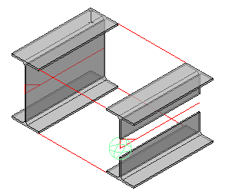 | 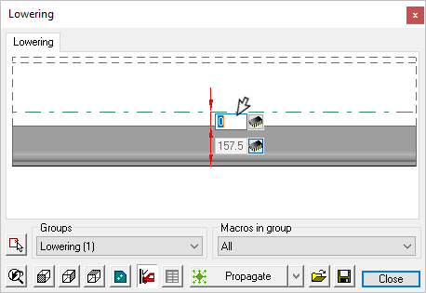

Corrugated Sheet Sections
Command - Prb_Wave
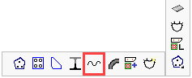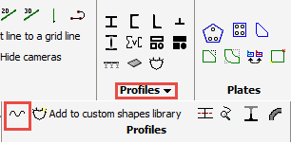
This command will draw the section of Sandwich panels or corrugated sheet metal sections as one PolyLine. This PolyLine can be used as a section to draw a profile. You can choose between 3 types of sections with help from the illustrations. The first wave, the last wave and the repeating wave in the middle.
If you want to create more waves, you have to use the option Advanced wave patterns.
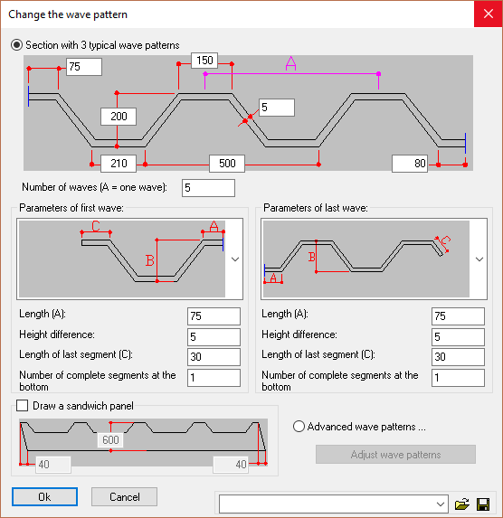

Miscellaneous
Command - (Prb_MacroGroup "Misc")
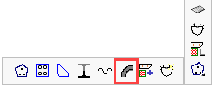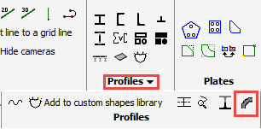
This command offers 2 options:
- Arc
- Perforated Plate

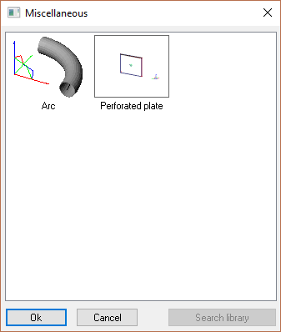

Arc
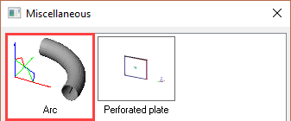

This command will 'bend' any profile or section through a prescribed radius and angle
On selecting the 'Arc' icon, you will be prompted to 'Select the point that will determine the placement'. this point will be the center-line intersection of the radius. After selection, the default profile will be drawn with the following customization dialog:
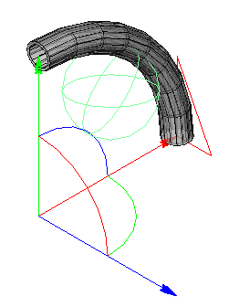 | 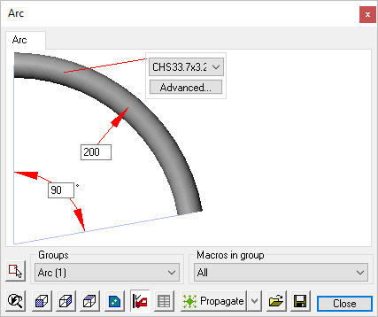
Here you may modify the profile size - or a completely new profile may be selected using the 'Advanced' tab
You may also modify the bend radius and segment angle.
The changes made in the customization dialog will be immediately be shown on screen.

Perforated Plate
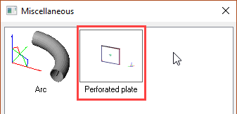

Add to Elements Library
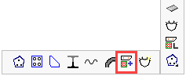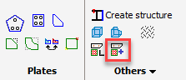
For more information, see the Elements Library topic.

Add to Custom Shapes Library
Command - Prb_NewCustomProf
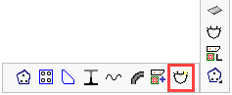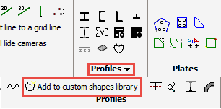
Customized sections are sections the dimensions of which can be determined by the user.
If the normal profile-section library does not support a desired shape or section, it can be drawn by the user, given a name and added to the library for general use in all projects.

Creating a new custom shape
First, draw the cross section with polylines.
Make sure that you draw these polylines on the XY plane of the world coordinate system of the drawing. The profile will not be drawn later on if the polyline is positioned 'upright' in the Z direction.
Multiple polylines may be drawn if necessary! For example, a round tube requires two PolyLines because the two circles do no touch.
For this example we have drawn a simple solid stair tread-plate
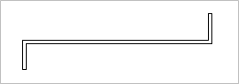
- Choose a frontal view of the cross section, and zoom in on it. A small preview will be captured using this view.
- Start the command to add a customized section
- On the left-hand side, select the name for the new customized profile - press <Enter>
This will store the profile in the folder c:\Parabuild\Pb_Lib\User_Sections\
If sub folders are to be created or deleted in this folder, then you can do so in the directory c:\Parabuild\Pb_Lib\User Sections\... using Windows Explorer.
(if c:\Parabuild is the installation directory).
This folder contains the contents and representation of the dialog window in Parabuild. Any folder created within this folder in Windows Explorer, will subsequently appear in the dialog window for creation and using of custom section shapes.
The name of the custom shape that you enter here will be used in the library and as the profile name for all Parabuild functions (part lists, workshop drawings...) when the 3D profile is drawn.

Main - 3D Modeling
This chapter covers the commands for 3D Modeling, and includes the following Sub-Chapters:

- Draw Profiles
- Context Modeling
- Views and Visibility
- General - Grids
- Model Lines
- Constrained Profiles
- Bolts / Holes
- Bolt Standards
- Cutting
- Modify Profiles and Plates
- Tools
- Stairs
- Review Macro
- Erase Macro
- Modify Macros
- Connections
- Bracing
- Trusses
- Framework
- Pre-engineered buildings (PEB)

Context Modeling
Command - PrB_ContextModeler
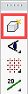
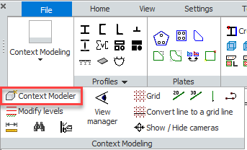
The Context Modeler is unique to Parabuild - It allows you to create a complete accurate skeletal structure, simply and intuitively from the commands contained within the modeler.
Activating this command will open the Context modeler dialog, which will remain open, or may be docked to the side of the working area for the duration of the work session. It may be closed at any time by clicking the button.
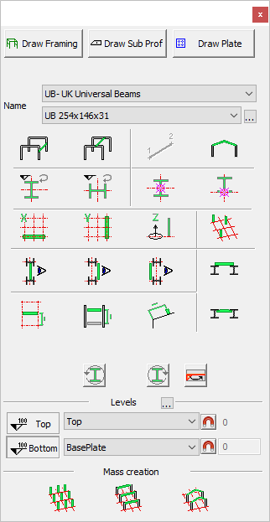

This dialog covers 5 main modeling operations:
- At the top are the three action buttons and include:
- Draw Framing
- Draw Sub Profiles
- Draw Plate
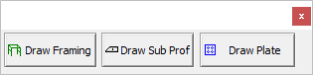

- Below are the Selection options - where you may select profiles from the Profile Libraries
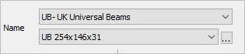
The Top drop-down will show the section types which have been activated in the Profile Library
The second drop-down will provide the options available within the selected section type.
The button to the right, when clicked, will open the Draw Profiles dialog - from where you may select any profiles from all the groups.
3. Next are the Context Buttons which offer a set of limitations and impositions so that you can more easily draw the type of profile that you need
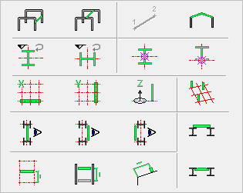
4. The Rotate Profile buttons can rotate the section of a profile through 90 °. As an alternative for these buttons in the dialog box, you can also use the keyboard Arrow left and Arrow right buttons to change the rotation.
You can also switch the start and end of the profile.
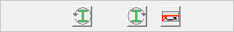
5. Using the Context Modeler, it's possible to set and establish Levels
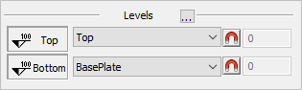
6. The last section on the dialog is for Mass Creation where you are able to draw a range of profiles of the same type
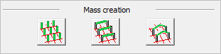

Some other keys that are available :
<Space>: When pressed, searching for solutions is temporarily suspended. The last element will remain on the screen. You can now freely move the cursor without changing the element, and you can also adjust the element using the arrow keys. Then press <Enter> to draw the element, or return to finding other solutions by pressing <SpaceBar> again.
Left Mouse Button: Draw the element that is currently visible
Right Mouse Button or <Escape>: Cancels the command without drawing the last element

Draw Framing
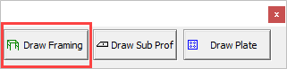
With the Draw Framing action button you can draw columns, beams and rafters. Additionally, you can also draw side rails, purlins, joists and all longer profiles of your structure.

The profiles that you draw are based on :
- Grid lines
- Levels
- Other profiles that already exist in the drawing
- The World coordinate system (in case there are no grid lines)
Drawing profiles will become easier when using the functions offered by the Context Buttons
Before drawing the skeletal frame, it is recommended but not obliged to first:
- Establish a Grid
- Establish Levels
This is so that you may take advantage of the View manager functions and importantly, when planning and preparing 2D views in the General Arrangement drawings.
An additional advantage will be the relations between the members, the grids and the levels. The context modeler will create the relations between them automatically and later when you modify the grid or a level, the profiles will follow suit.
Drawing Columns
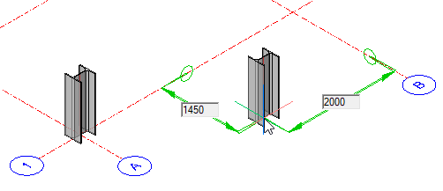
Ensuring that the levels are set as required, select a profile from the Selection options and press Draw framing - the column will be attached to the mouse pointer which may be placed anywhere on the model relative to the grid lines. When placing the column on a grid line, its orientation may be changed by moving the mouse pointer along either the X or Y axis - when satisfied with the orientation, press the left mouse button to accept. You may continue adding columns - but the selected orientation will remain. Terminate the operation by either clicking the right mouse button, or pressing <Enter>
When placing columns off grid lines, Parabuild will automatically recognize the closest grid intersection, and any offsets will be indicated by editable dimension boxes.
If there are no grid lines, the column will be placed relative to the WCS
Once the column has been placed it is effectively constrained to the placement point and cannot be moved with the AutoCAD/BricsCAD move command. To move or modify that point, it's necessary to edit the constraints.
Alternatively, one can use the Advanced property of the profile to disconnect the profile from it's macro, so that manually moving the profile becomes possible.

Modifying Constraints
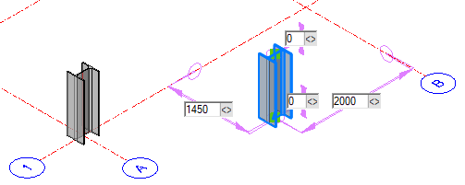
Clicking on the column will reveal the editable constraints - the relative points include dimensions on the X, Y, and Z axes. Here you may enter different values which will immediately be reflected on the model.
Alternatively, you may edit the constraints by using the drag constraint function
Activating this function you will be prompted to: Move the mouse to modify the constraint, then left-click to accept:
Once complete, click the right mouse button or press <Enter>
Double-clicking the column will open the AutoConstrain dialog. Here you are presented with more options for editing the constraints, which include the offsets listed above, but in tabular form, and additionally:
- Section - Where you may choose another profile from the group by selecting from the drop-down menu
- Other - Will open the Select profile dialog where you may select a different group and profile
- Placement point - Where you may select a new placement point from the drop-down menu - alternatively you may select Advanced.
- Advanced - Which will open the Profile Placement dialog
- Rotation - Where you may change the profile rotation
- Reference plane - Where you may select the reference plane
- Choose plane - Where you are prompted to select a reference plane to match the section rotation to another part

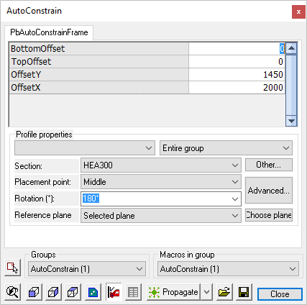

Draw Sub-Profiles
With the Draw Sub Prof button you can draw smaller profiles. These profiles will be attached to existing profiles or plates on the drawing.
This button shares the dialog with Draw Plate - the relevant buttons for this command are highlighted below
- Select the section profile and length
- Move the mouse cursor to a part on the drawing to which the profile is to be attached
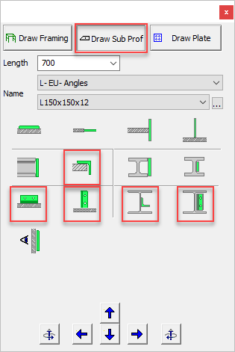

While drawing smaller profiles:
With these buttons you can rotate the element in all directions.
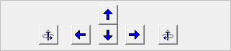
The rotate buttons will rotate the element on it's base surface (the base surface is the plane to which the element was oriented)
TIP : Use the arrows and <Page Up/Down> keys on the keyboard to quickly access these functions without having to move the cursor to the window!

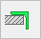 | 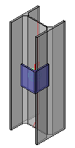 | 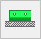 | 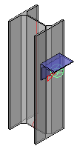 | 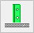 | 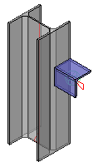 | 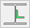 | 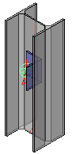 | 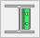 | 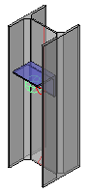
The Inside of the new section is attached |  | The new section is attached at the side |  | The new section is attached at the end |  | The new part axis is parallel to the base part axis |  | The new part axis is perpendicular to the base part axis
At any time after the sub-profile is drawn, it's constraints may be edited by either:
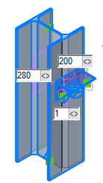
- Selecting the part which will reveal the constraint dimensions which may be edited to suit requirements. When the context modeler dialog is closed, these constraints will not be shown.
- Double clicking the part to open the Auto Constrain dialog
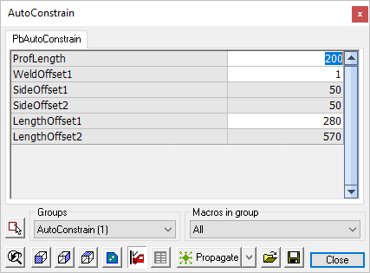

Draw Plates
With the Draw Plate button you can draw plates which will be attached to existing sections or plates on the drawing.
This button shares the dialog with Draw Sub-Profiles - the relevant buttons for this command are highlighted below
- Select the plate size and length
- Move the mouse cursor to a part on the drawing to which the profile is to be attached
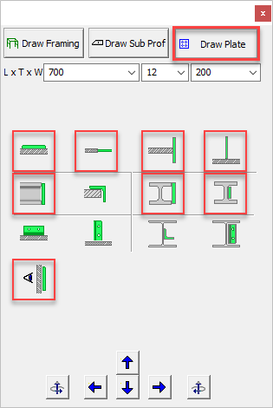

While drawing smaller plates:
With these buttons you can rotate the element in all directions.
The rotate buttons will rotate the element on it's base surface (the base surface is the plane to which the element was oriented)
TIP : Use the arrows and <Page Up/Down> keys on the keyboard to quickly access these functions without having to move the cursor to the window!

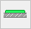 | 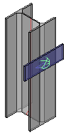 |  | 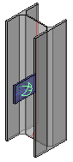 | 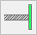 | 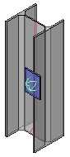 | 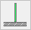 | 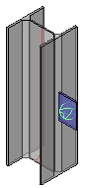 | 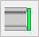 | 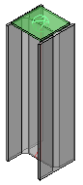
Plate faces touching |  | Plate sides touching |  | New plate face touches base plate side |  | New plate side touches base plate face |  | Attach plate to the end of a member
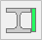 | 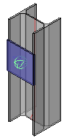 |  | 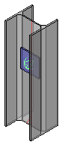 | 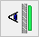 | 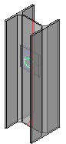
The new part attached to the flanges of a member |  | The new part's face is attached to the web of a member |  | The new part is located on the back side of the base part

At any time after the plate is drawn, its constraints may be edited by either:
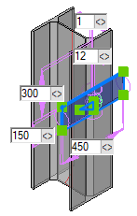
- Selecting the part which will reveal the constraint dimensions which may be edited to suit requirements. When the context modeler dialog is closed, these constraints will not be shown.
- Double clicking the part to open the Auto Constrain dialog
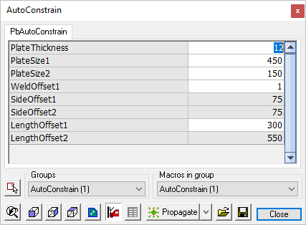

Draw welds
The Context Modeler has a button 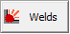 that allows you to quickly draw a weld with a single mouse-click
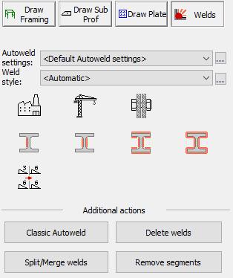

After selecting the Welds options in the context modeler, one only needs to point the cursor to a joint.
The context modeler will show the weld that could be drawn at that location.
By clicking on the left-mouse button, the weld will be drawn.
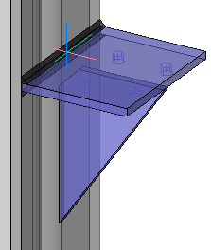 | 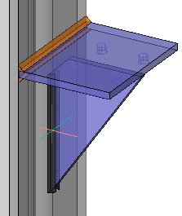
As you move the mouse around, welds are proposed at that location. | The resulting weld after clicking the left mouse-button. New welds will be put on the Welds layer, which is orange by default.

Disclaimer
Welds created automatically will get sizes that may not sufficiently account for loads and stresses. All welds should be checked versus engineer specifications.

Influencing what welds are proposed
There are several options in the dialog that determine which weld is drawn by the context modeler :

- AutoWeld settings - Choose which AutoWeld settings should be used for the welds drawn by context modeler
The context modeler uses the same technique as the AutoWeld to determine the weld type and size that should be drawn at any given location.
Use any of the following options to choose a different AutoWeld configuration :
  - <Default AutoWeld settings> - The default AutoWeld settings that are loaded when Parabuild starts are used. The default AutoWeld settings can be stored in the AutoWeld settings dialog box
  - All of the saved AutoWeld settings files - All of the previously saved AutoWeld settings are listed here. You can choose one of them here and also use the button to edit the settings file directly. The AutoWeld settings can be saved in the AutoWeld settings dialog box.
  - <Add new AutoWeld settings file> - By choosing this option, you can create a new AutoWeld settings file from scratch.
- Weld style - Choose the weld style that should be used for the welds drawn by context modeler.
The following options are available :
  - <Automatic> - When this option is active, the weld style is chosen automatically based on the rules in the chosen AutoWeld settings.
  - All of the saved Weld tag style settings files - All of the previously saved weld tag styles are listed here. You can choose one of them here and also use the button to edit the settings file directly. The Weld tag style can be saved in the Weld Symbol dialog box.
  - <Add new weld tag> - By choosing this option, you can create a new Weld tag settings file from scratch.
- Allow shop welds - When enabled, welds between elements that are in the same assembly can be created
- 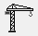Allow field welds - When enabled, welds between elements that are not in the same assembly can be created
- 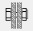Allow bolted parts - When enabled, welds between elements that are already bolted against each other can be created
- Only draw a single weld segment - When enabled, only welds with a single segment can be created
- Draw on the opposite plate-side too - When enabled, then the weld on the opposite side of the plate can also be created (if it is found)
- Draw multiple segments - When enabled, all the valid segments between the same 2 parts can be created (consistent with the chosen AutoWeld settings).
- Draw all-around welds - When enabled, an all-around weld can be created for the same contact surface (The resulting weld may not be fully all-around if the geometry does not allow it)
- 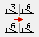 Unify weld sizes - When enabled and multiple welds can be created with one click, then all of the segments will get the same weld size

Additional actions
The following buttons do not influence the context modeler behavior, but were added here for your convenience :
- Classic AutoWeld - Opens the AutoWeld command that allows you to draw welds automatically on a selection of parts or on the entire drawing
- Delete welds - The Delete welds command allows you to delete a selection of welds
- Split / Merge welds - The Split/Merge welds command allows you to split or merge the weld segments of welds
- Remove segments - The Remove weld segment command allows you to remove certain segments of a weld

Context Buttons
More about the context buttons (restrictions)
When you press one of the action buttons, then you will see the available options for that action underneath.
If you press one of these context buttons, then you put a restriction on Parabuild.
This is sometimes very useful, because in some situations, there are many different possible solutions for Parabuild to consider. Parabuild can not always show all the possible solutions at once. In that case the context buttons offer a solution. For example, if you want to draw a beam, you can press one or both beam buttons. Then Parabuild will not propose to draw a column or rafters.
Note, that when selecting one of the context buttons, ensure all other buttons are deactivated unless you explicitly want the extra filter to be active.
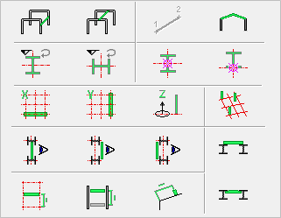

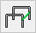 Draw beams between columns
Move the mouse pointer between the columns to which the beam is to be connected - the selected beam will be automatically drawn showing the reference elevation.
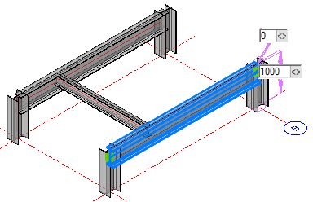

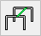 Draw beams between beams
Move the mouse pointer between the beams to which the beam is to be connected - the selected beam will be automatically drawn showing the reference dimension from the closest grid line. When satisfied with the position, click the right mouse button or press <Enter>
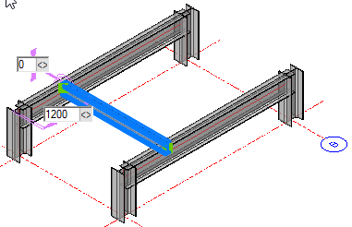

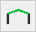 Draw a Pitched Rafter

Activate the Pitched rafter button (Ensuring all other Context buttons are deactivated) and select the rafter profile - press the Draw framing button and move the mouse cursor between the two columns.
The eaves height of the rafter is usually established at the top level of the column - the apex height is set according to the chosen levels.
Left click the mouse to draw the rafter in the current position.
The dimensions may be edited at the time of setting the rafter in position by editing the reference dimension - Alternatively you can double click one of the rafter legs to open the Edit dialog.
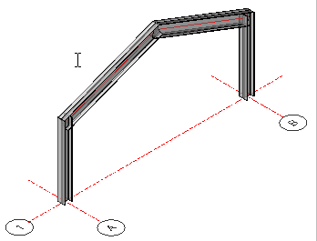 | 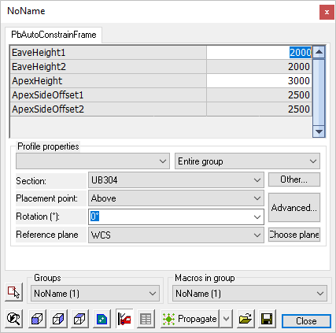

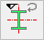 Parallel to World Y - A column's orientation may be adjusted by the user by moving the cursor over either the X or Y axis of the grid line. This command will maintain the orientation to the Y axis - this is particularly useful when placing multiple columns.
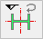 Parallel to World X - As above, but maintaining the X axis.

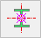 Grip on member axis - This will maintain the grip on the geometric center of the member.

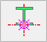 Grip on member side - This will maintain the grip on the outside face of the flange.

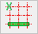 Parallel WCS X Axis - Will draw a beam between members while maintaining the X Axis

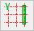 Parallel WCS Y Axis - Will draw a beam between members while maintaining the Y Axis

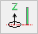 Parallel WCS Z Axis - This button effectively forces Parabuild to only draw columns

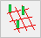 Draw member based on Grid - Will force Parabuild to draw columns based on the grids only.

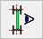 Centered on Section - Will draw a member in line with the centers of 2 other members

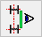 Near-side of Section - Will draw a member against the near-side flanges of 2 other members

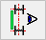 Far-side of Section - Will draw a beam against the far-side flanges of 2 other members

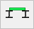 New beam above beams - Will draw a beam sitting on the top flanges of existing beams

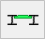 New beam aligned with top of beams beams - Will draw a beam in line with the top flanges of existing beams

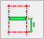 Length offset from grid - Will force Parabuild to draw horizontal members based on the grids only. This effectively disables the Offset from parallel obligation : 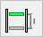

Length offset from parallel - Will force Parabuild to draw horizontal members based on other members only. This effectively disables the Offset from grid obligation :

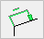 Length offset by model line ends - Will force Parabuild to use model lines as reference point wherever it can (instead of the grid or other members).

Rotate Profile
The Rotate Profile tool will only work while the beam or column is still attached to the mouse pointer. To rotate the profile after its been placed you will need to double click the profile to open the Auto Constrain dialog.
As an alternative for these buttons in the dialog box, you can also use the keyboard Arrow left and Arrow right buttons to change the rotation.
Additionally, you may Switch the Profile StartPoint (Triangle) by activating the button

Levels
From within the Context Modeler, it's possible to set and establish Levels
Pressing the will open the Modify Levels dialog. Use this function to set and establish levels.
When the Anchor button is activated, it will lock the level forcing Parabuild to draw members on that level only. The edit button to the right enables you to fix an offset relative to the level. Here you may enter positive or negative values.

Mass Creation
These 3 tools allow you to quickly draw a range columns, beams or rafters.
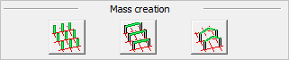

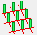 This tool will draw a column on each intersection between the grid lines that you selected.

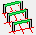 This tool will draw a beam between all columns that it can find on the grid lines that you selected.

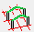This tool will draw 2 rafters between all columns that it can find on the grid lines that you selected.

View - Visibility
This chapter covers the visibility options for the 3D model, enabling you to hide and isolate objects, sub-chapters include:

- Visibility Manager
- Saved Views
- View Angle
- Quick select
- Search for Objects
- Isolate Objects
- Isolate a Selection
- Hide Objects Entirely
- Volumes -> Axes
- Axes -> Volumes
- Show / Hide cameras
- Assembly / Single Object Selection
- Weld Check
- Clash Check

Visibility Manager
Command : PrB_VisibilityMgr
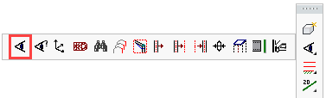
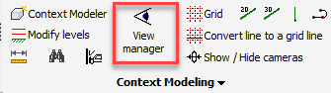

Selecting this command will open the Visibility manager window.
This dialog box may be docked by dragging it by the title bar to one of the edges of the application window.
This window contains a set of tools that will enable you to:
- Change the color of all elements
- Hide elements
- Change the view
- Change the UCS and other tools related to the UCS
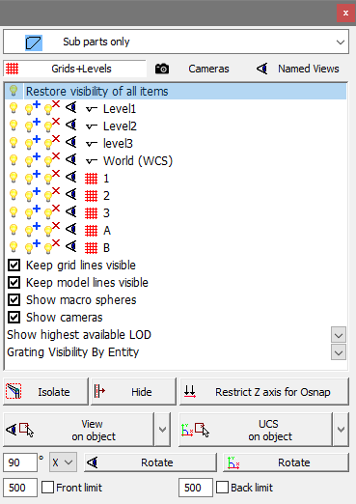

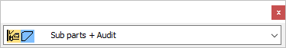
This list shows the available color styles for Parabuild objects. Change the style if you want the elements to follow the layers, or if you want the welded elements in a striking color (green or blue). Or if you want the clashing elements in a striking color (Yellow)

When one of these buttons are activated, the corresponding element types will be shown in the list below:
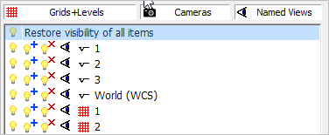
In this list the levels, grid lines and cameras that exist in the drawing are shown if the button is activate.
Clicking on the lamp next to grid 1, all elements in the drawing will be hidden except the elements that are close to grid 1
This lamp can be used to restore visibility of all elements close to grid 1 in case they were rendered invisible by a previous lamp button operation
With this lamp, you can hide all elements close to grid 1
Click on the eye next to an item to align the view with the level / grid / camera

When you right-click an item in the list then you also have the possibility to change the UCS and the view limitation according to the item, as well as to zoom in on this element in the drawing.
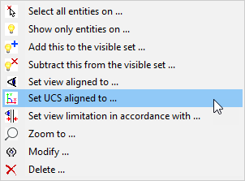

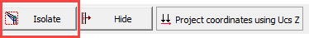
By selecting the Isolate button you will be prompted to select the objects to be isolated - press <Enter> and all other objects will be hidden.
To restore the visibility of all elements, select at the top of the list in this dialog.

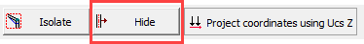
By selecting the Hide button you will be prompted to select the objects to be hidden.
To restore the model, select at the top of the list in this dialog

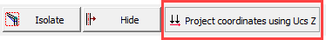

By activating this button, all Z coordinates will be projected to the XY plane. The Z coordinates will thus always be 0. Note: This button affects only the Object Snap tool of AutoCAD / BricsCAD.
(This tool works by modifying the AutoCAD variables OSNAPZ and ELEVATION)
This is a useful tool if you want to temporarily work in the current UCS XY plane. One can then easily draw something in a roof if the UCS was set to align with a rafter.
Do not forget to disable this button again after you're done. When this button is enabled and you're not aware of it, then your object snaps will not work as you would expect it.

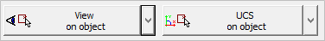
These buttons provide access to a range of view options - press the arrow button to see the full range of available options.
We will explain the most important tools.
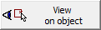 This is a good tool because you just need to select 1 object, and the view will be oriented according to the geometry of that object. If the object has an axis then this will be the new X coordinate of the view. Otherwise it will choose the longest geometry as X axis (this tool works on any type of object).

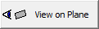 This tool is very powerful because we can determine with just 2 clicks which surface the view should be aligned to. As opposed to View on object this tool does not assume an X axis automatically. Instead it relies on the surface that you selected as basis for the view's new orientation (This tool only works on Parabuild objects).

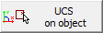 Same as View on object but in this case the UCS will be aligned to the object.

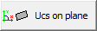 Same as View on plane but in this case the UCS will be aligned to the surface.

With these buttons it is possible to rotate the view or UCS.
This refers to the old view AutoCAD limitation that will clip in front of and behind the current viewing point.
The downside to this old clipping tool is that it will only work well with 2D views. For this reason, it is not being used that often anymore.
The check boxes allow you to activate or deactivate the view limitation at any time.
The distances in front of the checkboxes determine how much in front and how much behind the viewing point should remain visible.
These 2 distances will also be used whenever you click on any of the isolate buttons to determine which parts should be isolated in front of or behind your target gridline or level (regardless of whether the view limitation is on or off).

Saved Views
Command : ddview
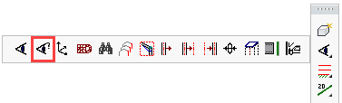

Selecting this command will open the Drawing Explorer window, where you can view and edit saved views
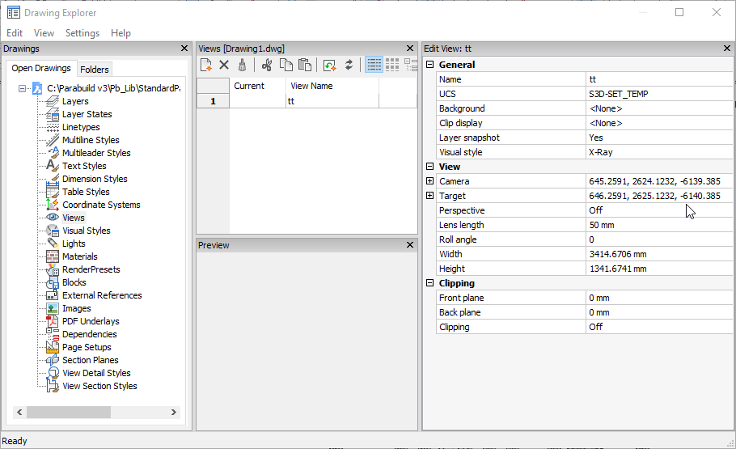

View Angle
Command : ddvpoint

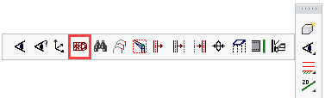

Selecting this command will allow you to set the view angle
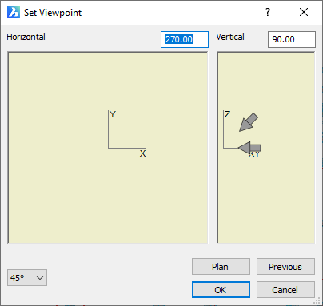

Quick select
Command - Prb_QuickSelect
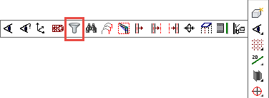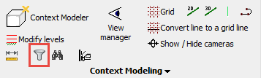
This tool allows you to quickly adapt the current selection by removing or adding certain objects from the selection.
The dialog box can stay open permanently.
It can be used at any time : when no command is active, during a commend, and even while you are inside a selection prompt of a command.
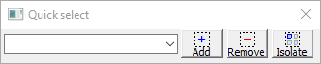
The dialog box has the following capabilities :
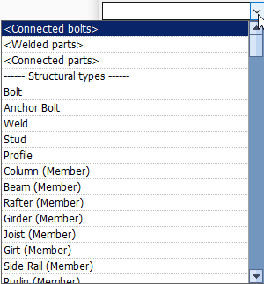
Filter combobox - Use this combobox to choose any of the filter methods that are listed below. You can start typing a part of a word to reduce the amount of options in the combo list. For example, if you type col then only the structural types and filters for columns will appear in the list.
- <Connected bolts> - This filter method will search for all the bolts that are connected to the currently selected objects (bolts have a relation to parts through the hole)
- <Welded parts> - This filter method will search for all the parts that are welded to the currently selected objects
- <Connected parts> - This filter method will use the macros to find the parts that are connected to the currently selected parts
- -- Structural types -- This lists all of the available structural types. Each structural type can be used as a filter here
- -- Filters -- This lists all of the available objects filters. Each object filter can be used as a filter here
Add to selection - When you press this button, then all the objects that match the chosen filter in the combobox will be added to the current selection set.
Remove from selection - When you press this button, then all the objects that match the chosen filter in the combobox will be removed from the current selection set.
Isolate as selection - When you press this button, then all the objects that match the chosen filter in the combobox will be added to the current selection set, and all objects that do not match the filter will be removed from the current selection set.

Search for Objects
Command : Prb_LookUp

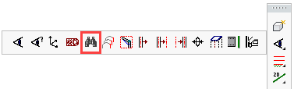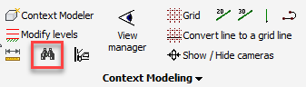

Selecting this command will allow you to search for objects.
Selecting an object value from any of the DropDown lists will hide all items that do not comply to the filter.
To restore the model - select: View manager > Restore visibility of all items.
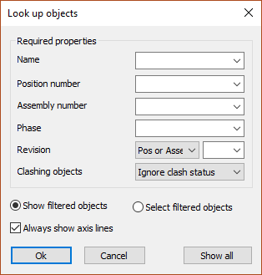
The radio button at the bottom allows you to select the filtered objects instead of highlighting them.

Isolate Objects
Command : Prb_IsolateObjects

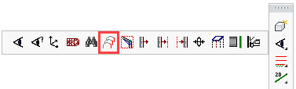

Selecting this command will allow you to isolate selected objects.
Clicking the DropDown menu will list the current levels and grid-lines - selecting one will hide all objects not close to that level or grid line.
To restore the model - select View manager > Restore visibility of all items
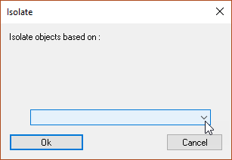

Isolate a Selection
Command : PrB_IsolateSelection
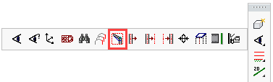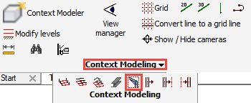

Selecting this command will isolate the selected objects.
At the command prompt, select the entities you wish to isolate, then press <Enter>.
All objects except those selected will be hidden.
To restore the model - select View manager > Restore visibility of all items.

Hide Objects Entirely
Command : Prb_HideObjectsNoAxis
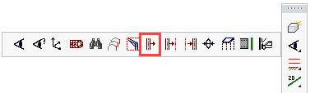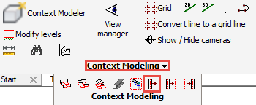

Selecting this command will hide all selected objects.
At the command prompt, select the entities you wish to hide, then press <Enter>.
The selected objects will be hidden.
To restore the model - select View manager > Restore visibility of all items

Volumes -> Axes
Command : PrB_HideObjects

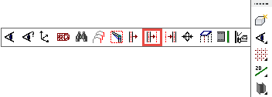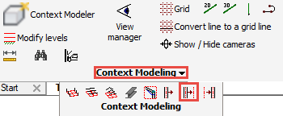

This command allows you to hide a selection of objects, if they obstruct the view.
At the command prompt, select the entities you wish to hide, then press <Enter>.
All objects except those selected will be hidden, however, the axes of profiles and plates remain visible
To restore the model - select View manager > Restore visibility of all items

Axes -> Volumes
Command : PrB_ShowObjects

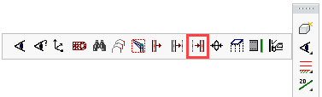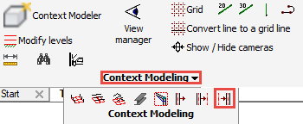

This command will restore the visibility of a selection of hidden objects.
The volumes of which only the axes were visible can be selected and their full visibility restored.
To restore the visibility of all objects in the drawing, press <Enter>.
Alternatively - select View manager > Restore visibility of all items

Show / Hide Cameras
Command : Prb_SwitchViewDefVisibility

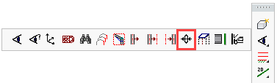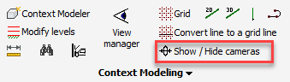

This command works as a switch.
It will hide all the cameras in the 3D drawing if they are currently visible or show them if they are currently invisible.

Assembly / Single Object Selection
Command : Prb_AssemblySelection

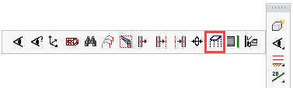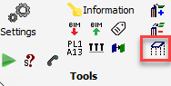

This command functions like a ‘switch’. Every time you click on it the assembly selection is turned on or off.
All components of one assembly are grouped together. If you turn off assembly selection, then you can for example move a welded plate without moving all of its assembly members at the same time. The groups will always stay intact, i.e. when you turn assembly selection back on all components of that mark will ‘stick together again’.
To make things clear: assembly selection only changes something about the way in which elements are selected while drawing, not which element is welded against which. So the welding data remains intact after the assembly selection has been turned on or off.

Weld Check
Command : PrB_WeldCheck

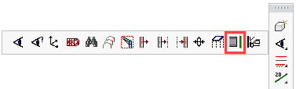

Currently not fully implemented yet

Clash Check
Command : PrB_FullClash

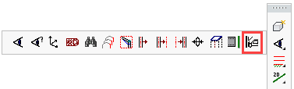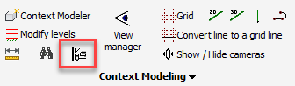

You can use this command to check for clashes between elements.
If a plate clashes with a beam, both will be colored yellow. This will immediately show errors in the design or drawing.
Bolts are colored yellow when they are :
- Too close to a plate or beam, thus warning for a possible lack of space surrounding the bolt for tightening it
- Too close to the edge, thus warning for a possible material weakness issue
So a yellow bolt could be ignored by the draftsperson if they know that in that situation it will be possible to tighten the bolt, or that there is no material weakness issue in that situation.
These maximum distances between the bolt and the edges of other parts can be set in the Global settings dialog box.
Bolts will be colored red if they are drawn in the air or if they are colliding with a part because there is no hole drawn.
Bolts usually get all of their holes automatically.
But in these (impossible) situations the holes are skipped by Parabuild :
- The hole would extend beyond the material. Parabuild does not draw these partial holes because most CNC machines would not drill this hole anyway. If you need to draw this hole anyway, then use this command to draw a special cut for it : . You can just use the bolt as the cylinder that defines the special cut.
- The bolt head or the bolt nut touches too much the radius between the flange and web of a member.
Mounting the bolt there would create an unforeseen tension on the bolt head or the nut that touches the radius.
So therefore a red bolt indicates a serious problem and should never be ignored by the draftsperson.

General - Grids
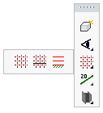
This chapter covers the use of Grid lines and Levels. The sub-chapters include:
- Draw Grid
- Convert Line to Grid-Line
- Modify Levels

Draw Grid
Command - Prb_DrawGrid
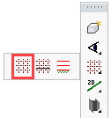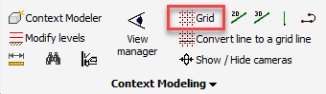
This tool will open the Draw Grid dialog.
To draw grids that are unequally spaced then you should enter in the Distance between grid lines field the distances separated by spaces or comma's. If you are working in inches units, then you can only use the comma to separate the distances because the space can be used to denote feet and inches.
i.e. 1000,2000
When you click OK, the grid will be drawn at the origin.
By checking Change placement manually you will be prompted to select the insertion point and indicate the X and Y axes.
You can Move / Rotate / and Stretch the resulting grid lines. They are regular lines which have their grid name attached.
By convention, the grid line numbering system will begin at the bottom-left hand corner, incrementing along the X and Y axes.
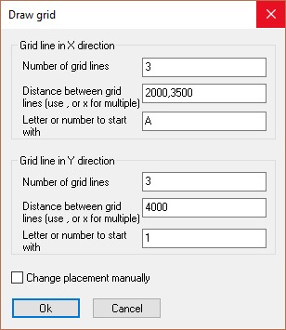
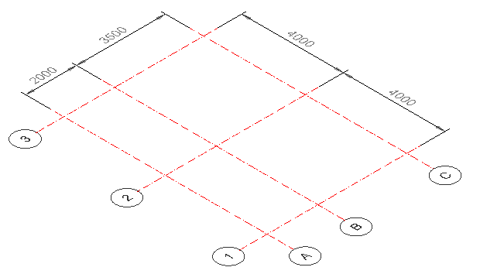

Convert Line to Grid-Line
Command - Prb_SetAsGridLine
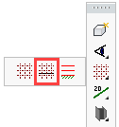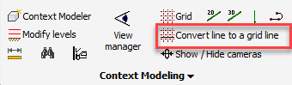
This command allows us to convert a regular line into a grid line.
It also allows us to change the grid names of existing grid lines.

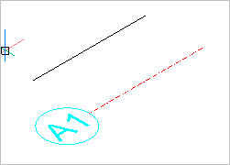

Modify Levels
Command - Prb_ModifyLevels
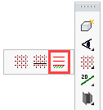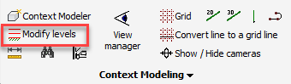
This command may be activated from the Context modeler, or from the General / Grids toolbar FlyOut.
Activating this command will open the Modify levels dialog. Here you can add, subtract, or modify levels and elevations.
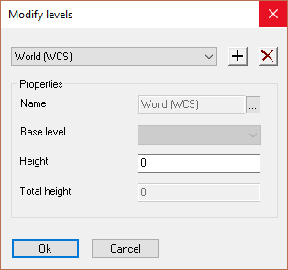
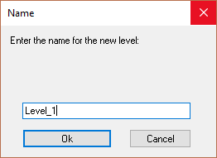

To add a level - press the button to open the Name dialog where you should add the name for the level. Press Ok to close the dialog. Enter the height of the level in the Modify levels dialog and press Ok again.
Repeat this process for all other levels.
At any time you may review and/or modify the levels by activating the drop down menu.
Any modifications to the levels will be immediately reflected in the model when you close this dialog.
To delete a level, highlight it from the drop down and press
The base level may be the WCS (World Coordinate System) or another level.

Model Lines
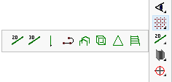
This chapter covers the use of Model Lines and the principles of WireFrame modeling. The sub-chapters include:
- 2D Line
- 3D Line
- Vertical Line
- 3D PolyLine
- Portal Frame
- Tower
- Pyramid
- Ladder

2D Line
Command - PrB_modlijn2D
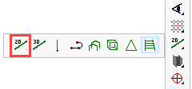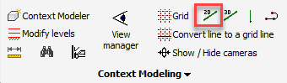
Draws a 2D Line that is restricted to use X-Y plane of the current UCS.

3D Line
Command - PrB_modlijn2D
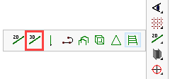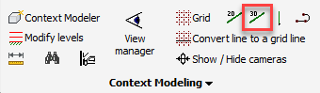
Draws a 3D Line, which does the same as the AutoCAD/BricsCAD line command.

Vertical Line
Command - S3d_NokLijn
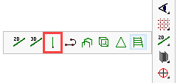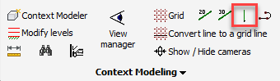
Draws a vertical line. The tool asks for the insertion point and the height of the line.
The new line will be parallel to the current Ucs Z axis.

3D PolyLine
Command - PrB_3dPoly
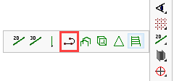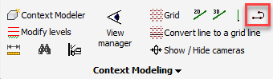
Draws a 3D PolyLine that can handle arcs in more 3D situations than the AutoCAD/BricsCAD 3D polyline.

Portal Frame
Command -
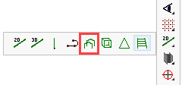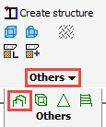

This command will be renewed soon

Tower
Command -
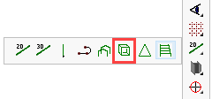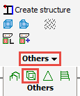
Command will be renewed soon

Pyramid
Command -
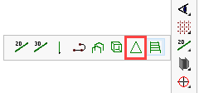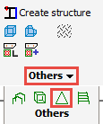
Command will be renewed soon

Ladder
Command -
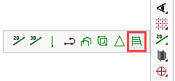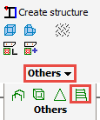
Command will be renewed soon

Constrained Profiles
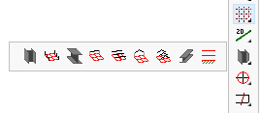
All of the following commands will draw members that are constrained to the grids, the levels and other members.
- Column with Point
- Columns with Grid-Lines
- Beam with Points
- Beam between Columns
- Beams with Grid-Lines
- Apex between Columns
- Apex with Grid-Lines
- Free Member
- Modify levels

For more information about geometric constraints, see the chapter Macros and modules

Column with Point
Command - Prb_PointColumn
Draws a column on a point.
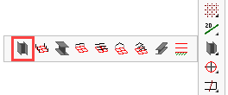
On activating this command, the Add a column dialog will appear prompting you to select the profile to be drawn, together with the top and bottom levels. If levels have already been established, they will be reflected here, additionally, you have the opportunity to create new levels or choose an extra height offset of the column by entering a value for Offset top.
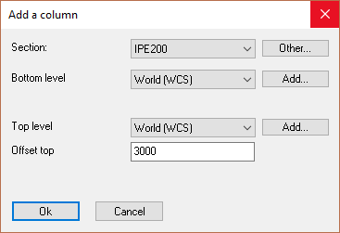. 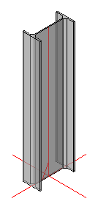

After selection, you will be prompted to choose a point. You may then select multiple points if you so desire, and then press <Enter> to end the command.
The column will be constrained to the grid lines that are closest to the point. If you selected a point at an offset from a grid line, then this offset will become modifiable in the macro dialog. Just double-click the column to open this dialog box.
The column cannot be moved independently of the grid lines, unless if the profile is disconnected from the macro.

Columns with Grid Lines
Command - PrB_Columns
Draws columns on the intersections of grid lines.
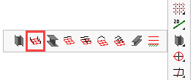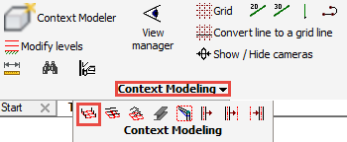
On activating this command, the Add a column dialog will appear prompting you to select the profile to be drawn, together with the top and bottom levels. If levels have already been established, they will be reflected here, additionally, you have the opportunity to create new levels or or choose an extra height offset of the column by entering a value for Offset top.
. 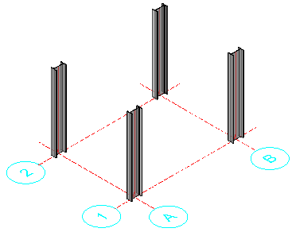
The command will draw a column on each intersection it finds between the grid lines that you select.
The columns will be drawn constrained to the grid lines. Moving or adjusting the grid line centers will automatically move the columns.
The columns cannot move independently of the grid lines, unless if the profile is disconnected from the macro.

Beam with Points
Command - PrB_PointsBeam
Draws a beam constrained between 2 points
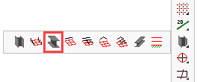
On activating this command, the Add a beam dialog will appear prompting you to select the profile to be drawn, together with the top level for the beam(s). If levels have already been established, they will be reflected here, additionally, you have the opportunity to create new levels.

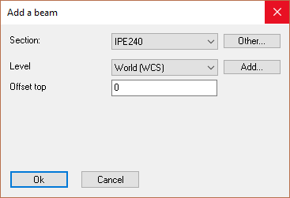
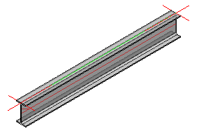

You will then be prompted to Select the first point, followed by the next point - on completion, press <Enter>.
The horizontal beams(s) will be drawn at the selected points, but at the height that was chosen in the first step. Moving or adjusting the points will automatically move the beams.
The beams will be constrained to the grid lines that are closest to the selected point. If you selected a point at an offset from a grid line, then this offset will become modifiable in the macro dialog. Just double-click the beam to open this dialog box.
The beams cannot move independently of the grid lines, unless if the profile is disconnected from the macro.

Beam between Columns
Command - PrB_BeamBetweenCol
Draws a beam between 2 columns.
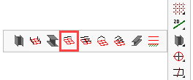
On activating this command, the Add a beam dialog will appear prompting you to select the profile to be drawn, together with the level for the new beam. If levels have already been established, they will be reflected here, additionally, you have the opportunity to create new levels.
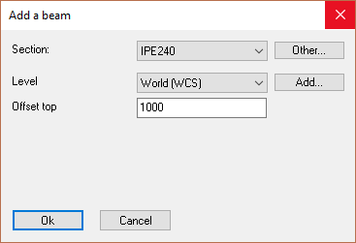
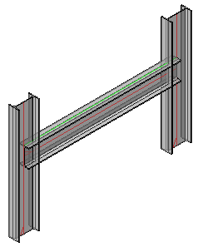
You will be prompted to Select the first column, followed by the second column.
Then press <Enter> and the beam will be drawn at the selected level or offset constrained between the two columns. Moving or adjusting the columns will automatically adjust the beam.
The beams cannot move independently of the columns, unless if the profile is disconnected from the macro.

Beams with Grid Lines
Command - PrB_Beams
Draws beams between columns
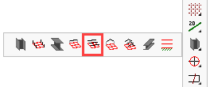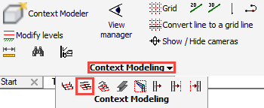
On activating this command, the Add a beam dialog will appear prompting you to select the profile to be drawn, together with the level for the new beam. If levels have already been established, they will be reflected here, additionally, you have the opportunity to create new levels.

You will then be prompted to Select the grid lines, when done press <Enter>.
In this example the blue beams are drawn automatically after selecting the 4 blue grid lines.

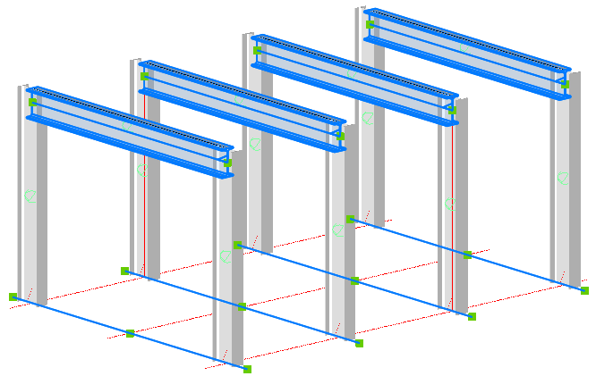

A condition is that the grid line that you selected needs to have at least 2 columns located on them.
Another condition is that the height that you choose should not be higher than the height of the columns.
Otherwise the tool will not draw any beams.

Moving or adjusting the columns will automatically adjust the beams.
The beams cannot move independently of the columns, unless if the profile is disconnected from the macro.

Apex between Columns
Command - PrB_ApexBetweenCols
Draws a portal rafter constrained between 2 columns
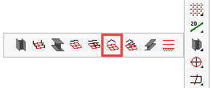
On activating this command, the Draw an apex dialog will appear prompting you to select the rafter profile to be drawn, together with the start height, which in most cases will be the top of the column. You have the opportunity to select the apex height (from the start height), or if the Determine apex height with an angle checkbox is checked you may enter the rafter angle.

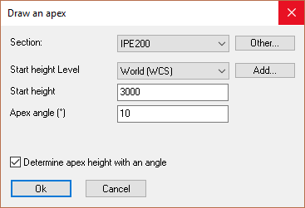
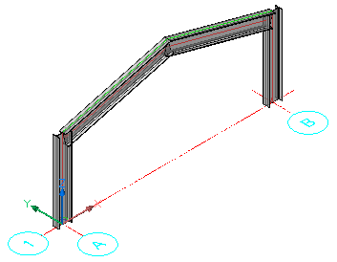
You will then be prompted to Select the first column, followed by the second column.
On completion, the rafter will be drawn at the selected level and either the apex height or angle constrained between the two columns. Moving or adjusting the columns will automatically adjust the rafter.
The rafter cannot be moved independently of the columns, unless if the profile is disconnected from the macro.

Apex with Grid Lines
Command - PrB_Apexes
Draws portal rafters constrained between 2 columns.
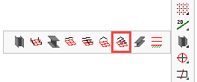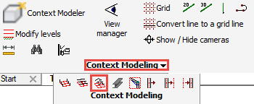
On activating this command, the Draw an apex dialog will appear prompting you to select the rafter profile to be drawn, together with the start height, which in most cases will be the top of the column. You have the opportunity to select the apex height (from the start height), or if the Determine apex height with an angle checkbox is checked you may enter the rafter angle.

You will then be prompted to Select the grid lines, when done press <Enter>.
In this example the blue rafters are drawn automatically after selecting the 4 blue grid lines.
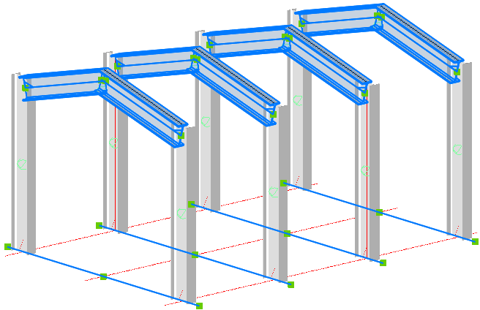

A condition is that the grid line that you selected needs to have at least 2 columns located on them.
Another condition is that the height that you choose should not be higher than the height of the columns.
Otherwise the tool will not draw any rafters.

Moving or adjusting the columns will automatically adjust the rafters.
The rafters cannot move independently of the columns, unless if the profile is disconnected from the macro.

Free Member
Command - PrB_FreeMember
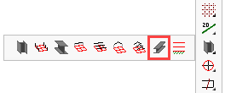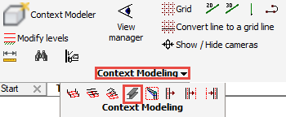
On activating this command, the Draw a member dialog will appear prompting you to select the profile to be drawn.
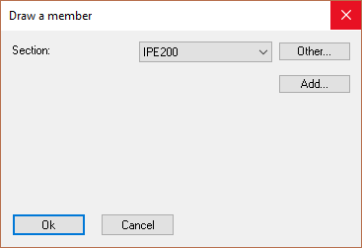
You will then be prompted to Select the first point, followed by the next point. Here you may enter as many points as you wish, on completion, press <Enter> and the profile(s) will be drawn.

There are some limitations to the points that you can use :
- When you choose a point in free space, the tool will project the point flat to the world XY plane, and will constrain the point to the closest grid line
- Choosing points in 3D is possible if you choose to use object snap on another entity.
But then only endpoints will work. Midpoints will not work.
This will only work on lines, plates, profiles and structures.
The new profile will stay linked to the endpoint that you chose.

The profile(s) cannot be moved independently of the chosen points.

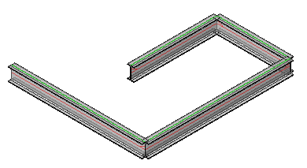

Modify Levels
Command - PrB_ModifyLevels
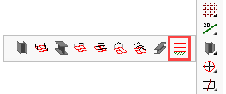
This command allows us to add, remove or modify levels.
See Modify Levels

Bolts / Holes
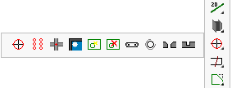
This Chapter covers the placing of bolts and holes, sub-chapters include:
- Bolt Standards
- Draw Bolt
- Bolts on a Plane
- Bolts on Touching surfaces
- Galvanizing Holes
- Check for New Holes
- Remove Holes and Cuts
- Slotted Hole
- Hole <-> Threaded Hole
- Hole <-> Countersunk Hole
- Hole <-> Blind Hole

Bolt Standards
When a bolt is drawn in a connection or manually, a bolt assembly should be assigned. These Bolt Assemblies contain the description of the standard for the bolt, nut and washers.
If bolt DIN 931 is adopted within the assembly, then Parabuild reads the entire Bolt parts database.
Parabuild will then select a bolt with the DIN931 standard, the selected diameter, and one of adequate length. Depending on the options in the assembly, a number of washers and nuts will be added to the bolt.
The standard of the nuts and washers are also determined by the assembly and are selected from the parts list.
There are two types of lists : The list of assemblies and the list of bolts, nuts and washers. These lists can be added to in the Global settings.
The part lists contain the sizes of each part that Parabuild is able to use.
See the Properties for a detailed explanation of the bolt properties that can be changed.

Shop Bolts
By default, all bolts are designated as 'Site Bolts'. To convert them to 'Shop Bolts', one can use the Bolt properties panel :
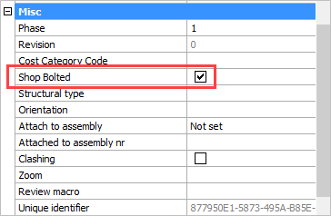
The bolt(s) will also be shown on the assembly shop drawing, and will appear on the Bill of Materials of this shop drawing.
This property will also influence the number of the assembly.
It's possible to influence which assembly the bolt is attached to.

Influencing which Assembly a Bolt is attached to
A bolt is always attached to one reference assembly, even if it connects 2 or more assemblies together.
We call this the reference assembly of the bolt. This reference assembly is important, because it will determine on which assembly drawing the bolt will appear. (a bolt will never appear on 2 assembly drawings to avoid counting the bolt more than once)
A priority list that determines which assembly the bolt is attached to, can be changed in the Document generation Settings dialog :
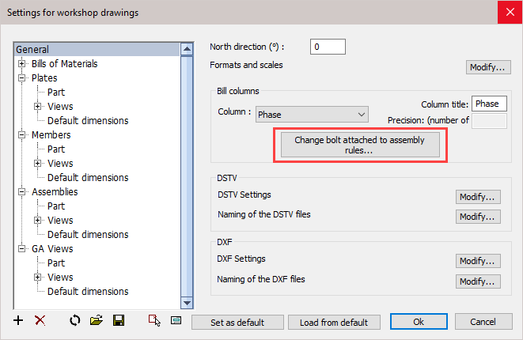
With this priority list you can influence the automatic assignment of reference assembly of all bolts - the list is ordered according to priority.
You can add, delete, and sort all items in the list :
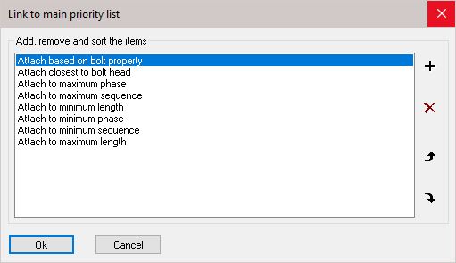
In exceptional cases where the automatic choice taken by Parabuild is not as desired, it is still possible to manually set the reference assembly in the properties of the bolt:
Attach to assembly - In this property we can choose the assembly from the drop-down menu: Closest to bolt head or Closest to Bolt end
This will effectively override the main priority list
Attached to assembly nr - This will indicate to which assembly the bolts are attached
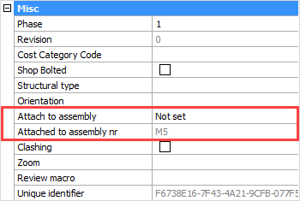

Draw Bolt
Command - PrB_ArxBolt
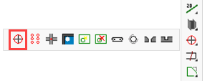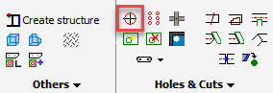
This command draws a single bolt through a plate or profile.
At the command line prompt, select a part, then the following dialog will appear:
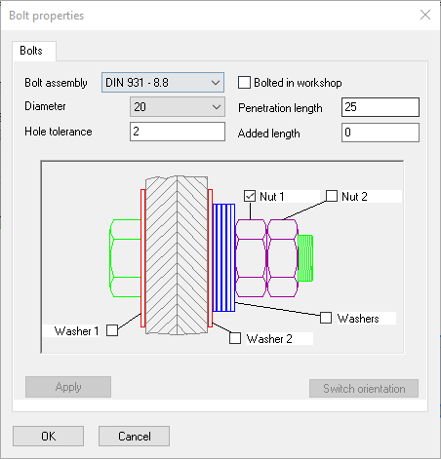
Here you are able to select:
- The Bolt-assembly
- Bolt diameter
- Penetration length (Grip) = the plate thickness
- Hole tolerance (Bolt hole clearance)
- Added length - The bolt length is calculated as: (Length = Penetration length (Grip) + Washers + Nuts + Added length)

If the 'Bolted in workshop' checkbox is checked, then it is assumed that the assembly is at least partly bolted in the shop.

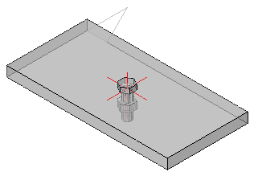

Bolts on a Plane
Command - PrB_BoltsOnPlane
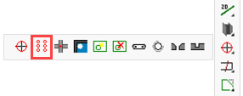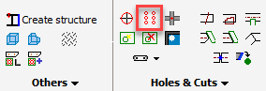
This command draws a range of bolts on a plate or profile's surface.
On selecting this command, you will be prompted to select a plane on a plate or profile.
You can select this plane by moving the cursor inside a plane, and then clicking the left mouse button.
The circumference of the plane will be drawn thicker so that you can see the selected plane.
To select a different plane, you need to move the cursor and left-click the mouse again.
To accept the plane selection, press the <Enter> key or right-click the mouse.
A dialog will appear prompting you to enter the dimensions for the bolt group.

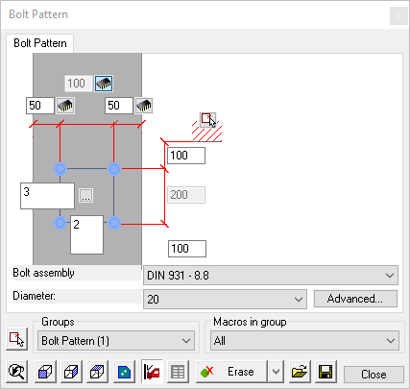
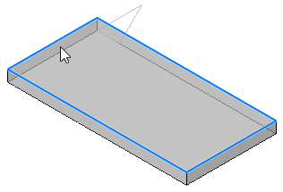

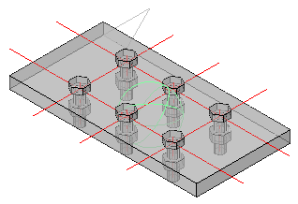

Bolts on Touching Surfaces
Command - PrB_AutoBolts
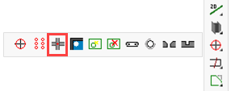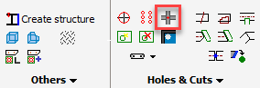
This command automatically draws bolts where plates or profiles are touching each other.
On selecting this command, you will be prompted to select the entities which are to be bolted.
A dialog will appear prompting you to enter the dimensions for the bolt group.
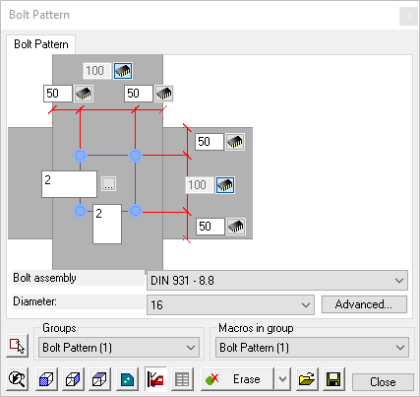
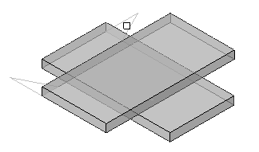

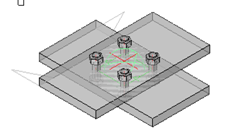

Galvanizing Holes
Command - PrB_AutoGalvaHoles
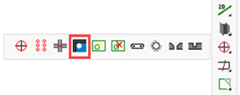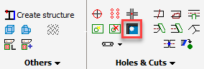
This command draws drain holes in end-plates of hollow sections or I shaped sections.
On selecting this command, you will be prompted to select the profile and the end-plate. You could also select the entire drawing.
Parabuild will search for all the 'corners' in which pockets of liquid zinc are possible.
This tool will zoom in on each group of galvanizing holes that it has identified. The holes will be automatically drawn and you will be prompted to either accept the proposed holes or not.
After all the groups have been iterated, the customization dialog will appear, prompting you to enter the hole diameter and location relative to the inner profile of the (hollow) section.
Parabuild uses bolts with the name Hole helper to draw these galvanizing holes - These bolts are not visible and will not be shown in the bill of materials.
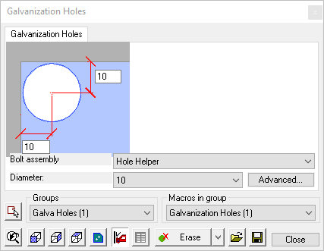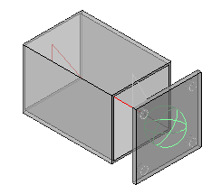

Check for New Holes
Command - PrB_HoleCheck
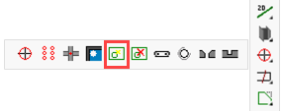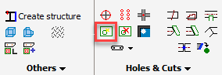
This command will check for and draw missing holes where bolts are colliding with parts.
The command Verifying new holes lets Parabuild check if there is a plate or beam with a bolt inserted but without a hole. In this case Parabuild will draw the hole.
On selecting this command, you will be prompted to select the beams, plates, and bolts.
Any missing holes will automatically be identified and corrected.
Note!
If the bolt is too close to the edge of a beam or plate, or if it's too close to another bolt, it will be colored yellow. If this is the case, you need to move the bolt or change the settings:
Reduce the bolt to edge or bolt to bolt distance in the Global Settings dialog box.
Bolts could also be shown in red when it was impossible to draw a hole. For more information about this see the Clash check.

Remove Holes and Cuts
Command - PrB_RemoveCutOrHole

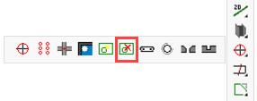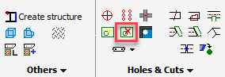
This tool will remove any hole or cut that you select.
On selecting this command, you will be prompted to select the edge of the hole or cut to be removed.

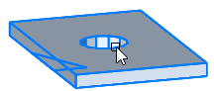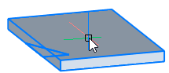

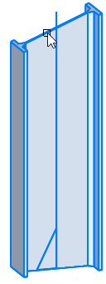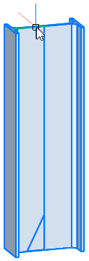

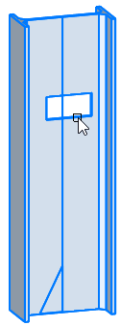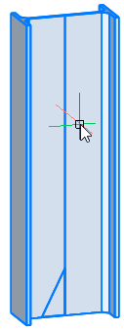

Slotted Hole
Command - PrB_SlotHoleDlg
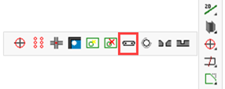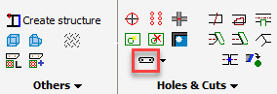

This command converts a round hole to a slotted hole.
Tip It is easier and quicker to modify a hole from within the properties of the bolt instead of this command.
At first, Parabuild will ask you to select the hole you want to convert into a slotted hole.
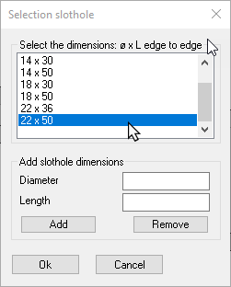
In the dialog, you can then select a specific measurement or with Other specify your own measurements.
After that, you need to specify the rotation angle by selecting a point relative to the axis of the slotted hole.

Hole <-> Threaded Hole
Command - PrB_ChangeHoleThread
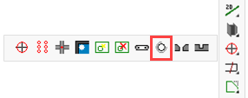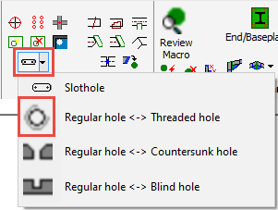
Tip It is easier and quicker to modify a hole from within the properties of the bolt instead of this command.

With this command you can convert a regular hole into a threaded hole and vice-versa. For illustration purposes, extra lines will be added to simulate the thread of the hole.
After starting this command you should select the edge of a hole. It will be converted instantly.
For more information about how Parabuild annotates threaded holes in the shop drawings, refer to the Global settings dialog.

Hole <-> C/Sunk Hole
Command - PrB_ChangeHoleCountersunk
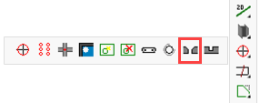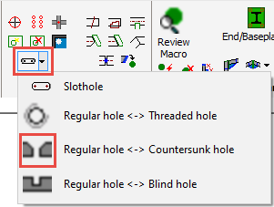

Tip It is easier and quicker to modify a hole from within the properties of the bolt instead of this command.

With this command you can convert a regular hole into a threaded hole and vice-versa.
At the command line prompt: Select a hole or a bolt, which will then bring up the following window:
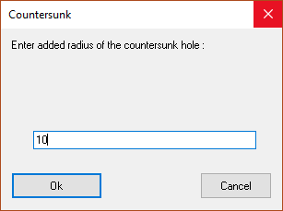
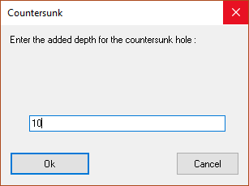

Here you are prompted to Enter the added radius of the countersunk hole, press Ok and the second window will appear prompting you to Enter the depth for the countersunk hole - press Ok
The countersunk hole is shown in 3D.
The depth and diameter of the countersunk part are determined by the head of the bolt.
If the hole contains a bolt with a hexagonal head, then the countersunk won't be drawn oblique (a counter-bore hole is drawn).
If the bolt's head is oblique, then the hole will be oblique too at the same inclination as the bolt head.
The bolt heads of all the bolts are adjustable in the Bolt Parts Database.

Hole <-> Blind Hole
Command - PrB_ChangeBlindHole
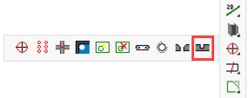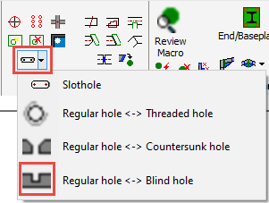

Tip It is easier and quicker to modify a hole from within the properties of the bolt instead of this command.

With this command you can convert a regular hole into a threaded hole and vice-versa.
When first starting the command you will be prompted to select either a hole or a bolt.
Then the following windows will appear :
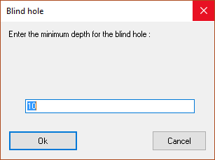
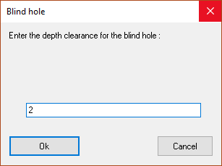
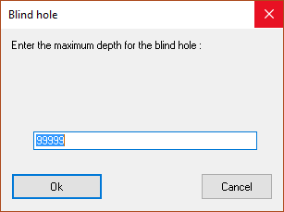

A blind hole is a hole with a limited depth. In steel material, this hole should be threaded.
The bolt should not have a nut.
A blind hole can only be activated for the last hole of a bolt.
The depth of the blind hole is determined by the ending of the bolt. If preferred the hole can be drilled deeper than the bolt (A on the illustration).
The minimum and maximum depth of the hole can be adjusted (B on the illustration).
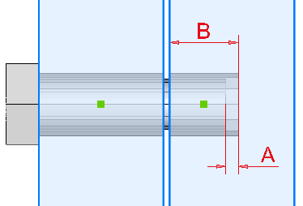
If the bolt length would cause the hole depth to be outside of the minimum and maximum, the hole depth will be adjusted automatically to adhere to the minimum and maximum.
When trying out this tool, choose a bolt standard that has an adequate amount of bolt lengths. If the standard does not have the right bolt length then this tool can't draw the blind hole.

Cutting
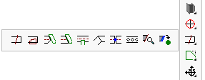
This chapter covers the modification of elements by cutting. The sub-chapters include:
- Cut on a Line
- Cut on a PolyLine
- Cut against a part (shorten only)
- Cut against a part (shorten and extend)
- Cut out with a part
- Miter cuts
- Break Profile
- Hex. Holes (Castellated)
- Edit a Profile's Cuts
- Add Cut to macro

Cut by a Line
Command - Prb_LineCut
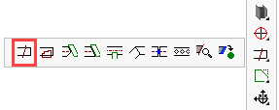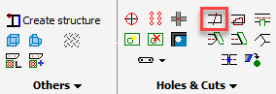
This command allows us to modify the start or end of a profile by shortening or extending it, but also by adding non-perpendicular cuts to it.
At the command line prompt, the following dialog will appear:
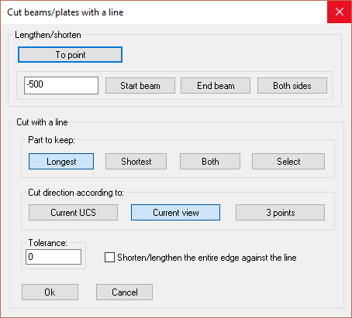
Here there are 2 options:
- To lengthen or shorten the plate or profiles
- To cut the plate or profile along a line

Shorten/Lengthen:
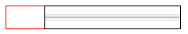 | 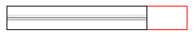 | 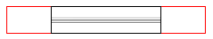
Start Beam | End Beam | Both Sides
First you enter the distance to be shortened or extended. A positive value will extend the entity, while a negative value will shorten it.
Choose from To Point, Begin beam and End beam.
To point - you have to indicate a reference point on screen and the beam will be cut to that point.
Start beam will shorten/lengthen the beam according to the entered value. The start beam position is the origin of the entity (where the triangle is located)
End beam does the same as Start beam but at the opposite end of the beam.
Both sides - will shorten/lengthen the beam at both ends

Cut using a line:
Part to keep - Longest: Will cut away the shortest section, keeping the longest measured from the cut line
Shortest: Will cut away the longest section, keeping the shortest measured from the cut line
Both: Will cut the beam or plate at the cut line, keeping both sides
Select: Will allow you to manually select which side to keep
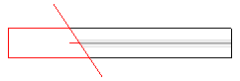 | 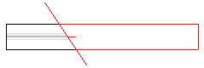 | 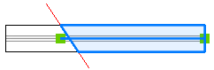
Longest | Shortest | Both

Orientation cutting plane:
    - Current UCS: Cut along the current work plane (UCS).
    - Current view: Cut according to the current view.
    - 3 points. You are requested to set/select 3 points. The cut will be according to the plane defined by these points.
Tolerance: You can also set an offset between the line and the profile.
Shorten/lengthen the entire edge against the line when enabled this will shorten or extend the profile during the cut operation \

This is an example with the option Shorten/lengthen enabled :
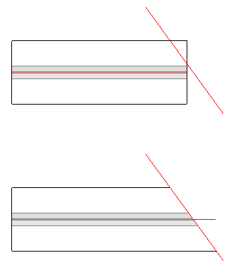

This is an example with the option Shorten/lengthen disabled :
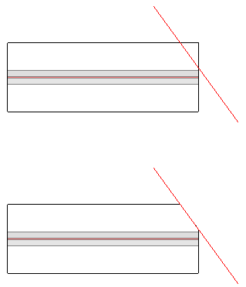

This is a second cut operation on the same profile with the option Shorten/lengthen disabled :
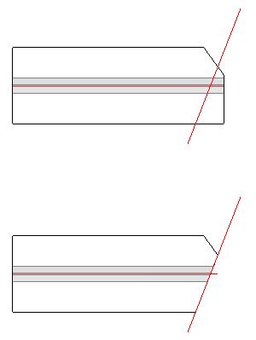
With the Shorten/lengthen enabled it would not be possible to achieve this miter.

Cut by a PolyLine
Command - Prb_CutByPoly
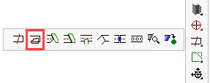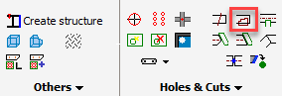
This command allows us to add internal copes to a profile or a plate.
At the command line prompt, first select the plates and/or profiles to be cut, and then press <Enter>.
You will then be prompted to indicate the PolyLine.
The PolyLine may be a Circle, a Rectangle, or a user-defined PolyLine.
The following dialog will appear where you have the option of making the cut Unlimited - which will cut through the entity entirely - or alternatively, you may prescribe the depth of the cut.
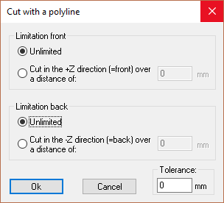 | 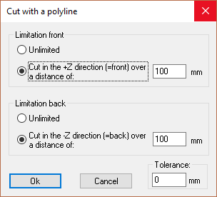

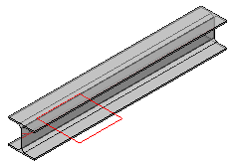 | 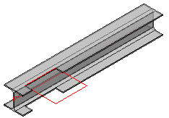 | 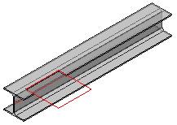
The PolyLine before applying the cut | Cut result with unlimited depth | Cut result with limited depth in Z Direction

Cut against a part (shorten only)
Command - PrB_AddPrPlCut
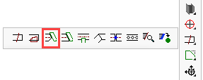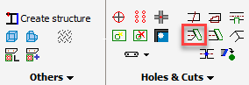
This command allows us to shorten a profile against another part. The new end cut of the profile will be aligned to the other part.
On activating this command, you will be prompted to: Select the plates or beams you would like to cut.
You will be further prompted to indicate: The cutting plate or profile.

The profile or plate will immediately be cut to the main face of the cutting plate/profile.

This tool will cut against the web of I or U shapes.
If you need to cut to another face, then use the Manually select cutting plane option in the Add cut to macro tool.

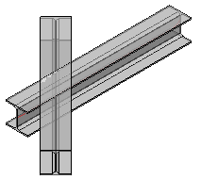 | 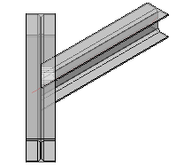
The profiles before applying the cut | The profiles after applying the cut

This tool will only shorten the profile. Therefore it becomes possible to combine multiple end-cuts on a profile at the same end :
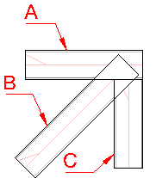 | 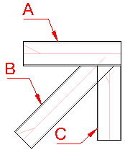 | 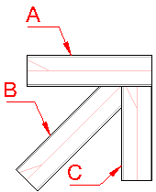
The profiles before applying the cuts | The result after cutting profile B against profile A | The result after cutting profile B against profile C

Cut against a part (shorten and extend)
Command - PrB_PrPlCut
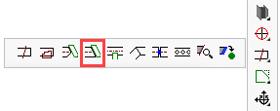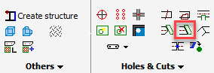
This command allows us to shorten or extend a profile against another part. The new end cut of the profile will be aligned to the other part.
On activating this command, you will be prompted to: Select the plates or beams you would like to cut.
You will be further prompted to indicate: The cutting plate or profile.

The profile or plate will immediately be cut to the main face of the cutting plate/profile.

This tool will cut against the web of I or U shapes.
If you need to cut to another face, then use the Manually select cutting plane option in the Add cut to macro tool.

The profiles before applying the cut | The profiles after applying the cut

This tool will shorten and extend the profile when needed. Therefore it is not possible to combine multiple end-cuts on a profile at the same end.
However, this command will automatically correct profiles that are too short :
 |  | 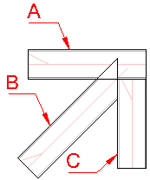
The profiles before applying the cuts | The result after cutting profile B against profile A | The result after cutting profile B against profile C
If you need to combine two end-cuts, then use this command first and then use the Cut against an element (shorten only) command for the second end-cut.

Cut out with a part
Command - PrB_CutInProfile
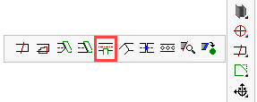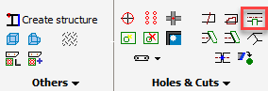
This command will draw a cut that matches the contours of the entity determining the cut.
The tool will ask for an offset value at the command line prompt. This value represents the clearance between the cut entity and the profile that determines the cut.

If the plate or beam is completely severed by the entity that determines the cut, the plate or beam will be split up into 2 parts and both parts will be cut against the determining part.

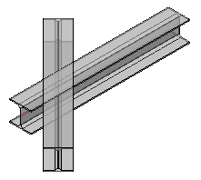 | 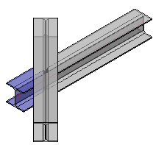
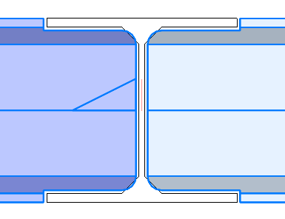

This tool will also accept a bolt for the cut definition
A practical use case for this is when a part of a hole needs to be drawn on a miter.
The Parabuild bolt/hole tools refuse to draw a partial hole like this.
But with this cutting tool we can still draw this :
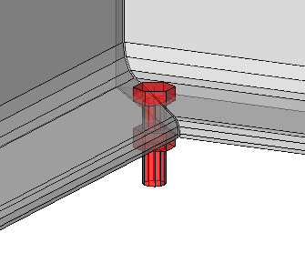 | 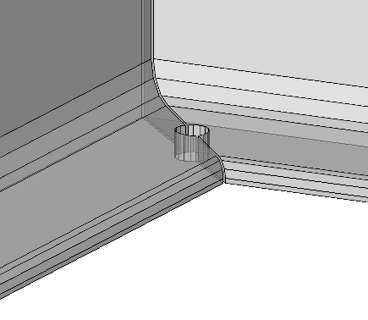
A bolt drawn in the middle of a miter.  The holes are not drawn automatically in such case. | By selecting the bolt as defining object, we can draw 2 half holes in the channels.

Miter cuts
Command - PrB_CutProfsVsEnds
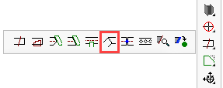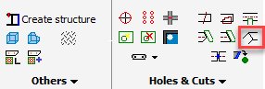
This command will insert a miter joint between two profiles. You will be prompted to select the two beams to be joined, after which, the joint will be placed. This command will repeat until you press <Enter> to stop.
This will work with all profiles, at any angle relative to each other. It will also join intersecting or non-intersecting profiles.
Profile of different sizes may also be mitered, but this practice is not recommended without an analysis of the result.
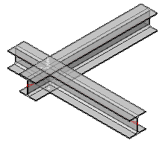 | 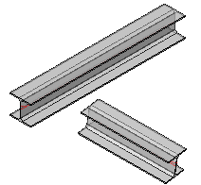 | 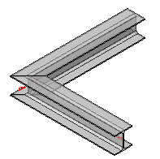
Intersecting Profiles | Non-Intersecting Profiles | Resulting Mitered Joint

Break Profile
Command - PrB_BreakProf
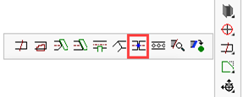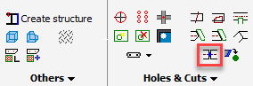

This command will break one or more profiles into 2 separate profiles.
After selecting the profiles that need to be broken, uou will then be prompted to select either the break-point, or to specify a distance.
When choosing a break-point, the point can reside anywhere outside the profile. The point that you select is projected to the axis of the profile(s).
When choosing a distance, the distance will be measured from the start of the profile (the start of the profile is where the triangle is located)
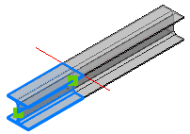 | 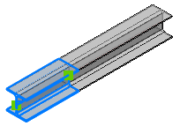
Select Break point | Specify a Distance

Hex Holes (Castellated)
Command - PrB_Hex
This command will draw a range of hexagonal holes over the length of a beam.
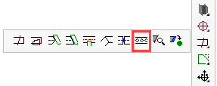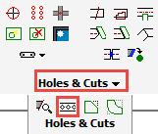
This command will create a Castellated or Cellular profile from a standard I section beam. Select the profile you wish to cut to open the following dialog
Here you have a choice of creating hexagonal holes to form a Castellated beam, or circular holes to create a Cellular beam
The options provided in the dialog are fairy straightforward - The spacing of the holes may be set from the ends, one hole centered on the center-line of the beam, or spaced equally about the center-line of the beam.
You also have the option of displaying the dimensions of the holes on the workshop drawings.
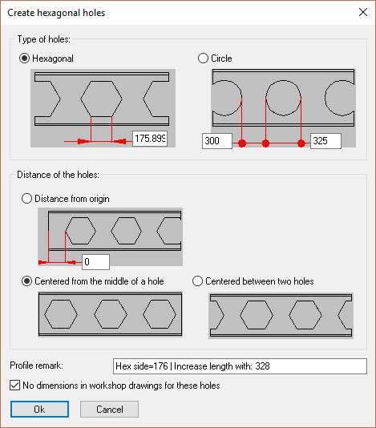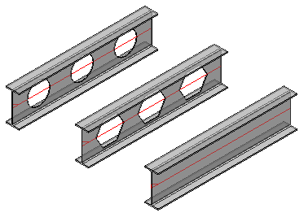

Edit a Profile's Cuts
Command - Prb_EditProfCuts
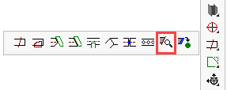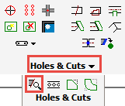
This command allows you to Edit / Remove a cut
Select the profile to be edited and press <Enter> - the following dialog will appear
The cut(s) applied to the profile are indicated in the window - selecting one and pressing the X button will remove the cut.
Checking the Preserve cut representations checkbox will leave the original line or PolyLine upon which the cut was originally determined.
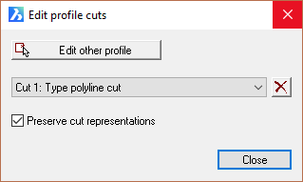
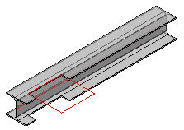 | 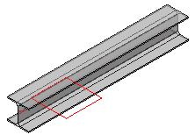
Original Cut | Cut was removed  but cut polyline was preserved

Add Cut to Macro
Command - PrB_AddMacroCut

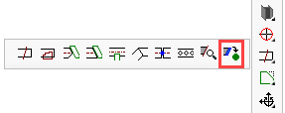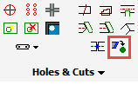
With this command, you are able to add cuts to a macro. The advantage of this is that the cut will adapt automatically if one of the base profiles of the cut changes. Also the options of the cut can always be modified after the cut has been drawn, without the cut needing to be drawn again.
Activating the command, the following dialog will appear:
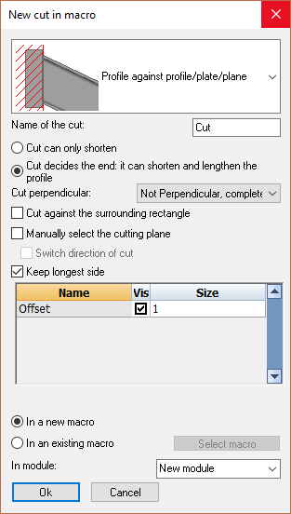
First of all at the top you must choose a type of cut, this will affect some options which are dependent on the type of cut chosen: The options include:
  - Profile against profile/plate/plane: This is a straight end-cut against a profile or a plate.
  - Miter joint: This is a miter joint between 2 profiles
  - Cutout profile/plate: This cut cuts out the form of one profile in another profile or plate.
  - Against plane with 3 segments: This cut is used for connections that have clearance cuts.
  - Chamfer: With this cut we cut a chamfer from a profile using two distances. You must select two planes as a basis.
  - Fillet: With this cut we cut a fillet from a profile using a radius. You must select two planes as a basis.

This is an explanation of the most important options :
- Cut can only shorten : This is explained extensively in the Cut against an element (shorten only) topic.
- Cut decides the end : This is explained extensively in the Cut against an element (shorten and extend) topic.
- Cut perpendicular : With this option you can force the cut to be fully or partially perpendicular to the profile's axis. Consider this example :
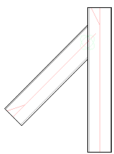 | 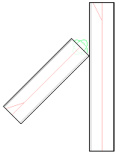
An end-cut drawn with the option Not perpendicular | An end-cut drawn with the option Completely perpendicular
- Cut against the surrounding rectangle : Enable this for drawing a cut outside of the bounding box of the profile's section shape.
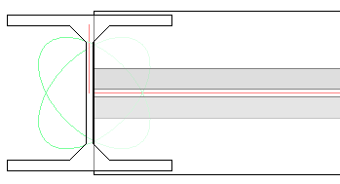 | 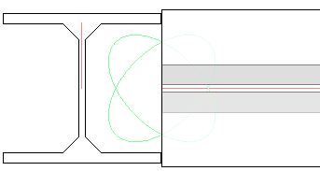
With Surrounding rectangle disabled, the tool will find the main face, and in this orientation it is the web of I and U shapes. | With Surrounding rectangle enabled, the tool will create a bounding box around the section and will draw a cut against that box.
- Manually select the cutting plane : With this option you can manually select the cutting plane. This allows you to choose a plane that would not be possible to choose with the other options in this dialog box.
This is an example case for which this option can be used :
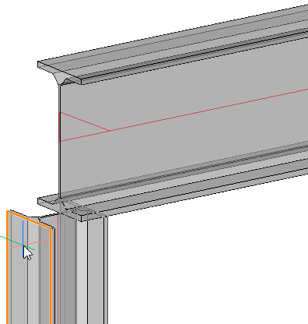 | 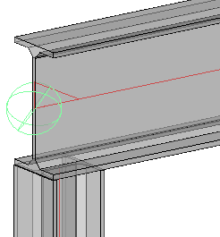
In orange you can see the plane that is being selected manually. | The end result.
The desired result in this case is a cut that extends as far as the farthest plane of the determining profile. We can only achieve this by selecting this plane manually.
- Switch direction of cut : Do not use this unless if you are designing a new connection with geometric rules.
- Keep longest side : If you enable this, then the longest side will be kept in case the profile intersects the determining profile. Disable this if you are designing a new connection with geometric rules, and instead use the Switch direction of cut option which is safe for connections that will be smart-copied and arrayed.

At the bottom you will find the options In a new macro and In an existing macro.
Leave this on In a new macro, unless if you are designing a new connection with geometric rules.

As soon as you click on OK, you are asked to select the components or planes.
Afterwards the cut is produced and stored in a macro. You can revise the macro to modify for example the offset. If you remove the macro, the cut will remain but it will no longer be intelligent.

Modify Profiles and Plates
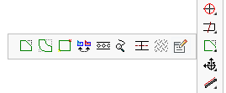
This chapter covers the modification of elements. The sub-chapters include:
- Chamfer
- Fillet
- Modify Plate Vertices
- Convert Strip / Plate
- Hex Holes (Castellations)
- Correct Twist of Helix
- Modify Axis of a Profile
- Modify Surface Treatment
- Edit Entity

Chamfer
Command - Prb_Chamfer
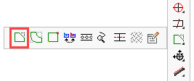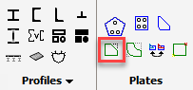

This command will work on almost all edges of plates and profiles.
It will also work on the axis of a profile if you use it on a profile with at least 2 axis line segments.
At the command line prompt:
- Enter the first distance
- Enter the second distance
- Select the first edge or axis segment
- Select the second edge or axis segment
Note that the first edge will be equal to the first distance entered, the second edge will be equal to the second distance that was entered.
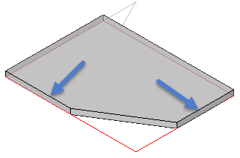
The result after applying a chamfer on a plate

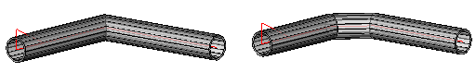
Before and after applying a chamfer on the axis of a profile

Fillet
Command - Prb_Fillet
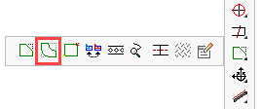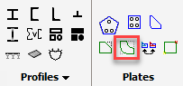
This command will work on almost all edges of plates and profiles.
But it will also work on the axis of a profile if you use it on a profile with at least 2 axis line segments.
At the command line prompt:
- Enter the fillet radius
- Select the first line
- Select the second line
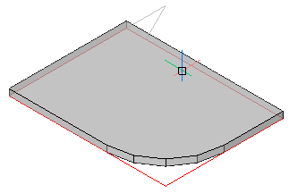
The result after applying a fillet on a plate

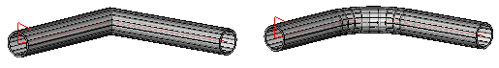
Before and after applying a fillet on the axis of a profile

Modify Plate Vertices
Command - Prb_EditPlate
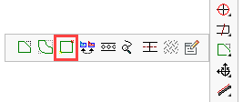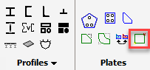
A vertex is a corner point of a polygon formed by the intersection of edges of the object.
Activating this command you will be prompted as to whether you wish to add or remove a vertex.

To add a vertex:
At the command line prompt, type 'A' (Add) and then the location for where to insert a new point.

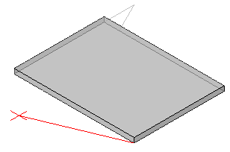
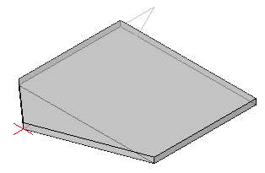

To remove a vertex:
At the command line prompt, type 'R' (Remove) and then select the plate near the point you wish to remove
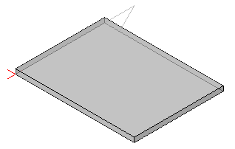
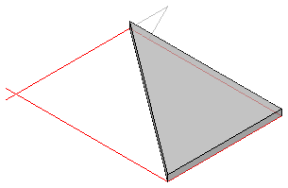

Convert Strip or Plate
Command - PrB_ConvertStripOrPlate
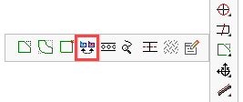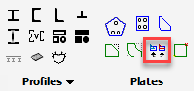
This command allows you to automatically convert a strip to a plate, and vice versa.
We will explain the 2 different object types, and why there are 2 different object types for basically the same thing.
One can always recognize the type of object (strip or plate) with the help of the axis.
These are the visual difference between a strip and a plate :
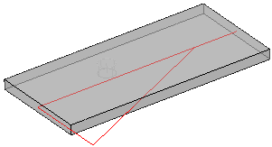 | 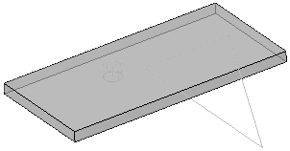
The strip has a red axis and a red triangle at the origin of the object, just like any other profile. | The plate only has a triangle in the same color as the plate itself. The location of this triangle is not important, but the rotation is.
The triangle of the plate can be rotated freely. The orientation of the triangle of a plate determines the direction in which the width and length of the plate are calculated.
For strips, the length is always the axis and it can't be rotated.

Plate
Plates are usually drawn automatically by connections. But they can also be drawn manually with the Plate with polyline command.
The plate is a unique object in Parabuild because it has a geometric limitation.
We can't cut the plate oblique in it's thickness. So it is actually a 2D circumference with a thickness.

Strip / Flat
A strip is a profile that happens to have the section shape of a plate.
It is drawn with the help of the Select Profile dialog box on the Flats/Bars/Rounds tab :
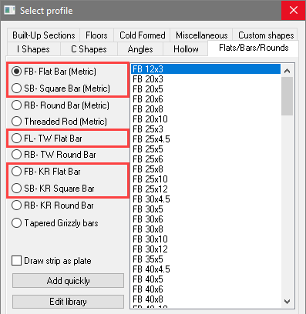
The advantage of strips over regular plates is the fact that these are fully flexible 3D objects.
We can draw bent plates and curved plates if we use a polyline for the model line of the strip.
We can also do more cutouts than with a plate. More specifically we can do changes to the thickness of the plate.
These are the geometric limitations of plates compared to strips :
- Strips can be drawn bent and on arcs with polylines, on splines and on 3D polylines :
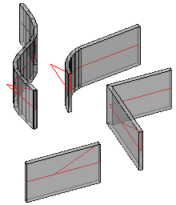 | 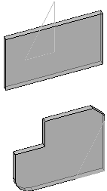
All supported shapes of the strip | The plate only supports contours
- Strips will follow the exact contours when cutting the thickness. Whereas the plate's thickness will always be drawn perpendicular.
Consider these differences when using the Cut against an element tool on a strip vs a plate:
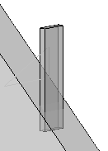 | 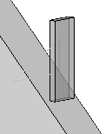
The plate before the cut was applied | The plate after the cut was applied
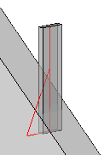 | 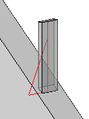
The strip before the cut was applied | The strip after the cut was applied

Conclusion
This tool solves the inconvenience that arises due to there being 2 different object types for plates/strips in Parabuild. We can convert one to the other at any time.
At the same time, having the 2 different object types gives us greater flexibility and convenience for modeling in 3D. Because the plate's geometric limitations are exactly the same limitations that a Plasma/Burning table has.
Therefore while drawing a plate in Parabuild, you're sure that this plate will automatically get a DXF file generated and the plate that you see in 3D is exactly the plate that will be produced.
For strips, Parabuild can't generate the DXF file unless you convert it to a plate first.
During the conversion process we will see the modifications that are needed to the 3D model to make it producible on a Plasma/Burner table.

The conversion
The conversion is straightforward and automatic.
However when converting a strip to a plate, the tool will ask whether it needs to remove material or add material.
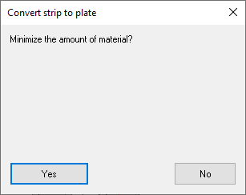
The difference between the 2 options is explained in this example :
A. is the strip being converted
B. is the resulting plate after choosing the minimize material option.
C. is the resulting plate after not choosing the minimize material option (which implies maximize material).

Hex Holes (Castellations)
Command - PrB_Hex
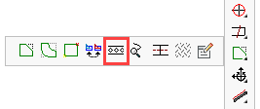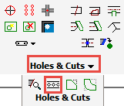
This tool is already explained in another topic : Hex Holes (Castellations)

Correct Twist of Helix
Command - Prb_ResetTwistAngle
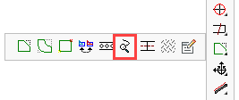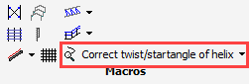

This tool is already explained in another topic : Correct twist of Helix

Modify Axis of Profile
Command - PrB_EditProfPath
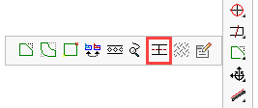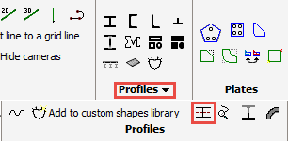

This command can be used to add to or remove bends from the axis of a profile.

Add a new vertex
In order to add a new bend to the profile, one must first select the red axis of the profile.
After that, the location of the new vertex is requested.
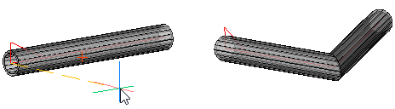
This is the profile before and after adding a new vertex to the axis

Remove a vertex
Select the profile close to the 'bend' in order to remove the vertex at that location.
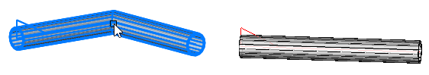
This is the profile before and after removing a vertex from the axis

Modify Surface Treatment
Command - PrB_ModifySurfaceTreatment
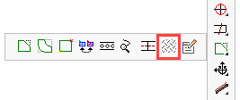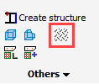
This command allows you to apply surface treatment to any surface of a profile or plate.
This treatment will influence the numbering, so if the treatment of all the surfaces are not the same then the parts will get a different pos/mark number.
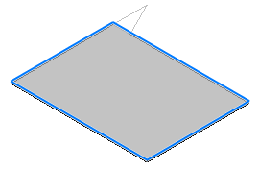
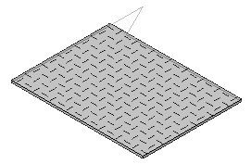
Before and after applying a surface treatment

The following dialog allows you to change some properties of the treatment :
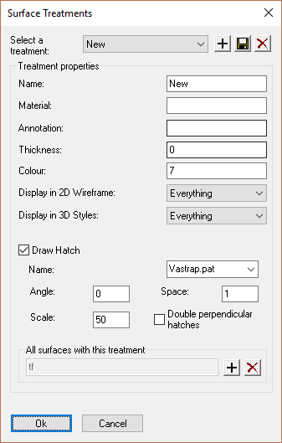
Some example values for a treatment could be :
- Name : Galvanizing
- Material : Zinc
- Annotation : Galv.
- Thickness : 0
- Color : 7 (index number of the color)
- Display in 2D wireframe/3D Styles : Display of the treatment can be limited per display style
- Activating the Draw Hatch checkbox will enable you to select a hatch pattern from the drop-down which will be drawn onto the surface of the plate or profile
- The Hatch Angle, Scale, and Spacing all refer to the display style of the hatch
- All surfaces with this treatment : Use this to assign the treatment to more than 1 surface, or to remove the treatment from a surface

Edit Entity
Command - PrB_EditEntity
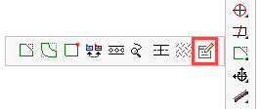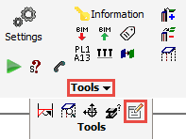
This is the command that is used when you would double-click an entity.
But with this icon we can call this command directly.

This tool will first check if entities are already selected.
If none are selected, then it will ask you to select some entities.

After acquiring the entity or entities, it will start the Review macro dialog box automatically if :
- A macro sphere was selected
- An entity owned by a macro was selected

For other Parabuild entities it will open the respective editing dialog box for that entity.
For example the Weld symbol dialog box for a weld symbol.

For all other entities that do not have such a dialog box (or in case a non-Parabuild entity was selected), the Properties dialog will be opened.

Tools
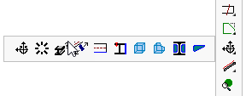
This chapter covers the manipulation of elements, structures, and stiffeners. The sub-chapters include:
- Move / Rotate
- Copy / 3D Rotate
- Show / Modify Properties
- Move along a Line
- Draw Line on an Edge
- Create Structure
- Draw a Body
- Manipulate a Body
- Web Stiffeners
- Flange Stiffeners

Move / Rotate
Command - Prb_MoveRotate
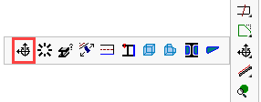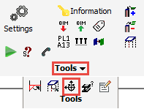
This tool allows one to directly change the distance between 2 parts, or to set a rotation between 2 parts.
The uniqueness of this tool is that it works on sub geometries for the input.
Counterpart commands such as move and rotate will work on coordinates instead of geometries.

In order for this dialog box to work, we need to select at least 1 geometry under the fixed geometry, and select 1 geometry under the flexible geometry.
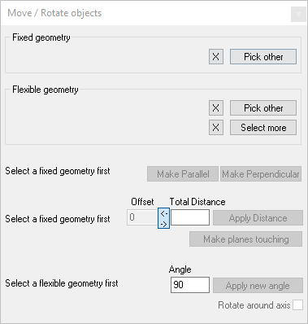

A short description for each option in this dialog :

Fixed Geometry
This is the reference geometry that will not be moved or rotated.
This would be the geometry to which you may want to align the flexible geometry to.
This geometry can be a point, a line or any planar surface of a Parabuild part.

Flexible Geometry
This is the geometry that will be moved and/or rotated to satisfy the distance or angle action (see below).
This geometry can be a point, a line or any planar surface of a Parabuild part.
You can use the button to add more objects to the selection set. All of these extra objects will join in the same move/rotate operations.

Make parallel and Make Perpendicular
These buttons will only do a rotate operation to make both flexible geometry parallel or perpendicular with the fixed geometry

Offset
Use this only if you want to move the part(s) in the direction of the Fixed geometry, while ignoring the current distance between the parts.

Total distance
This value will be filled with the current distance between the parts.
This value can thus be seen as a measurement.
However this value may be misleading when the fixed and flexible geometries are not parallel.

Apply Distance
This action will move and rotate the Flexible geometry to satisfy either the Offset value or the Total Distance value (whichever value is active).
- In case of the Offset value a simple move operation will be done in the direction of the Fixed geometry
- In case of the Total Distance value the flexible geometry is moved and rotated so that the gap between the parts is the distance entered here.

Make planes touching
This does almost the same as Apply Distance, but the distance will be 0, and the flexible part is rotated so that the material directions are opposed so that the parts are not colliding.

Apply new angle
This will do a rotation only.
It will rotate the Flexible geometry around the fixed geometry.
If you selected planes for both the fixed and the flexible geometry, then the flexible geometry will rotate with the plane's normal as the axis of the rotation.
The value in the angle field is not filled in automatically so this shouldn't be seen as a measurement.

Example
This is an example move operation that can be achieved with the Apply distance button.
This is the issue that needs to be solved : the plate was drawn relative to World but instead it should follow the roof's pitch :
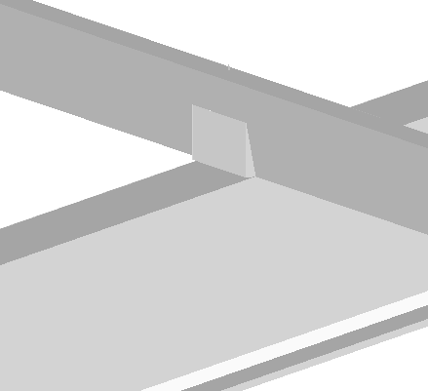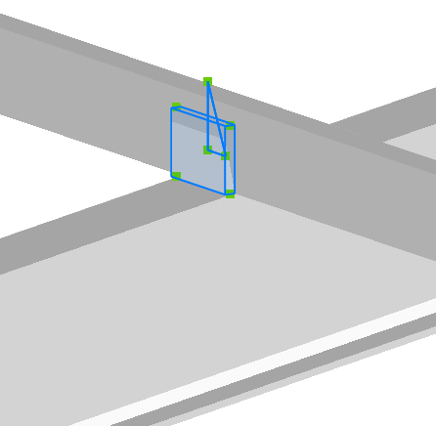

Selecting the fixed plane :
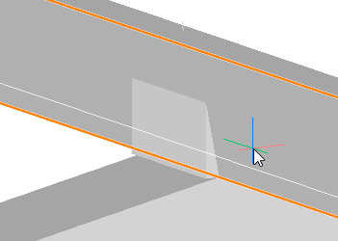

Selecting the plane that needs to be rotated :
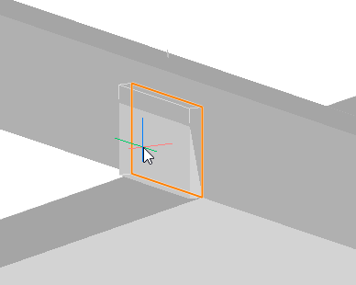

The end result after applying a Total Distance of 0 :
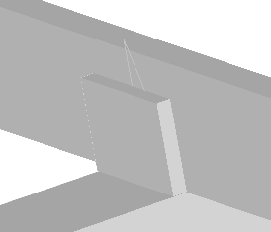

Copy / 3D Rotate
Command - PrB_ArrayRotate

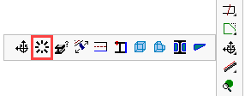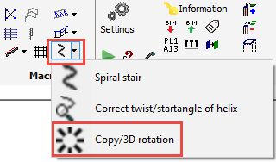

This tool can create copies of a set of objects, while rotating the new entries incrementally.
This tool was created for copying the steps of a spiral stair.

In this image, the red cross is the rotation base point which should be the center of the spiral stair :
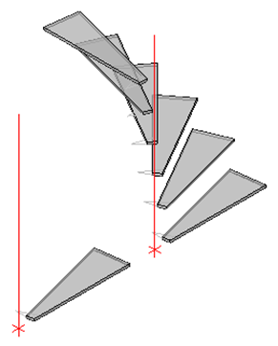

Show / Modify Properties
Command - Prb_Properties
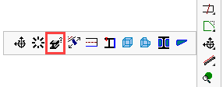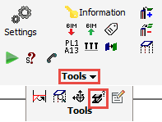
This command allows you to review and edit the properties of the selected item.
Compared to the AutoCAD/BricsCAD properties panel, it provides an alternative user interface and an alternative selection method.
The properties panel has many more capabilities so therefore it is recommended to use the panel instead of this command.
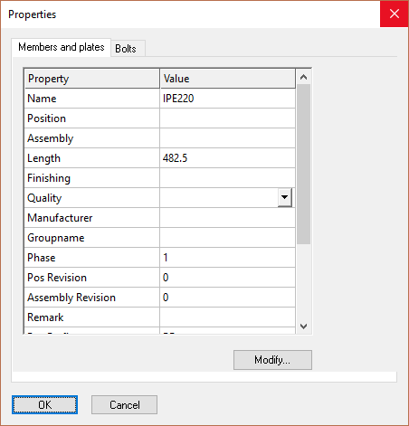

Move along a Line
Command - PrB_LineMove
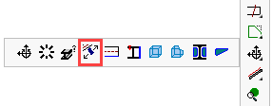
This tool allows you to move a part in the same direction as another part's edge.
So in the below case the orange line is selected, and this allows us to move the plate along the inclination of the profile.
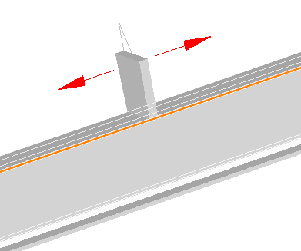

The advantage of this tool is that it replaces 2 handlings if we wanted to do the same thing with a standard move command : First set the ucs according to the profile, and then do the move command.

Draw Line on an Edge
Command - PrB_SubGeomPoly

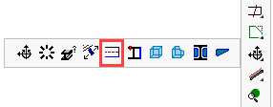
This tool will draw a line or polyline on the edge or on a surface of a profile or plate.
The command prompts you to select an edge or a surface.
A line will then be drawn on top of the edge(s) of the selected geometry.
The resulting lines will not always be visible as they are lying on top of the profile lines.
This function can also be used to select the edges and faces of cuts.
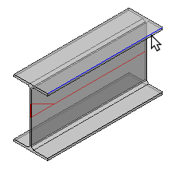
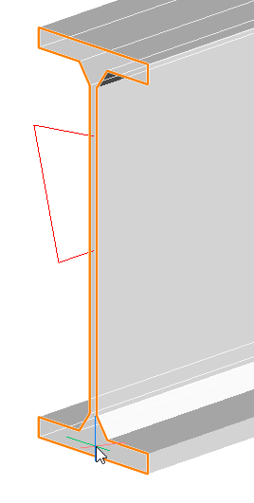

Create Structure
Command - PrB_Struct
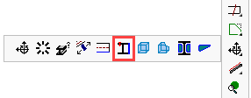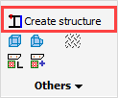
A structure is a group of elements that are grouped into one part and will therefore appear as one element in the part lists and workshop drawings.
A good example use for the structure is a stair tread.
The alternative to this tool is to leave the items as separate component parts, i.e. Profiles and Plates but the disadvantage is that these components will appear as separate parts in the workshop drawings and parts lists, which may defeat the objective, especially if the part is intended to be bought-out as one unit.
Another option is to draw the part using lines / solids, but here the component parts will not be added to the parts lists, and a variety of advantages will be lost i.e. No bolt-check, No clash-check ....
The solution is to create a Structure object.

To Create a Structure
In this example we will create a simple solid stair tread which comprises of a bent plate with a supporting angle welded to each end.
The tread plate has been created using the Custom Shapes command, while the angles have been drawn using the Draw Profiles command.
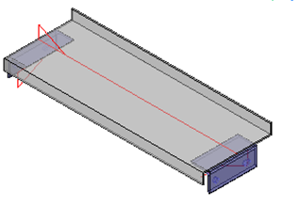
After drawing the tread as individual parts, there are 2 methods for converting them into a single structure :
- Use the command PrB_Struct to create a structure of the parts, directly inside the drawing.
- Save the elements together into the Elements library.
Choose the name in the library that will later appear in the part lists.
Now open the Elements library. To insert the new structure just click the option located on the left-hand side at the bottom Insert as one structure
The stair will appear on the screen, but the objects are now merged into 1 object.

The tread will now be added to the part list as a single part (under the name selected by the user).
If this element is selected, and the properties are requested, the element will be recognized as a structure with its own properties.
The structure also has a position number, a mark number, a phase and a revision. It can also be welded to Parabuild elements which means that it will be added to the mark drawing as an auxiliary element!
Parabuild can calculate the weight of the structure. This weight is of course dependent on the material assigned to the structure.
Multiple treads can be added to the drawing by simply using the copy command. The actual number of treads used will appear automatically in the parts list.
What exactly are structure objects?
A structure is a reference to a block.
This Block Reference is labeled as a Structure type by Parabuild and is expanded so that the following features can be used with structures: properties, welding, clash control, numbering, part lists and workshop drawings.

Draw a Body
Command - PrB_CreateBodyDlg
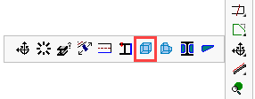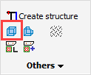
This command will create any of these volume types :
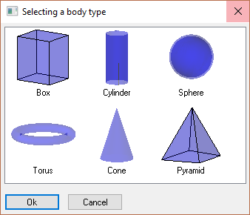

Manipulate a Body
Command - PrB_ManipulateBody
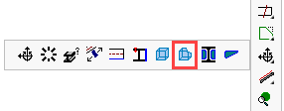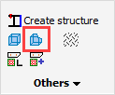
This command can perform 3 actions on 2 volumes :
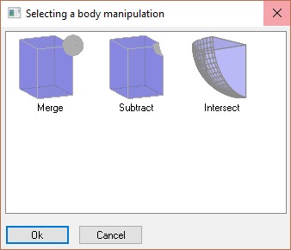

Web Stiffeners
Command -
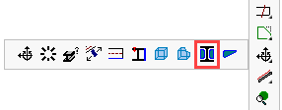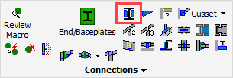

This command will add web stiffeners to any I or C channel section profile
After starting this command you will be prompted to select the profile to which the stiffeners are to be added.
After this selection, a dialog will open offering the following options:
Reinforced cut out
Small stiffeners to plane
Small stiffeners to point
Stiffeners to plane
Stiffeners to point
Stiffeners with fillets to point
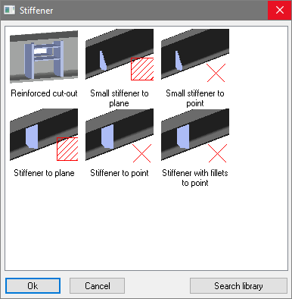

For many stiffeners there are 2 variants, to point or to plane.
We will explain the difference here :

To point
When you choose this method, Parabuild will prompt you to select a point sub-geometry.
However by pressing <Enter> instead of selecting the point, you will be able to select a coordinate using the Object Snap tools.
The point on the axis of the profile that is closest to your selected point will determine the position of the new stiffeners.

An example of using the point sub-geometry :
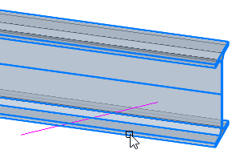 | 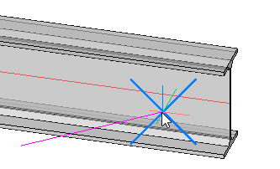 | 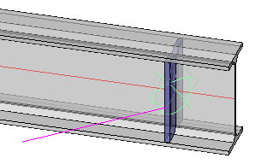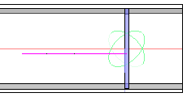
Selecting the profile that needs a stiffener attached to it | Selecting an endpoint of a line. We could select any point of any profile, plate, structure, volume, line, or polyline. | The end result, showing that the stiffener is positioned at the end of the line
An example of using the point coordinates :
 | 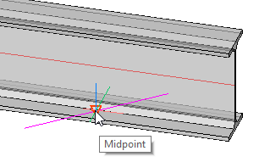 | 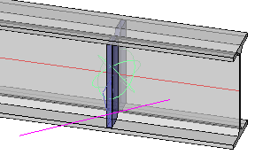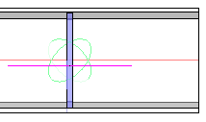
Selecting the profile that needs a stiffener attached to it | After pressing <Enter> for not wanting to select a sub geometry : Selecting the midpoint of the line with the help of Object Snapping. This is just an example.  We could snap to any point on any object. This can be a point on an object unknown to Parabuild such as 3D Solids or 3rd party software objects. | The end result, showing that the new stiffener is positioned in the middle of the line

To plane
When you choose this method, Parabuild will prompt you to select a planar surface sub-geometry.
The intersection of the selected surface with the point on the axis of the profile will determine the position of the new stiffeners.
The selected surface should not be parallel to the selected profile because otherwise, an intersection cannot be found.
A practical example of using the planar surface method :
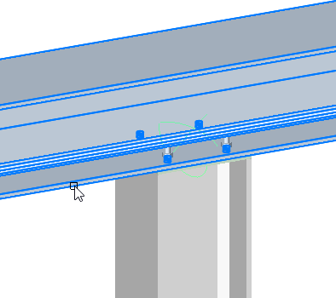 | 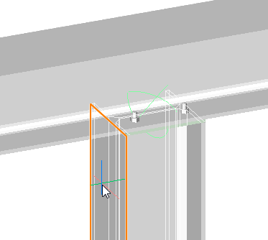 | 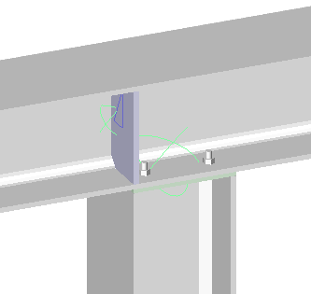
Selecting the profile that needs a stiffener attached to it | Selecting a surface of another object. The selected surface is highlighted on screen. We could select any planar surface of any profile, plate, structure, or volume. | The end result

Reinforced cut-out
This macro only exists with the to plane method.
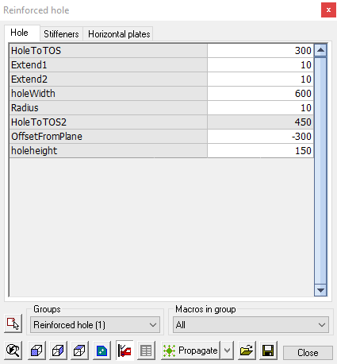 | 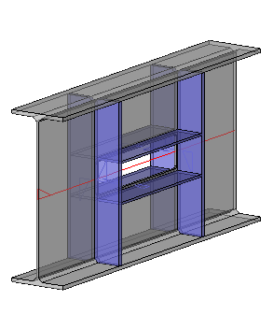
This edit dialog has 3 tabs:
Hole - where you can edit the size and position of the hole
Stiffeners - where you can edit the size and thickness of the vertical stiffeners
Horizontal plates - where you can edit the size and offsets of the plates

Small stiffeners to plane
The stiffener will be placed adjacent to the plane of an incoming column or beam.
The stiffeners are placed on each side of the profile's web, with the top of the plate in-line with the selected plane.

Here, the top flange of the incoming beam was selected :

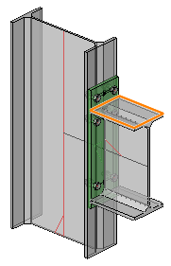 | 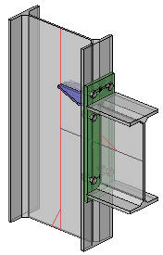 | 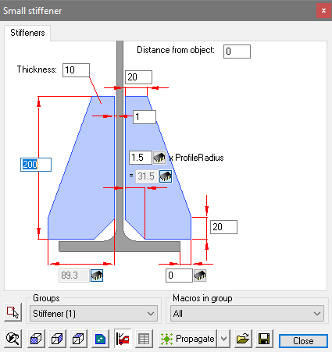
Select a Plane | Stiffener placed | The macro edit dialog
If the stiffener is to be placed at the bottom flange of the incoming beam, it may be necessary to adjust the Distance from object variable by the thickness of the plate. This will ensure the bottom of the plate is in-line with the plane of the bottom flange.

Small stiffeners to point
The stiffener will be placed adjacent to the point of an incoming column or beam
The stiffeners are placed on each side of the profile's web, with the top of the plate in-line with the selected plane.

Here, the top flange of the incoming beam was selected :
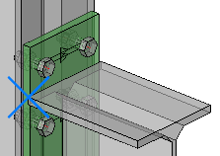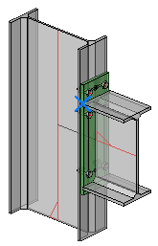 | 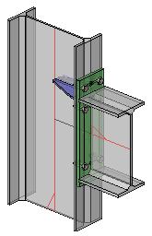 | 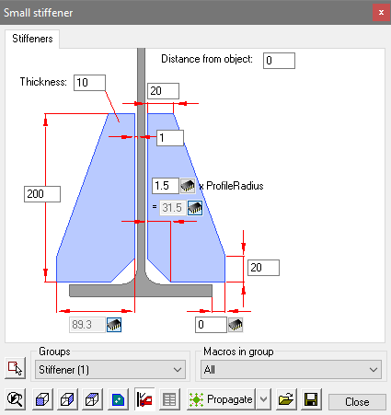
Select a Point | Stiffener placed | The macro edit dialog
If the stiffener is to be placed at the bottom flange of the incoming beam, it may be necessary to adjust the Distance from object variable by the thickness of the plate. This will ensure the bottom of the plate is in-line with the plane of the bottom flange.

Stiffeners to plane
This works exactly the same as Small stiffeners to plane, except a full-depth stiffener is drawn

Stiffeners to point
This works exactly the same as Small stiffeners to point, except a full-depth stiffener is drawn

Stiffeners with fillets to point
This works exactly the same as Small stiffeners to point, except a full-depth stiffener with fillets is drawn

Flange Stiffeners
Command -
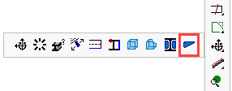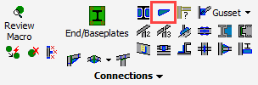

This command allows us to add Flange Stiffeners to a profile.
Activating this command, you will be prompted to select the profile to which the stiffeners are to be added. This may be either a beam or column.
After selection, the following dialog will open offering the following options:

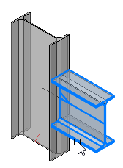 | 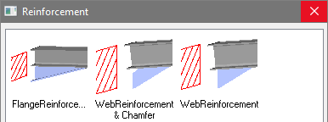
Selecting the profile
Note! Selecting the top of the beam will place the stiffener above the top flange - likewise, selecting the bottom of the beam will place the stiffener under the bottom flange.

After making the selection, you will be prompted to Select a plane. This plane will determine the face to which the selected member will be stiffened.
This may be the flange or web of a profile or plate:
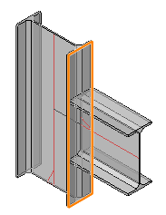 | 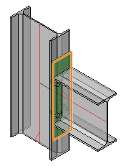
Selecting a plane  of a profile | Selecting a plane  of a plate

The default stiffener will be drawn :
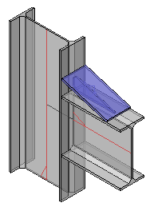 | 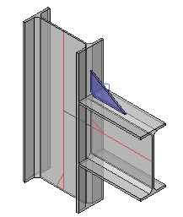 | 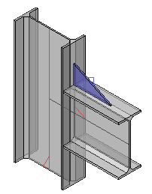
Flange Reinforcement | Web Reinforcement with Chamfer | Web Reinforcement

Stairs
- Stair
- Handrail
- Ladder
- Spiral Stair
- Correct twist of Helix
- Railing End-Connections
- Railing Intersection-Connections
- Connect Post
- Railing to Post - 2 Base
- Railing to Post - 3 Base
- Weld Connections
- Draw Grating

Stair
Command - Prb_Stair
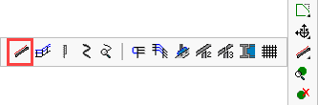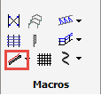
This command will automatically draw 2 stair stringers with accompanying treads and bolts.
There are 3 basic stair models covered by this command:
- Draw a stair from the ground level (UCS World) to a beam
- Draw a stair - from beam to beam
- Draw a stair on a line
Connections between the stair stringers and the supporting steelwork may be selected from the standard range of Connections
All 3 models can be drawn with the same command.
The types of objects that you select will determine which of the 3 stair types will be drawn.

Draw a stair from the ground level (UCS World) to a beam
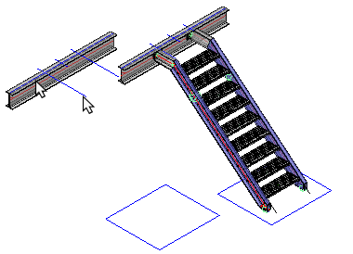
At the command line prompt:
Select the near side face of the top beam. Note! this selection will determine the direction of the stair.
As there is no bottom beam press <Enter>
Next, select either a line or profile to indicate the horizontal placement of the stair. Note! that the horizontal geometry will determine the inside face of the left hand stringer. Press <Enter>
The Stair configuration dialog will appear prompting you to select the desired stair type.
The default stair will be drawn accompanied by the Stair macro edit dialog. Note! that the stair will be drawn with the top stringer aligned with the top flange of the beam
You can review the stair at any time by selecting the large macro sphere and activating the Review macro command, or you can double-click the sphere - both options will open the Edit dialog.
You can also edit components of the stair, for example the base connection, by selecting the smaller macro sphere

Draw a stair - beam to beam
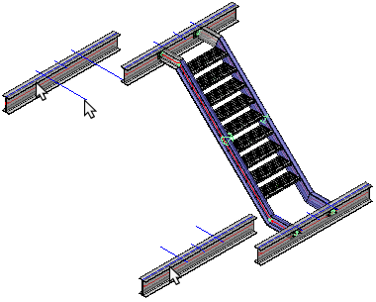
At the command line prompt:
Select the near side face of the top beam. Note! this selection will determine the direction of the stair.
Then select the bottom beam and finally the horizontal geometry, which again, may be either a line or an incoming profile. press <Enter>
The Stair configuration dialog will appear prompting you to select the desired stair type.
The default stair will be drawn accompanied by the Stair macro edit dialog. Note! that the stair will be drawn with the top and bottom stringers aligned with the top flanges of the beams
You can review the stair at any time by selecting the large macro sphere and activating the Review macro command, or you can double-click the sphere - both options will open the Edit dialog.

Draw a stair on a line
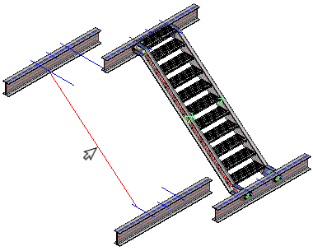
The line drawn will define the geometry of the stair, i.e. the angle and stringer length.
At the command line prompt: Select the line for the stair - this will open the Stair configuration dialog prompting you to select the desired stair type.
Note! that the line will determine the inside face of the left hand stringer
When done, press OK and the default stair will be drawn accompanied by the Stair macro edit dialog.
The stair will be constrained to the line, my moving the line, the stair will move and the stringers,cranks, and connections will automatically update.

The Stair configuration dialog
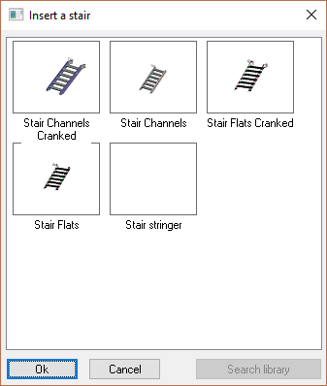
The stair configuration dialog will prompt you to select the stair type - the main options include:
- Stair Channels Cranked - This selection will draw a stair with channel stringers, cranked at the top and/or bottom.
- Stair Channels - This selection will draw a stair with channel stringers but not cranked. By default, Parabuild will draw the top of the stringer intersecting the toe of the beam. This may be modified using the Stair macro edit dialog
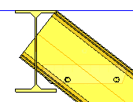

- Stair Flats Cranked - This selection will draw a stair cranked at the top and/or bottom with flat bar stringers.
- Stair Flats - This selection will draw a stair with flat bar stringers without cranks. The geometry will be the same as for Stair Channels.

The Stair macro edit dialog
The default stair is accompanied by the customization dialog:
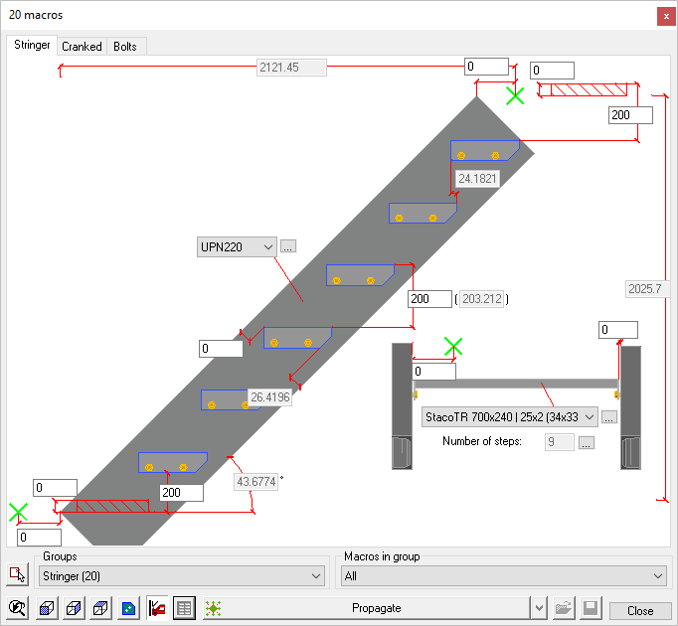

This dialog enable you to revise the geometry of the stair within the boundaries of the selected supporting steelwork. The dialog has 3 tabs:
1. / Stringer - 2. / Cranked - 3. / Bolts
The stringer tab enables you to set the profile size, stair tread risers, and the stair slope. Note! that the stair slope cab be modified directly if the stair is drawn from ground level. If the stair is constrained between a top and bottom beam, the angle can only be changed by revising the geometry of the horizontal component of the crank (Refer to the cranked tab). Or moving one of the beams up or down would also change the stair's slope.
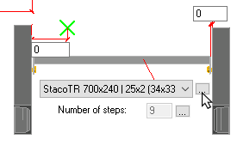
The stair treads may be set from the drop-down options - where the default options are drawn from the 'Staco' standard range. Note! that the width of the tread will determine the width of the stair.
For stair treads not included in this range, you may include standards of your choice by editing the treads table
To open the tread table, press the button on the right-hand side of the stair tread drop-down.
Here you will see a table wherein each row represents a tread.
The columns determine the geometry of the treads, more specifically:
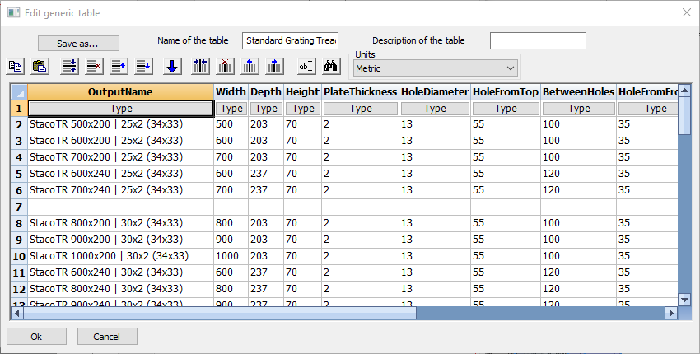

- Output name - Enter a unique name for the stair tread
- Tread width - Measured over the side plates
- Tread depth - Measured from the nosing to the back of the tread
- Plate thickness - Side-plate thickness
- Hole diameter - Bolt-hole diameter
- Hole from top - Measured from the top of the tread to the center of the hole
- Between holes - Measured as the horizontal distance between the holes
- Hole from front - Measured from the front nosing to the center of the first hole
- Chamfer front1 - Side plate front chamfer
- Chamfer front2 - Side plate front chamfer
- Chamfer back1 - Side plate back chamfer
- Chamfer back2 - Side plate back chamfer

Railing
Command - PrB_Railing
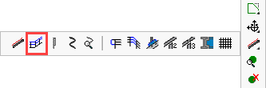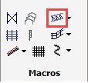
This command can draw railing segments on top of lines or profile edges. It will also connect these railing segments wherever possible.
After activating this command the Insert a railing dialog will appear, giving you the following options:
- Railing: This option will draw both handrail / knee-rail complete with a flexible amount of stanchions. By default it has a minimum of 2 stanchions. The number of stanchions will grow depending on the railing segment's length.
- Railing 1 post: This option will draw the Hand and Knee-rail only with just 1 vertical stanchions. This option would be used when the railing segment is so small that only 1 stanchion is needed. An example of such situation :
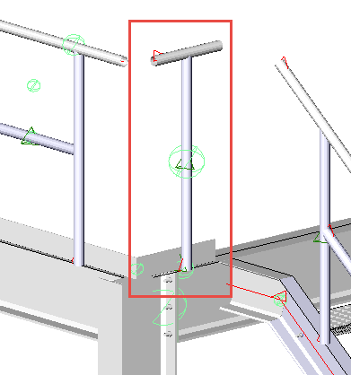 | 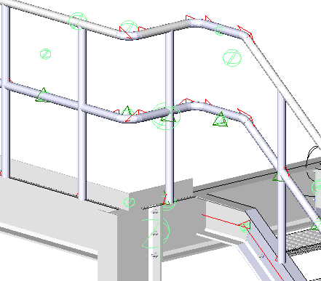
The first result after drawing the railing segment with just 1 post | The end result after using the Railing intersection connections on it
- Railing - no posts: This option will draw the Hand and Knee-rail only without vertical stanchions. This option would be used when the railing segment is so small that no stanchions are needed. An example of such situation :
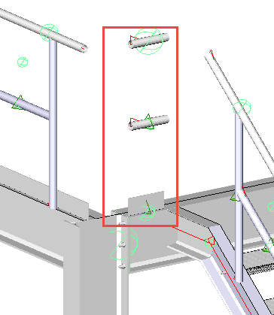 | 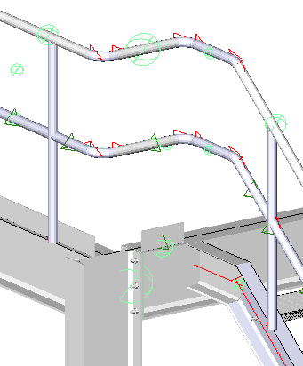
The first result after drawing the railing segment without posts | The end result after using the Railing end connections and Railing intersection connections on it
- Curved railing - A curved railing can be drawn by selecting an arc or an edged of a curved profile.
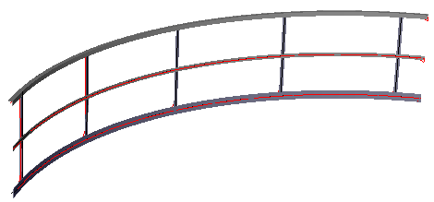

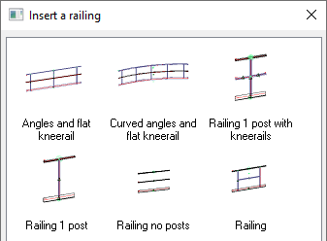
Select the desired option and press OK - then select the profile or line on which to place the railing
Here, it's important to note, that the selected edge of the beam will determine the placement, which may be either of the top edges, the center of the beam, or a user drawn line.
Note that the selected edge will become the center of the handrail. This location can still be offset afterwards.
The handrail may be edited at any time by means of the Review Macro command.

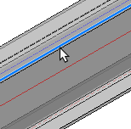 | 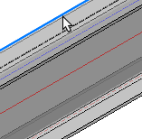 | 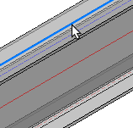 | 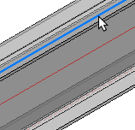
Near Side Edge | Far Side Edge | Center | User defined line

Next you will be prompted to select a geometry to shorten the railing
Pressing <Enter> will draw the handrail the full length of the selected member or line, disregarding any incoming stairs or platforms (See Fig. 1)
Alternatively, you may select an incoming beam or stair stringer to shorten the railing (See Fig. 2)
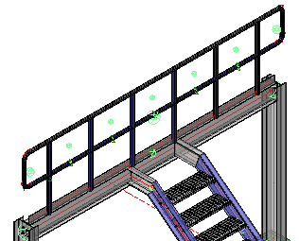 | 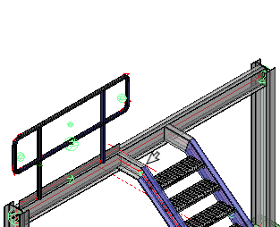
Pressing <Enter> will draw the handrail the full length of the selected member or line | Indicating a geometry to shorten the railing - in this case - the inside face of the incoming stair stringer

Chaining the handrail segments
After drawing the first handrail segment - the prompts will repeat allowing you to continue to trace the handrail route. Parabuild will automatically join the handrail segments together. To enable this sequential operation to work at its best, the handrail segments should be selected contiguously.
Parabuild will automatically insert a closure at non-contiguous joints. In the example illustrated below, the handrail was begun and ended at the stair - in which case the closures at the bottom of the stair are appropriate.
If the handrail is placed around a platform with no shortened segments, the closures will still be placed at the beginning and end of the chained handrail segments. To rectify this, delete the closure segments using the Delete macro command and activate the Railing intersection connections command and select the handrail stanchions - Press <Enter> and the returns will be automatically drawn.
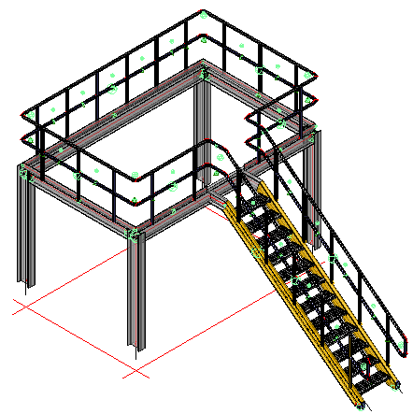
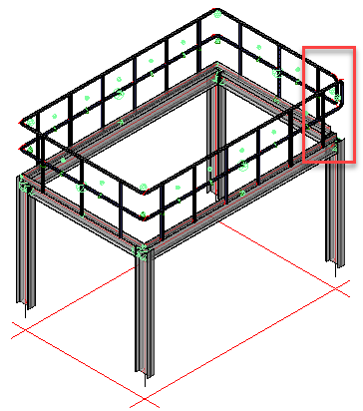

Editing the Handrail Dialog
As the handrail is drawn, the handrail edit dialog will appear. This dialog has 3 tabs: Railing / Toe Plate / Connectors
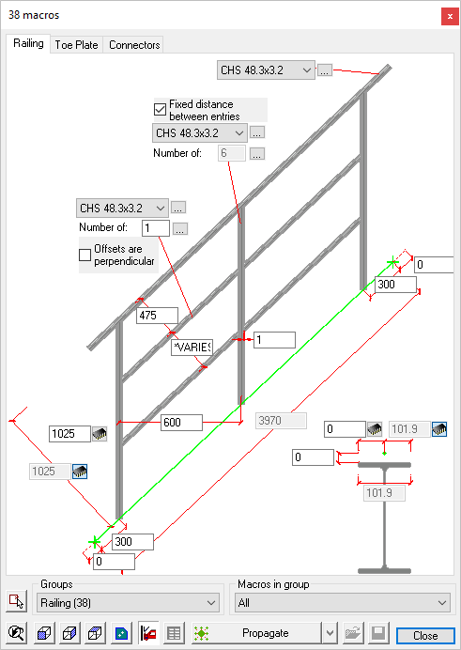

Railing:
Here, you may edit the handrail, knee rail, and stanchion section sizes. By default they are drawn as standard Circular Hollow Sections - by activating the drop down options menus adjacent to the default size, you may select another size.
Hitting the button to the right will open the Profile placement dialog where you are able to select a section from another group. (Be careful when doing this as it may require significant editing of the various handrail joints and connections)
It is also possible to edit the stanchion and handrail spacing.
Placing the handrail relative to the beam or stringer can be done by revising the dimensions at the bottom/right of the dialog

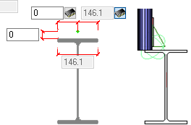 | 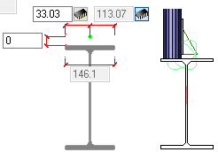 | 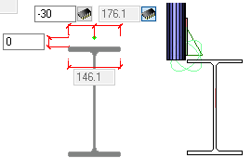
Handrail located on edge of beam | Handrail located on beam flange  For base-plate mounting | Handrail located to clear beam flange  For side-plate mounting

Toe Plate:
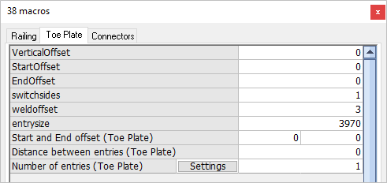
The options for editing the Toe Plate or Kick Plate include:
Vertical offset - the distance between the bottom of the toe plate and top of steel
Start offset - The horizontal offset at the beginning of the toe plate
End Offset - The horizontal offset at the end of the toe plate
Switch sides - Is a boolean variable, a value of 0 will place the toe plate on the inside of the handrail stanchion, while a value of 1 will place it on the outside
Weld offset - refers to the weld gap between the stanchion and the toe plate, the default setting is 3 mm

Connectors:
The Connectors tab contains 2 options:
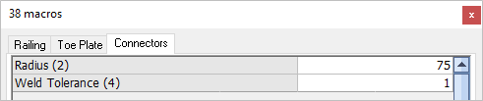

Radius - Here you may edit the radius of the bends
Weld Tolerance - Here you may edit the weld gap between the bends and the horizontal rails.

Ladder
Command - PrB_Ladder
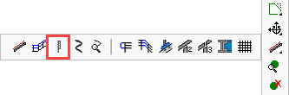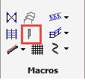
This command allows you to draw a variety of ladders, among which :
- Cage Ladder - First hoop larger
- Cage ladder UPN
- Cage Ladder
- Ladder with Opening
- PIP Caged Ladder
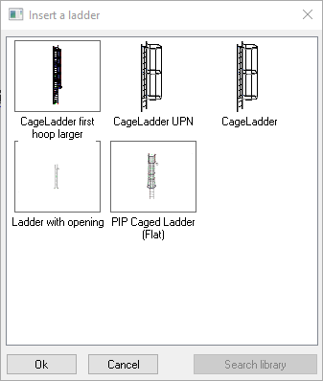

Some ladders like the PIP caged ladder require you to select 3 surface planes and 1 other geometry.
The purpose of these 4 geometries is to immediately insert the ladder at the right location with the correct start height and stop height.
And even after initially inserting, the ladder will stay connected to these 4 geometries. So when any of these geometries change, the ladder will move or change in length automatically.
These are the 4 geometries that are asked for in the command in this order :
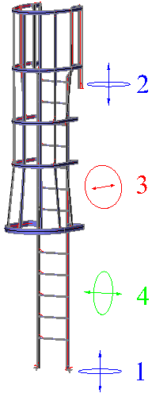
  - The first plane is the bottom starting location of the ladder
  - The second plane is the position for the highest rung. This could be the top plane of a beam of the top platform.
  - The third plane is the plane against which the ladder should be positioned or mounted.
  - The fourth and last geometry can be a plane, a line, or a point. It determines the placement of the ladder in the last undetermined direction.
For the first 3 planes, the planes of existing beams and a column could be used.
For the fourth and last geometry, a grid line that is not parallel to plane 3 could be used (this line or plane needs to intersect with plane 3).
After the selection of the 4 geometries, the ladder should be inserted and the following dialog box is shown afterward :
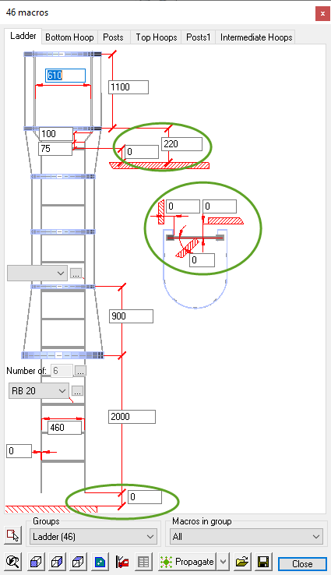
In this image, you can see 6 encircled values. These 6 values still allow us to displace and rotate the ladder relative to the 4 geometries that were selected during the insertion of the ladder.

Spiral Stair
Command -
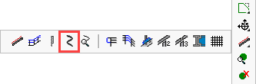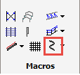
This command allows you to draw a profile on a 3D spiral axis. The axis of the profile is drawn using straight segments, as an approximation of a spiral. The accuracy of this approximation is set by the user.
This command will draw the following entities :
- The spiral model line
- The spiral profile
- A macro that connects the spiral profile to the model line, and calculates the twist angle of the profile.
To change the location and rotation of the spiral you need only move/rotate the model line.
To change the dimensions of the spiral itself, you need to use the Properties of the model line.

Correct Twist of Helix
Command - Prb_ResetTwistAngle
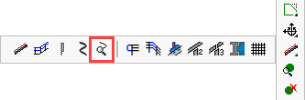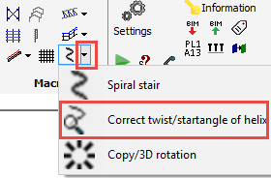

This command will recalculate the twist angle of a profile with a helix axis.
The twist angle is what keeps a flat bar 'upright' on the helix path.
The current twist angle value can be found in the properties of the profile.
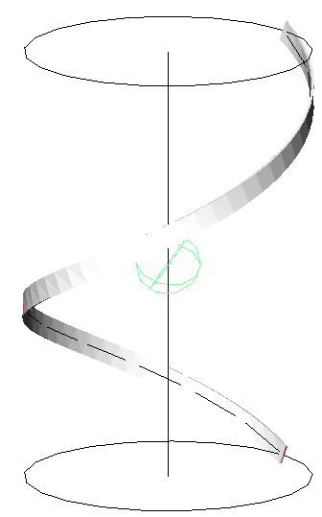
Moreover, when a profile is linked with a macro to the helix, then the macro will maintain the twist angle so that this command is not needed.
A Circular Hollow Section does not need to have a correct twist angle because the section shape is fully symmetric.

Railing End Connections
Command - PrB_AddRailingEndConns
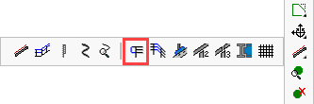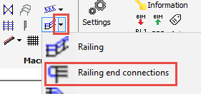

This command will add a closure to a railing segment.

The railing segment command already does this automatically.
But there may be instances where a handrail closure must be added manually.
This command has 2 distinct methods :

Automatic Method
This method is unique, because you just need to select the handrails and the last posts.
It does not matter if you select more posts or knee-rails. The sequence is also not important.
Block-select the handrail end that needs to be connected and press <Enter> The closures will be automatically placed.

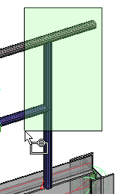 | 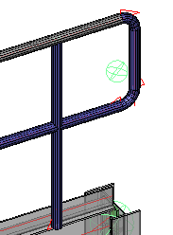
Automatic Method

Manual Method
Right after starting this command, press the <Enter> button without selecting anything.
This brings us to the manual method.
Now you will have to first select the handrail close to it's end.
Note : Parabuild will use this handrail's side as an orientation marker to decide on which side of the post to place the connection.
After that, select the post and you will have the option to choose any of the connections in the group :
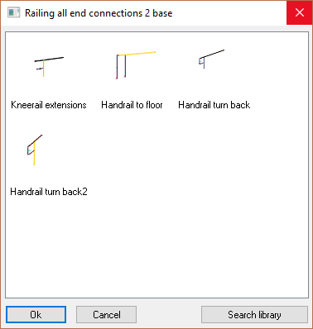
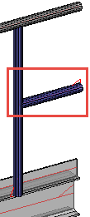 | 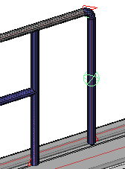
Knee rail Extensions. These are needed when you want to connect a stanchion to a railing segment without stanchions. An example case is shown in the Handrail section. | Handrail to floor
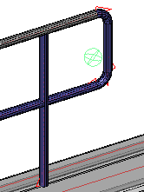 | 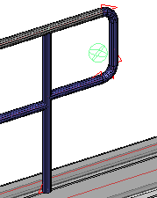
Handrail Turn-back | Handrail Turn-back 2  This is exactly the same macro, but it has a different orientation.  In this command it does not matter which one you choose, but it does matter for automated tools that draw these end connections automatically.

Railing Intersection Conns.
Command - PrB_AddRailingInterConns
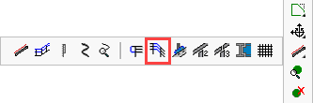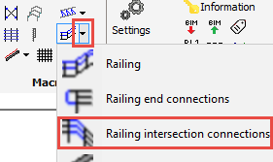
This command can connect 2 railing segments.

The railing segment command already does this automatically.
But there may be instances where a handrail closure must be added manually.
This command has 2 distinct methods :

Automatic Method
This method is unique, because you just need to select the handrails and the last posts.
It does not matter if you select more posts or knee-rails. The sequence is also not important.
Parabuild will try to automatically connect all the members in the selection using the connections in the chosen library group.
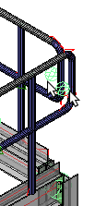 | 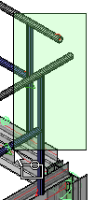 | 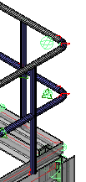
1  Select and delete the unwanted macros | 2  Block select the handrail stanchions - Press <Enter> | 3  The returns are automatically drawn

Manual Method
Right after starting this command, press the <Enter> button without selecting anything.
This brings us to the manual method.
Now you will have to select both the handrails and the posts.
After that you will have the option to choose any of the connections in the group :
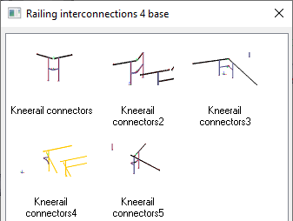

Connect Post
Command -
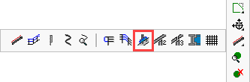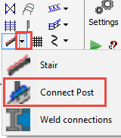

This command will apply handrail stanchion connections to a beam of stair stringer

Select the beam or stair stringer and Parabuild will automatically detect the angle of the stair stringer and adjust the connection orientation to suit.
Then select the post and press Ok - The default connection will be drawn - Pressing <Enter> will open the connection edit dialog.
Note! Ensure that the handrail post is properly located on the stringer to accommodate the selected connection. For more information on this go to - Stairs / Handrail / Railing
For more information on editing macro dialog boxes see the Review macro topic.

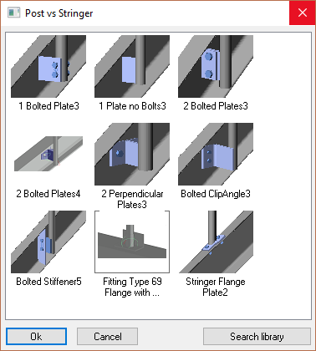
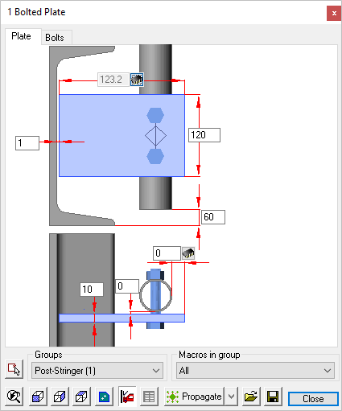

Connect Post to Handrail - 2 Base
Command -
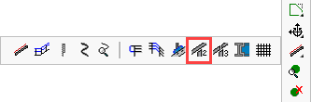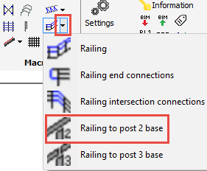
This command can connect a post to a railing.
Some example connections are :
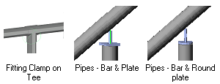

Connect Post to Handrail - 3 Base
Command -
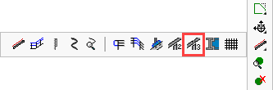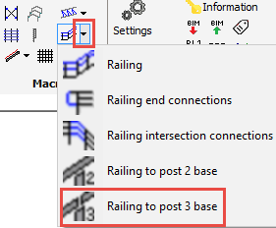
This command can connect a post to 2 railings when they are spliced.
For now the only application for this command is for fitting connections :
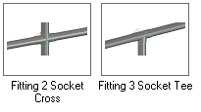

Weld Connections
Command -
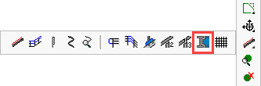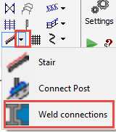
For more information about these connections, see the Weld connections topic in the connections chapter.

Draw Grating
Command - PrB_Grating

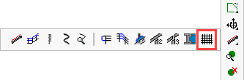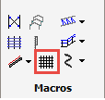
This command allows you to draw floor grating or raised pattern floor plates over a defined surface area. The flooring options include:
PLBG - Press lock bar grating
WBG - Welded bar grating
SLBG - Swage lock bar grating
RPFP - Raised pattern floor plates
These options are explained in more detail under Floors
You will be prompted to select the entities that define the boundary for the floor, when don, press <Enter> The floor will be automatically drawn accompanied by the edit dialog.
The floor panels will be placed as an array at the extremities of the selected entities with the bearing bars running in the direction of the shortest span. The floor panels are set according to the selected standard width. These widths have been established by Parabuild at 800 mm, 900 mm, 1000 mm, 1100 mm, and 1200 mm.
At the time of writing, the command only supports flooring patterns of which the contour is described by 4 profiles.
Note! Standard widths, maximum panel lengths, bearing bars, transversal bars, may be customized to suit regional or manufacturers standards by editing the Flooring Profile Library. The same library allows you to create new libraries to meet the above criteria.
The floor panels will be placed, with the width of the last panel being non-standard to accord with the total overall width of the defined surface area. This may be edited in the flooring edit dialog.
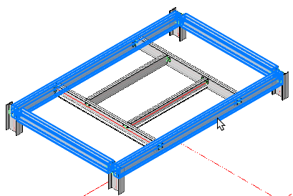 | 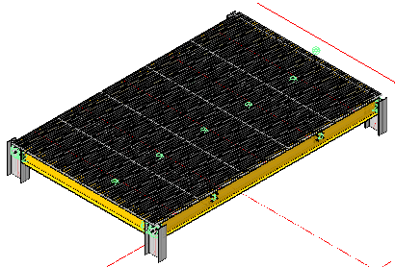
Select Entities | Draw Grating

The initial flooring edit dialog will edit the entire flooring array providing the following options: Individual floor panels may be edited by using the Review macro command.
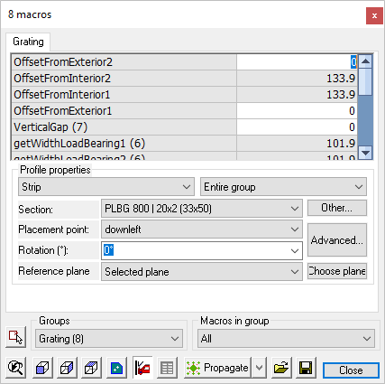

OffsetFromExterior2 - (Variable) - The offset between the floor panel and the right side extreme edge of the defined surface area
OffseFromInterior2 - (Fixed) - The value given is representative of the width of the top flange of the beam. This value will update as the former is edited.
OffsetFromExterior2 - (Variable) - The offset between the floor panel and the right side extreme left of the defined surface area
OffsetFromInterior2 - (Fixed) - The value given is representative of the width of the top flange of the beam. This value will update as the former is edited.
VerticalGap - Is the distance between the top of the floor beams and the underside of the flooring panels
GetWidthLoadBearing1 - Is the flange width of the top load bearing member
GetWidthLoadBearing2 - Is the flange width of the bottom load bearing member
OffsetFromLoadBearingExterior1 - (Variable) - The offset between the floor panel and the top side extreme edge of the defined surface area
OffsetFromLoadBearingInterior1 - (Fixed) - The value given is representative of the width of the top flange of the beam. This value will update as the former is edited.
OffsetFromLoadBearingExterior2 - (Variable) - The offset between the floor panel and the top side extreme edge of the defined surface area
OffsetFromLoadBearingInterior2 - (Fixed) - The value given is representative of the width of the bottom flange of the beam. This value will update as the former is edited.
GapBetweenGratings - Is the gap between the grating panels
TotalLength - This is the total length of the area from first to last beam.
Start and End offset (Grating array) - This will set the start and end offset of the entire grating array measured from the defined surface area
Distance between entries (Grating array) - This value is derived from the floor panel width and the gap between panels. This value will automatically update as the gap between panels is changed.
Number of entries (Grating array) - The number of panels forming the flooring array
Profile Properties
From the drop-down menu - Strip - All the grating panels are grouped under the name Strip. In other macros, more or other group names might be listed here.
From the drop-down menu - Entire group - Select this to edit all of the grating panels
Section - From the drop down menu you may select a different flooring type e.g. panel width, depth, bearing bar .....
Pressing the Other button will open the Select profile dialog, where you may select flooring from another group (PLBG, WBG, SLBG, RPFP)
Placement point - From the drop-down menu, you may select the placement points for the individual floor panels in the array. pressing the Advanced button will open the Profile placement dialog - where you may edit all the profile properties and placement.
Rotation - where you may select a vertical rotation angle from the drop-down options menu.
Reference plane - where you may select from the drop-down options menu the reference plane options, here you have the option to select a plane by pressing the Choose plane button. By default Parabuild will place the floor panels on top of the selected defined surface.

Modify Macros

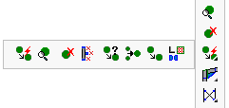
- Smart copy
- Review Macro
- Erase macro
- Erase objects and dependent macros
- Smart copy settings
- Merge macros
- Copy a macro
- Connection components library

Review Macro
Command - PrB_DlgMacro
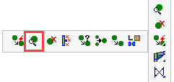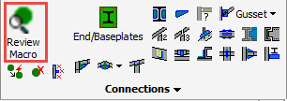

Using this command you can review and edit multiple macros.
Here you may select one macro sphere using the mouse pointer, or any number individually, or using a frame.
A Macro is identified by a sphere, which is a collection of geometric rules that holds the 'intelligence' of the elements making up the connection.
When a base profile of a connection is modified, the rules in the sphere will ensure that the elements in that connection adapt automatically to whatever modifications are made.

Reviewing macro using double-click
This command can also be accessed without the use of the icon.
When double-clicking a macro or a part, the corresponding macro will be opened in the Review macro dialog box.
More advanced options are available by pressing the SHIFT and/or CTRL keys while double-clicking, this will change the behavior of the action.
These are all the different behaviors, with an example drawing of what would happen when double-clicking a side rail :
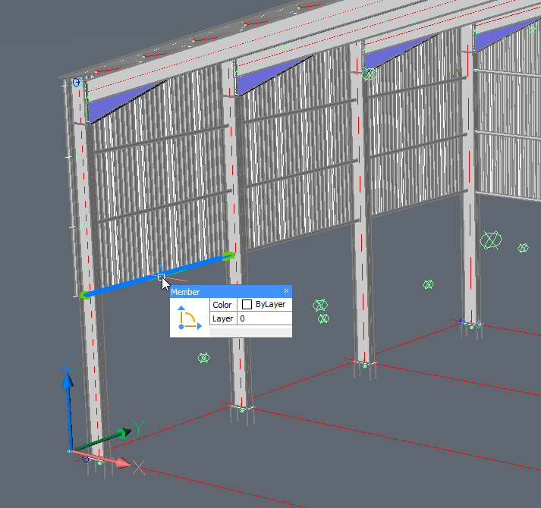
This is a Parabuild portal frame template that was fully parameterized, and we're double-clicking one of the side rails.
- Double-click without SHIFT nor CTRL pressed - Only the macro of the selected part will be reviewed. In the example, just the macro of the single side rail will be reviewed.
- Double-click with SHIFT OR CTRL pressed - All of the parts that are dependent on the same array will be reviewed. In the example the 4 side rails and the array itself will be reviewed.
- Double-click with SHIFT AND CTRL pressed - The top owning macro of the part that you selected will be opened, together with all of its sub-macros. In the example, the top owning macro is the portal frames macro so the entire drawing will be reviewed. That is because the entire drawing is fully parameterized.

The dialog box
In this example we'll be working with a drawing fragment which is comprising of two connection types and two column web stiffeners.
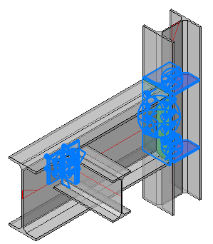
Clicking the Groups drop-down menu will show which macros have been captured by the selection (the number of each of the macros is shown in parenthesis).
Clicking on one of these macros will open the specific edit dialog (For more information on editing the dialog see the Review Macro dialog).
Should there be more than one macro in the selected group, any changes made will reflect in all macros within that group. An example, in this case, are the stiffeners.
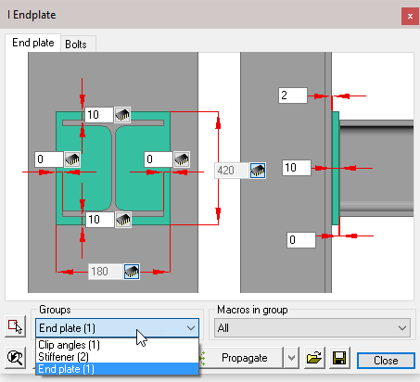

Select Stiffener (2) from the drop-down menu to open the edit dialog and change one of the dimensions, both of the stiffener macros will update
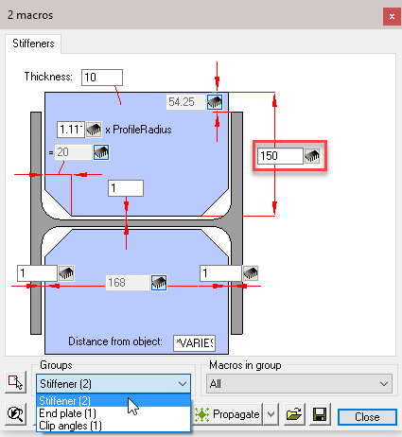

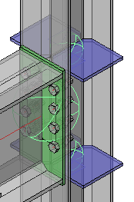

To change only one of the macros, click on the Select other macros button, and following the command line prompt: Select Entities.
Here you may select the stiffener macro sphere, or the stiffener itself and press <Enter>. Now edit the macro dialog as before, but this time only the selected macro will be updated.
This function will work with all macros.
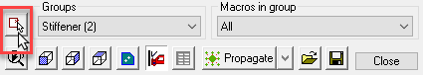

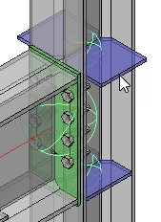

The Macro edit dialog is available for all connections and will appear whenever a new connection is drawn.
Alternatively, the edit dialog may also be accessed by the Review macro command.
Each dialog is divided into 5 sections:
- The Title bar - which displays the current macro name (or the number of macros if more than 1 is being edited)
- The Tabs bar - which indicates the number of modules making up the macro. Selecting one of the tabs will open the appropriate edit dialog window. (Note! that the tabs will vary according to the selected connection type)
- The Dialog edit window - where the dimensions may be edited. This is explained in detail later in this chapter
- Bolts - (Under the Bolts tab) where you may select the bolt assembly and diameter from the drop-down menus
- The functions bar - where you may select, view, copy, and adjust macro settings. This will also be explained in detail later in this chapter.

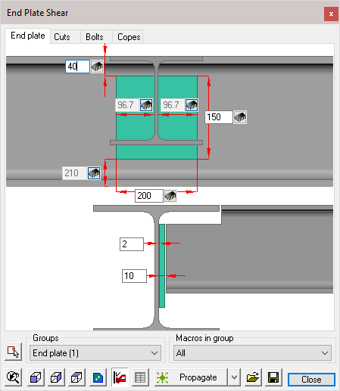

The Dialog Edit Window
There are 4 different types of dimension controls:
- Switchable - This dimension type will be found where a dimensions is part of a string. Activating the switch will either enable or disable the dimension making it editable or responsive. A responsive dimension will automatically update when other dimensions in the string are changed.
Active | Responsive
- Active - an active dimension may be edited at any time
- Responsive - A responsive dimension is shown 'greyed' and cannot be directly edited, it will automatically update when other dimensions in the macro are changed, or when a dependent object in the drawing has changed. These dimensions are to be considered 'Reference dimensions'.
- Bolt spacing - These dimensions are found with bolt groups and can be identified by their elongated nature. There are two ways in which these dimensions are used. A single value will indicate the number of bolts to be equally spaced within the overall centers.
In the first example, there will be 3 bolts, equally spaced inside the overall centers of 140 (2 x 70)
In the second example, the hole centers are specified separated by a comma (70 x 70). Any number of bolt centers may be specified.
This is particularly useful when the bolts are not equally spaced.
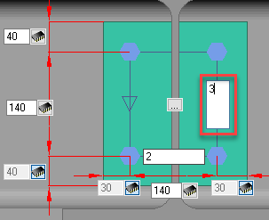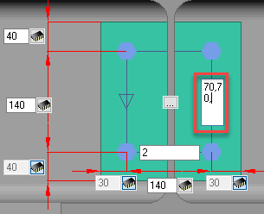

Pressing the button at the center of the section will open the Bolt pattern settings dialog, where you can perform the following actions:
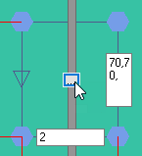

The Functions Bar
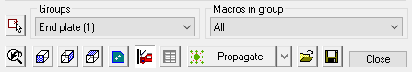

Select other macros Activating this command will prompt you Select entities, enabling you to modify a different selection set of macros.

Groups - The drop-down menu will list all the selected macros, the number in the (parenthesis) will indicate the number of selected macros in the group. Selecting a macro will open the macro edit dialog.
Any changes that you do in the dialog will be applied to all the macros within the group. If you wish to edit only one of the macros, use the Select other macro function below.

Macros in group - From the down menu you can choose to edit all macros in the group, or only one of the macros. This second list is therefore dependent on the group that you have selected: the list will be updated each time you select another group.

View buttons
Restore original 3D view of the selected macro
Front view of the selected macro
Side view of the selected macro
Top view of the selected macro
Front view of the current part. This button will give you a view of the parts of the current module tab : If the Bolts module is active, you will see a top view of the bolts.
When you modify a dimension of the connection, the complete connection will be checked for collisions. This icon works as a switch to enable or disable this automatic clash control. It can be useful to turn it off when you are editing many connections simultaneously and the clash control demands too much calculation time.
This will execute the standards on the connection again. For more information about this see the chapter Standards for connections.

Next to the propagate button, there is a drop-down button that gives us access to a range of tools that will do something with the currently active macro(s) :
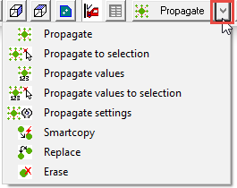

These are the purposes of all the tools :
This tool will automatically copy the macro to all similar geometric locations in the drawing, potentially saving you a lot of time. For more information about this automation tool, see chapter Propagate.
For more information about this automation tool, see chapter Propagate.
For more information about this automation tool, see chapter Propagate.
For more information about this automation tool, see chapter Propagate.
For more information about this automation tool, see chapter Propagate.
This tool allows you to copy the macro to other profiles. For more information about this tool, see chapter SmartCopy.
This tool will replace the current macro with a new one from the library.
This tool will erase the macro and all of it's components.

With these tools you can save all values of the current selected connection(s) under a name and recall them at a later time.

Bolt Pattern Settings
This dialog comprises of 2 columns, the left hand column applies to bolts in the horizontal, while the right column applies to the vertical direction.
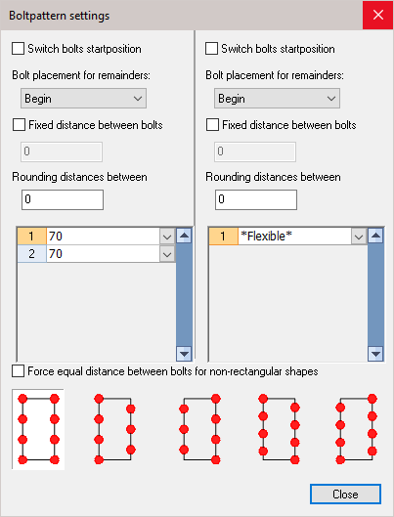

Switch bolts start position: Activating this check-box will reverse the order of the bolts, either from top to bottom, or side to side. This checkbox will only have an effect when the manual bolt spacing has been used.
Bolt placement for remainders: This option works in combination with the Fixed distance between bolts option because with it you stipulate at which side the remaining distance will be placed.
Fixed distance between bolts: The distance that you enter will always be respected.
Rounding distances between: This is an important option to avoid undesirable distances. Imagine that we have a pattern with a length of 100 mm. You choose 3 bolts for this pattern. The bolts are divided equal and as a result we get a distance between the bolts of 33.33 mm. Later that distance (rounded to 33 or 33.5) will be put on the workshop drawings, which is of course undesirable!
We avoid this by setting the rounding to 1 (or 5 or 10?). The distance between bolts is taken never smaller than the number that you enter here. Therefore with this option the bolts will never be drawn at distances of 33.33 but at distances of 33, or 35 or 30, depending on the rounding you choose.
Force equal distances between bolts for non-rectangular shapes:
If you enable this option, the bolts that fall outside of the pattern will be removed.
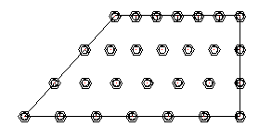 | 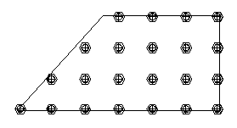
Example with force equal distances disabled | Example with force equal distances enabled

Bolts
The bolt options are only available from the Bolts tab
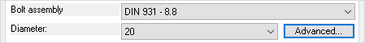

Bolt assembly - Select from the drop-down menu - The bolt assemblies can be configured, see chapter Bolt Assemblies
Diameter - Select one of the available bolt diameters from the drop-down menu
Advanced - Will open the Advanced bolt settings dialog - the settings entered here will only apply to the selected macro(s)
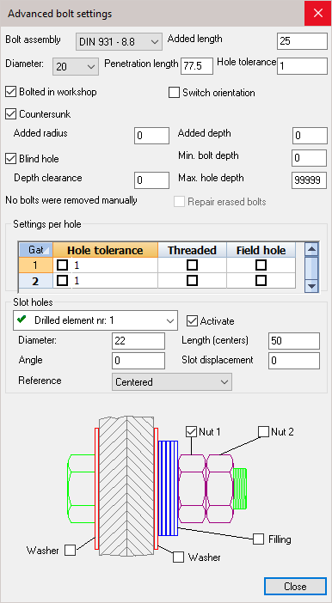

Bolt assembly - Select a new bolt assembly from the drop-down menu
Added length - increase the distance between the nut and the plate, the bolt length will increase accordingly
Diameter - Select a new bolt diameter
Penetration length - This length is calculated automatically : it is the total thickness of all the parts that are bolted together
Hole tolerance - Changes the bolt hole diameter. The value = Bolt diameter + Hole Tolerance
Bolted in workshop - Enabling this will make the bolt a shop-bolt, which will then be shown in the Position and Assembly sheet
Switch orientation - Enabling this will switch the orientation of the bolt - reversing the orientation of the nut and bolt-head
Countersunk - will change an ordinary bolt-hole to countersunk. This will enable the options to enter the countersink diameter and depth
Blind hole - This will change an ordinary bolt-hole to a blind hole. This will enable the options to enter the blind-hole depth.
Repair erased bolts - If a bolt was manually deleted, the prompt will read One or more bolts were removed manually. Checking this option will reintroduce the bolts.
Settings per hole - Here you can change the individual settings for the bolt-hole by selecting a new hole tolerance, making the hole threaded, and indicate whether its to be shop or site drilled.
Slot hole - Will change an ordinary hole into a slotted hole in one of the joined elements. Activating the checkbox will enable you to enter a hole diameter, slot length, the angle, and the slot displacement.
Finally - you can add or remove nuts, washers, and filling by checking or un-checking any of the checkboxes.

Drawing welds for the macro
When a new connection is drawn, it is possible to draw the welds for that connection from within this dialog box.
Each connection has a Welds tab for this purpose :
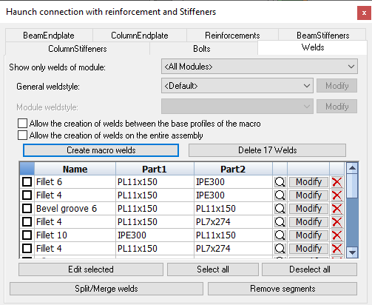
This dialog also allows us to choose a specific AutoWeld settings file that AutoWeld should respect for this macro and it's modules.
This tab dialog has the following options and actions :
Show only welds of module - The value that is chosen here will have an effect on several items in this dialog tab. The 2 main differences are :
When <All modules> is selected - In the list of welds in this dialog, all of the welds that relate to the macro are listed.
The action button Create macro welds will create welds for all modules in the macro.
The action button Delete xx welds will delete all welds that are related to the macro.
When a specific module is selected - In the list of welds in this dialog, only the welds that relate to the selected module will be listed.
The action button Create module welds will only create welds for the selected module.
The action button Delete xx welds will only delete welds that are related to the selected module.
General weld style - This setting is only available when <All modules> was chosen in the Show only welds of module dropdown box.
This setting has the following available options :
  - <Default> - When Default is chosen, then this macro does not get special treatment for weld creation.
The AutoWeld settings that are currently active will be used to create the welds for this macro.
  - <No welds> - When No welds is chosen, then weld creation is effectively disabled for this macro.
The Create welds button will not create any welds for this macro, and also the AutoWeld command will respect this setting, and will not create any welds for the parts in this macro.
  - AutoWeld saved configurations - All of the AutoWeld styles that were previously saved in the AutoWeld dialog are listed here.
When you choose one of the AutoWeld styles here, that style will be used for welds in this macro, instead of the currently active AutoWeld settings.
Module weld style - This setting is only available when a specific module was chosen in the Show only welds of module dropdown box.
This setting allows us to override the weld style that should be used per module. When set, this takes preference over the macro weld style.
The setting has the following available options :
  - <Default> - When Default is chosen, then the currently selected module does not get special treatment for weld creation.
The AutoWeld settings that are currently active will be used to create the welds for the currently selected module.
  - <No welds> - When No welds is chosen, then weld creation is effectively disabled for the currently selected module.
The Create welds button will not create any welds for this macro, and also the AutoWeld command will respect this setting, and will not create any welds for the parts in the currently selected module.
  - AutoWeld saved configurations - All of the AutoWeld styles that were previously saved in the AutoWeld dialog are listed here.
When you choose one of the AutoWeld styles here, that style will be used for welds in this module, instead of the currently active AutoWeld settings.
Allow the creation of welds between the base profiles of the macro - This option is only available when <All modules> was chosen in the Show only welds of module dropdown box.
This option should only be used on all-weld connections that do not draw plates or profiles, but that only draw endcuts and copes.
Normally, the weld creation routine would draw welds between the parts drawn by the macro themselves, and between macro-created parts and the base profiles of the macro.
But for weld-only connections, no parts are between the base members, they should be welded directly.
By enabling this option, the base members themselves will be analyzed and welds will be added to them if appropriate and allowed by the selected AutoWeld style.
This is an example of such as weld-only connection :
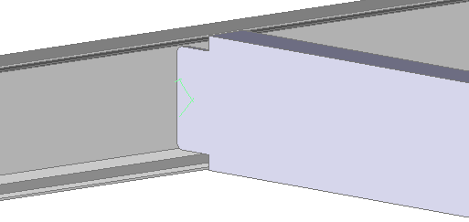

Allow the creation of welds on the entire assembly - This option is only available when <All modules> was chosen in the Show only welds of module dropdown box.
This option can be useful on macros that are a part of array(s) such as PEB or Truss macro arrays.
When the macro is (part of) an array that draws several component parts of an assembly, then by default the welds between the array entries would not be drawn.
The 'neighboring' entry macros are by default not in the selection set for drawing the welds.
This can be solved by activating this option : the parts of the macro that is currently being edited will be checked against all the parts of the same assembly for weld creation.

Create macro/module welds - By clicking on this button, the welds of this macro or the currently selected module will be created.
This is in effect the same as running the AutoWeld command, but here it is done selectively on this macro/module.
Do note that AutoWeld relies on classification in order to work optimally.
Automatic classification works best when the parts are finished and the relation between the parts is known: when the connections are finished.
Delete xx welds - By clicking on this button, the welds of this macro or the currently selected module will be deleted.
The list of welds - All the welds that are related to the macro or the currently selected module will be listed here.
Each weld is listed here as one row. Each row has the following information and actions :
- Use this checkbox to activate the weld, so that you can edit multiple welds at once using the Edit selected button below
Name - This will show the type of weld and if has a size, it will also show the size of the weld.
Part 1 - This is the first part that the weld connects
Part 2 - This is the second part that the weld connects
- This will zoom in on the weld in 3D. The 3D weld will also be selected at the same time.
Modify - This will open the Weld Symbol dialog box which allows you to change all of the 3D weld's settings. The 3D weld will also be selected at the same time.
- This will delete the 3D weld object.
Edit selected - This will open the Weld Symbol dialog box which allows you to change the 3D weld settings of all the welds that are toggled in the above list. These 3D welds will also be selected at the same time.
Select all - This will check the checkbox of all the welds in the above list
Deselect all - This will uncheck the checkbox of all the welds in the above list
Split/Merge welds - This will open a separate tool that allows you to Split or Merge weld segments of 3D weld objects
Remove segments - This will open a separate tool that allows you to Remove weld segments of 3D weld objects

Users can also edit existing connection templates (or create new ones) with all welds completed to their preferences. Upon applying the connection between members, the welds are copied along with the rest of the connection objects and will be recalculated to fit the new members. Fine-tuning the templates of frequently used connections in this way can save the detailer additional time while modeling.

Disclaimer
Welds created automatically will get sizes that may not sufficiently account for loads and stresses. All welds should be checked versus engineer specifications.

Delete Macro
Command - PrB_EraseMacro

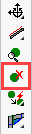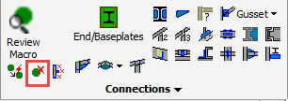

This command will erase all parts of the macro and all holes or cuts that were determined by the macro.

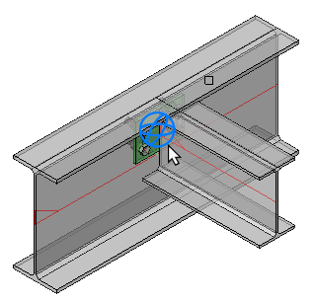

Smart Copy
Command - PrB_AutoApplyMacro
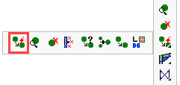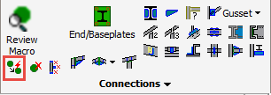

This command will copy an existing macro to other base profiles in the same drawing.

Select the macro and then the base profiles for the new macro.
You should select the profiles in the same order they were selected when the original macro was inserted.
The macro will be copied in its entirety to the new profiles. You may modify or remove components of the new macro without affecting the original macro.
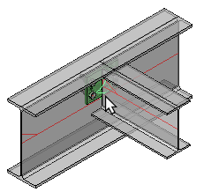 | 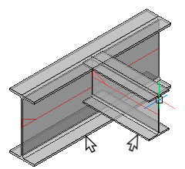

Smart Copy and macro mirroring
Some macros can be mirrored by the smart copy command. Other can only be rotated.
The Smart Copy command uses the location where you select the base profiles to know how you want the new macro to be rotated and mirrored.
With the following four examples we illustrate what happens with a connection that can be rotated and mirrored.
For each example the left image shows the selection that was during the smart copy. The right image is the result.

Example 1
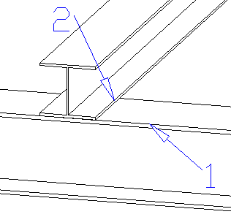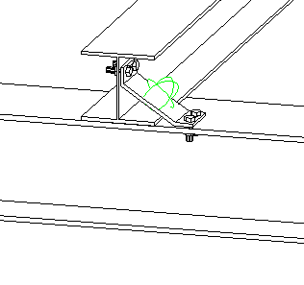

Example 2
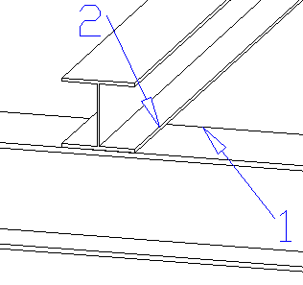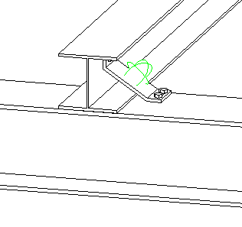
In this example the first base profile was selected on another spot, on the other side of the upper flange. The result is that the bent plate is also placed on that side of the flange. The bent plate was mirrored over 1 axis.

Example 3
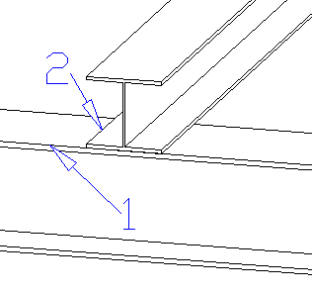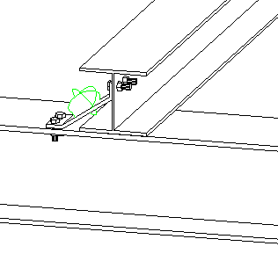
In this example the second base profile was selected on another spot, on the other side. Again we get a mirrored plate but at the opposite side of the second profile.

Example 4:
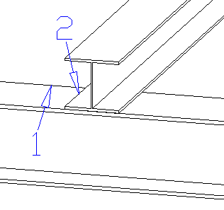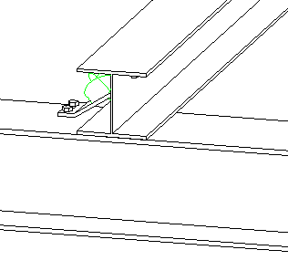
In this last example both the first and the last base profile were selected on another spot. The result is a double-mirrored plate.

As you can see, some macros can be copied in a lot of ways. With other macros, such as a haunch or an apex connection, only the order of the selection matters.

Erase Macro
Command - PrB_EraseMacro
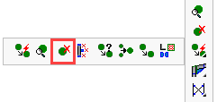
For more information, see Delete Macro

Erase Objects and dep. Macros
Command - PrB_EraseObjectsAndDependentMacros
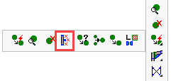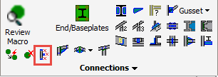

This command will not only delete the objects that you select, but it will also clean up all the macros that are attached to the objects.

Indicate the object. Here, you may select one or multiple objects.
Press <Enter> and the objects and their dependent macros will be deleted
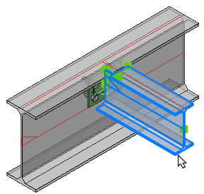 | 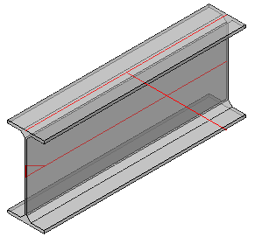

Smart Copy Settings
Command - PrB_AutoApplySettings
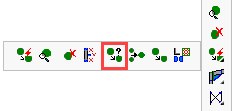
For more information, see Smart copy settings

Merge Macros
Command - PrB_MergeMacros
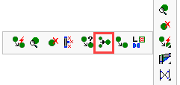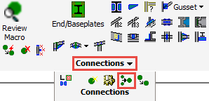

With this command you can merge two or more macros into one macro. There will be no loss of intelligence.
You will need this command if you are composing a new macro by means of combining multiple smaller components from the library.

Select the first macro, which will be preserved - followed by the second macro - press <Enter> and the macros will be merged into one.

Copy a Macro manually
Command - PrB_ApplyMacro
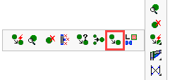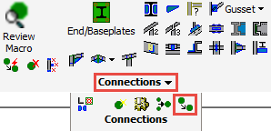

For more information, see the topic Manually copy a Macro

Connection Components Library
Command -
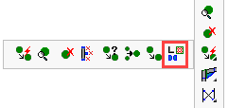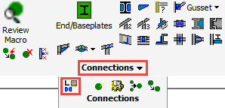

This tool allows us to store and retrieve component macros.
A typical macro is based on one or more base profiles.
The macros found in this command could have a plate or line as base element.
The purpose of this command is to store and later retrieve partial macros as components.
These components would contain objects that are frequently recurring in connections.
Saving them with this command allows you to retrieve the components in any other drawing for reuse.
At the time of writing, this command only works in AutoCAD.

Connections
These are all the available commands under this category :
- Standards for Connections
- Applying Connections
- The Review macro dialog
- Haunch
- Apex
- Apex with Column
- Column under Beam
- Beam Offset to Column
- Beam to Column
- Adjacent Beams to Column
- Purlin on top of Beam
- Purlin Brackets
- Purlin to Rafter - 3 base
- Purlin / Rail supports
- Beam to Beam
- Beam / Column splice
- Connect Railing Post
- Connect Railing Post - 2 Base
- Connect Railing Post - 3 Base
- Welded Connections
- Connections for 1 PEB member
- Connections for 2 PEB members
- Connections for 1 PEB member and 1 regular member
- New Connection from a Group
- Web Stiffeners
- Flange Stiffeners
- Connection Components Library
- Miscellaneous ending connections
- End / Base Plates

Standards for Connections

The connection standards is a collection of rules that can automate filling the values of dimensions and components in connections.
Below are some examples of things that can be automated:
- Plates shouldn't be too thick or too thin.
- Plates can not have a width of 137.4 but should be 140, or 150
- Bolts need to have a certain diameter, and need to be at predetermined distances from the edge and from each other, depending on the situation
These are common modifications, which we can easily write in rules.
It is important to know that the standard system does not carry out an analysis of the structure. It is only a tool to automate repetitive modifications. To use the standards you do not need to do anything; initially they are activated for you and changes are applied to new connections that you apply.
Deactivating the standards is possible in the general Global Settings dialog box using the checkbox: Execute standards on new applied connections:
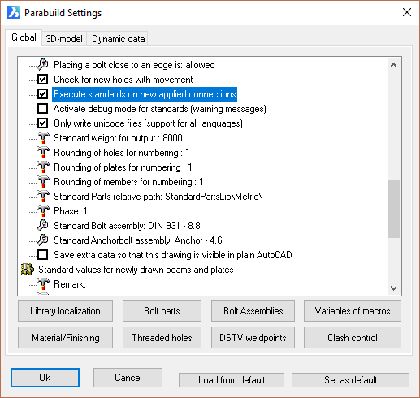

Applying Connections
The connections from the library are sub-divided in groups, so that selecting the correct connection from the extensive library is made simpler and more intuitive. There are also a geometric filter that reduce the number of connections to choose from.

Some examples of groups are Haunch connections, Apex connections, End plates, Base plates, etc…
Each group has its own icon. After you click on the icon you will be asked to select the base profiles. A logical and intentional consequence determines that all connections of the same group must have the same amount of base profiles.
The order in which you select the profiles is important!
Follow the command line prompts, when selecting the profiles. Generally, you will be prompted to select the supporting member first, followed by the connecting member. In cases where this is not clear, we can follow the rule of first selecting the profile that should not be modified in length, and afterwards the profile that will be lengthened.
If you select in the wrong order, the orientation of the resulting connection will be wrong.

Its possible to inadvertently mirror connections by not being consistent when selecting the sections using the mouse pointer. To avoid surprises you should always select the underside of the members, thus ensuring the connection will be drawn correct.
Selecting the tops of members may mirror the connection (upside-down) as illustrated in the example below.

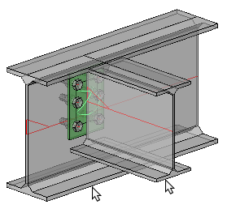 | 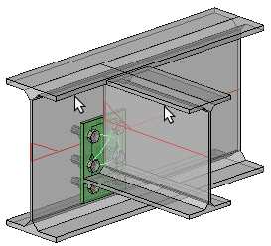
Result after selecting the underside of the members | Result after selecting the tops of the members

This 'mirroring' is not always evident when editing the connection in the Review Macro dialog. The edited dialog (Below) is identical for both the options shown above. But you can clearly see the difference with the end result. These differences are based solely on the manner in which the members were selected.
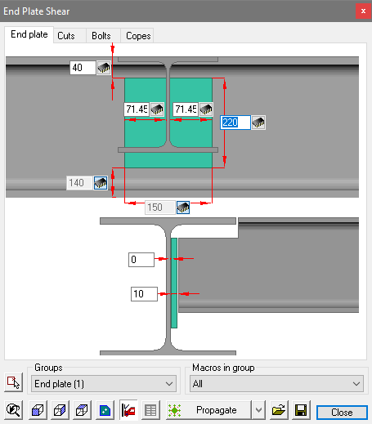 | 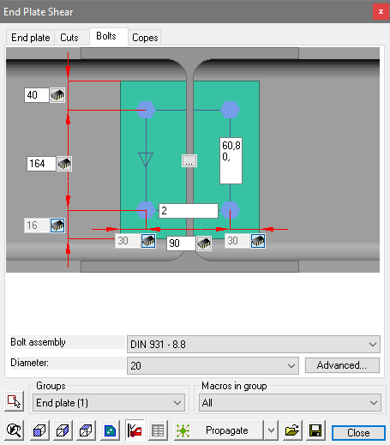
The edited End Plate tab | The edited Bolts tab

Geometric Filters
The base profiles selected are checked against those in the library to determine which connections are applicable. This is a filter that happens automatically.
The connections that are not compatible with the chosen profiles will not be visible.
For example: a typical haunch connection would imply that the beam connects to the column flange, should the orientation be such that the beam is connecting to the column web, Parabuild will check the library, and if no suitable connection is available the following window will be displayed offering Parabuild to check the entire library for a suitable alternative.
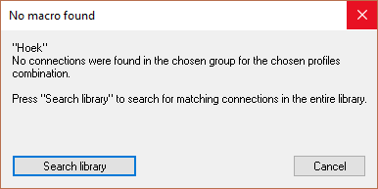

Inserting a macro from the library
After you have chosen a connection and clicked on Ok the connection is inserted and a dialog box will be opened that allows you to adapt the dimensions of the connection. (The chapter Review Macro discusses this dialog box)

Deleting unwanted parts of a connection
You are free to remove a part of the connection (components such as plates or profiles). The macro will not redraw the elements that you have removed. All other elements of the macro will usually continue to work normally after this, depending on the situation:
For example you can remove the stiffeners of an apex connection without any impact for the other parts of the connection.
The only parts that we should avoid removing is the base profiles themselves. Once 1 or more base profiles have been removed, Parabuild does not have enough information to calculate the location of the objects in the connection.
As a consequence, the macro sphere may become red and the objects in the macro might move to unwanted locations.
In this case it is advised to erase the macro.

Deleting bolts in a macro
We can delete bolts that were drawn by a macro bolt pattern.
When a bolt has been manually deleted, Parabuild will not try to restore the erased bolt.
If you do want to restore the deleted bolt(s), then use the checkbox in the Advanced bolt dialog box :
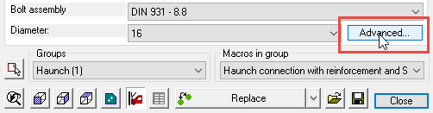

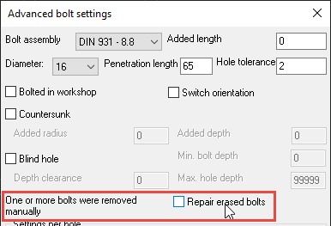

Deleting the macro sphere
You are free to remove just the macro sphere. The components of that macro will stay intact, but they will no longer be automatically adapted because the macro sphere takes care of that.
Also the part sizes can no longer be adapted. The connections elements become "Static parts" as if they were drawn manually.

Propagate
This tool is accessible from within the Review Macro :
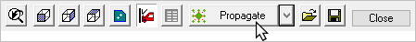
Propagate is much more than a 'copy' command.
This tool will automatically copy a macro to all similar geometric locations in the drawing, which can potentially save you a lot of time.
This will work for all connections including, haunches, apex, splices, base-plates, bracings etc.
It will thus work on all macros that have 1 or more profiles as basis.
Other macros that have other bases (points, lines, ...) such as stairs, some railings, an entire portal frame, a staircase ... are not supported by propagate.
After the connection has been 'Propagated' the Review Macro will appear. At this point the connection macro may be edited which will be reflected on all propagated macros.
Each propagated connection is a unique copy though : you can apply changes to them individually using the Review Macro.

The available Propagate actions
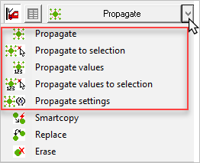

This will copy all macros to matching profiles in the entire drawing.
This works the same as the normal propagate, but it will only propagate to a selection of profiles, instead of the entire drawing.
This tool will not propagate any geometry. Instead it will only propagate the sizes of the macro that is currently being edited. The sizes will be copied to the macros of the same type, and with roughly the same geometry.
Works the same as the Propagate values, but it will only propagate to a selection of profiles, instead of the entire drawing.
This will open the Propagate options dialog. With these options, it is possible to influence the behavior of the propagate tools :

This is a detailed explanation of all of the options for propagate :
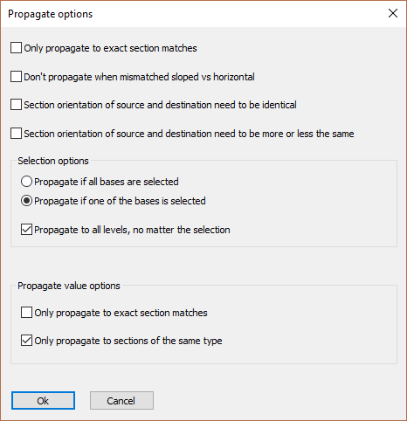
Only propagate to exact section matches - When this option is activated, the source and destination profiles need to have the exact same section sizes.
For example, when the source profile is an IPE200, and the destination profile is an IPE300, then the propagate will never happen.
When the option is disabled, the connection will be copied regardless of the difference in sizes between all the source and the destination profiles.
Don't propagate when mismatched sloped vs horizontal - When this is activated, and the source profile(s) axis is/are sloped, and the destination profile(s) are not, then the propagate will never happen (and vice versa).
Section orientation of source and destination need to be identical - When this is activated, then the source and destination profile's section(s) need to have the same rotation relative to each other.
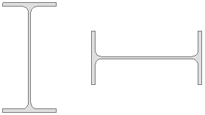
An example of 2 sections that are rotated relative to each other
Section orientation of source and destination need to be more or less the same - This is the same as the previous option, but some more tolerance in orientation is allowed.
Selection options - These options only apply when the Propagate (values) to selection action was performed
Propagate if all bases are selected - The bases are referring to the base profiles of the macro. This may be 1 or more profiles, and it is the profile(s) that were selected when inserting the macro from the library.
When this option is activated, and the to be propagated macro has 2 base profiles, then both the 2 destination profiles need to be selected.
Propagate if one base is selected - When this option is deactivated, then just 1 destination profile needs to be selected for the propagate to continue, regardless of the amount of base profiles the macro has.
Propagate to all levels, no matter the selection - When this is activated, you will have to select the destination base profiles on 1 level only.
The propagate will happen on all equivalent destination profiles on all levels (equivalent to the destination profile that you selected on 1 level).
Propagate value options - These options only apply when the Propagate values (to selection) action was performed
Only propagate to exact section matches - When this option is activated, the source and destination profiles need to have the exact same section sizes.
For example, when the source profile is an IPE200, and the destination profile is an IPE300, then the propagate will never happen.
Only propagate to sections of the same type - When this option is activated, the source and destination profiles need to have the exact same section types.
For example, when the source profile is an IPE200, and the destination profile is an HEA300, then the propagate will never happen.

Haunch
Command -
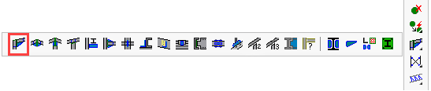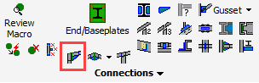
The Haunch connection is a roof rafter connection to a column flange. The rafter may be set to the horizontal or at any angle specified by the design.
Selection order
First select the column, and then the beam.
Note!
When selecting the profiles to be connected, Parabuild will automatically filter the proposed connections.
The filtering will not only be based on the profile types, but also their orientation with respect to each other. For example, Parabuild will recognize if a beam is connecting to a column flange or web. This information is used to filter out the incompatible connections in the selection dialog.
Therefore, the presented options may differ from those illustrated here.
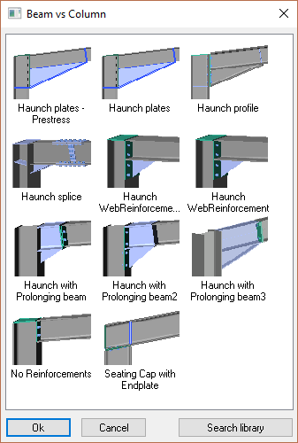

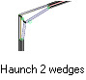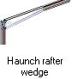

Apex
Command -
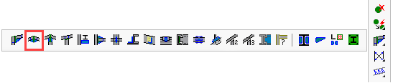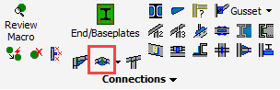
The Apex connection is a roof rafter connection at the apex of the roof. The rafter may be set at any angle specified by the design.
Selection order
The order of the rafters does not matter.
Note!
When selecting the profiles to be connected, Parabuild will automatically filter the proposed connections.
The filtering will not only be based on the profile types, but also their orientation with respect to each other. For example, Parabuild will recognize if a beam is connecting to a column flange or web. This information is used by this command to filter out the incompatible connections in the connection selection dialog.
Therefore, the presented options may differ from those illustrated here.
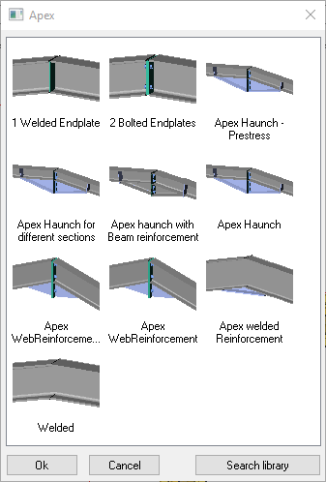

Apex with Column
Command -
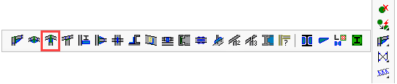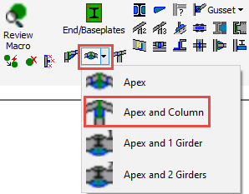

The Apex with column connection is a roof rafter connection at the apex of the roof. The rafter may be set at any angle specified by the design.
Selection order
First select rafter 1, then rafter 2, and then the column.
The order of the rafters does not matter.
Note!
When selecting the profiles to be connected, Parabuild will automatically filter the proposed connections.
The filtering will not only be based on the profile types, but also their orientation with respect to each other. For example, Parabuild will recognize if a beam is connecting to a column flange or web. This information is used by this command to filter out the incompatible connections in the connection selection dialog.
Therefore, the presented options may differ from those illustrated here.
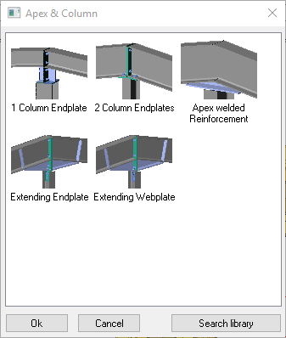

Column under Beam
Command -
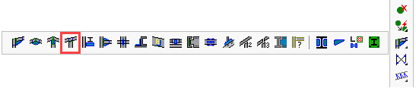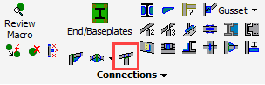
The Column under Beam connection is a post connection connecting a column to the underside of a beam. The beam may be horizontal or set at any angle specified by the design.
Selection order
First select the beam and then the column.
Note!
When selecting the profiles to be connected, Parabuild will automatically filter the proposed connections.
The filtering will not only be based on the profile types, but also their orientation with respect to each other. For example, Parabuild will recognize if a beam is connecting to a column flange or web. This information is used by this command to filter out the incompatible connections in the connection selection dialog.
Therefore, the presented options may differ from those illustrated here.
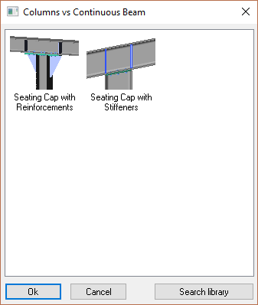

Beam Offset to Column
Command -
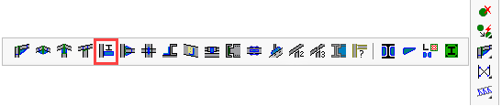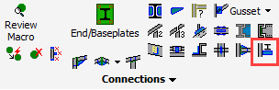
The Beam Offset to Column is a beam connection connecting to the side of a column. This connection is usually applied where the column is supporting some form of runway or crane beam.
Selection order
First select the column and then the beam.
Note
When selecting the profiles to be connected, Parabuild will automatically filter the proposed connections.
The filtering will not only be based on the profile types, but also their orientation with respect to each other. For example, Parabuild will recognize if a beam is connecting to a column flange or web. This information is used by this command to filter out the incompatible connections in the connection selection dialog.
Therefore, the presented options may differ from those illustrated here.
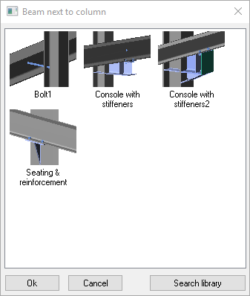

Beam to Column
Command -
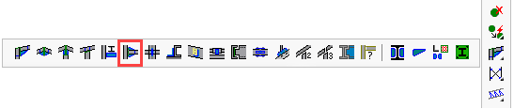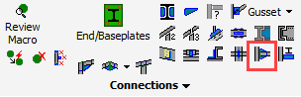
The Beam to Column is a beam connection connecting to the web or flange of a column. This connection may be either 'Moment-resisting' or 'Flexible' (flexible connections are also referred to as 'Shear' or 'Simple' connections).
As a general rule - a Moment connection is identified when the flanges of the incoming beam connect in some form to the supporting column - conversely, a flexible connection is identified when the beam is connected to the column by its web only.
Selection order
First select the column and then select the beam.
Note
When selecting the profiles to be connected, Parabuild will automatically filter the proposed connections.
The filtering will not only be based on the profile types, but also their orientation with respect to each other. For example, Parabuild will recognize if a beam is connecting to a column flange or web. This information is used by this command to filter out the incompatible connections in the connection selection dialog.
Therefore, the presented options may differ from those illustrated here.
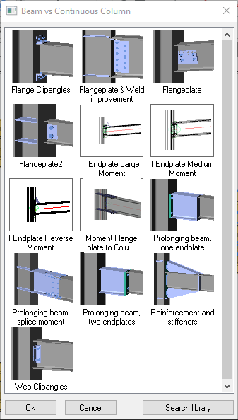

Adjacent Beams to Column
Command -
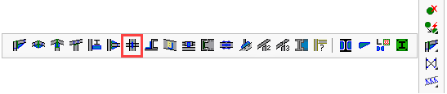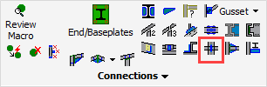

This connection group can be seen as the merger of 2 Beam to Column connections : When 2 beams both connect to the web of the column, then the 2 end plates will have to share the same bolts.
Or it might be a merge of 2 Beam Offset To Column connections : When 2 beams are spliced on top of the seat connection.
Selection order
First select the column, then beam 1 and then beam 2.
Note!
When selecting the profiles to be connected, Parabuild will automatically filter the proposed connections.
The filtering will not only be based on the profile types, but also their orientation with respect to each other. For example, Parabuild will recognize if a beam is connecting to a column flange or web. This information is used by this command to filter out the incompatible connections in the connection selection dialog.
Therefore, the presented options may differ from those illustrated here.
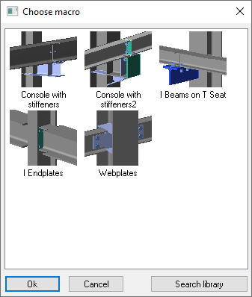

Purlin on top of Beam
Command -
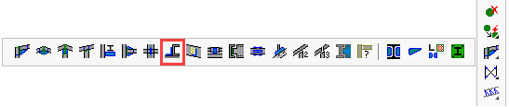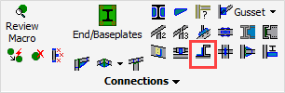

The Purlin on top of Beam connection connects the purlin to a roof beam or rafter.

Stays
This command can also draw stays between the rafter and the purlin. The purlin can be a lipped channel or Z shaped.
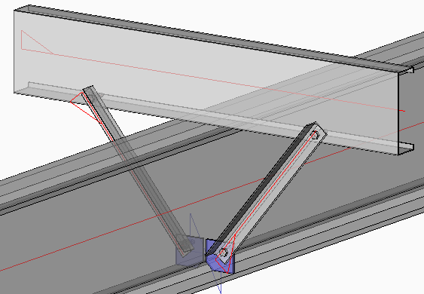

Selection order
First select the rafter, then select the purlin on the side where the bracket is to be placed.

Note
When selecting the profiles to be connected, Parabuild will automatically filter the proposed connections.
The filtering will not only be based on the profile types, but also their orientation with respect to each other. For example, Parabuild will recognize if a beam is connecting to a column flange or web. This information is used by this command to filter out the incompatible connections in the connection selection dialog.
Therefore, the presented options may differ from those illustrated here.
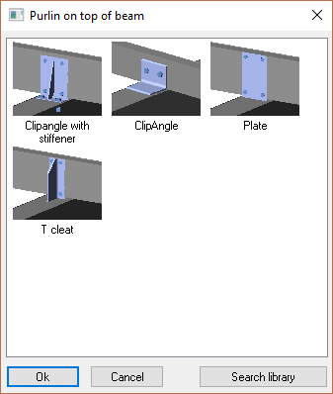

Purlin Brackets
Command -
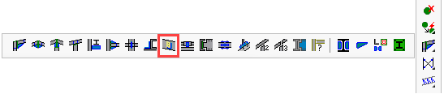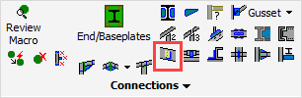
The Purlin bracket connects the purlin to a roof beam or rafter.

Selection order
First select the beam, then select the purlin on the side where the bracket is to be placed.

Eaves beam cleat
This command can also draw an eaves beam cleat if you first select a column (I or H shaped) and then a lipped C eaves beam.
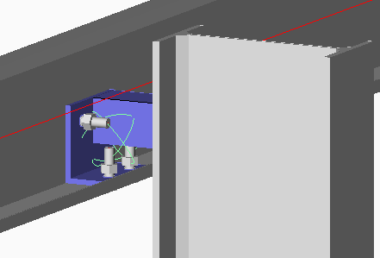

Note
When selecting the profiles to be connected, Parabuild will automatically filter the proposed connections.
The filtering will not only be based on the profile types, but also their orientation with respect to each other. For example, Parabuild will recognize if a beam is connecting to a column flange or web. This information is used by this command to filter out the incompatible connections in the connection selection dialog.
Therefore, the presented options may differ from those illustrated here.
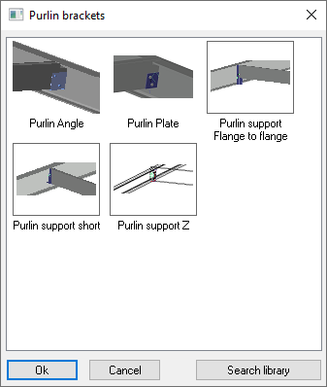

Purlins on Beam / 3-bases
Command -
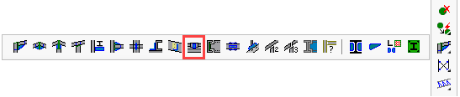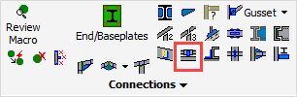

The Purlin on Beam 3-base connection joins 2 purlins or siderails at the center of the supporting beam or rafter.
It can also draw sleeves for the purlins and siderails, either solo sleeves or sleeves combined with brackets.

Selection order
First select the beam, then select the purlin 1 and then purlin 2.

Note!
When selecting the profiles to be connected, Parabuild will automatically filter the proposed connections.
The filtering will not only be based on the profile types, but also their orientation with respect to each other. For example, Parabuild will recognize if a beam is connecting to a column flange or web. This information is used by this command to filter out the incompatible connections in the connection selection dialog.
Therefore, the presented options may differ from those illustrated here.
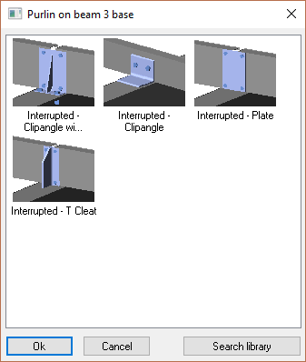

Purlin / Rail supports
Command -
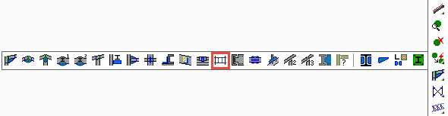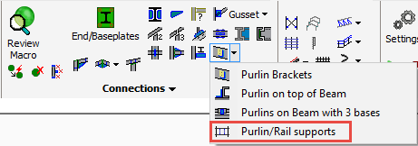

The Purlin / Rail support connections can draw supporting parts for purlins and rails.
It can draw these types of connections :
- An array of Apex ties for the 2 top Z purlins
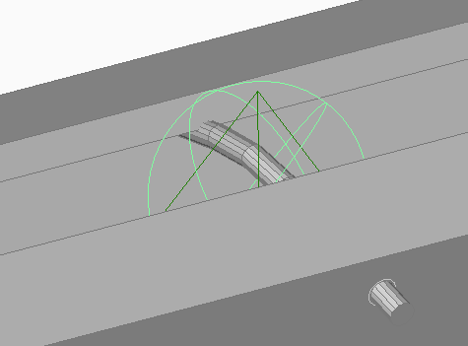
- An array of Eaves ties between a Z purlin and a lipped C eaves beam
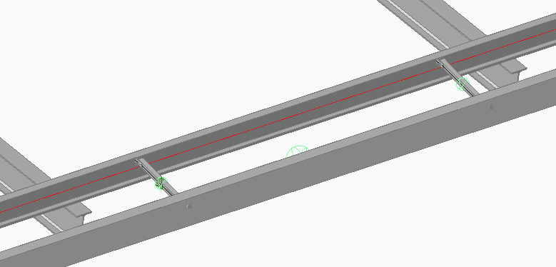
- An array of Snaptites between 2 purlins or between 2 siderails (Z shapes)
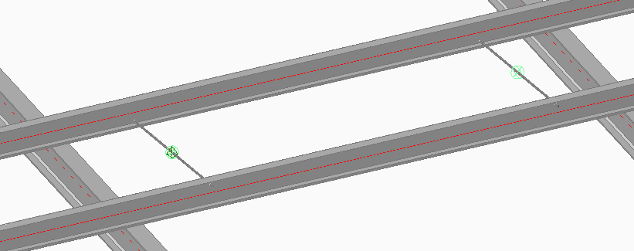
- An array of supports between 2 side rails
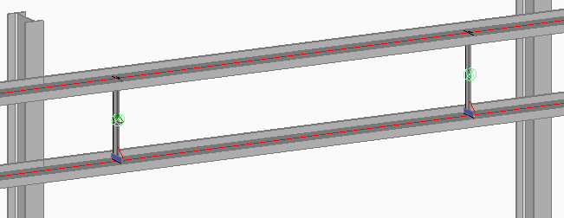

Selection order
- Left beam or rafter
- Right beam or rafter
- Top Purlin or Siderail
- Bottom Purlin or Siderail or Eaves beam

Beam to Beam
Command -
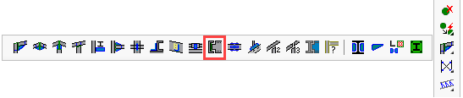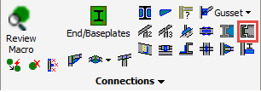

The Beam to Beam connects a beam to the web of a supporting beam.
Selection order
First select the supporting beam which is not to be lengthened, then select the incoming beam (which will be lengthened).
Note!
When selecting the profiles to be connected, Parabuild will automatically filter the proposed connections.
The filtering will not only be based on the profile types, but also their orientation with respect to each other. For example, Parabuild will recognize if a beam is connecting to a column flange or web. This information is used by this command to filter out the incompatible connections in the connection selection dialog.
Therefore, the presented options may differ from those illustrated here.
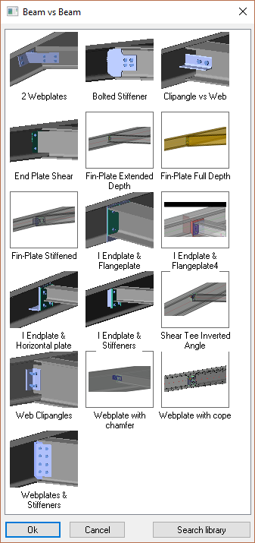

Beam / Column Splice
Command -
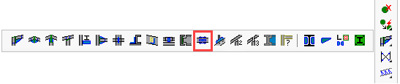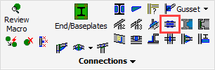

The Beam or column splice connection requires that the profile be split at the point to be spliced.
Selection order
First select the base beam, then select the beam that will be lengthened.
The ending of the first beam will determine the location of the splice and thus the location of the plates.
Note
When selecting the profiles to be connected, Parabuild will automatically filter the proposed connections.
The filtering will not only be based on the profile types, but also their orientation with respect to each other. For example, Parabuild will recognize if a beam is connecting to a column flange or web. This information is used by this command to filter out the incompatible connections in the connection selection dialog.
Therefore, the presented options may differ from those illustrated here.
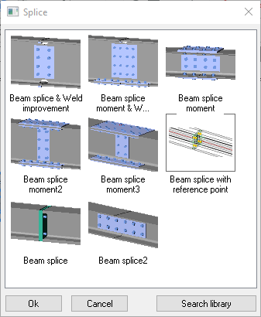

Connect Post
Command -
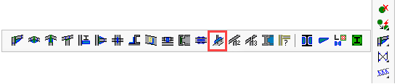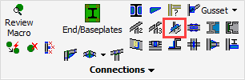

For more information about these connections, see the Connect Post topic in the stairs chapter.

Connect Post to Handrail - 2 Base
Command -
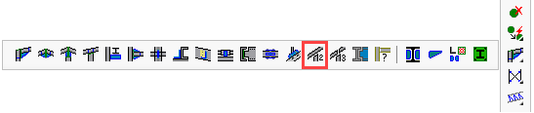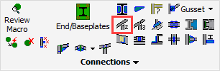

For more information about these connections, see the Connect Post to Handrail - 2 Base topic in the stairs chapter.

Connect Post to Handrail - 3 Base
Command -
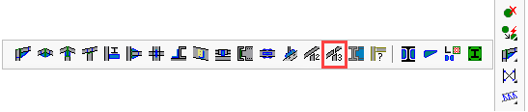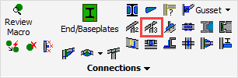

For more information about these connections, see the Connect Post to Handrail - 3 Base topic in the stairs chapter.

Connections for 1 PEB member
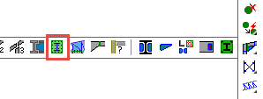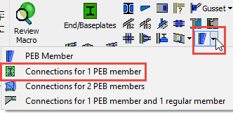

This command will ask you to select 1 PEB member.
The PEB plates need to be selected in this order :
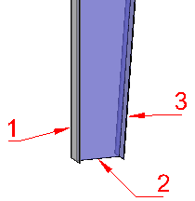

This command allows you to draw the following connections :
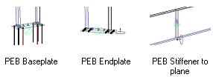
The PEB member can have any position or rotation when using the endplate or stiffener macros.

Connections for 2 PEB members
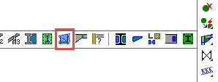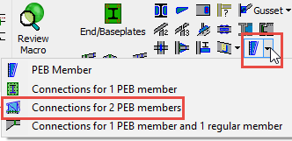

This command will ask you to select 2 PEB members.
The PEB plates need to be selected in this order :
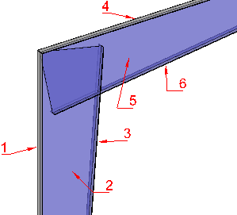

The valid configurations of the PEB members is the haunch configuration like above, an apex configuration and a splice configuration.
This command allows you to draw the following connections :
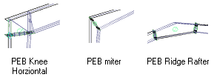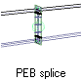

Connections for 1 PEB member and 1 regular member
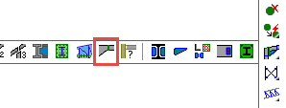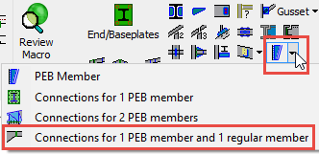

This command will ask you to select 1 PEB member first and then a regular profile.
The PEB plates and the profile need to be selected in this order :
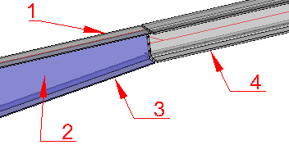

This command allows you to draw the following connections :
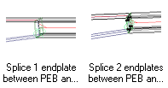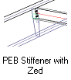

Weld Connections
Command -
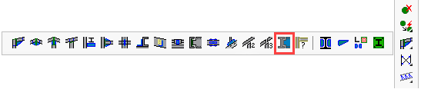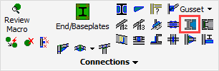

This command will draw a mix of weld connections such as rat tail copes and elbows :
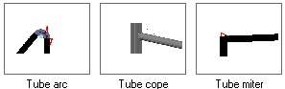

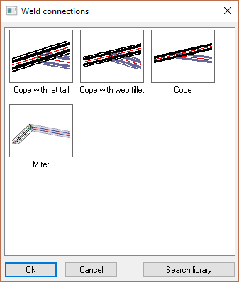

New Connection from Group
Command -
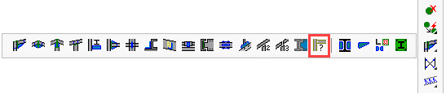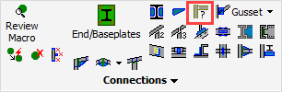

This command allows you to access all of the connection groups that are available in the library.
This can be useful in case someone has added a new group of connections to the library, but an icon for this group was not (yet) created.

Web Stiffeners
Command -
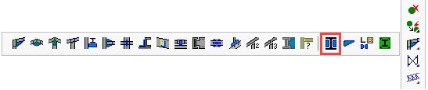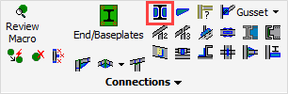

For more information about this, see the topic Web Stiffeners in the Tools chapter.

Flange Stiffeners
Command -
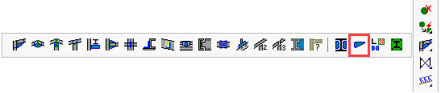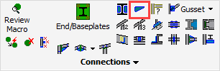

For more information about this, see the topic Flange Stiffeners in the Tools chapter.

Connection Components Library
Command -
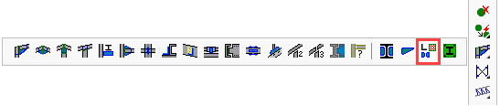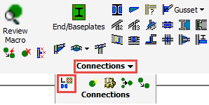

For more information about this, see the topic Connection Components Library in the Modify Macro chapter.

Miscellaneous ending connections
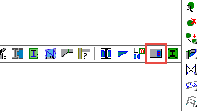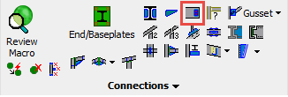
This command collects a set of ending connections.
These connections are similar to those found in the End / Base-Plates command, but instead of an ending plate, it draws other parts such as plate and angle cleats at the end of a profile.
The geometry that needs to be selected is 1 profile, and then 1 planar surface or nothing for footing connections.
The macros in this command were designed to be deploy-able in many different situations by requiring only 1 profile to be selected.
For the positioning of the parts, you are free to select a planar surface of any other profile, plate, structure or volume.
These are the new connections that are available with this new command :
For I shapes :
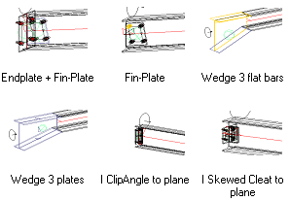

For channels :
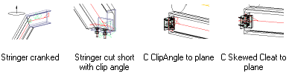

For Angles :
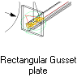

For CHS and RHS :
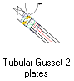

For flat bars (strips) :
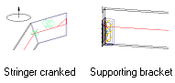

End / Base-Plates
Command -
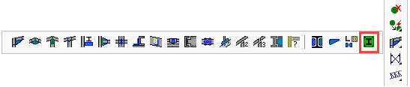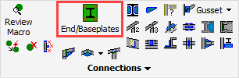
The End / Base-Plates connection will add an end or cap plate to any profile shape.
Some of the available connections are :
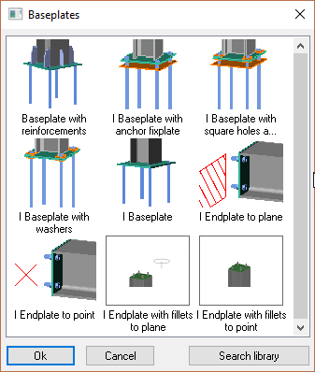
Note! When selecting the profiles to be connected, Parabuild will automatically filter the proposed connections based on the profile type.
Therefore, the presented options may differ from those illustrated here.

Baseplates
By default, baseplates will always be drawn to the World Z plane of the drawing.
To change the height of the baseplate, one can use the offset in the dialog box indicated here :
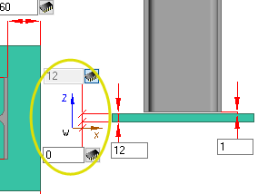

Endplate/clipangle to plane
This is the preferred tool, as apposed to the Endplate to point tool.
The big advantage of this tool is that our new endplate will assume the inclination and the position of the selected planar surface.
Therefore, the endplate's position and rotation will immediately be correct.
The only condition is, of course, that we have a profile or plate in place to which the endplate should be positioned and bolted.
A possible example use of this tool :
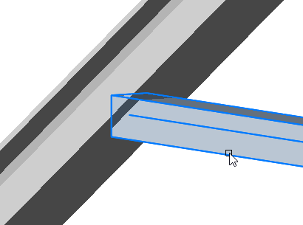 | 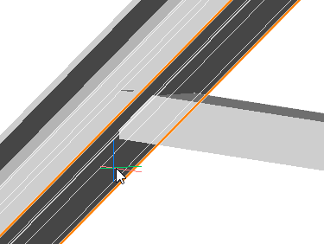 | 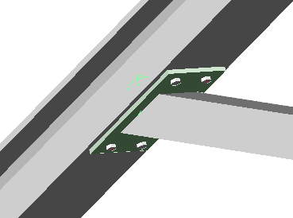
Selecting the profile that needs an endplate attached to it | Selecting the underside of the flange (the circumference of the flange is highlighted here in orange).  We could select any planar surface of any profile, plate, structure, volume, or polyline. | The end result
Note It is not recommended to select the profile's own end face. Parabuild will not be able to determine the plate's position reliably. In this case the end cut of the profile changes the face that you selected, creating an unsolvable loop.

Drawing a connection to a cylindrical or spherical surface
The "Connections to a plane" can also be used against cylindrical or spherical surfaces.
When Parabuild prompts you to select the planar surface, you can simply select a cylindrical or spherical surface.
While the macro is created, the tool will first calculate the intersection between the profile and the sphere.
Then, the planar surface is calculated by making it tangent to the sphere or cylinder. This planar surface is then used by the macro to position the parts.
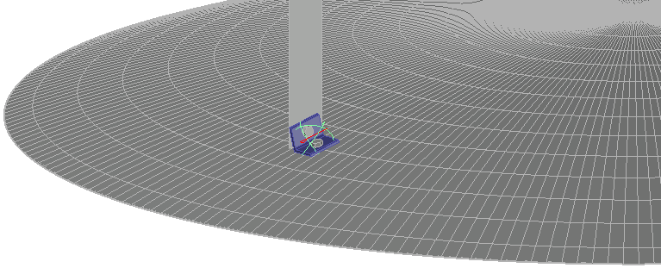
Example of a clipangle drawn against a spherical volume, which could be the roof of a tank

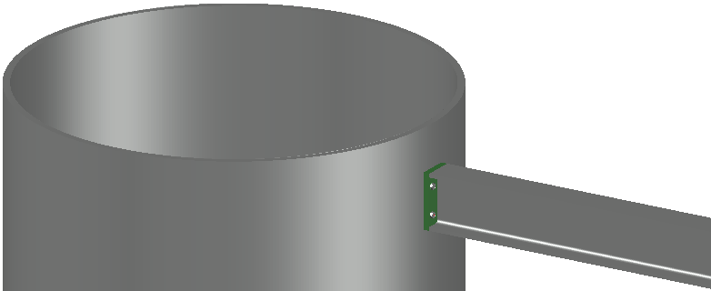
Example of an endplate drawn against a cylindrical profile

Endplate to point
In some cases we have no desire to draw a profile or plate that determines the position of the endplate.
Then we can use this tool to either select an point sub-geometry, or to use Object Snap to snap to any point to any object.

Selecting a point sub-geometry
This is the default behavior of the tool. We can use this to select any point on any object that Parabuild recognizes.
The endplate that is drawn will stay connected to the selected point by the macro sphere.
A possible example use of this tool is where a line determines the endplate's position :
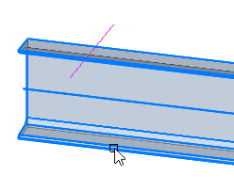 | 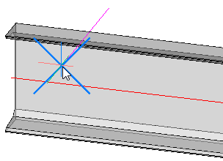 | 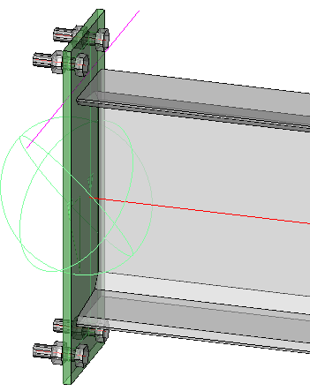
Selecting the profile that needs an endplate attached to it | Selecting an endpoint of a line. We could select any point of any profile, plate, structure, volume, line, or polyline. | The end result

The position of the endplate is determined by projecting the point to the axis of the profile.
Note It is not recommended to select a point on the profile that needs to receive the endplate. Parabuild will not be able to determine the plate's position reliably. In this case the end cut of the profile changes the point position that you selected, creating an unsolvable loop.

Object Snapping
When the Selecting a point sub-geometry tool is too limiting, then we can use object snapping.
With object snapping, we can select the midpoint of a line, center of a circle, intersection of lines, etc.
It is also object-independent so it will work on any object, even object types that are unknown to Parabuild.
To access this capability, follow the exact same procedure as for the point sub-geometry, but press <Enter> when prompted to select the point sub-geometry.
A possible example use of this tool :
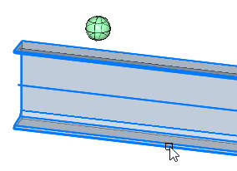 | 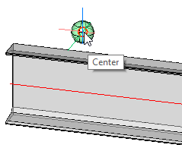 | 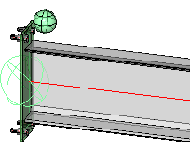
Selecting the profile that needs an endplate attached to it | After pressing <Enter> for not wanting to select a sub geometry : Selecting the center of the sphere with the help of Object Snapping. This is just an example.  We could snap to any point on any object. This can be a point on an object unknown to Parabuild such as 3D Solids or 3rd party software objects. | The end result

This tool will draw a new point object at the location that you snapped.
The new endplate will stay connected to that point object by the macro sphere.
The position of the endplate is determined by projecting the point to the axis of the profile.

Bracing
- Bracing
- Gusset Plate - 2 Base
- Gusset Plate - 3 Base
- Gusset Plate - 4 Base
- Gusset Plate - 5 Base
- Gusset Plate - Middle 3 Base
- Gusset Plate - Middle 4 Base
- Transmission - 5 Base

Bracing
Command - PrB_Bracing
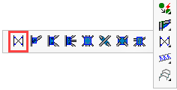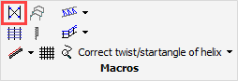
Activating the Bracing command will bring up the following bracing options dialog, from which you are prompted to select the Wind Bracing configuration.
After that, the Fixing the bracing dialog is shown where you are prompted to fix the top and bottom bracing elements:
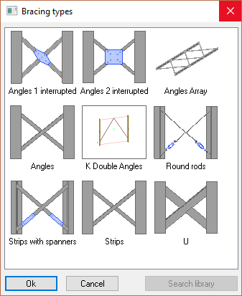
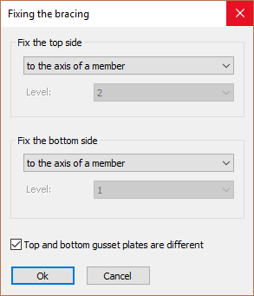

The options for fixing the top and bottom bracing elements include:
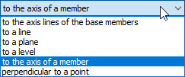
All bracing will be drawn on the axes of the main members - which may be either columns or main lateral profiles.
The bracing fixing options only apply to transverse members.
- To the axis lines of the base members - This option will draw the selected bracing between the ends of the 2 main profiles, ignoring any transverse members.
- To a Line - The model line should be drawn to intersect with the axes of the base members.
Note!
- In case the line extends beyond the length of the base member and there is no real intersection, then Parabuild will use the apparent intersection of the line with the main member axis. In this case, the gusset plate connection(s) might be drawn outside of the members in the air.
- In case the line is not drawn in the same plane as the plane of the bracing and thus no real intersection, then Parabuild will project the line to the plane of the bracing to obtain the intersections.
- To a plane - The same procedure as with lines, but in this case the intersection of the plane (surface) with the members axis is used.
- To a level - The same procedure as with planes, but the difference is that these planes are always horizontal. This option therefore cannot be used for bracing in the roof. (You will be prompted to enter the applicable levels)
- To the axis of a member - The same procedure as with lines, but in this case the axis of the selected member will be used.
- Perpendicular to a point - You will be prompted to select a point (for example a point of a plate). The start point is then determined by projecting the point perpendicular to the member axis.

Top and bottom gusset plates are different - When you activate this option, Parabuild will show you the gusset plate selection dialog box twice. The first time for the top gusset plates and the second time for the bottom gusset plates
If this option is deactivated, the gusset plate dialog box will be shown just once and all four gusset plates will be the same.

When you click on Ok, the following prompts will show on the command line:
Select the left profile on the side where the bracing should be placed: and Select the right profile:
We select the backside of the flange of the member, on the side of the bracing
Hereafter the Gusset plate connections dialog box appears :
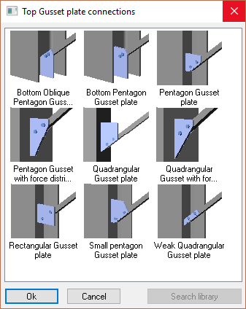
We choose the desired gusset plate and click on Ok.
It is acceptable to click the cancel button at this stage. In this case the bracing will still be drawn but without gusset plates.

Now the dialog box Connections for the middle of the bracing appears:
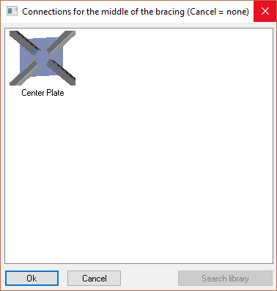

We choose an option and click on Ok.
It is acceptable to click the cancel button at this stage. In this case the bracing will still be drawn but without the center connection.

Now Parabuild draws the wind bracing.
The previous prompts are repeated so that you can draw the same bracing on other locations.

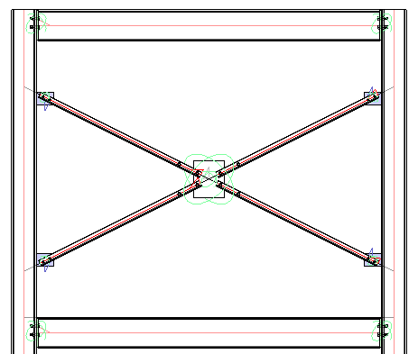
This example shows an angle cross brace with a center plate.

The bracing edit dialog
After completing the bracing, all of the dialog s of the newly drawn parts are displayed.

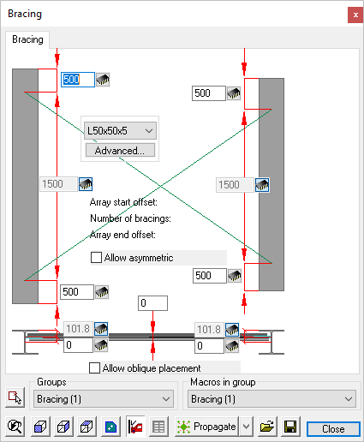
Bracing
- 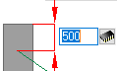 Change the offset at top and at bottom. Only the values to the left apply because Parabuild has drawn a symmetric bracing. If we activate the Allow asymmetric checkbox, the values to the right will apply too.
- Change the member section by using the drop down tool.
- Choose another section type by using the Advanced... button.
Note! if you change the profile type of the bracing using this tool, then the gusset plate connections will likely become corrupted. In this case you should redraw them.
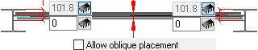
- Change the horizontal position of the wind bracing. This is possible by changing the position of the bracing axis relative to the member axis or the member edge. Only the left values apply.
- If you activate the Allow oblique placement checkbox, then the right values also apply. This last setting gives you the possibility to draw a bracing between members whose axes are not aligned.
- Note! The gusset plates that Parabuild has drawn are suggestions and should be reviewed to make sure the dimension adhere to the load calculations.
The gusset plates can be modified individually with the Review macro command on the 4 smaller spheres.
For more information on these macro dialogs, see the topic Review macro dialog.

Gusset Plates
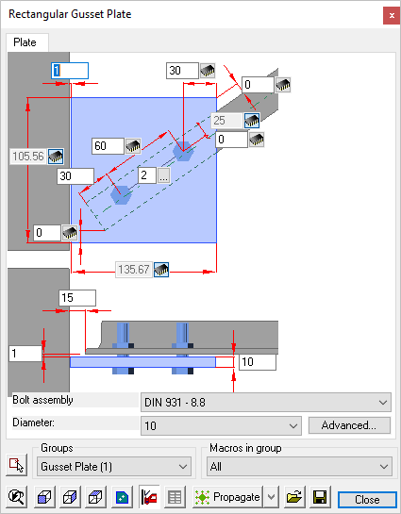
Here you may edit the gusset plates connecting to the main members.
The gusset plates can be modified individually with the Review macro command on the 4 smaller spheres.
For more information on these macro dialogs, see the topic Review macro dialog

Center Plate
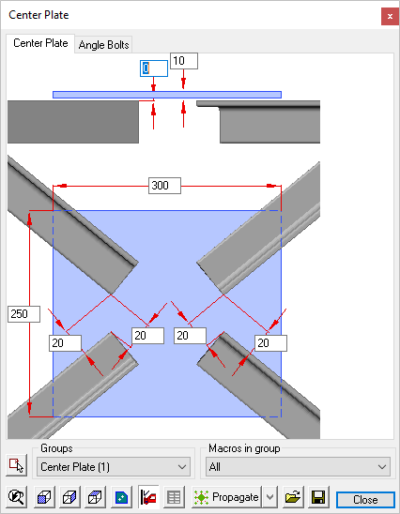
Here you may edit the center plates connecting the bracing members
The center plates can be modified individually with the Review macro command on the specific macro sphere.
For more information on these macro dialogs, see the topic Review macro dialog

Gusset Plate - 2 Base
Command -
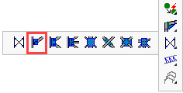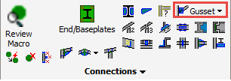
The 2 base gusset plate group connects a single brace to either a beam or column.
On activating this command you will be prompted to:
- Select the Column (or beam)
- Select the bracing member

Note!
When selecting the profiles to be connected, Parabuild will automatically filter the proposed connections.
The filtering will not only be based on the profile types, but also their orientation with respect to each other. For example, Parabuild will recognize if the gusset plate is connecting to a column flange or web. This information is used by this command to filter out the incompatible connections in the selection dialog.
Therefore, the presented options may differ from those illustrated here.

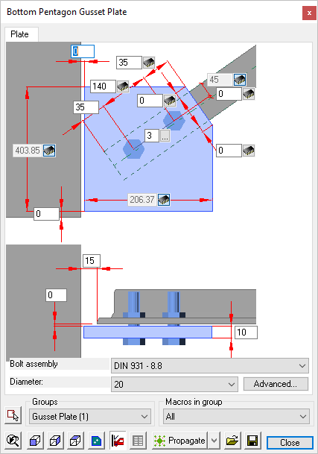
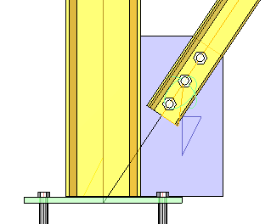
An example of the finished gusset plate

Gusset Plate - 3 Base
Command -
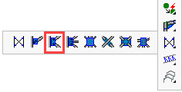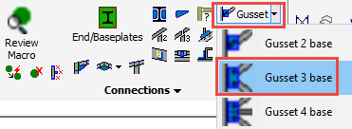
The 3 base gusset plate group connects 2 bracing members to either a beam or column.
On activating this command you will be prompted to:
- Select the Column (or beam)
- Select the top (or right for beam) bracing member
- Select the bottom (or left for beam) bracing member

Note!
When selecting the profiles to be connected, Parabuild will automatically filter the proposed connections.
The filtering will not only be based on the profile types, but also their orientation with respect to each other. For example, Parabuild will recognize if the gusset plate is connecting to a column flange or web. This information is used by this command to filter out the incompatible connections in the connection selection dialog.
Therefore, the presented options may differ from those illustrated here.
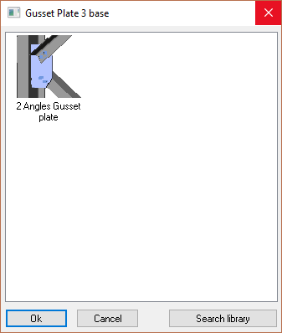

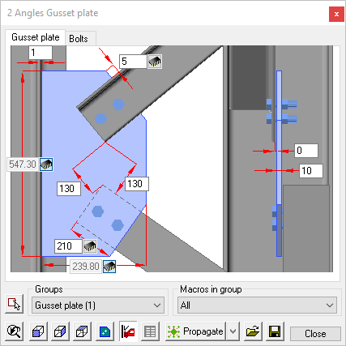
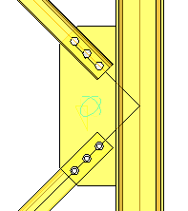
An example of the finished gusset plate

Trusses
- Truss
- Truss between Columns
- Truss for Portal Frame
- Truss Strut
- Truss haunch Connection
- 2 Trusses v Column
- Truss - Apex
- Truss to Truss

Truss
Command -
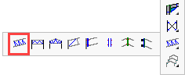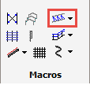

Activating this command will open the Truss dialog, from which you may choose a configuration.
The truss options include:
Truss double perpendicular
Truss oblique beam as base
Truss oblique
Truss oblique2
Truss perpendicular
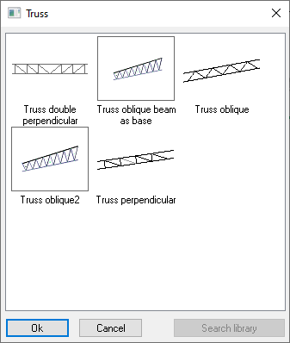

Draw a Truss on a line
After clicking on Ok, just select the model line and the complete truss will be drawn on top of it.

Draw a truss by indicating 2 points
At the command line prompt you will be prompted to Select the line that will determine the location of the parts, or <Enter> to draw a new line :
If there is no preexisting line, press <Enter> and you will be prompted to indicate the first and second points of the line, after which the default truss will be drawn.

Some information about the truss
The line will determine the length and position of the top chord of the truss, it may be drawn between columns, beams, or independently in space, depending on its function and how it is to be supported.
The location of the top chord relative to the line is determined by the Section displacement which may be set from the Profile placement dialog. By default, all profiles forming the truss are set to Middle. This means that all the truss component members are set so that they intersect at their geometric centers eliminating eccentricities at the joints and is considered to be the optimum configuration for efficient load distribution.
Altering the Profile placement will alter the truss geometry. If this is not desirable, then the line should (In the instance of connecting to columns) be placed below the column cap at a distance of 0.5 x the depth of the top chord ensuring the top of column = top of truss.
Likewise, the depth of the truss is determined by the same geometry.

Add truss end-connections
You can select bolted connections for connecting the truss chords to the columns from the Connections menus

Truss double perpendicular
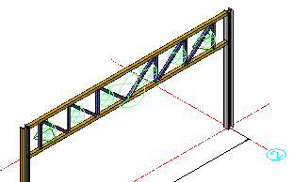

Truss oblique beam as base
This is the same as Truss oblique2, except the base of the entire truss will not be a line but it will be the top chord itself.
So for this truss the top chord will need to be adapted to determine the truss's size and location.
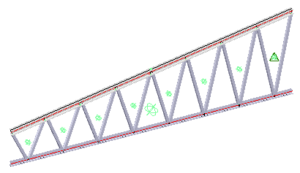

Truss oblique
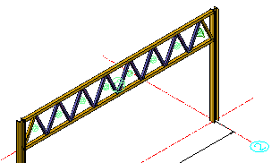

Truss oblique2
Unlike most other trusses, when the top chord of this truss is sloped, then the bottom chord will always remain horizontal.

Truss perpendicular
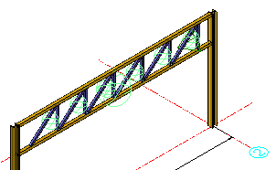

The macro edit dialog for Trusses
The edit dialog will vary according to the chosen truss, but the general principles will apply to all.
Here you are able to change the number of struts, truss depth, and profile types and sizes. The length of the truss is predetermined by the model line.
The truss is made up of a number of macros, each of which may be edited individually. Activate the Review macro command and indicate the green sphere of the macro that you want to modify individually.
The geometry of the truss is determined by the Profile placement. This can be accessed by clicking on the button next to the profile size drop-down.

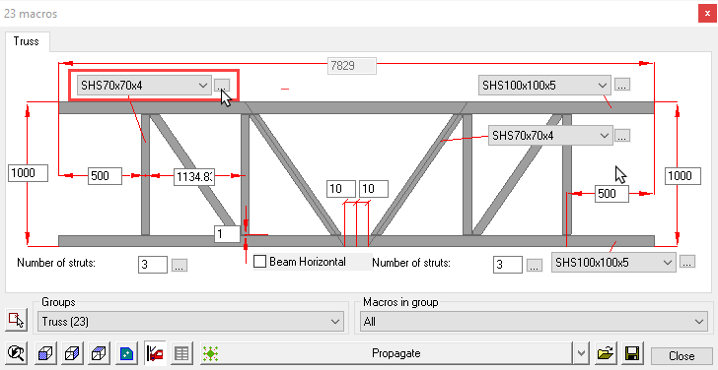

Note The top and bottom chords do not have to be parallel. The slenderness of both chords may be changed with the two depth options.
In the example below, the truss depth will be 1000 at one end - sloping to 350 at the other.
Making both ends the same will give a parallel truss.
Checking the Beam Horizontal checkbox will override the dimension differential.
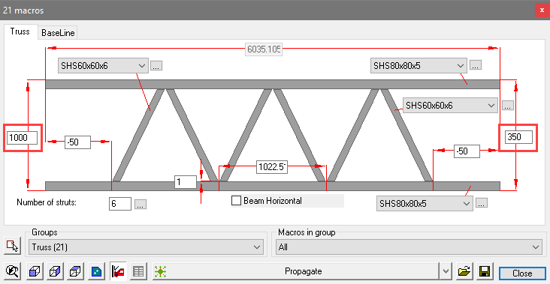

Truss between Columns
Command -
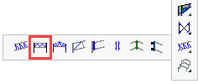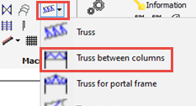
This command will draw a truss between square or rectangular hollow section columns.
This command will first prompt for the columns. When prompted to select the coordinate system, press <Enter>.

For now there is just 1 type of truss implemented in this tool :
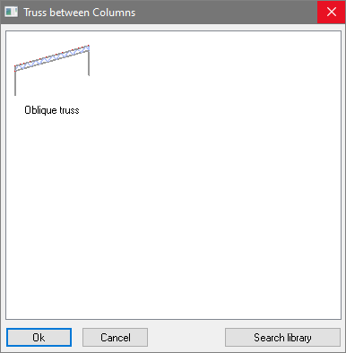 | 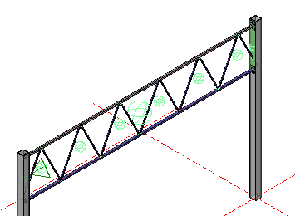
For more information about the truss dialog box's options, see the Truss topic.

The truss is made up of a number of macros, each of which may be edited individually. Activate the Review macro command and indicate the green sphere of the chosen macro.
Example: To edit the end plate, select the macro sphere, press <Enter> or right-click the mouse button to open the macro edit dialog
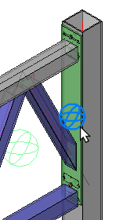 | 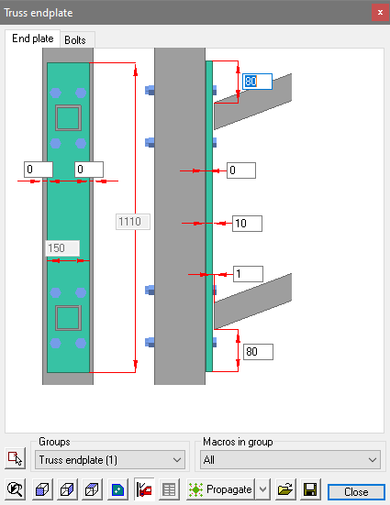

Truss for Portal Frame
Command -
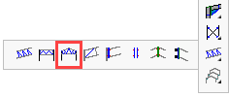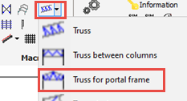
This tool can draw a double truss inside a portal frame.
It will ask you to select the following items in this order :
- The column on the left hand side
- The left rafter on the left hand side
- The rafter on the right hand side
- The column on the right hand side

For now there is just 1 type of truss implemented in this tool :
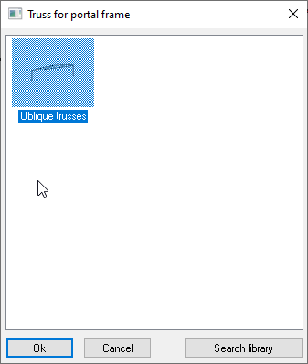
When prompted to select the coordinate system, press <Enter>.
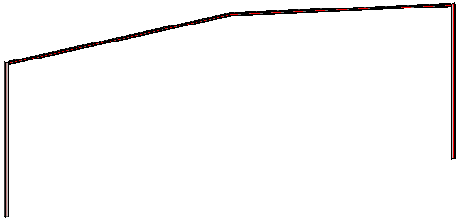 | 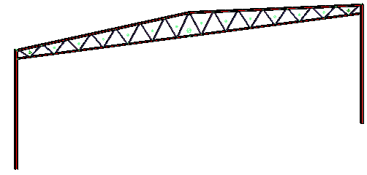
You will first need a a portal frame in order to use this tool | The end-result : The truss with a spliced bottom chord and connections to the columns
For more information about the truss dialog box's options, see the Truss topic.

Truss Strut
Command -
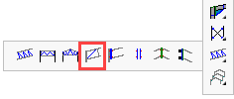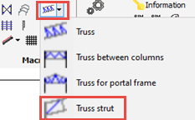
This command will add a strut to the end of a truss.
On activating the command you will be prompted to select in this order :
- The column
- The lower chord of the truss
- The upper chord of the truss
- The vertical strut
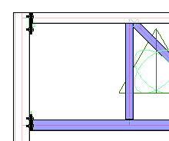

After selection, the options dialog will appear - select the required option:
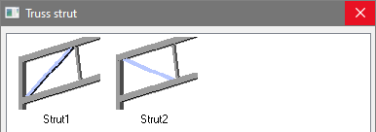

The strut will be placed accompanied by the macro edit dialog
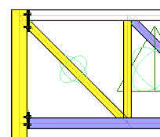 | 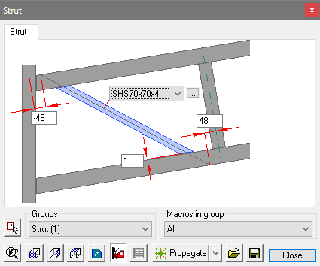

In this case, the reference dimensions have been edited to read 48, so that the center-line of the new strut intersects with the centers of the top and bottom chords of the truss.
Note that the color of the struts and the adjacent column indicate an interference. This is because the required cuts have not been included:
You can add these with the Add cut to macro tool that is available in the Cutting toolbar.
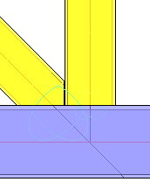 | 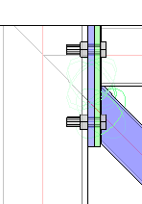
Cut 1 | Cut 2

Running the Clash check command should indicate the interference has been resolved

Truss Haunch Connection
Command -
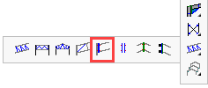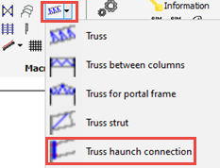

This command will add a full depth end-plate connection for a truss.
On activating the command you will be prompted to select in this order :
- The column
- The lower chord of the truss
- The upper chord of the truss
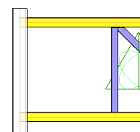

After selection, the options dialog will appear :
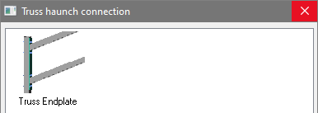

The end-plate will be drawn immediately :
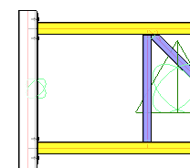 | 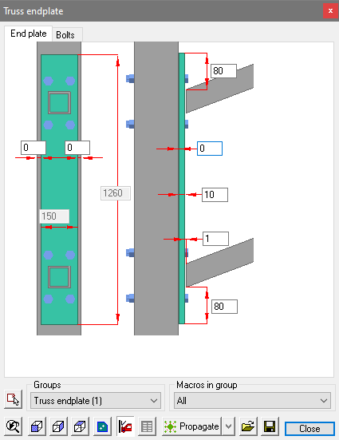

2 Trusses v Column
Command -

This command will add full depth end-plates truss connection where 2 trusses connect to one column.
On activating the command you will be prompted to select in this order :
- The column
- The lower chord of the left truss
- The upper chord of the left truss
- The lower chord of the right truss
- The upper chord of the right truss

After selection, the options dialog will appear :
The end-plates will be drawn immediately :

Truss Apex
Command -

This command will add full depth apex end-plates for 2 trusses.
On activating the command you will be prompted to select in this order :
- The lower chord of the left truss
- The upper chord of the left truss
- The lower chord of the right truss
- The upper chord of the right truss

After selection, the options dialog will appear :
The end-plates will be drawn immediately :

Truss to Truss
Command -

This command will add full depth end-plates for intersecting trusses in a T-connection.
On activating the command you will be prompted to select in this order :
- The lower chord of the truss that will be lengthened
- The upper chord of the truss that will be lengthened
- The lower chord of the truss that is continuous
- The upper chord of the truss that is continuous

After selection, the options dialog will appear :
The end-plates will be drawn immediately :

Framework
- Frames /
    - Building Imperial
    - Building Imperial / No Connections
    - Building / No Connections
    - Building
    - Platform
    - Staircase / Cranked Stringers
    - Staircase / Floors only
    - Staircase / with UB Platforms
- Stair
- Railing
- Ladder
- Spiral stair
- Cladding
- PEB member
- Feeding excel values to macros and arrays
- Draw a Body
- Manipulate a Body

Frames
Command -
Activating this command will open the below dialog.
From here you can select one from the range of predefined building structures. Each one is explained in detail below:
- Building - no connections
- Building - with defined connections and braced bays
- Platform
- Staircase Cranked Stringers - Stair tower
- Staircase - Floors only
- Staircase with UB platforms

Building - no connections

The customization dialog of this macro looks like this :

Here, you are able to fix the height, roof height, width, number of bays, and the steel section sizes.
Note that by default the bays will always be equally spaced. This can be changed by pressing the button next to the number of bays value.

You can revisit any of the individual macros by using the Review Macro command

Building - with defined connections and braced bays
The customization dialog of this macro looks like this :

Here, you are able to fix the height, roof height, width, number of bays, and the steel section sizes.
Note that by default the bays will always be equally spaced. This can be changed by pressing the button next to the number of bays value.
Sheeting rails and roof purlins may be added by activating the Cladding command
You can revisit any of the macros by activating the Review Macro command and selecting the individual macro spheres.

Platform
The customization dialog of this macro looks like this :
This tab enables you to edit the overall parameters of the platform, Height, Width, Depth

This tab enables you to edit the beam profiles and their placement

You can revisit any of the macros by activating the Review Macro command and selecting the individual macro spheres

Staircase Cranked Stringers - Stair tower
This tool draws a freestanding stair tower.
There are 3 tabs to the dialog, enabling you to edit the Floors, Staircase, and Columns
Selecting the Review Macro command, and selecting any of the macro spheres, you are able to individually edit the connections, stair treads, and HandRailing to suit requirements

The starting height, X and Y starting position, width, and depth of the staircase are all determined by the blue planes a the bottom of the structure.
When any of these are moved, the staircase will adapt to this change.

Staircase - Floors only
This tool draws a freestanding stair tower structure without the stair.
There are 3 tabs to the dialog, enabling you to edit the Floors, Staircase, and Columns
Selecting the Review Macro command, and selecting any of the macro spheres, you are able to individually edit the columns and beams to suit requirements
This command will allow the user to install a custom stair with parameters outside of the Staircase-Cranked Stringers
The starting height, X and Y starting position, width, and depth of the structure are all determined by the blue planes a the bottom of the structure.
When any of these are moved, the structure will adapt to this change.

Staircase with UB platforms
This tool draws a freestanding staircase without any supporting columns.
There are 3 tabs to the dialog, enabling you to edit the Floors, Staircase, and Columns
Selecting the Review Macro command, and selecting any of the macro spheres, you are able to individually edit the connections, stair treads, and HandRailing to suit requirements
This command will allow the user to install a custom stair with parameters outside of the Staircase-Cranked Stringers

The starting height, X and Y starting position, width, and depth of the staircase are all determined by the blue planes a the bottom of the structure.
When any of these are moved, the staircase will adapt to this change.

Stair
Command - PrB_Stair
For more information about this tool, see the Stairs chapter.

Railing
Command - PrB_Railing
For more information about this tool, see the Railings chapter.

Ladder
Command - PrB_Ladder
For more information about this tool, see the Ladder chapter.

Spiral Stair
Command -
For more information about this tool, see the Spiral Stair chapter.

Cladding
Command - PrB_Cladding

Activating this command will open the Select a cladding type dialog - select one of the options and press Ok
In this manual topic, we will explore the 3 options: Apex, Floor, and Wall

Apex
This tool will place roof purlins.
After confirming the Apex configuration, select the first row of roof beams on one side of the apex.
Then, select the next row of beams on the other side of the apex.
Select the roof beams on one side of the Apex | Purlins after selecting Connections

From the connection selection dialog, select the appropriate purlin to roof-beam connection.
Where the purlins are interrupted, a second dialog will appear prompting you to select the bracket at the interrupted joint.
You may skip these connections by pressing the cancel button.

The purlins are drawn complete with the selected brackets accompanied by the edit dialog where you can change all the parameters of the purlins.
Read below to learn how to Edit the new purlin brackets

Floors
This command will place floor beams.
After choosing the Floors configuration, select the row of roof beams on which to support the floor.
Select the supporting beams | Floor beams after selecting Connections

From the connection selection dialog, select the appropriate floor to beam connection.
You may skip these connections by pressing the cancel button.

The floor beams are drawn complete with the selected connections accompanied by the edit dialog where you can change all the parameters of the floor beams.
Any changes will be automatically reflected on the model.
Read below to learn how to Edit the new purlin brackets

Wall
This command will place Side Cladding or Girts.
After selecting the Wall configuration, select the row of columns on which to place the side cladding girts.
At the prompt, select the side of the columns to which they are to be placed.
Select the Columns | Side girts after selecting direction and Connections

From the connection selection dialog, select the appropriate side girt connection.
Where the girts are interrupted, a second dialog will appear prompting you to select the bracket at the interrupted joint
You may skip these connections by pressing the cancel button.

The side girts are drawn complete with the selected connections accompanied by the edit dialog where you can change all the parameters of the girts.
Any changes will be automatically reflected on the model.
Read below to learn how to Edit the new purlin brackets

The Cladding configuration dialog
All of the options in this dialog box are explained here :
Profile Section - The profile shape and size that needs to be used for the new purlins/girts
Selection for the Beginning / End - This will set the position of the first purlin. For the roof purlins this would be the eaves of the structure, for wall girts this could be the ground floor or a concrete slab.
From the drop-down menu, there are the following options:
To Plane - Will allow you to select any column face of any profile or plate
To Grid line - Will allow you to select any grid line.
To Beam - Will allow you to select any beam.
To Column - Will allow you to select any beam. Use this for floor or apex configurations only
Start of Profile - This will measure from the start of the base profiles. This will be the selected columns in case of the wall cladding, or the selected beams in case of Floor or Apex configurations.
End of Profile - This will measure from the end of the base profiles. This will be the selected columns in case of the wall cladding, or the selected beams in case of Floor or Apex configurations.
Purlin placement - This will set the orientation of the purlin relative to the base profiles. From the drop down menus, there are the following options:
No Rotation - Accept the default rotation
Rotate follow-up row of purlins - Alternate every second purlin rotation
Rotate for Zed purlins with overlap - Zed purlins with an overlap will need a rotation for each instance
Purlin interruption - This will set the purlin span. From the drop down menus, there are the following options:
Interrupt at every location - Span the purlins between each base profile
Draw the purlins between the base members - This will draw the purlins flush : The top of the purlins will be coincident with the top of the base profiles. This also means that the purlins will be interrupted at each intersection with the base profiles.
No interrupts - This will span the purlins over the base profiles without any breaks
Skip interruption over some members - Do not break the purlins over a specified amount of base profiles.
Skip interruption over some members, Alternating - Same as above, but the breaks on the followup row of purlins will be alternated. If you use this then the interruption will not be placed on the same base profiles for all the purlins.
Number of members with no interruption - This option is to be used in combination with the above Skip interruption over some members options
Reverse the orientation of the purlins - This switches the start/end orientation of all the purlins

Edit the Purlin Brackets
There are likely to be numerous brackets and to edit them one at a time would take too long. It is however possible to edit all the brackets simultaneously.
Click on the Review macro icon and block select the entire roof structure.

This will open the macro edit dialog. At the bottom of the dialog, open the Groups drop-down menu and select Continuous purlin (the number in brackets is the number of macros included in the selection).
This will automatically open the relevant edit dialog.
Note! If the option for Interrupted purlin was chosen, it will be necessary to edit the brackets separately.
This method will work for any connection type or group.

PEB member
This command allows you to draw a single PEB member or an array of PEB members.
The macro drawn by this command works much the same as drawing a regular profile : you select a model line, and the PEB member is drawn on the line.
The orientation of the PEB member around that line can be changed afterwards.
This command can be used to draw columns as well as rafters. Both can be drawn with the same macro.

Single PEB member
It suffices to simply select a line in order to draw a single PEB member.
The rotation of the single PEB member can be changed in the dialog box that appears when you insert the PEB member :
Do make sure that you change the BaseProfile when changing the rotation of the PEB member.
The starting and ending depths and gaps can be changed directly from the same dialog :
The Web thickness setting in this dialog is a guideline for the macro. It will be applied if a PEB plate with the chosen thickness exists in the library.
The size of the web plate is determined by the 2 depths and the web thickness.
But the size of the flange are not fully determined by those settings.
You can change the flanges by switching to one of the flanges in the profile properties combobox :
Here, you can change the width and thickness of the flanges individually.
By clicking on Other, you can add more PEB plate sizes to the section table :
PEB plates were given a separate section table so that they won't interfere with the normal flat bar sizes.

Array of (spliced) PEB members
It suffices to simply select a line in order to draw an array of PEB members.
This will draw an array of PEB members evenly distributed over the selected line's length.
Initially, the members are already connected with a double endplate splice connection.
They are separate connections so they can be modified or replaced.
The dialog box that appears will show all of the settings of all the PEB members in the array merged together.
We can change the number of PEB members as well as all the other options of all the spliced PEB members :
There is however one consequence that we need to take into account, and that is the depth of each PEB member.
The depths of all the members are merged by this dialog, resulting in a *VARIES* value.
To change the depth of the individual members, one simply needs to double-click a plate of a PEB member.
The dialog box that then appears allows you to change the start- and end-depth of the individual PEB member.
This gives us the flexibility to draw PEB member arrays with varying depths that are not necessarily continuous across the length of the array :

Feeding excel values to macros and arrays
Command : PrB_FeedExcelToMacros
This command can be used to feed cell values from an excel file directly into macros and arrays in a Parabuild drawing.
A mapping file can be used to reduce the need for having to repetitively enter names, but the mapping file is not a requirement.
You can download and use this sample template and accompanying excel files to test out this command :
- Template drawing of a portal frame with cladding sheets
- The excel feeder file that was created to feed values the portal frame template
- The excel mapping file that was created to map the values to the macros and arrays in the portal frame template

To use these 3 files, first open the dwg file in Parabuild, and then start the excel feeder command.
Then enter the locations of the feeder and mapping files.
This is a detailed explanation of the options in the dialog box :
Excel values file - Select an excel file that was prepared to work with the drawing that is currently open. What the contents of this file can/should be is explained hereafter.
Sheets to process - After choosing an excel file, this list of sheets will be populated with all of the available sheets in the excel file. Select the sheets that Parabuild should process.
Excel mapping file (optional) - Select an optional excel file that was prepared to work in tandem with the Excel values file. What the contents of this file can/should be is explained hereafter.
Feed data to - Choose which macros the feeding should be applied to (or the entire drawing).
Add dependent macros to the selection - This option is only available when you have chosen a selection to limit the macros that should be changed by this feeding tool.
By activating this, the tool will automatically add all the macros that are dependent on the macros that you select.
The dependent macros tool works 'downward' if you would look at the macro dependencies as an upside down tree with the largest macro at the top.
When we take a basic portal frame building as example, and we select the macro of 1 portal frame, then the tool would automatically add the haunch, apex, baseplate and gussets/bracing macros. But it will only add the sub-connections of those portal frames that you select.
When pressing Ok, the excel files will be read and the changes will be applied to the macros and arrays in the drawing.
The sample template drawing looks like this before and after applying excel values to it :
The template drawing before applying the excel values | The template drawing after applying the excel values
In this example the excel file(s) changed the roof height, enlarged the structure, changed the number of portal frames, modified the side rails and did changes to the apex and haunch connections.

To explain the workings of this command, consider the following simple example mapping and feeding files :

Sample mapping file
Unique name | Macro/array name or groupname | Module name or groupname | Variable name | Pre-Filter
Number of portals | PortalFrameArray | (none) | NumEntries
Apex height | PortalMacro | ModelLines | ApexHeight
Portal1 Column section | PortalMacro | ProfilesModule | Column.SectionName | PortalFrameArray.0

Sample feeding file
Unique name | Value
Number of portals | 8
Apex height | 15000
Portal1 Column section | IPE220

The above sample files would do the following changes on a drawing that contains the correctly named array and macros :
- Change the number of portal frames to 8
- Change the apex height to 15000
- Change the section of the column of only the first portal frame to IPE220

The columns that reference the Parabuild macros and arrays are Macro/array name or groupname, Module name or groupname and Variable name.

Macro/array name or groupname
The Macro/array name or groupname column references the name or groupname of the macro in which a variable needs to be changed.

Module name or groupname
The Module name or groupname column references the name or groupname of the module in which a variable needs to be changed

Variable name
The Variable name column references the name of the variable itself.

Pre-Filter
The Pre-Filter column allows you to add a filter to which the value will be applied. This can be particularly useful for arrays, where we can configure this to only apply the value to a particular index in the array.
The supported strings are :
- Macro name. Ex: "MacroName"
- Defining array (with optional entry). Ex: "PortalArray.Last", "PortalArray.3"
You can combine multiple strings by using a comma separated list. Ex: "PortalArray.Last, RoofPurlins.First"
When this is used in a full path variable with redirection included, then put it between <>
For example :
- "<DefiningMacro>MacroName.ModuleName.VariableName"
- "<PortalArray.Last>MacroName.ModuleName.VariableName"
- "<PortalArray.Last, RoofPurlins.First>MacroName.ModuleName.VariableName"

Unique name
The unique name columns is there to assign a name to the row's configuration. This unique name can then be used in the feeding file to reference the macro/array/variable without having to mention all of the information again.

Using a single excel file to feed excel values
Alternatively, we can use a single excel file that directly feeds values to the macros.
The mapping file can be left out if the Unique name column contains all of the necessary information to target the macro, module and variable.
This is achieved by adding a '.' separator in the Unique name column
This is an example of such a single feeding excel file :
Unique name | Value
Staircase.Staircase.NumEntries | 5
Staircase.Staircase.RigidEntryDistance | 5000
Staircase.Staircase.2.EntryDimFixedByUser | 1
Staircase.Staircase.2.UserEntrySize | 3000
Staircase.Columns.ColumnsDistanceFromSide1 | -500
Staircase.Floors.DistanceFromSide1 | -500
Staircase.Floors.DistanceFromSide3 | -500
Stringer.Stringer.Profiles.SectionName | UPN220
In this example, a different height between floor 2 and 3 was deliberately chosen to show the flexibility of the array.
If you want to try out this excel file, then you will need these files :
- Download the excel feeder file for the staircase from here
- The template staircase itself can be found in the library folder : \Parabuild\Pb_Lib\Macros\Frames\Staircase Cranked Stringers.dwg
Alternatively, you can download the staircase template file from here

Variable types
For the variable name, a lot of different types are available.
These are all the different types that can be used :

Normal variables
Normal variables that reside inside modules can simply be changed by referencing their name.

General variables
A general variable of a macro is a variable that resides throughout the entire macro, and this across all modules of the macro.
These variables always start with "gen_" in their name.
You can simply use the general variable's name, but leave the modules field empty whenever you use a general variable.
The general variables of a macro can be consulted and modified in the General macro settings.

Cuts
Cuts can be located in any module.
Cuts can have several variables depending on the type of cut.
To reference a variable of a cut, enter the cut name and the variable name separated by an underscore.
To see the supported variables of a particular cut, you can open the cut in the edit macro dialog box.
The correct naming is already shown in the edit cut dialog :

Profiles
Most of the settings that are available in the Profile placement dialog, can also be changed through the Excel variables.
The variable names listed below are unique to profile placements in a profile module, and they can be used to feed variables :
- SectionName : See Profile section in the dialog
- RotationAngleRadians and RotationAngleDegrees : see Rotation in the dialog
- ReversePath : see Switch direction in the dialog
- SectionOffset : This value should be the x and y coordinates for the displacement of the section, delimited by a comma. For example: 10,15
See Move in X-Direction and Move in Y-Direction in the dialog
- SectionOffsetType : Changes the location of the cardinal point on the section. See Section displacement in the dialog
These are the supported numbers and what they do :
  - 4 = Middle
  - 5 = Neutral axis
  - 6 = Above
  - 7 = Under
  - 8 = Left
  - 9 = Right
  - 10 = upleft
  - 11 = upright
  - 12 = downleft
  - 13 = downright
- SectionOffsetTypeName : Changes the location of the cardinal point on the section. See Section displacement in the dialog
The supported names for offset type are :
  - Startpoint of polyline
  - Middle
  - Neutral axis
  - Above
  - Under
  - Left
  - Right
  - upleft
  - upright
  - downleft
  - downright
Note : Change only one of the values SectionOffset/SectionOffsetType/SectionOffsetTypeName, because these 3 variables change the same setting.
These variables can be used directly for a profile module. All of the profiles that are defined in this module will then get the new setting.
You can also 'target' specific profiles in the module by specifying the groupname of the profile(s) first, like this :
Column1.SectionName
In this example Column1 is the groupname, and to find out the groupname of a profile, you can use the command PrB_GroupName.

Bolt module
Many of the settings that are available in the Advanced bolt settings dialog, can also be changed through the Excel variables.
The following variable names can be used to feed variables that are unique to bolt modules :
- BoltAssembly - See Bolt assembly in the dialog
- BoltDiameter - See Diameter in the dialog
- BoltLength - This setting will change the bolt length temporarily, but the bolt length will immediatly be corrected again by the check new holes tool. This variables is therefore only useful to try to extend the bolt to be connected to more parts that are located on the side of the nut
- BoltAddedLength - See Added length in the dialog. Another name for this is protrusion. This will force the bolt to add more length to the bolt after the last nut
- ShopBolted - See Shop bolted in the dialog
- HoleOffset - This is the radius based offset between bolt and hole
- HoleTolerance - See Hole tolerance in the dialog. This is the diameter based tolerance between bolt and hole
- HoleDiameter - This changes the hole diameter directly, instead of through the tolerance. The hole tolerance is simply calculated and changed based on the value that you enter here

Note : Change only one of the values HoleOffset/HoleTolerance/HoleDiameter, because these 3 variables change the same setting

Bolt Pattern
Many of the settings that are available in the Bolt pattern settings dialog, can also be changed through the Excel variables.
The following variable names can be used to feed pattern objects :
- ReversePositions1 - This value refers to the Switch bolts startposition setting in the dialog
- ReversePositions2 - Same as ReversePositions1 but it refers to the right side of the dialog
- IsFixedEntryDistance1 - Enable this to set a fixed distance between all the bolts. Refers to the Fixed distance between bolts checkbox in the dialog
- IsFixedEntryDistance2 - Same as IsFixedEntryDistance1 but it refers to the right side of the dialog
- UserEntryDist1 - Use this in combination with IsFixedEntryDistance1 to set a fixed distance between all the bolts
- UserEntryDist2 - Same as UserEntryDist1 but it refers to the right side of the dialog
- EntryDistRounding1 - This value refers to the Rounding distance between setting in the dialog
- EntryDistRounding2 - Same as EntryDistRounding1 but it refers to the right side of the dialog
- Count1 - Changes the number of bolts that are distributed evenly. This value changes the number of rows in the dialog
- Count2 - Same as Count1 but it refers to the right side of the dialog
- OffsetsAsList1 - Use this to set varying distances between the bolts. Enter all of the distances separated by a comma. For example : 100,150,100
- OffsetsAsList2 - Same as OffsetsAsList1

The left side of the dialog refers to the variables names 1, the right of the dialog refers to the variable names with 2.
Note : Change only one of the values Count1/OffsetsAsList1, because these 2 variables change the same setting.

Array
Many of the settings that are available in the Array settings dialog, can also be changed through the Excel variables.
To reference an array, use the array name and/or array group name in the excel columns. You can find these strings in the properties panel of the array object.
The following variable names can be used to feed array objects :
- Type - This changes the type of array, see the Type setting in the dialog. Enter a number from 1 to 3 here :
  - 1 : Normal distribution
  - 2 : Normal but entries use distance between
  - 3 : Entries decide distance between
- EnableRigidEntryDists - Refers to the Fixed distance between entries setting in the dialog. Only use 1 or 0 as value in excel to change the checkbox value
- RigidEntryDistFromEntryMacro - Refers to the Distance is retrieved from entry macro setting in the dialog. Only use 1 or 0 as value in excel to change the checkbox value. This value only works when EnableRigidEntryDists is enabled
- RigidEntryDistance - Refers to the distance between entries: setting in the dialog
- RigidEntryDistanceMax - Refers to the distance between entries Max: setting in the dialog
- AdjustCountToFitSize - Refers to the Adjust count to fit size setting in the dialog
- TotalDimName - Refers to the Total length (number or variable) setting in the dialog
- EntryDimName - Refers to the Variable for distance from the start setting in the dialog
- EntrySizeDimName - Refers to the Variable name for entry size (will be filled) setting in the dialog
- EntryDistRounding - Refers to the Rounding for entry distances setting in the dialog
- RemainderDestination - Refers to the Destination for remainders setting in the dialog. Enter one of the valid numbers here :
  - 0 : None
  - 1 : Start - Remainder goes before the first entry
  - 2 : End - Remainder goes after the last entry
  - 4 : Both ends - Remainder goes half before the first entry, half after the last entry (= centered)
  - 8 : Distribute - All entries without a UserEntrySize get a share of the remainder. Limited by "mEntryDistRounding"
- NumEntries - Refers to the Number of entries setting in the dialog
- MinNumEntries - Refers to the Number of entries minimum setting in the dialog
- AppendByAlternating - Refers to the Add entries alternating setting in the dialog. Only use 1 or 0 as value in excel to change the checkbox value
- AlternatingSourceOffset - Refers to the Nr of entries to skip setting in the dialog
- UserStartOffset - Refers to the Begin distance setting in the dialog
- UserEndOffset - Refers to the End distance setting in the dialog
- DefaultInsertIndex - Refers to the Location for new entry setting in the dialog
- DefaultSourceIndex - Refers to the Source entry for new entry setting in the dialog
- SkipEntry - Refers to the Entry manipulations listbox in the dialog. Setting this to 1 will skip the entry, setting this to 0 will restore the entry
This name gives the ability to skip (remove) a certain entry in the array.
The variable name needs to include the entry index number.
Some valid examples of variable names are :
  - 1.SkipEntry - Skip the second entry (any index number of the array can be used)
  - -1.SkipEntry - Skip the second from last entry (any index number of the array can be used)
  - First.SkipEntry - Skip the first entry
  - Last.SkipEntry - Skip the last entry
- EntryDimFixedByUser - Refers to the Entry manipulations listbox in the dialog. Setting this to 1 will enable the distance between entries override, setting this to 0 will disable the distance override
The variable name needs to include the entry index number.
Some valid examples of variable names are :
  - 1.EntryDimFixedByUser - Enable distance override between the second and third entries (any index number of the array can be used)
  - -1.EntryDimFixedByUser - Enable distance override between the second from last and third from last entries (any index number of the array can be used)
  - First.EntryDimFixedByUser - Enable distance override between the first and the second entries
  - Last.EntryDimFixedByUser - Enable distance override between the last and the second from last entries
- UserEntrySize - Refers to the Entry manipulations listbox in the dialog. This will set the distance between entries override 2 particular entries. This needs to be used in combination with the EntryDimFixedByUser variable (enable this option first)
The variable name needs to include the entry index number.
Some valid examples of variable names are :
  - 1.UserEntrySize - Sets the distance override between the second and third entries (any index number of the array can be used)
  - -1.UserEntrySize - Sets the distance override between the second from last and third from last entries (any index number of the array can be used)
  - First.UserEntrySize - Sets the distance override between the first and the second entries
  - Last.UserEntrySize - Sets the distance override between the last and the second from last entries

Draw a Body
Command - PrB_CreateBodyDlg
For more information about this tool, see the Draw a Body chapter.

Manipulate a Body
Command - PrB_ManipulateBody
For more information about this tool, see the Manipulate a Body chapter.

Pre-engineered buildings (PEB)
Several commands in Parabuild will facilitate drafting of Pre-Engineered buildings.
The commands can be categorized into 2 categories : Drawing PEB members and Drawing connections between PEB members.

Drawing a new PEB member
The PEB member command allows you to draw a single PEB member or an array of PEB members.
The macro drawn by this command works much the same as drawing a regular profile : you select a model line, and the PEB member is drawn on the line.
The orientation of the PEB member around that line can be changed afterwards.
This command can be used to draw columns as well as rafters. Both can be drawn with the same macro.

Drawing connections between PEB members
These commands will ask you to select the individual plates of the PEB members in this order :
- The main flange (grey or black plate)
- The web (blue)
- The other flange (blue)

The following connection commands are available :
- Connections for 1 PEB member
- Connections for 2 PEB members
- Connections for 1 PEB member and 1 regular member

Drawing wedges
The classic Haunch connection command allows us to draw wedges between 2 regular members.

PEB portal frame template
The structural Frames command contains a template drawing of a portal frame with PEB members to demonstrate some of the capability.
It was configured with PEB member columns, spliced PEB rafters, PEB Ridge rafters and PEB haunch connections.
This is the template drawing when it is first inserted
This is the result after simply changing the width, depth and height of the portal frames

Main - Output
This chapter is divided into two: The first topic covers welding as applied to the 3D model and includes a number of sub-categories listed separately under it's heading Welding / Numbering
The remaining topics apply to the preparation and editing of 2D drawings and their respective bills-of-material and schedules, including:
- Welding Numbering
- Sheets Manager
- Tools for 2D Drawings
- Dimensioning
- Modifying Dimensions
- Parabuild General

Assemblies / Groups
- Assembly / Object selection
- Attach parts to assembly
- Remove parts from assembly
- Set as end-plate
- Switch profile triangle direction
- Restore group selections
- Edit weld symbol
- Numbering / Revisions

Assembly / Object Selection
Command - PrB_AssemblySelection

This command functions like a ‘switch’. Every time you click on it the assembly selection is turned on or off.
All components of one assembly are grouped together. If you turn off assembly selection, then you can for example move a welded plate without moving all of its assembly members at the same time. The group always stays intact, i.e. when you turn assembly selection back on all components of that assembly will ‘stick together again’.
To make things clear: assembly selection only changes the way in which elements are selected while drawing, not which element is welded against which. So the welding data remains intact after the assembly selection has been turned on or off.

Add parts to assembly
Command - PrB_Attach

This tool allows you to attach one or more parts to a main part, which combines them into an assembly.
The attached sub parts will receive a blue or green color by default (if the visibility mode Sub parts is activated).
This allows you to see immediately which parts are welded.
All parts of each assembly are merged together into one selection group.
This means that if you select one part then all parts of that assembly will automatically be selected.
This behavior can be disabled (so you can switch between part selection and assembly selection).
To learn more about this see Assembly/Part selection switch
Note: A plate cannot be used as a main part to attach other parts to it. Only profiles can be main parts.
In cases where you really need to have a plate as main part (for example the assembly is composed of plates only), then you can convert 1 plate to a strip and use the strip as main part.

An assembly in Parabuild is a collection of parts that are supposed to be attached to each other in the workshop.
The assembly will receive an assembly number (Parabuild detects equal assemblies and assigns them the same assembly number).
The fact that parts are in the same assembly does not necessarily mean that the parts are welded.
It is up to the draftsperson to still define/draw the attachment method of the parts in the assembly if this is necessary.
For example :
- Adding 3D Welds to define the weld requirements. Note that it is not required to draw the 3D welds. The assembly will get a shop drawing with all the necessary dimensions for producing the part with or without 3D welds. The 3D welds will show up in the shop drawing as additional information if they are drawn.
- Drawing the Shop Bolts in case the parts are not to be welded

Remove parts from assembly
Command - PrB_Detach
This tool allows you to disconnect one or more parts from an assembly.
The disconnected sub parts will revert to their default color (if the visibility mode Sub parts is activated).
The coloring allows you to see immediately which parts are not attached to a main/assembly.

Set as End-Plate
Command - PrB_SetTracPlate

With this command you can convert an ordinary welded (blue) plate to an End / Base-Plate (green).
The only difference between the two is that the end (green) plate gets an additional front view in the assembly workshop drawing.
The properties panel of the plate has a property that does the exact same thing as this command.

Switch Profile Triangle Direction
Command - PrB_SwitchProfEcs
This tool allows you to switch the location of the triangle of a profile.
The triangle of a profile determines the profile's orientation on the workshop drawings, at least if the workshop drawings are set up to use the profile's direction for the views.

Restore Group Selections
Command - PrB_ResetGroups
This tool rebuilds all the groups in the 3D drawing, based on the assembly data that Parabuild has stored for all the parts.
This tool can be used if the selection groups are mismatching the actual assemblies.
Parabuild always manages the selection groups so that they perfectly match with the actual weld data.
But the selection groups could become mismatched after a corrupted 3D drawing was repaired or other extreme cases.

Welds
Parabuild allows you to model 3D welds for the most used structural weld types. There are several advantages to explicitly modeling welds. Visualization of welds will aid the user in determining problematic welding situations and wrongly sized welds. Weld symbols will be automatically added when generating shop drawings. Bills of material of a project’s welds can help with estimating, planning and scheduling of the welders. The 3D weld objects can also receive fabrication data and get a unique number for tracking purposes. In the near future we intend to extend these capabilities to include support for robotic welding.
A traditional hurdle with modeling welds is the amount of work involved for the detailer.
To make this go a lot faster we created the AutoWeld engine that can automatically create welds based on very flexible rulesets that the user can customize. Different weld types and sizes can be automatically assigned by a ruleset based on available model information like plate thickness, angle, structural types and much more. The standard Parabuild ruleset will create most structural welds automatically and can be used as the base for your own customized fabricator specific rulesets.
Further editing of the automatically created welds is then easily and quickly done using the properties panel or the weld editing dialog, making the overall process very efficient.

These are all the topics for the creation of welds and the automatic addition of weld symbols on the shop drawings :
- The 3D Weld object
- It is possible to use the properties panel on the 3D Weld object. This topic also explains the purpose of each property.
- Automatically draw weld objects using AutoWeld
- Drawing welds with the context modeler
- Drawing welds from within the Macro dialog box
- Reviewing and modifying welds
- Deleting welds
- Removing weld segments
- Splitting / Merging welds
- Numbering welds
- There are settings in the shop drawings that will influence how the weld symbols are drawn and grouped on the 2D drawings.
See the Weld symbols on shop drawings topic for more information

Welding practices
If you need more general information about welding practices, we can refer you to the Structural Detailer site :
- Welding processes
- Joint types
- Fillet welds
- Weld preparations
- Basic weld symbols and an example weld for each
- ISO weld symbols

The 3D Weld object
The 3D weld object represents the welding that needs to be performed between 2 parts.
The 3D weld (orange) is visualized approximately to how the weld would look like when finished

3D welds can be drawn in 3 ways :
- Automatically using the AutoWeld command
- Automatically with the help of macros. See the Welds tab inside the review Macro for more information about this method
- Manually using the Draw welds option in the context modeler

Users can also edit existing connection templates (or create new ones) with all welds completed to their preferences. Upon applying the connection between members, the welds are copied along with the rest of the connection objects and will be recalculated to fit the new members. Fine-tuning the templates of frequently used connections in this way can save the detailer additional time while modeling.

Modeling welds in 3D is useful in multiple ways:
- The estimation of a project : knowing how many welds will need to be made, the length and size of the welds, and how material will be spent on them, can be useful for composing a project quote.
- Optimization: quickly generating welds for the whole project allows the user to cost-optimize a project by comparing different project permutations. In the same way AutoWeld can be used to compare the cost of different connection options.
- 3D welds will automatically receive Weld Symbols on the assembly shop drawings. This is a practical way to indicate weld requirements that fall outside of the company's standard welding rules on the shop drawing.
- Visualization of welds will aid the user in determining problematic welding situations and wrongly sized welds
- Some industries or companies require each weld to be annotated on shop drawings, regardless of company weld standards or rules.
- In shop floor planning stages it is useful to know which assemblies require significant welding so that their component parts may be produced sooner.

You can double-click a 3D weld to review or edit the weld's settings in a visual dialog box.

You can also use the AutoCAD/BricsCAD properties panel to review or edit one or multiple 3D welds at the same time.
You can find a full breakdown of the all the properties of the 3D weld in the 3D Weld properties topic. Each property is explained in this topic.

Options and behaviors specific to bevel welds
Here are some behaviors that are specific to bevel welds that you need to be aware of :
- The bevel weld has a root face height setting that will work when the weld size is 0.
- A bevel weld with size 0 means that the size will be automatically determined (Plate thickness minus the Root face height)
- The root opening should be the desired gap between the materials at the closest point.
When you set the root opening to 0, then Parabuild will try to find the existing root opening from the 3D model automatically. You can set the root opening to -1 if you do not want Parabuild to find the root opening automatically. A root gap larger then the gap in the model implies additional weld preparation.
- When the angle of the bevel weld is set to 0°, and there is an oblique opening, then the existing opening will be filled without an additional beveling of the part.This example shows this case :

AutoWeld
Command - PrB_AutoWeld
This command will automatically draw 3D welds for the most frequently used structural weld types.
A traditional hurdle with modeling welds is the amount of work involved for the detailer. To make this go a lot faster we created the AutoWeld engine that can automatically create welds based on very flexible rulesets that the user can customize. Different weld types and sizes can be automatically assigned by a ruleset based on all available model information like plate thickness, angle, structural types and much more. The standard Parabuild ruleset will create most structural welds automatically and can be used as the base for your own customized fabricator specific rulesets.
Further editing of the automatically created welds is then easily and quickly done using the properties panel or the weld editing dialog, making the overall process very efficient.
Some examples of welds that can be drawn automatically with varying settings :

Requirements
The following requirements should be met before using this command :
- The 3D parts that you want to add welds to should be touching or nearly touching. Parabuild will use the position of parts relative to each other to determine which welds to add.
- The 3D parts should already be organized into assemblies if you want this command to draw shop welds. This is not a requirement if you want to draw site welds. You can use the Attach command to organize the parts into assemblies by attaching sub parts to their main part. Parts drawn with macros are usually already attached to their main parts.
This command will only draw 3D welds between parts that do not have a 3D weld between them yet. So you can use the command multiple times without having to worry about duplicate welds being drawn.
This means if you want to redo the automatic 3D welds, you will have to delete the existing 3D welds first. A shortcut for deleting existing 3D welds was added at the top of the dialog for convenience.

Disclaimer
Welds created automatically will get sizes that may not sufficiently account for loads and stresses. All welds should be checked versus engineer specifications.

This is a full breakdown of all the different options that are available in the dialog box of AutoWeld :
Use this button to open a previously stored AutoWeld settings file. The settings file contains all of the setting values and overrides inside this dialog box. This tool can be used to save and re-use the company's welding standards.
Use this button to save the current settings to an AutoWeld settings file. The settings file contains all of the setting values and overrides inside this dialog box.
This button allows you to reset all of the settings in the AutoWeld dialog to the Parabuild defaults.
It shows a dialog that allows you to change the most common weld settings :
These options are also available in the main AutoWeld dialog, but this dialog is a way to quickly configure the AutoWeld settings with some common settings, without having to resort to editing the more complex AutoWeld settings and overrides.
For more detailed information about these options, see the General tab below.
*Note* The option Switch to bevel will consider sizes above the given fillet size.
The option Switch to double bevel will consider sizes above the given plate thickness.
When you press this button, then the current settings in the dialog will be saved as default for the next Parabuild sessions. So the next time that you start Parabuild, these settings will be loaded.
This will delete all 3D welds from a selection. AutoWeld does not draw a new weld between two parts if they already have a weld between them. So if you have previously already used the AutoWeld command, and you want to re-run this command, then delete the previously drawn welds first with this button.
This will delete all 3D welds from the entire drawing. AutoWeld does not draw a new weld between two parts if they already have a weld between them. So if you have previously already used the AutoWeld command, and you want to re-run this command, then delete the previously drawn welds first with this button.
Enable this if you want the command to first classify the parts before drawing the welds. If classification is not done before AutoWeld then the resulting welds of this command will be less relevant to the characteristics of the base parts.
Clicking on this will prompt for a selection of parts that should be AutoWelded.
Clicking on this will start AutoWeld on the entire drawing.

The following settings will allow you to configure the AutoWeld command to draw the welds more closely to your company's weld rules.
However these settings are extensive and may be overkill for many users.
We recommend users the following process;
1. First edit the standard Tag Styles and set the properties to your preferences (to reduce editing individual welds later)
2. Also modify the standard weld size tables, which match certain plate thicknesses and angles with specific weld sizes
3. Next use the set to defaults button for a simple way to customize the weld settings according to your requirements
At this time you can choose which weld size tables to use in different scenarios
4. If after these changes you still want to change the welds in certain situations then the AutoWeld filter and override system allows you fine-tune the welding for very specific or very general situations as needed. This system is described below.
This configuration will usually only need to be done once for each fabricator and then it can be used by all the other draftspersons within the company.

General tab
This tab lists the default settings specifying when welds should be drawn, which types and what properties. All these settings can later be changed by overrides that define settings for specific situations. These overrides are defined in the other tabs. The default settings include many overrides for specific situations so if you want to change the welding behavior it is best to also review the related overrides.

We will explain each option in this list in detail :
Weld standard - Choose the weld standard ISO or ANSI (AWS)
Allow shop welds - When enabled parts within the same assembly can get welds between them
Allow site welds - When enabled parts not in the same assembly can get welds between them
Allow weld if bolted - When enabled parts bolted to each other can get shop or field welds between them
Allow Tee joint - When enabled welds can be created for Tee joint situations
Example of a tee joint
Allow Butt joint - When enabled welds can be created for Butt joint situations
Example of a butt joint
Allow Touching by edge - This setting allows enabling or disabling welds for situations where two parts have no full contacting surfaces to weld, but are still (nearly) touching with an edge of one part (or two edges in the case of butt joints). These skewed joint situations also have other related settings and overrides to influence weld type and behavior
In this example, the blue plate is touching the arriving face with an edge only. A Bevel groove with a backing run is drawn here.
Allow weld on both plate faces - If this is enabled then double fillets, double bevels, etc can be drawn. If it is disabled then only a single side will be welded (unless other settings force the other side, such as a bevel+backing run)
For fillets an example application of single sided welds are base plates with light column loads.
For bevel welds a single side is usually beveled for thinner plates, and both sides for very thick plates. This is defined by settings in the overrides
Example of both plate faces being welded | Example of only one plate face being welded

Allow groove on both plate faces - As above, but this applies only to groove welds, not fillets. The main use for this setting is to avoid double sided groove welds in uneconomical and impractical situations.
An example where grooves on both plate faces was enabled. Two groove welds could be drawn if this is desired. | An example where grooves on both plate faces was disabled. When a thin plate is welded, then a groove weld on just 1 side is usually desired. | An example where grooves on both plate faces was disabled. The backing run can be added easily by choosing a Tag Style with backing run or other backing type enabled.

Single side of folded plate - When this option is active, then only 1 side of folded plates or cold-formed plates will be welded.
This option was created because it is otherwise hard to create rules that can detect all of the surface on 1 side of these types of plates.
To make this option work it is also necessary to choose the side on which the weld should be added.
This can be achieved by creating an override that :
  - Filters on one of the side faces of the part. See override filters below in this topic.
  - The override should also enable the Prefer as arrow side setting.
This is an example of a plate that falls under this category :
Example of both sides of a folded plate being welded | Example of only 1 side of a folded plate being welded

Allow far side weld overwrite - When you enable this option, then it will be possible to override the far side of the weld with specific settings, for example a backing run. This setting will cause the 'other side' weld of the current Tag Style to take precedence over the weld assigned to that side by other settings (ex: an other side fillet weld may be replaced by a backing run when the tag style is a Bevel Weld with backing run)
In some geometric cases like this one a backing run or other type of backing is usually preferred over a full fillet weld on the other side of the bevel.
Prefer as arrow side - It may happen that there are conflicts between the 2 welds on opposite sides of the same plate (a conflict may be that one setting asks for a different type of weld on one side than on the other side). When this option is enabled, the arrow side will take preference above the far side. For example in skewed joints we generally assign the larger angle as the arrow side. On beam flanges we assign the side pointing to the outside of the beam is assigned as arrow side.
To make it possible to automatically draw this weld, the Prefer as arrow side was activated for the larger angle between the welded parts in an override. In the override topic, the filter being used for this is called Plate angle min/max.
Always merge weld sides on tag - Front & back welds of a plate are by default modeled using the same arrow side on the tag, if both sides are equal. Enabling this settings forces more double-sided tags.
Disabling this makes manual modification easier but sacrifices flexibility. Enable this option if you want to have the flexibility of being able to set different sizes for each side.
Use with care; this option does not work well in combination with the all-around setting of the weld tag or other settings that enable welds on plate edges or on member section fillets, because those welds have no other side counterparts.
  - This is an example result when using the Always merge weld sides on tag disabled : the 8 weld segments are all drawn in a single weld object all using the arrow side. In shop drawings these welds may still be automatically grouped into arrow side / other side symbols to reduce clutter.
  - This is an example result when using the Always merge weld sides on tag enabled : the 8 weld segments were drawn with the help of both arrow side / other side, allowing more control over the weld sizes. In shop drawings the corresponding weld symbols will likely be similarly grouped.

Swap bases for butt joints - This option only works on butt joints, and gives you control control over which side is beveled.
A possible scenario where the blue plate is beveled | When enabling the Swap bases for butt joints option, the other plate is beveled in this scenario
Allow weld inside section - When enabled welds inside hollow sections can also be created
The result when this option is disabled for a CHS profile | The result when this option is enabled, the CHS is also welded on the inside

Allow weld on section fillet - When enabled all the section fillets of members like I/Channel/Angle shapes can also get welds
The result when this option is disabled for an I shape profile | The result when this option is enabled for an I shape profile
Allow weld on section fillet if standalone - When disabled, then standalone fillet welds will not be drawn. This situation can occur when not all plates are welded. In almost all situations it is best to turn this option off.
The result when this option is disabled for an I shape profile | An undesirable result when this option is enabled and welds on fillets are also enabled, while the other welds may be skipped for other reasons.

Allow weld on plate edge - When enabled the edges of plates such as flange toes will also be welded.
The result when this option is disabled for an I shape profile | The result when this option is enabled for an I shape profile : the flange toes are also welded. Note that to get this result some overrides were removed.

Allow weld towards member - Enable this to allow the weld facing the inside of a member (this will result in welds that are difficult to access)
The result when this option is disabled for a toe plate. In the default settings this result is achieved by certain overrides. | The result when this option is enabled for a toe plate : the hard to access side is also welded. Note that to get this result some overrides were removed.
Allow tee joint between plate faces - A plate face is the top or bottom face any plate; essentially the two largest faces of the plate. A plate may be part of a more complex object, for example a plate could also be the web or flange of a member.
Each fillet leg is on the top or bottom face of a plate. Welds between plate faces are the most common tee joint case : baseplates, endplates, stiffeners, ...
This should usually be enabled except in certain cases. Here are some example when these welds should be skipped :
  - When the back side of a toe plate is welded, which is hard to get to
  - When the angle between the plate faces is too big or too small.
The result when this option is disabled for stiffeners | The result when this option is enabled for stiffeners

Allow tee joint between plate edges - Plate edges are the faces along the thickness of a plate, including flange toes and the two ending faces of a member. This setting can disable creation of welds between two plate edges.
An example of a tee joint between plate edges. This is in fact a corner joint type, but AutoWeld considers the individual Tee joint situations on each side of the joint, not the overall joint situation.
In this example, the edge face of the profile's flange is the continuous arriving to surface. The edge face of the end plate is the arriving or ending face.

Allow tee joint between plate edges if not aligned - Plate edges are the faces along the thickness of a plate, including flange toes and the two ending faces of a member. When two plate edges are not aligned to each other (not parallel), then the need for a weld is unlikely. This option allows us to disable the creation of welds in this situation.
If this option is enabled, it could trigger the creation of undesirable small welds on the sides of plates.
An example of the result when this option is disabled | An example of the result when this option is enabled

Allow tee joint for overlapping plates - This option allows you to enable or disable welds for lap joints. Examples of overlapping plates are welded cleats, welded clip angles and web or flange doubler plates.
The result when this option is disabled for a clip angle | The result when this option is enabled for a clip angle

Tee joint weld tag name and Butt joint weld tag name: Choose the weld configuration to be used for Tee joints.
You can review, modify and add new weld styles here directly.
This will bring up the Weld Symbol dialog that allows you to modify the weld style with the help of a weld symbol drawn on the dialog.
Note that you are modifying the settings of the 3D weld, the 2D weld symbols are drawn later when shop drawings are generated.
Some properties of this style may eventually be overridden by other rules, see lower in this topic.
Size by thinnest plate - Enable this if you want the fillet size of the weld to be dictated by the thickness of the thinnest plate of the 2 joined parts. This option applies to fillet welds only, and is usually enabled. The fillet leg size table uses this thickness to determine the weld size (see next setting).
The result when this option is disabled : fillet size is determined by the thickest plate | The result when this option is enabled : fillet size is determined by the thinnest plate

Prefer design throat - When enabled, all of the created welds will have the design throat size set.
This is the same as the nominal throat size (a for ISO).
When this option is disabled, all of the created welds will have the leg size set (z for ISO).
All of the weld size tables have a column for throat size and one for leg size. The column that applies to this setting will be used.
Fillet leg size table - This table lets AutoWeld match plate thickness to a weld size. The first row with thickness that is equal or larger and with matching material is selected and the corresponding weld size is used.
You can review, modify and add new size tables here directly :
The rules for this table are :
  - The table needs to contain at least 2 columns : the first containing the plate Thickness, and the other containing the Weld Size.
  - The thickness and all the weld size columns need to be of type Distance. By default weld size will be the fillet leg size (z for ISO).
  - It is also possible to have a column with the design throat size (a for ISO) of the weld. The column name needs to contain the word Throat.
This column will then be used automatically when the option Prefer design throat is enabled. This setting is located just above the size table settings.
  - The optional column Material can also be used. This column needs to contain the word Material and should be of type String.
This column will work as an extra filter besides the plate thickness :
When the field is empty, then the material filter is effectively disabled for the thickness of that row.
When the field contains text, then this text should be a match with the material property of the part. Otherwise the row will be skipped.
Instead of doing an exact text match we can also use wildcards in the text.
If we use the text *S355*, then the material should contain S355, but other letters may precede or come after S355 in the part's material property.

Bevel depth table - This table lets AutoWeld match plate thickness to a bevel depth. The first thickness that is equal or larger and with matching material is selected and the corresponding bevel depth is used.
You can review, modify and add new size tables here directly :
The rules for this table are :
  - The table needs to contain at least 2 columns : the first containing the plate Thickness, and the other containing the Bevel Depth..
  - The Thickness and Bevel Depth columns need to be of type Distance.
  - The optional column Material can also be used. This column needs to contain the word Material and should be of type String.
This column will work as an extra filter besides the plate thickness :
When the field is empty, then the material filter is effectively disabled for the thickness of that row.
When the field contains text, then this text should be a match with the material property of the part. Otherwise the row will be skipped.
Instead of doing an exact text match we can also use wildcards in the text.
If we use the text *S355*, then the material should contain S355, but other letters may precede or come after S355 in the part's material property.

Skewed Tee factor table - This table tells AutoWeld to increase or decrease fillet leg size depending on the angle of the skewed parts. This is done by retrieving a factor.from this table : When the factor is 0.5, the normal weld size is halved.
Note that fillet leg sizes are measured perpendicular to the welded surfaces, as if using a fillet gauge.
You can review, modify and add new size tables here directly :
The rules for this table are :
  - The table needs to contain the column named Skew Angle (type Angle Degrees)
  - The table needs to contain the column named Factor (type Distance).

Z loss dimension - Fillet welds in skewed T-joints sometimes need a Z-Loss dimension added to the throat size. This should be set by overrides.

The settings Shrink fillet size for free space, Minimum fillet size for free space and Minimum offset to free edge after shrinking work together to allow the reduction of the weld size depending on the available space:
  - Shrink fillet size for free space - When enabled and there is not enough space for the weld that would be drawn, the weld size will be shrunk to make it possible to add the weld. This is an example of a location where there is not enough free space to create the weld. Enabling this option will make creation of this weld possible :
When this option is disabled: not enough space to weld | When this option is enabled: the reduced-size weld is created
  - Minimum fillet size for free space - The weld size of the shrunken weld does not go below this value. If it does, the weld will not be created.
  - Minimum offset to free edge after shrinking - When the weld is being shrunk, this offset from the free edge will prevent material melting at the edge :
Offset from the free edge

Add root gap to fillet leg size - When enabled the root gap between the 2 joined parts will be added to the fillet leg size.
The root gap is the situation of the to be joined parts before any weld preparation is being done.
This option is especially useful for skewed Tee joints.
An example of the root gap between the to be joined parts
The settings Unify fillet sizes between 2 parts and Maximize fillet size on unify work together, they allow you to make sure the weld segments between two parts all have the same sizes even they are on a member with plates of different sizes.
  - Unify fillet sizes between 2 parts - Enable this to make sure that all the welds have the same size. It is useful when an all-around weld is needed on a part with varying plate thickness (for example, the different thickness of web and flange of a I shaped member). This is not applied to fillet welds on plate edges when the weld is aligned with the plate edge
  - Maximize fillet size on unify - Determines if the largest or smallest fillet size is chosen when fillet sizes are unified. This is usually the safer option
These 3 examples illustrate the 2 unify settings :
Unify fillet sizes disabled : the flange and web may get different weld sizes | Unify fillet sizes enabled and Maximize fillet size enabled : the flange and web get the same weld sizes (the biggest one) | Unify fillet sizes enabled and Maximize fillet size disabled : the flange and web get the same weld sizes (the smallest one)
Note: in this example the setting Size by thinnest plate was disabled to make the above 3 examples possible. Otherwise the base plate's thickness was used for determining the weld size. This demonstrates how results may vary in different situations.

Layer name - All of the 3D welds drawn by this command will be set on this layer name

Show debug info on the command line - When this option is enabled then a lot of information will be shown on the command line about each individual Tee or Butt joint situation that is processed during the automatic welding performed by AutoWeld.
Each face combination is treated separately, so the front and back surface of a plate will each get their own treatment and will be printed. The filtering information such as plate thickness, surface types, angle between the plates, and the root gap are printed. Next, all the overrides entries being used for a joint are also printed on the command line.
Because this prints a lot of information about the process we recommend to activate this setting only when selecting two elements to weld to each other, and not when many objects or the whole drawing is being welded.

Tee Joint Overrides and Butt Joint Overrides tabs
The Tee joint and Butt joint override tabs are similar. They both contains overrides, but the overrides have been split up by joint type for convenience.
The purpose of these overrides is to allow automatic weld creation fine-tuned to very specific situations. In essence this list will override the weld creation settings in the situations that are filtered for in each entry.
A simple example of the override system is when a different weld size table is assigned for welds between specific types parts. For example the overrides that set the weld size table for base plates, end plates, stiffeners, etc...
Each entry in this list is an override for a specific situation. The row contains only a part of the filters and settings of the override. The rest of the settings of the entry are accessible through the and buttons.
An override entry has 2 important aspects that determine what it does :
- Filters : The rules to which the parts and weld joint need to comply. If one of the filters did not pass then the override does not apply to that situation and is skipped.
- Overrides to set : The settings that should be applied to this joint situation when the filters were all passed successfully.
Both of these are explained in detail lower in this topic.
The arrangement of the override entry is of importance : AutoWeld will process entries in the list from top to bottom.
If the weld joint situation matches with all active filters of an override, then that entry's overrides will be applied. The next entries will still be processed after that, unless an override is being applied that has the setting All are final enabled.
If the setting Current is final is enabled, then only the settings overridden by the current override are final, but not the other weld settings so AutoWeld will keep processing other entries to complete the non-finalized settings.
Important: Each joint being processed for welding considers one surface of one part versus one surface of another part. This means that in typical plate vs plate situations there will be two joints processed in a separate run: one on each side of the plate.

This is a clarification of each column in this list :
'Arriving to' part 1 and 'Arriving' part 2 for Tee joints  We can also say that part 1 is continuous and part 2 is ending at part 1. | Beveled part 1 and non-beveled part 2 for Butt joints
Part filter 1 - For Tee joints this is the continuous part to which the other (ending) part is arriving to. For Butt joints this is the part that is beveled when only one part is beveled.
Part filter 2 - For Tee joints, this is the ending part that is arriving at the continuous face of part 1. For Butt joints this is the part that is not beveled when only one part is beveled.
Filter options - Use the button to review or modify all of the filter settings of this override. See below for more information about all of the settings in this dialog.
Overrides - Use the button to review or modify all of the overridden settings of this override. See below for more information about all of the settings in this dialog.
Current is final - When this is enabled and the override is being applied then only the settings overridden by the current override are final, but not the other settings so AutoWeld will keep processing other entries to complete the non-finalized settings.
All are final - When this is enabled and the override is being applied then all of the settings for this joint are final. The list of overrides will stop being processed for this joint.
Description - This description was added for convenience only, to provide a summary of each entry when desired.

These are the purposes of the buttons next to the list :
Pressing this button will open the Reset AutoWeld settings dialog. It is almost the same as the main reset button at the top of the dialog, except this will only reset the override lists, and not the settings on the General tab.
Pressing this will move the current row up.
Pressing this will move the current row down.
Allows you to add a new override row to the list.
Allows you to copy the currently selected override row.
Allows you to delete the currently selected override row.

Override filters
When clicking on the button of an override, you can review and change all of the filters of the override.
All of these settings are in an AND relation : When one of the settings in this tab dialog are not met for a certain situation, then the override is skipped entirely for that situation.
This is an explanation for all of the filter settings :
Joint type - Choose the joint type, Tee or Butt, to which this override should apply.
'Arriving to' part 1 and 'Arriving' part 2 for Tee joints  We can also say that part 1 is continuous and part 2 is ending at part 1. | Beveled part 1 and non-beveled part 2 for Butt joints
Part filter 1 - For Tee joints this is the continuous part to which the other (ending) part is arriving to. For Butt joints this is the part that is beveled when only one part is beveled. Leave this empty to skip the filter.
Part filter 2 - For Tee joints, this is the ending part that is arriving at the continuous face of part 1. For Butt joints this is the part that is not beveled when only one part is beveled. Leave this empty to skip the filter.
Plate thickness min/max - Enter the minimum and/or maximum thickness of the plate. This applies to all types of plates including a flange or web of a member. If both minimum and maximum are set to 0 then the filter is disabled.
Plate angle min/max - Enter the allowed minimum and maximum included angle between the plates on the side of the joint. If both minimum and maximum are set to 0 then the filter is disabled.
Existing root gap min/max - Enter the minimum or maximum root gap that is allowed between the 2 parts. This existing root gap is not set by the 3D weld itself. It is retrieved from the parts that are to be welded together. If both minimum and maximum are set to 0 then the filter is disabled.
'r' is the root gap in this tee joint | 'g' is the root gap in this butt joint
Fillet leg size min/max - If you want this override to only work on welds with a certain fillet size, then set the minimum and maximum here. If both minimum and maximum or set to 0, then the filter is disabled. Overrides using this filter should be used after overrides that determine the fillet weld size.
L on this image is the leg size
Current weld type - If you only want this override to apply to a particular weld type only, then select it here. If you set this to No type, then the override will be used on all weld types. Overrides using this filter should be used after overrides that determine the fillet weld type.
Parts are touching with an edge - Enable if you want the override to work on parts that are not touching with a surface, but are (nearly) touching an edge
Example of 2 parts touching with an edge to a face
Parts are touching with a surface - Enable this if you want the override to work on parts that are touching each other with a surface
Example of 2 parts touching with their surfaces
Filter on insufficient free space to edge, required free space - Enable this if you want this override to only apply to cases where there is not enough space for the weld. You could then use this override to automatically reduce the weld's size, or skip the weld entirely.
The required free space that should remain after the weld is added in this lap joint example
Description - This description was added for convenience only, to provide a summary of each entry when desired.
Surface filters for - Use this list to filter based on the types of side and root faces of the welded parts.
All of the enabled settings need to comply in order for the override to activate.
So all of the settings are in an AND relation, just like all of the other settings in this tab dialog.
The faces of a Tee joint, with each side of part 2 treated as a separate joint by AutoWeld | The faces of a Butt joint, with each side the plates treated as a separate joint by AutoWeld
A = Side face(s) of part 1
B = Root face of part 1
C = Side face(s) of part 2
D = Root face of part 2
The Root face of part 1 does not exist for Tee joint types.
Note again that in AutoWeld logic, the flanges and the web of a member are also considered individual 'plates'
When you select one of these surfaces in the dropdown, the list below will show all the geometric filters that can be activated for that face.
These are all the different surface types that can be used as filters per face :
  - Top or bottom face of plate - These are the largest faces of a plate object :
  - Web face of a member - This refers to the web faces of an I shape or channel profile
The web faces of the member are highlighted in red
  - Flange face of a member - This refers to the flange faces of an I shape or channel profile
The flange faces of the member are highlighted in red
  - Edge face of a member - This refers to the edge faces of plates in the section.
The edge faces of the member are highlighted in red
  - Curve of a section - This refers to any curve in the section of a member
  - Fillet of a section - This refers to the fillets between 2 straight edges in the section of a member :
The fillet surfaces of the member are highlighted in red
  - Hole in a section - This refers to the hole geometry that makes CHS and RHS sections hollow
  - All surfaces on the extrusion side of a member - All surfaces of a member except the ending and starting surface, and except all cut surfaces.
  - Member end - This refers to the end plane of a member (can also be cuts at the end of the member)
  - Any type of cut - This refers to any of the cut types that can be drawn with Parabuild (For all available types, see Add Cut to Macro)
  - Other topology - These are the faces that remain if we exclude all plate sides, plate faces, fillets, cuts, and member ends.
  - Faces on the extent of the section - This refers to all of the faces that are touching the outer extent box of the section :
The faces on the extent of the member's section are highlighted in red
  - Faces NOT on the extent of the section - This refers to all of the faces that are not touching the extent box of the section :
The faces not on the extent of the member's section are highlighted in red
  - Face in +-XYZ direction of part - These are the faces that follow one of the directions of the part's ECS.
ECS stands for Element Coordinate system.
For profiles the X direction of the Ecs is the axis line, the Y direction is the small side of the profile's triangle, and the Z direction is derived from these X and Y directions.
This is an example of what the directions of a profile's Ecs faces can be :
The Ecs +X faces are highlighted in red, the -X faces are highlighted in orange | The Ecs +Y faces are highlighted in green, the -Y faces are highlighted in light green | The Ecs +Z faces are highlighted in blue, the -Y faces are highlighted in light blue

  - Face in +-XYZ direction of world - These are all the faces that are parallel to one of the World directions of the 3D drawing.
This is an example of what the directions of a profile's faces can be when they are translated to the world coordinate system :
The World +X faces are highlighted in red, the -X faces are highlighted in orange (coincidentally the same as ECS X directions in this case) | The World +Y faces are highlighted in green, the -Y faces are highlighted in light green | The World +Z faces are highlighted in blue, the -Y faces are highlighted in light blue

Settings to override
When clicking on the button of an override entry, you can review and change all of the settings that can be overridden.
All of the settings in this list that are enabled will be applied to each weld joint occurrence that has passed all filter rules.
Each row in this list represents a setting that can be overridden by this override rule.
This list contains the following columns :
Override is enabled - When enabled this setting will be overridden to the value set in the last column.
Setting name - The name of the setting that should be overridden
Setting value - The value that should be used for the setting. This value can only be changed when the override of this setting is enabled. When it is gray, the setting will not be overridden and so will not be applied by the override.
The following option is unique for the overrides and warrants extra explanation :
Switch to AutoWeld style - When you enable this then you will be able to choose a saved AutoWeld style from the list. In order to use this, you would first have to save at least 1 AutoWeld style. Saving a AutoWeld style can be done with the button at the top of the main AutoWeld dialog box.
This option allows us to isolate certain weld cases into an AutoWeld style of its own, and will cause all of the weld settings for the current joint to be retrieved from that AutoWeld settings file.
One use case for this setting is to have certain types of welds (such as bevel welds) treated in a dedicated saved AutoWeld style.

The other options in the beginning of the list are the same as those on the General tab of the main AutoWeld dialog. You can find more information about these options in the beginning of this topic.
Default settings can be overridden here for specific situations.
Below those settings it is also possible to override any of the individual properties of the 3D weld :

You can find more information about these 3D Weld properties here.

Reviewing and modifying welds
The 3D Weld objects drawn by AutoWeld, the context modeler, or by macros can be reviewed and altered after the commands are finished.
You can use The Properties Panel on them or double-click on the welds to review or modify them.
The weld object in 3D does not have a simplistic 1-to-1 relation to the resulting weld symbols on shop drawings. Modeling welds in 3D is focused on flexibility, convenience and efficiency while shop drawing symbols are more about the standards and reducing excess symbols.
The same welds can be constructed in the 3D model in several ways, with different methods affecting how the 3D weld can be modeled and edited even though the different styles may have the same BOM and shop drawing end results.
Here are 3 scenarios of how the welds could be drawn differently for the same baseplate, and what that difference means for you practically while modeling :
- In this example, the 8 weld segments are all drawn as separate segments in a single 3D weld object.
This means that the fillet size only needs to be modified once in the arrow side setting of the weld tag dialog box.
As a downside, it is in this case not possible to quickly change the arrow side segments differently from the other side segments.
In shop drawings these welds may still be automatically grouped into arrow side / other side symbols to reduce clutter.
- In this example, the 8 weld segments were drawn with the help of the arrow side / other side tool of the weld tag, in a single weld object.
The fillet size can now be modified separately per side. The user will have to make changes to each weld side separately.
In shop drawings the corresponding weld symbols will likely be similarly grouped.
- In this example, 2 separate weld objects were drawn : one for the outside of the I shape, and another one for the inside of the I shape.
This offers useful flexibility in changing weld sizes per side, but we have drawn 2 separate objects which changes the way we need to modify the welds in the 3D model.
Again, in the shop drawings these welds may still be automatically grouped into arrow side / other side symbols to reduce clutter.

Delete welds
Command - Prb_DeleteWelds
Welds can be deleted by simply selecting the weld objects and pressing the delete button.
But this command allows you to delete a selection of welds, or delete all welds in the entire drawing.
One can just select several entities with a selection window.
Parts in the selection other than welds are ignored.
Selecting all of the welds that need to be deleted with the help of a crossing window | The result : all welds inside the selection are deleted

Remove weld segment
Command - Prb_RemoveWeldSegment
This command allows you to delete a single weld segment from a weld object.
Just select a weld, and the segment that is closest to the location where you clicked will be removed.
This is an example 3D weld that consists of 2 weld segments on each side of the plate :
Selecting the.segment that needs to be deleted | The result : the other segments remains

Split/Merge welds
Command - Prb_SplitMergeWelds
This command allows you to split or merge the weld segments of 3D welds.
This dialog box can remain open for your convenience, and it has the following capabilities :

Split welds
The Split welds button is influenced by the 3 radio buttons :
- Split all segments into separate welds - When this is selected, you will be able to choose a crossing window to select multiple welds at once. All of the welds inside the selection will be split.
- Split selected segments into separate welds - When this is selected, then you will be asked to select each individual weld segment that needs to be split. Each segment that you select will be stored into a new separate 3D weld.
- Split selected segments into a single new weld - When this is selected, then you will be asked to select each individual weld segment that needs to be split. If you select multiple segments of the same 3D weld, then at the end of the command those segments will be stored together into a single new weld.

Merge welds
The Merge welds button is influenced by the following options :
- Merge fillet welds only - When this is enabled, only welds of type Fillet will be merged
- Merge only if equal weld sizes - When this is selected, then only welds with the same size will be merged
- Maximal merging, even if weld size differs - When this is selected, then welds will always be merged, even if they differ in size.
The merge action allows you to merge several 3D welds at once by using a crossing window.

Number welds
Command - Prb_NumberWelds
This command allows you to assign a number to the 3D welds in the drawing.
Note that this numbering tool does not work in the same way as the Part numbering in Parabuild.
The purpose of these numbers is to assign a unique number to each.
Welds that are the same will still get a different number.
The dialog box has the following options :
Selection of welds to be numbered - When you choose All, then all the welds in the drawing will be numbered. Alternatively, you can choose Selection to only number some welds.
Renumber - When this is enabled, then all the welds that already have a number will also get a new number. When it is disabled, then welds with a number will be left intact.
Reset prefix - When this is enabled, then the Prefix text of welds will be overwritten. When it is disabled, then the prefix of the welds will be left intact if the welds already have a prefix. This option has no influence on the number behind the prefix, which is influenced by the Renumber checkbox.
Prefix - You can optionally enter a prefix text string here for the welds, for example 'W'
Start number - The first weld will get the number that you enter here, and all the following welds will get a number higher than the start number. This can be used when the weld numbers need to be split up into several group without having to use the prefix for this purpose.

Weld symbols on shop drawings
Parabuild will automatically draw weld symbols on the assembly shop drawings for the welds that were drawn in 3D.
There are settings to skip or merge certain weld symbols so that the assembly drawings are not cluttered with weld symbols.
The following settings are for influencing how and when the weld symbols are drawn on the 2D drawings :
- It is possible to disable the weld symbol individually per 3D weld.
You can find this setting in the properties panel of the 3D Weld.
- The above property can also be changed using overrides in the AutoWeld command.
By changing the property here, one can automatically disable weld symbols for certain 3D welds :
- Each 2D view in the workshop drawing settings has an option that can be used to disable the automatic addition of weld symbols on that view.
By disabling this setting for all the different 2D view types, one could effectively disable the drawing of all weld symbols.
However this setting can also be used to confine weld symbols to certain views, for example only on side views.
- In the Sheet settings, there are several options available that allow you to skip the annotation of common or repetitive weld symbols :
The following options are available for this purpose :
  - Skip filet welds with design throat min/max - Enable this to hide all fillet welds whose design throat are within the given minimum and maximum sizes.
Design throat is the same as nominal throat size (a for ISO).
  - Skip fillet welds with fillet size min/max - Enable this to hide all fillet welds whose fillet leg size ('z' size) are within the given minimum and maximum sizes.
  - Enable typical welds for reducing repetitive weld symbols - Typical welds are identified as welds with the same sizes and type that are also welding together geometries with the same part numbers. By enabling this identical welds can be represented by a single typical weld symbol with an added automatically generated tail description.
    - Text to show in tail of the typical weld - Enter the typical weld identifying text that should be added to the tail, so that the weld symbol can be recognized as such
    - Add the number of welds the symbol represents in the tail - When you enable this, the total number of parts that should be welded using this typical weld symbol will be added to the weld tail
    - Add the part number to which the typical weld points to in the tail - When you enable this, the part number of the welded part will be added to the tail (the part number of the stiffener in our example)
    - Suffix text to show in the tail - Enter the optional extra text that should be added after the part count and part number in the tail.

Weld Symbol
Command - PrB_DrawWeldTag
Activating the Weld Symbol command will open the weld symbol dialog.
There are 3 standards available:
- None
- ISO (International Standards Organization)
- ANSI AWS (American Welding Society)
Though the systems differ, there are many commonalities in the dialog, which will be explained here:

Visibility options
Selecting this button will allow you to customize how the weld symbol will look. The dialog is self-explanatory :

For more about the 2 weld standards, see ISO Weld Symbol and AWS Weld Symbol.

ISO Weld Symbol
The Basic ISO Weld Symbol
The diagram below illustrates the various elements making up the weld symbol
- Arrow
- Leader
- Reference line
- Dashed line
- Weld type
- Shop or Field weld
- Weld size * a / s / z
- Weld symbol
- Weld face contour
- Intermittent staggered weld symbol **
- Number, Length and Spacing of weld elements **
- Tail
- Welding process reference and Welding class
Note!
* = Fillet welds only
** = Intermittent welds only
Note: Weld symbols on the full reference line relates to welds on the arrow side of the plate being welded. Weld symbols on the dashed line relates to weld on the far side of the plate. If the welds are symmetrical on both sides of the plate the dashed line is omitted. If the dashed line is below the full line then the symbol for the arrow weld is drawn above the reference line and the symbol for the far side weld is below the dashed line.
The following illustrations clarify this :
Continuous Fillet Weld - Arrow Side
Dialog Setting | Weld | Weld Symbol

Continuous Fillet Weld - Far Side
Dialog Setting | Weld | Weld Symbol

Continuous Fillet Weld - Both Sides
Dialog Setting | Weld | Weld Symbol

Editing the Parabuild ISO Weld Dialog

- The Arrow is at the point of the mouse pointer and should be placed at the weld position
- The Leader will stretch in compliance with the movement of the mouse pointer
- The Reference line contains all the weld information for the weld on the near side of the plate being welded
- The Dashed line contains all the weld information for the weld on the far side of the plate being welded
- The Weld type is to indicate whether the weld is to be only at the indicated position or all-round - select either from the dialog

- Shop or Field weld - select either from the dialog

- Weld size - With the ISO system, the weld size is placed to the left of the weld symbol and is preceded by the letters: (z) / (a) / or (z) - depending on whether the leg length or throat size is to be specified. Unless otherwise instructed, it is usually the leg length that is specified, in which case only the (z) box needs to be added. If the throat thickness is to be specified, only the (a) box needs to be added.
(s) refers to the effective throat thickness for deep penetration welds and is placed in front of the throat size dimension (a) - therefore, if the effective throat thickness (s) is to be specified, both (a) and (s) boxes need to be added
z = Leg Length
a = Throat size (Nominal or Design)
s = Effective throat thickness - for deep penetration welds

- Weld Symbol - Available weld symbols may be chosen from the list
- Weld face contour - select from the dialog

- Intermittent staggered weld symbol - this will be added automatically when the Staggered option is activated in the Length type drop-down options menu
Notes on the length type drop-down
a. No length - No specified weld length
b. Auto - Weld length assumed to be full length
c. Specified length - enter the specified length in the weld length box (See Number, Length, and Spacing of weld elements)
d. Intermittent - Enter the number of welds, weld length, and the spacing of the intermittent weld (See Number, Length, and Spacing of weld elements)
If the number of welds are either not known, or not necessary, simply leave blank, or enter a value of zero
e. Staggered - As with Intermittent welds, enter the number of welds, weld length, and the spacing of the intermittent weld (See Number, Length, and Spacing of weld elements)
If the number of welds are either not known, or not necessary, simply leave blank, or enter a value of zero

11. Tail - In the tail, ISO recommends placing the welding process reference and the weld class.
The welding process refers to the manner in which the weld, (e.g. Arc welding / ERW welding etc.) is to be placed and are in the form of a numeric code as specified by EN ISO 4063.
The Weld Class refers to the quality of the weld which are designated B / C / and D.
(For a list of codes and classes refer to the ISO website, or Parabuild's Practical Steel Construction web resource.

AWS Weld Symbol
The Basic AWS Weld Symbol
- Arrow
- Leader
- Reference line
- Weld type
- Shop or Field weld
- Weld size *
- Weld symbol
- Contour
- Finish
- Root Gap
- Intermittent welds **
- Tail
- Welding process reference and Welding class
Note!
* = Fillet welds only
** = Intermittent welds only
Note: Weld symbols placed under the reference line relates to welds on the arrow side of the plate being welded. Weld symbols above the line relates to weld on the far side of the plate. Weld symbols placed above and below the reference line, indicate the weld is to be placed on both arrow-side and far-side of the plate.
The following illustrations clarify this :
Continuous Fillet Weld - Arrow Side
Dialog Setting | Weld | Weld Symbol

Continuous Fillet Weld - Far Side
Dialog Setting | Weld | Weld Symbol

Continuous Fillet Weld - Both Sides
Dialog Setting | Weld | Weld Symbol

Editing the Parabuild ISO Weld Dialog
- The Arrow is at the point of the mouse pointer and should be placed at the weld position
- The Leader will stretch in compliance with the movement of the mouse pointer
- The Reference line contains all the weld information for the weld on the near side of the plate being welded
- The Weld type is to indicate whether the weld is to be only at the indicated position or all-round - select either from the dialog

5. Shop or Field weld - select either from the dialog
6. Weld size - With the ISO system, the weld size is placed to the left of the weld symbol and is preceded by the letters: (z) / (a) / or (z) - depending on whether the leg length or throat thickness is to be specified. Unless otherwise instructed, it is usually the leg length that is specified, in which case only the (z) box needs to be added. If the throat size is to be specified, only the (a) box needs to be entered.

Edit Weld Symbol
Command - PrB_EditWeldTag
This tool will open the configuration dialog so that you can change an existing weld symbol.
You can also double-click on a weld symbol which brings up the same dialog box.

Numbering / Revisions
Anything drawn - a bolt, a plate or a profile - will be given the current revision.
With a new blank drawing, the current revision will be 0 unless this is edited.
The revision of an element can not be edited. The only influence that the user has over the revision of an element is at the creation or the adaptation of an element: in these cases, the element will be given the current or 'work' revision.
If a new revision is required, the previous revision with which the user had worked will be locked. Once a revision has been locked it can no longer be edited.
Revision Lists
The purpose of the revision system is to enable the user to easily identify the differences between two revisions.
In the Bill of Materials dialog box, a part list can be made for two revisions which will clarify the differences between the two revisions.
Example:
revision 0: Position part PR5 total:5
revision 1: Position part PR5 total:3
In revision 0 there were five elements with Pr5 in the drawing.
After revision 1 only three of PR5 remain. This can happen due to PR5 in revision 1 being deleted or modified.

The only way to delete a locked revision is by deleting all revisions.

It is allowed to create workshop drawings and part lists from a revision that is still “open” i.e. not yet locked.
The numbers are still kept stable (they do not change) if the revision is never locked.

Numbering
Position numbers and Assembly numbers
Parabuild has 2 types of part numbers :
- Position number (or Part number) : This is the number assigned to a single part. This can be a single plate, profile or structure object.
- Assembly number (or Mark number) : This is the number assigned to a group of parts.
These parts are typically welded together in the workshop. An assembly can contain any combination of any number of plates, profiles and structures. However, the main of the assembly always needs to be a profile.
It is possible that the assembly group contains just 1 part when it is not welded.
While assigning numbers to parts, Parabuild looks up the entire drawing and assigns identical parts the same number.
The tolerance for the matching of identical parts can be found in the Global Settings.
The purpose of the automatic numbering of parts is to reduce the number of shop drawings and CNC files that would need to be produced, which simplifies the fabrication in the workshop.
All of the tools that are available in Parabuild for influencing these numbers are available for both the part and the assembly numbers.
So all of the below clarifications are true for both number types.

The composition of the part number
The Parabuild numbering system allows for a Prefix / Number / and an optional Suffix i.e. (PL 1 A)
The prefix can be used to identify the part as a Plate, Member, Structure, or an Assembly.
The default Prefixes are:
PL – for Plates
PR – for Members
St – for Structures
A – for Assemblies
These values may be changed from within the Global Settings. Additionally you may change the Start number form it's default value of 1 to any number you choose - the numbers will be assigned sequentially beginning with the start number i.e. 100, 101, 102 ...

How Parabuild assigns Part / Assembly numbers
This is the order (or hierarchy) that Parabuild uses for assigning numbers to parts :
- Standard part number
If the geometry of the part matches with one of the standard parts (off the shelf parts), then this part will get the standard part's prefix, suffix and number.
For more information about this mechanism, see the Parabuild Global settings dialog.
- Previous number (not visible in properties)
If there was no match with a standard part, and the part had a previous number, then it will reassign this number to the part if it is not already in use by another part. The previous number is stored in a ‘Previous number’ property, which is not visible in the Properties dialog.
- Preferred number (see properties)
If the previous number is already occupied, and the part has a Preferred number assigned to it, then Parabuild will try to assign that number to the part, provided it is not already in use.
- Start number (see properties)
If the preferred number was not set or is already occupied, then Parabuild will try to assign the Start number to the part, provided it is not already in use.
- Next available number (see properties)
Finally, if the Start number is already occupied, then Parabuild will assign the part the next available number, counting upwards from the start number.

Identical parts will however be assigned the same number, the quantities of which will be reflected in the pos / assembly sheets, and the bills of material.
This number assignment will be done the next time you generate a bill, workshop drawing, or when you press the Assign part numbers button in the Sheets manager, and will be immediately reflected in the assembly list.

Removing the Previous number
If at some point you want to force Parabuild to use the preferred number, then use this button in the properties dialog :
This action button will remove the previous number property that may have been stored in the part(s).

Preferred numbers
Preferred numbers may be assigned to parts or assemblies.
You can change the automatically assigned part number by assigning a preferred number. The default value is 0, indicating that a preferred number has not been assigned – here you may enter the preferred number provided it's not already in use. If it is, Parabuild will automatically assign the next available (free) number. Note! only numeric characters will be recognized.
If, at some point, you want to force Parabuild to use the preferred number, then use the Remove Pos & Mark number history button illustrated below. Parabuild will then remove the part's previous number property so that the preferred number property will be used, provided it's not already in use.

Add a Suffix
Another option available is to add a suffix to the Part / Assembly number. This suffix may be any combination of alpha/numeric characters. i.e. A1, Rev-A ……….
This works best when you wish to identify the part as a variant, i.e. If there are a number of identical parts, but one has an additional hole or some other minor difference – working with the automatic numbering system, that small variation will cause Parabuild to recognize it as a different part, consequently, it will be allocated a different number, and likewise, the same will apply to the assembly.
by adding a suffix to part (PL 1) creating (PL 1 A) will identify it as a variant of (PL 1). This is acceptable to Parabuild as it will not cause a conflict with (PL 1) – this same principle will apply to the assembly.

Conclusion
The above mechanisms were put into place to give the user the perfect mix of these capabilities :
- Assigning numbers fully automatically (do nothing, Parabuild does the numbering)
- Assigning numbers semi automatically (prefix, suffix and start number)
- Assigning numbers fully manually (preferred numbers)
- To store and find previous numbers for parts (Store preferred numbers in Revision manager + Properties panel)
- Never being able to make a mistake with assigning wrong numbers to parts. Parabuild will never allow you to make a mistake by assigning 2 different parts the same part number if you assign part numbers manually.
Parabuild always has the last say about the part number, so that is how we ensure that no mistakes can be made.

Revisions manager
Command -PrB_RevisionManager

Activating this command will open the Revisions manager dialog.
A few points to note:
- Working within a revision is compulsory.
- Anything drawn - a bolt, a plate or a profile - will be given the current revision.
- With a new blank drawing, the current revision will be 0 unless this is edited.
- The revision of an element can not be edited. The only influence that the user has over the revision of an element is at the creation or the modification of an element: in these cases, the element will be given the current or 'work' revision.
- If a new revision is required, the previous revision with which the user had worked will be locked.
- Once a revision has been locked it can no longer be edited.

The actions in this dialog are explored below :
- Current active revision (not yet locked) - will display the current revision
- Locked revision (Nonadjustable) - will display all the currently locked revisions
- Store current position numbers in the preferred property - this will copy all current Position numbers to the preferred numbers for all parts.
This is a handy tool when someone needs to do changes to the model, but GA drawings or shop drawings are already done or printed.
When you apply a change to assembly A7, it might loose it's number A7 (when there were 2 assemblies with number A7 and only 1 of them has changed).
But you will still see the "7" number in the preferred number property thanks to this tool.
A user could change the suffix of that assembly to "B" which would result in an assembly number "A7B".
Parabuild is happy because it does not create a conflict with A7. And the user has integrated the old number in the new number for easy recognition.

- Store current assembly numbers in the preferred property - this will copy all current Assembly numbers to the preferred numbers for all parts. This is basically the same as the position number storing tool.
- Renumber active revision - Use this to fill in unused part numbers. This may corrupt shop drawings because it may change the numbers of all parts. It will not corrupt GA drawings.
- Lock active revision - Will lock the active revision - and automatically allocate the next sequential revision number.
- Remove all revisions - This action will remove all revisions from the drawing and all locked revisions will be removed.
This may corrupt shop drawings because it may change the numbers of all parts. It will not corrupt GA drawings.

Using revisions is not a requirement at all. It is possible to work in revision 0 without ever locking that revision.
Parabuild has other mechanisms than the revisions in place to make sure that parts keep their part number. It will store the 'previous' number so that it can reassign that previous part number after a change to the part. But this will happen only if that previous number is not yet in use by a different part already.
Using revisions has some consequences
An important point to note with Revisions is that part/assembly numbers will never be overwritten across revisions.
For example, if revision "0" is locked and it contains parts (PL1) and (PL2), and after locking (PL1) is modified - It will then automatically get the property Revision "1" assigned to it.
So in this example of (PL1), it will not be assigned (PL1) again after the change, it will get PL3 or whatever number that is not yet in use.
The preferred number will also not enforce it to (PL1) in the example because it can't override the numbers that were once used in locked revision. The revisions "lock-in" their numbers and will never allow other revisions to use their part numbers.
If the revision was never locked, then the part PL1 might have gotten the same PL1 number after a change to the part.
Another tool for locked revisions is the revision bill, which can be generated with the Bill of Materials dialog. It will show an overview of the part and assembly numbers in each revision.
This bill will only work when there are at least 2 locked revisions.

Standard Parts Library
The numbering system in Parabuild will look at standard parts in the library, and will use the numbers found in those drawings to automatically assign numbers in the current 3D drawing.
The purpose of this tool is to assign predetermined part numbers to "off the shelf" parts so that those parts can simply be taken out of storage instead of produced.
Typically there is no shop drawing needed for these parts.

This is how it works:
- During the numbering stage Parabuild will open the drawing files in the designated folder and store the parts in memory.
- When a part needs a new number, if a part with the same geometry is among the standard parts then the standard part number will be inherited by the part being numbered.
- Properties such as Skip shop drawing generation, material, finishing, structural type, etc... will be inherited if the property was set in the standard parts library.

The folder where Parabuild needs to look for dwg files with standard parts is \Parabuild\Pb_Lib\StandardPartsLib\Metric\, but this folder can be changed in the Parabuild global settings dialog :

Unfolding
Parabuild can natively unfold cold formed profiles, without the need for any additional module.
Profiles will need to be modeled correctly with fillets to make the unfold work.
The following topics and settings will help you with activating and using the unfolding tools:
- Enabling unfolding for Dstv and shop drawings
- Testing unfold in 3D
- There is an option called This is a view of an unfolded part in the View settings of shop drawings :
- The following options are available in the Dstv options that are specifically for unfolding :
- The following options are available in the Dxf options that are specifically for unfolding :

- The Advanced properties of the to be unfolded 3D part has some unfold options :
- The Profile section table also has some unfold options
- In the Parabuild global settings dialog box, there is an option to choose which K-factor table should be used :
- The following setting in the Sheet properties allows you to configure the bend annotations contents on the shop drawing :
- The following properties are available for unfolded parts.
All of them can be used for annotations, but only PbBillColUnfoldedName can be used in bills :
  - PbBillColUnfoldedName
This will contain the name of the unfolded plate when the part was already unfolded.
The name includes the thickness, width and length of the unfolded plate.
  - PbBendRadius
This will contain the bend radius of a bend line of an unfolded part.
This will only work in annotations when the annotation arrow points towards a bend-line of an unfolded part on shop drawings.
  - PbBendAnglePlusMinus
This will contain the bend angle of a bend line of an unfolded part.
The angle is in degrees and when it is positive, then the bend should be done in the +Z direction of the view.
This will only work in annotations when the annotation arrow points towards a bend-line of an unfolded part on shop drawings.
  - PbBendAngleUpDown
This will contain the bend angle of a bend line of an unfolded part.
The angle is in degrees and will add the suffix Up or Down to indicate the bending direction.
This will only work in annotations when the annotation arrow points towards a bend-line of an unfolded part on shop drawings.

An example shop drawing with an automatic unfolded view

Rules to adhere to in order to make models unfoldable
These are the current limitations of the unfolding tool :
- It will only work on profiles, and to a lesser extent on 3D solids
- It does not work on parts with a closed section such as hollow profiles
- The bends need to be modeled with fillets. Sharp edges are not yet supported.
- The plate needs to have the same thickness everywhere
- The fillets of the bends need to be tangent with the straight faces.
- The opposing faces of the plates need to be parallel.
- The radius of the fillet needs to be correct on both sides of the bend. The outer radius needs to be the inner radius plus the plate thickness.

Parabuild cannot automatically heal these geometries yet if they are not modeled according to these rules.
Some of these limitations may be resolved in the future.

Enabling unfolding for Dstv and shop drawings
Parabuild can automatically unfold cold formed sections and some general sheet metal parts. More importantly the DSTV NC File of the unfolded section with bend lines can be generated automatically. A dimensioned view of the unfolded section can also be shown on the shop drawings next to the views of the folded part.
By default, parts will not be unfolded. The unfolding of parts can be activated in the Profiles library, or in the Properties of individual parts.
Parabuild will search for the unfold settings in these locations :
- The Properties of the 3D part that is to be unfolded : In the Advanced properties dialog, unfold override settings are available.
- In the section table of the part. In the section table, it is possible to add 2 columns with the column titles K-Factor and BendRadius.
This allows you to set specific K-Factor and Bend radius values per part inside the section table.
- In the More options dialog of the section table of the part. In each section table, unfold can be activated for all of the sections inside the table.
- In the Parabuild global settings dialog box there is an option to choose which K-factor table should be used. The table allows you to assign K-factors based on material, part name, plate thickness, bend radius, and bend angle.
The above list is also the priority in which Parabuild assumes the unfold settings for the part.
The first location where settings are found and active, those settings are used.
When unfolding is enabled for a part Parabuild will automatically unfold the part when needed during Generate DSTV Files, Generate DXF Files, or Generate shop drawings.

Testing unfold in 3D
Command - Prb_Unfold
This command allows you to unfold a 3D part directly in the 3D model.
It will draw the unfolded plate if you select a starting face on which the unfold should be initiated.
Also the bend lines will be drawn on top of the unfolded plate.
Selecting the starting surface | The resulting plate drawn on top of the starting surface

This command will work on Parabuild profiles as well as generic 3D Solids.
This is a detailed explanation of each option in the dialog box :
Which type of objects should be unfolded :
Parabuild profiles - Enable this if you want to unfold Parabuild profiles
3D Solids - Enable this if you want to unfold generic AutoCAD/BricsCAD 3D solids. The selection method differs a bit from Parabuild profiles.
Unfold settings :
Settings to use for unfolding :
  - Use the unfold settings below - When a Parabuild profile is unfolded, the profile's own settings will be ignored and the settings in this dialog box will be used
  - Use the part's unfold settings - When a Parabuild profile is unfolded, the profile's own settings will be used if they are set. Otherwise, the settings in this dialog box will be used.
When a solid is selected, the settings in this dialog box will be used in either case.
Enable K-Factor override - Enter a value here if you want to specify a specific K-Factor for this part
Enable bend radius override - Enter a value here if you want to specify a specific bend radius for this part. This bend radius will only be used on sharp edges (not yet implemented).
Curve choice override - When unfolding, the bends are not only neutralized from the part, but also the part is flattened to a 2D plate. As a consequence, there are multiple ways in which the flattening can be done. These are the available options for the flattening :
  - Minimum material - Always assume the minimum amount of material
  - Maximum material - Always assume the maximum amount of material
The difference between minimum and maximum material is most easily explained with an example :
A. is the part being flattened to 2D
B. is the resulting plate after choosing the minimum material option.
C. is the resulting plate after choosing the maximum material option.
  - Top surface of the unfolded part - Always assume the top surface of the part
  - Bottom surface of the unfolded part - Always assume the bottom surface of the part
Unfold results :
Draw plate - When this is enabled, the unfold result will be drawn as a Parabuild plate
Draw strip - When this is enabled, the unfold result will be drawn as a Parabuild strip (plate shaped member / profile)

Document generation : Sheets, BOM, CNC
This topic covers the control and output of all 2D sheets including: Position and assembly sheets, Bills, Schedules, General arrangement and detail drawings.
Additionally you can :
Generate Position and assembly sheets
Generate DXF files
Generate DSTV NC files
Generate WrapAround for pipes
Generate step files
Generate bills of material
Add plan views and elevations to general arrangement drawings

Sheets Manager
Command - Prb_Sheets
The Sheets Manager enables you to manage all the output that results from the 3D model.
This includes: Position and assembly sheets, Bills, Schedules, and General arrangement & detail drawings.
The Sheets manager dialog can be accessed from the main ToolBar - which, when opened, will remain open until it's closed, or may be docked to the edge of the work area.
This dialog contains the following main elements:

Top buttons
The Top buttons allow you to view, generate, export and print drawings and CNC files.
Activating the left and right arrows enable you to view and scroll through all the 2D drawing sheets that have been prepared

Activating the Generate button allows you to:
- Generate Position and assembly sheets
- Generate DXF files
- Generate DSTV NC files
- Generate WrapAround for pipes
- Generate step files
- Generate bills of materials
- Add plan views and elevations to general arrangement drawings

Activating the Export button allows you to:
- Create a slide-show of drawing sheets
You can enter the delay in seconds between sheet display.
The slide show may be terminated at any time by selecting the Stop button
- Print all sheets
Activating this command will print all 2D sheets listed in the Sheets manager - the following dialog will prompt you to:
  - Select the printer
  - Select page size
  - Select the desired CTB plot file
  - You may then save these settings as default values for the current format
- Export sheets to DWG files
Activating this command will export all drawing sheets listed in the Sheets manager in DWG format. The file will be located in the same folder as the location of the 3D model.

Top List
The Top list contains all the 2D sheets created, and also all available bill of materials. Right clicking a 2D sheet in this list will bring up a series of available tools.

Bill of Materials
Scrolling to the bottom of the top list, there are a number of pre-defined materials lists.
Double-clicking a bill here will generate just that bill and will also open it in the default editing program as it was set in Windows.
Right clicking on any of these BOM items will bring up the available BOM tools.

Bottom List
The Bottom list reflects all 3D parts in the drawing. Each member or plate is listed here according to it's position or assembly number. Right clicking on an assembly in this list will bring up a series of options.
At the head of the bottom list, there are a number of options:
Save and close sheet - will save and close the current sheet
Assign part numbers - this tool will assign part numbers to all the parts in the drawing. To learn more of how this is done, see the Numbering chapter.
Settings - For adjusting the settings for BOMs, CNC output, workshop drawings and GA drawings (For more about this see Document generation Settings)
The Tabs: Positions / Assembles / Cameras - these tabs provide a way to filter the bottom list on the part type

Left or Right-click on the list's headers
You can Right-Click on the headers of both lists to add or remove columns from the list.
You can also Left-Click on the headers to sort all of the items in the list based on the header that you clicked. The last-clicked header gets first priority in the sorting, the header that was clicked before the last-clicked header gets second priority, etc...

Generate Part and Assembly shop drawings
From within the sheets manager, click on to start the function Generate Pos+Assembly drawings

A dialog will appear to warn you that the revision is not locked - here you have the option to lock the revision using the Revision manager or to continue without locking. It is safe to continue without locking.

Before generation of the 2D sheets you will be prompted to select which 3D objects are to be processed.
By opening the All drop-down menu, you have the choice to process a part of the 3D drawing, for example a particular phase or revision.
The phase or revision choice you make here will be permanently stored with the 2D sheet.
The number of parts that will be shown on the sheet is only the number of parts counted in the phase/revision selection.
If you've changed the 3D drawing which would cause the number of parts on the sheet to change, then you can start the function Refresh views on the sheet(s) to update the bill on the sheet(s).
The refresh view function is done automatically on all sheets when you print or export the 2D sheets.

Assembly shown upside-down
Sometimes, the assembly will be drawn upside-down if you use Parabuild's default shop drawing options.
The cause of this is the main profile's Y axis, which is flat (in combination with the No cardinal view direction in the default option)
To fix this, we can use the view override of the main part in Properties

Select the part and open the Properties panel - scroll down to Output and click on the button under Main view override.
Following the command line prompt, Select a plane that determines the main view's direction, or <ESC> to clear the current plane selection
Select the front face of one of the members making up the assembly.

Then it's necessary to Erase Position or Assembly history of the assembly. Otherwise, the existing history will be used which doesn't have the override.

Before | After

Generate DXF Files
You can start this function by clicking on the button in the sheets manager
The dropdown allows you to filter the selection on : All / Selection / Phase / Revision.

Parabuild will only create DXF files for plates. These DXF files are only meant for plate table machines (laser, plasma, jet) that only have 2D capacity.
The DXF files will be stored in the same folder as the location of the 3D DWG file.

Pronest compatibility
A ProNest PNL Job file is always generated automatically whenever DXF files are generated

Generate DSTV NC Files

DSTV NC files can be read by most cutting- and drilling CNC machines. Also some plate machines (laser, plasma) can read DSTV files.
The DSTV NC files will be stored in the same folder as the location of the 3D DWG file.
You may also change the DSTV NC Settings location from within this dialog :

Generate WrapAround for Pipes

This tool allows you to generate WrapAround details in DXF format for pipes and circular hollow sections.
On activating the command the following dialog will appear :

It allows us to filter the objects to be treated on :
- All - will generate WrapAround DXF files for all elements in the 3D model
- Selection - will prompt you to select the required objects
- Phase - where you will need to enter the project phase
- Revision - where you will need to enter the required revision

In the same dialog it is also possible to directly change the Pipe WrapAround options
Example of a 3D model | The resulting wraparound generated by this tool

Pipe Wraparound Options
This tool will generate a wraparound of circular hollow sections. A wraparound is a foldout of the pipe on a flat 2D surface.

The different options in the dialog are explored below :
Include internal cuts - If disabled, only the cuts at the endings of the pipe would be processed.
Shorten along length - If enabled, the wraparound will be shortened on the straight lines, saving the space.
Minimum distance for break to closest - This relates to the shortening : It is the minimum distance that should be kept between the shortening line and the closest curves that can't be shortened.
Curve choice - Generating the wraparound of the 3D model will cause a loss of information.
We are after all exporting just 1 layer of the pipe, whereas the actual pipe in 3D consists of many layers that could be exported.
These are the available options for the curve choice :
- Inner cylinder - The curves of the inner cylinder are used (cylinder B in the illustration)
- Outer cylinder - The curves of the outer cylinder are used (cylinder A in the illustration)
- Minimum material - Parabuild will choose the inner or outer automatically depending on which would cut the most amount of material away. Perpendicular cutting is assumed.
- Maximum material - Parabuild will choose the inner or outer automatically depending on which would cut the least amount of material away. Perpendicular cutting is assumed.
- Draw both curves - This option will draw both the inner and the outer curves.

Generate STEP Files
This tool will generate a step file for each position number in the drawing.

STEP file is a CAD file format, usually used to share 3D models between users with different CAD systems.
The step file is often needed for CNC machines that can automatically cope (plasma/laser) hollow profiles.
The number of parts to be produced is added to the name of the file : "PR5 x 6.stp"
Note
At the time of writing this command will only work in BricsCAD and when the Communicator module is installed and licensed.

Generate Bills
When using this tool, all bills of materials that are listed in the sheets manager will be generated.
The files will be stored in the same folder as the folder of the 3D DWG file.
If you want more or other bills in this list, then see the topic Bills of Materials

Slideshow of sheets
This tool allows you to create a slide-show of all the sheets.
You can enter the delay in seconds between sheet display.
The slide show may be terminated at any time by selecting the Stop button.

Print all sheets

This tool allows you to print all of the sheets.
Before the actual printing is executed, Parabuild will first refresh all of the shop drawings.
This is done to ensure that the number of parts in the BOM of each corresponds with the actual parts in the 3D model.
During this process, it will warn you in case you're about to print an expired drawing.
The print dialog will be prompted once per page size.
This allows you to assign a different printer per size.

The dialog has the following options :
- The printer
- Page size
- The desired CTB plot file - this is used to match the color of entities to the desired line thicknesses on the printed sheet
- Set as Default - Press this button to save the current configuration as the default for all future print sessions. The default is only saved for the current paper size.

Export sheets as DWG files

This tool allows you to export all of the sheets to DWG files.
The files will be located in the same folder as the location of the 3D model.

Add New Plan Views

With this tool you can create a new general arrangement view based on a grid, a level, an ISO view or the current 3D view.
The new view will be drawn on a new 2D sheet if no sheet is currently active.

Activating this command will open the Creating Plan views dialog. Here you may select which view(s) to generate by checking one or more items in the list.

By selecting multiple views you will be prompted to select the position where each view is to be drawn. Unless you've planned exactly where each view is to be positioned within the sheet, this method can lead to some editing of the view placement afterwards.
Placing one view at a time may sometimes be easier. To place one at a time means repeating the Add new plan views process for each view.
After that the Format and scale dialog will appear, enabling you to set the drawing parameters:

The different options in the dialog are explored below :

General tab
Format - Set the size for the new sheet
Scaled to fit - Selecting this option will set the drawing scale to fit the new view.
Scale - Manually sets the drawing scale. The scale will be set as a ratio to 1.
Update project data - When this is enabled during the Refresh Views operation, then the project data inside the title blocks of the sheet will be refreshed as well. The current Project Data of the 3D project will be entered into the title block.
Shorten along the X or Y axis - When enabled, the view will be shortened in X and/or Y directions. This is usually only used on floor plans for laying out the anchors.

Annotations tab
Annotate assemblies - When you activate this, each assembly will automatically receive an annotation. Choose the annotation style for those annotations in the drop-down next to it. More information on the annotation styles can be found at Tools for 2D drawings
Annotate main profiles - When you activate this, each main profile will automatically receive an annotation
Annotate welded profiles - When you activate this, each welded profile (non-mains) will automatically receive an annotation
Annotate plates - When you activate this, each plate will automatically receive an annotation
Annotate bolts - When you activate this, each bolt will automatically receive an annotation

Annotate all parts - When activated, parts that have the same part number will still each be annotated
Geometry size - This options works as a filter for the annotations. Parts smaller than the minimum or larger than the maximum will not receive an annotation. The length of the axis of the parts are used for this filter.
Add ordinate dimensions to the view - Checking this checkbox will add ordinate dimensions to the view.
Add dimension when the profile is perpendicular to the view - Checking this checkbox will add dimensions when the profile is perpendicular to the view - it will not add dimensions when the profile is at an angle to the view.
Back of Angle Leg / Back of Channel is dimension reference - Checking this checkbox will place dimensions from the back (Heel) of the channel or angle.
Top of Steel is reference in side views - Checking this checkbox will make the top-of-steel the reference for placing of dimensions.
Add dimensions for extents of assembly - Checking this checkbox will add O/All dimensions to the view.
Geometry size Minimum - This options works as a filter for the dimensions. Parts smaller than the minimum will not be dimension-ed. The length of the axis of the parts are used for this filter.

Minimum ratio of unclipped portion of the part - Sometimes parts can be drawn partially on a view. This happens when the part is clipped by one of the camera's boundaries. With this setting, you can choose whether clipped parts should be annotated or not.
A ratio of 0.5 means the part needs to be on the view for at least half of it's size. A ratio of 1 would mean that parts that have any clipping should not be annotated at all.
Maximum angle between profile and view - With this setting you can choose whether members that are not drawn flat on the view should be annotated. An angle of 0° means only members drawn flat on the view get annotations.
An angle of 45° could for example be a bracing, or any part in case of isometric views.
Do note that there is another related option in this dialog called Annotate profiles/plates that are perpendicular to the view.
When this option is enabled, and the part is perpendicular to the view, then it will be annotated regardless of this maximum angle setting.
Parts that are exactly perpendicular to the view are often interesting parts to be annotated, and for this reason they can be enabled separately.
Sticky tag options - You can find more about these sticky tag options in the Annotations and dimensions topic.

Dimensions tab

Minimum ratio of unclipped portion of the part - Sometimes parts can be drawn partially on a view. This happens when the part is clipped by one of the camera's boundaries. With this setting, you can choose whether clipped parts should be dimensioned or not.
A ratio of 0.5 means the part needs to be on the view for at least half of it's size. A ratio of 1 would mean that parts that have any clipping should not be dimensioned at all.
Maximum angle between profile and view - With this setting you can choose whether members that are not drawn flat on the view should be dimensioned. An angle of 0° means only members drawn flat on the view get dimensions.
An angle of 45° could for example be a bracing, or any part in case of isometric views.
Do note that there is another related option in this dialog called Add a dimension when the profile is perpendicular to the view.
When this option is enabled, and the part is perpendicular to the view, then it will be dimensioned regardless of this maximum angle setting.
Parts that are exactly perpendicular to the view are often interesting parts to be dimensioned, and for this reason they can be enabled separately.
Add dimensions for grid lines - When you enable this, dimensions between parallel grid lines will be added.
Add total dimension for grid lines - When you enable this, 2 total dimension for parallel grid lines in the X and Y direction will be added.
Grid line dimensions direction - Choose the location of the grid dimensions on the view

Right Click on a 2D sheet
When you right-click on a 2D sheet from within the Sheets manager you can perform a range of actions on the sheet.

Most of these functions can also be executed on multiple sheets simultaneously.
To do this you first need to select the first sheet, press and hold the SHIFT key, and then select the last sheet : all sheets within the chosen sheets will be selected. Now click the right mouse button to perform an action on the sheets.

We will explain in more detail the available actions :

New sheet - A new empty sheet will be created - you will be prompted to:
    - Choose the type of sheet from the drop-down options
    - Choose the sheet format (Sheet size)
    - Choose a settings group from the drop-down options
    - Select a unique sheet name
Edit sheet - The sheet will be opened for editing (this is the same as double-clicking on the sheet in the list).
Copy sheet - Allows you make a copy of the entire sheet.
Delete sheet - The sheet will be removed.
Rename sheet - Use this to change the name of the sheet. The name must be unique and should not contain any of the following symbols : < > ? ; / \
Print sheet - Prints the sheet. You will be prompted for the printer and format, per different format.
But, if for example you already printed an A4 page and you are again printing an A4 page, then Parabuild has remembered the printer and printer format from the previous print operation.
Print as PDF file. Will export the 2D sheet directly to a PDF file. The file will be located in the same folder as the location of the 3D drawing.
Export to DWG files. Exports the sheet to a DWG file. The file will be located in the same folder as the location of the 3D drawing.
Generate DXF NC - Generates a DXF file for machine cutting if the sheet contains a plate. The file will be located in the same folder as the location of the 3D drawing.
Generate DSTV NC - Generates a DSTV NC file for machine cutting/drilling if the sheet contains a member or a plate. The file will be located in the same folder as the location of the 3D drawing.
Generate WrapAround for Pipes - Generates a Dxf file that contains a wraparound of CHS/Pipe profiles.
Generate Step Files - Generate a step file for each position number in the drawing. At the time of writing this command will only work in BricsCAD and when the Communicator module is installed and licensed.
Zoom and show properties for part - will zoom in and highlight just 1 occurrence of the 3D model - together with the Properties window
Select all parts in 3D - will zoom in and highlight all the 3D models that are drawn on the sheet
Isolate all parts in 3D - This tool will hide all the 3D models that are not drawn on the sheet
Change Scale / Format / Project data - will allow you to change the sheet size, scale and project data of the selected sheet. The project data refers to the project data used in the title block. Enabling this checkbox will refresh the title block with the latest Project data as set in the 3D model.
Refresh views - When you perform this function on a General Arrangement view, all of the views on the sheet will be refreshed. All the changes you made to the 3D model up to this point will be adopted by the view(s).
If you run this tool on a non-expired shop drawing, then the BOM on the sheet will be renewed so that it matches the current amount of parts in the 3D model.
If you run this tool on an expired shop drawing, then you will be prompted to 'match up' the sheet to a new 3D model.
Sheet properties - This will enable you to edit the properties of the currently active sheet, but only work with the currently active sheet.

Right Click on a Part number
When you right-click on a position or assembly number from within the Sheets manager you can perform a range of actions on that part number.

We will explain in more detail the available actions :

Add to new sheet - The selected part number will be added to a New Sheet, with automatic dimensioning. This will function will do the same as the Generate Pos. and Assembly sheets, but it will do so only for the selected part number.
Add to new sheet with property filter - This will do the same as above, but it allows you to filter the number of parts on the shop drawing on : All / Phase / Revision
Add to current sheet - This will add the selected part to the sheet that is currently active. At the time of writing, the views will not be dimensionned or annotated.
Edit sheet - This allows you to edit the sheet on which this part is currently drawn (if any)
Zoom and show properties for part - will zoom in and highlight the selected part on the model - together with the Properties window
Select all parts in 3D - will zoom in and highlight all parts with this part number on the 3D model
Isolate all parts in 3D - This tool will hide all the models in 3D that are not drawn on the sheet

Right Click on a BOM Item
When you right-click on a BOM item from within the Sheets manager you can perform a range of actions on the bill.

We will explain in more detail the available actions :

Modify settings - This allows you to edit the formatting options for the bill
Add another bill - This allows you to add an additional bill to the list in the sheet manager
Erase bill - This allows you to erase a bill from the list
Generate this bill - This will generate the selected bill. The bill will be stored in the same folder as the current 3D model drawing file.
Generate this bill with a selection filter - This will do the same as the above, but it allows you to filter the number of parts in the bill on : All / Phase / Revision.

Left or Right Click on the list headers
The Sheets manager has a sheet list and a parts list.

Right-click
On both lists, we can right-click the header :
By doing so, we can activate additional columns in the lists.
This will give you more information about the part or about the parts on the sheet.
All the properties that Parabuild stores for the part can be shown this way.

Left-click
On both lists, we can also left-click the header :
This will influence the sorting of the entries in the list.
It would allow you to see all of the expired drawings together if you click on the Status header, like shown in the image above.
Parabuild often needs multiple columns to complete the sorting. In the above example, the first sorting columns is Status, the second is Length of main member and the third is Sheet Name.
To specify the priority list, Parabuild sets the last selected column first, and the second last column as second, etc..
So to achieve the above sorting you would have to select the columns in this order :
- Sheet name
- Length of main member
- Lastly, the Status

Refresh Views
There are 4 methods to refresh the view(s) of a 2D sheet.
  - By right-clicking on a sheet in sheets manager
  - By right-clicking on a view (if the BricsCAD/AutoCAD context menu is enabled)
  - In the properties panel of the view
  - By pressing the <F5> function key while 1 or more views are currently visible

On a GA drawing
When you perform this function on a General Arrangement view, then the entire view will be refreshed. All the changes you made to the 3D model up to this point will be adopted by the view(s).
While updating the view, Parabuild will keep the dimensions and annotations that are drawn on the view and if necessary they will be moved or stretched.
It is possible that the connection between 2D view and 3D model is lost. This happens when a 3D model was deleted. Or it might happen when a 3D model falls out of scope of the camera. In this case the dimension remains untouched and the value of the dimension will contain '?' because it becomes immeasurable.

On a shop drawing
When you perform this function on a position- or assembly workshop drawing, then the number of parts in the bill of the sheet will be recounted. The 2D views on the shop drawing will not be renewed because the views are connected to a position or assembly number.
When the subject of a sheet, the 3D position or assembly, doesn't exist any more, then the sheet will get a warning triangle in front of it's name in the sheet manager.
The views will be indicated as being deprecated so that no mistake can be made in case the sheet would be printed at this point.
Reusing an expired workshop drawing
When a position or assembly drawing has expired (), then you can use the Refresh views tool on this drawing in order to reuse the drawing.
Once you do that, Parabuild searches for 3D positions and assemblies that are not yet inserted on a 2D drawing.
You need to choose from the list the number you want to apply to the expired drawing.
When you press Ok Parabuild will only update the views of the position or assembly, and nothing further is changed or added.
You will still need to modify the dimensions for the elements of the assembly that are added or modified.
This tool is especially useful for large assemblies in which you have invested time adapting them.

Document generation Settings
Command - Prb_Sheets
The settings dialog can be accessed form the Sheets Manager / Settings button
In the dialog box, the list on the left is divided into 6 main headings:
- General - Where you can change the sheet format and scale, organize the columns for the bills of material, and edit the settings for DXF and DSTV files
- Bills of material - Where you can create or erase a new bill, determine a folder where the bill will be stored and retrieved, and change the name and settings.
- The remaining headings: Plates / Members / Assemblies / and GA Views share the same settings format and dialogs and are dealt with collectively. Each heading has 3 items: Part / Views / Default dimensions
Selecting one of the 6 headings from the list will display different options in the right of the dialog
At the bottom of the dialog, we have a few controls that need some explanation :
This will create a new group. A group could be for example a truss or a stair. A new group should only be created if you need to be able to change all of the object type's output settings.
This will erase a group. The four default groups can't be erased.
This will remove all of the changes done in the current dialog, and revert all of the options to the default 'out of the box' settings. This will not erase settings that have been stored to file.
With this button you can load a settings file that has been stored previously. All of the settings on this dialog box and their sub-dialogs are stored in this file.
These files are stored in the folder : \Parabuild\Pb_Lib\Workshop Drawings\Settings\
With this button you can save all of the settings on this dialog box and their sub-dialogs into a file.
These files are stored in the folder : \Parabuild\Pb_Lib\Workshop Drawings\Settings\
This feature has been temporarily disabled because of stability issues
This feature has been temporarily disabled because of stability issues
Use this button to store all of the current settings into the standards file.
The next time that Parabuild starts, it will load this file automatically.
This standards file is located here : \Parabuild\DefaultWorkshopSettings-English.dat
Use this button to load all of the settings from the standards file.
This standards file is located here : \Parabuild\DefaultWorkshopSettings-English.dat

General
Selecting General will open the following dialog:
All of the options on this dialog are explored below :

North direction (°)
This option is simply a shortcut to the NORTHDIRECTION variable of the 3D drawing.
The shop drawings can optionally use the cardinal directions for views. Parabuild uses the current drawing's NORTHDIRECTION variable to know this direction.

Formats and scales
This dialog box allows you to add more formats that can then later be used by Parabuild for the generation of sheets.
Do note that after adding a new format, you also need to create a new sheet template drawing that should be used in combination with the new format. The name of this sheet template drawing should exactly match the name of the format. You can find out more about the sheet templates and their location in the Settings for page and layout.

Bill Columns
These options allow you to configure the bill columns in the regular Bill of materials but also in the bill table that is shown on all 2D sheets.
You can change the column title for each property, which is often used to enter a shorter word to reduce the column's width requirement.
For columns that contain numerical values, you can set the precision value - i.e. 0.5 / 0.1 / 0.01 etc...

Change bolt attached to assembly rules
With this priority list you can influence the automatic assignment of reference assembly of all bolts. The list is ordered according to priority. You can add, delete, and sort all items in the list.
In exceptional cases where the automatic choice taken by Parabuild is not as desired, it is still possible to manually set the reference assembly in the properties of the bolt:
The property Attach to assembly allows you to override the main priority list for the bolt by choosing Closest to bolt head or Closest to Bolt end.
The property Attached to assembly nr can't be changed. This will indicate which assembly the bolt is currently attached to. It is the assembly that was effectively chosen by the either the main priority list or by the Attach to assembly property if it has been set.

Dstv Settings
For more information about the DSTV options, see the DSTV NC Settings topic.

Dxf Settings
For more information about the DXF options, see the DXF Settings topic.

DXF Settings
Settings for DXF files may be changed from the Document generation Settings / General

Scope of these settings
This topic explains the general Dxf settings.
However the settings for weld contours and match lines are general settings that apply to all CNC files, not just the Dxf files.
You can read more about these general settings in these 2 topics :
- The Check CNC contours when numbering parts settings influence the numbering of parts, so that the CNC filenames become shorter and simpler.
- The CNC contour and matchline settings allow you to enable lines or punch marks in the CNC files automatically at the locations where parts need to be welded. This will greatly reduce time spent and mistakes made in the workshop.

Clicking the DXF Settings / Modify button will open the following dialog where you can change the following settings :

The General tab
Assign the plate thickness to the Dxf model lines - When active, the thickness of the plate will be assigned to the model lines in the dxf files. This creates a semi 3D model and the machine can know the required thickness of the plate this way. Some machines can't read the dxf file when this option is active.
Add part position numbers - The position number of the plate will be added as text to the DXF file so that the machine can engrave it on the plate.
Text height for position numbers - Set the text height for position numbers on the part.
* The remaining options allow you to set the layers and colors of the different line types and texts.

The contours tab has the following options :
General contour settings - For more information about the options behind this button, see the CNC contour and matchline settings topic.
Also related to the contours and match lines are the Check CNC contours when numbering parts settings.
Allow to add welded part contours - When active, the weld contour options become visible. Contours will be added as per the CNC contour settings.
Leg length for contour corners - This is the length of the 2 legs whenever a contour corner is drawn
Allow to add position numbers to weld contours - Wen active, position numbers will be added to weld contours as per the CNC contour settings.
Minimum text height - Set the minimum text height for the position numbers of the contour. Parabuild will deviate from the standard text height in order to fit the text in places without much room, but will not use a text height below this value.
Preferred location for annotation : Normal behavior is to place this annotation outside of the contour. You can choose inside of the contour, but if the text is too large to fit in the contour then it will be placed outside of the contour.
Minimum distance to edge - Set the minimum distance that should be kept between the text and the edge of the plate
Weld detection, maximum collision offset between parts - If the welded parts in 3D collide with each other too much then the weld contour won't be added to the DSTV file.
Weld detection, maximum gap offset between parts - If the gap between the welded parts in 3D is too much then the weld contour won't be added to the DSTV file.
What to unfold - This option allows you to choose what should be unfolded : the section of the profile or the axis of the profile, or both.
Unfold curve choice - When unfolding, the bends are not only neutralized from the part, but also the part is flattened to a 2D plate. As a consequence, there are multiple ways in which the flattening can be done. For more information about this option, see the topic Unfolding options in section tables.

The Naming of the DXF files button will open the following dialog where you can change the following settings :

DSTV NC Settings
Settings for DSTV files may be changed from the Document generation Settings / General

Scope of these settings
This topic explains the general Dstv settings.
However the settings for weld contours and match lines are general settings that apply to all CNC files, not just the Dstv files.
You can read more about these general settings in these 2 topics :
- The Check CNC contours when numbering parts settings influence the numbering of parts, so that the CNC filenames become shorter and simpler.
- The CNC contour and matchline settings allow you to enable lines or punch marks in the CNC files automatically at the locations where parts need to be welded. This will greatly reduce time spent and mistakes made in the workshop.

Naming of Dstv files
Clicking the DSTV Settings / Naming of the DSTV files button will open the following dialog where you can change the following settings :

Clicking the DXF Settings / Modify button will open the following dialog where you can change the following settings :

General tab
The options in the dialog box are explored below.
Generate DSTV for plates - When activated, DSTV files will be generated for plates.
Generate DSTV for profiles - When activated, DSTV files will be generated for profiles.
Create 2 holes instead of each SlotHole - If activated then Parabuild will insert two holes in the DSTV file instead of a single slothole. This is useful if the machine doesn't have a tool for creating slotholes.
Sort L-profiles apart from the rest - If activated then the DSTV files of L-profiles will be stored into a separate folder. This is useful when the L-profiles need to be done with a different machine.
Annotate plates with the position number - The machine that supports this will engrave/write the position number on the plate.
Annotate profiles with the position number - The machine that supports this will engrave/write the position number on the profile.
Default view for this annotation - Here, you can choose on which side of the part the position number should be scribed.
Text height for position numbers - Set the text height for position numbers scribed on the part.
Position of tag as an offset from the start of the profile (mm) - This setting only applies to the tag of the part itself (not the tags of parts that are welded to it). The tag is positioned at the beginning of the part, plus this offset value. This value is always in millimeters, regardless of the drawing's units
Add DSTV weld points to assembly drawings - For each weld point in DSTV Parabuild well draw a cross in the assembly drawing.
Add DSTV weld points to DSTV file - The drill of the machine can be used to create a dot to facilitate the welder. You can find out more about this in the DSTV weld points topic.
Circular section treatment - Select a treatment option for Circular hollow sections or circular bars.
- Skip all circular sections - No Dstv files will be generated for CHS profiles or round bars.
- Process end-cuts only - The circular profiles will be treated like any other profile. Due to the circular form, no holes can be described in the dstv file if this option is enabled. And only simple planar end-cuts will be described in the dstv file.
- Process with wrap-around method - A wrap-around of the circular profile will be written in the Dstv file. This method writes a detailed description of the holes and cuts of the section in the Dstv file. Use the Curve choice option to configure the wrap-around calculation method.
Curve choice - In case of the wrap-around method, choose how the curves of the wrap-around should be calculated.
Generating the wraparound of the 3D model will cause a loss of information.
We are after all exporting just 1 layer of the pipe, whereas the actual pipe in 3D consists of many layers that could be exported.
These are the available options for the curve choice :
  - Inner cylinder - The curves of the inner cylinder are used (cylinder B in the illustration)
  - Outer cylinder - The curves of the outer cylinder are used (cylinder A in the illustration)
  - Minimum material - Parabuild will choose the inner or outer automatically depending on which would cut the most amount of material away. Perpendicular cutting is assumed.
  - Maximum material - Parabuild will choose the inner or outer automatically depending on which would cut the least amount of material away. Perpendicular cutting is assumed.

What to unfold - This option allows you to choose what should be unfolded : the section of the profile or the axis of the profile, or both.
Unfold curve choice - When unfolding, the bends are not only neutralized from the part, but also the part is flattened to a 2D plate. As a consequence, there are multiple ways in which the flattening can be done. For more information about this option, see the topic Unfolding options in section tables.
Add the section information of folded part - When this is enabled, the section information of the part in folded state will be added to the Dstv file.
It is not necessarily needed for producing the unfolded part, so it can be disabled in case a machine fails on this information.
This information is written in the PR block in Dstv and could look like this :
PR
+ 88.00 34.00 0.00
+ 88.00 8.00 -8.00
+ 80.00 0.00 0.00
+ 8.00 0.00 -8.00
+ 0.00 8.00 0.00
+ 0.00 34.00 0.00
+ 4.00 34.00 0.00
+ 4.00 8.00 4.00
+ 8.00 4.00 0.00
+ 80.00 4.00 4.00
+ 84.00 8.00 0.00
+ 84.00 34.00 0.00
+ 88.00 34.00 0.00

Contours and Match lines
General contour settings - Many of the contour and match line settings are stored generally, because they apply to both Dxf and Dstv files. Also the numbering can optionally be influenced by the contours and match lines. See the CNC contour and match line settings topic for more information.
Also related to the contours and match lines are the Check CNC contours when numbering parts settings.
Allow to add welded part contours - This setting works as an override of the general contour settings. By disabling the contours here, the general contour settings are ignored. Here you may choose between either, Punch / Powder / or Both. If you choose 'Both' then all the contours are added double to the DSTV file.
Add weld contours to sub parts as well - When you enable this, then weld contours will also be added to sub parts that are touching other sub parts. This will occur in assemblies where 2 sub parts are touching each other.
If this option is disabled, then only the subparts that are touching the main part will get a contour on the main part.
Allow to add position numbers to contours - This setting works as an override of the general contour settings. By disabling the position numbers here, the position numbers are not added, regardless of what the general contour setting is set to. When you enable this, then weld contours that are placed on a main part will get a position number text close to them.
Add position numbers to weld contours on sub parts - When you enable this, then weld contours that are placed on sub parts will also get a position number text. This will occur in assemblies where 2 sub parts are touching each other.
Text Height and Minimum text height : Here you may select the text height and minimum text height. If the part number text is located (especially) inside the contour, then a reduced height may be used. With this option, you can choose the minimum text height that the function is allowed to use for this purpose.
The Preferred location of the annotation - The default behavior is to place the annotation outside of the contour. If you choose to place it inside the contour, but the text is too large, then Parabuild will automatically place it outside anyway.
Selecting 'No Preference' will allow Parabuild to select the most suitable position.
Draw PolyLines of contours that were stored in the DSTV files - When this is enabled, Parabuild will draw a contour in the 3D model for each contour that it has written in the Dstv file. This is useful for checking the contour results, but this can clog your 3D model with lines.
Draw offset polylines of contours that were stored in Dstv files - Same as above, but a larger offset around the contour will be drawn
Edge offset - Parabuild will trim the contour so that it does not come any closer to any edges than this offset value.
Leg length for contour corners : The length of each leg of the contour corners
Weld detection, maximum collision offset between parts - If the welded parts collide with each other too much then the weld contour won't be added to the DSTV file.
Weld detection, maximum gap offset between parts - If the gap between the welded parts is too much then the weld contour won't be added to the DSTV file.

Cuts / Notches
These options allow you to automatically :
- Add chamfers to cuts/notches
- Add fillet arcs to cuts/notches
- Add corner arcs to cuts/notches
- Swap fillet arcs for corner arcs
- Swap corners for drill holes
- Swap arcs for drill holes
This will allow you to match the Dstv files generated by Parabuild with the machine's capability.
These options will also require less modeling in 3D, as arcs can simply be skipped because they can be added by the Dstv export automatically.
The following options drive these capabilities :
Treatment for notches (inside corners of cuts) - When enabled, Parabuild will automatically add holes and/or arcs to notches. Notches will be detected automatically in the cuts of the 3D models. Arcs/holes are added to the DSTV file only, the actual 3D model is not modified. Therefore there is no update of the part numbers when arcs or holes are automatically added by these settings. By using this option the user could choose to omit 3D modeling these arcs/holes, saving valuable time.
Radius for automatically added arcs or holes - The radius for any arcs or holes that are added automatically. Warning! This value will always be in millimeters, even when you are working with imperial units.
Cut type - There are three distinct types of cuts that have notch settings. For each of these three types there are settings to modify below after selecting the cut type.
Make sure to review the settings for each of these cut types :
- Corner cuts - Cuts that cut away a corner at the end of the profile (AK block in DSTV)
Example of a corner cut
- Outer cuts (all but corners) - Cuts at an edge of the member's material, except corner cuts (AK block in DSTV)
Example of an outer cut
- Inner cuts - Cuts that do not reach the edge of the material, forming a hole in the material (IK block in DSTV)
Example of an inner cut
Notch corner type - The type of arc that should be inserted at notch locations that do not have an arc yet:
  - None - No arc is added and no hole is drilled at the corner
  - Fillet arc - A basic fillet is added to the corner (arc with angle < 180°)
  - Corner arc - An arc with its center at the corner of the cut (arc with angle > 180°)
  - Corner hole only - No arc is added, only a drill hole is created centered at the corner of the cut
Consider the following Dstv end-results that are generated automatically from the same 3D model:
This is the example 3D model that incorporates the 3 different cut types. This is the original unmodified model thus generated with the notch corner type None
The example 3D model generated with the notch corner type Fillet arc enabled
The example 3D model generated with the notch corner type Corner arc enabled
The example 3D model generated with the notch corner type Corner hole only enabled.
In some Dstv viewers we can't see the difference between the arc and the hole because the end-result is the same.
The second image shows a view with a different representation for holes compared to arcs.
Notch drill hole type - This option will cause drill holes to be placed on top of fillets and/or corner arcs. This is done both for 3D modeled arcs and for those automatically added using the "Notch corner type" setting.
This option can be used in the following scenarios:
  - The machine can't cutout the current cut type. By adding holes to the cut corners, the machine will drill a hole for each inside corner. This in turn reduces the amount of manual labor still needed to cut out the remainder material manually.
  - The machine can do the cut-out, but it takes too much time. Only drilling the holes for each inside corner of the cuts will reduce the time needed per cut.
  - When a cut is removed, this can result in excess material falling off the part when the last part of the cut is done. Care should be taken that this material does not fall on the moving drill/mill. Depending on the machine's programming for this situation, the machine operator may want to deal with this problem himself/herself. A way to avoid this issue entirely is to not cut out the material but to use this option to only add holes in the cut's corners.
Do note that this option will add holes on top of the corners of the cut, but the cut themselves will still be added to the Dstv file.
The machine operator will still have to instruct the machine to not process the cut if you want to use this option in the above scenarios 2 and 3.
In scenario 1, we are assuming that the machine will automatically warn that the cut can't be processed by the machine.
The following drill hole options are available :
  - Never - Drill holes are not automatically added
  - For fillet arcs - A drill hole is added only on top of fillet arcs
  - For corner arcs - A drill hole is added only on top of corner arcs
  - Fillet and corner arcs - A drill hole is added on top of both fillet and corner arcs
Consider this example 3D model :
This is the model as it is drawn in Parabuild
This is the end-result after generating the Dstv with the option Drill hole type For fillet arcs enabled.
Extra holes are added on top of the existing arcs.
Add DSTV information line with the theoretical corner of the notch (ON is according to DSTV spec) -
For inside corners, this activates the additional information line with the point at the theoretical intersection of the notch edges.
The DSTV specification contains this line, but it is not suitable for all machines.
Merged information line for sharp notch corners - Only for sharp corners of notches; instead of a separate notch information line the 't' or 'w' tag gets merged into the regular line of the corner point
An example of a sharp corner model's Dstv file with the merged line option enabled
The same example of a sharp corner model's Dstv file with the merged line option disabled

Compatibility settings
Some machines do not follow the DSTV standard, or are based on an old version of the DSTV standard. That is why some compatibility settings are necessary in order to support as many machines as possible. Only change these settings if you are experiencing problems with reading the DSTV files in your CNC machine.
Add filename as remark - Some machines expect this, and it does no harm.
Planar cuts correction tolerance - This settings filters out small planar cuts using a tolerance. Thanks to this option, the machine will not block on double saw cuts on one end of the profile if one of the cuts is negligible.
Skip coordinates with value 0 - Some machines do not expect any values with value 0 in the DSTV file.
Skip AK contour blocks for simple cuts - Some machines always need the AK block, others don't support the AK block at all.
Skip AK contour blocks when the part has no cuts - See above
Skip AK contour blocks for rectangular plates - See above
Add length to the name of plates - Normally the plates receive a name such as PL150x10. But some machines also expect the length in this name, so it will become PL150x10*200.
Thickness first in plate name - Some machines will require this
Allow profile to be rotated in the DSTV file so that the perpendicular side is set at the origin
Orientation of the part in DSTV is determined by the position shop drawing settings
Reverse loop direction on back plates - This is needed for Voortman machines
Make weld contours clockwise
Threaded holes
Compatibility for machine - These are a collection of changes to the standard that some old machines need

DSTV WeldPoints
DSTV weld points are points that are placed in the automatically produced DSTV NC-files. A point indicates on which spot an element must be welded on the profile. Because the CNC-machine can drill these points automatically, it can result in gaining time because one has to measure less when welding.
The points will normally be made by the machine with the tip of the (currently mounted) drill.
Because of the flexibility of the numbering of profiles and plates the program must place the points automatically. With some general options you can influence the placement of the point for each element.
Creating a points list
First of all we have to make some DSTV points that we will later use for each element.
In the Parabuild Settings dialog box (icon SET) there is a button “DSTV weld points”.
When clicking that button you will see a small dialog box with a list of WeldPoint groups.
Here you have to set one group as current in order for the DSTV weld points to work. The points in the current group will be used for this drawing (the current group can be established separately for each drawing).
The purpose of several groups is that one can create a different set of weld points for a certain project, and thereby can keep the normal weld points intact.
Creating a point
When you click on Edit…, a new dialog box will appear.
At the top of the dialog you see all points in the group. You can create new points or remove points with the buttons next to the list.
If you select a point from the list then the options for that point will be visible beneath it and you can modify these.
Properties of a point
Name: The name for the point. We will later use this name if we want to use this point for a welded element.
Choose corner: You choose the corner where the weld point should be positioned on the welded element. The following illustrate all possible choices with an example:
Corner left under
Corner left above - The point will only be placed where there is material, in this case below but the upper part of the angle bracket.
Corner right under
Corner right above - The point was not placed entirely at the top because the drill head cannot come this close to the flange. This clearance space is adjustable, see further in the manual.
Choose intersection: To understand this option we must imagine that a line is drawn through the welded element (on the weld plane). The weld point is placed on the first point where the line intersects the welded element. With this option you choose where this intersection line should be placed.
The following illustrate all possible choices with an example:

Intersection left
Intersection Right
Intersection Above
Intersection under + middle - With this example not only the option Intersection under was enabled but also the option In the middle of the welded element's thickness - The result is that the point will be placed in the middle of the bracket's thickness.
In the middle of the welded element's thickness: If this is activated then the point will be placed in the middle of the thickness at the local intersection.
Choose view: If this is set to Automatic then the software will always use the view that directly looks at the welding plane. However you can choose to manually set another view, in those cases where the automatic view is not desired (for example for brackets that are welded against the flanges of an I profile).
Minimum distance to edge: The machine can't move its drill too close to obstacles. If there is a point on the web of an I profile, then the weld point should keep clear a distance from the flange. Otherwise the drill would collide against the flange and CNC machine refuses to create the point.
The value you enter here is the clearance Parabuild will use automatically to avoid these occurrences.
Drill complete hole: If you activate this option, a complete hole will then be drilled instead of a point. This hole will never be visible in the 3D drawing. It will still be treated as if it is a weld point. Only during the communication with the CNC-machine a complete hole will be passed on instead of a point.
This hole can be useful, for example for stiffeners: we only have to drill one hole for both stiffeners and the hole is also more visible while welding.
Hole diameter dependent on plate thickness: If you activate this, you do not have to enter a diameter for the hole, but how much larger than the thickness the hole has to be (offset).
The points we just looked at have to be set up just once.
Coupling weld points to elements (you have to do this for each project)
Now you have to give each welded element that needs it a weld point.
This is possible using the AutoCAD Properties (see group ‘Output’).
In the field DSTV weld point of the properties you enter the name of the weld point.
This property is of course only useful for welded elements.
This property exists both for plates and profiles.
You can give one element multiple WeldPoints.
When the above options were completed successfully, then you will see crosses on the mark (assembly) drawings. These are the weld points that will be passed on to the machine. The crosses were added to the assembly for the convenience of the welder. This way one can see more easily on which spot the welded element and the weld point must match.
Assembly drawings and DSTV files will also get different names. Normally you have one DSTV file for each position number, but that is no longer possible when that profile has weld points. In that case the file name of the assembly drawing and the DSTV file will contain both the mark number and the position number. The result is more files and drawings, but it is an inevitable disadvantage.

Bills of Material
Here you can activate, add or remove bill of materials.
All of the options on this dialog are explored below :
New bill - Create a new bill of materials from scratch.
Folder for all bills - Here you may create add a sub folder name, and all of the bills will be written in this sub folder in the same folder as the 3D drawing
Load bills - Load a file that contains all your favorite bills.
Save bills - The current bills will be stored to a file.
Save as default - The current bills will be stored as default, which means that these bills will be loaded each time you start Parabuild.

When a bill is selected from the list on the left, you can perform the following actions:
All of the options on this dialog are explored below :
Activate this bill - The bill will become visible in the list of the Sheets Manager , so that it can be generated
Use the new bill generation method - Starting from version 7, it is possible to activate the new generation method for each individual bill. See the Bill Formatting Options topic for more information
Modify name - Use this to change the name of the bill in this dialog box as well as in the Sheets Manager
Change settings - Here you can customize the Formatting options which includes: Bill type, Columns, Columns order, Column sorting options, and Sub-totals
Erase bill - Permanently erases this bill

Bill Formatting Options
Starting from version 7, it is possible to activate the new generation method for each individual bill.
However, we allow a transition period in which both the new and old bill generation methods can be used to generate bills.
The version in which the old generation method will disappear is not yet determined.
Below you can find the breakdown of both the new and the old Bill of material options.

New Bill of Material options
The new bill generation method has these improvements compared to the old bill method :
- They allow you to use many more properties as columns in the bill. For a full list of available properties see Properties to be used in annotations and bills.
- Many new file formats for bills are now supported :
  - Pdf (Portable Document Format)
  - Excel xlsx
  - Excel xlsb (smaller than xlsx file)
  - Ods (Open Office and Libre Office)
  - Xps (Microsoft presentation file)
  - Html
  - Csv (semi-colon separated table file)
  - Xml (cross-platform schema file)
- A new option Merge identical rows : When enabled, the bill will react like any other bill, namely identical rows are merged and the total amount of that part is increased to counteract the merged rows.
However when this is disabled, rows are never merged and each part to be produced will be listed on a row.
- Template files are now supported. The excel-based template file allows you to configure the layout of the bill (primarily the header and footer).
To use the template file, simply save an excel file in the Parabuild folder : \Pb_Lib\Bills\
Parabuild will open the template file, replace any project data properties inside it with an actual value, and will then simply fill the excel file with the bill.
To learn how to set project data in the template file, see the Settings for page and layout topic.
Two example template files were created to demonstrate the capability :
  - ExcelTemplate.xls : This file uses the excel header and footer feature to personalize the header and footer.
By switching the view mode to Page layout in Excel, you can see and modify the header and footer :
  - ExcelTemplateLargeHeader.xls : The header is written in the cells themselves, which allows more control over the position of text, images, and the size of the header :
To make this work, you have to use the text %InsertTitle% and/or %InsertBill% in the first field where Parabuild can start inserting the bill rows.
%InsertTitle% is the location of the column titles.
%InsertBill% is optional, and is the location for the first row of the bill.
Parabuild will add all of the rows above the bill title to the Excel repeat titles property in the resulting excel file. This causes the title to be repeated on each page when printing the bill.

Old Bill of Material options
Here you can customize the Bill type, Column order, Column sorting options, and Sub-totals
All of the options on this dialog are explored below :
Bill type:
Bill name - here you can enter a new bill name
Output type - here you can select from the drop-down either: Excel / Regular text / Parabuild spreadsheet
Spreadsheet standards
Separation line between all columns
Repeat column title for every new page
Number of lines for a page
Add totals to the end of the bill
Column order:
Each column may be activated or deactivated
Column name - this is the descriptive name of the column
Column width - this may be edited as required
User column - these are the headings as they appear on the bill
Column Sorting:
These columns will determine the sorting of the parts on the bill.
Sub-totals:
This table is slightly more complicated, because every row no longer works independently. This table has a tree structure.
One complete tree is one sub total line. A tree is added for every sub total that has been clicked on in the column sorting.
Every tree has a variety of settings.
Separation: This describes the final appearance of the division between the normal elements of the part list and the sub total. All possible combinations can be selected by checking or UnChecking the boxes. The sequence can also be edited using the arrows (e.g.: first a line and then a new page).
Subtotal row: The columns where a subtotal is to be made. If an extra column is placed in the subtotals, but is not on, the description will be used.
Element filters:
This can be used to determine from which elements the part list will be created. This can be useful to generate a separate order list for steel and concrete for example.
The filter system works in accordance with a list of rules. The rules are in an AND relation, this means that all rules have to apply to an element before it will be included in the part list. If no rules have been created then all elements will be applied to the part list.
To create or delete a new rule, click on the right-hand button. The field 'Editing rule' allows the rule to be edited. Click on the rule in the list and this will allow the rule to be edited. When the rule is edited, the change is displayed immediately.
By way of example the rule for a part list containing only steel elements:
If the property Position Quality starts with SS
In another part list, but then for concrete the following rule would be used:.
If the property Position Quality starts with concrete

Plates / Members / Assemblies / GA Views
Here we look at the main groups (Plates, Members, Assemblies and GA Views) collectively as they share the same settings and accompanying dialogs.

The sections and sub dialog boxes are explored here :

- Name for this group - This will reflect the name from the left column.
- Folder name for exported sheets - This is the folder name where the dwg and pdf files of exported sheets should be stored.
This is a local subfolder of the main folder of the 3D drawing.
- Settings for objects on the sheet

- Template settings

- Other sheet settings

- Settings for automatic generation of sheets

This topic will guide you through the locations where the contents of all the annotations on the shop drawings can be changed :
Where to change the contents of annotations on shop drawings

Sheet properties
This dialog may be opened in one of two ways:
- By Right clicking on a 2D sheet in the Sheets manager. This will enables you to edit the properties of the currently active sheet, editing these properties will only work with the currently active sheet.
- It can also be opened by clicking Settings in the Sheets manager and selecting either the Plates / Members / Assemblies / Views headings - and selecting the Settings for the objects on the page :
Editing the settings by this route will effectively establish them as a default for all future sheets of this type.

Non applicable settings will be enabled or disabled for certain sheet types. This is shown in the descriptions below.
In this dialog box you can change the following settings :
Sheet number - By default, the sheet number is the same as the sheet name, here, you may change the number manually
Sheet created by - For tracking purposes
Created on - The created time and date are recorded automatically
(These first 3 properties are written to KISS files - See Export BIM to File for more information on KISS file settings)
Line type scale - The scaling of dashed lines and center lines
Accuracy - The measurement accuracy for linear dimensions
Angle accuracy - The measurement accuracy for angle dimensions
Arrow size - The size of the arrows of dimensions.
Text height for dimensions - The text height of all dimensions on the sheet
Dimension style for dimensions - The dimension style (AutoCAD) for all dimensions on the sheet
Text height for level - The text height for all level annotations on the sheet
Style for level - The text style for all level annotations on the sheet
Text height for comment - The text height for all comment annotations on the sheet
Style for comment - The text style for all comment annotations on the sheet
Text height for assembly annotations - The text height of all assembly number annotations on the sheet. (Not applicable for Plates and Members)
Text style for assembly annotations - The text style of all assembly number annotations on the sheet. (Not applicable for Plates and Members)
Text template for assemblies - This is a text override for assembly number annotations. Enter the text that should be shown in the frame of the annotation. Use variables that can be entered between % symbols. Look at all the available variable names by clicking the button Show all properties button at the bottom of the dialog.
If you leave this value empty then the override is not in effect and the text of the annotation style will be used.
Style for others: View name, Position number, Grid, Bolt, Hole - The style for all other annotations such as members, holes, bolts, etc...
Text height for hole/bolt/part annotations - The text height for annotations on holes and bolts.
Text height for position number annotations - The text height for position number annotations.
Text template for positions - This is a text override for position number annotations. Enter the text that should be shown in the frame of the annotation. Use variables that can be entered between % symbols. Look at all the available variable names by clicking the button Show all properties button at the bottom of the dialog.
If you leave this value empty then the override is not in effect and the text of the annotation style will be used.
Text template for bend lines - This is the text that will be used on all annotations for the bend lines on the unfolded views.
The following properties can be used in this text template :
  - PbBillColUnfoldedName
This will contain the name of the unfolded plate when the part was already unfolded.
The name includes the thickness, width and length of the unfolded plate.
  - PbBendRadius
This will contain the bend radius of a bend line of an unfolded part.
This will only work in annotations when the annotation arrow points towards a bend-line of an unfolded part on shop drawings.
  - PbBendAnglePlusMinus
This will contain the bend angle of a bend line of an unfolded part.
The angle is in degrees and when it is positive, then the bend should be done in the +Z direction of the view.
This will only work in annotations when the annotation arrow points towards a bend-line of an unfolded part on shop drawings.
  - PbBendAngleUpDown
This will contain the bend angle of a bend line of an unfolded part.
The angle is in degrees and will add the suffix Up or Down to indicate the bending direction.
This will only work in annotations when the annotation arrow points towards a bend-line of an unfolded part on shop drawings.
Text height for section annotations - The text height of the annotation of end plate views and section views on assembly workshop drawings. (Not applicable for Plates, Members and GA views)
Text style for section annotations - The text style of the annotation of the end plate views and section views on assembly workshop drawings. (Not applicable for GA views)
Text height for view number annotations - The text height of view numbers 1,2,3,4 that are shown on workshop drawings. (Not applicable for GA views)
Text style for view number annotations - The text style of view numbers 1,2,3,4 that are shown on workshop drawings. (Not applicable for GA views)
Text height for grid annotations - The text height for the grid balloon text.
Text height for view annotations - The text height will generally be larger than other annotations.
Text template for main views - This is a text override for main GA view annotations. Enter the text that should be shown in the frame of the annotation. Use variables that can be entered between % symbols. Look at all the available variable names by clicking the button Show all properties button at the bottom of the dialog.
If you leave this value empty then the override is not in effect and the text of the annotation style will be used.
Text template for detail view - This is a text override for detail view annotations. Enter the text that should be shown in the frame of the annotation. Use variables that can be entered between % symbols. Look at all the available variable names by clicking the button Show all properties button at the bottom of the dialog.
If you leave this value empty then the override is not in effect and the text of the annotation style will be used.

Show all properties
With this button you can review all variables that can be used in the text template of annotations.
More information about all of the properties that can be used in text template can be found in the Properties to be used in annotations and bills topic.

Empty values in the fields
The text height and text template settings of this dialog box can be empty. If for example the text height of an annotations is empty, then the text height in the annotation style will be used instead.
Also if the text template of an annotations is empty then the text template in the annotation style will be used. The reason why these settings still exist here is so that we can still choose different text heights on a per-sheet basis.

Template settings
In this dialog we can choose the standard drawing sheet templates.
It is possible to personalize the templates to reflect your company's or clients identity.
To do this, you can open and modify these template .DWG files in the Parabuild directory: Parabuild\Pb_Lib\Workshop drawings\
In this dialog box you can change the following settings :
Bolt types to show on all bolt bills (override) - If there are bolt bills active on the drawing, then this option will determine which types of bolt will be listed in those bolt bills.
Frame template - By default, this is set to %format%. It is important to keep this variable, because the frame template to be used is dependent on the format. As the format is chosen automatically by Parabuild, we can't enter an actual format here but we use the variable to automate the frame template selection.
You can use the Modify template button to directly open the drawing template file, so that you could do manual modifications to the template file. This page settings dialog will be closed to make it possible to open the drawing file.
Layer template - Here you may switch the layer template from light to dark. Both templates were created to accommodate users working with a light background while others prefer to use a dark background for sheets. Do note that the layers are usually only inserted the first time per 3D drawing. After the first time, the layers exist already and they are not overwritten.
You can use the Modify template button to directly open the drawing template file, so that you could do manual modifications to the template file. This page settings dialog will be closed to make it possible to open the drawing file.
Dimension style template - The dimension styles in this template drawing will be inserted in the current 3D drawing, so that the styles can be used for dimensions on the 2D drawing.
Bill template and its location in the frame - This is the main bill that contains the list of all parts on the 2D drawing
  - You can use the Modify bill button to directly edit this bill's table settings. This will open the Bill Formatting dialog box so that you can directly modify the columns and sorting of the bill table in the drawing file. This will modify the drawing file in the background for you.
  - You can use the Modify template button to directly open the drawing template file, so that you could do manual modifications to the template file. This page settings dialog will be closed to make it possible to open the drawing file.
Secondary bill template and its location in the frame - This is a secondary optional bill. It is used most often for listing all of the connected field and/or shop bolts.
  - You can use the Modify bill button to directly edit this bill's table settings. This will open the Bill Formatting dialog box so that you can directly modify the columns and sorting of the bill table in the drawing file. This will modify the drawing file in the background for you.
  - You can use the Modify template button to directly open the drawing template file, so that you could do manual modifications to the template file. This page settings dialog will be closed to make it possible to open the drawing file.
Secondary bill template and its location in the frame - The secondary bill is usually used to list all the site and/or shop bolts that are linked to the parts on the 2D drawing.
You can use the Modify template button to directly open the drawing template file, so that you could do manual modifications to the template file. This page settings dialog will be closed to make it possible to open the drawing file.
Title template and its location in the frame - The title blocks of the sheet can be personalized by opening the drawings in the folder : \Parabuild\Pb_Lib\Workshop drawings\Title Templates\
The default value is "%outputLanguage% %format%", which could result in for example "English A4". So in that case the file "English A4.dwg" will be used in the Title templates folder.
Both strings can variate, so therefore the variables are necessary.
If the user works for several contractors that each want their own logo on the title block, then this can be accommodated by using the variable %Contractor_Name%.
This variable can be entered in the Project data of the 3D drawing.
For this to work, the user will also have to create the title blocks for each contractor.
You can use the Modify template button to directly open the drawing template file, so that you could do manual modifications to the template file. This page settings dialog will be closed to make it possible to open the drawing file.
Notes template and its location in the frame - The notes is an extra template that can be used to freely add more information on the sheet.
You can use the Modify template button to directly open the drawing template file, so that you could do manual modifications to the template file. This page settings dialog will be closed to make it possible to open the drawing file.

More about frame templates
These template files are located in the folder \Parabuild\Pb_Lib\Workshop Drawings\Sheet Templates\.
The overall size of the templates will match with the size of the standardized ISO or ANSI sheets.
Should you wish to create a non-standard template, then you can add a new frame template here, but don't forget to also add the accompanying format in the Format scales dialog.

More about Title Templates
These template files are located in the folder \Parabuild\Pb_Lib\Workshop Drawings\Title Templates\.
You can add or delete text fields, rename the fields, rearrange them, and add your own or the companies identity in the form of a logo.

A typical edited title block with fields added, together with the company logo

The variables that are used by these title blocks can be set in the Parabuild General / Project data dialog :
Each row first contains the title header and then the variable - e.g. Project Name : Name
By entering the appropriate values adjacent to the Project Name will substitute the variables in the title block template.
The first 15 variables in this dialog are fixed and always there, no matter what the title blocks contain.
These 15 fields are used not only for filling title blocks in sheets, but also for writing project data to KISS format files for example.
These 15 fields will work across all languages. If you would change the Parabuild language then the field values will stay intact.
In the below image, the fixed fields are indicated in red.
When using these fields in a title block, it is possible to use the text "Project Name" or "Project_Name". Both texts will be replaced by the actual project name.
The dynamic fields are indicated in green. These fields can be entered freely.
The dynamic fields can be added by simply typing them in a title block, and saving the dwg file.
When you open the Project data dialog box, all of the title blocks that start with the current language (English*.dwg) will be loaded and all text fields are analyzed. The non-standard fields are then added to the list of fields.

More about Bill templates
These template files are located in the folder \Parabuild\Pb_Lib\Workshop Drawings\Bill Templates\.
The column titles are normal texts inside a table object. Just double-click a text field to edit them.
The first row is always the titles row.
The second row is used for filling the bill.
You can change the color, text style, text height and column widths of each field.
You can add or delete columns or rows, rename rows, and rearrange them all with the BricsCAD/AutoCAD table tools.
The column headings are variables and will be replaced with their values in the bill. For a list of available variables go to Plates / Members / Assemblies / GA Views / Settings for objects on the page / Show all properties

The sorting of the rows and the totals row are adjustable by using the command PrB_BillTableSettings or by right-clicking on the view :
The table bill settings dialog looks like this :
The Bill type will determine the types of objects that will be fed into the table.
The visible columns are only shown as information, because they are entered in the table as text.
The Add field bolts and Add shop bolts are extra filters only available for bolt bills. You can optionally filter one of the bolt types from the table. Do note that the same filter option already exists in the Page settings dialog and it works as an override of this setting. See above in this topic, the setting is called Bolt types to show on all bolt bills (override).
You can use the other buttons to change the columns on which the sorting of rows will be done, and also which columns should get a total field on the last row.

Other sheet settings
This dialog collect various sheet-related options.
In this dialog box you can change the following settings :

No annotation for holes with standard diameter - Checking the checkbox will result in holes with the given diameter not getting any annotations on the 2D drawings.

Clearance between parts - Enter the minimum space that Parabuild should keep between the parts on the drawing. A part is considered to be the collection of all the views of the part.
Clearance between views - Enter the minimum space that Parabuild should keep between the views on the drawing.
Clearance between sheet edges and views - Enter the minimum space that Parabuild should keep between the views and the edges of the sheet. The edges are the frame of the sheet, the title block, the BOM and the note on the sheet.
Skip filet welds with design throat min/max - Enable this to hide all fillet welds whose design throat are within the given minimum and maximum sizes.
Design throat is the same as nominal throat size (a for ISO).
Skip fillet welds with fillet size min/max - Enable this to hide all fillet welds whose fillet leg size ('z' size) are within the given minimum and maximum sizes.
Enable typical welds for reducing repetitive weld symbols - Typical welds are identified as welds with the same sizes and type that are also welding together geometries with the same part numbers. By enabling this identical welds can be represented by a single typical weld symbol with an added automatically generated tail description.
  - Text to show in tail of the typical weld - Enter the typical weld identifying text that should be added to the tail, so that the weld symbol can be recognized as such
  - Add the number of welds the symbol represents in the tail - When you enable this, the total number of parts that should be welded using this typical weld symbol will be added to the weld tail
  - Add the part number to which the typical weld points to in the tail - When you enable this, the part number of the welded part will be added to the tail (the part number of the stiffener in our example)
  - Suffix text to show in the tail - Enter the optional extra text that should be added after the part count and part number in the tail.

Settings for automatic generation of sheets
This dialog allows us to influence the automatic generation of shop drawing sheets.
More specifically, we can choose when and which sheet formats and scales Parabuild may use.
In this dialog box you can change the following settings :
Allow multiple parts per sheet, max amount - If disabled, Parabuild will always produce 1 sheet per part
When this option is enabled, the plate or profile sheets will be generated as gather sheets.
Note: This feature will only work well when the sheet in the format list is large enough. If the chosen format is small such as A4 then there is usually only room for a single part.

No drawings for simple parts - Rectangular plates that don't have any holes will not get a workshop drawing. Members without holes or cuts will not get a workshop drawing. Assemblies without welded parts will not get a workshop drawing.

Add position details to assembly sheets - All of the position details will be added to the sheet, around the assembly views. An example is shown below
Skip the position details of the main part - When activating this, the main part's position details will not be added, but all of the other details will be drawn. All of the main part's dimensions can also be activated on the views of the assembly itself so that all of the information for fabrication is still there on the sheet in case you would use this option.
A drawing with position details on the assembly, but without the main part position detail.

Priority of formats and scales - In this priority list you should put the preferred format and scale at the top of the list. Parabuild will try to fit the part on the first format+scale combination in the list. If it doesn't fit, then it will try the next format+scale item in the list until the part fits. You can choose multiple scales for the same format before switching to a different format. Make sure that the list doesn't become large (less than 30) because this can slow down the generation process.
Format/Scale - Enter the format and the scale that Parabuild should try.
Maximum re-scaling - With which percentage can Parabuild re-scale the views even further in order to let the part fit on the sheet? This re-scaling will apply for the most part to 3D views on the sheet. Other view types are not re-scaled automatically.
Side view placement freedom - Enter the freedom that Parabuild has in rearrangement of the side views:
- Always - The side views can be drawn freely on the sheet.
- Default - The side views will be outlined most of the time, but in some cases where the part is big and not linear Parabuild will not align the side views in order to achieve more efficient space usage on the sheet (for example for a handrail).
- Minimal - The side views always need to be aligned with each other.

Where to change the contents of annotations on shop drawings
On each shop drawing, several annotations are automatically added underneath most views and close to parts.
This is an overview of where each annotation can be changed in the workshop settings :
In the above image the different annotation types are each designated with a letter.
In the default installation, the annotations B, D and F are empty so these annotations are by default not drawn.
You can find each annotation type in the following dialog boxes of the Document generation Settings :
Where to find the template string for the name of the assembly 'A'

Where to find the template strings for all the different view types.
The annotation 'C' is actually the view name, but this is referred to as the number of the view.

The part number annotations 'X' are located on the sheet properties dialog :

Part
In this dialog you can change the shortening options of the side-views as well as configure the extra section views and end plate views.
In this dialog box you can change the following options :
Draw view triangle tags on section view - When enabled, this will draw triangular annotations with the view numbers next to each side view and also on the section view:
Settings for assemblies - For more about these options, see the Assembly-specific settings topic.
Shorten along the X or Y axis - When active, the side views will be shortened linearly to save space on the sheet. The side views are always shortened equally.
Features such as holes or cuts are not shortened.
Use the options below to configure the 'aggressiveness' of the shortening.
Shorten oblique - When active, also oblique lines will be shortened.
Type of shortening - Choose the type of lines that should be drawn at each break location that was created by the shortening.
Gap between axis lines - This is the small gap between two shortening lines. If no shortening lines were chosen this will create a small opening of the shortened lines.
Extension of shorten lines - How far the shortening lines should extend beyond the model lines of the part.
Minimum distance of one shortening - The minimum distance that is required between 2 features. If the distance is smaller, the shortening will not be done. This value will prevent shortenings being created between the holes of a hole pattern.
Minimum open space remaining on each side of the shortening - The open space that needs to be kept between the shortening line and the feature.
Minimum part length after shortening - The minimum length of the part after all the shortening have been applied. This setting will avoid a 8000mm long profile being shortened into a 50mm part, which would look strange on the sheet.

Assembly-specific settings
In this dialog you can influence which additional section views Parabuild should automatically add to the assembly drawings.
This dialog is due for review - most options are replaced by newer ones.

Views
In this dialog you can configure all of the views that should be drawn on the sheet.
In this dialog box you can change the following options :

New view - Create a new view by entering a unique name
Delete view - Enables you to delete the selected view
Rename - Enables you to rename the selected view
Modify view - For more information about this, see the Modify view settings topic
First angle projection - First angle orthographic projection is used often in the EU
Third angle projection - Third angle orthographic projection is used widely in the USA
Pre-configure view arrangement - Allows you to change and re-arrange the views of the profile or assembly settings.

Note
Using the Pre-Configure dialog box as well as the First/Third angle radio buttons can cause a reset of all of your views.
It is therefore best to first use the Pre-configure dialog to configure the views.
If needed after that you can tweak the arrangement some more with the View Settings and Configure view directions dialogs view.

Pre-configure View Arrangement
The Pre-configure dialog box will change and re-arrange the views of the profile or assembly settings.
Using this dialog box can cause a reset of all of your views.
It is therefore best to first use this dialog to configure the views.
If needed after that you can tweak the arrangement some more with the View Settings and Configure view directions dialogs view.
In this dialog box you can change the following options :
First angle projection - This option will arrange the side views and the left/right views so that they are arranged according to the First angle orthographic projection.
First angle orthographic projection is used often in the EU.
Third angle projection - This option will arrange the side views and the left/right views so that they are arranged according to the Third angle orthographic projection.
Third angle orthographic projection is used widely in the USA.
Align side views with model Z axis - When activated, columns will be drawn upright, beams horizontal, rafters sloped, etc...
Each part will have the same slope in 2D as it does in 3D.
When deactivated, the main member of the assembly will be drawn horizontal on the page.
Align column 3D view with Model Z axis - When activated, the 3D view of columns will be drawn upright.
The 3D view of all other assemblies will be drawn horizontal, even rafters and bracings.
Minimum/Maximum number of side views - The difference between the minimum and maximum number of side-views determines how many side-views will be activated dynamically.
A dynamically chosen side-view is a view that will only be drawn when there are parts on the view that would be invisible on the minimum side views.
If you want a fixed number of views, set minimum and maximum to the same number.
Front view Z direction - The Front view is the main view, on which most other views are based.
The Z direction is the viewing direction.
With this option you can choose the viewing direction to follow :
- The object itself, so that we're looking at the part locally (this is the default)
- The world directions, so that we can look at it from the 3D model's direction
- The cardinal directions. The AutoCAD/BricsCAD variable NORTHDIRECTION will be used to determine the cardinal directions in 3D. The front view will then point to the North/South/East/West direction in the 3D model.
This option works in combination with the Align side views with model Z axis option.
The Align side views option decides most of the placement of the side views. The Front view Z direction option only has an influence on the viewing direction of the side views
Front view X direction - This is the same as Front view Z direction, but this relates to the X direction of the view instead of the viewing direction.
The Y direction of the view is derived from the Y and X directions.
Direction of End plate views - Use one of the options to change the viewing directions of all of the end plate views
Allow Left/Right view's location to be free - When this is enabled, the Left/Right views will not be located next to the correct side views as instructed by the angle projection rules.
One would enable this to allow Parabuild to fit the part on a smaller format and a better scale because Parabuild will be able to move the view to a free space.
Allow the endplate view's location to be free - Same as above but this applies to all the endplate views.
The endplate views are not restricted by the angle projection rules.

Modify View Settings
This dialog allows you to change the settings of all the views that will be generated in the future.
In this dialog box you can change the following options :
Type of view - The main purpose of this type if for Parabuild so that it know whether this is a side view, an endplate view or something else
This view is for the unfolded version of the part - This options should only be enabled on one of the views in the assembly. When this is enabled and the type of view is "Side view", then the settings of this view will be used for the creation of the view of an unfolded part
Added scale - This currently has no effect as the scale is determined dynamically by Parabuild.
Description - This description is just a data field stored in the view. It could be used as extra information in an annotation.
Number for annotation - This is the actual view number that will be shown in the triangular annotation of side views.
Only draw this view if it has the following features - When none of the checkboxes are enabled, then the view will never be drawn. When Always draw is activated it will always be drawn.
When one of the other 3 checkboxes is enabled, the view will only be drawn when there are parts on the view that would be invisible on the other side views.
This view depends on another view - Enabling this will make this view's directions dependent on another view. This makes it easier to do changes to the view direction options, as there are less options that have an influence.
Configure view directions and placement - For more about this see the Configure view directions topic
Visible/Invisible/Perpendicular holes - These options allow you to change the appearance of holes, or completely disable them. Perpendicular holes are holes seen from the side.
Dimensioning of the view - This allows you to activate or deactivate the automated dimensions and the different annotation types for the view.
Objects to be fetched from the 3D drawing to the view - In this dialog you can choose whether the axis lines, grid lines, 3D Solids, ... should be copied over to the 2D view. For more about this, see the Objects to be copied from 3D to 2D views topic.

Configure View Directions

This dialog box determines the viewing direction and the placement rotation of the view on the sheet.
In this dialog box you can change the following options :
View Y follows model Z - When activated, columns will be drawn upright, beams horizontal, rafters sloped, etc...
Each part will have the same slope in 2D as it does in 3D.
This has no influence on columns.
View Y follows model Z for columns - Same as the above option, but this option applies to columns only.

View Z direction configuration
- View Z direction - The Z direction is the viewing direction.
With this option you can choose the viewing direction to follow :
- The object itself, so that we're looking at the part locally (this is the default)
- The world directions, so that we can look at it from the 3D model's direction
- The cardinal directions. The AutoCAD/BricsCAD variable NORTHDIRECTION will be used to determine the cardinal directions in 3D. The front view will then point to the North/South/East/West direction in the 3D model.
- Follow Element Coordinate Systems for asymmetric sections - This is an override of the above View Z direction option.
When enabled, it forces Parabuild to use the X Y and Z directions of the object if the object has an asymmetric section shape such as a channel or an angle. This will ensure the for example that the "back plate" of a channel is always drawn visible or always drawn invisible, and not mixed visible/invisible.
- Upwards direction for floor plates - This is an override of the above View Z direction option.
When enabled, all floor plates will always point upwards no matter what the other direction options are set to in this dialog.

View X direction configuration
- View X direction - This is the same as View Z direction, but this relates to the X direction of the view instead of the viewing direction.
- Follow Element Coordinate Systems for asymmetric sections - This is an override of the above View X direction option.
When enabled, it forces Parabuild to use the X Y and Z directions of the object if the object has an asymmetric section shape such as a channel or an angle. This will ensure the for example that the "back plate" of a channel is always drawn visible or always drawn invisible, and not mixed visible/invisible.
- Top of Beam points upwards - This is an override of the above View X direction option.
When enabled, all of the 'Top of Steel' faces of beams in 3D will always be drawn upward on the view no matter what the other direction options are set to in this dialog.
- Lowest end of member is left - This is an override of the above View X direction option.
When enabled, all of the members that have a slope such as rafters and bracings will always be drawn with their "lowest" end in 3D on the left hand side on the view. No matter what the other direction options are set to in this dialog.

View placement - With this option you can influence how free Parabuild can move the view around on the sheet.
The Strict Alignment option refers to the First/Third Angle projection rules : When enabled, the location of the side views and Left/Right views will be strictly done according to the First/Third Angle projections.
The Flexible Alignment does also follow the First/Third Angle projection rules at first, but the views will be displaced when the view alignment takes up a lot of space on the sheet. This can happen for railings, trusses and skids.
Depending on the type of view, Parabuild does not always adhere to all of the options that are enabled here.

Annotations and dimensions
We will explore all of the settings in the dialog box :
Automatic dimensions for the view - Enable this if you want the view to receive automatic dimensions. This will only have an effect on support view types such as sideviews and section views
Annotate assemblies - Enable this checkbox if you want to enable annotations for the view. This setting will not have an effect on general arrangement views
Annotations for welded plates - Enable this if the welded plates should be annotated. This setting will not have an effect on general arrangement views
Annotations for welded members - Enable this if the welded members should be annotated. This setting will not have an effect on general arrangement views
Annotate bolts - This setting will not have an effect on general arrangement views
Annotations for holes - This setting will not have an effect on general arrangement views
Annotations for workshop bolts - This setting will not have an effect on general arrangement views

Sticky tags for sub/main/assembly - Sticky tags are tags that will stick to the edge of the annotated part, so that a leader is not necessary.
When activated, Parabuild will automatically decide for each tag whether to make it sticky or not. A tag will only become sticky if the part has an edge that is long enough for the tag to stick to, without intersecting any other lines.
This setting has the following options :
  - Never - This disables the sticky tags for this type of object
  - Allowed - Sticky tags will be used
  - Preferred - Sticky tags will be used as often as possible
An example view with sticky tags disabled
An example view with sticky tags enabled
Minimum part length for allowing sticky tag - Use this setting to disable sticky tags for small parts
Minimum size factor for allowing sticky tag - Use this setting to skip the sticky tag in cases where the tag is too large compared to the annotated part

Objects to be copied from 3D to 2D views

This dialog box allows us to decide which 3D objects are added to the 2D view.
We can also configure how the translation from 3D to 2D should be done.
In this dialog box you can change the following options :
Add invisible lines - On workshop drawings, these lines should always be drawn. But on 3D views or GA views, the invisible lines will quickly overcrowd a view.
Remove invisible lines that are occluded by the part itself - By activating this, many of the hidden lines are cleared, uncluttering the view.
To illustrate the differences between all of the hidden line options, here are examples of the 3 different hidden line options that are available :
All hidden lines disabled | All hidden lines enabled | Hidden lines are enabled and the new 'skip occluded by self' option as well
With the hidden lines option active, we can see the part behind the column.
With the occluded by self option active, most of the clutter of invisible lines will be cleared while still keeping hidden parts visible.
This option will be very useful for the 3D isometric view on shop drawings.
The new hidden line method will help clarify the assembly's composition.
Draw member rounding - This option enables or disables the rounding on a select number of standard sections.
Example 2D view with member rounding disabled | Example 2D view with member rounding enabled
Grid lines - Enable this option to copy grid lines to the 2D view
Project grids to higher levels - When enabled, the grid lines on the 'floor' will be copied to higher levels, even if the floor falls out of scope of the view.
Max length for rotated grids - Thanks to this option, elevation views will get grid lines.
Use this option to set the size of these 'rotated' grid lines.
Set this value to 0 to disable grid lines on elevation views all together.
Grid line annotations - This option causes the grid lines to automatically get grid line annotations on the view.
AutoCAD solids - When enabled, AutoCAD 3D Solids will be shown in the view
Draw span symbol on gratings - When enabled, grating panels will get a span symbol on 2D views. The span symbol indicates the direction of the load bars :
Workshop bolts - Typically, workshop bolts are shown on both the shop drawings and on the GA views
Site bolts - Typically, site bolts are not shown on the shop drawings
Draw Axis for bolts - When enabled, a red axis will be drawn for all bolts
Lines/Polylines - When enabled, lines/polylines that are drawn in 3D will also be copied to the view.
This option has no effect on workshop drawings because the workshop drawings are not based on a camera. Instead they work based on a part number filter.
Minimum size for lines - If a line is smaller than the size entered here, then the line will not be copied to the view. This option was created to overcome performance problems that happened with large drawings that contain many small lines. 2D drawings that act as an underlay will often contain many of these lines.
Draw axis of members - This option will draw the red axis line for members.
Use faster but less accurate 3D models - If you activate this option then the Parabuild 3D models will be used for the generation of the 2D views. Arcs will be drawn tessellated with short straight lines. Use this option only if you are experiencing difficulties with the option deactivated.
Search for source objects of 2D lines - This option must be activated for measuring of levels, for measuring shortened view and for the adjusting of dimensions and annotations when the view is refreshed. Thanks to this option the dimensions are measured in 3D, not in 2D.
Hatches - When enabled, all of the parts that are cut off by the view limitation of the camera will receive a hatch.
Use the additional options to configure the hatch's appearance.

Change Existing View Settings
To change the settings of an existing view you can use the Properties panel.
Properties changed here will only apply to the chosen view, and will not affect the general settings.
Note that none of the Model Appearance options will be reflected immediately on the view after you change them.
After changing these appearance settings, the 2D lines in the view need to be regenerated.
In order to see the changes you have to refresh the view with the button next to the Refresh views property (see image below).
Alternatively, you can also push the <F5> function key. This will refresh all the views that are currently visible on your screen.

Double-clicking an existing view will open the Modify view Settings dialog directly.
This dialog will then change the options of the selected view only.

Default Dimensions
Default dimensions are dimensions that Parabuild draws automatically for you on the workshop drawings of plates, members and assemblies.
These are programmed dimensions based on the settings in this dialog box.
You can access this dialog from the Document generation Settings
In this dialog box you can change the following options :

General dimension settings - With this option you restore all the dimension settings to a certain dimensioning-style such as EU or US. Do not use this option after you've changed other settings, otherwise your other settings will be lost.
Plate dimension settings - The settings for the dimensions on all plates. This dialog box contains instant help for each settings. (This button is only available for Plates)
Side view settings - The settings for the dimensions on all side views. This dialog box contains instant help for each settings. (This button is only available for Members and Assemblies)
Section view settings - The settings for sections and end plate views. (This button is only available for Assemblies)
Advanced settings - With difficult but advanced settings you can change the dimensions even more to your needs. The settings you changed here may get lost when you change something in one of the settings above.

Plate Dimension Settings
This is an interactive dialog - placing the mouse over an option will open an example on the right side of the dialog.
Click on to preview your selected options on a test drawing before applying.

Side View Dimension Settings
This is an interactive dialog - placing the mouse over an option will open an example on the right side of the dialog.
Click on to preview your selected options on a test drawing before applying.

Section View Dimension Settings
This is an interactive dialog - placing the mouse over an option will open an example on the right side of the dialog.
Click on to preview your selected options on a test drawing before applying.

Advanced Dimension Settings
With difficult but advanced settings you can change the dimensions even more to your needs. The settings you change here may get lost when you change something in one of the other settings.
Activating this button will open an interactive dialog where you can edit Base dimensions / Local dimensions / Others

Bill of materials
Command - Prb_Bill
Activating this command will open the dialog to notify you that the revision is not locked. More information about revisions can be found in the Revision manager topic.
There is no harm in not/never locking the revision.

Next the Bills of material dialog is shown. This dialog has 2 tabs, Selection and Bills selection:

The Selection Tab - has the following options:
- Destination directory - here you may choose a directory to store the bills - the default is the directory where the 3D model is stored
- Elements to Generate - here you may choose, Selection / All / Phase / Revision. If you select Phase or Revision you will be prompted to enter the name of the phase or revision in the Phase/Revision field
- Filtering - here the options are:
    - No filters - where all bills will be produced
    - Use the filters from each bill on its own - For information on this go to Element Filters
    - Use the quick-filter for all bills - Selecting this radio button will activate the Position Quality drop-down options list from which you may select an item.
- You may also create a Position list for all revisions, create an Assembly list for all revisions, and Open all the bills automatically as they are written by activating the checkboxes.

The Bills selection Tab
Here you may select the bills of material you would like to generate by enabling the various checkboxes
- New - will enable you to create a new Bill from the Formatting options dialog
- Modify - will enable you to modify an existing Bill from the Formatting options dialog
- Copy - will enable you to make a copy of an existing bill
- Remove - will enable you to remove a bill from the list
- Rounding accuracy for column types - allows you to change the rounding accuracy per column

Profile Length Optimization
Command - PrB_Opt
This command can search an efficient method for you to cut the required profile lengths from the available stock in order to waste as minimum material as possible.
First, it is required to input the required profile lengths and the available stock. To do this you have to fill the first 2 dialog boxes.

In the second dialog box you have to enter the lengths to cut and the stock for each problem. What is a problem? Each type of profile is a problem, for example HEA200. The problems are automatically retrieved from the drawing and entered into this dialog box using the properties you enabled in the first dialog box.
Also the lengths to cut are automatically retrieved from the drawing and entered into this dialog.
Of course you can always add, remove or adjust problems, lengths to cut and stock.
There are two types of stocks: 'Workshop stock' and 'To buy stock'. They are split apart so we can later easily renew the workshop stock: Removing used lengths and adding new remainder lengths. You can automatically load the most recently saved stocks with the button at the bottom right! The command will then search and load the newest workshop stock (.shp) and the newest to buy stock (.buy) for each problem. The location being searched is as follows:
"x:\Parabuild\Pb_Lib\Cutting Stock\HEA200\... "
x:\Parabuild\Pb_Lib\ is the location of the library; this location can differ depending on your installation. The last directory HEA200 is the name of the problem.
The field 'Cost' for stocks is the price ratio of the length. Later while calculating efficient combinations these prices will be taken into account. Lengths that have a lower cost will be used more quickly than the expensive. This means the to buy lengths should always have a higher cost ratio than the shop lengths. The cost ratio difference depends on how fast you want to get rid of the stock.

The third dialog box is meant for saving the end results. You have to enter the location where the lists with results have to be saved, and also which type of lists you want.
Also in this dialog box you can choose whether the workshop stock should be renewed. If you enable this feature, you will get another dialog box after calculation that shows you the updated workshop stock for each problem. The used lengths will be removed. The new remainder lengths will be added. That last dialog box can also save all the generated workshop stocks in the following location:
x:\Parabuild\Pb_Lib\Cutting Stock\HEA200\Stock1.shp
The directory HEA200 is the name of the problem. The file Stock1.shp will become Stock2.shp should the first already exist, or Stock3.shp should it already exist too.

Erase Position or Assembly history
Command - PrB_PosEraseHistoryBlocks and PrB_MarkEraseHistoryBlocks
These commands will erase either the position (single part) or the assembly history block.
The history blocks are automatically filled in by Parabuild with 3D models whenever single part or assembly drawings are generated.
These 3D models are the basis of each shop drawing. It is essentially a backup copy of the part or assembly number, to which the views on the shop drawings are linked to.
This allows Parabuild to keep the shop drawing intact, even when you have deleted the particular parts in the 3D model.
When you delete the part(s) in a history block, the shop drawings that were linked to those parts will break and need to be deleted.
These commands can or should be used in the following cases :
- When you want to reduce the drawing's size (the effect is minimal unless you have generated and modified parts a lot in the drawing)
- When you did a weld change that does not trigger an assembly number change.
Such a change is for example changing the main part of the assembly, or changing the End-Plate state of one of the sub parts.
- After using the Main view override property on a part that already had a shop drawing at one time
The history blocks can also be reviewed with the command PrB_ShowHistoryBlocks

Tools for 2D Drawings
The topics under this category are :
- Position number tag
- Assembly number tag
- Part name
- Comment
- Other annotations
- Level
- Weld symbol
- Edit weld symbol
- Automatic annotations and dimensions on views
- Show annotation settings
- Draw Section
- Detail in G.A. drawing
- Properties to be used in annotations and bills

Position Number Tag
Command - (Prb_TagGroup "Position Numbering")
This command will draw a position number tag or a bolt tag.
The annotations are meant to show additional information about a part on the 2D sheet.
You can also place annotations in model space between the 3D parts, but drawing them this way is not recommended.

After activating this command, you should first select the part to be annotated.
After that, the tag will attach itself to the mouse pointer : select a position and right click.
The appearance of the annotation can be adjusted by referring to Annotation Styles.

Assembly Number Tag
Command - (Prb_TagGroup "Mark Numbering")
This command will draw an assembly number tag or a bolt tag.
The annotations are meant to show additional information about a part on the 2D sheet

After activating this command, you should first select the part to be annotated.
After that, the tag will attach itself to the mouse pointer : select a position and right click.
The appearance of the annotation can be adjusted by referring to Annotation Styles.

Part Name
Command - (Prb_TagGroup "Part name")
This command will draw a part name tag or a bolt tag.
The annotations are meant to show additional information about a part on the 2D sheet.

After activating this command, you should first select the part to be annotated.
After that, the tag will attach itself to the mouse pointer : select a position and right click.
The appearance of the annotation can be adjusted by referring to Annotation Styles.

Comment
Command - (Prb_TagGroup "Comment")
This command will draw a comment tag.
The annotations are meant to show additional information about a part on the 2D sheet.

After activating this command, you should first select the part to be annotated.
After that, the tag will attach itself to the mouse pointer : select a position and right click.
The appearance of the annotation can be adjusted by referring to Annotation Styles.

Other Annotations
Command - PrB_Tag
This command will draw a tag of a different group, for which no icon exists.
Having this tool, one can draw tags based on custom tag styles created by the user.

The annotations are meant to show additional information about a part on the 2D sheet.

After activating this command, you should first select the part to be annotated.
After that, the tag will attach itself to the mouse pointer : select a position and right click.
The appearance of the annotation can be adjusted by referring to Annotation Styles.

Level
Command - (Prb_TagGroup "Level Symbol")
This command will draw a level annotation.
The annotations are meant to show additional information about a part on the 2D sheet.

After activating this command, you should first select the part to be annotated, at the location where the height should be measured.
After that, the tag will attach itself to the mouse pointer : select a position and right click.
The appearance of the annotation can be adjusted. For more information see the Annotation Styles topic.

Weld Symbol
Command - PrB_DrawWeldTag

For more information about this object, seen the Weld Symbol topic.

Edit Weld Symbol
Command - PrB_EditWeldTag

For more information about this object, seen the Weld Symbol topic.

Automatic annotations and dimensions on View
Command - PrB_DrawTagsOnView
This command can automatically annotate all parts on a 2D view.

After activating this command, you will first have to select the view, and the following dialog will appear:

Annotations
For more information about the options in the annotations tab dialog, see the Add new Plan view topic.
Just a note of warning: Select only the options that you feel are necessary to achieve your intent. Activating all options may unnecessarily 'clutter' the view with unwanted annotations.
Dimensions

Label templates
The label template system allows flexible property assignment in annotations.
Members and plates have label template fields that the user can set for each object individually using the OPM, or automatically through the structural types system. These label templates can then be used in annotation styles to determine the content of the annotation.
This set of options allows you to have a different contents template for different objects within the same annotation style, which can be useful if the annotation should be structured differently for different structural types, such as columns and beams.
To demonstrate the capability, we have an example where we want to annotate the grid positions of the members on a General Arrangement view.
The columns would be labeled with the two closest grid lines automatically; X and Y.
The rafters would be labeled with just one closest grid line automatically; X or Y.
This is the end-result when the settings laid out below are applied to a simple example drawing
To make this example work, we have to make sure that the following settings are set correctly :
- In the Structural types, we can change the LabelTemplate1 property for columns to %ClosestGridX% - %ClosestGridY% :
- In the Structural types, we can change the LabelTemplate1 property for rafters to %ClosestGrid% :
- Then after Reclassifying all parts in the drawing, these new label templates will be automatically set for all elements classified as columns and rafters in the drawing. The label templates are accessible in the Properties panel of profiles, plates, structures and volumes :
Note that it is not necessary to use the structural types to set these label templates. It is possible to use the advanced properties in the OPM to set the label manually. The current example is shown to demonstrate the automation advantage.
- Then, we can use one of the annotation commands to draw an annotation that has the label template1 override enabled.
This override can be enabled in the Annotation style :
- We then use the Automatic annotations on View command to draw the grid annotations :
The annotation command will then label the parts accordingly : Rafters will get the name of the closest grid, and the columns will get the name of both grids on which they are positioned.

Annotation styles
Command - Prb_TagSettings
Activating this command will open the Managing annotation styles dialog, which can also be accessed from the Sheet Properties dialog.

This dialog allows you to create and modify annotation styles. Each annotation style is part of an annotation group.
The purpose of the annotation group is to allow us to access multiple styles from a single icon.
If we take for example the Position number group, which is accessed through this icon : we can use this icon to draw a part number tag or a bolt tag, both of which have a completely different annotation style.
This is accomplished by adding multiple annotation styles in the group, and also by correctly setting the Object types per style (explained below).
The group name can be used directly on the command line to draw annotations using the command name as follows :
(Prb_TagGroup "Group name")
By using the above line as the command line command in a new icon, it is possible to create custom icons that access custom annotation styles.
Alternatively, we can also access custom group names from the Other Annotations command in Parabuild. Creating a new icon is not necessary thanks to this command.

The actions in this dialog are explored below :

Current group and New group - These allow you to manage the groups
New style - This will create a new style within the current group
Remove style - This will remove the selected style
Edit Style - This will open the Settings for annotations dialog
Change object types - This allows us to change the object types for the currently selected style.
As explained above, the object types in this list allow us to dictate which style should be used for each different object type.

Settings for property annotations
Many of the options in this dialog box are self-explanatory, but we will explore the less obvious options :
Type of annotation - The following annotation styles are available :
- Properties - This is the typical annotation that displays one or more properties of a 3D part
- Comment - This annotation type's purpose is to show a manually written comment. In essence there is no difference with the properties type.
- Property through proxy object - This annotation type is the same as the Properties type. But a difference was created here to allow the user to differentiate between an annotation that shows the property of a part directly, or 'by proxy' when the annotation is touching the part indirectly.
An example could be an annotation touching a dimension. Usually, the annotation would not depict properties of the dimension but rather properties of the part that is dimensionned.
- Arrow for section view - This type has some unique properties that only apply to section annotations. A section annotation is used to depict the viewing direction and location of a section view. For more about the options, see below.
- Level annotation - This type has some unique properties that only apply to level annotations. For more about these options, see below.
Type of frame - All of the frame types should be obvious except for Text above and below a divider line.
This frame is an annotation with 2 or 3 text fields. For more information about this, see the Minimum length of divider line and Circle radius options.
Minimum length of divider line - This option will only work if the text %HorDivider% is used in the Template text (see below). The purpose of this is to draw an annotation with a horizontal divider that has text above and below the divider line. The contents before the %HorDivider% will be displayed above the divider line, the text after the %HorDivider% will be drawn below the divider line
Circle radius - This option will only work if the text %BubbleText% is used in the Template text (see below). The text that is written after the %BubbleText% will be drawn inside a circle. The circle will be drawn on the left-hand side of the divider line.
Text height in circle - This is the height of the text inside the special %BubbleText% circle.
Grip location - This is the location where the cursor attaches to the frame when we try to move an annotation frame.
Action when the tagged object moves - What Parabuild should do when the tagged part moves. Not implemented yet.
Draw frame using dashed lines for invisible parts - Not implemented yet.
Line for arrow - At the time of writing, only the options None and One flexible line and a fixed line are supported.
Allow multi-line text - When enabled, the text will be shown on multiple lines if necessary. The below options will decide when new lines are introduced :
Offset between text lines - This is measured as a factor of the text height
Maximum text length - If the text field would become larger than this value, then a new line will be introduced.
Template text for contents of annotation - This is the most important option for the annotations.
With this option we can decide the contents that should be written in the annotation.
We need to use variable names to set the properties that should be depicted in the annotation.
But it is still allowed to write regular 'static' text in the same string.
The variables are always entered between % symbols to make this possible.
Some examples annotation texts that demonstrates this mix :

The template text for a hole annotation :
ø%PbColBoltDiamater%
Could result in the text :
ø16

The template text for a profile annotation :
%PbColPosNumber%-%PbColName% L%PbColLength%
Could result in the text :
PR1-IPE200 L3590

Use the button Show all properties to display all the Part properties that Parabuild supports.

Settings for section annotations
Many of the options in this dialog box are the same as the regular annotations dialog box, except these:
Arrow points away from the cutting plane - Not implemented yet.
Draw text close to the view - Not implemented yet.
Full tail :
Half tail :
Double tail - Not implemented yet.

Settings for level annotations
Many of the options in this dialog box are the same as the regular annotations dialog box, except these:
Text on the symbol - This works the same as the Template text of the property annotations. The only difference is that for this annotation type the variable %PbColLevel% can be used.
Level measurement starting from - This should be "World", or the name of the level that should be used as starting plane for the height measurement. Levels can be reviewed in the Modify levels topic.
Draw big V symbol :
An example level annotation with Draw big V symbol enabled | An example level annotation with Draw big V symbol disabled

Underline Text :

An example level annotation with Underline text enabled | An example level annotation with Underline text disabled

Tip type or arrow type :

Tip set to : None | Tip set to : Hollow

Tip set to : Filled tip | Tip set to : Half filled

Tip set to : Fully filled

Draw Section
Command - (Prb_TagGroup "View Annotation")
This command will do different things depending on the space in which you start it :
- If you start this command from the 3D model, then it will create a new camera.
- If you start this command from a 2D sheet, then it will draw a new section view together with a camera in 3D. The new section view is connected to the new camera because the camera defines the viewpoint of the view.

The first point that you indicate will become the center of the camera.
The second point will determine the viewing direction as well as the depth of the view limitation.

Drawing the camera in the 3D model
The command will ask for two points, as indicated in the illustration :
The center location (1) and the viewpoint location (2) of the camera as it is drawn in the 3D model.

Drawing a section view on a sheet
The command will ask you to indicate two points on an existing sheet. You should indicate them as in the illustration :
Where to indicate the center location (1) and the viewpoint location (2) for the new view in 2D.

Name of section - This is the name for the new camera but also for the new view. This name should be unique for the 3D model. If you do not enter a unique name, Parabuild will make it unique automatically by adding a digit at the end of the text string.
Size of the symbol - This is the size of the camera's appearance in the 3D model : the camera and the circular plane.
Draw plane/camera/boundary - When active, the camera will be drawn on the 2D sheet. By default detail camera's are drawn on 2D sheets as a rectangle to indicate the boundary of the detail.
Print plane/camera/boundary - Same as above, but these options refer to printing.

For more information about the other options in this dialog box, see the Camera properties topic.

Detail in G.A. Drawing
Command - PrB_CreateDetail
This command will draw a new detail view based on an existing view.
When you start this command you first need to indicate two points that form the rectangle of the detail :

After that you will be asked to enter the scaling for the new detail view :
Parabuild will automatically show correct 3D measurements on the dimension values of scaled 2D views.

The 'Settings for section' dialog will appear. The options in this dialog are explained in the Draw Section topic..

Properties to be used in annotations and bills
These properties are available to be used in annotations and bill of materials to retrieve data from 3D or 2D entities.
The properties listed in this topic were made to retrieve data from the following objects :
- All 3D parts : Plates, profiles, structures, volumes and bolts
- Holes (which are sub-entities)
- Sheets
- Views
- Cameras
- Special properties for counting the number of parts. These will only work inside bills of materials and sometimes also on the annotation of a view.

The property names are always entered between % symbols so that they are properly recognized as properties that still need to be replaced by an actual value.
These are 2 examples of how the properties can be used in the contents of annotations :

Text used in the template string | Resulting text
ø%PbColBoltDiamater% | ø16
%PbColPosNumber%-%PbColName% L%PbColLength% | PR1-IPE200 L3590

Below you can find the full list of all the available properties :

Property name | Description
Common properties for plates, profiles, structures and volumes
PbColPhase | Phase
PbColPosRevision | Pos Revision
PbColSequence | Erection sequence
PbColClashing | Clashing
PbColObjectType | Object type (number)
PbColObjectTypeDesc | Object type (description)
PbColStructuralType | Structural type
PbColAssemblyStructuralType | Assembly Structural type
PbColName | Name
PbColPosNumber | Position number
PbColPosPrefix | Pos Prefix
PbColPosSuffix | Pos Suffix
PbColPosStartNr | Pos Startnumber
PbColPosPreferredNr | Pos preferred number
PbColLength | Length
PbColUnitWeight | Weight per piece
PbColWeightPerMeter | Weight per meter
PbColWeightFactor | Weight factor
PbColVolume | Volume
PbColPaintSurface | Paintsurface
PbColLevel | Level height
PbColRemark | Remark
PbColMaterial | Quality
PbColFinishing | Finishing
PbColPaintColor | Paint
PbColFabricator | Manufacturer
PbColGroup | Extra property
PbColGUID | Unique identifier
PbColCostCategoryCode | Cost Category Code
PbColAssemblyCostCategoryCode | Assembly Cost Category Code
PbColLotName | Lot name
PbColIsMainPart | Is main part
PbColIsWelded | Is welded
PbColNrOfHoles | Number of holes
PbColNrOfCuts | Number of cuts
PbColNrOfDstvPoints | Number of DSTV welds
PbColNrOfDstvContours | Number of DSTV contours
PbColBiggestHoleDiam | Largest hole diameter
PbColAllMarksForPos | All assemblies
PbColStatus | Is the part located on a sheet or not
Properties for plates only
PbColWidth | Width
PbColThickness | Plate thickness
PbColIsEndplate | Is an endplate
Properties for profiles only
PbColStartAngle1 | Ang start 1
PbColStartAngle2 | Ang start 2
PbColEndAngle1 | Ang end 1
PbColEndAngle2 | Ang end 2
PbColIsStrip | Is a strip
PbColBeamCamber | Beam Camber
Properties for assemblies only
PbColMarkNumber | Assembly number
PbColMarkPrefix | Assembly Prefix
PbColMarkSuffix | Assembly Suffix
PbColMarkStartNr | Assembly Startnumber
PbColMarkPreferredNr | Preferred assembly number
PbColMarkPaintSurface | Paint surface of assembly
PbColMarkWeight | Weight of assembly
PbColMarkVolume | Volume of assembly
PbColMarkTotalLength | Total length of assembly
PbColMarkTotalWidth | Total width of assembly
PbColMarkTotalHeight | Total height of assembly
PbColMarkRevision | Assembly Revision
PbColMarkSequence | Assembly production sequence
PbColMarkGrid | Assembly grid line
PbColMarkMainName | Name of main part
PbColMarkMainPosNumber | Main part number
PbColMarkMainLength | Length of main
PbColMarkMainMaterial | Material of main
PbColMarkMainFinishing | Finishing of main
PbColMarkMainColor | Color of main
PbColMarkMainFabricator | Fabricator of main
PbColMarkStructuralDesc | Assembly structural description
PbColMarkNrOfSubs | Number of welded parts
PbColMarkNrOfHoles | Assembly number of holes
PbColMarkNrOfCuts | Assembly number of cuts
Properties for sheets only
PbColSheetName | Sheet name
PbColSheetType | Type of sheet
PbColSheetScale | Sheet scale
PbColSheetFormat | Format of the sheet
PbColSheetPrinted | Sheet was printed
PbColSheetLastPrintTimeDate | Last print time
PbColSheetChanged | Sheet has changed
PbColSheetChecked | Sheet was checked
PbColSheetCheckedBy | Sheet checked by
PbColSheetRevision | Revision of sheet
Properties for views only
PbBillColViewName | Name of the view
PbBillColViewScale | Scale of the view
Properties for bolts only
PbColBoltDiameter | Bolt diameter
PbColBoltHoleDiameter | Hole diameter
PbColBoltHoleTolerance | Hole tolerance
PbColBoltAssembly | Bolt type
PbColBoltAssemblyNorm | Bolt standard
PbColBoltLength | Bolt length
PbColBoltNetLength | Bolt net length
PbColBoltAddedLength | Bolt added length
PbColBoltShopBolted | Shop bolted
PbColBoltLastHoleThreaded | Last hole is threaded
PbColBoltLastHoleBlind | Last hole is blind
PbColBoltCountersunk | With countersunk hole
PbColBoltConnectedMarks | Connected assemblies
PbColBoltWasher1Assembly | Washer 1
PbColBoltWasher2Assembly | Washer 2
PbColBoltWashersAssembly | Filler washers
PbColBoltNut1Assembly | Nut 1
PbColNrOfBoltsInPattern | Number of equal bolts in the same pattern
PbColBoltNrOfNuts | Number of nuts used by the bolt
PbColBoltNrOfRegularWashers | Number of regular washers used by the bolt
PbColBoltNrOfFillerWashers | Number of filler washers used by the bolt
PbColBoltNrOfAllWashers | Total number of washers used by the bolt : regular and filler washers combined
PbColBoltNut2Assembly | Nut 2
PbColBoltConnectedAssemblies | Connected assemblies
PbColBoltName | Bolt name
PbColBoltType | Bolt type
PbColBoltStandard | Bolt standard
PbColBoltMaterial | Bolt material
PbColBoltGrade | Bolt grade
PbColBoltWrenchWidth | Bolt wrench width
PbColBoltHeadDiameter | Bolt head diameter
PbColBoltHeadHeight | Bolt head height
PbColBoltThreadLength | Bolt thread length
Properties for holes only
PbColHoleDiameter | Hole diameter
PbColThreadDiameter | Thread diameter
PbColCountersunkDiameter | Countersunk diameter
PbColCountersunkDepth | Countersunk depth
PbColBlindDepth | Blind hole depth
PbColHoleComment | Hole comment
PbColIsThreadedHole | Is threaded hole
PbColIsCountersunkHole | Is countersunk
PbColIsCounterboreHole | Is counterbore
PbColIsBlindHole | Is blind hole
PbColIsFieldHole | Is site hole
PbColSlotHoleCentersLength | Length axis to axis
PbColSlotHoleTotalLength | Slothole total length
PbColCommentForHoleDriller | Comment for hole driller
PbColHoleType | Contains Countersunk, Blind, Slot, Threaded, or empty if regular hole
PbColHoleSize | Contains øxx for hole, øxx+length for slot, øxx+angle for countersunk, øxx+øxx+depth for counterbore
PbColNrOfHolesInPattern | Number of equal holes in the same pattern
Properties for annotations only
PbColElevation | Level
PbColWeldOffset | Weld offset
Properties for bills only
PbUnitQuantity | Quantity for one unit
PbTotalQuantity | Total quantity
PbMarkQuantity | Number of assemblies
PbPosQuantityInOneMark | Number of parts used in one assembly
PbColTotalWeight | Total weight
PbColTotalPaintSurface | Total paint surface
PbColTotalVolume | Total volume
PbColInternalPosNumber | Internally used part position number
PbColInternalMarkNumber | Internally used assembly number
PbColOutputTag
Properties for cameras only
PbColViewDefType | Type of the camera (number)
PbColViewDefTypeDesc | Type of the camera (description)
PbColViewDefName | Name of the camera
PbColViewDefMasterName | Name of the accompanying master camera

Properties for welds only
PbColWeldType | The weld type of the arrow side as an integer (Fillet, Bevel, V, ...)
PbColWeldTypes | Combines ArrowSide weld type with OtherSide weld type (Fillet, Bevel, V, ...)
PbColWeldNumber | Unique number for each weld object
PbColWeldSize | Combination of sizes (ISO: asz style)
PbColWeldFilletLegSize | Fillet leg size
PbColWeldBevelDepth | Bevel depth
PbColWeldDesignThroat | Design throat. Design throat is the same as nominal throat size (a for ISO).
PbColWeldAngle | Bevel angle / Groove angle
PbColWeldInShop | For shop welded: 1, For site welded: 0
PbColWeldLength | Length of the weld path
PbColWeldSectionArea | Cross section area of the weld (average if area varies)
PbColWeldVolume | volume
PbColWeldWeight | Weight
PbColWeldNumSegments | Num segments
PbColWeldProcessType | Process type
PbColWeldInspection | Inspection
PbColWeldTailReference | Tail reference
PbColWeldPart1 | The part number of the first part to be welded
PbColWeldPart2 | The part number of the second part to be welded
PbColWeldAssembly | The assembly number if both parts are in the same assembly

The following properties are currently only available to be used in annotations, and not yet in bill of materials :

Property Name
AcadLayer
AcadMaterial
AcadColor
IsSubPart
IsMainPart
IsBolt
IsWeld
IsPlate
IsStrip
IsProfile
IsBody
IsStruct
IsGrating
IsFloorPlate
IsStud
IsTread
Phase
LotName
BeamCamber
Material
Finishing
Paint
Manufacturer
Remark
ColorGroup
StructGroup
Sequence
CostCategoryCode
GUID
DisplayStyle
BoltDisplayStyle
StructuralType
StructuralTypeParent
StructuralTypeChain
StandardStructuralType
PreClassifiedType
HasStructuralType
HasStandardStructuralType
Name
Length
LengthGross
Thickness
WebThickness
FlangeThickness
SectionName
SectionSysName
SectionPrefix
SectionType
SectionHeight
SectionWidth
SectionDiameter
SectionInnerDiameter
SectionFilletRadius
SectionArea
SectionPerimeter
SectionExtentRadius
SectionNumVertices
SectionHasArc
SectionSymmetricX
SectionSymmetricY
SectionApproximation
NumberFull
NumberInteger
NumberPrefix
NumberSuffix
NumberStart
NumberPreferred
Revision
IsStandardPartFromLib
LabelTemplate1
LabelTemplate2
SkipBOM
SkipTags
SkipPartDrawings
SkipAssemblyDrawings
SkipGADrawings
VolumeNet
VolumeGross
SurfaceAreaNet
SurfaceAreaGross
Weight
WeightNet
WeightGross
WeightPerLengthUnit
MaterialWeight
PartHasHole
PartHasSlotHole
PartHasCSunkHole
PartHasCBoreHole
PartHasThreadedHole
PartHasFieldHole
PartHasFieldHole
PartNumHoles
PartHoleDiam
PartMinHoleDiam
PartMaxHoleDiam
PartIsBolted
PartIsShopBolted
NumCuts
NumPlaneCuts
NumPolyCuts
SawAngleStartY
SawAngleStartZ
SawAngleEndY
SawAngleEndZ
PlateNumVertices
PlateHasArc
IsRoundPlate
IsSquarePlate
IsRectangularPlate
IsTriangularPlate
PathNumVertices
PathIsStraight
PathIsArc
PathHasArc
PathApproximation
IsUnfoldedPart
UnfoldEnableType
NumPartsInAssembly
NumShopBoltsInAssembly
BoltDiameter
BoltHoleDiameter
BoltHoleTolerance
BoltAssembly
BoltAssemblyStandard
BoltLength
BoltNetLength
BoltIsShopBolted
BoltIsSunken
BoltNumParts
BoltIsAnchor
MinBoundX
MinBoundY
MinBoundZ
MaxBoundX
MaxBoundY
MaxBoundZ
MidPointX
MidPointY
MidPointZ
CenterOfGravityX
CenterOfGravityY
CenterOfGravityZ
AxisStartX
AxisStartY
AxisStartZ
AxisEndX
AxisEndY
AxisEndZ
PartParaToWcsX
PartParaToWcsY
PartParaToWcsZ
PartPerpToWcsX
PartPerpToWcsY
PartPerpToWcsZ
PartAngleToWcsX90
PartAngleToWcsY90
PartAngleToWcsZ90
PartAngleToWcsX180
PartAngleToWcsY180
PartAngleToWcsZ180
PartParaToMainAxis
PartParaToMainEcsY
PartParaToMainEcsZ
PartPerpToMainAxis
PartPerpToMainEcsY
PartPerpToMainEcsZ
PartAngleToMainAxis90
PartAngleToMainEcsY90
PartAngleToMainEcsZ90
PartAngleToMainAxis180
PartAngleToMainEcsY180
PartAngleToMainEcsZ180
PartMainEcsYCentered
PartMainEcsZCentered
PartInsideMainSection
PartOutsideMainSection
PartDistanceOnPath
PartDistanceToPathEnd
PartOutsideMainEnd
PartOffsetInsideMainEnd
PartOffsetOutsideMainEnd
PartTouchesMainEnd
PartTouchesMainExtrusion
PartTouchesMainOuterExtent
PartTouchesMultiMainPlates
PartTouchesMainPlateFace
PartTouchesMainWebPlate
PartTouchesMainFlangePlate
PartTouchesMainFlangeSide
PartTouchesMainTopFlange
PartTouchesMainBottomFlange
PartTouchesMainBothFlanges
PlateSideTouchesMain
PlateFaceTouchesMain
CutPlaneTouchesMain
PartTouchesSubPart
PartTouchesEndPlate
PartTouchesTriangularPlate
PartTouchesSubPartPlateFace
PartTouchesSubPartPlateSide
PartPlateFaceTouchesSubPart
PlateSideTouchesSubPart
PartTouchesPartType
PartBoltedToMain
PartBoltedToPartType
PartBoltedToWeb
PartBoltedToFlange
PartBoltedToWebOfType
PartBoltedToFlangeOfType
PartBoltedToTopFlange
PartBoltedToBottomFlange
DetectColumn
DetectBeam
DetectRafter
DetectGirder
DetectGirt
DetectPurlin
DetectEaveStrut
DetectBracing
DetectStairStringer
DetectStairAssembly
DetectHandrail
DetectRailingPost
DetectKneerail
DetectKickPlate
DetectRailingAssembly
DetectLadderAssembly
DetectTrussAssembly
DetectCladding
DetectSagRod
DetectBasePlate
DetectEndPlate
DetectStiffener
DetectClipAngle
DetectToePlate
DetectFinPlate
DetectShearTab
DetectSplicePlate
DetectHaunchWeb
DetectHaunchFlange
DetectHaunchProfile
DetectGussetPlate
StartConnectedToBeam
StartConnectedToColumn
EndConnectedToBeam
EndConnectedToColumn
StartConnectionIsT
EndConnectionIsT
MacroName
MacroGroup
ModuleName
ModuleGroup
MacroIsMainEndConn
MacroVariableValue
ProjectedAreaWcsX
ProjectedAreaWcsY
ProjectedAreaWcsZ
ProjectedAreaWcsXGross
ProjectedAreaWcsYGross
ProjectedAreaWcsZGross
ProjectedAreaEcsX
ProjectedAreaEcsY
ProjectedAreaEcsZ
ProjectedAreaEcsXGross
ProjectedAreaEcsYGross
ProjectedAreaEcsZGross
ClosestGrid
ClosestGridX
ClosestGridY
ClosestLevel
ClosestGridXOffset
ClosestGridYOffset
ClosestLevelOffset
StartGridX
StartGridY
StartLevel
EndGridX
EndGridY
EndLevel

Properties that need extra explanation
The properties PbColStartAngle1, PbColStartAngle2, PbColEndAngle1, and PbColEndAngle2 refer to the planar end-cuts of profiles.
These planar end-cuts can be described by the four angles.
The angles are all measured according to the ECS (Element Coordinate System) of the profile, which is drawn as a triangle for each profile.
The angles can be positive as well as negative.
Below you can find a practical example of each angle property, in case they are positive or negative :
Angle end1 : -18°

Angle end1 : 18°

Angle start 1: 18°
Angle start 1: -18°

Angle end 2: -20°

Angle end 2: 20°

Angle start 2: 20°

Angle start 2: -20°

Dimensioning
All dimensions that are drawn automatically by Parabuild are regular BricsCAD or AutoCAD dimensions.
You can change these dimensions and draw new ones using the default BricsCAD/AutoCAD commands.
In some cases these tools are not the most efficient, especially for drawing chain dimensions, ordinate dimensions and oblique dimensions where it can often take too many steps to draw such dimensions.
For this reason, some commands were added to Parabuild to intercept these shortcomings.
These commands will however draw standard CAD dimensions, so you can still use the properties and dimension styles on the dimensions drawn by Parabuild.
- Chain dimension
- Ordinate dimension
- Chain + ordinate dimension
- Aligned dimension
- Angular dimension
- Radius dimension
- Diameter dimension
- Arc length dimension
- Measure distance

Chain Dimension
Command - Prb_ChainDim

This command will draw a continuous set of dimensions that share the same baseline.
The command input is almost the same as the AutoCAD/BricsCAD Aligned Dimension command.
With the difference that it will ask you for more than 2 dimension points.

It also allows you to draw oblique dimensions. To do that, press <Enter> right after starting the command. Then select an oblique line in the view to which you want the new dimension to be aligned to.

Ordinate Dimension
Command - Prb_OrdinateDim
This command will draw a set of ordinate dimensions.
The command input is almost the same as the AutoCAD/BricsCAD Aligned Dimension command.

It also allows you to draw oblique dimensions. To do that, press <Enter> right after starting the command. Then select an oblique line in the view to which you want the new dimension to be aligned to.

Chain + Ordinate Dimension
Command - Prb_ChainOrdinateDim
This command will draw a chain dimensions set combined with an ordinate dimensions set.
The command input is almost the same as the AutoCAD/BricsCAD Aligned Dimension command.

It also allows you to draw oblique dimensions. To do that, press <Enter> right after starting the command. Then select an oblique line in the view to which you want the new dimension to be aligned to.

Aligned Dimension
Command - _dimaligned
This is the default AutoCAD/BricsCAD command for drawing a single aligned dimension.
The icon was added to this toolbar for your convenience.

Angular Dimension
Command - _dimangular
This is the default AutoCAD/BricsCAD command for drawing an angular dimension.
The icon was added to this toolbar for your convenience.

Radius Dimension
Command - _dimradius
This is the default AutoCAD/BricsCAD command for drawing a radius dimension.
The icon was added to this toolbar for your convenience.

Diameter Dimension
Command - _dimdiameter
This is the default AutoCAD/BricsCAD command for drawing a diameter dimension.
The icon was added to this toolbar for your convenience.

Arc Length Dimension
Command - _dimarc
This is the default AutoCAD/BricsCAD command for drawing an arc length dimension.
The icon was added to this toolbar for your convenience.

Measure distance between 2 sub-geometries
Command - Prb_Measure
With this command, you can measure the distance between 2 (sub) geometries.
The measurement will stay visible in the drawing after the command, and the value will be updated when one of the sub-geometries has changed.
The following sub-geometries are currently supported for measuring the distance between :
- Points
- Lines
- Circles
- Planar surfaces
You can use any combination of these geometries, for example line vs point or plane vs plane.
The command will ask you to select the 2 sub-geometries, after which the distance is immediately drawn on screen.
This command will actually create a new macro to do the measurement.
The measurement will always occur relative to the selected geometry.
This makes measurements on sloped geometry effortless.
By choosing the right geometry, we can do a lot of different measurements with just a few mouse clicks.
We can usually achieve the best measuring result by measuring between a planar surface and a point geometry.
Here are some examples of how choosing the right geometry can influence the measurement.
This is a profile with a sloped ending cut.
Measurement between 2 points.  The measurement direction is determined by the 2 points, which means that the flange thickness along the slope of the cut is measured. | Measurement between a line and a point.  The measurement direction is determined by the line, which means the distance value is simply the flange thickness.

Measurement between a line and a point.  The measurement direction is determined by the line, which means that the total distance along the slope of the cut is measured. | Measurement between a plane and a point.  The measurement direction is determined by the plane, which means the distance value is simply the height of the I shape.

Measurement between 2 lines that are not parallel.
When this command is used on geometries that are not parallel, then an angle dimension is drawn instead of a distance dimension.
A line to plane angle dimension is also supported.
The location of the new measurement value may not always be that obvious, especially when measuring between 2 large geometries.
The value is usually drawn in the middle of the selected geometry.
Sometimes the dimension may be drawn inside a part.
Changing the visual style to X-Ray or 2D wireframe will make the dimension visible in those cases.

Measure
Command - _dist

This is the default AutoCAD/BricsCAD command for measuring the distance between 2 points in 3D or 2D.
Contrary to the Parabuild Measure Distance between 2 sub-geometries tool, this tool uses Entity snapping to choose the points between which to measure.
The icon was added to here for your convenience.

Modifying Dimensions
- Add extension line to chain dimension
- Remove extension line to chain dimension
- Change origin of ordinate dimension
- Search for dimensions and merge
- Manually merge into chain dimension
- Disconnect dimensions from chain
- Modify settings of chain dimension

Add Ext. Line to Chain Dim.
Command - PrB_AddToDims
This command allows you to add more dimension points to an existing dimension.
It works on a chain dimension, on single aligned dimensions and also on ordinate dimensions.

Selecting the dimension to which you want to add more dimension lines | Selecting the location for the new dimension line and the result

Remove Ext. Line from Chain Dim
Command - PrB_RemoveDimLine
This command allows you to remove dimension lines from existing dimensions.
It works on chain dimensions and on ordinate dimensions.
Selecting the dimension line that should be removed | The result : the 2 dimensions are merged into 1

Change Origin of Ordinate Dim.
Command - Prb_SetDimOrigin
This command allows you to change the origin point of ordinate dimensions.
Selecting the ordinate dimension that needs to be modified | Selecting the new origin point and the end result

The origin (0) will be moved to the indicated point, and all ordinate dimensions in the same set will be automatically updated.

Search for Dims. and Merge
Command - Prb_MergeDims
This command will automatically try yo merge several single dimensions into a chain dimension.
It works proximity based : dimension that are close to each other and that share the same base line position will be merged.

Manually Merge into Chain Dim.
Command - PrB_ManualMergeDims
This command allows you to manually merge dimensions into a chain dimension.
It works on dimensions that do not share the same baseline position.
Separate dimensions before using the merge command on them | The result after merging the dimensions

Disconnect Dims. from Chain
Command - PrB_DetachDims
This command allows you to disconnect dimensions from a chain.
This can be useful if you do not want the dimensions to react as a single chain dimension.
To learn more about the chain dimension's capabilities, see the Modify chain dimension settings topic.

Modify Settings of Chain Dim.
Command - PrB_DimOptions
This command will show the following dialog box when you select a linear dimension :

We will explore the options in this dialog :
- Convert the Chain dimension to an Ordinate dimension or vice versa by activating the radio button
- Merge multiple equal distances into one dimension - This option will merge several repetitive dimension into a single dimension. This option is particularly useful for repetitive parts or holes. The number of instances is then shown in the merged dimension :
The dimensions before activating the merge option | The resulting dimension after activating the merge option

- Rotate text through 90° - Activate this to rotate all of the dimension text fields 90°
- Text template - You can use this field to compose the text for the fields of the dimension(s).
Use this field the same way an annotation's text field is set. Refer to the Annotation styles topic to learn how to do this.
This could be used for example to show the section size of the dimensioned part.
The actual measurement value can be entered here as the variable %Measure%.

Parabuild General
- Help
- Exercises
- Allow remote control
- Project data
- Parabuild Information
- Settings
- Export BIM to file

Help
Command - PrB_ArxHelp
This command will open this manual which was stored during installation of Parabuild.

Exercises
Command - PrB_Exercises
These exercises are designed to familiarize the user with the basic functionality of Parabuild.
They will take you, step-by-step from drawing a typical 3D structural model, adding connections and finishes, to generating General Arrangement drawings, workshop details, Bills-of-material, and DSTV NC files for CAM machines.
You may work on the exercises directly from with the Parabuild interface - or the PDF version of the exercises may be opened for printing, which can sometimes be easier to use.

Allow Remote Control
Command - PrB_RemoteControlHelp

This tool allows a support technician to take control of your computer.
By giving the ID and password to someone else, they can see your screen and execute actions on your computer.
It is a great tool to train and help you remotely, and also to resolve technical issues.

However be careful who you give access to your computer!
Generally, if you contacted Parabuild or a Parabuild reseller yourself for assistance, then you know who will take control of your computer.
However if someone calls or emails you and comes up with an excuse for needing access to your computer, then you are most likely dealing with a scammer. After gaining access to your computer, such people might lock your computer and all of it's data and require you to pay a ransom before unlocking your computer.
Access to your computer with this tool is only possible if you start this tool and then give the ID and password to a person.

Parabuild Information
Command - PrB_Info

Here you will find information about your current Parabuild license and version.
See the License management topic for more information about this.

Settings
Command - PrB_Settings

For more information about this dialog box, see the Global Settings topic.

Import BIM from File
Command - PrB_Import

With this command you can read files of types that are not recognized by AutoCAD.

The following file types can be read:
- Ifc 2x3 : Allows you to read files coming from for example Revit or ArchiCAD, with BIM data. It is used widely in the EU.
- CIS/2.1 LPM6 : This format is used widely in the US. It has been tested to work together with CADWorx Structure. The format is not actively being expanded anymore, and if possible it is recommended to switch to Ifc.
- Measuring points : Allows you to read a simple text file that contains the measuring points that were obtained on site. For each measure point a point object is created.

BIM stands for Building Information Modeling.
In short: BIM is keeping the important information of a 3D Model, and not only the geometry. For example a beam is not only a volume existing of planes and lines, but it has a name, material, welding data, position number, etc... These data are what is known as BIM data. Parabuild saves this data in the drawing together with the geometric data.
BIM data can be exchanged between different applications with the help of the IFC format.
Only the Ifc and CIS/2 formats support exchanging of BIM data.
The other formats support only the exchanging of geometry.

Export BIM to File
Command - PrB_Export
With this command you can export the current Parabuild drawing to a range of file types that AutoCAD cannot write directly.
The following file types can be written:

AutoCAD 3D-Solids drawing
Will export to an AutoCAD 3D-Solids (DWG) file so that each Parabuild part will become a 3D Solid without any built-in intelligence.
Elements to export:
Template for bolts - Default templates - M%PbColBoltDiameter% and %PbColBoltAssemblyNorm%
Template for plates and members - Default templates - %PbColPosNumber%, %PbColMarkNumber% and %PbColName%

Acis .SAT file
This export method is comparable to the 3D-Solids drawing, but the .DWG file is not written. This facilitates the compatibility with software that does not recognize the DWG format.
Elements to export:
Template for bolts - Default templates - M%PbColBoltDiameter% and %PbColBoltAssemblyNorm%
Template for plates and members - Default templates - %PbColPosNumber%, %PbColMarkNumber% and %PbColName%

Ifc 2x3
Allows you to deliver the Parabuild drawing with BIM data to the client for checking and planning purposes.
Allows you to write files that are readable in Revit or ArchiCAD, with BIM data. It is used widely in the EU.
Elements to export:
Add profiles with a curved path - This should be disabled if Autodesk 'Advance Steel' will be used to read the file.
Use counter clockwise PolyLines for sections - This should be enabled if Autodesk 'Advance Steel' will be used to read the file.

CIS/2.1 LPM6 - CIM Steel Integration Standards
This format is used widely in the US. It has been tested to work together with CADWorx Structure. The format is not actively being expanded anymore, and if possible it is recommended to switch to Ifc.

WireFrame model for analysis software
Used for exporting the Wire-frame model in DWG format - not widely used.
Elements to export:
Template for plates and members - Default templates - %PbColPosNumber%, %PbColMarkNumber% and %PbColName%

KISS format for ERP software
The KISS format (Keep It Simple Steel) is a format for exchanging construction data with ERP/MIS software.
Elements to export: Also export field bolts : Shop bolts are always exported
Export nuts and washers : Nuts and washers get separate 'detail parts'
Also export labor info : Will calculate and export labor data for all holes, cuts and burns
Allow accumulation of labor : Should normally be disabled: according to KISS specification the counts should be per piece. But Kiss files written by 'Tekla structures' are accumulated so that is why this is available as an option.
For the main part, use the assembly number instead of the main part's position number
Export type - Options : Estimate / Advanced bill / Final bill / Revised bill / Change order
Sequence template : Optional, to make the sequence field a combination of phase&sequence. Currently supports %Sequence% and %Phase% ex: "%Sequence% - %Phase%"
Section name column keywords : Columns with these keywords will be used for the section shape's name. These keywords are accessible in the profile section tables.
Assembly number for sheet name when the assembly does not have a shop drawing : When no sheet was found with this assembly on it, the number could serve as a good place holder (default on)
Default drawing number when assembly has no shop drawing : This is used when the option 'Use assembly number for sheet name' is not active

Detailed list of parts for Enterprise Resource Planning (ERP) software
This will generate a simple text file (.txt) that contains a complete list of all parts in the 3D model. All of the data fields that Parabuild has for the parts are also stored.
It can be used for ERP software that only supports reading of simple text files.

Steel3D drawing for versions 7.0 until 7.2
This export allows you to save the drawing to an older version of Parabuild, but with the loss of some data.

BIM stands for Building Information Modeling. What does that mean?
In short: BIM is keeping the important information of a 3D Model, and not only the geometry. For example a beam is not only a volume existing of planes and lines, but it has a name, material, welding data, position number, etc... These data are what we call BIM data. Parabuild saves this data in the drawing together with the geometric data.
BIM data can be exchanged between different application with the help of the IFC format.
Only the IFC format supports exchanging of BIM data.
The other formats support only the exchanging of geometry.

Project Data
Command - Prb_ProjectSettings
Whenever Parabuild generates a new 2D sheet, it will insert a title block into it.
The text that should be inserted in the fields of these title blocks can be entered in this dialog box.
The 2D sheets will always guard the project data. So changing the project data in this dialog box will not automatically update the text fields in all the 2D sheets.
To update the project data in 2D sheets, right-click on the sheet to Change Scale / Format / Project data. See the Right-click on a 2D Sheet topic for more information about this.

More about the project data fields in this dialog box
In this dialog box the first 15 fields are fixed and always there, no matter what the title blocks contain.
These 15 fields are used not only for filling title blocks in sheets, but also for writing project data to KISS format files for example.
These 15 fields will work across all languages. If you would change the Parabuild language then the field values will stay intact.
In the below image, the fixed fields are indicated in red.
When using these fields in a title block, it is possible to use the text "Project Name" or "Project_Name". Both texts will be replaced by the actual project name.
The dynamic fields are indicated in green. These fields can be entered freely inside title blocks.
More dynamic fields can be added by simply typing them in a title block, and saving the dwg file.
When you open the Project data dialog box, all of the title blocks that start with the current language (English*.dwg) will be loaded and all text fields are analyzed. The non-standard fields are then added to the list of fields.

Miscellaneous

Various commands without icons
The commands listed below do not have an icon associated with them.
Their usefulness is often too limited to allow them to take up space in the standard Parabuild ribbon and toolbars.

Command : PrB_Menu
When you enter this command, all of the Parabuild ribbons and toolbars will be unloaded and loaded again.
This can be a useful command when no Parabuild icons are loaded, when a part of them are missing, or when the icons do not show properly.

Command : PrB_IconColorsOverride
Normally, Parabuild will automatically show dark icons when light theme is active, and light icons when dark theme is active.
The color theme can be set with the COLORTHEME variable.
This command allows you to override the Parabuild icons to dark or light, regardless of the current color theme of AutoCAD/BricsCAD.

Command : PrB_GetCenterOfGravity
This command can work on a single or on multiple parts.
It will draw a plane object at the center of gravity location of all the selected parts combined.

Command : PrB_CutCommandsCreatesMacros
This is actually a variable that enables the creation of macros during various Parabuild cutting/coping commands.
The advantage of enabling this is the fact that the cuts will be updated automatically whenever one of the profiles change.
The default value is to enable the automatic creation of macros.
The following commands apply to this variable : Cut against an Element (shorten only), Cut End against an Element (shorten and extend), and Miter cuts.

Command : PrB_DrawProfSection
This command asks you to select a profile, after which it will draw the polyline(s) that form the extrusion of the profile.
The polyline(s) are drawn at the start of the selected profile.

Command : PrB_ConvertLinearSolidsToProfiles
This command only works in BricsCAD when the BIM module is licensed.
The purpose of it is to convert general 3D Solids into Parabuild profiles.
To use it, you should follow the following procedure :
  - Open a drawing that contains 3D Solids (the solids could have been imported from a STEP file)
  - Start the BricsCAD BIMIFY command. This will analyze the solids and store profile section information in the solids.
  - Start the PrB_ConvertLinearSolidsToProfiles command. This will create a new profile on top of each solid that has section information.
  - Use the Visibility Manager to switch between LOD visibility modes, because we now have multiple objects on top of each other.
This is solved by assigning all the 3D Solids as LOD200 objects.
All Parabuild objects are considered as LOD400 objects.

Command : PrB_CacheMacrosFromLibrary
This command will load all of the Parabuild macros in the library into memory.
After using this command, all the commands for inserting new connections will now respond faster than usual.
(normally, the macros need to be loaded into memory the first time that you start a certain connection command)
This command's effect will be lost when you close Parabuild.

Command : PrB_DrawBoltsOnHoles
You can use this command to automatically draw bolts on all holes in the selected parts.
This can be useful when you have parts with a lot of holes but the bolts were deleted.

Command : PrB_EraseAllHoles
This command will erase all holes in the selected parts.

Command : PrB_EraseAllCuts
This command will erase all of the end-cuts and all other cuts that reside in the selected parts.

Command : PrB_CheckPunchHolesVsThickness
Some hole punching tools shouldn't be used when the hole diameter that needs to be punched is smaller than the plate thickness.
This command will loop the entire drawing and search for such plates with small holes.
It prompts the part number when such a plate is detected.

Command : PrB_CreateAcisBody
This command will create a 3D Solid copy of the selected part. The solid is drawn exactly on top of the Parabuild part.

Command : PrB_DefaultStockLength
This command allows you to change the default length of all stock items listed in the Profile Length Optimization command.

Command : PrB_SetViewLimitation
This command refers to the 2D front/back view limitation shown in the Visibility Manager. By allowing you to change these values through the command line, scripts, icons or tablets can also change these values.
Command : PrB_AddFramesAroundViewsInSheets
This command will draw a frame around each set of views that belong together in the workshop drawings.
This may be useful on gather sheets, when the workshop drawings contain a lot of views.

Command : PrB_BillTableSettings
This command allows you to change the bill settings when you've opened a bill template drawing.
More information about the bill templates can be found in the Settings for page and layout topic.

Command : PrB_InsertQuantityBill
This command is meant to be used in the single part shop drawings.
Therefore you should start it when a plate or profile shop drawing is already open.
Then it will draw a quantity bill for each part on the drawing (it asks you for the location for the bill for each part).
The bill contains a list of all the assemblies where the part is being used, and also the amount of parts used by those assemblies.
The bill that is inserted is located here : \Parabuild\Pb_Lib\Workshop drawings\Bill Templates\QuantityOnAssemblyBill.dwg

Command : PrB_ShowHistoryBlocks
This command can create a block reference of the position or assembly history block.
It allows you to see what has been stored in the history block. It is used primarily for debugging.

Command : PrB_RefreshAllSheets
This command will loop all of the shop drawings and General Arrangement drawings and refreshes each sheet.
For shop drawings refreshing entails that the Bill of Material on the sheet will be refreshed so that the number of parts shown in the bill matches the number of parts drawn in the 3D model.
For General Arrangement drawings this entails that each view and the Bill of Material on the sheet are refreshed to match with the drawn 3D model.

Command : PrB_RefreshPartSheetsBeforePrinting
This command activates or deactivates refreshing of shop drawings just before printing.
The shop drawings are by default refreshed in order to avoid mistakes (forgetting to refresh the drawings manually before printing).
However this may be disabled for example when the model is very large and there are hundreds of shop drawings, which will slow down the printing process.
This variable only applies to single part and assembly shop drawings. It does not apply to General Arrangement drawings because these are never refreshed automatically before printing.
The default value of this is activated.
When Parabuild is restarted this value will be reset to the default value.

Command : PrB_CheckExpiredPartsWhenOpeningSheet
This command activates or deactivates the expired part number check when a shop drawing is opened.
The expired part number check will compare the part on the shop drawing with all of the parts in the 3D model. If not a single part that exactly matches the part number and the geometry of the part(s), then the shop drawing is considered to be expired and a warning is displayed in front of the sheet in the sheets manager.
The default value of this is activated, but it can be deactivated for example when the model is very large and there are hundreds of shop drawings, which will slow down the browsing between all of the sheets.
This variable only applies to single part and assembly shop drawings. It does not apply to General Arrangement drawings because these do not have the same expired part number check. Only shop drawings are linked to a particular part or assembly number.
When Parabuild is restarted this value will be reset to the default value.

Command : PrB_ConfirmPrinterIfPrinterWasStored
This command activates or deactivates the printer confirmation dialog box when a printer was stored for the format that is about to be printed (in case a printer had already been stored for the sheet's format).
The default value of this is activated, but it can be deactivated when for example the model is very large and there are hundreds of shop drawings to be printed.
After printing hundreds of pages of the same format size and then a new format size is next then the confirmation dialog box would pop up and the printing process is then paused.
By disabling this option the printing process will not pause allowing Parabuild to complete the print jobs unattended.
A condition is that the printer settings already had to be saved once for all of the format sizes in the same print dialog box.
When Parabuild is restarted this value will be reset to the default value.

Phases
Large projects may need to be divided into phases so that each phase will conform to the planning schedule.
By dividing into phases, it's possible to determine in advance which parts of the overall project need to be fabricated and delivered to site in a specified sequence.
In Parabuild, it's possible to split any project into any number of phases.
Organizing the phases
The the default phase is set at 1 - This can be adjusted in the Global Settings dialog - any adjustment made here will define the phase for all following component parts of the structure.
If for example, a structure comprises of multiple levels, with the levels to be built in succeeding phases - it will be necessary to adjust this default setting for each phase.
You can change the Phase for individual components by adjusting the Properties of objects.

Changing the Phase in 'Properties'
To change the phase for individual parts, click on Modify > Properties from the top menu and select the member to change. Adjust the value in the dialog.

Erection Sequence
All plates, profiles and structures have a sequence property
The sequence of a part has the following capabilities:
- The reference assembly of a bolt can be determined by the sequence number of the assemblies
- The sequence is exported to KISS file
- It should be available in bills when you make the columns : %PbColSequence% (doesn't work yet)
- A planning tool for erection is a future addition

Advanced - Producing Intelligent objects
It is possible to modify the connections in Parabuild, or to develop your own connections.
You do not have to learn programming for this. You must however learn this chapter so that you can draw intelligent connections by means of geometrical rules.
If you want to draw intelligent elements, you must think in a different way concerning the drafting of the 3D-Model.
The traditional manner of drawing each element has been based on coordinates in 3D. Those coordinates are replaced by geometrical rules and as a result of this we obtain intelligent elements.
The advantage of intelligent elements is therefore that we draw the intention of elements, not simply the final result. For example we hang the upper part of a base plate fixed to the lower part of a column with a geometrical rule. The consequence is that the base plate automatically moves if the column moves/is extended.
Using geometrical rules it is also possible to draw other things than traditional connections, for example the wireframe of a building.
This can offer large advantages, especially if the drawing must be adapted afterwards.
To learn how to draw with geometrical rules we must adapt our way of thinking. At present we have been tuned to coordinate-based drafting.
The fundamental difference between the two manners of drafting is the following:
- Coordination-based drafting: The draftsman puts logic into coordinates and enters the coordinates in the computer. The computer itself on the basis of other coordinates calculates a part of the coordinates. These coordinates are fixed; they modify only if the draftsman modifies them.
- Geometric rules-based drafting: The draftsman enters the logic of the elements in the computer. The computer calculates the coordinates using these rules. The coordinates can at every time modify because the computer uses the rules each time to (re) calculate the coordinates.

All of the macro commands are accessible from a hidden ToolBar.
To activate this hidden toolbar, you will need to right click any Parabuild toolbar, and then select Parabuild English > Activate the toolbar Geometric Rules

The commands reading from left to right include:
- Create new macro
- Create an array of macros
- Set macro as current
- Calculate all macros
- Edit macro
- SmartCopy settings
- Edit macro groups
- Create dialog boxes
- Edit automatically translated text
- Copy a macro
- Manually copy a macro without geometric help

Geometric Rules
- Parallel
- Perpendicular
- Coincident
- Concentric
- Tangent
- Equal radius
- Distance between
- Angle between
- Radius
- Create bolts pattern
- Create coordinate system
- Create plane help geometry

Macros and Modules
Introduction to macros
Geometric constraints determine and control the relationships of objects with respect to each other. An object that is constrained to another object, cannot move independently of the object to which it's constrained.
An object may be constrained against another profile, a plate, a line, a point, or a combination of each.
Geometric constraints are the foundation principle of parametric drafting.
Macros in Parabuild are represented green spheres. The Macro is a collection of Modules containing data which defines the shape, size, and form of it's components parts, together with their relationship to each other. This is done by the application of Geometric Rules.

Macros
A macro is a collection of modules. The Geometric Rules are contained within the Modules. It's not compulsory to create a macro using more than 1 module - all data can be compiled into one module, but it's not advised, for reasons given in the next chapter (Modules)
As an example, a typical beam to column connection may be comprised of an end-plate on the beam connecting to a column with web stiffeners - making the connection complete would be the bolts fitted through both the end-plate and column (in this instance) flange. The component parts of this connection are contained within the modules making up the macro.
This macro may be re-used in all situations where the supporting column and incoming beam are of similar profiles, or groups, because the same Geometric Rules will apply, however it will not work if one or other of the profiles are different to that defined by the macro. For example, if the column has been replaced by a channel section, the stiffeners cannot be applied.

Modules
A module is a collection of Geometric Rules: if a Geometrical Rule is created, it will always be added to a module. A module will split the connection macro into a number of logical parts, which in doing so, offers several advantages:
  - The calculation work that is necessary for Parabuild to solve the macro is greatly reduced if you work with several modules
  - Modules can be reused in new macros
  - The logical division of the connection in modules ensures a more synoptic macro during the design, especially when it contains many components
To prevent modules from contradicting each other, there is a list for each module that contains the various elements used by the module and which of these elements it adapts.
If a module needs a certain element (or a part of it), its possible with one of the 3 “Possession Degrees”:
  - Fixed - This means that the module uses the element as a basis and the module cannot change or move the element.
  - Rigid (=to move) - The module cannot change the size of the element itself, but can move it.
  - Flexible. The module can adapt and move the element.
These 'Possession Degrees' ensure that modules will never contradict each other, but there are rules:
- An element can only be 'Flexible' or 'Rigid' in 1 module in 1 macro. And that is the case for the entire 3D drawing.
- There is no restriction on the number of 'Fixed' elements in a module
The 'Rigid' Possession Degree is only needed if an element will never be adapted intelligently, but should be moved.
All elements in a module are added to the module 'Element list' with one of the 3 possession degrees, the exception being 'Profiles'
A profile may be split by means of its Cuts, it's therefore possible that a module does not posses the 'Flexible' possession degree in the profile itself, but it does a Cut of the profile. Thus several macros can shorten/extend or cut out a profile without having to posses the complete profile (in a flexible way).
Modules can posses both end cuts and internal cuts separately.

Parabuild calculates modules in series. If a macro is calculated, then each module in it is calculated in sequence. Parabuild will choose automatically which module must be calculated first. This depends on which modules are dependent on which modules.
As an example, assume a plate with bolts:
There is a module 'plate' that entirely defines the plate (width, thickness,…). There will be a second module 'bolts' that defines the bolt pattern on the plate. The bolts module will become dependent on the plate module because the bolts module uses the plate as 'fixed'.
Parabuild will calculate the plate first, followed by the bolts module. We could call the plate module the parent module of the bolt module.
Due to this serial manner of calculating the modules, a module can never adapt an element upon which one of it's parent modules is dependent. This would be a circle of dependence, which can never be calculated.
Parabuild detects such bad dependencies automatically : it will refuse to add geometric rules that do not comply to this rule.

Geometric Rules
A rule defines the relation between two (sub) geometries.
A rule can be set both between 2 sub-geometries of the same element or between 2 different elements.

Parallel
Command: Prb_Parallel
- 2 parallel planes: 2 sides of a plate parallel to obtain a rectangular plate.
- A plane parallel to a line

Perpendicular
Command: Prb_Perpendicular
Perpendicular planes: For example to obtain a rectangular plate

Coincident
Command: Prb_Coincident
A plane flat on another plane: The bottom plane of an end plate on the upper cut plane of a column
This rule can also be used between a cylinder and a plane, a cylinder and a point,… Cylinders appear when we use rules on round tubes or bended profiles.

Concentric
Command: Prb_Concentric
Because the center point of a circle or the center-line of a cylinder are not visible, this rule exists to put circles or cylinders on each other.
This rule can also be used to set a line concentrix with a cylinder's axis (or vice versa).

Tangent
Command: Prb_Tangent
This rule can be used only in the following combinations:
- Plane vs Cylinder
- Line vs Circle

Equal radius
Command: Prb_EqualRadius
This is a useful rule to reduce the number of dimensions. For example a plate with fillets. One needs to set the radius of only one circle or cylinder, and with this rule all radius can be set equal.
The following rules are dimensions. Further in the manual it is explained how and when the values can be adapted.

Distance
This dimension is placed between two (sub) geometries.
Note! that this dimension is automatically also a parallel rule: we cannot, as it happens, define the distance between two geometries if they are not parallel. It would be therefore superfluous to make two planes or a plane and a line parallel when there is already a distance between them.

Angle
This dimension is placed between two (sub) geometries.
To place an angle can be time-consuming, for this reason we recommend to add only an angle dimension if there is no other possibility: If you can obtain the same result without angles, then execute it without angles.
An alternative for angle dimensions could be a sin/cos equation.

Radius
With this dimension you can set the radius of a circle or a cylinder.

Geometries
These are all possible geometries that one can use in rules:
- Point
- Line
- Circle
- Plane
- Spline
- Ellipse
- Cylinder
- Helix (Diagrid)
- Cone
- Torus
- Sphere

Create Geometric Rules
For creating geometrical rules there are icons on two locations. The first range icons are in the hidden ToolBar Geometric rules.
The second range has been processed in the dialog box Edit macro
The icons are all the same: they were added twice for the convenience of the user.

While creating a rule you are being asked to select 1 or more geometries. Because we must be able to select sub geometries, the selection works differently than what we are used to in AutoCAD. On your screen you see a cross as the cursor of the mouse. If you wish to select a plane, then you should move the cross inside the area of the plane and click once on the left mouse button. Take care that your cursor is not located too close to a line because then you could select that line.
Now you will immediately see on screen what you have selected: the lines of the selected plane will become dashed. There are however always several planes behind each other. For this reason, if the desired plane is not selected you should push the left mouse button a second time. You can continue clicking the left button - without moving the mouse – to cycle through all the planes under the cursor.

Selection of the upper plane

Selection of the bottom plane by clicking a second time on the left without moving the mouse.

Selection of a line
To select a line you need to move the cursor over a line and click on the left mouse button. On the screen you see immediately which line you have selected as a dashed line. If the selection is wrong you can try simply again with the left mouse button.
Selection of a line

Selection of a point
To select a point you need to move the cursor to an endpoint. On the screen you see that a diagonal cross appears on the location of the selected point.
Selection of a point

If you are satisfied with the selection on the screen – whether this is a point, a line or a plane - then click the right mouse button or <Enter> to go to the next selection/question.
After you have selected all sub geometries the dialog box Edit macro will be opened. The macro and module in which you have created the rule is active immediately. The geometrical rule that you have just created will also be selected so that you can immediately modify the options for that rule.

Degrees of Freedom
The restrictions that the rules impose on a 3D-model can be seen as removing degrees of freedom of the 3D-Model.
A degree of freedom is the way an element can move in 3D.
Each rule puts restrictions on the 3D-Model. The one rule imposes more restrictions than the other. Also the type of geometry plays a role: two planes that are coincident on each other will put more geometric restrictions than two lines that are coincident. A plane means in that respect more than one line, and a line more than one point. You must therefore use as many planes as possible, because then you have to produce fewer rules and you will reach your expected result more rapidly and intuitively.

An intelligent 3D-Model should ideally be seen as having absolutely no degrees of freedom. It is possible to use a 3D Model with degrees of freedom, but this can end in unexpected results.
Imagine yourself the following scenario as an example:
You put a plane of a plate on a plane of a profile. The thickness of the plate was not defined (degree of freedom!).
When you would move the profile, the plate must move too. While calculating your macro Parabuild has a problem: does the plate have to become thicker in the distance that was moved, or will the plate be moved entirely and preserve the same thickness? In this case Parabuild will preserve the thickness. Parabuild will always try to preserve the original form of the plate, but it is not a perfect solution: Parabuild sometimes has to “gamble”, or sometimes will not be able to find a solution. To receive results that are always correct you should therefore always add rules until your 3D-model has 0 degrees of freedom.
Another example of too many degrees of freedom can be found in the Calculate all Macros topic.

Create New Macro
Command - PrB_CreateMacro

This command will create a single new, empty macro.

Create an Array of Macros
Command - PrB_CreateArray
This command will create an array object.
The Parabuild array object provides a totally different approach to arraying objects compared to the AutoCAD/BricsCAD array commands.
The Parabuild array object should be seen as a macro copier.

Before starting this command you will need to create a macro that is ready for being arrayed.
We call this the entry macro.
That means the entry macro should :
- Define 1 or more objects
- The position of these element(s) should be influenced by a variable.
This variable should be a user-modifiable variable (we could give this variable the name StartPosition).
The initial value of the StartPosition variable is not that important and only temporary. It will be changed by the array object once we create the array object.
The array will need this variable name, because it will use this variable to position each macro copy's position
- Optionally the macro can also contain a total distance variable (we could give this variable the name TotalLength).
This would be a variable determined by Parabuild (so not modifiable by the user).
The array can use this variable to know the total distance over which macros should be copied.

All that the array object does is copy and delete the entry macros (and their dependent macros), and it uses the total length variable in the entry macro to calculate the number of macros that are needed.
It uses the start distance variable to position each individual entry macro.
When more or less entry macros are needed, the array object automatically copies or deletes entry macros (and the objects that they define), and corrects all of the entry macro's position by changing the StartPosition variable.
The array has a lot of options that will allow you to change the spacing between the entry macros, or to change the number of entry macros.
The array object has the following options :
The settings that influence the number of and position of the entry macros are indicated in blue.
The settings that allow the array to retrieve and set data in the entry macros are indicated in blue.
Basically, the Total length and Distance from start variables are what drives everything. If they are not set correctly in the array object or in the entry macro then nothing will work.
We will review all of the options of the dialog box in more detail :
Type -
- Normal distribution -
- Normal but entries use distance between -
- Entries decide distance between -
Fixed distance between entries -
Max (distance between entries) -
Adjust count to fit size -
Distance is retrieved from entry macro -
Total length (number or variable) -
Variable for distance from the start (filled in by array) -
Variable name for entry size -
Rounding for entry distances -
Destination for remainders - Where the remainder distance should be placed : before or after the entries. See below for the explanation of what a remainder is.
Distribute remainders - When enabled, the remainder distance will be distributed evenly among the distances between all the entries of the macro. Enabling this will effectively disable the above Destination for remainders option.
What are remainders? We'll explain by way of an example :
The remaining distance of this example array is calculated as follows :
TotalLength / DistanceBetween = NumberOfEntries
1000 / 300 = 3.333
The NumberOfEntries needs to be rounded to a whole number, so it becomes 3 :
Remainder = 1000-(300*3) = 100
In this example, the remainder is 100. This distance can be distributed evenly between the entries, or moved to before or after the entries.
Number of entries -
Minimum (number of entries) -
Begin distance -
End distance -
Total start offset -
Total end offset -
Add entries alternating -
Nr of entries to skip -
Hide entry-macros -
Ignore macros that are based on the first and the last entries -
Location for new entry -
Source entry for new entry -
Entry manipulations -
Image -

Set Macro as Current
Command - PrB_SetCurrentMacro
This command can be used to set the active macro and module.
The active module is the module in which we want to do modifications.
Because a geometrical rule always must be placed in a module, you must indicate which macro and which module are current/active.
All geometrical rules that you create will be placed in that current module. This command is carried out automatically for you when the Edit macro dialog box is opened. Therefore you only need this command if you use one of the 10 geometrical rules commands in the toolbar.
This command also regulates the automatic calculation of macros. When you have set a module as current, then no single macro will be recalculated. As you know macros always ensure that its components automatically adapt when a base geometry is adapted. That automatic adaptation is temporarily suspended for all macros in the drawing. You can recalculate the macros with the command Calculate all macros. Now you decide when macros are recalculated.
To incite the automatic recalculation, you set no module as current by starting this command and immediately pressing <Enter>.

Calculate all Macros
Command - PrB_Evaluate
This command recalculates all macros that were modified in the entire drawing (geometrical rules added, element position changed,…)
You will need this command while you are creating geometrical rules.
After you have created or adapted a geometrical rule, in general the macro will not be automatically recalculated.
The automatic calculation of macros can be suspended by the Set Macro as Current command and the Edit Macro dialog box.
This is useful because this way you can recalculate the macros only after a large part or all geometrical rules of an element were created.

If an element was not defined entirely with geometrical rules, then you leave some variables to the computer concerning the placement/size of an element.
It is the current placement of the elements that the computer will try to preserve (as far as possible).
It can however happen that when your elements were not defined entirely and you recalculate, that something unexpected happens with your element (ex. the element is placed some meters further away so that it disappears from your screen).
For this reason it is useful that you decide yourself when the elements should be calculated, and if necessary make the calculation undone with UNDO so that your elements move back to their original location.
We explain this problem a bit more closely by means of a concrete example:
In this example we have a plate next to a profile.
The profile is fixed (we do not adapt). The plate is flexible (move + adapt).
In this image, only one geometric rule was added - the dimension between the plate and profile
In this image, the value of the dimension was changed and the macro was recalculated. But as the plate itself was not defined, the solution was left undetermined, which means either the plate could be moved, or in this instance, made longer.
The solution: define the plate.

Pay attention that it is also possible that the plate in this example could move in altitude or along the profile. It did not happen in this case because the computer tries to preserve the original placement. This system will not work in every situation the way you expect it to. You cannot count on Parabuild always preserving the correct placement.
This calculation command in combination with one UNDO command is a skillful manner to test your solution while you are placing geometrical rules.
Take care that the elements in your macros were entirely defined!

Edit Macro
Command - PrB_DlgEditMacro

This dialog box is useful for having an overview of what a macro does, and also for editing the macro.
This dialog box can only edit one macro at the same time.
Just like most dialog boxes the upper options have influence on the bottom options. If you modify something at the upper options, the options below it will modify. We will first discuss the 4 buttons and the list on top of the dialog box
Other macro: Click on this if you want to edit another macro.
List: This is the list with all the modules in the macro. Select the module that you wish to edit. The options in the 4 tabs below this dialog box are the options of the module that you choose here.
+: Adds a new module.
Rename: Modifies the name of the module that was selected.
X: Removes the module that was selected.
See Also:
- The Rules tab
- The Geometries Tab
- The Variables tab
- The Commands tab
- Automatic selection of profiles

The Rules Tab

This tab contains a list with an overview of all geometrical rules in the chosen module.
One line in the list presents one rule. The list contains 4 columns. The first is the dimension name - the second column is the type of rule, while the third and fourth columns describe the geometries connected to the rule.
In selecting a rule:
- Options of that rule are shown such as dimension name, value,…
- In the drawing itself the geometries of the rule will be highlighted. In the above example we see that two planes of the plate in a rule defines the width of the plate.

The Properties of rules
The first four properties are only available for dimensions.
Dimension name: This is actually a variable name that is linked to the dimension. We use the variable name as a unique recognition of the dimension in the module. The name must contain at least one character. The name can contain numbers as long as the first character is not a number. A name can only be used once by one dimension within the module.
Visible: This makes the variable visible in the Review macro dialog box. You can hide dimensions that contain formulas and thus cannot be modified. It can also be useful that one can see the value of a dimension without it being adaptable. You can create a dimension with the only purpose of it to view the value of that dimension: for value of the dimension you enter a number (no formula) and you set the type as flexible.
X: With this button you can remove the selected rule.
Value: This can be an ordinary number, a dimension name or an equation. For example “Length1+Length2”.
For more information about the mathematical symbols and equations that can be used, see the Variables tab.
Type: The type determines the flexibility of the value of the dimension:
  - Adjustable by the user: The value of the dimension is a number and can be modified during the use of the macro (the dimension will be adjustable in the Review macro dialog box!)
  - Fixed value: the value must be a number. This value is not adjustable afterwards during the use of the macro.
  - Flexible value: You must use this if other dimensions can influence the value of the dimension. Or it can be used to just 'measure' a distance. If you enter for example an equation then this option must be used (this is generally already done automatically for you).

Directions of rules
The directions refer to the relationships between objects - of which there are 4 options:
  - Gap between Planes
  - Planes passing through each other
  - Planes are aligned - Plane 1 extends beyond Plane 2
  - Planes are aligned - Plane 2 extends beyond Plane 1
The following examples illustrate the directions:

Here the gap between planes of the plates have been set at 100

Here the plates overlap one another over a given distance

The one plate is put here beyond the other. Which plate is put beyond which plate depends on the order in which the sub geometries were selected during creation of the rule.

Again one plate is put beyond the other but the roles are switched.

This is the coincident rule. In this case we put the two right planes on each other with the “body” of the plates in the same direction.

The planes in the middle become placed on each other with their body in opposed direction.

There are other situations possible such as distance between plane and line, cylinder and line,… but the functioning is always similar.

The Geometries Tab
This list contains all (sub) geometries of which the module is dependent or which the module defines (=flexible).
Each line is one geometry.
This list is created automatically when you add geometrical rules to the module.
The purpose of the 4 columns:
Element:
The name of the element. The unique number of this element is also visible between brackets. This number serves to be able to recognize in this list several elements with the same name.
Geometry:
The component of the element that it refers to. If this is Base, then it refers to the entire element. For a profile this geometry can be something other than Base, namely Cut x. It refers to only the cut of the profile with that number.
Flexibility:
  - Flexible: The element can be adapted and moved.
  - Rigid: The element cannot be adapted, only moved.
  - Rigid fixed to base: This option only works on cuts. The cut will be rigid relative to the profile itself.
The purpose of this option is to make an entire profile rigid together with all of it's cuts.
Using the regular rigid option on a cut would still allow the cut to be moved.
Using the fixed option on a cut would make the cut fixed in world coordinates. In this case the cut would not move together with the profile.
  - Fixed: The element is only used, cannot be adapted/moved.
Helper geometry:
If you activate this checkbox, then the geometry will become invisible when the macro is not being adapted. This is intended for geometry that is only used to calculate a certain position. An example of its use is the apex connection: this contains a hidden coordinate system or plane that determines the intersection point between the two beams.

The Variables Tab
When adding new dimension rules, we are already automatically using variables and equations.
The name of each dimension is, as it happens, is a variable.
In the value of a dimension you can also enter equations (enter for dimension A the value B: you have made the comparison A = B).
We can only add 1 equation per dimension rule and that is sometimes not enough.
This variables tab can be used if you need to add more variables and equations for doing specific intermediate calculations.
In the above example, the value of the variable weldspacefactor is calculated by the equation weldspace=weldspacefactor*getflangewidth
The variable weldspacefactor can now be used in several places (for example for the value of a dimension).
We will explore the different variables type :
- Adjustable - Use this when you want the end-user of the macro to be able to change the value of the variable in the Review macro dialog box
- Fixed - Use this when the value of this variable should be fixed at all time. So the end-user can't change the value, but the macro calculation can't change it either. This variable will be visible in the Review macro dialog box.
- Flexible - Use this when the value of this variable should not be modifiable by the end-user, but it should be calculate by the macro. It should thus be calculated by an equation. This variable will be visible in the Review macro dialog box.
- Fixed Invisible - Same as Fixed, but the variable will not be visible in the Review macro dialog box.
- Flexible Invisible - Same as Flexible, but the variable will not be visible in the Review macro dialog box.
- Adjustable invisible - Same as Adjustable, but the variable will not be visible in the Review macro dialog box.
- Adjustable degrees - Same as Adjustable, but the variable contents filled in by the macro will be converted into degrees before the value is shown in the Review macro dialog. The degrees that the user enters for this variable in the Review macro dialog will be converted into radians because macros always work in radians.
- Flexible degrees - Same as Flexible, but the variable contents filled in by the macro will be converted into degrees before the value is shown in the Review macro dialog

NOTE : Parabuild macros always use radians internally. If we want to input something in degrees, the conversion will have to be done by enabling the degrees conversion option in the variable or in the dimension rule.

Equations
There are only 2 locations where you can add equations to macros.
The first location is on the Rules tab , namely in the values field of a geometric rule.
Only the second half of the equation should be written in this field (without the '=') :
The full equation shown above is "Platelength=Length1+Length2"
The first half of the equation will always be the name of the geometric rule.

Equations can also be added in the equations field of the variables tab :
The number of allowed equations in this field is unlimited.
When adding more variables, it is possible to split up larger equations into several smaller equations to make them more readable.
Concerning the equations that are allowed
Any equation is allowed as long as it can be calculated.
You have to make sure that the variables/expressions that you use in the equation make the entire equation solvable.
Let's take for example the above equation :
weldspace = weldspacefactor*getflangewidth
In order for Parabuild to calculate weldspace, the weldspacefactor and getFlangeWidth need to be determined first.
In this case, the weldspacefactor is an adjustable variable for the end-user so that is easily determined by Parabuild.
And the getFlangeWidth variable is determined by a geometric rule with that name. So Parabuild will measure the distance of getFlangeWidth before it solves the equation.
But another equation could just as well set the value of getFlangeWidth. Parabuild is smart enough to then first solve that equation before solving this one.
If an equation contains an 'error' (for example you used a variable name that doesn't exist, or the equations chain is insolvable), then the equation will disappear from this list entirely (it will disappear the first time that the macro is calculated).

Mathematical symbols
You can use the following mathematical symbols to create equations:
  - +-/*: To add, subtract, divide and multiply.
  - sin() cos() tan(): Calculates the sine/cos/tangent of the value that stands between the brackets. The value between the brackets can itself be a variable or comparison.
  - asin() acos() atan() : Calculates the inverted sinus, cosinus or tangent.
  - () ^2: Would return the power of 2
  - A % B : Returns the remainder that results from dividing A by B
  - sqrt (): Return the square root
  - log() : Returns the natural logarithm (base-e logarithm) of the argument
  - log10() : Returns the common logarithm (base 10 logarithm) of the argument
  - exp() : Returns the exponential (For example the exponential value of 5 is 148.413159)
  - abs() : Returns the absolute value. So this will always strip off the minus sign of a value (-5 will become 5).
  - sign() :
  - int() : Returns an integer value even when the input is a comma-separated value.
  - frac() :
  - dtr() : Converts the degrees value into radians
  - rtd() : Converts the radian value into degrees
NOTE - Internally Parabuild always works in radians. Therefore any angle variable calculated by Parabuild will always contain radian values. Care should be taken when variables are used as input or output in the Review macro dialog box.
All the dimension rules have a Input in degrees checkbox property, which activates the automatic degrees/radians conversion in the Review macro dialog box.
Also all the variables that are created in the Variables tab have an option to do the degrees/radians conversion automatically.
  - Conditions can be used inside equations
For example a condition could look like this :
offset = (useTopSide>0)?0:-thickness
This equation demonstrates how a switch for the position of a plate can be achieved, for example to let a plate switch from left/right side or top/bottom side.
So if the switch useTopSide is larger than 0, the displacement is 0. If useTopSide is 0, then a displacement of the thickness of the plate is applied.

The Commands Tab
With these commands you can add new geometrical rules or patterns to the module.

General macro settings
This dialog box can be started with a button at the bottom of the Edit macro dialog box.
This dialog box contains 5 tabs that all influence the behavior of the macro in the Review Macro dialog box and also the behavior when the macro is inserted, smartcopied, copied by an array and propagated.

We will explore all the options of each tab.
The two tabs Filters on angles and Filters on distances contain options that are used during the application/insertion of the macro from the library using one of the connection icons.
With these options it will be decided if the macro is appropriate for the base profiles that the user has selected or not.

Filters on angles
It is not obligated to fill any of the filters. You should fill in these filters only if you do not want a connection to be applicable in certain orientations.
For each filter type we will find a list with combinations. Each element in the list represents a filter. As soon as you select a filter in the list, all of its options will become visible. Only the filters that you activate will later be used.

Filters on angles of the axis
You can produce filters on the angle between the axis of the base profiles and another line/plane. The angle between the elements must lie somewhere between the minimum and maximum values that you specify, otherwise the macro is considered as not appropriate.
In the list there are also filters that are in fact ordinary filters on the orientation of the base profiles versus the World of the drawing. Entirely below there is also a filter that filters on the orientation (angle) between the base profiles themselves.

Filters on angles between axes (A) and sections (X)
If we look at the section of a profile, then we can obtain a line from that section (x). Here we add filters on the angle of this line and the axis of another profile.

Filters on distances
Filters on the distances between axes
Here we can add filters that require that the base profiles should not be positioned too far from each other or just the opposite.
An apex connection or a haunch connection can use these filter well: it is not desired, as it happens, that the base profiles are positioned 1 meter besides each other. It can however occur that the profiles are not exactly positioned on each other. In the case of a haunch or apex connection we can use as example a minimum of 0 and a maximum of 100.
(0 = the axis cross each other!)
This filter can therefore also be used for connections where we do not want that the profiles intersect each other. An example of this is a connection where one profile lies on top of the other. In such a case we would take for example a minimum of 100 and a maximum of 1000.

Filters on the size of the section
You can limit the size of each section. It can be useful not to allow certain small sections or not to allow certain large sections.

Module properties
When we obtain a macro from the library and apply it automatically in the drawing, then we always see a dialog box with a choice of several macros. At the top of this dialog box are the properties of all the macros in the list.
With this tab you can enter all the properties of this macro, so that this macro appears or disappears from the list according to the quick filters that the user enabled.
The properties are stored per module. Therefore first select the module at the top and then modify the properties for that module.
Image of this module (optional): Select from the list a dialog box design. An image dialog box is an image on which all modifiable dimensions are placed. These dimensions are coupled with a dimension name. More information about this see the topic Create Dialog boxes.

Variables
The general variables that you enter here will be available in the value of dimensions or in equations in all modules of this macro.
This is very useful for situations where a distance needs to be set just one time, but it has to be used in several modules. Example: the thickness of 4 stiffeners in 4 separate modules that of course always must be the same.
The general variables of a macro will always be adjustable in the Review Macro dialog box.

There are also general variables that are stored in the drawing instead of in the macro. This means therefore that these variables are established one time for all macros in the entire 3D drawing. A practical example of this is the variable for the welding gap between welded elements.
You can create these drawing variables in the Parabuild Settings dialog box > tab Global > button Variables of macros.
You should change the general variables in the drawing that contains the macro and you would use the names of the general variables in the macro. As soon as a macro that contains drawing variables is copied to a new drawing, and this drawing does not have that general variable, the variable in the drawing will be copied.

All these general variables always start with gen_ (gen comes of general = commonly used).
If you do not add this gen_ prefix to the name, then Parabuild will automatically add the gen_ prefix.

Groups
First of all you must enter a short and a long name for the macro.
Example Short: Haunch Long: Haunch with end plates, reinforcements and stiffeners
These two names are used in the Review Macro dialog box when several macros are selected: it allows editing these macros simultaneously (those with the same short name).

Lower in the dialog you can enter a group name for each module that exists in the macro.
Each module will automatically receive a tab in the Review Macro dialog box.
But in case you have many modules and you want fewer tabs (many modules is the best manner of working) then you should give the modules that must be merged a common group name.
For example two stiffeners that were each placed in another module: “Stiffener-left” and “Stiffener-right”.
You can give both modules the group name “Stiffeners” and the variables of both modules will be merged in one tab called “Stiffeners”.
When tabs are merged, the variable names are also merged :
In case they have the same name they will be merged into one variable. When the user modifies this variable then that modification will be made for both dimensions in both modules.
Sorting number: Using this number you can determine the order in which the modules appear in the Review macro dialog box.

Creating smart structure objects
The Parabuild structure objects are considered single-part objects.
But the structure is actually just a block reference, and the collection of the objects inside the block is considered to be a single part by Parabuild.
We can however make the objects inside the block smart, so that they can change size as if it were a modifiable library part.
We can use a table that drives the variables of a macro inside the structure.
The goal of this topic is to create a structure who's size can be easily changed.
In the default Parabuild Stair command, the treads are such structures that are modifiable by the end-user.
To create a smart structure, the following procedure should be followed.
We are assuming that you start from within a drawing that will use the smart structure. So in the case of the stair, we are starting with the stair template drawing that contains the stair stringers, and to which an array of tread structures should be added.

1. Create a structure
Draw at least 1 object and 1 macro, and constrain it to the World coordinate system.
When that is done, Create a Structure of your objects and include the macro inside the structure.
The structure contents does not need to be finished when you create the structure as it can be modified afterwards.

2. Edit the structure
Use the REFEDIT commands to edit the block of the structure if needed. Do not use the BEDIT command, as the World coordinate system is not shown when using this command.
You can modify the macro or add objects to the structure at this point.
While editing the structure afterwards, it may be possible that your macro is not visible anymore.
The macro is still there, but Parabuild automatically hides it because it would clutter the drawing too much.
You can resolve this by simply starting the Edit Macro command and select one of the parts. This command will find and open the macro that owns the object.

3. Constrain the structure with a positioning macro
Close the REFEDIT if the command is still active.
Now create a new macro, and use it to position the structure. You can constrain to any object that Parabuild recognizes inside the structure such as lines, planes, plates and profiles.
Be sure to set the flexibility type of the structure to Rigid in the module that positions the structure.
Due to the design of a structure, a structure can never be set as Flexible in modules. We can only modify a structure with REFEDIT.
In the example of the stair template, this is a single macro per tread that positions the tread.
There is also an array object that arrays this macro together with the tread, but that is specific to the stair template.

4. Create a table for the structure and set it in the owning module
Open the General macro settings dialog of the positioning macro.
Navigate to the Module properties tab, and select the module that positions the structure. In the stair template example, this module is called SetStruct. To be clear, the owning module is the module that has the structure set as Rigid.
Click on the button for creating or editing the table.
If the field is empty, then a new table will be created and the filename location will be asked.
We recommend storing it in the Struct tables folder, and creating your own folder(s) there.
The table itself should contain at least 2 columns for it to work :
- The OutputName column, which contains the name of the structure for the Bill of Materials. The type of this column needs to be String.
- At least one column that has the same name as a variable in a macro inside the structure. You can have as many of these variable columns as needed. The type of these columns needs to be Distance or Angle in degrees.
So in this table, each row represents a variation of the structure. The variable values will drive the changes to the structure.
So whenever the user chooses a different variant of the structure (end-users will only see the OutputName), Parabuild opens the block, applies the new variable values to the macro inside the block and saves the block again. All of the references of the block will show the change.

5. Letting the end-user choose a variant of the structure
The only way (at the time of writing) to let the end-user change the size of the structure, is to add the dropdown list to an image dialog of the macro.
So in the dialog for the module that positions the structure, we can add a control type Switch structure and optionally also the Structure advanced button :
The structure advanced button will allow the end-user to choose a different table or to modify the table, so that they can add more size variants of the structure. It also allows swapping for a different structure, this is explained below.
The switch Structure dropdown and Structure advanced button work simply by the presence of a rigid structure inside the module. So these controls are assuming that a dialog tab can only have 1 modifiable structure.
That is everything we need to do in this dialog to make the structure modifiable.

6. Making the structure swap-able (optional)
This capability is optional.
With swapping the structure, we mean that the structure could be swapped for a different one entirely. This new structure would come from a different dwg file.
The tool can be accessed from this button in the stair macro :
To make the swapping work successfully, the 'handles' or reference objects of the structure need to be numbered with a reference index in both structures (in the old and in the new structure)
The 'reference objects' are the objects that were used to position the structure with the help of constraints.
In the case of the stair template, these 10 plane objects are the handles :
By only using these planes in the macro that positions the structure, the other objects do not really matter and can be anything else.
So the only purpose of these 10 plane objects is to support structure swapping.
It is possible to directly use the plates or profiles to position the structure, but then the swapping will fail if the new structure does not have a plate with number 'x'. There must be the same type of object behind each structure reference index number in both structures.
The objects inside both the old and the new structure need to be numbered with a reference index. This is especially necessary for the 'reference' objects.
When the structure is swapped, Parabuild will remap the constraints that were set on 'Object 1' in the old structure to the 'Object 1' in the new structure. By doing this with all the constraints to the old structure, the structure will be swapped and the old structure is removed.
The object reference indexes can be changed with the command PrB_SetStructRefIndexes.
This command should be called while the structure is being edited with the REFEDIT command.
This will number the objects, the first object getting number 0, the second gets number 1, etc..
The current structure reference index of an object will be displayed when using the LIST command on the object.
This will display on the command line : Struct Reference Index : x.
You can also easily review all of the reference objects inside a structure by using the LIST command on a structure.
For all the standard Parabuild treads, the 10 reference objects look like this as shown by the LIST command :
Reference index 1 inside structure is: Plane Left
Reference index 2 inside structure is: Plane Right
Reference index 3 inside structure is: Plane Top
Reference index 4 inside structure is: Plane Bottom
Reference index 5 inside structure is: Plane FrontLeft
Reference index 6 inside structure is: Plane BackLeft
Reference index 7 inside structure is: Plane FrontRight
Reference index 8 inside structure is: Plane BackRight
Reference index 9 inside structure is: Plane FrontChamfer
Reference index 10 inside structure is: Plane BackChamfer
The names of the planes is not important for the swapping to work. The names were set for us to interpret the purpose of each plane.
But the position inside the structure and the index number of each plane is important for the swapping tool.

Automatically changing section sizes
It is possible to let the macro automatically change a profile's section size.
The following conditions need to be met to achieve this :
- A profile module that contains at least 1 profile with a profile placement (preferably only 1 profile per module)
- At least 1 variable with the name "Prof_ColumnName" : Prof_ is fixed, and ColumnName should exactly match a column name in the section table.
- It is advised to have enough variables that are matching with columns in the section table, so that Parabuild does not have multiple valid section rows to choose from. You wouldn't know which section row Parabuild would pick.
All of the valid column names of the flat bar section.

Example
To illustrate how this should be done, we're showing an example of a simple macro that contains 1 profile module.
The module just contains 1 Profile placement for a flat bar :
In the variables tab 2 variables were created which would be the minimum to determine the section size of a flat bar.
We have chosen for user adjustable variables, but these could as well be flexible variables that are set by equations or other rules.

This is the result after changing the prof_width variable to 300. As the 300x10 section exists, the macro has switched the section automatically :
If the section with the chosen sizes does not exist in the tables, then the closest matching section size will be chosen.

Minimum and maximum
It is possible to not specify an exact size, but minima and maxima for the sizes.
The only change we need to apply is to use Prof_Min and/or Prof_Max for the variable names.
In this example we've set the minimum thickness to 9, and the maximum to 12.
As thickness 9 does not exist, the thickness 10 was chosen automatically :

Automatically changing structure sizes
It is possible to let the macro automatically change a smart structure's size.
The following conditions need to be met to achieve this :
- A module that contains a smart structure as Rigid (preferably only 1 smart structure per module)
- This module needs at least 1 variable with the name "Struct_ColumnName" : Struct_ is fixed, and ColumnName should exactly match a column name in the structure's table.
- It is advised to have enough variables matching the table columns, so that Parabuild does not have multiple valid rows to choose from in the table. You wouldn't know which row Parabuild would pick.
All of the valid column names of the macro tread that is included in the Parabuild installation.

Example
The working and procedure is the same as with the Automatically changing section sizes tool.
Look at that topic to see an example of how to use this tool in a module.

Minimum and maximum
It is possible to not specify an exact size, but minima and maxima for the sizes.
The only change we need to apply is to use Struct_Min and/or Struct_Max for the variable names.
See the Automatically changing section sizes topic for an example of this.

Smart Copy Settings
Command - PrB_AutoApplySettings

With this command you can define how the function that copies macros must react during the selection procedure. The copy function is among other things started when we obtain a macro from the library. You must define these options on the source macro (the macro that resides in the drawing in the library).
The new, unconnected base profiles that the draftsman selects are compared to the base profiles of the macro from the library. With the aid of the options set with this command it will be decided firstly if the copy operation is possible. If copying is possible, then the order and the location of the objects that you select in this command determines how the macro will be copied.

The base defining objects of the macro
This smartcopy command works on macros that use profiles as base (defining) objects.
However, it is also possible to use points and Parabuild plane objects as base objects.
When a point or a plane is used by the macro you will also have to select them in the right order and this command will ask for the name of the points and/or planes. The name is displayed when the macro is inserted so that the user knows what point or plane to select in the correct order.
The Smart copy settings command stores the settings that are needed for inserting the macro from the library, and also for the Smart Copy command.
Do note that the Smart Copy command is not yet as powerful and does not support making copies of macros that use several of these points and planes. It only supports a single plane. The multiple points/planes feature only works when inserting the macro from the library.

Using the command
When starting this command you are first asked to select the macro of which you want to adapt the options. These options are stored inside each macro separately.
Afterwards you are asked to select the base profiles of the macro one for one.
The order in which you select the base profiles will also later determine the way the macro will be copied: for example an haunch connection: you select first the column and then the beam. When this macro is then being copied somewhere else then one must also select first the column and then the beam so that the connection will be oriented correctly.
Sometimes not only the order in which you select the base profiles matters, but also the position on the profile that you indicate can play a role for some connections. A bit further we explain this with some examples.

After you have selected all base objects, a dialog box with some options will appear :
We will explore the options in this dialog box :
Does the orientation of the base profiles have to be the same?
If you enable this option, then the orientation of the base profiles of this macro will be compared with the orientation of the new base profiles and copying will be refused if the orientation differs too much.
This option must always be enabled except for some special macros that allow an orientation difference.

Don’t allow mirrored situations
The macro will never be copied if the new situation would be a mirrored macro.
Example: A connection with a U profile as base profile.

Allow but avoid mirrored situations
Avoid mirrored situations if possible, but mirror if it cannot be copied differently.

Allow mirrored situations
Always allow mirrored situations.

The following connection is an example where mirrored situations play a key role and it also explains the importance of where you select a base profile.

The above image is the image of the macro source itself (the drawing that resides in the macro library). The indicated points 1 and 2 were clicked in the Macro Smart copy settings command. The bottom profile is therefore the first; the upper is the second base profile. The above image only illustrates the settings of the source macro, because it influences the way the macro will be copied.

With the following four scenarios we illustrate what happens if during the copy operation of the above connection, the base profiles are indicated on other locations.
For each scenario the left image shows the selection that was made for copying the macro. The right image is the result after the macro was copied with those selections.

Scenario 1:
The result of this scenario is no surprise: the base profiles were selected on exactly the same spots as those of the macro source. The macro is copied to exactly the same place as the source macro.

Scenario 2:
In this scenario the first base profile was selected on another spot, on the other side of the upper flange. The result is that the bent plate is also placed on that side of the flange. The bent plate was mirrored over 1 axis.

Scenario 3:
In this scenario the second base profile was selected on another spot, on the other side. Again we get a mirrored plate but at the opposite side of the second profile.

Scenario 4:
In this last scenario both the first and the last base profile were selected on another spot. The result is a double-mirrored plate.

As you can see, some macros can be copied in a lot of ways. With other macros, such as a haunch or an apex connection, only the order of the selection matters.

Edit Macro Groups
Command - PrB_EditMacroGroups
As you already know we have access to the macros library by means of several icons.
Behind each icon a "group” of similar macros can be accessed from the library.
With this command you can edit these groups and create new groups.
Each macro in such a group must have the same number of base profiles.
Aside from that, there are no obligations on the type of macros that can be put in which group, but it is of course useful that we subdivide the macros in logical groups such as haunch connections, apex connections, end plates,…
As soon as you start this command you will see the Add groups of macros dialog box with on top a list of all groups.
Choose the group from the list that you want to modify: the options of that group will become visible underneath the list.
At the bottom of the dialog box a list with all drawings that belong to the group appears (a drawing should contain one main macro that will be applied automatically).
Besides drawings you can also add folders to this list.
A folder means that all drawings in that folder belong to the group.
This is very useful because if you save all macros of a group together in one folder then you only have to set the options to this group once and when you add a macro, this macro will automatically belong to the group.
After you have produced a new group you also have to create an icon that gives direct access to that group. You do this by creating a new icon that starts the following command:
(PrB_MacroGroup “Haunch connections”)
The brackets and quotation marks are obliged! Also add a space at the end of the last bracket : a space is the same as <Enter>.
Between the quotations mark you must fill in the unique name of the group (the unique name is the very first option of a group in the Add groups of macros dialog box).
Alternatively if you do not wish to spend the time on creating a new icon for your new group, you can use the New connection from group command to draw a new connection from any group.

Create Dialog Boxes
Command - PrB_DlgDesigner
With this command you can create or edit a dialog box. Each dialog box will appear as one tab in the Review Macro dialog box if the dialog box was activated in a module.
This design dialog can also be opened directly from within the Review Macro dialog box. Just press the <F12> function key, and the dialog of the module that is currently active will be opened in the design dialog box.
To couple a dialog design with a macro/module, one should activate it in the macro. The option for doing this is in the General macro settings dialog, on the tab Module properties.

We will explore the capabilities of the dialog box :

When you select a dimension control, then you will see 4 black squares. With these squares you can change the size of the control. You can also move the control by dragging it.
Also the properties of the control below in the dialog will become adjustable.
Enter a type (is it an ordinary dimension? A number of bolts? A profile’s section?).
In the second property you should enter the name of the dimension name, the name of the bolts pattern or a profile group.

With these save/open buttons you can store the complete dialog box under a filename.

Use these buttons to add or to remove a dimension control.

Use these buttons to change the size of the selected dimension controls.

In order to create a new dialog, one first needs to create a bitmap file (with extension .bmp).
Then the bitmap can be opened with this button. If you then add controls to the dialog and save the design with the button , then the dialog is created.

Use these buttons to make 2 or more controls coincident horizontally or vertically. This is very practical to align a flex/fix button with it's edit control.

This button will copy all of the currently selected controls.

Automatic Text Translation
Command - PrB_MacroLanguages
Parabuild contains a lot of dwg files with macros that contain text strings.
These strings are always written in English, so that they can be automatically translated to other languages with the help of the tables inside this command.
This command allows you to manage the text translations of :
- Texts used in macros and shown in the Review Macro dialog box
- Macro names shown in the macro selection dialog box. Parabuild attempts to translates the dwg filename with the help of the tables in this command.
- Texts used in the ribbon and toolbars of Parabuild

When first starting the command, you are prompted for the table that you want to edit :
The purpose of each table is as follows :
Menu - Do not modify this table. It can be overwritten after performing a Parabuild update! This table is specifically used for translating all the texts used in the ribbon and toolbars. The purpose is to have just 1 CUI file for Parabuild in English. The CUI files in other languages are generated automatically based on the English CUI file, with the help of this table.
Standard - Do not modify this table. It can be overwritten after performing a Parabuild update. This table is used for translation of macro dialog boxes and macro names.
UserStrings - This table is reserved for end users. It will not be overwritten by a Parabuild update.

After choosing the desired table you will see the table :

In the very first column you fill in the reference name. This is the name of a macro or a variable in the reference language (English).
In the other columns you can enter the translated text for that reference name, for each language.

Manually copy a Macro
Command - PrB_ApplyMacro
Starting from version 7, this command is now also supported in BricsCAD.

This command does approximately the same such as Smartcopy, only you have more control concerning the way the macro is applied.

Normally you can only copy a macro to base profiles of the same type.
Normally, if the base profiles of the macro have both I-sections, then the destination profiles also have to be I-sections.

However for some connections the section does not matter that much, and in those situations you can remedy this restriction with this command.
You are not being asked to select destination base profiles, but you are asked to select sub geometries of the new base profiles.
After you have selected a macro, a special dialog box appears. In this dialog box you see a new, small drawing. This is the drawing of the source macro.

You can zoom in and out in this window.

In this window 3D-orbit is active: you can rotate the view by clicking and dragging the left mouse button.
In the window you should see flickering sub geometry in thick red lines.
You must select the equivalent sub-geometries of the destination base profiles.
If you move away from the window with the mouse, you can select the sub geometry in the real drawing (the window remains visible).
After you have selected the sub geometry you should click on the right mouse button, immediately in the window the next sub-geometry is indicated of which you must indicate the equivalent again.
The number of sub geometries that you must select depends on the macro.

Manually copy a Macro with more control
Command - PrB_ApplyMacroManually
Starting from version 7, this command is now also supported in BricsCAD.

This command does approximately the same as Manually copy a macro, but it serves as a backup in case the latter fails.
The latter may abort the macro copy when the sub-geometries that you selected differs too much.
In that case you can use this command to redo the manual copy operation.
This command differs from the other macro copy command in the following ways :
- It will prompt for you to select more sub-geometries because it does no assumptions
- It has no geometric rules checking mechanism that aborts on rule combinations that are impossible to calculate.
This is not a problem as long as you test your macros thoroughly and make sure there are no degrees of freedom!

Create Bolts Pattern
Command - PrB_AddPattern

This command will add a new bolt pattern to the currently active module.
You can only add bolt patterns to a bolts module.
The problem with bolts is that we need a range of bolts and the number of bolts must be flexible. You cannot draw a flexible number of bolts just like that with geometrical rules.
For this reason the bolt pattern was made. We create a pattern that can be determined with geometrical rules. The placement length and width of this pattern will determine later where the bolts must be placed. At any moment the end-user can adapt the number of bolts in the Review Macro dialog box.
There are 3 types of patterns:
• Line: Allows us to create one row of bolts.
• Rectangle: Allows us to create several rows of bolts in the rectangle.
• Circle: Allows us to create a circle of bolts (think of pipe connections)

When starting this command, you are asked to indicate the type, name and placement of the new pattern.
The name of the pattern will later serve to recognize the pattern in the Review Macro dialog box. A bolts module can contain several bolt patterns.
The placement that is asked is only for your convenience and is not the definitive placement. You should define the pattern entirely with geometrical rules.
Each pattern type as a plane that determines somewhat the location of the bolt heads. You should set the location of this plane with a geometric rule.

Create Coordinate System
Command - PrB_CreateCoordsys

If you are looking for an object that calculates 'intermediate' geometries, then you should definitely use the Plane helper geometry. The plane object is far better suited for that purpose.

A coordinate system is a type of UCS object in the drawing. This object has no practical use for the output of the drawing itself (this object will never appear in a bill of material or workshop drawing).
This type of object is almost never used, except for baseplate-like connections.
The baseplate connections use this coordinate system to stick the macro to the drawings' World coordinates.
As you have already seen, each 3D drawing has such a coordinate system that is fixed on the World of the drawing and that you cannot remove.
The baseplate connections have geometric rules to this world coordinate system.
Whenever the baseplate macro is copied or inserted, the geometric rules are fixed to the World coordinate system of the 3D drawing.
This ensures a fix to the WCS coordinates across all drawings.

Create Plane Help Geometry
Command - PrB_CreatePlane

This object serves only as helper object for the placement of intelligent elements in certain geometrical situations.
A plane object has no practical use for the output of the drawing itself (this object will never appear in a bill of material or workshop drawing).

This object contains a planar surface, a line and a point. You can use all of them to add geometrical rules.
The plane object is useful in modules with parts that are hard to achieve with geometric rules on only the parts directly.
The plane can be used to calculate intermediate geometries, that can then be used to complete the rules for the part that needs to be constrained.
An example use for a plane : calculating the intersection of 2 profiles
In this example we want to calculate the intersection position of 2 profiles, but not on the axis but on the top of steel.

The plane is a perfect tool to quickly calculate a position (or surface).
The plane that needs to be constrained to the intersection of the profiles.

We need just 2 constraints to fix the center of the plane to the intersection at the top of the profiles :
A coincident rule between an edge of the first profiles and the line of the plane

A coincident rule between the top plane of the second profile and the center of the plane

Choosing the top plane is a better choice than choosing the edge of the second profile.
If the 2 profiles are not perfectly aligned, the position of the plane can still be calculated by Parabuild.
If the edge of the second profile was chosen and the profiles are not perfectly aligned, the macro will fail to calculate the plane's position.

This plane object can now be used as a basis for other parts, for example 2 endplates between the profiles.

Do note that the plane is not fully defined. With these rules the direction of the plane was not defined.
But the macro is not 'complaining' about this either. There is no "1 degrees of freedom" warning when calculating this macro.
Plane objects are special in this regard: the macro allows for some underconstrained degrees, especially the direction of the plane.
There are many safeguards in the macro calculation routines that will keep the plane's orientation always consistent.

Release Notes

Version 5.1
Export to KISS Format
The KISS format (Keep It Simple Steel) is a format for exchanging construction data with ERP/MIS software.
The new file format can be written with this tool :
Here's a short explanation for each option :
Also export field bolts : Shop bolts are always exported
Export nuts and washers : Nuts and washers get separate 'detail parts'
Also export labor info : Will calculate and export labor data for all holes, cuts and burns
Allow accumulation of labor : Should normally be disabled: according to KISS specification the counts should be per piece. But Tekla Kiss files are accumulated so that is why this is available as an option.
Sequence template : Optional, to make the sequence field a combination of phase&sequence. Currently supports %Sequence% and %Phase% ex: L"%Sequence% - %Phase%"
Section name column keywords : Columns with these keywords will be used for the section shape's name. These keywords are accessible in the profile section tables.
Use assembly number for sheet name when the assembly does not have a shop drawing : When no sheet was found with this assembly on it, the Assembly number could serve as a good place holder (default on)
Default drawing number when assembly has no shop drawing : This is used when the option 'Use assembly number for sheet name' is not active
Shop Bolts
If you enable this bolt property, then the bolt will be drawn on the assembly drawing.
The bolt will act as if it is welded to the assembly.
This property will also influence the number of the assembly.
Add Bolts bill on assembly drawings
A new secondary bill can be added to the shop drawings. By default, this is a bolts bill on the assembly drawings.
You can change the bill template file, and also the types of bolts to be inserted here :
Influencing to which assembly a bolt is attached
A bolt is always attached to 1 reference assembly, even if it connects 2 or more assemblies together.
We shall call this the reference assembly of the bolt.
This reference assembly is important to have because it will determine on which assembly drawing the bolt will appear.
(a bolt will never appear on 2 assembly drawings to avoid counting the bolt more than once)
With this priority list you can influence the automatic assignment of reference assembly of all bolts - the list is ordered according to priority.
you can add, delete, and sort all items in the list.
In exceptional cases where the automatic choice taken by Parabuild is not as desired, it is still possible to manually set the reference assembly in the properties of the bolt:
Attach to assembly - In this property we can choose the assembly from the drop-down menu: Closest to bolt head or Closest to Bolt end
This will effectively override the main priority list
Attached to assembly nr - This will indicate to which assembly the bolts are attached
Erection Sequence Property
All plates, profiles and structures now have a new sequence property
The sequence of a part has the following capabilities:
- The reference assembly of a bolt can be determined by the sequence number of the assemblies
- The sequence is exported to KISS file
- It should be available in bills when you make the columns : %PbColSequence% (doesn't work yet
- A planning tool for erection is a future addition
New features for Dxf files
The automatic location of text on the plate is now much better : It is drawn close to the contours, and making sure that the text does not collide with contours.
Here we outline the new options that were added to the Dxf dialog box :
Assign the plate thickness to the Dxf model lines : When active, the thickness of the plate will be assigned to the model lines in the dxf files. This creates a semi 3D model and the machine can know the required thickness of the plate this way. Some machines can't read the dxf file when this option is active.
Draw only the contour corners with a leg length of : When this is active, only the corners of the contour are scribed to save the machine some time with scribing work.
Preferred location for annotation : Normal behavior is to place this annotation outside of the contour. You can choose outside of the contour, but if the text is too large to fit in the contour then it will be placed outside of the contour anyway.
Skip inside corners : Inside corners will occur when an I-shaped profile is welded with the I shape to the profile. This case would have 4 inside corners. You can skip these corners with this option.
New features for Dstv file generation
- Countersunk and blind holes are now implemented in Dstv (509)
- The automatic location of text on the parts is now much better : It is drawn close to the contours, and making sure that the text does not collide with contours.

Here we outline the new options that were added to the Dstv dialog box :
Default view for this annotation : You can choose on which side the part's number should be scribed
Add weld contours : You can now choose between either punch, powder, or both. If you choose both, then all of the contours are added double to the dstv file.
Weld contour text height : Sets the default height of welded part numbers text (this is a separate value from the main part's number).
Weld contour minimum text height : If the part number text would fit somewhere (especially inside the contour) if it were of a smaller size, then a reduced height will be used. With this option you can choose the minimum text height that the function is allowed to use for this purpose.
Weld contour preferred location for annotation : Normal behavior is to place this annotation outside of the contour. You can choose outside of the contour, but if the text is too large to fit in the contour then it will be placed outside of the contour anyway.
Skip inside corners : Inside corners will occur when an I-shaped profile is welded with the I shape to the profile. This case would have 4 inside corners. You can skip these corners with this option
New project data for the title block in shop drawings
The title blocks have now received 15 fixed fields.
These fields can be modified in the Project data dialog box :
In this dialog box the first 15 fields are fixed and always there, no matter what the title blocks contain.
These 15 fields are used not only for filling title blocks in sheets, but also for writing project data to KISS format files for example.
These 15 fields will work across all languages. If you would change the Parabuild language then the field values will stay intact.
In the below image, the fixed fields are indicated in red.
When using these fields in a title block, it is possible to use the text "Project Name" or "Project_Name". Both texts will be replaced by the actual project name.
The dynamic fields are indicated in green. These fields can be entered freely.
The dynamic fields can be added by simply typing them in a title block, and saving the dwg file.
When you open the Project data dialog box, all of the title blocks that start with the current language (English*.dwg) will be loaded and all text fields are analyzed. The non-standard fields are then added to the list of fields.
New sheet properties
There are 3 new properties available for sheets
By default, the sheet number is the same as the sheet name. But this number can be changed manually.
The created on date and time is filled automatically.
All of the 3 new properties are written in KISS files.
New plate / profile properties
Cost Category code : These codes are usually determined while a quote for the project is made. This code can then later be assigned to the 3D model when the project was ordered. This way the parts can be traced from estimation to production and to completion inside ERP/MIS software. This value is exported to KISS files. (PbColCostCategoryCode and PbColAssemblyCostCategoryCode)
Assembly Cost Category code: See Cost Category code
Sequence: The erection sequence of the part. This value is exported to KISS files. (PbColSequence)
Lot name: The lot that the part belongs to. This value is exported to KISS files. (PbColLotName)
Structural type: To be used in the future. For example : Bracing/Rafter/Stringer/Handrail/Post/etc.... (PbColStructuralType)
Assembly Structural type: To be used in the future. For example : Stair/Railing/etc.... (PbColAssemblyStructuralType)
Beam camber (profiles only): The camber (distance) to be used for the beam. This value influences the position number of the beam. This value is exported to KISS files. (PbColBeamCamber)
New bolt properties
Structural type : to be used in the future
Cost Category code : important for ERP/MIS software (PbColCostCategoryCode)
Hole annotation override
A new property was added for holes, which allows you to set a custom annotation text for a hole.
The property is only modifiable from the properties of the bolt.
This text will appear on position shop drawings
Skip holes for drain / vent holes in shop drawings
When active, all 'drain / vent' holes will not receive dimensions on the position shop drawings.
Connect view to a camera
It is now possible to connect a view to a different camera.
This is a useful tool to fix broken views
Raised pattern floor plates
The hatch pattern in the profile tables work now.
New profiles drawn with a table that has these special hatch columns will now automatically get a surface treatment on 1 face.
(this features is only supported for flat bar shapes)

Cardinal directions for 2D drawings
The shop drawings can optionally use the cardinal directions for views (this is nothing new).
Parabuild uses the current drawing's NORTHDIRECTION variable to know this direction.
An option in the shop drawings dialog box was added to more clearly show this relation:
Additional visibility options
The isolate lamp buttons will now use the front/back values to determine how many parts should be isolated

Version 6.0

Structural types
The purpose of structural types is to assign type names to parts and assemblies so that those types can be used to automatically assign properties, define behavior specific to that type, or select objects based on their type.
The most obvious examples of structural types are columns and beams.
During or after the structural types are assigned to parts, we can use several tools on these parts, such as :
- Automatically assigning properties to the part. For example, assigning numbering prefix B for Beams and C for columns.
- Automatic selection of all the parts with a particular structural type
- Define a CNC scribing style specific to a structural type
- In the near future, many more applications for structural types will be implemented
Assigning structural types can be done in a number of ways :
1) Assigning automatically during numbering
When this option is enabled in the Parabuild Settings, Parabuild will automatically assign structural types to all parts when the model is numbered.
This value is enabled by default when you install Parabuild.
However, if you have updated Parabuild from an older version to v6, or if you open a drawing that was saved with a Parabuild version older than v6, then this setting will be disabled. By disabling it in older projects we can ensure that the numbering of older projects will not have a mix of old and new numbering prefixes.
If the numbering was done premature before the project was finished (for example a bill was generated), then the assigned structural types might not always be the best.
To solve this either run Classify parts on those objects, or disable automatic classification and run Classify parts when the model is (mostly) ready.

2) Assigning automatically on demand
You can use the Classify parts command to purge the previous classification of parts and automatically classify them again.

3) Assigning manually
You can use the Properties panel to assign structural types to parts.

Many Structural types can be detected and assigned automatically.
However, for most structural types the connections between the different members are used to determine the type of the parts.
The structural type detection uses the connected bolts, welds and macros to learn more about the part.
For example for a profile to be classified as a beam, it will need an end-connection on both sides.
Columns on the other hand are more quickly classified as such because their upright position alone is enough to distinguish them from all the other structural types.
Therefore it is best to automatically classify the parts when the 3D model is (largely) finished.
Once a structural type is assigned (manually or automatically), then the numbering will not try to classify the part anymore.
If you want to re-assign the structural type of parts that already have a structural type, then use the Classify parts command.
You can read more about Structural types here.

Classify parts
Command : PrB_Classify
This command can automatically classify all parts or a portion of the parts.
Many Structural types can be detected and assigned automatically.
However, for most structural types the connections between the different members are used to determine the type of the parts.
The structural type detection uses the connected bolts, welds and macros to learn more about the part.
For example for a profile to be classified as a beam, it will need an end-connection on both sides.
Columns on the other hand are more quickly classified as such because their upright position alone is enough to distinguish them from all the other structural types.
Therefore it is best to automatically classify the parts when the 3D model is (largely) finished.
This command can re-assign all parts, or only assign parts that do not have a structural type yet.
Read more about the Classify parts command here.

Modifying structural types

Structural types can be modified or new types can be added.
The structural types modification dialog can be accessed from the Parabuild Settings command.

Read more about the Structural types here.

Filters
The purpose of filters is to identify specific objects in the model based on a set of rules..
The structural types rely on these filters to classify objects, but that is not the only use case for filters.
Filters can also be used in general to find certain types of parts.
The CNC contour settings for example also use filters to assign different contour options to the type of part.
Filters can use the part properties and even geometrical traits as condition for passing the filter.
In the near future, many more applications for filters will be implemented

The filters modification dialog can be accessed from the Parabuild Settings command.
Read more about the Object Filters here.

New match lines capability for DXF and Dstv + contours update
The following new capabilities and updates were done to both DXF and Dstv export :
- Scribing of contours has been updated with more capabilities such as choosing different scribing on main parts than on sub parts, only scribe outer extent corners to minimize the amount of corners, and choosing punch marks instead of scribing of full lines or corners..
- In addition to the scribing of sub-part contours, now hole matching lines can also be automatically scribed. The hole axis is projected, and here both the main member and the sub-part can be marked with a short line or a punch mark. Those matching lines/marks can then be simply matched up in the shop to position the parts on the assembly.
- Filters and structural parts can be used to configure which situations should get certain types of scribing. This allows for great user control in the fully automatic scribing system. For example, the user could specify that main members get only punch marks to save time on the beamline, but plates get corner contours with hole match lines for clarity. Another example: a different type of sub-part could get a different style of contour scribing on the main part.

These capabilities will offer the draftsperson and the workshop the following advantages :
- These advanced scribing options replace the manual scratching/marking when laying out the steel, saving significant man hours in the shop.
- Contours, punch marks and hole matching lines are generated directly from the 3D model and can reduce mistakes on the shop floor.
- The capability to use punch marks on some types of parts coupled with scribing on other types can save time on the beamline by using punch marks there, while still having the option to use full or corner contours and scribed hole matching lines on plates.
- Scribing contour and/or part numbers can be skipped entirely for specified situations. This offers further opportunities for optimizing the utilization of the machines in the shop.
- Automatic scribing options can be configured based on the type of part. These settings only need to be configured once, and after that CNC files for the whole model can be generated automatically. This will save the draftsperson time in not having to do changes manually.
All together these features will increase productivity of the drafters, shop floor staff, and machines in the shop.

You can read more about CNC contour settings here.
Here are some examples of what is possible with contours and match lines in different situations.
An example baseplate and gusset plate where only match lines were enabled
An example with match lines on the plates, and punch marks on the profiles
An example of brackets where match lines are transferred to the top flange automatically. There are also sub parts that have contours for other sub parts, this is optional and can be turned off.
An example of corner contours combined with hole match lines
The same example as above, but with punch marks on both the main part and on the attached part, no contours and no part numbers
Another example of corner contours combined with hole match lines
Hole match lines were transferred to the flange automatically
Example of a haunch connection end-plate, with it's hole match lines transferred to the flange. The scribing on the outside of the end-plate can be turned off
Example of a toe plate where the hole match lines were transferred to the flange
Example of double end plates where hole match lines are transferred to the flange
New DSTV options
The following new capabilities were added to the Dstv command :
- Export wraparound-style plate for pipe/CHS to DSTV files
- Automatically add fillets to notches, or replace cuts/notches with drill holes (highly configurable)
- A new option that filters out small planar cuts using a tolerance. Thanks to this option, the machine will not block on double saw cuts on one end of the profile if one of the cuts is negligible.
Dstv Cuts / Notches

Consider the following Dstv end-results that are generated automatically from the same 3D model:
This is the example 3D model that incorporates the 3 different cut types. This is the original unmodified model thus generated with the notch corner type None
The example 3D model generated with the notch corner type Fillet arc enabled
The example 3D model generated with the notch corner type Corner arc enabled
The example 3D model generated with the notch corner type Corner hole only enabled.
In some Dstv viewers we can't see the difference between the arc and the hole because the end-result is the same.
The second image shows a view with a different representation for holes compared to arcs.
Notch drill hole type - This option will cause drill holes to be placed on top of fillets and/or corner arcs. This is done both for 3D modeled arcs and for those automatically added using the "Notch corner type" setting.
This option can be used in the following scenarios:
  - The machine can't cutout the current cut type. By adding holes to the cut corners, the machine will drill a hole for each inside corner. This in turn reduces the amount of manual labor still needed to cut out the remainder material manually.
  - The machine can do the cut-out, but it takes too much time. Only drilling the holes for each inside corner of the cuts will reduce the time needed per cut.
  - When a cut is removed, this can result in excess material falling off the part when the last part of the cut is done. Care should be taken that this material does not fall on the moving drill/mill. Depending on the machine's programming for this situation, the machine operator may want to deal with this problem himself/herself. A way to avoid this issue entirely is to not cut out the material but to use this option to only add holes in the cut's corners.
Do note that this option will add holes on top of the corners of the cut, but the cut themselves will still be added to the Dstv file.
The machine operator will still have to instruct the machine to not process the cut if you want to use this option in the above scenarios 2 and 3.
In scenario 1, we are assuming that the machine will automatically warn that the cut can't be processed by the machine.
The following drill hole options are available :
- Never - Drill holes are not automatically added
- For fillet arcs - A drill hole is added only on top of fillet arcs
- For corner arcs - A drill hole is added only on top of corner arcs
- Fillet and corner arcs - A drill hole is added on top of both fillet and corner arcs
Consider this example 3D model :
This is the model as it is drawn in Parabuild
This is the end-result after generating the Dstv with the option Drill hole type For fillet arcs enabled.
Extra holes are added on top of the existing arcs.
You can read more about cuts and notches in the DSTV NC Settings topic.

Floating network licenses
A floating Parabuild license can easily move from one user to another user over the internet. The floating license is only available for Full versions of Parabuild and comes at an additional cost.
In Parabuild, a floating network license does not require the installation of a network server.
This service is provided by Parabuild directly over the internet.
Read more about the floating license in the License management topic.

Feeding excel values to Macros and arrays
Command : PrB_FeedExcelToMacros
This command can be used to feed cell values from an excel file directly into macros and arrays in a Parabuild drawing.
A mapping file can be used to reduce the need for having to repetitively enter names, but the mapping file is not a requirement.
You can download and use this sample template and accompanying excel files to test out this command :
- Template drawing of a portal frame with cladding sheets
- The excel feeder file that was created to feed values the portal frame template
- The excel mapping file that was created to map the values to the macros and arrays in the portal frame template

An example template drawing before applying the excel values | An example template drawing after applying the excel values
In this example the excel file(s) changed the roof height, enlarged the structure, changed the number of portal frames, modified the side rails and did changes to the apex and haunch connections.
Read more about the Feeding excel to macros command here.

Dark theme
Dark theme is now supported for the ribbon and toolbars.
The correct color scheme for the icons are loaded automatically without intervention.
The color theme can be changed with the variable COLORTHEME.
If you encounter a problem with the Parabuild toolbars or ribbon, you can use the commando PrB_Menu to reset and reload all Parabuild toolbars and ribbon.

New Materials table
This table is used by Parabuild to find out what the weight factor of the materials are.
It also allows us to automatically assign certain properties at the time when a material is assigned to a part.
Each row in the table represents a material.
The grade is combined with the material, that is why we have several different entries for steel in this table.
You can read more about the materials table in the Material / Finishing topic.

Curved railings
The macro and array system in Parabuild have been expanded to support curved railings.
A curved railing can be drawn with the regular Railing command, by selecting an arc or an edged of a curved profile.
For now, only 1 curved railing type was added to the railing command.

Macros that use a planar surface now also support other surface types
This new feature applies to all macros that use a planar surface.
When Parabuild prompts you to select the planar surface, you can also select a cylindrical or spherical surface.
While the macro is created, the tool will first calculate the intersection between the profile and the sphere.
Then, the planar surface is calculated by making it tangent to the sphere. This planar surface is then used by the macro to position the parts.
Example of a clipangle drawn against a spherical volume, which could be the roof of a tank

Example of an endplate drawn against a cylindrical profile

You can read more about the Macros to a planar surface here.

Behavior change to double-clicking parts and macros
When double-clicking a macro or a part, the corresponding macro will be opened in the Review Macro dialog box.
However, pressing the SHIFT and/or CTRL keys while double-clicking will determine the behavior of the action.
These are all the different behaviors, with an example drawing of what would happen when double-clicking a side rail :
This is a Parabuild portal frame template that was fully parameterized, and we're double-clicking one of the side rails.
- Double-click without SHIFT nor CTRL pressed - Only the macro of the selected part will be reviewed. In the example, just the macro of the single side rail will be reviewed.
- Double-click with SHIFT OR CTRL pressed - All of the parts that are dependent on the same array will be reviewed. In the example the 4 side rails and the array itself will be reviewed.
- Double-click with SHIFT AND CTRL pressed - The top owning macro of the part that you selected will be opened, together with all of its sub-macros. In the example, the top owning macro is the portal frames macro so the entire drawing will be reviewed. That is because the entire drawing is fully parameterized.

New option for adding position details on the assembly drawing
The assembly shop drawing generation now has a new option for adding all of the position details on the shop drawing.
This will of course result in a larger drawing, but there is also the possibility to skip the position details of the main part.
All of the main part's dimensions can also be activated on the views of the assembly itself so that all of the information for fabrication is still there on the sheet in case you would use this last option.
You can find this new option in the Settings for automatic generation of sheets dialog
A drawing with position details on the assembly, but without the main part position detail.

New view option for shop drawings : annotate the isometric view
Adding the annotations to the isometric view will help with more quickly identifying parts of the assembly.
This options is adjustable in the Annotations and dimensions dialog box for the view.

New view option for views : do not show lines occluded by the part itself
It can be activated from the Objects to be copied from 3D to 2D views dialog.
By activating this, many of the hidden lines are cleared, uncluttering the view.
To illustrate the differences, here are examples of the 3 different hidden line options that are available :
All hidden lines disabled | All hidden lines enabled | Hidden lines are enabled and the new 'skip occluded by self' option as well
With the hidden lines option active, we can see the part behind the column.
With the occluded by self option active, most of the clutter of invisible lines will be cleared while still keeping hidden parts visible.
This option will be very useful for the 3D isometric view on shop drawings.
The new hidden line method will help clarify the assembly's composition.
New option for automatic tags : sticky tags
Sticky tags are tags that will stick to the edge of the annotated part, so that a leader is not necessary.
When activated, Parabuild will automatically decide for each tag whether to make it sticky or not. A tag will only become sticky if the part has an edge that is long enough for the tag to stick to, without intersecting any other lines.
This option can be activated in the Annotations and dimensions dialog box for the view.
An example view with sticky tags enabled
The same example view with sticky tags disabled

An example view with sticky tags disabled
The same example view with sticky tags enabled

New options for the relation between the thread and the shear plane of bolts
The Bolt Assemblies have the following new options :
These options allow you to choose the location of the thread end, at one of these 3 locations :
Thread starts anywhere, it passes through the shear plane in this case | Thread starts after the shear plane | Thread starts after the gripped parts
For more information about this feature, see the Bolt Assemblies topic.

New bolt property : number of filler washers
When the Filler washers (Packing washers) option of the bolt is enabled, and the shank of the bolt extends beyond the Grip (see illustration), then Parabuild will automatically add as many washers as necessary to make sure that the nut does not touch the thread runout or shank.
This property shows the number of filler washers that were applied on this bolt for this purpose.

New bolt property : Do not drill filters
With this property, it is possible to have the bolt not add any holes to certain objects
This is done with the help of multiple filters that can be entered per bolt.
In the value field of this property, you have to enter all the filter values separated by a semicolon ;
The bolt will not create any holes in parts that match one of the values you have entered here in the following properties :
- Material
- Phase
- Remark
- Structural type
- Struct group

Version 7.0

3D welds

You can now model 3D welds for the most used structural weld types. There are several advantages to explicitly modeling welds. Visualization of welds will aid the user in determining problematic welding situations and wrongly sized welds. Weld symbols will be automatically added when generating shop drawings. Bills of material of a project’s welds can help with estimating, planning and scheduling of the welders. The 3D weld objects can also receive fabrication data and get a unique number for tracking purposes. In the near future we intend to extend these capabilities to include support for robotic welding.
A traditional hurdle with modeling welds is the amount of work involved for the detailer.
To make this go a lot faster we created the AutoWeld engine that can automatically create welds based on very flexible rulesets that the user can customize. Different weld types and sizes can be automatically assigned by a ruleset based on available model information like plate thickness, angle, structural types and much more. The standard Parabuild ruleset will create most structural welds automatically and can be used as the base for your own customized fabricator specific rulesets.
Further editing of the automatically created welds is then easily and quickly done using the properties panel or the weld editing dialog, making the overall process very efficient.

These are all the topics for the creation of welds and the automatic addition of weld symbols on the shop drawings :
- A new object was created : The 3D Weld object
- It is possible to use the properties panel on the 3D Weld object. This topic also explains the purpose of each property.
- Automatically draw weld objects using AutoWeld
- Drawing welds with the context modeler
- Drawing welds from within the Macro dialog box
- Reviewing and modifying welds
- Deleting welds
- Removing weld segments
- Splitting / Merging welds
- Numbering welds
- There are settings in the shop drawings that will influence how the weld symbols are drawn and grouped on the 2D drawings.
See the Weld symbols on shop drawings topic for more information

Welding practices
If you need more general information about welding practices, we can refer you to the Structural Detailer site :
- Welding processes
- Joint types
- Fillet welds
- Weld preparations
- Basic weld symbols and an example weld for each
- ISO weld symbols

Unfolding
Parabuild can natively unfold cold formed profiles, without the need for any additional module.
Profiles will need to be modeled correctly with fillets to make the unfold work.
The following topics and new settings will help you with activating and using the unfolding tools:
- General information about unfolding and the settings for it in Parabuild
- Enabling unfolding for Dstv and shop drawings
- Testing unfold in 3D
- There are rules to adhere to in order to make models unfoldable
You can read more about the unfolding rules here
- There is a new option called This is a view of an unfolded part in the View settings of shop drawings
- New options are available in the Dstv options that are specifically for unfolding
- New options are available in the Dxf options that are specifically for unfolding
- The Advanced properties of the to be unfolded 3D part also has some unfold options
- The Profile section table also has some unfold options
- In the Parabuild global settings dialog box, there is an option to choose which K-factor table should be used
- A setting was added to the Sheet properties for configuring the text in the annotations of bend lines
- The properties PbBillColUnfoldedName, PbBendRadius, PbBendAnglePlusMinus and PbBendAngleUpDown were added for unfolded parts.
All of them can be used for annotations, but only PbBillColUnfoldedName can be used in bills.

An example of an automatically generated unfolded view
For a more complete list about these new features for unfolding, you can review this section in the migration guide.

Bill of materials changes and additions
The bill of material generation tools have been replaced by a new generation system.
The new bill generation method has these improvements compared to the old bill method :
- They allow you to use many more properties as columns in the bill.
- Many new file formats for bills are now supported : Pdf, Excel xlsx, Excel xlsb, Ods, Xps, Html, Csv and Xml
- A new option Merge identical rows.
- Template files are now supported. The excel-based template file allows you to configure the layout of the bill (primarily the header and footer).
For more information about these new features, you can review this section in the migration guide.

New commands and macros for PEB (Pre-Engineered Buildings)
Several new commands were added to facilitate drafting of Pre-Engineered buildings.
The new commands can be categorized into 2 categories : Drawing PEB members and Drawing connections between PEB members.
You can learn all about these new connections and commands in the Pre-engineered buildings (PEB) topic.

New connections group : Miscellaneous ending connections
This command collects a new set of ending connections.
These connections are similar to those found in the End / Base-Plates command, but instead of an ending plate, it draws other parts such as plate and angle cleats at the end of a profile.
The geometry that needs to be selected is 1 profile, and then 1 planar surface or nothing for footing connections.
The macros in this command were designed to be deploy-able in many different situations by requiring only 1 profile to be selected.
For the positioning of the parts, you are free to select a planar surface of any other profile, plate, structure or volume.
You can learn more about this new command in the Miscellaneous ending connections topic.
Some examples of the newly available ending connections

New tool : Quick select
This tool allows you to quickly adapt the current selection by removing or adding certain objects from the selection.
You can learn more about this tool in the Quick select topic.

New command : persistent measuring
With this command, you can measure the distance between 2 (sub) geometries.
The measurement will stay visible in the drawing after the command, and the value will be updated when one of the sub-geometries has changed.
You can learn more about this command in the Measure Distance topic.
Example measurement between 2 points. | Example measurement between a line and a point.

New label template system for flexible property assignment in annotations
This is an example of what the label template system can be used for :
The columns would be labeled with the two closest grid lines automatically; X and Y.
The rafters would be labeled with just one closest grid line automatically; X or Y.
These are automatically drawn annotations but with properly configured label templates
You can learn more about this system in the Label templates topic.

Gather sheets
The gather sheets option will now also work on member shop drawings.
The option for enabling gather sheets can be found in the Settings for automatic generation of sheets dialog.

Additions and changes to bolts and holes
The following changes were made to bolts :
- A new advanced property was added called Only draw holes in parts that are used by the macro that draws the bolt
This option can be used to reduce the amount of holes drawn by the bolt.
For more information about this feature, see the Advanced properties of the bolt.
An example of helper bolts that add holes in one part, but purposefully does not add holes in the other part
- A behavioral change has been applied to bolts :
When the Maximum number of holes property is used, and once the bolt is connected to the maximum amount of holes specified, then the bolt will prefer to link to the same parts, even after changes to the bolt or the parts.
To let the bolt draw holes in a different part after that, you can use the Remove hole property of the bolt to let the bolt forget it's previously linked part.
This behavioral change minimizes the risk of the bolt linking to a different part after the initial link was made.

Modifications to the Parabuild library
There is now a new folder in the library : \Parabuild\Pb_Lib\Default template files\
This folder has 4 sub-folders and each one has a different purpose.
This is what will happen with the files in these 4 new folders :
- The CTB files are automatically copied to the AutoCAD/BricsCAD support files folder when Parabuild is opened
- The CUI files are automatically loaded when Parabuild is opened (the actual loading will happen once a drawing is opened)
- The DWT files are automatically copied to the AutoCAD/BricsCAD templates folder when Parabuild is opened
- One of the Plate standard width and thickness files can be chosen as active file in the Library Localization dialog box

Changes to annotations on shop drawings
On each shop drawing, several annotations are automatically added underneath most views and close to parts.
The location where the contents of these annotations can be modified has changed.
You can find out all of the setting locations here : Where to change the contents of annotations on shop drawings

New options for the workshop drawings
The following new options/features were added :
- A new option in the Workshop drawing settings for the folder location where the dwg and pdf files of exported sheets should be stored.
This is a local subfolder of the main folder of the 3D drawing.
- The gather sheets option will now also work on profile shop drawings.
The option for enabling gather sheets can be found in the Settings for automatic generation of sheets dialog.
- 3 new clearance settings were added to the Other sheet settings dialog, so that it becomes possible to configure the minimum space that Parabuild should keep between parts, between views of the same part, and between the views and the sheet frame and sheet title.

New options for the automatic annotations and dimensions on GA drawings
The GA view tool that automatically adds annotations and dimensions to General Arrangement views has been expanded.
The dialog box has new options for annotations and dimensions on GA views such as minimum ration minimum angle and grid line dimension direction.

Other new features
- The complete Parabuild 3D drawing can now be exported to a Step file (only available with the BricsCAD Communicator license)
- It is now possible to Generate STEP Files for all members (one file per part number). Before, this function only worked on hollow profiles (only available with the BricsCAD Communicator license)
- All structure objects such as stair treads and shear studs are now exported to Ifc files
- New shortcut buttons were added to the status bar at the bottom of the screen :
They are a shortcut to the Assembly / Single Object Selection command and the Restrict Z axis for OSNAP setting in the Visibility Manager.
You can use the buttons to switch between the modes and you can also see the current mode if the button is pressed.
- In BricsCAD, the properties of plates and members are now merged which makes it easier to do changes to multiple parts. This means you can now change many properties of the plates and members in a selection set in a single step. For this to work you should filter out the other types of elements in the selection set (bolts, curves, ...)
- It is now possible to automatically create a placement macro for a member that has none.
Just click on the All placement options button in the properties panel to create a new macro for the member.
To read more about this feature, see the Profile placements options in the member properties panel.
- It is now possible to activate the Current UCS option in the Profile placement dialog box.
More information about this option is explained in the Profile placement tool topic.
- The Profile placement tool now allows you to select any endpoint on the section, as well as any midpoint of any edge of the section.
More information about this tool is explained in the Profile placement tool topic.
- The history parts used by shop drawings can now be purged partially when you delete a sheet or through the existing Erase Position or Assembly history commands
- When you reset the workshop drawings settings (see below in red), then a new bill called Parts in each assembly for ERP will be added.
This new bill can be used to import into the ERP software from Construsteel.
- The bill templates that are used by shop drawings can now be directly edited from within the Settings for page and layout dialog.
It is not necessary anymore to open the template file and modify the cells in the table manually : this is done automatically when you use the Modify bill button to edit the template table.
Modifying the template drawing file is now only necessary if you want to change the table text styles and other appearance changes.
- The Profile Length Optimization command has an improved bill that more clearly shows the batch results of which parts to cut from stock lengths.
- 2 new options were added to the Bill of materials, that are specifically for the bills with cutting images :
Angle accuracy for images generated on bill - Choose the accuracy to which the angles on the image should be rounded
Angle dimension style for images generated on bill - Choose the bases to which the angles should be measured.
This is an example image result that was generated with the option Horizontal, always top side
- When printing sheets, it is now possible to enter the number of copies that should be printed.
- It is now possible to automatically generate DXF files for all strips in the drawing.
As you know, a strip in Parabuild is actually a member. So to make this possible, the strip is converted to a 2D plate in the background.
Do note that the dxf files for strips generated this way will not get any contour or match lines.
- 2 new options were added to the DSTV NC Settings that allow you to change the precision of all the values in the generated Dstv files.
- The annotations and Annotation styles have received several new properties, such as layer and Label templates.
- The following additional new fields can be used in the shop drawing title templates :
  - PrB_3DFoldername - This field contains the full path to the 3D dwg filename
  - PrB_3DFilename - This field contains the filename of the 3D dwg file

- The property list has been expanded.
They can be used in Object Filters, in Annotations, and in Structural types for automatically assigning the properties to objects.

- A new command was added : PrB_DefaultStockLength. It allows you to change the default length of all stock items listed in the Profile Length Optimization command.
- A new command was added : PrB_IconColorsOverride. This command allows you to set the Parabuild icons to dark or light, regardless of the current color theme of AutoCAD/BricsCAD.
- A new command was added : PrB_SetViewLimitation. This refers to the 2D front/back view limitation shown in the Visibility Manager. By allowing you to change these values through the command line, scripts, icons or tablets can now also change these values.
- The macro representations have 2 new properties :
  - Macro appearance : instead of a sphere, you can now enable an Extent box for the representation. The box will be drawn around the extent of all the parts that the macro owns/created :
  - Show macro constraints : When you set this property to Show constraints always, then all the dimension values inside the macro are shown on screen.
The Measure Distance command uses this feature to show the distance between objects on screen.
- An expansion was made for inserting macros from the library. This feature is only valuable to users that create their own custom macros.
Normally, a members-based connection that is to be inserted from the library can only have members as base (defining) objects.
But now, you can also use multiple points and Parabuild plane objects as base objects.
The Smart Copy Settings command has been modified to make this possible. This command will ask the order in which the parts need to be selected, and also the name of the points and/or planes. The name is displayed when the macro is inserted so that the user knows what point or plane to select in the correct order.
The Smart Copy command can't yet make copies of macros that use these points and planes. The new feature only works when inserting the macro from the library.

Version 8.0

We are proud to announce a new release of Parabuild that focuses on improved automation document generation and expanded bolt features

These are the most important new features that were made available in this update:

Much more flexibility for the settings of workshop drawings, CNC files and parts lists
The settings of workshop drawings can now be made dependent on the type or properties of each part or assembly.
Both simple conditions such as the structural type and complex filtering that combine different properties are possible, using the existing Parabuild filter system.
Some application examples for this new option are:
- To provide structural columns different settings for their dimensions on the assembly drawing
- Configure railings to use other side views as well as other dimensions
- Configure simple parts or assemblies with just 1 view
- Group parts or assemblies of the same type on the same pages, or on consecutive pages
- Based on size, type or other properties, decide what type of CNC file should be automatically generated (e.g. DSTV and/or DXF), and with what settings, such as whether or not to allow outline scribing and/or part numbers.
You can read more about this topic in the Migration guide

GA view presets and multiple views per camera
These tools allow the drafter to very quickly add general arrangement views, section views and detail views on the GA sheets with automatic annotation placement done automatically.
Pre-configuring view settings allows some views to have different annotations or appearance than other views, such as disabled or enabled hidden lines.

A single camera in the model can now be used as a basis for multiple views that each have a different view point, and can have different appearance and annotations. Upon creation, each view can be placed one after the other with a single click for each view.
You can read more about this topic in the Migration guide

Transfer colors and line types from 3D to 2D views
In this update, the user gains more control over colors and line types of the views on shop drawings and general arrangement drawings. This way they can be configured individually per saved "representation style". It will also be possible to transfer the colors and layers of 3D objects to the 2D views.
Furthermore, the representation of the objects in a view can be configured based on object filters, to present objects differently depending on the purpose of the 2D drawing - for example to make certain types of elements more or less striking. This can be used, for example, to make an underlayer or an existing construction light gray on the surface.
You can read more about this topic in the Migration guide

Automatic creation of cameras in the model
A new tool was added for automatically creating cameras in the model based on macro spheres or a manual selection of parts. Either select multiple connections/macro's and a box camera will automatically be created for each selected macro, or select a set of geometries and a camera will be created that fits the selection. This is especially useful for creating connection detail views.
If the chosen primary view direction was not ideal, a quick grip stretch operation is enough to change the viewing direction.
You can read more about this topic in the Migration guide

Sheet and View numbers
Sheets and views can now be automatically numbered based on a template string that allows you to choose the prefix, suffix and start number.
Numbers are assigned sequentially based on time of creation, but can be updated later and once changed Parabuild will renumber other views/sheets to avoid conflicts when needed.
Further, a new view renumbering command allows to quickly renumber all views on a sheet sequentially while still respecting their number template.
You can read more about this topic in the Migration guide

View symbols and callouts
The Parabuild annotations now support view symbols and callout symbols. View symbols will be automatically placed under views when configured that way in drawing settings and annotation styles.
Detail and section view callouts that refer to other views can be created using the callout command on cameras contained in a view. When adding a new detail on an existing view a callout will be drawn automatically. By default the callout symbol will contain the view number on the top half of the circle, and if the called out view is on a different sheet, the bottom half will contain the sheet number.
View symbols and callouts will update when view numbers or sheet numbers change.
View symbol example | Section view symbol example
Detail callout example | Section callout example
You can read more about this topic in the Migration guide

Cameras inside views
Cameras on the model can be automatically inserted into main views during creation, or they can be pulled in while editing the view.
It is also possible to add so-called referring callout cameras to a view, this way a single view can be linked to multiple callouts on multiple other views.
It is possible to manage all the cameras of a view in the new camera management dialog.
The drafter can do the following changes :
- Enable or disable a camera for printing
- Show all cameras even those that will not be printed
- Add a referring callout camera to the view. This can be any camera anywhere in the model
- Change the view to which a camera is referring to. This can be useful as a camera can be linked to several views.
In aligned views box-based detail cameras are shown using a rectangle. Views that are not aligned with the detail camera, such as on isometric views, can now also show the detail camera as a 3D box to support callouts.
You can read more about this topic in the Migration guide.

Object appearance overrides
The appearance of objects on the view can be overridden on a per-object level. Filters can be created to target objects based on layer, material, structural type, and other properties and geometric characteristics and assign those objects a certain color, linetype, transparency, or have them be skip entirely in a specific view.
Example usages of this are to give an underlayer a grey color, making concrete slabs transparent so the parts behind them are still fully visible, or skipping certain part types from section views to unclutter them.
You can read more about this topic in the Migration guide

Improved hatches on views
Hatch patterns can be configured based on material type or any other property of the parts.
Hatch patterns will automatically be drawn for sectioned objects on section views and on isometric views that were clipped.
You can read more about this topic in the Migration guide

Automatic section views on assembly drawings
Section views can be automatically created for assembly drawings, based on object filters to identify which parts should get which type of section view.
Settings for automatic section views are very flexible, allowing the user to choose many aspects of the section view, such as:
- View direction and orientation
- View appearance including using object level overrides mentioned above
- Box size can be either absolute, or an offset relative to the objects in the section view
- Section views can be merged when view directions match and the sections are within a user specified distance
- Duplicate sections can be detected and skipped based on user preferences
You can read more about this topic in the Migration guide

Other drawing generation improvements
- Multiple assemblies per sheet are now supported
- Default shop drawing and GA drawing settings are filled with multiple configurations allowing simple experimentation with various combinations and getting closer to the end-goal before having to dig into detailed settings. This is especially useful for view arrangements.
- Part drawings can now get different settings when shown on part sheets versus on assembly sheets, which also opens up the possibility of including and skipping specific part drawings on assembly sheets, based on the characteristics of each part.
- Sheet names and subfolders can be better controlled, for example to put all plates in a subfolder for each thickness, or grouping parts based on any other property.
- When a text override is applied to an AutoCAD dimension, Parabuild will attempt to apply the override upon view/sheet refresh
- Parts and assemblies can more easily be added to existing sheets using "Add to current sheet", you will get a chance to choose which settings to use and which views to add. This can also be used to pull in an additional view of a part or assembly that is already on the sheet.

Rods
It is now possible to draw simple and complex rods with the same tools that are used for drawing bolts, nuts and washers.
A rod can tighten up to 3 groups of materials where a normal bolt can only tighten 1 group of material. A maximum of 4 parts can be activated on each side of the material for a total of 8 parts per tightening group. A group can also be a standalone combination of (square) washers and nuts such as for anchors embedded in concrete. In this scenario the group does not fasten any plates together.
In the rod assembly settings we can choose the type of part to be used in each position, and when drawing the actual rod we can activate or deactivate individual parts as needed.

Additional bolt part types
It is now possible to add the following parts to the library and draw them as part of a bolt assembly:
- Square nuts
- Square washers
- Square head bolts
- Cylindrical head bolts
- Domed head bolts for rivets, screws or nails
- Sharp ending for screws

Standalone nuts
Nuts and washers can now be drawn without a base bolt. We can still use the same bolt object for this which gives us all the bolt object advantages such as ease of drawing and editing, automatic hole creation and unified handling in reports and exports.
Standalone nuts could be solitary, or a combination of nuts and washers in case they are to be used with custom-created bent rods.

Bolt assembly and bolt part numbering
It is now possible to let Parabuild automatically number bolt assemblies and their individual parts: base bolt, nuts and washers.
Different prefixes and start numbers can be chosen for assemblies and each bolt part type. If enabled, bolt numbering will automatically run during the existing numbering commands.
Numbered bolt assemblies and parts can be used in annotations and bill columns, and can be useful on shop drawings (for shop bolts), GA drawings (field bolts), for shipping and on-site use for easy labeling and identification.
Some new reports were added to let you make use of these numbers :
You can read more about rods in the Migration guide

Manage colors in 3D
Parabuild currently chooses the colors for welded parts, colliding parts, etc. It is now possible to adjust the colors in the view management yourself, based on almost all properties of the parts. This allows you to do much more with colors, such as creating your own color scheme that gives all elements a color based on their phase.

Add span symbol to regular plates
A span symbol can be activated for plates to indicate a certain direction on the workshop drawing. The span direction can be used to determine the load bearing direction of grating and floor panels, grain direction for wood, or the direction of fibers in fiber reinforced plastics. Reference geometry can be chosen, and additional angle specified. The span symbol can be set to affect part numbering as well.
This tool can also be used to influence the orientation of the coordinate system of a plate without adding the span symbol on the shop drawings.
You can read more about this topic in the Migration guide

Length optimizer can now generate complete reports
The profile length optimization command calculates an optimized solution for cutting profiles from readily available stock sizes.
The optimizer command can now write a full report of the items by merging the chosen stock length report with another report containing the parts that were not included in the stock lengths. The complete report could for example be used for an advance bill of materials.
You can read more about this topic in the Migration guide

Product codes
Product codes can be used to uniquely identify items that may be standardized or available off-the-shelf and have an associated code. Product codes can be proprietary formats, or they can be standardized like UPC or EAN codes.
When a product code is needed for reports or annotations, Parabuild will look it up in one of these sources:
- The product code property of the part, if it was set. This property can be automatically assigned using the "Standard Parts Library"
- For bolt assemblies the product code property in the bolt assembly library
- For bolt parts the product code property in the bolt parts library
- For profiles the Product code in the section table of the profile
- Lastly, the product code tables that are stored in the library
You can read more about this topic in the Migration guide

Annotation style changes
Annotations styles and groups are now split: styles no longer need to be part of a group, and multiple groups can refer to the same annotation style. this makes annotation styles much easier to configure. Annotations with multiple template string inputs (e.g. template strings above and a divider line) are easier to configure. When there are multiple template string inputs, such as shop drawing settings and annotation style, it is now possible to assign which of the inputs gets priority.
You can read more about this topic in the Migration guide

Assembly name and description
Assemblies now have a name and description property which is useful to be used in bills. These properties can be a template string combining any number of properties, such as the structural type, material, main part name, etc...
This property also can be automatically assigned using template drawings or by structural type classification.
When the property was not individually set the default template string is used for that assembly, this default can be determined by the user.
When neither the assembly property or drawing default was set, the name of the main part is used instead.
You can read more about this topic in the Migration guide

Improved rule-based automatic dimensions
Aside from convenient and simplified dimension settings, Parabuild already had a system for the user to add additional dimensioning rules.
However this system was too difficult to use and too limited, so it has now been redesigned.
The new rule-based system is more user friendly and has more powerful functionalities.
These are some of the characteristics of the new auto-dimension system:
- A sequential rule based system similar to the one in AutoWeld and the contour marking system.
- Custom rules can easily be inserted without having to understand the automatically generated dimensioning rules.
- Aside from the preexisting geometric shop drawing-specific filters, now also the general object-based filter system can be used to detect and dimension specific scenario's. These filters can include shape, size, properties, structural type, etc...
- Intercept only the cases that are not to your liking and leave the remainder to the rules that were automatically generated based on general dimension settings.
- Automatically generated rules can be adapted or copied. Custom rules, whether newly created or adapted from automatic rules, can be preserved when the automatic rules are reset after a change in general dimension settings
- Various new dimension options to better fine-tune the result.
Further enhancements are in progress and will be released in the first half of 2024.

New bill for printing a sticker per assembly
With the new bill Stickers for assemblies you can have a sticker printed for each assembly.
The BOM creates one page per sticker to send to a sticker printer. A sticker contains much more information than a scribed number and less scribing means your beamline can finish a member faster.

Improvements to bills/reports
- Reports can have other reports automatically attached so that the combined report shows up as a single file. The columns are not required to match up
- New default bills were added called Welders checklist, Bolt parts, and Assembly and bolt parts combined were added
- Pre-set template strings: Configure template strings for use in reports and drawing BOM columns which allows for more advanced contents in the bill
- Excel templates for reports can be more flexibly configured, for example to determine the cell formats and to determine where the columns get inserted.

Other new features
A full list of all the smaller features can be found in the Migration guide
- This version of Parabuild is compatible with BricsCAD V24
- The export to step file feature now has the option to write a step file for each assembly in the drawing.
Previously it was only supported to write a step file for each part. For now this feature is only supported when the BricsCAD Communicator module is installed and licensed.
- Some improvements were made to the Quick select : it is now possible to filter on all properties with a certain value and with a wildcard (*).
If you need to search all IPE shaped section then use the text IPE*
- Improvements for the weld seams in 3D and the weld symbols in 2D
Weld seams with a limited length can now also be drawn in 3D and also indicated in 2D
Improvements were made to reduce the number of weld symbols on the shop drawings
- An additional option for automatic numbering of 3D parts was added: main parts that do not have welded parts can optionally adopt the part number of the main part.
- Improvement for the Dxf file of unfolded parts
With a new setting you can have the folding lines drawn in the Dxf file.
The folding lines are drawn on both sides of the plate and you can also give the fold lines a limited length.
- Parts now have a property that allows skipping participation in clash checking, and a property for clash volume to be ignored
- When bolts are set to shop (or field) bolted, small parts are now automatically attached to (or detached from) the assembly of the larger part. Likewise when parts are joined into a single assembly, and there are bolts between those parts, they are automatically set to shop bolted.
- Shop bolts have better handling on drawings, reports, and drawing bills
- The bolt assembly library has additional properties available that automatically get assigned upon bolt creation
- The macro dialog box for stairs and railings can now save and load the entire configuration of the values on the dialog box.

Versie 8.0 - Nederlands

Met trots kondigen we een nieuwe release van Parabuild aan die zich richt op verbeterde automatisering van het genereren van documenten en uitgebreide boutfuncties

Dit zijn de belangrijkste nieuwe features die in deze update beschikbaar zijn gekomen:

Veel meer flexibiliteit voor de instellingen van de werktekeningen, CNC bestanden en stuklijsten
De instellingen van de werktekeningen kunnen nu afhankelijk worden gemaakt van het type of eigenschappen van elk onderdeel of samenstelling.
Zowel eenvoudige voorwaarden zoals het structurele type als complexe filtering die verschillende eigenschappen combineren zijn mogelijk, door het gebruik van het bestaande Parabuild filter systeem.
Enkele toepassingsvoorbeelden voor deze nieuwe mogelijkheid zijn :
- Kolommen andere instellingen geven voor de bemating ervan op de samenstellingstekening
- Voor leuningen andere zij-aanzichten alsook andere bematingen configureren
- Simpele onderdelen of samenstellingen configureren met slechts 1 zicht
- Onderdelen of merken van hetzelfde type groeperen op dezelfde paginas, of op opeenvolgende paginas
- Op basis van grootte, type of andere eigenschappen beslissen wat voor type CNC bestand er automatisch moet gegenereerd worden (bv DSTV en/of DXF), en met welke instellingen zoals het al dan niet toelaten van omtrekken krassen en/of onderdeelnummers.

Voorinstellingen voor montageplans en meerdere zichten per camera
Met deze tools kan de tekenaar zeer snel overzichtplans, doorsnedes en details aan de montageplans toevoegen, waarbij de automatische plaatsing van benoemingen automatisch gebeurt.
Door de weergave-instellingen vooraf te configureren, kunnen sommige zichten andere benoemingen of weergave hebben dan andere zichten, zoals uitgeschakelde of ingeschakelde verborgen lijnen.
Eén enkele camera in het model kan nu worden gebruikt als basis voor meerdere zichten die elk een ander kijkpunt hebben en een andere weergave en benoemingen kunnen hebben. Bij het aanmaken kan elk zicht met één klik per zicht achter elkaar worden geplaatst

Kleuren en lijntypes van 3D naar 2D zichten overbrengen
In deze update krijgt de gebruiker meer controle over kleuren en lijntypes van de zichten op werktekeningen en overzichtstekeningen. Zo kunnen deze individueel worden geconfigureerd per bewaarde "representatie stijl". Ook zal het mogelijk zijn om de kleuren en layers van 3D objecten over te brengen naar de 2D zichten.
Verder kan de representatie van de objecten in een zicht geconfigureerd worden op basis van object filters, om objecten afhankelijk van het doel van de 2D tekening anders voor te stellen - bijvoorbeeld om bepaalde types elementen opvallender of juist minder opvallend te maken. Dit kan gebruikt worden om bijvoorbeeld een onderlaag of een bestaande constructue licht grijs te maken op het zicht.

Automatische creatie van camera's in het model
Er werd een nieuwe tool toegevoegd om automatisch camera's in het model te maken op basis van macro-bollen of een handmatige selectie van onderdelen. Selecteer meerdere verbindingen/macro's en er wordt automatisch een dooscamera gemaakt voor elke geselecteerde macro, of selecteer een set geometrieën en er wordt een camera gemaakt die rond de selectie past. Dit is vooral handig voor het maken van detailzichten voor verbindingen.
Als de gekozen primaire kijkrichting niet ideaal was, dan is even een grip van de camera verslepen voldoende om de kijkrichting te veranderen.

Tekening- en zichtnummers
Tekeningen en zichten kunnen nu automatisch worden genummerd op basis van een sjabloon tekst waarmee u het voorvoegsel, achtervoegsel en startnummer kunt kiezen.
Nummers worden opeenvolgend toegewezen op basis van het tijdstip van creatie, maar kunnen later worden bijgewerkt en zodra ze zijn gewijzigd, zal Parabuild andere zichten/tekeningen hernummeren om conflicten te voorkomen wanneer dat nodig is.
Verder maakt een nieuw commando voor het hernummeren van zichten het mogelijk om snel alle zichten op een blad opeenvolgend te hernummeren, terwijl hun nummersjabloon nog steeds wordt gerespecteerd.

Zicht symbolen en verwijzingen
De Parabuild benoemingen kunnen nu zicht symbolen en zicht verwijzingen tonen. Zicht symbolen zullen automatisch onder zichten geplaatst worden wanneer het zo geconfigureerd is in de tekening-instellingen en benoemings-stijlen.
Toelichtings-benoemingen van detail- en doorsnedezichten die naar andere zichten verwijzen, kunnen worden gemaakt met behulp van het toelichtings-commando op camera's in een zicht. Wanneer u een nieuw detail toevoegt aan een bestaand zicht, wordt er automatisch een toelichting getekend. Standaard bevat de toelichtings-benoeming het zichtnummer op de bovenste helft van de cirkel, en als het verwezen zicht op een andere tekening staat, bevat de onderste helft de tekeningnummer.
Zicht symbolen en toelichtingen worden bijgewerkt wanneer zichtnummers of tekeningnummers veranderen.
Zicht symbool voorbeeld | Doorsnede zicht symbool voorbeeld
Detail toelichting voorbeeld | Doorsnede toelichting voorbeeld

Camera's in zichten
Camera's op het model kunnen tijdens het maken automatisch in de hoofdzichten worden ingevoegd, of ze kunnen naar binnen worden getrokken tijdens het vernieuwen van het zicht.
Het is ook mogelijk om zogenaamde verwijzende toelichtings-camera's aan een zicht toe te voegen, op deze manier kan een enkel zicht worden gekoppeld aan meerdere toelichtingen op meerdere andere zichten.
Het is mogelijk om alle camera's van een zicht te beheren in het nieuwe camerabeheer dialoogvenster.
De tekenaar kan de volgende wijzigingen aanbrengen:
- Een camera in- of uitschakelen voor afdrukken
- Toon alle camera's, zelfs de camera's die niet worden afgedrukt
- Voeg een verwijzende toelichtings-camera toe aan het zicht. Dit kan elke camera zijn waar dan ook in het model
- Wijzig het zicht waarnaar een camera verwijst. Dit kan handig zijn omdat een camera aan meerdere zichten gekoppeld kan worden.
In uitgelijnde zichten worden doos-gebaseerde detailcamera's weergegeven met behulp van een rechthoek. Zichten die niet zijn uitgelijnd met de detailcamera, zoals bij isometrische zichten, kunnen de detailcamera nu ook weergeven als een 3D-doos ter ondersteuning van toelichtingen.

De weergave van objecten overschrijven
De weergave van objecten in de zichten kan op objectniveau worden overschreven. Er kunnen filters worden gemaakt om objecten te targeten op basis van layer, materiaal, structureel type en andere eigenschappen en geometrische kenmerken en deze objecten een bepaalde kleur, lijntype, transparantie toe te kennen, of ze volledig over te slaan in een specifiek zicht.
Voorbeelden van toepassingen hiervan zijn een onderlaag een grijze kleur geven, het transparant maken van betonplaten zodat de onderdelen erachter nog steeds volledig zichtbaar zijn, of het overslaan van bepaalde onderdeeltypen uit doorsnedezichten om ze overzichtelijker te maken.

Verbeterde arceringen in zichten
Arceringspatronen kunnen worden geconfigureerd op basis van het materiaaltype of elke andere eigenschap van de onderdelen.
Er worden automatisch arceringspatronen getekend voor doorgesneden objecten op doorsnedezichten en op isometrische zichten die zijn bijgesneden.

Automatische doorsnedezichten op merktekeningen
Doorsnedezichten kunnen automatisch worden gemaakt voor merktekeningen, op basis van objectfilters om te identificeren welke onderdelen welk type doorsnedezicht moeten krijgen.
Instellingen voor automatische doorsnedezichten zijn zeer flexibel, waardoor de gebruiker veel aspecten van de doorsnedezichten kan kiezen, zoals:
- Kijkrichting en oriëntatie
- Weergave van het zicht, inclusief het gebruik van de hierboven genoemde overschrijvingen op objectniveau
- De doosgrootte kan absoluut zijn, of een offset ten opzichte van de objecten in het doorsnedezicht
- Doorsnedezichten kunnen worden samengevoegd wanneer de zichtrichtingen overeenkomen en de doorsneden zich binnen een door de gebruiker opgegeven afstand bevinden
- Dubbele doorsnedes kunnen worden gedetecteerd en overgeslagen op basis van gebruikersvoorkeuren

Andere verbeteringen voor het genereren van tekeningen
- Er worden nu meerdere samenstellingen per tekeningen ondersteund
- De standaard instellingen voor werkplaatstekeningen en Overzichtsplans zijn voorgevuld met meerdere configuraties, waardoor eenvoudig experimenteren met verschillende combinaties mogelijk is en u dichter bij het einddoel komt voordat u zich in gedetailleerde instellingen moet verdiepen. Dit is vooral handig voor zichtarrangementen.
- Onderdeeltekeningen kunnen nu andere instellingen krijgen wanneer ze worden weergegeven op onderdeeltekeningen dan op merktekeningen, wat ook de mogelijkheid opent om specifieke onderdeeltekeningen op merktekeningen op te nemen of over te slaan, op basis van de kenmerken van elk onderdeel.
- Onderdeelnamen en submappen kunnen beter worden beheerd, bijvoorbeeld om alle platen in een submap voor elke dikte te plaatsen, of om onderdelen te groeperen op basis van een andere eigenschap.
- Wanneer een tekstoverschrijving wordt toegepast op een AutoCAD-dimensie, zal Parabuild proberen de overschrijving toe te passen bij het vernieuwen van het zicht of de tekening
- Onderdelen en samenstellingen kunnen gemakkelijker aan bestaande tekeningen worden toegevoegd met behulp van "Toevoegen aan huidige tekening". U krijgt de kans om te kiezen welke instellingen u wilt gebruiken en welke zichten u wilt toevoegen. Dit kan ook worden gebruikt om een extra zicht bij te plaatsen van een onderdeel of samenstelling dat al op de tekening staat.

Draadstangen
Het is nu mogelijk om eenvoudige en complexe draadstangen te tekenen met hetzelfde hulpmiddel dat wordt gebruikt voor het tekenen van bouten, moeren en ringen.
Een draadstang kan maximaal 3 groepen materiaal vastdraaien, terwijl een normale bout slechts 1 groep materiaal kan vastdraaien. Aan elke kant van het materiaal kunnen maximaal 4 delen worden geactiveerd, voor een totaal van 8 delen per aanspangroep. Een groep kan ook een op zichzelf staande combinatie zijn van (vierkante) ringen en moeren, bijvoorbeeld voor ankers ingestort in beton. In dit scenario maakt de groep geen platen aan elkaar vast.
In de draadstang samenstellings-instellingen kunnen we het type onderdeel kiezen dat in elke positie moet worden gebruikt, en bij het tekenen van de eigenlijke draadstang kunnen we indien nodig afzonderlijke onderdelen activeren of deactiveren.

Meer bout onderdeel types
Het is nu mogelijk om de volgende onderdelen aan de boutenbibliotheek toe te voegen en om ze te tekenen als onderdeel van een boutsamenstelling:
- Vierkante moeren
- Vierkante rondellen
- Bouten met vierkant vormige kop
- Bouten met cilindervormige kop
- Bouten met een afgeronde kop voor bijvoorbeeld pop rivetten, vijzen of nagels
- Scherpe punt einde voor vijzen

Alleenstaande moeren
Moeren en ringen kunnen nu zonder basisbout worden getekend. We kunnen hiervoor nog steeds hetzelfde boutobject gebruiken, wat ons alle voordelen van het boutobject geeft, zoals het gemak van tekenen en aanpassen, het automatisch maken van gaten en uniforme afhandeling in stuklijsten en exporteren.
Alleenstaande moeren kunnen solitair zijn, of een combinatie van moeren en ringen als ze moeten worden gebruikt met op maat gemaakte gebogen staven.

Boutsamenstelling en nummering van boutonderdelen
Het is nu mogelijk om Parabuild boutsamenstellingen en hun individuele onderdelen automatisch te laten nummeren: basisbout, moeren en ringen.
Voor samenstellingen en elk type boutonderdeel kunnen verschillende voorvoegsels en startnummers worden gekozen. Indien ingeschakeld, wordt de nummering van bouten automatisch uitgevoerd tijdens de bestaande nummerings-functies.
Genummerde boutsamenstellingen en onderdelen kunnen worden gebruikt in benoemingen en stuklijsten, en kunnen nuttig zijn op werkplaatstekeningen (voor werkplaatsbouten), Overzichtsplans (werfbouten), voor verzending en gebruik op locatie voor eenvoudige etikettering en identificatie.
Er werden enkele nieuwe stuklijsten toegevoegd zodat u gebruik kunt maken van deze nummers:

Kleuren beheren in 3D
Parabuild kiest momenteel zelf de kleuren voor gelaste onderdelen, botsende onderdelen, etc... Nu is het mogelijk om in het zichtbeheer zelf de kleuren aan te passen, en dat op basis van bijna alle eigenschappen van de onderdelen. Hierdoor kan u veel meer met kleuren doen, zoals bijvoorbeeld een eigen kleurschema dat alle elementen een kleur geeft op basis van hun fase.

Span-symbool voor gewone platen
Voor platen kan een spansymbool worden geactiveerd om een bepaalde richting op de werkplaatstekening aan te geven. De spanrichting kan worden gebruikt om de draagrichting van rooster- en vloerpanelen, de nerfrichting van hout of de richting van de vezels in vezelversterkte kunststoffen te bepalen. Er kan een referentiegeometrie worden gekozen en een extra hoek kan worden gespecificeerd. Het spansymbool kan zo worden ingesteld dat het ook de onderdeelnummering beïnvloedt.
Deze tool kan ook worden gebruikt om de oriëntatie van het coördinatensysteem van een plaat te beïnvloeden zonder het overspanningssymbool op de werkplaatstekeningen toe te voegen.

De lengte-optimalisatie kan nu volledige rapporten genereren
Het commando voor het optimaliseren van de profiellengte berekent een geoptimaliseerde oplossing voor het snijden van profielen uit direct beschikbare voorraden.
Het optimalisatiecommando kan nu een volledig rapport van de artikelen aanmaken door het gekozen voorraadlengterapport samen te voegen met een ander rapport dat de onderdelen bevat die niet in de voorraadlengtes zijn opgenomen. Het volledige rapport kan bijvoorbeeld gebruikt worden voor een voorschotlijst.

Product codes
Productcodes kunnen worden gebruikt om artikelen uniek te identificeren die mogelijk gestandaardiseerd of kant-en-klaar verkrijgbaar zijn en een bijbehorende code hebben. Productcodes kunnen eigen formaten zijn, of ze kunnen gestandaardiseerd zijn, zoals UPC- of EAN-codes.
Wanneer een productcode nodig is voor stuklijsten of benoemingen, zal Parabuild deze opzoeken in één van deze bronnen:
- De productcode-eigenschap van het onderdeel, als deze is ingesteld. Deze eigenschap kan via de "Standard parts lbibliotheek" automatisch worden toegewezen
- Voor boutsamenstellingen de productcode-eigenschap in de boutsamenstellingsbibliotheek
- Voor boutonderdelen de productcode-eigenschap in de boutonderdelenbibliotheek
- Voor profielen de Productcode in de doorsnedetabel van het profiel
- Ten slotte de productcode tabellen die in de bibliotheek zijn opgeslagen

Wijzigingen in benoemingsstijlen
Benoemingsstijlen en -groepen zijn nu gesplitst: stijlen hoeven niet langer deel uit te maken van een groep en meerdere groepen kunnen naar dezelfde benoemingsstijl verwijzen. Dit maakt benoemingsstijlen veel eenvoudiger te configureren. Benoemingen met meerdere sjabloonteksten (bijvoorbeeld sjabloonteksten boven en onder een scheidingslijn) zijn eenvoudiger te configureren. Wanneer er meerdere sjabloonteksten zijn, zoals werktekeninginstellingen en benoemingsstijl, is het nu mogelijk om toe te kiezen welke van de invoer prioriteit krijgt.

Naam en beschrijving voor merken
Merken hebben nu een naam en beschrijvingseigenschap die handig is om in stuklijsten te gebruiken. Deze eigenschappen kunnen een sjabloontekst zijn die een willekeurig aantal eigenschappen combineert, zoals het structureel type, het materiaal, de naam van het hoofdonderdeel, enz...
Deze eigenschap kan ook automatisch worden toegewezen met behulp van sjabloonteksten of via structureel type classificatie.
Wanneer de eigenschap niet is ingesteld voor een merk, dan wordt de standaardsjabloontekst voor dat merk gebruikt. Deze standaard kan door de gebruiker worden bepaald.
Als noch de merkeigenschap, noch de standaard is ingesteld, dan wordt in plaats daarvan de naam van het hoofdonderdeel gebruikt.

Verbeterde, op regels gebaseerde automatische dimensies
Naast handige en vereenvoudigde dimensieinstellingen beschikt Parabuild al over een systeem waarmee de gebruiker aanvullende dimensieregels kan toevoegen.
Dit systeem was echter te moeilijk in gebruik en te beperkt, daarom is het nu opnieuw ontworpen.
Het nieuwe, op regels gebaseerde systeem is gebruiksvriendelijker en heeft krachtigere functionaliteiten.
Dit zijn enkele kenmerken van het nieuwe automatische dimensiesysteem:
- Een op sequentieel regel gebaseerd systeem vergelijkbaar met dat in AutoWeld en het contourmarkeringssysteem.
- Aangepaste regels kunnen eenvoudig worden ingevoegd zonder dat u de automatisch gegenereerde dimensiesregels hoeft te begrijpen.
- Naast de reeds bestaande geometrische werktekeningspecifieke filters, kan nu ook het algemene objectgebaseerde filtersysteem worden gebruikt om specifieke scenario's te detecteren en te dimensioneren. Deze filters kunnen vorm, grootte, eigenschappen, structureel type, enz. omvatten.
- Onderschep alleen de gevallen die u niet bevallen en laat de rest over aan de regels die automatisch zijn gegenereerd op basis van algemene dimensie-instellingen.
- Automatisch gegenereerde regels kunnen worden aangepast of gekopieerd. Aangepaste regels, of deze nu nieuw zijn gemaakt of zijn aangepast op basis van automatische regels, kunnen worden behouden wanneer de automatische regels worden gereset na een wijziging in de algemene dimensie-instellingen
- Diverse nieuwe dimensie opties om het resultaat beter af te stemmen.
Verdere verbeteringen zijn in voorbereiding en zullen in de eerste helft van 2024 worden uitgebracht.

Nieuwe stuklijst voor het printen van een sticker per merk
Met de nieuwe stuklijst Stickers voor merken kan u een sticker laten afdrukken voor elke samenstelling.
De stuklijst maakt één pagina per sticker zodat een stickerprinter deze kan afdrukken.
Een sticker bevat veel meer informatie dan een ingekrast nummer en minder inkrassen betekent dat uw boorstraat het profiel sneller kan afmaken.

Verbeteringen voor stuklijsten
- Aan stuklijsten kunnen automatisch andere stuklijsten worden toegevoegd, zodat de gecombineerde stuklijst als één bestand wordt gemaakt. Het is niet vereist dat de kolommen overeenkomen
- Er zijn nieuwe standaardrstuklijsten toegevoegd, genaamd Lassers controlelijst, Boutonderdelen en de gecombineerde Merk- en boutonderdelen
- Vooraf ingestelde sjabloonteksten: configureer sjabloonteksten voor gebruik in stuklijsten, waardoor geavanceerdere inhoud op de stuklijst mogelijk is
- Excel-sjablonen voor stuklijsten kunnen flexibeler worden geconfigureerd, bijvoorbeeld om de celformaten te bepalen en om te bepalen waar de kolommen worden ingevoegd.

Andere nieuwe features
- Deze versie van Parabuild is nu compatibel met BricsCAD V24
- Het exporteren van STEP bestanden kan nu ook op samenstellings-niveau gebeuren.
Met deze Step bestanden kan dan in een ander software pakket eventueel de lasaanduidingen of nieuwe verbindingen toegevoegd worden vooraleer de stukken met de laser gefabriceerd worden.
Deze tool voor het schrijven van STEP bestanden werkt op dit moment enkel in combinatie met de BricsCAD Communicator module.
- Er werden enkele verbeteringen voor Quick select doorgevoerd: het is nu mogelijk om te filteren op alle eigenschappen met een bepaalde waarde en daatbij ook gebruik te maken van een wildcard (*).
Als u alle IPE profielen wenst te zoeken dan vult u de tekst IPE* in
- Verbeteringen voor de lasnaden in 3D en de lassymbolen in 2D
Lasnaden met een beperkte lengte kunnen nu ook getekend worden in 3D en ook aangeduid in 2D
Er werden verbeteringen gemaakt om het aantal lassymbolen op het 2D plan te verminderen
- Extra optie voor de automatische nummering van 3D onderdelen :
Hoofdonderdelen die geen gelaste onderdelen hebben kunnen optioneel het merknummer overnemen als onderdeelnummer.
- Verbetering voor het Dxf bestand van een ontplooid onderdeel
Met een nieuwe instelling kan u de plooilijnen laten tekenen in het Dxf bestand.
De plooilijnen aan beide kanten van de plaat worden getekend en u kan de plooilijnen ook een beperkte lengte geven.
- Onderdelen hebben nu een eigenschap die toelaat om ervoor te zorgen dat ze niet meedoen aan de bots controle, en een eigenschap om een bepaald botsend volume van het onderdeel te negeren bij de botscontrole
- Wanneer bouten ingesteld zijn als werkplaats (of werf) bouten, dan zullen de kleine onderdelen nu automatisch gekoppeld (of ontkoppeld) worden van de samenstelling van het grootste onderdeel. Ook wanneer onderdelen samen gestoken worden in een samenstelling, en ze zijn bouten die deze onderdelen koppelen, dan zullen deze bouten automatisch als werkplaatsbouten aangeduid worden.
- Werkplaats bouten hebben een betere behandeling gekregen op de werktekeningen, stuklijsten en de stuklijsten op de tekeningen
- De boutsamenstellingen bibliotheek heeft verschillende nieuwe eigenschappen gekregen die toegepast worden op de bout bij creatie van de bout
- Het macro dialoogvenster voor leuningen en trappen kan nu de volledige configuratie van het venster bewaren en opladen van bestand

Versie 7.0 - Nederlands

3D-lassen

U kan nu 3D-lassen modelleren voor de meest gebruikte structurele lastypes. Er zijn verschillende voordelen aan het expliciet modelleren van lassen. Visualisatie van lassen zal de gebruiker helpen bij het bepalen van problematische lassituaties en lassen met een verkeerde maat. Lassymbolen worden automatisch toegevoegd bij het genereren van werkplaatstekeningen. Stuklijsten van de lassen van een project kunnen helpen bij het schatten, plannen en plannen van de lassers. De 3D-lasobjecten kunnen ook fabricagegegevens bevatten en een uniek nummer krijgen voor trackingdoeleinden. In de nabije toekomst willen we deze mogelijkheden uitbreiden met ondersteuning voor robotlassen.
Een traditionele hindernis bij het modelleren van lassen is de hoeveelheid tekenwerk dat dit meebrengt voor de tekenaar.
Om dit een stuk sneller te laten gaan, hebben we de AutoWeld engine gemaakt die automatisch lassen kan tekenen op basis van zeer flexibele regels die de gebruiker kan aanpassen. Verschillende lastypes en -afmetingen kunnen automatisch worden toegewezen door regels op basis van alle beschikbare modelinformatie zoals plaatdikte, hoek, structurele types en nog veel meer. De standaard Parabuild-regels zal de meeste structurele lassen reeds automatisch tekenen en kan worden gebruikt als basis voor uw eigen, op maat gemaakte, werkplaats-specifieke regels.
Verdere bewerking van de automatisch gemaakte lassen kan daarna nog eenvoudig en snel worden gedaan met behulp van het Properties paneel of het lasbewerkingsdialoogvenster, waardoor het algehele proces zeer efficiënt is.

Dit zijn alle onderwerpen voor het maken van lassen en het automatisch toevoegen van lassymbolen op de werkplaatstekeningen :
- Er werd een nieuw object gemaakt : Het 3D las-object
- Het is mogelijk om het eigenschappenvenster op het 3D las-object te gebruiken. Op deze pagina wordt ook het doel van elke eigenschap uitgelegd.
- Automatisch lasobjecten tekenen met AutoWeld
- Lassen tekenen met de Context Modeler
- Lassen tekenen vanuit het Macro dialoogvenster
- Controleren en wijzigen van lassen
- Lassen verwijderen
- Lassegmenten verwijderen
- Lassen splitsen / samenvoegen
- Lassen nummeren
- Er zijn instellingen in de werkplaatstekeningen die van invloed zijn op hoe de lassymbolen worden getekend en gegroepeerd op de 2D-tekeningen.
Bekijken het hoofdstuk Lassymbolen op werkplaatstekeningen voor meer informatie

Laspraktijken
Als u meer algemene informatie over laspraktijken nodig heeft dan kunnen we u doorverwijzen naar de Structural Detailer website :
- Lasprocessen
- Verbindings-types
- Hoeklassen
- Lasvoorbereidingen
- Basislassymbolen en een voorbeeldlas voor elk
- ISO-lassymbolen

U kan hier meer lezen over 3D-lassen

Ontvouwen
Parabuild kan koudgevormde profielen nu zelf ontvouwen, zonder dat er een extra module voor nodig is.
Profielen moeten correct worden gemodelleerd met filets/bogen om het uitvouwen te laten werken.
De volgende onderwerpen en nieuwe instellingen helpen je bij het activeren en gebruiken van de ontvouwingstools:
- Algemene informatie over het ontvouwen en de instellingen daarvoor in Parabuild
- Ontvouwen inschakelen voor Dstv en werkplaatstekeningen
- Het ontvouwen testen in 3D
- Er zijn regels waar u zich aan moet houden om 3D modellen uitvouwbaar te maken
U kan hier meer lezen over de regels voor het ontvouwen
- Er werd een nieuwe optie genaamd Dit zicht is voor de ontvouwde versie van het onderdeel in de zicht-instellingen van de werktekeningen toegevoegd :
- Nieuwe Dstv-opties specifiek voor het uitvouwen zijn nu beschikbaar
- Nieuwe Dxf-opties specifiek voor het uitvouwen zijn nu beschikbaar
- De Geavanceerde eigenschappen van het to ontvouwen 3D onderdeel heeft enkele ontvouwingsopties.
- De Profielsectietabel heeft ook enkele ontvouwingsopties
- In het dialoogvenster Parabuild globale instellingen is er een optie om te kiezen welke K-factortabel moet worden gebruikt
- Een instelling is toegevoegd aan de Tekening eigenschappen voor het configureren van de tekstsjablonrn voor plooilijnen
- Voor ontvouwde onderdelen zijn de nieuwe eigenschappen PbBillColUnfoldedName, PbBendRadius, PbBendAnglePlusMinus and PbBendAngleUpDown toegevoegd.
Een voorbeeld van een zicht van een automatisch ontvouwd profiel

U kan hier meer over lezen over ontvouwen

Vernieuwde stuklijsten
De stuklijst genereer-tool werd vervangen door een nieuw systeem.
De nieuwe genereer-methode voor het genereren van stuklijsten heeft de volgende verbeteringen ten opzichte van de oude methode:
- U kan nu veel meer eigenschappen gebruiken als kolommen in de stuklijsten. Zie Eigenschappen voor gebruik in benoemingen en stuklijsten voor een volledige lijst vande beschikbare eigenschappen.
- Veel nieuwe bestandsformaten voor stuklijsten worden nu ondersteund :Pdf, Excel xlsx, Excel xlsb, Ods, Xps, Html, Csv and Xml
- Een nieuwe optie Identieke rijen samenvoegen
- Sjabloonbestanden worden nu ondersteund. Met het op Excel gebaseerde sjabloonbestand kunt u de layout van de stuklijst configureren
U kan hier meer lezen over de nieuwe stuklijsten

Nieuwe commando's en macro's voor PEB gebouwen (Pre-Engineered Buildings)
Er werden een reeks nieuwe commando’s gemaakt om het tekenen van Pre-Engineered Buildings te vergemakkelijken.
Enkele van de nieuw beschikbare macro's zijn: Een enkel PEB-profiel, een array van PEB-profielen, splitsing tussen PEB-profielen, hoekverbinding tussen PEB-verbinding en PEB-kop/voetplaten.
U kan meer lezen over deze nieuwe verbindingen en commando's in het hoofdstuk Pre-engineered buildings (PEB).

Nieuwe verbindingsgroep : Diverse eindverbindingen
In dit commando worden een reeks eindverbindingen verzameld.
Deze verbindingen zijn vergelijkbaar met die in het commando Kop / Voetplaten, maar in plaats van een eindplaat worden andere onderdelen zoals plaat en hoekprofielen aan het einde van een profiel getekend.
De geometrie die moet worden geselecteerd is 1 profiel, en dan 1 vlak (of niets voor voetverbindingen).
De macro's in dit commando zijn ontworpen om in veel verschillende situaties te kunnen worden ingezet doordat slechts één profiel hoeft te worden geselecteerd.
Voor de positionering van de onderdelen bent u vrij om een oppervlak van een ander profiel, plaat, structuur of volume te kiezen.
U kunt meer leren over dit nieuw commando in het hoofdstuk Diverse eindverbindingen.
Enkele voorbeelden van de nieuw beschikbare eindverbindingen

Nieuw hulpmiddel: Quick select
Met deze tool kunt u de huidige selectie snel aanpassen door bepaalde objecten uit de selectie te verwijderen of toe te voegen.
U kunt meer informatie over deze tool vinden in het hooefdstuk Quick select.

Nieuw commando : persistent meten
Met dit commando kan u de afstand tussen 2 (sub)geometrieën meten.
De meting blijft na het commando zichtbaar in de tekening en de waarde wordt bijgewerkt wanneer een van de subgeometrieën is gewijzigd.
U kunt meer over dit commando leren in het hoofdstuk Afstand meten.
Voorbeeld meting tussen 2 punten. | Voorbeeldmeting tussen een lijn en een punt.

Nieuw labelsjabloonsysteem voor flexibele eigenschapstoewijzing in benoemingen
Dit is een voorbeeld van waar het labelsjabloonsysteem voor kan worden gebruikt:
De kolommen worden automatisch gelabeld met de twee dichtstbijzijnde stramienlijnen; X en Y.
De liggers worden automatisch gelabeld met slechts één dichtstbijzijnde stramienlijn; X of Y.
Dit zijn automatisch getekende benoemingen, maar met correct geconfigureerde labelsjablonen
U kan meer over dit systeem te weten komen in het hoofdstuk Labelsjablonen.

Verzameltekeningen
De verzameltekening instelling werkt nu ook op de werktekeningen van profielen.
Deze instelling kan geactiveerd worden in het dialoogvenster Instellingen voor het automatisch genereren van tekeningen.

Toevoegingen en wijzigingen aan bouten en gaten
De volgende wijzigingen zijn aangebracht aan de bouten:
- Er is een nieuwe geavanceerde eigenschap toegevoegd met de naam : Alleen gaten tekenen in onderdelen die worden gebruikt door de macro die de bout tekent
Deze optie kan worden gebruikt om het aantal gaten dat door de bout wordt getekend te verminderen.
Zie de Geavanceerde eigenschappen van de bout voor meer informatie over deze functie.
Een voorbeeld van hulpbouten die gaten in het ene onderdeel toevoegen, maar doelbewust geen gaten in het andere onderdeel toevoegen
- Er werd een gedragsverandering toegepast op bouten:
Wanneer de eigenschap Maximum aantal gaten wordt gebruikt, en als de bout eenmaal is verbonden met het maximale aantal gespecificeerde gaten, dan zal de bout er de voorkeur aan geven om aan dezelfde onderdelen te koppelen, zelfs na wijzigingen aan de bout of de onderdelen.
Als u de bout daarna gaten in een ander onderdeel wilt laten tekenen, kunt u de eigenschap Gat verwijderen van de bout gebruiken om de bout het eerder gekoppelde onderdeel te laten vergeten.
Deze gedragsverandering minimaliseert het risico dat de bout aan een ander onderdeel wordt gekoppeld nadat de eerste koppeling is gemaakt.

Aanpassingen aan de Parabuild bibliotheek
Er bestaat nu een nieuwe folder in de bibliotheek : \Parabuild\Pb_Lib\Default template files\
Deze folder heeft 4 subfolders en elk heeft een ander doel.
Dit gebeurt er met de bestanden in deze 4 nieuwe folders:
- De CTB-bestanden worden automatisch gekopieerd naar de AutoCAD/BricsCAD "Support files" folder wanneer Parabuild wordt geopend
- De CUI-bestanden worden automatisch geladen wanneer Parabuild wordt geopend (het daadwerkelijke laden gebeurt zodra een tekening wordt geopend)
- De DWT-bestanden worden automatisch gekopieerd naar de AutoCAD/BricsCAD "Templates" folder wanneer Parabuild wordt geopend
- Een van de bestanden met standaardbreedte en dikte van de plaat kan worden gekozen als actief bestand in het dialoogvenster Bibliotheeklokalisatie

Wijzigingen voor de benoemingen op de werktekeningen
Op elke werktekening worden automatisch verschillende benoemingen toegevoegd onder de meeste aanzichten en dichtbij de onderdelen.
De locatie waar de inhoud van deze benoemingen kan worden ingesteld, is gewijzigd.
U kan hier alle instellingslocaties terugvinden: Waar kunt u de inhoud van annotaties op werktekeningen wijzigen

Nieuwe opties voor de werkplaatstekeningen
De volgende nieuwe opties/functies zijn toegevoegd: :
- Een nieuwe optie in de Werkplaatstekeninginstellingen voor de folderlocatie waar de dwg- en pdf-bestanden van geëxporteerde tekeningen moeten worden opgeslagen.
- De optie verzameltekeningen werkt nu ook op profiel-werktekeningen.
- De volgende 3 opties werden toegevoegd aan het dialoogvenster Andere pagina instellingen, zodat het mogelijk wordt om de minimale ruimte te configureren die Parabuild moet behouden tussen onderdelen, tussen aanzichten van hetzelfde onderdeel, en tussen de aanzichten en het kader van de pagina.

Nieuwe opties voor de automatische benoemingen en dimensies op overzichtstekeningen
De tool Overzichtsplans dat automatisch benoemingen en dimensies toevoegt aan overzichtstekeningen, is uitgebreid.
Het dialoogvenster heeft nieuwe opties voor benoemingen en dimensies op overzichtstekeningen zoals minimum verhouding, minimum hoek en dimensie-richting.

Andere nieuwe functies
- De volledige Parabuild 3D-tekening kan nu geëxporteerd worden naar een Step-bestand (alleen beschikbaar met de BricsCAD Communicator-licentie)
- Het is nu mogelijk om STEP-bestanden te genereren voor alle onderdelen (één bestand per onderdeelnummer). Voorheen werkte deze functie alleen op holle profielen (alleen beschikbaar met de BricsCAD Communicator licentie)
- Alle structuurobjecten zoals traptreden en deuvels worden nu geëxporteerd naar Ifc-bestanden
- Er werden nieuwe sneltoetsen toegevoegd aan de statusbalk onder aan het scherm:
Ze zijn een snelkoppeling naar het commando Merkenselectie / Onderdeelselectie en de instelling Z-as voor OSNAP beperken in Zichtbeheer.
U kunt de knoppen gebruiken om tussen de modi te schakelen en u kunt ook de huidige modus zien als de knop ingedrukt is..
- In BricsCAD werden de eigenschappen van platen en profielen nu samengevoegd, wat het eenvoudiger maakt om wijzigingen aan meerdere onderdelen tegelijk aan te brengen. Dit betekent dat u nu in één stap veel eigenschappen van de platen en profielen in een selectieset kunt wijzigen.
Om dit te laten werken, moet u de andere soorten elementen in de selectieset uitfilteren (bouten, lijnen, ...)
- Het is nu mogelijk om automatisch een plaatsingsmacro te maken voor een profiel dat er geen (meer) heeft.
Klik gewoon op de knop Alle plaatsingsopties in het properties paneel om een ​​nieuwe macro voor het profiel aan te maken.
Zie voor meer informatie over deze functie de opties voor Profielplaatsing in het properties paneel van profielen.
- Het is nu mogelijk om de optie Huidige UCS in het dialoogvenster Profielplaatsing te activeren.
Meer informatie over deze optie wordt uitgelegd in het hoofdstuk Profielplaatsing van profielen.
- Het Profielplaatsing venster kan u nu elk eindpunt op de doorsnede selecteren, evenals elk middelpunt van elke rand van de doorsnede..
Meer informatie over deze tool wordt uitgelegd in het Profielplaatsing hoofdstuk.
- De onderdelen in de geschiedenis die door werktekeningen worden gebruikt, kunnen nu gedeeltelijk worden gewist wanneer u een tekening verwijdert of via het bestaande commando Positie of merkgeschiedenis verwijderen.
- Wanneer u de instellingen van de werkplaatstekeningen reset, dan wordt een nieuwe stuklijst met de naam Onderdelen in elke merk, voor ERP toegevoegd.
Deze nieuwe stuklijst kan worden geïmporteerd in de ERP-software van Construsteel.
- De stuklijstsjablonen die door werktekeningen worden gebruikt, kunnen nu rechtstreeks worden bewerkt vanuit het dialoogvenster Instellingen voor pagina en layout.
Het is niet meer nodig om het sjabloonbestand te openen en de cellen in de tabel handmatig aan te passen: dit gebeurt automatisch wanneer u de knop Wijzig stuklijst gebruikt om de sjabloontabel te bewerken.
Het wijzigen van het sjabloontekeningbestand is nu alleen nodig als u de tekststijlen van de tabel en andere visuele wijzigingen wilt toepassen.
- Het commando Profiellengte optimalisatie heeft een verbeterde stuklijst gekregen die duidelijker de batchresultaten laat zien van welke onderdelen uit voorraadlengtes moeten worden gesneden.
- Er zijn 2 nieuwe opties toegevoegd aan de Stuklijsten, die specifiek zijn voor de stuklijsten met zaagafbeeldingen:
Hoeknauwkeurigheid voor afbeeldingen gegenereerd op de stuklijst - Kies de nauwkeurigheid waarop de hoeken op de afbeelding moeten worden afgerond
Hoekdimensie-stijl voor afbeeldingen gegenereerd op de stuklijst - Kies de basis waarop de hoeken moeten worden gemeten.
Dit is een voorbeeldafbeeldingsresultaat dat is gegenereerd met de optie Horizontaal, altijd bovenkant
- Bij het Afdrukken van pagina's is het nu mogelijk om het aantal exemplaren in te voeren dat moet worden afgedrukt
- Het is nu mogelijk om automatisch DXF-bestanden te genereren voor alle strips in de tekening.
Zoals je weet is een strip in Parabuild eigenlijk een profiel. Om dit mogelijk te maken wordt de strip in de achtergrond omgezet naar een 2D plaat.
Houd er rekening mee dat de dxf-bestanden voor strips die op deze manier worden gegenereerd, geen contour of match lijnen zullen krijgen
- Er zijn 2 nieuwe opties toegevoegd aan de DSTV-instellingen waarmee u de precisie van alle waarden in de gegenereerde Dstv-bestanden kunt wijzigen.
- De benoemingen en Benoemingsstijlen hebben verschillende nieuwe eigenschappen gekregen zoals Layer naam en Label template.
- De volgende extra nieuwe velden kunnen worden gebruikt in de titelsjablonen voor werktekeningen:
  - PrB_3DFoldername - Dit veld bevat het volledige pad (folderlocatie) naar het 3D dwg-bestandsnaam
  - PrB_3DFilename - Dit veld bevat de bestandsnaam van het 3D dwg-bestand
- De volgende nieuwe eigenschappen zijn toegevoegd aan de lijst met eigenschappen.
Ze kunnen worden gebruikt in Object Filters, in Benoemingen en in Structurele types voor het automatisch toewijzen van eigenschappen aan objecten:
- Er werd een nieuw commando toegevoegd: PrB_DefaultStockLength. Hiermee kunt u de standaardlengte wijzigen van alle voorraadartikelen die worden vermeld in het commando Profiel-lengte optimalisatie
- Er werd een nieuw commando toegevoegd: PrB_IconColorsOverride. Met dit commando kunt u de Parabuild-icoontjes op donker of licht instellen, ongeacht het huidige kleurenthema van AutoCAD/BricsCAD.
- Er werd een nieuw commando toegevoegd: PrB_SetViewLimitation. Dit verwijst naar de beperking van het 2D-voor-/achteraanzicht die wordt weergegeven in Zichtbeheer. Doordat u deze waarden via de opdrachtregel kunt wijzigen, kunnen scripts, icoontjes of tablets deze waarden nu ook wijzigen.
- De macro-voorstellingen hebben 2 nieuwe eigenschappen: :
  - Macro weergave : in plaats van een bol kunt u nu Bounding box inschakelen voor de weergave. Het kader rond de omvang van alle onderdelen die de macro bezit/heeft wordt dan getekend: :
  - Toon macro geometrische regels : wanneer u deze eigenschap instelt op Toon altijd geometrische regels, dan worden alle geometrische regels binnen de macro op het scherm weergegeven.
Het commando Persistent meten gebruikt deze functie om de afstand tussen objecten op het scherm weer te geven.
- Er werd een uitbreiding gemaakt voor het invoegen van macro's uit de bibliotheek. Deze functie is alleen waardevol voor gebruikers die hun eigen aangepaste macro's maken.
Normaal gesproken kan een op onderdelen gebaseerde verbinding die moet worden ingevoegd vanuit de bibliotheek alleen onderdelen hebben als basis (definiërende) objecten.
Maar nu kunt u ook meerdere punten en Parabuild-vlakobjecten als basisobjecten gebruiken.
Het commando Smart Copy instellingen is gewijzigd om dit mogelijk te maken. Dit commando vraagt ​​de volgorde waarin de onderdelen moeten worden geselecteerd, en ook de naam van de punten en/of vlakken. De naam wordt weergegeven wanneer de macro wordt ingevoegd, zodat de gebruiker weet welk punt of vlak hij in de juiste volgorde moet selecteren.

Version 7.0 - Français

Soudures 3D

Vous pouvez désormais modéliser des soudures 3D pour les types de soudure structurelle les plus utilisés. Il y a plusieurs avantages à modéliser explicitement les soudures. La visualisation des soudures aidera l'utilisateur à déterminer les situations de soudage problématiques et les soudures mal dimensionnées. Les symboles de soudure seront automatiquement ajoutés lors de la génération des dessins d'atelier. Les nomenclatures des soudures d'un projet peuvent aider à estimer et planifier les soudeurs. Les objets de soudure 3D peuvent également recevoir des données de fabrication et obtenir un numéro unique à des fins de suivi. Dans un avenir proche, nous avons l'intention d'étendre ces capacités pour inclure le support pour soudage robotisé.
Un obstacle traditionnel avec la modélisation des soudures est la quantité de travail nécessaire pour le dessinateur.
Pour que cela aille beaucoup plus vite, nous avons créé le AutoWeld qui peut créer automatiquement des soudures basées sur des ensembles de règles très flexibles que l'utilisateur peut personnaliser. Différents types et tailles de soudure peuvent être automatiquement attribués par un ensemble de règles basé sur toutes les informations de modèle disponibles telles que l'épaisseur de la platine, l'angle, les types structurelle et bien plus encore. L'ensemble de règles Parabuild standard créera automatiquement la plupart des soudures structurelles et peut être utilisé comme base pour vos propres ensembles de règles spécifiques aux fabricants.
Une modification des soudures créées automatiquement est ensuite effectuée facilement et rapidement à l'aide du panneau des propriétés ou de la boîte de dialogue d'édition des soudures, ce qui rend le processus très efficace.

Voici tous les sujets pour la création de soudures et l'ajout automatique de symboles de soudure sur les dessins d'atelier :
- Un nouvel objet a été créé : L'objet 3D Weld
- Il est possible d'utiliser le panneau des propriétés de l'objet 3D Weld. Cette rubrique explique également l'objectif de chaque propriété.
- Dessinez automatiquement des objets de soudure à l'aide de AutoWeld
- Dessiner des soudures avec le context modeler
- Dessiner des soudures à partir de la boîte de dialogue Macro
- Révision et modification des soudures
- Supprimer des soudures
- Supprimer des segments de soudure
- Fractionnement / Fusion de soudures
- Numérotation des soudures
- Certains paramètres des dessins d'atelier influencent la façon dont les symboles de soudure sont dessinés et regroupés sur les dessins 2D.
Voir la rubrique Symboles de soudure sur les dessins d'atelier pour plus d'informations

Pratiques de soudage
Si vous avez besoin d'informations plus générales sur les pratiques de soudage, nous pouvons vous référer au site Structural Detailer :
- Procédés de soudage
- Types de joints
- Soudures d'angle
- Préparations de soudure
- Symboles de soudure de base et un exemple de soudure pour chacun
- Symboles de soudure ISO

Vous pouvez en savoir plus sur les soudures 3D ici

Dépliage
Parabuild peut déplier nativement des profilés formés à froid, sans avoir besoin de module supplémentaire.
Les profils devront être modélisés correctement avec des congés pour que le dépliage fonctionne.
Les rubriques et les nouveaux paramètres suivantes vous aideront à activer et à utiliser les outils de dépliage ::
- Informations générales sur le dépliage et ses paramètres dans Parabuild
- Activation du dépliage pour Dstv et les dessins d'atelier
- Tester le dépliage en 3D
- Il y a des règles à respecter pour rendre les modèles dépliables
Vous pouvez en savoir plus sur les règles de dépliage ici
- Il existe une nouvelle option appelée Cette vue est pour la version déplier de la pièce dans les paramètres de la vue des dessins de traçage
- Des nouvelles options suivantes sont disponibles dans les options Dstv spécifiques au dépliage
- Des nouvelles options suivantes sont disponibles dans les options Dxf spécifiques au dépliage
- Les Propriétés avancées de la pièce 3D à déplier comportent quelques options de dépliage
- Le Tableau de la section de profil comporte également des options de dépliage
- Dans la boîte de dialogue des Configuration Parabuild, il existe une option pour choisir quelle table de facteur K doit être utilisée
- Une paramètre a été ajouté aux Propriétés du dessin pour modifier le modèle de texte pour les lignes de pliage
- Les nouvelles propriétés PbBillColUnfoldedName, PbBendRadius, PbBendAnglePlusMinus et PbBendAngleUpDown ont été ajoutées pour les pièces dépliées.
Tous peuvent être utilisés pour les annotations, mais seul PbBillColUnfoldedName peut être utilisé dans les nomeclatures.

Un exemple vue d'une pièce automatiquement dépliée

Vous pouvez en savoir plus sur les outils de dépliage ici

Compléments de listes des pièces
Les nomenclatures ont fait l'objet d'un renouvellement complet.
La nouvelle méthode de génération de nomenclatures présente ces améliorations par rapport à l'ancienne méthode de facturation :
- Ils vous permettent d'utiliser beaucoup plus de propriétés comme colonnes dans la nomenclature. Pour une liste complète des propriétés disponibles, voir Propriétés à utiliser dans les annotations et les nomenclatures.
- De nombreux nouveaux formats de fichiers pour les nomenclatures sont désormais pris en charge : Pdf, Excel xlsx, Excel xlsb, Ods, Xps, Html, Csv and Xml
- Une nouvelle option Fusionner les lignes identiques
- Les fichiers modèles sont désormais pris en charge. Le fichier de modèle basé sur Excel vous permet de configurer la mise en page de la nomenclature.
Vous pouvez en savoir plus sur les nouvelles fonctionnalités de la nomenclature ici

Nouvelles commandes et macros pour Bâtiments PEB (Pre-Engineered Buildings)
Un nouvel ensemble de commandes a été créé pour faciliter à dessiner des bâtiments PEB (Pre-Engineered Buildings).
Certaines des macros nouvellement disponibles sont les suivantes : une seule pièce PEB, tableau des pièces PEB, épissure entre les pièces PEB, faîtière entre les pièces PEB et platines d'extrémité pour pièces PEB.
Vous pouvez en savoir plus sur les macros PEB et les connexions ici

Connexions d'extrémité diverses
Cette commande collecte un nouvel ensemble de connexions d'extrémité.
Ces connexions sont similaires à celles trouvées dans la commande Platine de pied / d'extrémité, mais au lieu d'une plaque d'extrémité, elle dessine d'autres pièces telles que des tasseaux d'angle à la fin d'un profil.
La géométrie qui doit être sélectionnée est 1 profil, puis 1 surface plane ou rien pour les connexions de semelle.
Les macros de cette commande ont été conçues pour être déployées dans de nombreuses situations différentes en ne nécessitant que la sélection d'un seul profil.
Pour le positionnement des pièces, vous êtes libre de sélectionner une surface plane de tout autre profil, platine, structure ou volume.
Vous pouvez en savoir plus sur cette nouvelle commande dans la rubrique Connexions d'extrémité diverses.
Quelques exemples des connexions de terminaison nouvellement disponibles

Nouvel outil : Sélection rapide
Cet outil permet d'adapter rapidement la sélection courante en supprimant ou en ajoutant certains objets de la sélection.
Vous pouvez en savoir plus sur cet outil dans la rubrique Sélection rapide.

Nouvelle commande : mesure persistante
Avec cette commande, vous pouvez mesurer la distance entre 2 (sous) géométries.
La mesure restera visible dans le dessin après la commande, et la valeur sera mise à jour lorsque l'une des sous-géométries aura changé.
Vous pouvez en savoir plus sur cette commande dans la rubrique Mesurer distance.
Exemple de mesure entre 2 points. | Exemple de mesure entre une ligne et un point.

Nouveau système de modèles d'étiquettes pour une attribution flexible des propriétés dans les annotations
Voici un exemple de ce à quoi peut servir le système de modèles d'étiquettes :
Les colonnes seraient automatiquement annotées avec les deux lignes de grille les plus proches ; X et Y.
Les chevrons seraient automatiquement annotés avec une seule ligne de grille la plus proche ; X ou Y.
Ce sont des annotations dessinées automatiquement mais avec des modèles d'étiquettes correctement configurés
Vous pouvez en savoir plus sur ce système dans la rubrique Label templates.

Plusieurs pièces par page
L'option plusieurs pièces par page fonctionnera désormais également sur les dessins d'atelier des profilés.
L'option se trouve dans la boîte de dialogue Paramètres de génération automatique des feuilles.

Ajouts et modifications aux boulons et aux trous
Les modifications suivantes ont été apportées aux boulons :
- Une nouvelle propriété avancée appelée Dessiner uniquement des trous dans les pièces utilisées par la macro qui dessine le boulon a été ajoutée.
Cette option peut être utilisée pour réduire le nombre de trous dessinés par le boulon.
Pour plus d'informations sur cette fonctionnalité, voir les propriétés avancées du boulon
Un exemple de boulons auxiliaires qui ajoutent des trous dans une pièce, mais n'ajoutent délibérément pas de trous dans l'autre pièce
- Un changement de comportement a été appliqué aux boulons :
Lorsque la propriété Nombre de trous maximal est utilisée et une fois que le boulon est connecté au nombre maximal de trous spécifié, le boulon préférera être lié aux mêmes pièces, même après des modifications du boulon ou des pièces.
Pour laisser le boulon dessiner des trous dans une pièce différente après cela, vous pouvez utiliser la propriété Supprimer trou du boulon pour laisser le boulon oublier sa pièce précédemment liée.
Ce changement de comportement minimise le risque que le boulon se lie à une autre pièce après la création du lien initial.

Modifications de la bibliothèque Parabuild
Il y a maintenant un nouveau dossier dans la bibliothèque : \Parabuild\Pb_Lib\Default template files\
Ce dossier comporte 4 sous-dossiers et chacun a un but différent.
Voici ce qui va se passer avec les fichiers dans ces 4 nouveaux dossiers :
- Les fichiers CTB sont automatiquement copiés dans le dossier des fichiers de support AutoCAD/BricsCAD lorsque Parabuild est ouvert
- Les fichiers CUI sont automatiquement chargés lorsque Parabuild est ouvert (le chargement réel aura lieu une fois qu'un dessin est ouvert)
- Les fichiers DWT sont automatiquement copiés dans le dossier des modèles AutoCAD/BricsCAD lorsque Parabuild est ouvert
- L'un des fichiers de largeur et d'épaisseur standard pour les platines peut être choisi comme fichier actif dans la boîte de dialogue Localisation de la bibliothèque

Modifications des annotations sur les dessins d'atelier
Sur chaque dessin d'atelier, plusieurs annotations sont automatiquement ajoutées sous la plupart des vues et à proximité des pièces.
L'emplacement où le contenu de ces annotations peut être modifié a changé.
Vous pouvez retrouver tous les emplacements de réglage ici : Où modifier le contenu des annotations sur les dessins d'atelier

Nouvelles options pour les dessins d'atelier
Les options/fonctionnalités suivantes ont été ajoutées : :
- Une nouvelle option dans les Paramètres de dessin de l'atelier pour l'emplacement du dossier où les fichiers dwg et pdf des feuilles exportées doivent être stockés.
- L'option de plusieurs pièces par page fonctionnera désormais également sur les dessins d'atelier de profils.
- Les 3 options suivantes ont été ajoutées à la boîte de dialogue Autres paramètres de feuille, de sorte qu'il devient possible de configurer l'espace minimum que Parabuild doit conserver entre les pièces, entre les vues de la même pièce, et entre les vues et le cadre de la feuille et le titre de la feuille

Nouvelles options pour les annotations et cotations automatiques sur les plans de montage
L'outil de Plans de montage qui ajoute automatiquement des annotations et des cotes aux vues général a été étendu.
La boîte de dialogue propose les nouvelles options pour les annotations et les cotes sur les plans de montage tels que le rapport minimum, l'angle minimum et la direction des dimensions.

Autres nouvelles fonctionnalités
- Le dessin Parabuild 3D complet peut maintenant être exporté vers un fichier Step (uniquement disponible avec la licence BricsCAD Communicator)
- Il est maintenant possible de Générer des fichiers STEP pour tous les profils (un fichier par numéro de pièce). Avant, cette fonction ne fonctionnait que sur les profils creux (uniquement disponible avec la licence BricsCAD Communicator)
- Tous les objets de structure tels que les marches et les goujons sont désormais exportés vers des fichiers Ifc
- De nouveaux boutons de raccourcis ont été ajoutés à la barre d'état en bas de l'écran :
Il s'agit d'un raccourci vers la commande Sélection d'assemblage / Sélection d'un seul objet et le paramètre Restreindre l'axe Z pour l'accrochage dans le Gestionnaire de visibilité.
Vous pouvez utiliser les boutons pour basculer entre les modes et vous pouvez également voir le mode actuel si le bouton est enfoncé.
- Dans BricsCAD, les propriétés des platines et des profils sont désormais fusionnées, ce qui facilite la modification de plusieurs pièces. Cela signifie que vous pouvez désormais modifier de nombreuses propriétés des platines et des profils d'un sélection en une seule étape. Pour que cela fonctionne, vous devez filtrer les autres types d'éléments dans la sélection (boulons, lignes, ...)
- Il est désormais possible de créer automatiquement une macro de placement pour un profil qui n'en a pas.
Cliquez simplement sur le bouton Toutes les options de placement dans le panneau des propriétés pour créer une nouvelle macro pour le profil.
Pour en savoir plus sur cette fonctionnalité, consultez les options de Placement de profil dans le panneau des propriétés des profils.
- Il est désormais possible d'activer l'option SCU courant dans la boîte de dialogue Placement du profil.
Plus d'informations sur cette option sont expliquées dans la rubrique Outil de placement de profil.
- L'Outil de placement de profil vous permet désormais de sélectionner n'importe quelle extrémité de la section, ainsi que n'importe quel point médian de n'importe quel bord de la section..
Plus d'informations sur cet outil sont expliquées dans la rubrique Outil de placement de profil.
- Les pièces d'historique utilisées par les dessins d'atelier peuvent désormais être partiellement purgées lorsque vous supprimez une feuille ou via les commandes existantes Effacer l'histoire position / assemblage
- Lorsque vous réinitialisez les paramètres des dessins d'atelier (voir ci-dessous en rouge), une nouvelle nomeclature appelée Pièces dans chaque assemblage pour ERP sera ajoutée.
Cette nouvelle nomeclature peut être utilisée pour importer dans le logiciel ERP de Construsteel.
- Les modèles de nomenclature utilisés par les dessins d'atelier peuvent désormais être directement modifiés à partir de la boîte de dialogue Paramètres de page et de mise en page.
Il n'est plus nécessaire d'ouvrir le fichier modèle et de modifier manuellement les cellules du tableau : cela se fait automatiquement lorsque vous utilisez le bouton Modifier la liste des pièces pour éditer le tableau modèle.
La modification du fichier de dessin du modèle n'est désormais nécessaire que si vous souhaitez modifier les styles de texte du tableau et d'autres changements d'apparence.
- La commande Optimisation longueur des profil a une nomenclature améliorée qui montre plus clairement les résultats de lot des pièces à couper à partir des longueurs de stock.
- 2 nouvelles options ont été ajoutées à la Liste des pièces, qui sont spécifiques aux nomenclatures avec images de coupure :
Précision angulaire sur les images générées sur la liste des pièces - Choisissez la précision à laquelle les angles sur l'image doivent être arrondis
Style de cote d'angle pour les images générées sur la liste des pièces - Choisissez les bases sur lesquelles les angles doivent être mesurés.
Ceci est un exemple de résultat d'image qui a été généré avec l'option Horizontal, toujours en haut
- Lors de l'impression des feuilles, il est désormais possible de saisir le nombre de copies à imprimer
- Il est désormais possible de générer automatiquement des fichiers DXF pour toutes les plats du dessin.
- 2 nouvelles options ont été ajoutées aux paramètres DSTV qui vous permettent de modifier la précision de toutes les valeurs dans les fichiers Dstv générés
- Les annotations et les Styles d'annotation ont plusieurs nouvelles propriétés tels que Nom du calque et Label templates
- Les nouveaux champs supplémentaires suivants peuvent être utilisés dans les modèles de titre de dessin d'atelier :
  - PrB_3DFoldername - Ce champ contient le chemin complet vers le nom du fichier dwg 3D
  - PrB_3DFilename - Ce champ contient le nom de fichier du fichier dwg 3D

- Les nouvelles propriétés suivantes ont été ajoutées à la liste des propriétés.
Ils peuvent être utilisés dans les Filtres d'objets, dans les Annotations et dans les Types structurels pour attribuer automatiquement les propriétés aux objets :
- Une nouvelle commande a été ajoutée : PrB_DefaultStockLength. Il vous permet de modifier la longueur par défaut de tous les articles en stock répertoriés dans la commande Optimisation longueur du profil.
- Une nouvelle commande a été ajoutée : PrB_IconColorsOverride. Cette commande vous permet de définir les icônes Parabuild sur foncé ou clair, quel que soit le thème de couleur actuel d'AutoCAD/BricsCAD.
- Une nouvelle commande a été ajoutée : PrB_SetViewLimitation. Cela fait référence à la limitation de la vue avant/arrière 2D affichée dans le Gestionnaire de visibilité. En vous permettant de modifier ces valeurs via la ligne de commande, les scripts, les icônes ou les tablettes peuvent désormais également modifier ces valeurs.
- Les représentations macro ont 2 nouvelles propriétés :
  - Affichage de la macro : au lieu d'une sphère, vous pouvez désormais activer une zone d'étendue pour la représentation. La boîte sera dessinée autour de l'étendue de toutes les pièces que la macro possède/crée :
  - Afficher les contraintes de macro : lorsque vous définissez cette propriété sur Toujours afficher les contraintes, toutes les valeurs de dimension à l'intérieur de la macro sont affichées à l'écran.
La commande Mesurer distance utilise cette fonction pour afficher la distance entre les objets à l'écran.
- Une expansion a été faite pour l'insertion de macros à partir de la bibliothèque. Cette fonctionnalité n'est utile que pour les utilisateurs qui créent leurs propres macros personnalisées.
Normalement, une connexion basée sur les profilés qui doit être insérée à partir de la bibliothèque ne peut avoir que des profilés comme objets de base (de définition).
Mais maintenant, vous pouvez également utiliser plusieurs points et objets plans de Parabuild comme objets de base.
La commande Paramètres de Smart Copy a été modifiée pour rendre cela possible. Cette commande demandera l'ordre dans lequel les pièces doivent être sélectionnées, ainsi que le nom des points et/ou plans. Le nom s'affiche lorsque la macro est insérée afin que l'utilisateur sache quel point ou plan sélectionner dans le bon ordre.
La commande Smart Copy ne peut pas encore faire de copies de macros qui utilisent ces points et ces plans. La nouvelle fonctionnalité ne fonctionne que lors de l'insertion de la macro à partir de la bibliothèque.

Version 8.0 - Migration guide for users

AutoCAD properties changes
In this update several new properties for Parabuild objects have been added.
To make sure that they work well on your installation, it is advised to start Parabuild as administrator the first time after installing this update.
Parabuild can be run as Administrator by right-clicking on the Parabuild shortcut
This will register the new Parabuild properties into the AutoCAD installation.
For BricsCAD this is not required because it has a different properties system.

Compatible with BricsCAD V24
This version of Parabuild is now compatible with BricsCAD V24.
Use the Parabuild Startup settings tool to switch between CAD platforms. This tool can be found in the start menu of Windows.

The new workshop and GA settings

Migrating output drawing settings to version 8
Workshop settings have changed so much in this release that it has become impossible to import the old workshop settings from version 7.
There are too many new features that did not exist in the version 7, and the general structure has been redesigned.
But bill settings from v7 can be imported into version 8. See below for the location of this import tool.
We've made it easy for you to get started with getting the most basic settings set up to your liking :
- Use this button to restore all the workshop settings to the defaults in case you want to start over from scratch :
- You will see in the lists that there are a lot of group settings that are disabled by default :
These disabled group settings were added to allow you to activate those that are relevant to you.
They serve as a starting point and can be further adjusted to your needs.
They can also give you an idea of the many possibilities that filtering into setting groups offers, so that you can learn from them and create your own if needed.
- To enable or disable settings just use this checkbox while the group is selected :
- Note that the order of these settings groups is important.
Parabuild looks at the first settings group and checks whether the part matches the filters in that group.
If it does then it uses those settings. If not then it continues to the next group down the list.
For this reason it is important to have a 'Catch all' group for each type: plate, profile or assembly.
The default configuration was set up like this, in this example the catch-all group "Members" enabled, and other optional groups by default disabled:
- If you want to import the version 7 bill settings into your v8 workshop settings you can use this button on the bills tab :
This will ask you for the location of the settings file from which you want to import just the bills.
The bills that are saved separately are stored in the folder : \Pb_Lib\Bills\
The bills that are saved along with all the other workshop settings are stored in the folder : \Pb_Lib\Workshop drawings\Settings\

Navigating the output settings dialog
The output settings dialog has 4 main tabs each of which will be explained below.

General
The General tab contains the following settings:
- Formats
- Layer and dimension template locations
- Hatch settings - Hatch patterns can be configured based on material type or any other property of the parts.
Hatch patterns will automatically be drawn for sectioned objects on section or detail views and on isometric views that were clipped.
- The accuracies of property values in bills and sheet tables
- The column titles in bills and sheet tables

Drawings
The drawings tab contains all of the settings for the shop drawings and GA drawings.
Each of these sub tabs are explained below.

1. Detail groups
This sub-tab is the primary location for the generation of part and assembly detail drawings (shop drawings).
The dialog is divided in 3 areas and each those areas is explained hereafter.

Area A
On the left side Area A there is a list of detail groups.
These are all the settings that Parabuild will loop from top to bottom when a shop drawing for a part needs to be generated.
When a detail group is selected, the settings for that group will be shown on the right side (Area B and Area C).
The greyed out groups in this list are not active so they will be ignored for the generation of sheets.
These disabled groups provide a quick way to influence the sheet generation if some of them are activated. Review the names, filters and settings of the groups to learn about the purpose of each group.
Note that the order of the items on this list has a big influence on the result of the sheet generation.

Area B
At the top Area B there is a filtering/validity section for the selected group. These settings will determine whether or not this group will be used for a specific part or assembly.
If both the part type and the object filters match, then this group will be used for the part/assembly.

Area C
In Area C you can find the drawing settings of the selected group. These settings will determine everything there is to the generation of the sheet.
It may look like there are not many settings but these settings actually refer to other named collections of named settings.
This allows us to re-use configurations across multiple groups, and to easily switch between various named settings.
The 4 main collections of settings are View arrangements and appearance (2), Automatic dimensions (4), Sheet configuration (5) and Automatic generation of sheets (7).
All of these 4 have their own sub-tab at the top. By clicking on the other sub-tabs at the top you can review and modify all of the collections.
But you can directly navigate to the settings that are in use by clicking on the Modify button next to the dropdown box. This will directly open the correct sub-tab and the settings collection within.
Then there are still sub-tabs 5, 6 and 7 which are not linked to directly by the detail group, but :
sub-tab 3 View appearance is referenced to by each view in the View arrangements (2)
sub-tab 6 Annotations is referenced to by Sheet configuration (5)
sub-tab 8 GA drawings stands on its own because it contains the settings for the creation of GA views.
Hereafter follows a more in-depth explanation of the other sub-tabs :

2 View arrangements
In this View arrangements list the order of the items do not influence the sheet generation but they are sortable for the convenience of the user.
The General settings determines which part and assembly types view arrangement entry is intended. This will not be used as a filter for the sheet generation but it will be used by the dialog box to determine which detail groups and GA drawings can utilize these named settings.
The other options in the dialog box are explained hereafter :
Pre-configure view arrangement
These options are not available to arrangements for plates. The options under this button will automatically arrange the views for you.
Some of the options that are available here are :
- Switch between First Angle (EU) projection and Third-Angle projection (US)
- Choose the alignment of side views and ISO view to follow the 3D model or not
- Minimum and maximum number of side views
- Activate more front/back views
- Switch between following projection rules very strictly or move section and endplate views around to use the space on paper more smartly
Note that after clicking on Ok of the Pre-configure dialog box then the views of the current arrangement will be modified and re-arranged. Any manual changes that you did to them might be lost.

Shortening and other settings
The available options are :
Extension lines grip the farthest hole - Make the extension line long so that it touches all of the hole centers, or only touch the first hole center
Draw view triangles - Draw the view triangular annotations with a view number next to each side view and also on the section view
Settings for shortening - Enable or disable shortening with a set of options for tweaking them

General
Next to the General tab all of the views are listed. The first view should be the primary view, and other views may be optionally projected off the first view, or off any other view.
For isometric views and endplate views the ordering is not important, but for section views the first is the one that will be used when a section is manually added on the page.
The available General options per view are :
Type of view - An important setting determining what kind of view this is : side view, endplate view, section view or Isometric view. This type allows Parabuild to determine appropriate behavior for this view.
View appearance - This refers to the appearance settings that need to be used for this view such as how to display holes, enable hidden lines or not, colors for lines and many more. Click on Modify to view and/or modify these settings.
Added scale relative to sheet scale - This can be used to increase the size of the view (for details) or to decrease it (Isometric views). There is a maximum scaling which is used for dimension-free isometric views during automatic sheet generation. Sheet generation will start out with the scale that you choose, and if there is more room on the page it will gradually enlarge the view up to the chosen maximum scale factor.
Annotation template text for view - Use this this template text to add an annotation underneath that view for describing the view. This is by default used for endplate and section views in assemblies, or for GA views. A general annotation for the whole part or assembly can be set in the Detail Groups tab.
Annotation style override for view - When the above template text is used then you can optionally choose an annotation style for the above annotation only. The purpose of this is to make the annotation stand out by making the text size larger or underlined, or for giving it a specific appearance such as a View Symbol.
View number template - A template can contain a static prefix and suffix, and a start number between the symbols "<" and ">". For more information see the view numbering topic. For part or assembly side views this number will typically be a static number from 1 through 4, for section and endplate views a template <A> is used which means that Parabuild should start numbering alphabetically starting from A. For GA views the default is usually <1>, and views will get an increasing number assigned based on which views were already added to the current sheet.
Only draw this view if it has the following features - These options allow you to activate or deactivate each view based on any object filter, or whether it has holes, cuts or welded parts visible.
View direction and placement - Use these settings to choose the viewing direction, the model placement on the page and the location of the view on the page for section views and endplate views
Annotation permissions - Choose whether this view should be dimensioned, and what kind of annotations can be added on the view

Section views
These settings are only available to section views and they allow you to configure the automatic generation of section views on assembly sheets.
We can influence the following parameters :.
- View direction and orientation
- View appearance including using object level overrides mentioned above
- Box size can be either absolute, or an offset relative to the objects in the section view
- Section views can be merged when view directions match and the sections are within a user specified distance
- Duplicate sections can be detected and skipped based on user preferences

3 View appearance
In this View appearance list the order of the items do not influence the sheet generation but they are sortable for the convenience of the user.
The General settings determines which part and assembly types each view appearance entry is intended. This will not be used as a filter for the sheet generation but it will be used by the dialog box to determine which view arrangement can utilize these named settings.
The other options in the dialog box are explained hereafter :
This view is for the unfolded version of the part - When this option is activated then this view will only be used for the unfolded view of a part, if unfolding was enabled for the part, and if the part can be unfolded.
Visible holes - Configure here how visible holes should be displayed, with the ability to choose a different display per hole type
Invisible holes - Configure here how invisible holes should be displayed, with the ability to choose a different display per hole type
Perpendicular holes - Perpendicular holes are holes seen from their side. They would be shown as 2 straight lines and optionally an axis
Curve layers should be adopted from the layers of the 3D parts - Enable this to have all the lines of an object get the same layer color and linetype as the 3D part in model space. This is typically only used on GA views. For more detailed fine-tuning such as giving only an underlayer a certain linetype you should use the Object settings overrides instead.
Curve colors should be adopted from the layers of the 3D parts - Enable this to have all the lines of an object get the same color as the 3D part in model space. This is typically only used on GA views. For more detailed fine-tuning such as giving only an underlayer a certain color you should use the Object settings overrides instead.
Objects to be fetched from the 3D drawing to the view - Configure here whether to show : invisible lines, grid lines, bolts, welds, cameras, axii, and hatches on the view
Object settings override - Use these settings to override the visibility of curves on the view. These filters can be created to target objects based on layer, material, structural type, and other properties and geometric characteristics and assign those objects a certain color, linetype, transparency, or have them be skip entirely in a specific view.
Example usages of this are to give an underlayer a grey color, making concrete slabs transparent so the parts behind them are still fully visible, or skipping certain part types from section views to unclutter them.

4 Dimensions
In this Dimensions list the order of the items do not influence the sheet generation but they are sortable for the convenience of the user.
The General settings determines which part and assembly types each dimensions entry is intended. This will not be used as a filter for the sheet generation but it will be used by the dialog box to determine which detail groups and GA drawings can utilize these named settings.
In this case the part type will also influence the dimension options that are available. Therefore the part type should be set first before attempting to change the dimension options
The dimension settings themselves have descriptions and examples in the dialog box itself.

5 Sheets
In this Sheets list the order of the items do not influence the sheet generation but they are sortable for the convenience of the user.
The General settings determines which part and assembly types each sheet entry is intended. This will not be used as a filter for the sheet generation but it will be used by the dialog box to determine which detail groups and GA drawings can utilize these named settings.
The other options in the dialog box are explained hereafter :
Format - This option is only used when this Sheets entry is used on a GA drawings group. For part and assembly sheet generation format is decided by the settings in 7 Auto generations.
Annotation settings - The annotation settings that will be used for this sheet. These annotation settings will also be stored in the sheet itself so that they can still be modified after creation on a sheet per sheet basis. Use the Modify button to directly edit the selected annotation settings.
Sheet properties - This contains the sheet number template and preferences such as LTSCALE, dimension accuracy, angle accuracy, text height for dimensions, and dimension style
Template settings - This contains the frame, bill table, title, and note that should be inserted on the sheet
Other sheet settings - This contains the clearance between views, between views and sheet edges, between parts, whether to skip a certain hole diameter, whether to skip weld symbols for a certain size, and also the typical weld sumbols for reducing the amount of weld symbols on the views

6 Annotations
In this Annotations list the order of the items do not influence the sheet generation but they are sortable for the convenience of the user.
The General settings determines which part and assembly types each annotations entry is intended. This will not be used as a filter for the sheet generation but it will be used by the dialog box to determine which detail groups and GA drawings can utilize these named settings.
The annotation settings allow us to set the annotation style and optionally override the text height for all the different types of annotations.

7 Auto generations
In this Auto generations list the order of the items do not influence the sheet generation but they are sortable for the convenience of the user.
The General settings determines which part and assembly types each auto generations entry is intended. This will not be used as a filter for the sheet generation but it will be used by the dialog box to determine which detail groups can utilize these named settings.
The auto generation settings allow us to set whether multiple parts are allowed on a single sheet, whether simple parts should be added (uncut, undrilled, unwelded), and which format and scale to be used. Parabuild will attempt to use the first format and scale in the list and if the page is too small it will attempt the next one and continues downwards until it finds a page large enough for the views at the specified scale.

8 GA Drawings
The GA drawing settings are used by the following commands/tools :
All of these tools will draw one or more new views based on a new or existing camera.
When choosing multi-view detail settings on a detail camera, a typical result looks like this :
All of the above commands will show this view preset selection and annotations dialog box :
The above dialog can be fully configured with the help of the GA Drawings dialog shown below. The relations are illustrated with areas A, B and C on both dialog images.
Note when Add to new/current sheet is used on a part or assembly number, then the Detail groups will be shown in the above dialog instead of the GA drawings.
In this GA Drawings list the order of the entries are only sort-able for the convenience of the user.
A set of GA drawings were pre-created for certain commands or types of cameras such as sections, details and isometric views.
The available options per GA drawing are explained hereafter :
The General settings has the Object filter which can be added to the views that will be created. The object filter is a way to quickly filter out objects that should be shown on the view.
View arrangement and appearance - Choose the views and their appearances that should be shown as an option when one of the above tools are started. The user still has the ability to enable or disable some views. Click on Modify to go directly to the chosen settings
Sheet configuration - This contains the sheet configurations such as format, template files and annotation styles. Click on Modify to go directly to the chosen settings
Annotation template text for this group - In case an annotation below the set of views is wanted then this template text can be entered
Folder name for exported sheets - When the sheet is exported as a dwg file or pdf file then it will be written in the provided sub folder name
File naming - Here we can change the sheet name as well as the sub-folder that should be used by the sheets manager.
GA drawing options - Here we can configure the default format and scale, whether the views should be shortened, whether annotations and dimensions should be added. Note that it is possible to enable or disable annotations on a per view basis in the settings B View arrangement and appearance. There we have the Annotation permission settings which will permit or forbid annotations per view.

CNC
This tab contains all of the settings for the creation of CNC files.
For each type of CNC there is a sub tab but there is also a main CNC group tab which drives the generation of CNC files :
The greyed out groups in this list are not active so they will be ignored for the generation of CNC files.
These disabled groups provide a quick way to influence the CNC file generation if some of them are activated. Read the names of the groups to learn about the purpose of each group.
Note that the order of the items on this list has a big influence on the result of the CNC files generation.
If the part matches the filter in the General settings of the group then the group will be used for that part.
If it does not then the next group in the list will be used until a group that matches is found.
Each of the 4 CNC file types can be chosen per group. Each of them refer to the sub-tabs DXFs, DSTVs, STEPs or Wraparounds.
It is possible to create only a single type of CNC a single CNC file per part when this is the intent. For example, for plates you may only want DXF files, and for members you may only want DSTV files. In this case make an entry that filters only for the objects you want to set, configure the correct CNC type, and set the other types to <None>
Sometimes this is not desirable, for example for round tubes you may want both a DSTV and a wraparound. If this is the case then you would need to make an entry for round tubes that sets both types.

Bills
This tab contains all the settings for the reports generation.
The list contains all of the bills that can be generated, but not all of them are active.
When a bill is activated (see checkbox) then the bill will become visible in the sheets manager.

Managing views and cameras

Automatic creation of cameras in the model
Command name : PrB_CreateCameras
This command was added for automatically creating cameras in the model based on macro spheres or a manual selection of parts.
This is especially useful for creating connection detail views.
When we choose Create cameras based on macros then a box camera will automatically be created for each selected macro.
When we choose Create cameras based on parts then a camera will be created that fits the parts selection.
If the chosen primary view direction was not ideal, a quick grip stretch operation is enough to change the viewing direction. See topic Manipulating a camera in model space

Manipulating a camera in model space
Cameras in model space can all be shown or hidden with this checkbox in the Visibility Manager :
To modify a camera in model space we need to select it after which 11 grip points are displayed.
The 6 grip points in the middle of each face of the box are the most important ones :
To swap the viewing direction of the camera we need to first click on the grip that is on the camera :
Then move the cursor towards any of the other 5 grips on the faces of the box. This will cause the camera to switch position :
It is easier to do this when the ORTHO tool is disabled.
We can do the same thing for any face on the box. For top and bottom view it is also possible to influence the rotation of the camera by moving the cursor around the grip point. You may have to zoom in more if the 4 view rotations are not presented :
When the desired camera viewing direction is shown on screen then just left-click to confirm the new position.

Callouts, cameras inside views, sheet and view numbers
A view callout is an annotation on a section or detail camera that displays view number and sheet number (and optionally additional information). It tells the person who reads the drawing where to find the view that is referenced there.
To make this annotation possible a view can contain cameras that may be printed or not printed.
Each view and each sheet get a number and a name so that the annotation can display these numbers.
The camera inside the view is linked to a camera in model space, which in turn is linked to all of its views. This is how the annotation can show the view and sheet numbers that are being referenced.
We will explore each of these different steps in the process hereafter :

Automatic assignment of Sheet and View numbers
Sheets and views are automatically numbered based on a template string that allows you to choose the prefix, suffix and start number.
The numbers are assigned sequentially, based on time of creation, but they can be updated later.
Automatic assignment of sheet numbers is determined by the template string that can be found in the workshop settings :
The links for getting to the location of the sheet number template text are highlighted in green

Automatic assignment of view numbers is determined by the template string that can be found in the workshop settings :
The links for getting to the location of the view number template text are highlighted in green

Some more information about the view or sheet number template text
For most sheets and views the text template is <1>. The number between brackets tells Parabuild that a number should be used starting from 1.
Some example template texts are :
- If the template is <100> then the start number should be 100 so the first 99 numbers will not be used.
- If the template is <A> then the result is A, and the next ones will be B, C, etc... This is typically used for section views on assembly drawings.
- If the template is D<1> then the result will be D1, D2, etc...
- If the template is GA<1> R2 then the result will be GA1 R2, GA2 R2, GA3 R2, etc...

Renumbering sheets
Once a sheet has been created, the number can still be modified afterwards with the following method.
The sheet number can also be used inside the sheet name, which gives you an additional option for your sheet naming strategy.
The sheet number can be changed in the sheet properties which is accessible by right-clicking on a sheet in the sheets manager.
Note Whenever you change a sheet number manually in the properties Parabuild will renumber other sheets to avoid conflicts when needed.

Renumbering views
The number of existing views can be changed on a view per view basis in the View properties :
When you change a view number this way then Parabuild may change the view numbers of other views on the sheet automatically in order to avoid same-number views.
If there are many views on the sheet then it may become hard to set the view numbers the way you want because of this.
The view renumbering command resolves this issue.

View Renumbering command
Command name : PrB_RenumberViews
This command allows you to change the sequential numbering of the views while still respecting the number text template of each view.
The first thing this command asks for is the start number for the first view.
After that you should select each view that needs to be renumbered starting with the view that needs to receive the lowest number, and each view that you select after that will get a higher number.
It is not necessary to select all the views on the sheet. The views that you did not select will be untouched if their view numbers do not conflict with the new view numbers that were assigned during this command.
Note Whenever you change a view number in the properties or through the numbering command Parabuild will renumber other views to avoid same-number views when needed.

Cameras inside views
Cameras on the model can be automatically inserted into main views during creation, or they can be pulled in while editing the view.
Which cameras are automatically added to a view is determined by this settings in the output settings :
The links for getting to the location of the camera copying are highlighted in green
For existing views it is possible to add more cameras to the view with the manage cameras command :

Manage cameras inside view command
Command name : PrB_ManageCamerasWithinView
This command is also accessible by double-clicking on a view, which will directly open the same manage cameras dialog box :
The purpose of all the items on the dialog are explained hereafter :
At the top we can see a list of all the cameras that are contained within the view.
Next to each camera name we can perform the following actions on the camera :
- Print camera - Enable this option if you want the camera to be visible when the sheet is printed.
- Modify camera - This button brings up the camera modification dialog of which the most important options are :
  - Draw plane/camera/boundary - Enable the geometries of the camera that you want to see when the view is not in print view mode
  - Print plane/camera/boundary - Enable the geometries of the camera that you want to see when the view is in print view mode
  - Callout referred view - When the camera was used to create several views, you can change the view that should be referred to. This referred view will then be used by annotations on the camera to know what view number and view name to display
  - Callout type - This allows us to change the type of camera. The following types are available :
    - Camera that follows the source camera - This is a camera that will move automatically when the model space camera linked to it moves (the move will happen on each view refresh)
    - Referring camera that can be moved - A referring camera is still linked to a model space camera but the position of this camera is not managed by Parabuild but by the user
    - Referring camera that can be moved and re-oriented - A referring camera is still linked to a model space camera but the position as well as the viewing direction of this camera is not managed by Parabuild but by the user
- Delete camera - To remove cameras from this view, this does not delete the original camera in the model. If you delete a camera that is within the view limitations of the current view then the camera might be re-inserted automatically the next time that the view is refreshed, depending on view settings.
The bottom of the dialog contains the following actions and settings :
Add cameras to this view - This will open a dialog allowing you to add more cameras to this view. This lists only the cameras that are at least slightly within the view's extents. This will create a normal camera whose position stays linked to the model space camera at all times.
Add referring cameras to this view - This will open a dialog allowing you to add more cameras to this view. It will list all of the model space cameras, even those that are far away from this view's extents.
This will create a referring camera whose position is not linked to the model space camera but instead is determined by you.
After selecting the camera that you would like to insert you also have to choose the view to which you want the new camera to refer to.
Lastly, you have to choose the location center point for the new camera.
The new camera will immediately be drawn on the view after that, end the process will be repeated for adding an additional referring camera to the view. Press the <Esc> button to stop adding cameras.
The new camera receives the same name as the model space camera but with Ref added to it to differentiate it from other cameras
View appearance options - This button is simply a shortcut to the advanced properties of the view
Visibility of cameras - Some cameras we want to print such as detail cameras and other we do not want to print such as section cameras.
However when a camera is not printed then the view does not display them making it hard to annotate that camera.
By activating this option we can show all cameras anyway independently of their print status.
The cameras that are set to no printing will not be printed even if the view is set to show all cameras with this setting.

Referring cameras allow you to create many references to the same detail view for cases where the details are the same :
An example usage of referring cameras. There are 3 referring cameras for view number 2 on this view. It is the drafter's responsibility to see and know the difference in details such as with views number 3 and 4.
Note Parabuild does not check whether the parts within the referring camera in any way resembles the parts displayed in the referred view. It is the drafter's responsibility to make sure that the references they make matches the parts in the referred view.

Moving a referring camera on the view
To move a referring camera the view needs to be selected first.
The referring cameras will have a grip point in the center of the camera.
Simply click on this grip to move the camera to any other location on the view.
Non-referring cameras can't be moved because Parabuild keeps their position locked to the position of the model space camera.

View symbols and callouts
View symbols and callout annotations are automatically drawn by the tools that draw plan views, section views, detail views, and adding cameras to a view, if the settings for the view and annotation style are configured that way.
The view symbol contains the view number, the view name and the camera name.
The callout annotation contains the view number above the horizontal line and the sheet number below the horizontal line.
If the referred view is on the same sheet as the annotated view then the sheet number field is empty.
View symbols and callouts will update automatically when view numbers or sheet numbers change.
View symbol example | Section view symbol example
Detail callout example | Section callout example
The annotation styles and groups themselves are explained in the Annotations topic.
The locations where the annotation groups or styles are configurable are explained hereafter :

Configuring view symbols
View symbol annotations can be configured per view.
This allows us to give a section view a different symbol than a detail view.
The links for getting to the location of the view symbol configurations per view are highlighted in green
If the above annotation Template text field is empty, then the template text configuration inside the annotation style will be used.
If the above Annotation style is empty then the Annotation label style of the sheet will be used for the view symbol.
The sheet's view label style can be found here :
The links for getting to the location of the default view label style are highlighted in green

Manually drawing a view symbol
There is no direct command for drawing a view symbol but we can use this generic annotation command to draw view symbols manually :
Command name : Prb_Tag
The first thing this command asks for is which annotation style of group you want to use to draw an annotation.
Choose the group Pb View Symbol :
Then simply select any point on the view that you want to annotate, after which the symbol can be drawn.

Manually drawing a callout annotation
Command name : (Prb_TagGroup "Pb View Callout")
After starting this command you are prompted to select a point on the view.
Normally this command expects you to select the center of the camera that you want to annotate.
But when the extents box of a detail is drawn on the view then we can simply move the cursor over these edges and the OSNAP endpoint will then snap to the center of that camera.
Once you correctly selected the center location of the camera you can then select the location of the callout itself :
Choosing the center point of the camera | Choosing the location of the callout camera
Some cameras such as section views are by default not drawn on the view. You can set the property Visibility of cameras to Visibility override on to make it possible to see and annotate all cameras in the view. This does not influence the visibility of the cameras when the view is printed.

Annotation styles and groups
Command name : PrB_TagSettings
Annotations styles and Annotation groups are now split.
Annotations no longer need to be part of a group in order to be used when drawing an annotation, and multiple groups can refer to the same annotation.
This makes annotation styles much easier to configure.
Note that only groups have filtering features for letting Parabuild automatically choose a style based on filtering rules.
In many locations throughout the Parabuild settings there are dropdown boxes for choosing an annotation style or group to be used.
Here both the groups and the individual styles will show up in the same dropdown, grouped together by type.
All the default Parabuild style names that come with a fresh installation of Parabuild now start with "Pb ", to differentiate them from user styles.

Annotation groups
Annotation groups are used to let Parabuild draw different annotations based on filters.
For example when a hole is selected we may want a completely different annotation than when a part is selected.
The annotation groups have the following capabilities :
Style entries in this group - This list contains all of the different styles that this group supports. The minimum is 1. Use the up and down button to change the order of the items in the list. The order of the items does matter because the first item in the list that positively matches filter values will be used to draw the annotation.
Annotation style of this entry - Choose the annotation style that is to be associated with this entry
Object types are - Choose one or several object types that are required for this annotation entry to be used. Object types can also be holes or assemblies.
Object filter - Choose the optional object filter that is required for this annotation entry to be used. This is a filter in addition to the above object types.

Annotation styles
Annotation styles simply store all the properties that the new annotations should receive.
Highlighted here are the new properties in this version:
The annotation style has the following new properties :
- View symbol type - Whenever the frame type View Symbol was activated this option will become available allowing us to choose the view symbol with an arrow in any of the 4 directions. An example view symbol with arrow down is :
If the option without arrow is drawn then the symbol looks like this :
- The divider crosses the bubble - This option enabled looks like this :
This option disabled looks like this :
- Text inside bubble is automatically resized to fit - When this is enabled, the size of the text inside the bubble will be decreased to fit the text inside the circle.
- Minimum length of divider line - Use this to increase the divider line's length in case no text is shown on the line such as with this example :
- Circle radius - Choose the radius of the bubble here (paper units)
- Text height in circle - Choose the default text height of the text inside the bubble here (paper units)
- The source of the contents should be - When there is an annotation template in both the shop drawing settings AND the annotation style, you can now configure which gets preference
- Template text for contents of the annotation - This is the normal text that any annotation has. In the case a divider line was enabled this will be the text above the divider line
- Template text contents for contents below the line - In the case a divider line was enabled this will be the text below the divider line
- Template text contents for contents in the upper part of the bubble or line 3 - When a bubble is activated this will be the contents of the text in the upper part of the bubble
- Template text contents for contents in the lower part of the bubble or line 4 - When a bubble is activated this will be the contents of the text in the lower part of the bubble

Rods
It is possible to draw simple and complex rods with the same Parabuild tools that are used for drawing bolts, nuts and washers.
A rod can tighten up to 3 groups of materials where a normal bolt can only tighten 1 group of material. A maximum of 4 parts can be activated on each side of the material for a total of 8 parts per tightening group. A group can also be a standalone combination of (square) washers and nuts such as for anchors embedded in concrete. In this scenario the group does not fasten any plates together.
In the rod assembly settings we can choose the type of part to be used in each position, and when drawing the actual rod we can activate or deactivate individual parts as needed.
Drawing new rods and configuring rods is explained hereafter :

Drawing rods or standalone nuts
Use any of the existing tools to draw new bolts. Many of them are highlighted here :
Once the bolts are drawn you can choose a bolt assembly that contains a rod or standalone nut.
In the default installation the rod and standalone nut assemblies rods are called Anchor rod, Rods, Rods single group, and Standalone nuts :
Once the rod or standalone nut is drawn we can change the parts in the Advanced Parts configuration dialog.
This dialog is available from the Advanced button in the macro dialog or from the Advanced parts configuration property of the bolt.
In the center of this dialog we can enable or disable the parts around the tightening groups.
However it is not necessary for these groups to tighten something.
In the case of an embedded anchor rod we may want the rod to embed a square plate which can be activated as a square washer. In this scenario there is no need to draw additional plates in the model.
The square plate will be listed in the reports as a square washer as part of the anchor rod assembly, the name for the square washer can be adapted in the Bolt Parts Library.
When we are activating the parts of a tightening group that is not tightening anything then we can use the group offsets at the bottom of the dialog to position the tightening group.
The start offset is the offset measured from the start of the rod.
The end offset is the offset measured from the end of the rod.
This is an example of an anchor rod with the last tightening group having a square washer and two nuts activated. The C Group Offset End was used to position the square washer and nuts relative to the ending of the rod.
Nuts and washers can now be drawn without a base bolt. We can still use the same bolt object for this which gives us all the advantages such as ease of drawing, automatic hole creation, and unified handling in reports and exports.
Standalone nuts could be solitary, or a combination of nuts and washers in case they are to be used with custom-created bent rods.

Configuring rods or standalone nuts
Rod and standalone nut assemblies can be configured in the Bolt Assemblies dialog.
On the Advanced parts configuration tab it is possible to choose what part type should be used on each position, and whether each part should be activated by default or not the first time that a rod is drawn.
A condition for being able to add these part types is that the bolt part types already exist in the Bolt Parts Database.
The following part types can be added to the Bolt Parts Database and can be used as part of a bolt assembly:

Example | Description
Rod
This is a rod without a head
Hex head bolt
This is the classic bolt with a hexagonal head
Square head bolt
This is a bolt with a square head
Cylinder head bolt
Cylinder head bolts can be used for allen bolts or nails
Countersunk bolt
The countersunk bolt's head is integrated in the material.
A countersunk hole is automatically activated when this type of bolt is chosen.
The bolt length in the parts library is determined excluding the bolt head (=Cylinder length). However in the model and in reports, the head height is included in the bolt length. This is an exception that applies to the countersunk bolt only because for all other bolt types the bolt head's size is never included in the bolt length.
Domed head bolt
This bolt head type can be used for screws, rivets, or nails
Rod type None
This type is used for allowing us to draw standalone nuts and washers. Just the axis of the bolt is drawn.
This base bolt type is not included in reports
 | Nut
 | Square nut
 | Washer
 | Square washer
Sharp point length
It is also possible to enable a sharp point at the end of the bolt, to represent screws.
The column called Sharp point length can be used for this purpose

Product codes
Product codes can be used to uniquely identify items that may be standardized or available off-the-shelf and have an associated code. Product codes can be proprietary formats, or they can be standardized like UPC or EAN codes.
When a product code is needed for reports or annotations, Parabuild will look it up in one of these sources:
- The product code property of the part, if it was set. This property can be automatically assigned using the Standard Parts Library
- For bolt assemblies the product code property in the Bolt Assemblies library
- For bolt parts the product code property in the Bolt Parts library
- For profiles the Product code in the section table of the profile
- Lastly, the Product code tables that are stored in the library
The above sources will be iterated in the same order. The first source for which a product code was found will be used.
The product code is retrieved whenever the columns PbBillColProductCode or PbBillColAssemblyProductCode are used in regular bills or profile length optimizer bills.

New commands and tools

New command : Draw intersection between 2 geometries
Command line name : PrB_DrawIntersection
After selecting 2 sub-geometries the command will draw a planar helper entity where the 2 geometries (apparently) intersect.
The goal of this command is to let you find complex intersections without the need for changing UCS or using Object snaps.
The fact that the new plane geometry is constrained with a macro is also an advantage because the intersection location will be re positioned automatically after a change to one of the objects that you used to draw the intersection.
For now this command only supports points, lines, planar surfaces, and cylinders.

The following combinations are currently supported :
- Point and line (selection order does not matter)
- Point and Plane (selection order does not matter)
- Line and Plane (selection order does not matter)
- Line and Line if the lines are not parallel. This is a special case because this combination will cause 3 helper planes to be drawn.
This combination will also work when the lines do not actually intersect. It will draw the apparent intersection in that case.
The selection order has a small influence on the position of the 3 helper planes that are drawn. They will be coincident with the first line that is selected.
- Point and cylinder. The position on the cylinder that is closest to the point will be drawn (selection order does not matter)
- Line and cylinder if they are not parallel. This will draw a plane object with the origin on the intersection and the direction tangent with the cylinder. (selection order does not matter)

New command : Designate object as helper geometry
Command line name : PrB_DisableObjectsForOutput
This command allows you to disable an object so that it will not be shown in any output be that bills, workshop drawings or GA drawings.
This command will do different things depending on whether the selected object is owned by a macro or not :
- When the object is owned by a macro the command uses the macro to hide the object from model space. In this case the object will never be visible anymore and it will not appear on any generated output documents.
- If the object is not owned by a macro then the settings of the object are modified so that it does not show up on any generated output documents.
This tool might not be the best solution if you want to use this tool to disable output for an object that acts as an existing structure.
This tool might also entirely hide the object and will also disable the visibility of the object on General Arrangement drawings.
In this case you should instead change the Output method properties of the object.

Additions for the optimize command
The profile length optimization command calculates an optimized solution for cutting profiles from readily available stock sizes.
The optimizer command can now write a full report of the items by merging the chosen stock length report with another report containing the parts that were not included in the stock lengths. The complete report could for example be used for advance bill of materials.
The optimize command can now use a filter or a selection to limit the amount of parts that are displayed in the primary dialog box.

New global settings
This is an overview of all the new settings that were added to the Parabuild global settings dialog box.
These are the locations of the new settings that are explained below

Generic numbering options
Use part number as assembly number for all single part assemblies - When this is enabled and an assembly is comprised of just 1 part, then that part's number will be used for the assembly number
Enforce a dash as separator if the prefix/suffix is a number - When this option is enabled and the prefix is 4 and the number is 3, the resulting number will be 4-3. When the option is disabled the resulting number would be 43
Default assembly name/description - This can be used to give an assembly a name. The default is to combine the assembly structural type with the main part name.
These properties can be a template string combining any number of properties, such as the structural type, material, main part name, etc...
This property can also be automatically assigned using template drawings or by structural type classification.
When the property was not individually set in the properties of the part then the default template string is used for that assembly. This default can be determined by the user in this dialog box.
When neither the assembly property or drawing default was set, the name of the main part is used instead.
The names PbColMarkName and PbMarkDescription can be used in bills and annotations to display the value of this property.
The name value will also be shown when the property PbColName is used in a bill or annotation.

More bolt assembly options
The most notable change is the Advanced parts configuration which allows us to draw rods and standalone nuts. Look at the Rods topic to learn more about these features.
Aside from that the following new options were added to the bolt assemblies :
- Product code
- Category code
- Is anchor bolt
- Maximum number of holes
- Last hole is threaded
- Do not drill filters
- Create field holes only
- Blind hole
- Skip clash check on bolt shaft
- Minimum distance around bolt / above nut : These are 2 overrides of the 2 clash check settings that are configurable in the Global settings.
For all of these new options the same properties exist for the bolt or holes.
The bolt library options allow you to set the default property value of the bolt or holes when the bolt is created.

Modify product code tables
Product codes can be used to uniquely identify items that may be standardized or available off-the-shelf and have an associated code. Product codes can be proprietary formats, or they can be standardized like UPC or EAN codes.
The product code table is just one of the 5 ways to assign product codes to parts. Look at the Product codes topic to learn more.
The product code table itself is a way to let Parabuild automatically assign product codes to objects based on a set of property values that you've set.
This task could as well be done by classification or other tools in Parabuild, but an important reason why these tables exist is because the tables can also assign product codes to parts that do not really exist in the 3D model.
This is the case with the Profile Length Optimization command, which has stock lengths of parts which we do not draw. The optimize command still uses these part lengths and when reports are generated in the optimize command it will lookup these product tables to find the product code for the stock length of the part.
In the table one product code van be entered per row. The product code is entered in the column with the name Product Code.
All the other columns are a way to filter the parts so that the correct part gets assigned the product code.
When a filter is not required you can simply leave the field of that column empty.
But it is the drafter's responsibility that the filtering is done adequately enough so that the product code does not get assigned to the wrong parts.
For each part, the first line that matches the filters is chosen. Therefore more lines with detailed filters should be higher in the list, and more generic, "catch-all" lines should be lower.
The column names carry a name but it is the column order that defines the filters. These columns should therefore not be removed, added to or re-arranged.
The product code table has the following columns :
- Machining - This is a boolean value that should be set to 1 or 0, or empty if the filter is not to be used. A part that needs machining is a part that has cuts, and/or holes, and/or non-rectangular plates.
- Object type - Enter one of these text values to filter on object type : Bolt Assembly, Bolt Part, Plate, Member, Body, Structure
- Part name - Enter the name of the part which is the section name for members, or the plate or bolt name. For this field it is permitted to use a wildcard f.e. IPE*
- Material / Object Color / Paint / Finishing - These fields correspond to the same-name properties of the parts. For these fields it is permitted to use a wildcard f.e. IPE*
- Minimum length/width/height - Specify the minimum length/width/height of the part. For bolts the width is the diameter. For plates the height is the thickness. Leave the field empty if the filter is not required.
- Maximum length/width/height - Specify the maximum length/width/height of the part. For bolts the width is the diameter. For plates the height is the thickness. Leave the field empty if the filter is not required.
- Filter - Enter an Object Filter name here if you want to use a custom way to filter on parts properties.
- Product code - The actual product code that needs to be assigned if all filters on the row are valid. This field is required.

Bolt assembly and bolt part numbering
Parabuild can automatically number bolt assemblies and their individual parts: base bolt, nuts and washers.
Different prefixes and start numbers can be chosen for assemblies and each bolt part type. If enabled, bolt numbering will automatically run during the existing numbering commands.
Numbered bolt assemblies and parts can be used in annotations and bill columns, and can be useful on shop drawings (for shop bolts), GA drawings (field bolts), for shipping and on-site use for easy labeling and identification.
At the end of the settings dialog most of the bolt numbering settings are shown.
The following settings were added :
Number bolt parts - When this is activated all the bolt parts will receive a part number. A bolt part is for example a base bolt, a nut or a washer
Number bolt assemblies - When this is activated all the bolt assemblies will receive an assembly number. A bolt assembly is a bolt together with all of it's washers and nuts as it is drawn in the 3D model. If 2 bolt assemblies have a nut of a different standard or a different amount of nuts then they will get a different assembly number
Rounding of sizes of the parts - The rounding that should be applied when 2 bolt parts are compared to check if they should get the same bolt part number
Take into account the offsets of nuts & washers when numbering bolt assemblies - When this is enabled then not just the bolt parts are used to check whether assemblies are equal, but also the position of the bolt parts on the shaft of the bolt
Rounding for nut & washer positions - When the above option is activated, then this setting will be the rounding that should be applied when the offsets of 2 bolt assemblies are compared
The below 3 settings are repeated per assembly and each bolt part. We will explain them just once because they all have the same purpose but for different parts.
A bolt part or assembly number is comprised of 3 parts : the prefix, the number and the suffix.
For example :
BA 4 X
prefix xx xx - Specifies the prefix before the number
xx startnumber xx - Specifies the start number for the number. If the number is occupied the next available number will be used.
xx xx suffix - Specifies the suffix after the number

New properties
The following new properties were added for profiles, plates, structures, volumes and bolts :
- Assembly name/description override - This property is useful to be used in bills. These properties can be a template string combining any number of properties, such as the structural type, material, main part name, etc...
This property can also be automatically assigned using template drawings or by structural type classification.
When the property was not individually set in the properties of the part then the default template string is used for that assembly. This default can be determined by the user in the Global settings dialog box.
When neither the assembly property or drawing default was set, the name of the main part is used instead.
This property is accessible from the advanced properties dialog box for profiles, structures and volumes
The names PbColMarkName and PbMarkDescription can be used in bills and annotations to display the value of this property.
- Product code - All volume entities including bolts now have this property.
For bolts this represents the assembly product code. bolt part product codes are set in the Bolt Parts Library.
Product codes can be used to uniquely identify items that may be standardized or available off-the-shelf and have an associated code. Product codes can be proprietary formats, or they can be standardized like UPC or EAN codes.
This property is just one of the 5 ways to assign product codes to parts. Look at the Product codes topic to learn more.
The name PbColProductCode can be used in bills and annotations to display the value of this property.
- Assembly product code - All volume entities excluding bolts now have this property.
Product codes can be used to uniquely identify items that may be standardized or available off-the-shelf and have an associated code. Product codes can be proprietary formats, or they can be standardized like UPC or EAN codes.
This property is just one of the 5 ways to assign product codes to parts. Look at the Product codes topic to learn more.
The name PbColAssemblyProductCode can be used in bills and annotations to display the value of this property.
- Category code - The category code can be used for a number of purposes but an example is for assigning a cost category to the parts in the estimation phase.
The name PbColCostCategoryCode can be used in bills and annotations to display the value of this property.
- Assembly category code - The same as category code but it assigns a code at assembly level
The name PbColAssemblyCostCategoryCode can be used in bills and annotations to display the value of this property.
- Object color - This would be the color of the part as it is without paint, as you want it to show up in reports. This is particularly used for non-steel material where the material itself can have a custom color and paint is not applicable.
The name PbColObjectColor can be used in bills and annotations to display the value of this property.
- Color group - This property can be used to group parts into color groups as an additional way to categorize the objects. The color groups are usable in filters and are especially useful to be used in the color schemas in the Visibility manager.
This property is accessible from the advanced properties dialog box. This property is available to macros, arrays, bolts, plates, profiles, structures, and volumes.
- Skip clash check - When this option is enabled then the object will not take part in the clash checking routine. Care should be taken when using this function because failure to erect the structure may occur if clashing elements are allowed.
This property is accessible from the advanced properties dialog box for plates, profiles and volumes. For bolts it is available directly on the properties panel.
- Ignore clash volume - Enter the volume that the clash control should ignore when the object is clashing with another object. If the clash volume is smaller than the given volume then the objects will not clash. If the volume is larger then the objects will be designated as clashing.
This property is accessible from the advanced properties dialog box. This property is only available to plates, profiles, structures and volumes.
- Minimum bolt length - With this setting we can let Parabuild increase the bolt size beyond the normal length that Parabuild chooses automatically. This setting is particularly useful to be used on anchors, because with this we can influence the depth of the anchors that needs to be embedded. Set this value to 0 if you do not want to influence the length and let Parabuild decide the length based on the tightened parts, bolt parts and offsets.
If Parabuild does not increase the bolt length to the minimum that was set then the bolt Bolt Parts Database does not contain the bolt length that is requested.
This property is also available in the bolt settings of any macro that draws bolts. This property is only available to bolts/rods.
- Only draw holes in parts that are used by the module that draws the bolt - This option is useful to those that create custom macros. When enabled, the bolt will only add holes to parts that are flexible, rigid or fixed geometry in the module. This allows you to limit the normally very flexible hole drilling behavior of bolts. You can add dummy constraints to a part if you want that part to also receive holes from the bolt.
This property is accessible from the advanced properties dialog box. This property is only available to bolts.
- This is a helper profile for a macro that uses it to draw several other profiles - This option is useful to those that create custom macros. When enabled, the profile will never be used to check clashes against and it will never be visible for the drafter. This property is used for the base profile of PEB members, BOX members, and boxed trusses. Look at those drawings in the library to see how it is used.
This property is accessible from the advanced properties dialog box. This property is only available to profiles.

Improvements to macros and constraints

New command : Chirality constraint
Command line name : PrB_ChiralityConstraint
This command is only useful to advanced users who create custom macros.
This new type of constraint allows you to define the direction of a planar surface, or to define the position of arcs relative to a planar surface.
The constraint is useful to reduce the amount of possible solutions for the geometric solver. It is most frequently used on arcs, cylinders, and plane objects.
Note that this constraint will only have an effect on objects that are fully constrained without any degrees of freedom, and gets lower priority than constraints that explicitly sets the location or direction of a geometry.

New command : Follow constraint
Command line name : PrB_FollowConstraint
This command is only useful to advanced users who create custom macros.
This command allows us to let any object follow the position of a coordinate system.
For this constraint to work we need a module that contains a coordinate system and another object, both of which are set as rigid objects in the module.
The coordinate system needs to be constrained in the module.
Then the follow constraint can be created by first selecting the coordinate system and then the object that needs to follow the coordinate system.
When created correctly the follow constraint will move the object to always have the same rotation and position relative to the coordinate system.
When the coordinate system moves or rotates the other object will follow suit.
This tool is especially useful for positioning 3D Solids inside Structure objects because there are no other ways to position 3D solids using macros at the time of writing.
Using the tool directly in the model is possible too, but that makes the part being constrained vulnerable to manual user changes, possibly triggering unintended consequences.

Structure table columns
The structure tables that can be used to modify the macros inside a structure now supports all of the following column names :
- OutputName
- Material
- Finishing
- Paint
- Remark
- ObjectColor
- CategoryCode
- ProductCode

New variable manipulation methods
The following manipulations can be done with variables inside a module and gives the macro designer a lot more flexibility.

Disabling a module
Modules can now be disabled through the variable name PbDisableModule in the module that needs to be disabled
When this variable's value is set to 1, then the entire module will be disabled :
- All of the flexible entities of the module will be set to construction geometry.
- Flexible bolts will be set as construction geometry and their holes will be removed.
- Cuts that are drawn with macro cuts will be removed but the cut constraint itself is preserved so that the cut can still be restored.
When the value is set to 0, the disable action will be undone.
The PbDisableModule variable can be a user adjustable or flexible variable.
We can use equations to let a module disable or enable itself based on a certain geometric condition.
Parabuild will watch for the value of the PbDisableModule variable, and will enable or disable the parts in the module at the right time during calculation of the macro.
Note When an object is attached to an assembly and disabled and then enabled again, then this tool will attach it back to that same assembly.
However to make the attach to assembly restore work it is required that the object is attached to a main object that is constrained in the module that contains the disabled object.
One could simply add a dummy distance variable on the main object to add it to the module as a fixed object.

The Get_ method to retrieve values from otherwise unattainable sources
The Get_ method for variables allows us to fill the variable with values coming from a certain source that are otherwise more work or impossible to retrieve.
As soon as a variable starts with Get_ in it's name then the variable gets a completely different approach by the module.
Right before the module is being calculated these variables are already filled with the value that you specified.
The name of the variable will influence the value retrieval and the format for the variable name is as follows :
Get_ModuleName_Prof/Struct/Bolt/Pattern/Cut/Array_VarName
The above 3 methods can all be combined in this order except for Prof/Struct/Bolt/Pattern/Cut/Array only one of them can be used in a variable name.
The module name and Prof/Struct/Bolt/Pattern/Cut/Array are optional.
Each part of the formatting options are explained below :
- ModuleName (replace this with an actual module name)
Enter the module name here to retrieve a value from another module
This method can be combined with the below methods Prof, Struct, Bolt and Varname
For this to work correctly the specified module needs to be calculated before the current module. The constrainer is responsible for checking this before using this method.
- Prof
Adding the prof syntax will allow us to either retrieve a variable from the section table directly by specifying the column name as the VarName, or we can retrieve a profile placement variable. See the Feeding excel values topic to know which variable names are available for profile placements If a profile placement name is not provided then there is no way to be sure which profile the data is retrieved from if the module contains more than 1 flexible profile.
- Struct
Adding the struct syntax will allow us retrieve a variable from the macro(s) inside the structure that is rigid in the module.
It is recommended to have just 1 rigid structure in the module when using this method.
- Bolt
Adding the bolt syntax will allow us to either retrieve a variable from the bolt module itself such as diameter or hole offset, but also bolt pattern variables.
When the module contains several bolt patterns then it is recommended to also add the pattern name just before the variable name and also seperated with a _
All the available bolt and pattern variables can be found in the Feeding excel values topic.
- Array
Adding the Array syntax will allow us to either retrieve a variable from the array or an entry of the array.
A condition is that this variable should be created in a module of an entry macro of the array. The array can then be found through the macro-array relation.
The array name should not be used in the variable name in this scenario. This tool will not loop the entire 3D model to find the arrays that have a provided array name.
It is possible to target individual entry indexes when you use the EntryIndex syntax after Array_
All the available array variables can be found in the Feeding excel values topic.
- VarName
The variable name can be any variable name of the other module or any of the variables that are explained in the Feeding excel values topi.topic.
The variable needs to be assigned as a User adjustable variable either visible or invisible.
If this variable is set to flexible then the entire mechanism will not work.
That is because the method of this tool circumvents the geometry calculation by setting the value right before the module is calculated.
The value is retrieved from either static data such as section tables, or from other modules that have already been calculated prior to this module.

The Sync_ method to change values of otherwise unattainable sources
The sync method follows the exact same logic as the Get_ method but with this method we do not only want to retrieve a value but also change a variable's value.
The procedure for using the Sync_ method is exactly the same as the Get_ method, but the Sync_ variable can be flexible as well.
This means that we can use equations to force a certain value to the variable that we are targeting.

More rounded shapes for section tables
The following section types now support a column with the name Radius. The section will be drawn with the radius provided the value is larger than 0. The outside radius should always be entered.
- Cold formed L profile (equal or unequal legs)
- Cold formed U profile (equal or unequal legs)
- C profile lipped
- V shaped profile
- Top Hat shape (Omega)
- Girt and purlin shapes : Z, Sigma, Sigma Plus, Sigma Sleeve, C Plus, C Sleeve
- Single Cleat and Double Cleat
For existing section tables this radius column will be added automatically but the values will be empty or 0.
There was also a new section table added called L Flex Angle Rounded for drawing angular profiles with a specified angle instead of always perpendicular like the standard angle shapes.
Tip Each section table has a property for automatically activating unfolding on all the profiles that are drawn with the section table

Add span symbol to regular plates
The span direction can be activated in the advanced properties of the plate.
A span symbol can be activated for plates to indicate a certain direction on the workshop drawing. The span direction can be used to determine the load bearing direction of grating and floor panels, grain direction for wood, or the direction of fibers in fiber reinforced plastics.
This tool can also be used to influence the orientation of the coordinate system of a plate without adding the span symbol on the shop drawings.
The short leg of the plate's triangle (ECS) shows the span direction in 3D (or load bearing/grain/fibers direction).
The span direction tool has the following options :
Allow the numbering to be affected by the span direction - When this is enabled, then the plate will receive a different part number from than plates if their span direction differs, even if the rest of their geometry is the same.
Draw a span symbol on 2D views - When this is activated the span symbol will also be shown on 2D views
Depth location of the span symbol - The available options are Centered, Top face or Bottom face. This depth is not visible on the plate in 3D but it does have an effect on the span symbol on the 2D view. The span symbol will be drawn on the specified depth of the plate. When the above setting Allow numbering to be affected... is enabled and the value is not centered then this setting will also affect the numbering sensitivity of the plate.
First/second reference for alignment of the span symbol - The reference geometry for the span symbol can be chosen, and additionally an angle.
When a second reference is chosen then the span symbol's alignment will be in between the 2 reference alignments that were chosen.
Only a geometry on the plate itself is allowed. See examples below.
Rotation of the span symbol - Here we can specify an angle witch which we can rotate the span symbol relative to the reference geometry(s).

Other new features

- During the Draw Section command a new option was added to the command line : or <Enter> to select an alignment geometry.
This allows the drafter to choose a (possibly sloped) alignment first before starting with the section creation tool
- Some improvements were made to the Quick select : it is now possible to filter on all properties with a certain value and with a wildcard (*).
If you need to search all IPE shaped section then use the text IPE*
- A new bill and annotation property called PbColMarkGrid was added which contains the position of the assembly relative to the grid lines. It will display the 2 closest grid line names.
This new property is used in a small table that can be added as a secondary bill table on assembly sheets.
The new bill table filename is : \Pb_Lib\Workshop drawings\Bill Templates\Grid position per assembly.dwg
- The new reports Assemblies combined with bolt parts and Bolt parts were added to let you make use of the bolt and assembly part numbers.
- New bills called Welders checklist, Bolt parts, and Assembly labels (stickers)
- Reports can have other reports automatically attached so that the combined report shows up as a single file. The columns are not required to match up
- Excel templates for reports can be more flexibly configured, for example to determine the cell formats and to determine where the columns get inserted.
- The export to step file feature now has the option to write a step file for each assembly in the drawing.
Previously it was only supported to write a step file for each part. For now this feature is only supported when the BricsCAD Communicator module is installed and licensed.
- Views have an extra option in the visibility property :
- It is now possible to directly choose the Assembly structural type when a new profile is being drawn :
- A new feature useful for bills called Fixed template strings.
These new strings allow you to configure the contents of a bill column. This offers a solution when you need to have a column contain custom contents such as project data or even multiple properties combined. Below an example template string where the project number and project name are configured as contents for fixed template column 1. In order to use this column in a bill all you need to do is activate the column PBColFixedTemplate1 in the bill.
The links for navigating to the fixed template strings are highlighted in green
- When bolts are set to shop (field) bolted, small parts are now automatically attached to (or detached from) the assembly of the larger part. Likewise when parts are joined into a single assembly, and there are bolts between those parts, they are automatically set to shop bolted.
- Shop bolts have better handling on drawings, reports, and drawing bills
- The macro dialog box for stairs and railings can now load and save the entire configuration of the values on the dialog box :
- The template text of a dimension now supports the additional "<>" characters to let Parabuild insert the measured value in that location of the text.
Before, only the %measure% word was supported, and only inside the Parabuild dimension template text.
The dimension template text can be modified with this command :
- Support for dimension text overrides in the AutoCAD/BricsCAD dimension property directly. The "<>" characters can be used to choose the location of the measurement value in the text. This dimension property will still be ignored if the Parabuild text template was set (see item above)
However do keep in mind that if the AutoCAD/BricsCAD measurement does not match with the actual measurement done by Parabuild, then the <> will be removed in the override.
This can happen with shortening or if the view has added scaling relative to the sheet.
Therefore Parabuild transfers such AutoCAD/BricsCAD override to the Parabuild dimension text template if the template is empty and the Parabuild measurement is not consistent with the AutoCAD/BricsCAD measurement.
From that point forward, the drafter should do further modifications in the text template and not the AutoCAD/BricsCAD override because only the Parabuild override will be persistent.
- Support for the prefix and suffix property of AutoCAD/BricsCAD dimensions was added. When Parabuild overrides the dimension labels then it will take these prefix and suffix values into account. The prefix/suffix will be inserted before/after the measurement itself.
- A new sheet-level setting was added to remove the inch symbol in specified cases.
With this setting we can have the inch symbol removed from part/assembly sheets, while using the same dimension style on GA drawings, where you might want to keep the inch symbol. The new setting can be found in the Sheet properties
- To avoid unlinked dimensions becoming red and getting brackets, a new setting was added to allow the user to take control in that situation.
The new setting can be found in the Sheet properties
When this is set to no link required then the link between the 2D view and the 3D model is not required by Parabuild, meaning the dimensions's measured is left as-is.
The measurement is done on the 2D view whether that is correct or not and it becomes drafter responsibility to make sure the value is correct.
The default value is off (Always require link) because unlinked dimensions are risky. But it is less risky if you do not use added scale and no shortening.
The dimension value can be wrong when :
  - The view has an added scale (added scale compared to the sheet scale)
  - The view is shortened
It is recommended to disable shortened views when you use this option.
It is very easy to create faulty dimension values with shortened views in combination with entities on 2D paper space like shown in this example :
Warning Here is an example where the measurement 569 is wrong because dimension linking was disabled, and shortening was enabled on the view, and the freely drawn red line was used to measure to
- It is now possible to enable/disable stacked fractions in the dimension styles, the annotation styles, and all reports.
For the dimension styles we can choose per sheet which dimension style it should use. This allows us to set a different dimension style for GA sheets versus workshop sheets.
For annotations we can change the stacked fractions with this new setting :
For the reports there is also the same stacking setting per property :

New annotation and bill properties
The following new properties/columns were added to the property list.
They can be used in Annotations and Bill of materials :
Name | Description
PbColSequence | Erection sequence
PbColNameOrMainName | Name
PbColNumber | Position number for a part, assembly number for an assembly, bolt assembly number for a bolt, part number for a bolt part
PbColGroup | Extra property
PbColObjectColor | Object color
PbColProductCode | Product Code
PbColAssemblyProductCode | Assembly Product Code
PbColFixedTemplate1 | Fixed template 1
PbColFixedTemplate2 | Fixed template 2
PbColFixedTemplate3 | Fixed template 3
PbColFixedTemplate4 | Fixed template 4
PbColFixedTemplate5 | Fixed template 5
PbColFixedTemplate6 | Fixed template 6
PbColFixedTemplate7 | Fixed template 7
PbColFixedTemplate8 | Fixed template 8
PbColFixedTemplate9 | Fixed template 9
PbColFixedTemplate10 | Fixed template 10
PbColByExcelTemplate | Keep contents of the cell in the excel template
PbColCostCategoryCode | Category code
PbColAssemblyCostCategoryCode | Assembly Category code
For assemblies only
PbColMarkName | Assembly name
PbMarkDescription | Assembly description
PbColMarkTotalLength | Total length of assembly
PbColMarkTotalWidth | Total width of assembly
PbColMarkTotalHeight | Total height of assembly
PbColMarkGrid | Assembly grid line
PbColMarkMainName | Name of main part
PbColMarkMainPosNumber | Main part number
PbColMarkMainLength | Length of main
PbColMarkMainMaterial | Material of main
PbColMarkMainFinishing | Finishing of main
PbColMarkMainColor | Color of main
PbColMarkMainFabricator | Fabricator of main
PbColMarkMainRemark | Remark of main
PbColMarkStructuralDesc | Assembly structural description
For sheets only
PbColSheetNumber | Sheet number
For views only
PbBillColViewNumber | View number
For bolts only
PbColBoltConnectedMarks | Connected assemblies
PbColBoltWasher1Standard | Washer 1
PbColBoltWasher2Standard | Washer 2
PbColBoltWashersStandard | Filler washers
PbColBoltNut1Standard | Nut 1
PbColBoltNut2Standard | Nut 2
PbColBoltWasher1PartName | Washer 1
PbColBoltWasher2PartName | Washer 2
PbColBoltWashersPartName | Filler washers
PbColBoltNut1PartName | Nut 1
PbColBoltNut2PartName | Nut 2
PbColNrOfBoltsInPattern | Number of equal bolts in the same pattern
PbColBoltNrOfNuts | Number of nuts used by the bolt
PbColBoltNrOfRegularWashers | Number of regular washers used by the bolt
PbColBoltNrOfFillerWashers | Number of filler washers used by the bolt
PbColBoltNrOfAllWashers | Total number of washers used by the bolt : regular and filler washers combined
PbColBoltAllPartNumbers | All of the part numbers and their amount in use by the bolt assembly
PbColBoltAssemblyNumber | Bolt assembly number
PbColBoltAllNumbers | Number of all bolt parts
For bills only
PbColSectionBoundingBoxArea | Area (m³) of bounding box of the section (also works on plates)
PbColTotalLength | This is for the total length of all items on the row
Extra properties, currently only available in annotations
ViewNumber | Number of the view
CameraName | Name of the camera (direct from camera or from view if there is a camera linked to the view)
OtherSheetName | Just like SheetName, but it only has a value when the callout camera refers to another sheet
OtherSheetNumber | Just like SheetNumber, but it only has a value when the callout camera refers to another sheet
View relation to the Part/Camera/WCS
ViewZAngleToEcsX | Angle rotation (up to 180°) to the EcsX of the MainPart on part/assembly drawings, or CameraX for GA's.
ViewZAngleToEcsY | Angle rotation (up to 180°) to the EcsY of the MainPart on part/assembly drawings, or CameraY for GA's.
ViewZAngleToEcsZ | Angle rotation (up to 180°) to the EcsZ of the MainPart on part/assembly drawings, or CameraZ for GA's.
ViewZAngleToWcsX | Angle rotation (up to 180°) to the WcsX
ViewZAngleToWcsY | Angle rotation (up to 180°) to the WcsY
ViewZAngleToWcsZ | Angle rotation (up to 180°) to the WcsZ

Versie 8.0 - Migratie gids voor gebruikers

De AutoCAD properties werden gewijzigd
In deze update werden verschillende nieuwe eigenschappen voor Parabuild-objecten toegevoegd.
Om er zeker van te zijn dat ze goed werken op uw installatie, is het aan te raden om Parabuild de eerste keer als administrator te starten na het installeren van deze update.
Parabuild kan als Administrator worden uitgevoerd door met de rechtermuisknop op de Parabuild-snelkoppeling te klikken
Hiermee worden de nieuwe Parabuild-eigenschappen geregistreerd in de AutoCAD installatie.
Voor BricsCAD is dit niet vereist omdat het een ander eigenschappensysteem heeft.

Compatibel met BricsCAD V24
Deze versie van Parabuild is nu compatibel met BricsCAD V24.
Gebruik het Parabuild Opstartinstellingen icoon om te wisselen tussen de CAD platformen. Dit icoon kan u terugvinden in de startbalk van Windows.

De nieuwe werkplaats- en montageplans instellingen

De werktekening instellingen migreren naar versie 8
De Werkplaatsinstellingen zijn in deze release zo sterk veranderd dat het onmogelijk is geworden om de oude werkplaatsinstellingen uit versie 7 te importeren.
Er zijn te veel nieuwe functies die niet bestonden in versie 7, en de algemene structuur is opnieuw ontworpen.
Maar stuklijstinstellingen uit versie 7 kunnen in versie 8 worden geïmporteerd. Zie hieronder voor de locatie van deze importtool.
We hebben het gemakkelijk voor u gemaakt om aan de slag te gaan door de meest elementaire instellingen naar uw wens in te stellen:
- Gebruik deze knop om alle werkplaatsinstellingen terug te zetten naar de standaardwaarden, voor het geval u helemaal opnieuw wilt beginnen:
- U zal zien dat er in de lijsten sommige groepen van instellingen standaard op inactief staan :
Deze uitgeschakelde groepsinstellingen zijn toegevoegd zodat u de diegene kunt activeren die voor u relevant zijn.
Ze dienen als vertrekpunt en kunnen verder worden aangepast aan uw wensen.
Ze kunnen u ook een idee geven van de vele mogelijkheden die het filteren in instellingsgroepen biedt, zodat u ervan kunt leren en indien nodig uw eigen mogelijkheden kunt creëren.
- Om instellingen in of uit te schakelen, gebruikt u dit selectievakje terwijl de groep is geselecteerd:
- Houd er rekening mee dat de volgorde van deze instellingengroepen belangrijk is.
Parabuild kijkt naar de eerste instellingengroep en controleert of het onderdeel overeenkomt met de filters in die groep.
Als dit het geval is, dan worden deze instellingen gebruikt. Als dit niet het geval is, gaat het door naar de volgende groep in de lijst.
Om deze reden is het belangrijk om voor elk type: plaat, profiel of samenstelling een 'Catch all' groep te hebben.
De standaardconfiguratie is als volgt ingesteld, in dit voorbeeld is de catch-all groep "Profielen" ingeschakeld en andere optionele groepen zijn standaard uitgeschakeld:
- Als u de stuklijstinstellingen van versie 7 in uw v8 werkplaatsinstellingen wilt importeren, kunt u deze knop op het tabblad stuklijsten gebruiken:
Hierbij wordt u gevraagd naar de locatie van het instellingenbestand waaruit u alleen de stuklijsten wilt importeren.
De stuklijsten die apart bewaard worden, worden opgeslagen in de map: \Pb_Lib\Bills\
De stuklijsten die samen met alle overige werkplaatsinstellingen worden opgeslagen, worden opgeslagen in de map: \Pb_Lib\Workshop drawings\Settings\

Het output instellingen venster navigeren
Het output instellingen venster heeft 4 hoofd tabbladen die elk hieronder uitgelegd worden.

Algemeen
Het tabblad Algemeen bevat de volgende instellingen:
- Formaten
- Locaties van layer- en dimensiesjablonen
- Arceringsinstellingen - Arceringspatronen kunnen worden geconfigureerd op basis van het materiaaltype of andere eigenschappen van de onderdelen.
Er worden automatisch arceringspatronen getekend voor doorgesneden objecten op doorsnede- of detailaanzichten en op isometrische aanzichten die zijn bijgesneden.
- De nauwkeurigheid van de waardes van kolommen in stuklijsten
- De kolomtitels in stuklijsten

Tekeningen
Het tekeningen tabblad bevat alle instellingen voor de werktekeningen en overzichtsplans.
Elk van deze sub tabs worden hieronder uitgelegd.

1. Detail groepen
Deze sub tab is de primaire locatie voor het genereren van positie en merktekeningen voor de werkplaats.
Het venster is opgesplitst in 3 gebieden en elk gebied wordt hieronder uitgelegd.

Gebied A
Aan de linkerkant van Gebied A bevindt zich een lijst met detailgroepen.
Dit zijn alle instellingen die Parabuild van boven naar beneden doorloopt wanneer een werkplaatstekening voor een onderdeel moet worden gegenereerd.
Wanneer een detailgroep is geselecteerd, worden de instellingen voor die groep aan de rechterkant weergegeven (Gebied B en Gebied C).
De grijs weergegeven groepen in deze lijst zijn niet actief en worden dus genegeerd bij het genereren van werktekeningen.
Deze uitgeschakelde groepen bieden een snelle manier om het genereren van werktekeningen te beïnvloeden als u sommige ervan zou activeren. Bekijk de namen, filters en instellingen van de groepen om meer te weten te komen over het doel van elke groep.
Merk op dat de volgorde van de items op deze lijst een grote invloed heeft op het resultaat van het genereren van werktekeningen.

Gebied B
Bovenaan Gebied B bevindt zich een filter-/geldigheidssectie voor de geselecteerde groep. Deze instellingen bepalen of deze groep al dan niet voor een specifiek onderdeel of merk wordt gebruikt.
Als zowel het onderdeeltype als de objectfilters overeenkomen, dan wordt deze groep gebruikt voor het onderdeel/merk.

Gebied C
In Gebied C vindt u de tekeninstellingen van de geselecteerde groep. Deze instellingen bepalen alles wat er is bij het genereren van het blad.
Het lijkt misschien alsof er niet veel instellingen zijn, maar deze instellingen verwijzen bij naam naar andere verzamelingen van instellingen.
Hierdoor kunnen we configuraties in meerdere groepen hergebruiken en eenvoudig schakelen tussen verschillende instellingen.
De 4 belangrijkste collecties van instellingen zijn Zicht schikkingen (2), Dimensies (4), Tekeningen (5) en Automatisch genereren (7).
Deze vier hebben allemaal hun eigen subtabblad bovenaan. Door op de andere subtabbladen te klikken, kunt u alle collecties bekijken en wijzigen.
Maar u kunt direct naar de gebruikte instellingen navigeren door op de knop Wijzigen naast de vervolgkeuzelijst te klikken. Hierdoor wordt direct het juiste subtabblad en de collectie van instellingen daarin geopend.
Dan zijn er nog subtabbladen 5, 6 en 7 waar de detailgroep niet rechtstreeks naar linkt, maar:
subtabblad 3 Zicht voorstellingswijze wordt naar verwezen naar elk zicht in de Zicht schikkingen (2)
subtabblad 6 Annotaties waarnaar wordt verwezen door Tekeningen (5)
subtabblad 8 Overzichtsplans staan op zichzelf omdat deze de instellingen bevatten voor het maken van overzichtsplans.
Hierna volgt een meer diepgaande uitleg van de andere subtabbladen:

2 Zicht schikkingen
In deze Zicht schikkingen lijst heeft de volgorde van de items geen invloed op het genereren van tekeningen maar ze zijn wel sorteerbaar voor het gemak van de gebruiker.
De Algemene instellingen bepalen voor welke onderdeel- en merktypes de zichtschikkingen zijn bedoeld. Dit wordt niet gebruikt als filter voor het genereren van werktekeningen, maar wordt door het dialoogvenster gebruikt om te bepalen welke detailgroepen en montageplans deze instellingen-collecties kunnen gebruiken.
De andere opties in het dialoogvenster worden hieronder uitgelegd:
Voor-configuratie van zichten
Deze opties zijn niet beschikbaar voor zichtschikkingen van platen. De opties onder deze knop herschikken de zichten automatisch voor u.
Enkele van de opties die hier beschikbaar zijn, zijn:
- Wisselen tussen eerste hoekprojectie (EU) en derde hoekprojectie (VS)
- Kies de uitlijning van zijaanzichten en ISO-weergave om het 3D-model te volgen of niet
- Minimum en maximum aantal zijaanzichten
- Activeer meer voor-/achteraanzichten
- Wissel tussen het zeer strikt volgen van projectieregels of verplaats doorsnede- en eindplaataanzichten om de ruimte op papier slimmer te gebruiken
Houd er rekening mee dat nadat u op Ok in het dialoogvenster Voor-configuratie heeft geklikt, de huidige zichten zullen worden gewijzigd en opnieuw gerangschikt. Eventuele handmatige wijzigingen die u hebt aangebracht, kunnen verloren gaan.

Inkorting en andere instellingen
De beschikbare opties zijn :
Maatlijnen grippen het verste gat - Maak de extensielijn zo lang dat het all gatcenters aanraakt, of net enkel het gatcenter van het eerste gat
Teken driehoekige zicht-benoeming - Teken de driehoekige zicht benoeming met een zichtnummer naast elk zijaanzicht en ook op het doorsnedezicht
Instellingen voor inkorting - Zet inkorting aan of uit met verschillende instellingen op de inkorting te beïnvloeden

Algemeen
Naast het tabblad Algemeen worden alle zichten weergegeven. Het eerste zicht moet het primaire aanzicht zijn, en andere zichten kunnen optioneel vanaf het eerste zicht of vanuit elk ander aanzicht worden geprojecteerd.
Voor isometrische zichten en eindplaatzichten is de volgorde niet belangrijk, maar voor doorsnede-zichten is de eerste degene die wordt gebruikt wanneer een doorsnede handmatig aan de pagina wordt toegevoegd.
De beschikbare Algemene opties per zicht zijn:
Type van dit zicht - Een belangrijke instelling die bepaalt wat voor soort zicht dit is: zijaanzicht, eindplaatzicht, doorsnedezicht of isometrisch zicht. Met dit type kan Parabuild het juiste gedrag voor het zicht bepalen.
Zicht voorstellingswijze - Dit verwijst naar de voorstellingswijze-instellingen die voor dit zicht moeten worden gebruikt, zoals hoe gaten moeten worden weergegeven, verborgen lijnen wel of niet moeten worden ingeschakeld, kleuren voor lijnen en nog veel meer. Klik op Wijzigen om deze instellingen te bekijken en/of aan te passen.
Toegevoegde schaal tov pagina-schaal - Dit kan worden gebruikt om de grootte van de zichten te vergroten (voor details) of te verkleinen (isometrische weergaven). Er is een maximale schaling die wordt gebruikt voor dimensievrije isometrische zichten tijdens het automatisch genereren van tekeningen. Het genereren van werktekeningen begint met de schaal die u kiest, en als er meer ruimte op de pagina is, wordt het zicht geleidelijk vergroot tot de gekozen maximale schaalfactor.
Sjabloontekst van benoeming voor zicht - Gebruik deze sjabloontekst om een benoeming onder dit zicht toe te voegen om het zicht te beschrijven. Dit wordt standaard gebruikt voor eindplaat- en doorsnedezichten in merken, of voor overzichtsplans. Een algemene benoeming voor het hele onderdeel of merk kan worden ingesteld op het tabblad Detailgroepen.
Benoemings-stijl override voor zicht - Wanneer de bovenstaande sjabloontekst wordt gebruikt, kunt u optioneel alleen een benoemingsstijl kiezen voor de bovenstaande benoeming. Het doel hiervan is om de benoeming te laten opvallen door de tekst groter of onderstreept te maken, of door deze een specifiek uiterlijk te geven, zoals een zichtsymbool.
Zicht nummer template - Deze sjabloon kan een statisch voor- en achtervoegsel bevatten, en een startnummer tussen de symbolen "<" en ">". Zie het onderwerp Zicht nummering voor meer informatie. Voor zijaanzichten van onderdelen of merken zal dit nummer doorgaans een statisch getal zijn van 1 tot en met 4, voor doorsnede- en eindplaatzichten wordt een sjabloon <A> gebruikt, wat betekent dat Parabuild alfabetisch moet beginnen te nummeren, beginnend bij A. Voor overzichtsplans is de standaardinstelling meestal <1>, en zichten krijgen een optellend getal dat toegewezen wordt op basis van de zichten die al aan het huidige blad zijn toegevoegd.
Dit zicht enkel tekenen indien het zicht de volgende kenmerken heeft - Met deze opties kunt u elk zicht activeren of deactiveren op basis van een objectfilter, of als er gaten, uitsnijdingen of gelaste onderdelen zichtbaar zijn.
Zichtrichting en plaatsing - Gebruik deze instellingen om de kijkrichting, de plaatsing op de pagina en de locatie van het zicht op de pagina te kiezen voor doorsnedezichten en eindplaatzichten
Toestemming voor benoemingen - Kies of dit zicht moet worden gedimensioneerd en wat voor soort benoemingen er aan het zicht mogen worden toegevoegd

Doorsnede zichten
Deze instellingen zijn alleen beschikbaar voor doorsnedezichten en bieden u de mogelijkheid om het automatisch genereren van doorsnedezichten op overzichtsplans te configureren.
We kunnen de volgende parameters beïnvloeden:
- Kijkrichting en oriëntatie
- De voorstellingswijze van het zicht, inclusief het gebruik van de hierboven genoemde overschrijvingen op objectniveau
- De doos grootte kan absoluut zijn, of een offset ten opzichte van de objecten binnen de zichtbeperking van de doorsnede
- Doorsnedezichten kunnen worden samengevoegd wanneer de zichtkijkrichtingen overeenkomen en de doorsneden zich binnen een door de gebruiker opgegeven afstand bevinden
- Dubbele doorsnedes kunnen worden gedetecteerd en overgeslagen op basis van gebruikersvoorkeuren

3 Zicht voorstellingswijzes
In deze Zicht voorstellingswijzes lijst heeft de volgorde van de items geen invloed op het genereren van tekeningen maar ze zijn wel sorteerbaar voor het gemak van de gebruiker.
De Algemene instellingen bepalen voor welke onderdeel- en merktypes de zicht voorstellingswijze zijn bedoeld. Dit wordt niet gebruikt als filter voor het genereren van werktekeningen, maar wordt door het dialoogvenster gebruikt om te bepalen welke detailgroepen en montageplans deze instellingen-collecties kunnen gebruiken.
De andere opties in het dialoogvenster worden hieronder uitgelegd:
Dit zicht is voor de ontvouwde versie van het onderdeel - Wanneer deze optie is geactiveerd, wordt dit zicht alleen gebruikt voor het uitgevouwen zicht van een onderdeel, als ontvouwen is ingeschakeld voor het onderdeel, en als het onderdeel kan worden uitgevouwen.
Zichtbare gaten - Configureer hier hoe zichtbare gaten moeten worden weergegeven, met de mogelijkheid om per gattype een andere weergave te kiezen
Onzichtbare gaten - Configureer hier hoe onzichtbare gaten moeten worden weergegeven, met de mogelijkheid om per gattype een andere weergave te kiezen
Loodrechte gaten - Loodrechte gaten zijn gaten gezien vanaf de zijkant. Ze worden weergegeven als 2 rechte lijnen
De layers van de curves moeten worden overgenomen van de layers van de 3D-onderdelen - Schakel dit in om ervoor te zorgen dat alle lijnen van een object dezelfde layer en lijntype krijgen als het 3D-onderdeel in het model. Dit wordt doorgaans alleen gebruikt voor overzichtsplans. Voor meer verfijnde instellingen, zoals het geven van een bepaald lijntype aan alleen een onderlaag, moet u in plaats hiervan de Objectinstellingen overrides gebruiken.
De kleuren van de curves moeten worden overgenomen van de layers van de 3D-onderdelen - Schakel dit in om ervoor te zorgen dat alle lijnen van een object dezelfde kleur krijgen als het 3D-onderdeel in het model. Dit wordt doorgaans alleen gebruikt voor overzichtsplans. Voor meer verfijnde instellingen, zoals het geven van een bepaald lijntype aan alleen een onderlaag, moet u in plaats hiervan de Objectinstellingen overrides gebruiken.
Over te nemen 3D-tekening naar zicht - Configureer wat u wilt tonen op het zicht: onzichtbare lijnen, stramienlijnen, bouten, lassen, camera's, assen en arceringen
Objectinstellingen overrides - gebruik deze instellingen om de zichtbaarheid van curven in het zicht te overschrijven. Deze filters kunnen worden gemaakt om objecten te targeten op basis van layer, materiaal, structureel type en andere eigenschappen en geometrische kenmerken en deze objecten een bepaalde kleur, lijntype, transparantie toe te wijzen, of ze volledig over te slaan in een specifiek zicht.
Voorbeelden van toepassingen hiervan zijn het geven van een onderlaag een grijze kleur, het transparant maken van betonplaten zodat de onderdelen erachter nog steeds volledig zichtbaar zijn, of het overslaan van bepaalde onderdeeltypen uit doorsnedezichten om ze overzichtelijker te maken.

4 Dimensies
In deze Dimensies lijst heeft de volgorde van de items geen invloed op het genereren van tekeningen maar ze zijn wel sorteerbaar voor het gemak van de gebruiker.
De Algemene instellingen bepalen voor welke onderdeel- en merktypes de dimensies zijn bedoeld. Dit wordt niet gebruikt als filter voor het genereren van werktekeningen, maar wordt door het dialoogvenster gebruikt om te bepalen welke detailgroepen en montageplans deze instellingen-collecties kunnen gebruiken.
In dit geval heeft het onderdeeltype ook invloed op de beschikbare dimensieopties. Daarom moet het onderdeeltype eerst worden ingesteld voordat u probeert de dimensieopties te wijzigen
De dimensie-instellingen zelf worden uitgebreid beschreven met voorbeelden in het dialoogvenster zelf.

5 Tekeningen
In deze Tekeningen lijst heeft de volgorde van de items geen invloed op het genereren van tekeningen maar ze zijn wel sorteerbaar voor het gemak van de gebruiker.
De Algemene instellingen bepalen voor welke onderdeel- en merktypes de tekeningen zijn bedoeld. Dit wordt niet gebruikt als filter voor het genereren van werktekeningen, maar wordt door het dialoogvenster gebruikt om te bepalen welke detailgroepen en montageplans deze instellingen-collecties kunnen gebruiken.
De andere opties in het dialoogvenster worden hieronder uitgelegd:
Formaat - Deze optie wordt alleen gebruikt als deze tekening-instellingen wordt gebruikt in een overzichtsplan. Voor het genereren van onderdeel- en merktekeningen wordt het formaat bepaald door de instellingen in 7 Automatische generen.
Benoemingen instellingen - De benoeming instellingen die voor dit blad worden gebruikt. Deze benoeming instellingen worden ook in de tekening zelf opgeslagen, zodat ze na het maken nog steeds per tekening kunnen worden gewijzigd. Gebruik de knop Wijzigen om de geselecteerde benoeming-instellingen rechtstreeks te bewerken.
Tekening eigenschappen - Dit bevat de bladnummersjabloon en voorkeuren zoals LTSCALE, dimensie nauwkeurigheid, hoeknauwkeurigheid, teksthoogte voor dimensies en dimensiestijl
Template instellingen - Dit bevat het frame, de stuklijst tabel, de titel en de nota die op het blad moeten worden ingevoegd
Andere pagina-instellingen - Dit bevat de afstand tussen zichten, tussen zichten en de bladranden, tussen onderdelen, of een bepaalde gatdiameter die moet worden overgeslagen, of lassymbolen voor een bepaalde maat die moeten worden overgeslagen, en ook de typische lassymbolen voor het verminderen van de hoeveelheid lassymbolen op de zichten

6 Benoemingen
In deze Benoemingen lijst heeft de volgorde van de items geen invloed op het genereren van tekeningen maar ze zijn wel sorteerbaar voor het gemak van de gebruiker.
De Algemene instellingen bepalen voor welke onderdeel- en merktypes de benoemingen zijn bedoeld. Dit wordt niet gebruikt als filter voor het genereren van werktekeningen, maar wordt door het dialoogvenster gebruikt om te bepalen welke detailgroepen en montageplans deze instellingen-collecties kunnen gebruiken.
De benoeming instellingen laten ons toe om een benoemingsstijl in te stellen en optioneel de tekst hoogte te overschrijven voor alle soorten benoemingen

7 Automatisch genereren
In deze Automatisch genereren lijst heeft de volgorde van de items geen invloed op het genereren van tekeningen maar ze zijn wel sorteerbaar voor het gemak van de gebruiker.
De Algemene instellingen bepalen voor welke onderdeel- en merktypes het Automatisch genereren zijn bedoeld. Dit wordt niet gebruikt als filter voor het genereren van werktekeningen, maar wordt door het dialoogvenster gebruikt om te bepalen welke detailgroepen en montageplans deze instellingen-collecties kunnen gebruiken.
Met de instellingen voor automatisch genereren kunnen we instellen of meerdere onderdelen op één tekening zijn toegestaan, of eenvoudige onderdelen moeten worden toegevoegd (niet gezaagd, ongeboord, ongelast) en welk formaat en welke schaal moeten worden gebruikt. Parabuild zal proberen het eerste formaat en de eerste schaal in de lijst te gebruiken en als de pagina te klein is, zal het de volgende proberen en verder naar beneden gaan totdat het een pagina vindt die groot genoeg is voor de zichten met de opgegeven schaal.

8 Overzichtsplans
De overzichtsplan instellingen worden gebruikt door de volgende commando's/tools :
Al deze tools zullen één of meer zichten plaatsen gebaseerd op een nieuwe of bestaande camera.
Wanneer een planinstellingen met meerdere zichten gekozen worden op een detail camera, dat ziet een typisch voorbeeld er als volgt uit:
De bovenstaande commando's zullen allemaal het volgende zicht en benoeming keuze venster tonen :
Het bovenstaande dialoogvenster kan volledig worden geconfigureerd met behulp van het onderstaande dialoogvenster overzichtsplans. De relaties worden geïllustreerd met gebieden A, B and C op beide dialoogvenster afbeeldingen.
Let op: wanneer Toevoegen aan nieuwe/huidige tekening wordt gebruikt voor een onderdeel- of merknummer, worden de Detailgroepen in het bovenstaande dialoogvenster weergegeven in plaats van de Overzichtsplans.
In deze lijst met overzichtsplans kan de volgorde van de instellingen alleen worden gesorteerd voor het gemak van de gebruiker.
Er is vooraf een verzameling overzichtsplans instellingen gemaakt voor bepaalde commando's of typen camera's, zoals doorsnedes, details en isometrische zichten.
Hieronder worden de beschikbare opties per overzichtsplan toegelicht:
De Algemene instellingen bevat de Objectfilter dat kan worden toegevoegd aan de zichten die worden gemaakt. Het objectfilter is een manier om snel objecten eruit te filteren die in het zicht moeten worden weergegeven.
Zicht schikkingen en voorstellingswijze - Kies de zichten en hun weergave die als optie moeten worden weergegeven wanneer een van de bovenstaande tools wordt gestart. De gebruiker heeft nog steeds de mogelijkheid om bepaalde zichten in of uit te schakelen. Klik op Wijzigen om direct naar de gekozen instellingen te gaan
Blad configuratie - Dit bevat de bladconfiguraties zoals formaat, sjabloonbestanden en benoemingsstijlen. Klik op Wijzigen om direct naar de gekozen instellingen te gaan
Sjabloontekst van benoeming voor deze tekst - Indien een benoeming onder de reeks zichten gewenst is, dan kan deze sjabloontekst worden ingevoerd
Foldernaam voor geëxporteerde tekeningen - Wanneer de tekening wordt geëxporteerd wordt als een dwg-bestand of pdf-bestand, wordt het in de opgegeven subfolder naam geschreven
Bestandsnamen - Hier kunnen we de tekeningnaam wijzigen, evenals de submap die door het tekeningenbeheer moet worden gebruikt.
Overzichtsplans opties - Hier kunnen we het standaardformaat en de standaardschaal configureren, of de aanzichten moeten worden ingekort, of benoemingen en dimensies moeten worden toegevoegd. Merk op dat het mogelijk is om benoemingen per zicht in of uit te schakelen in de instellingen B Zicht schikkingen en voorstellingswijze. Daar hebben we de toestemming voor benoeming instellingen die benoemingen per zicht toestaan of verbieden.

CNC
Dit tabblad bevat alle instellingen voor de creatie van CNC bestanden.
Voor elk type CNC bestaat er een sub tab maar er is ook een hoofdtab CNC groepen dat het genereren van de CNC bestanden aanstuurt :
De grijs weergegeven groepen in deze lijst zijn niet actief en worden dus genegeerd bij het genereren van CNC-bestanden.
Deze uitgeschakelde groepen bieden een snelle manier om het genereren van CNC-bestanden te beïnvloeden als sommige ervan worden geactiveerd. Lees de namen van de groepen om meer te weten te komen over het doel van elke groep.
Houd er rekening mee dat de volgorde van de items op deze lijst een grote invloed heeft op het resultaat van het genereren van CNC-bestanden.
Als het onderdeel overeenkomt met het filter in de Algemene instellingen van de groep, wordt de groep voor dat onderdeel gebruikt.
Als dit niet het geval is, wordt de volgende groep in de lijst gebruikt totdat er een overeenkomende groep is gevonden.
Per groep kan elk van de 4 CNC-bestandstypes gekozen worden. Elk van hen verwijst naar de subtabbladen DXFs, DSTVs, STEPs of Wraparounds.
Het is mogelijk om slechts één type CNC en één CNC-bestand per onderdeel te maken als dit de bedoeling is. Voor platen zou u bijvoorbeeld alleen DXF-bestanden willen, en voor profielen wilt u mogelijk alleen DSTV-bestanden. Voer in dit geval een invoer in die alleen filtert op de objecten die u wilt instellen, configureer het juiste CNC-type en stel de andere typen in op <Geen>
Soms is dit niet wenselijk, bijvoorbeeld voor ronde buizen wil je misschien zowel een DSTV als een wraparound. Als dit het geval is, moet u voor ronde buizen een invoer invoeren waarin beide typen worden ingesteld.

Stuklijsten
Dit tabblad bevat alle instellingen voor het genereren van stuklijsten.
De lijst bevat alle stuklijsten die kunnen worden gegenereerd, maar ze zijn niet allemaal actief.
Wanneer een stuklijst wordt geactiveerd (zie selectievakje) dan wordt de stuklijst zichtbaar in het werktekeningen beheer

Zichten en cameras beheren

Automatische creatie van camera's in het model
Commando naam : PrB_CreateCameras
Dit commando werd toegevoegd om automatisch camera's in het model te maken op basis van macrobollen of een handmatige selectie van onderdelen.
Dit is vooral handig voor het maken van verbindingsdetailzichten.
Wanneer we kiezen voor Camera's aanmaken gebaseerd op macro's, dan wordt voor elke geselecteerde macro automatisch een dooscamera aangemaakt.
Wanneer we kiezen voor Camera's aanmaken gebaseerd op onderdelen, dan wordt er een camera gemaakt die past rond de onderdelenselectie.
Als de gekozen primaire kijkrichting niet ideaal was, dan is even de juiste grip vastnemen voldoende om de kijkrichting te veranderen. Zie het onderwerp Een camera manipuleren in model space

Een camera manipuleren in model space
Camera's in model space kunnen allemaal getoond of verborgen worden met dit vinkje in de Visibility Manager :
Om een camera in de model space te wijzigen, moeten we deze selecteren, waarna 11 grippunten worden weergegeven.
De 6 grijppunten in het midden van elke zijde van de doos zijn de belangrijkste :
Om de kijkrichting van de camera om te wisselen moeten we eerst op de grip klikken die op de camera zelf ligt :
Beweeg dan de cursor naar eender welke van de andere 5 grips op de vlakken van de doos. Dit zal er voor zorgen dat de kijkrichting verwisselt :
Dit is gemakkelijker te doen als de ORTHO-tool is uitgeschakeld.
We kunnen hetzelfde doen voor elk vlak van de doos. Voor boven- en onderaanzicht is het ook mogelijk om de rotatie van de camera te beïnvloeden door de cursor rond het grippunt te bewegen. Mogelijk moet u verder inzoomen als de 4 zichtrotaties niet worden weergegeven :
Wanneer de gewenste camera kijkrichting getoond wordt op het scherm dan dient u enkel nog op de rechtermuisknop te klikken om de nieuwe positie te bevestigen.

Verwijzingen, camera's in zichten, tekening- en zicht nummber
Een zicht verwijzing is een benoeming op een doorsnede of detail camera dat een zichtnummer een tekeningnummer toont (en optioneel nog meer informatie). Het geeft aan aan de persoon die de tekening leest waar die het zicht kan terugvinden dat daar naar verwezen wordt.
Om deze benoeming mogelijk te maken kan een zicht meerdere cameras bevatten die geprint worden of niet niet.
Elk zicht en elke tekening krijgt een nummer en een naam zodat de benoeming deze nummers kan tonen.
De camera binnenin het zicht is gelinkt met een camera in model space, die op haar beurt gelinkt is met al haar zichten. Dit is hoe de benoeming een zicht en tekeningnummer dat verwezen wordt kan tonen.
De verschillende stappen worden hieronder uitgelegd :

Automatisch nummers toekennen aan tekeningen en zichten
Tekeningen en zichten worden automatisch genummerd op basis van een sjabloontekst waarmee u het voorvoegsel, achtervoegsel en startnummer kunt kiezen.
De nummers worden opeenvolgend toegewezen, op basis van het tijdstip van aanmaak, maar kunnen later worden bijgewerkt.
De automatische toewijzing van tekeningnummers wordt bepaald door de sjabloontekst die u kunt vinden in de tekening instellingen :
De links waarmee u naar de locatie van de tekeningnummer sjabloontekst kunt gaan, zijn groen gemarkeerd

De automatische toewijzing van zichtnummers wordt bepaald door de sjabloontekst die te vinden is in de Zicht schikkingen:
De links waarmee u naar de locatie van de zichtnummer sjabloontekst kunt gaan, zijn groen gemarkeerd

Wat meer informatie over de zicht en tekening nummer sjabloontekst
Voor de meeste tekeningen en zichten is het tekstsjabloon <1>. Het getal tussen haakjes vertelt Parabuild dat er een getal gebruikt moet worden beginnend bij 1.
Enkele voorbeeldsjabloonteksten zijn:
- Als de sjabloon <100> is, moet het startnummer 100 zijn, zodat de eerste 99 cijfers niet worden gebruikt.
- Als de sjabloon <A> is, is het resultaat A, en de volgende zijn B, C, enz... Dit wordt doorgaans gebruikt voor doorsneden op merktekeningen.
- Als de sjabloon D<1> is, is het resultaat D1, D2, enz...
- Als de sjabloon GA<1> R2 is, is het resultaat GA1 R2, GA2 R2, GA3 R2, enz...

Tekeningen hernummeren
Nadat een tekening is aangemaakt, kan het nummer achteraf nog worden gewijzigd met de volgende methode.
Het tekeningnummer kan ook in de tekeningnaam worden gebruikt, wat u een extra optie geeft voor uw bladnaamstrategie.
Het tekeningnummer kan worden gewijzigd in de tekeningeigenschappen, die toegankelijk zijn door met de rechtermuisknop op een tekening te klikken in het tekeningenbeheer.
Let op Telkens wanneer u handmatig een tekeningnummer wijzigt in de eigenschappen, zal Parabuild andere tekeningen hernummeren om conflicten te voorkomen wanneer dat nodig is.

Zicht hernummeren
Het nummer van een bestaand zicht kan gewijzigd worden per zicht in de Zicht eigenschappen :
Wanneer u op deze manier een zichtnummer wijzigt, kan Parabuild automatisch de zichtnummers van andere zichten op de tekening wijzigen om hetzelfde zichtnummer te vermijden.
Als er veel zichten op de tekening staan, kan het hierdoor moeilijk worden om de zichtnummers in te stellen zoals u dat wilt.
Het commando voor het hernummeren van de zichten lost dit probleem op.

Zichten hernummeren commando
Commando naam : PrB_RenumberViews
Met dit commando kunt u de opeenvolgende nummering van de zichten wijzigen, terwijl u toch de nummertekstsjabloon van elk zicht respecteert.
Het eerste waar dit commando om vraagt, is het startnummer voor het eerste zicht.
Daarna moet u elk zicht selecteren die opnieuw genummerd moet worden, te beginnen met het zicht die het laagste nummer moet krijgen, en elk zicht dat u daarna selecteert, krijgt een hoger nummer.
Het is niet nodig om alle zichten op de tekening te selecteren. De zichten die u niet hebt geselecteerd, blijven onaangeroerd als hun zichtnummers niet conflicteren met de nieuwe zichtnummers die tijdens dit commando zijn toegewezen.
Opmerking Telkens wanneer u een zichtnummer wijzigt in de eigenschappen of via het nummeringscommando, zal Parabuild andere zichten hernummeren om zichten met hetzelfde nummer te vermijden wanneer dat nodig is.

Camera's binnenin zichten
Camera's op het model kunnen tijdens het maken automatisch in de hoofdaanzichten worden ingevoegd, of ze kunnen naar binnen worden getrokken tijdens het vernieuwen van het zicht.
Welke camera's automatisch aan een zicht worden toegevoegd, wordt bepaald door deze instellingen in de tekeninginstellingen :
De links waarmee u naar de locatie van het camerakopiëren kunt gaan, zijn groen gemarkeerd

Voor bestaande zichten is het mogelijk om meer camera's aan het zicht toe te voegen met het commando camera's beheren:

Camera's binnenin zicht commando
Commando naam : PrB_ManageCamerasWithinView
Dit commando is ook toegankelijk door te dubbelklikken op een zicht, waardoor direct hetzelfde dialoogvenster voor het beheren van camera's wordt geopend:
Het doel van alle items in het dialoogvenster wordt hieronder uitgelegd:
Bovenaan zien we een lijst met alle camera's die zich in het zicht bevinden.
Naast elke camera naam kunnen we de volgende acties uitvoeren op de camera:
- Print camera - Schakel deze optie in als u wilt dat de camera zichtbaar is wanneer de tekening wordt afgedrukt.
- Wijzig camera - Met deze knop wordt het dialoogvenster voor het wijzigen van de camera geopend, met de belangrijkste opties :
  - Teken vlak/camera/kader - Schakel de geometrieën van de camera in die u wilt zien wanneer het zicht niet in de afdrukweergavemodus staat
  - Vlak/camera/kader afdrukken - Schakel de geometrieën van de camera in die u wilt zien wanneer het zicht zich in de afdrukweergavemodus bevindt
  - Verwezen zicht - Wanneer de camera werd gebruikt om meerdere zichten te maken, kunt u het zicht wijzigen waarnaar moet worden verwezen. Deze bedoelde zicht wordt vervolgens gebruikt door benoemingen op de camera om te weten welk zichtnummer en welke zichtnaam moeten worden weergegeven
  - Toelichting type - Hiermee kunnen we het type camera wijzigen. De volgende typen zijn beschikbaar:
    - Camera die de broncamera volgt - Dit is een camera die automatisch mee beweegt wanneer de daaraan gekoppelde model space camera beweegt (de beweging vindt plaats bij elke zichtvernieuwing)
    - Verwijzende camera die kan worden verplaatst - Een verwijzende camera is nog steeds gekoppeld aan een model space camera, maar de positie van deze camera wordt niet beheerd door Parabuild maar door de gebruiker
    - Verwijzende camera die kan worden verplaatst en geheroriënteerd - Een verwijzende camera is nog steeds gekoppeld aan een model space camera, maar zowel de positie als de kijkrichting van deze camera wordt niet beheerd door Parabuild maar door de gebruiker

- Camera verwijderen - Als u camera's uit dit zicht verwijdert, wordt de originele camera in het model niet verwijderd. Als u een camera verwijdert die binnen de zichtbeperkingen van het huidige zicht valt, dan wordt de camera mogelijk automatisch opnieuw geplaatst de volgende keer dat het zicht wordt vernieuwd, afhankelijk van de zicht-instellingen.

Onderaan het dialoogvenster vindt u de volgende acties en instellingen:
Camera's toevoegen aan dit zicht - Hierdoor wordt een dialoogvenster geopend waarin u meer camera's aan deze weergave kunt toevoegen. Hier worden alleen de camera's vermeld die zich op zijn minst enigszins binnen de weergavebereiken bevinden. Hierdoor ontstaat een normale camera waarvan de positie te allen tijde gekoppeld blijft aan de modelruimtecamera.
Voeg verwijzende toelichtings-camera toe aan dit zicht - Hiermee wordt een dialoogvenster geopend waarin u meer camera's aan dit zicht kunt toevoegen. Het zal alle model space camera's tonen, zelfs de camera's die ver verwijderd zijn van de reikwijdte van dit zicht.
Hierdoor wordt een verwijzende camera gecreëerd waarvan de positie niet is gekoppeld aan de model space camera, maar in plaats daarvan door u wordt bepaald.
Nadat u de camera heeft geselecteerd die u wilt invoegen, moet u ook het zicht kiezen waarnaar u wilt dat de nieuwe camera verwijst.
Ten slotte moet u het middelpunt voor de locatie van de nieuwe camera kiezen.
De nieuwe camera wordt onmiddellijk in het zicht getekend. Daarna wordt het proces herhaald voor het toevoegen van een extra verwijzende camera aan het zicht. Druk op de knop <Esc> om het toevoegen van camera's te stoppen.
De nieuwe camera krijgt dezelfde naam als de model space-camera, maar met Verw eraan toegevoegd om hem te onderscheiden van andere camera's
Zicht voorstellingswijze opties - Deze knop is eenvoudigweg een snelkoppeling naar de geavanceerde eigenschappen van het zicht
Zichtbaarheid van camera's - Sommige camera's willen we afdrukken, zoals detailcamera's, en andere willen we niet afdrukken, zoals doorsnede camera's.
Als een camera echter niet wordt afgedrukt, worden deze niet weergegeven in het zicht, waardoor het moeilijk is om die camera te benoemen.
Door deze optie te activeren kunnen we toch alle camera's tonen, onafhankelijk van hun printstatus.
De camera's die zijn ingesteld op niet afdrukken, worden niet afgedrukt, ook al is het zicht zo ingesteld dat alle camera's met deze instelling worden weergegeven.

Met verwijzende camera's kunt u veel verwijzingen maken naar hetzelfde detailzicht voor gevallen waarin de details hetzelfde zijn:
Een voorbeeld van het gebruik van verwijzende camera's. Er zijn 3 verwijzende camera's voor zicht nummer 2 op dit zicht. Het is de verantwoordelijkheid van de tekenaar om het verschil in details te zien en te kennen, zoals bij zichten nummer 3 en 4.
Let op Parabuild controleert niet of de onderdelen binnen de verwijzende camera op enigerlei wijze lijken op de onderdelen weergegeven in het verwezen zicht. Het is de verantwoordelijkheid van de tekenaar om ervoor te zorgen dat de referenties die hij/zij maakt overeenkomen met de onderdelen in het zicht waarnaar wordt verwezen.

Een verwijzende camera op het zicht verplaatsen
Om een verwijzende camera te kunnen verplaatsen, dient eerst het zicht zelf geselecteerd te worden.
De verwijzende camera's hebben een grippunt in het midden van de camera.
Klik eenvoudigweg op deze grip om de camera naar een andere locatie in het zicht te verplaatsen.
Niet-refererende camera's kunnen niet worden verplaatst omdat Parabuild hun positie vergrendeld houdt op de positie van de model space camera.

Zicht symbolen en toelichtingen
Zicht symbolen en toelichtings-benoemingen worden automatisch getekend door de tools die montageplans, doorsnedeaanzichten, detailzichten tekenen en camera's aan een zicht toevoegen, als de instellingen voor het zicht en de benoemingsstijl op die manier zijn geconfigureerd.
Het zichtsymbool bevat het zichtnummer, de zichtnaam en de cameranaam.
De toelichtings-benoeming bevat het zichtenummer boven de horizontale lijn en de tekeningnummer onder de horizontale lijn.
Als het bedoelde zicht zich op dezelfde tekening bevindt als het benoemde zicht, dan is het tekeningnummer veld leeg.
Zichtsymbolen en toelichtingen worden automatisch bijgewerkt wanneer zichtnummers of tekeningnummers veranderen.
Zicht symbool voorbeeld | Doorsnede zicht symbool voorbeeld
Detail toelichting voorbeeld | Doorsnede toelichting voorbeeld
De benoemings stijlen en groepen worden uitgelegd in het hoofdstuk Benoemingen.
De locaties waar elke benoemingsgroep of stijl instelbaar zijn is hieronder uitgelegd :

Zicht symbolen configureren
Zicht symbool benoemingen kunnen per zicht ingesteld worden.
Dit laat ons toe om een doorsnedezicht een ander symbool te geven dan een detailzicht.
De links waarmee u naar de locatie van de zichtsymbool configuraties per zicht kunt gaan, zijn groen gemarkeerd
Als het bovenstaande benoemings-sjabloontekstveld leeg is, dan wordt de sjabloontekst configuratie in de benoemingsstijl zelf gebruikt.
Als de bovenstaande benoemingsstijl leeg is, dan wordt de benoemingsstijl van de tekening gebruikt voor het zichtsymbool.
De benoemingsstijl van de tekening kunt u hier terugvinden :
De links waarmee u naar de locatie van de standaard zicht benoemingsstijl kunt gaan, zijn groen gemarkeerd

Manueel een zicht symbool tekenen
Er is geen rechtstreeks commando voor het tekenen van een zicht symbool maar we kunnen dit algemeen benoemings-commando gebruiken om manueel een zicht symbool te tekenen :
Commando naam : Prb_Tag
Het eerste dat dit commando vraagt is welke benoemingsstijl of groep u wenst te gebruiken om een benoeming te tekenen.
Kies de groep Pb View Symbol :
Daarna duidt u een punt aan ergens op het zicht dat u wenst te benoemen, waarna het zicht symbool getekend kan worden.

Manueel een verwijzings-benoeming tekenen
Commando naam : (Prb_TagGroup "Pb View Callout")
Nadat u dit commando hebt gestart, wordt u gevraagd een punt op het zicht aan te duiden.
Normaal gesproken verwacht dit commando dat u het midden van de camera die u wilt benoemen aanduidt.
Maar wanneer de doos van een detailcamerea op het zicht wordt getoond, dan kunnen we de cursor eenvoudig over deze dooslijnen bewegen en het OSNAP-eindpunt zal dan naar het midden van die camera springen.
Nadat u de centerlocatie van de camera correct hebt aangeduid, kunt u vervolgens de locatie van de verwijzingsbenoeming zelf selecteren :
De centerlocatie van de camera aanduiden | De locatie van de verwijzings-benoeming kiezen
Tip Sommige camera's, zoals doorsnedeaanzichten, worden standaard niet in het zicht getoont. U kunt de eigenschap Zichtbaarheid van camera's instellen op Zichtbaarheid override actief om het mogelijk te maken alle camera's in het zicht te zien en te benoemen. Dit heeft geen invloed op de zichtbaarheid van de camera's wanneer het zicht wordt afgedrukt.

Benoemingsstijlen en -groepen
Commando name : PrB_TagSettings
Benoemingsstijlen en benoemingsgroepen zijn nu gesplitst.
Benoemingen hoeven niet langer deel uit te maken van een groep om te kunnen worden gebruikt bij het tekenen van een benoeming, en meerdere groepen kunnen naar dezelfde benoeming verwijzen.
Hierdoor zijn benoemingsstijlen veel eenvoudiger te configureren.
Merk op dat alleen groepen filterfuncties hebben waarmee Parabuild automatisch een stijl kan kiezen op basis van filterregels.
Op veel locaties in de Parabuild-instellingen zijn er keuzelijsten waarin u een benoemingsstijl of -groep kunt kiezen die u wilt gebruiken.
Hier verschijnen zowel de groepen als de individuele stijlen in dezelfde keuzelijst, gegroepeerd op soort.
Alle standaard Parabuild-stijlnamen die bij een nieuwe installatie van Parabuild worden geleverd, beginnen nu met "Pb", om ze te onderscheiden van de stijlen die de tekenaar eventueel zelf bijmaakt.

Benoemingsgroepen
Benoemingsgroepen worden gebruikt om Parabuild verschillende benoemingen te laten tekenen op basis van filters.
Als er bijvoorbeeld een gat is geselecteerd, dan willen we mogelijk een geheel andere benoeming dan wanneer een onderdeel is geselecteerd.
De benoemingsgroepen hebben de volgende mogelijkheden:
Stijlen voorkomend in deze groep - Deze lijst bevat alle verschillende stijlen die deze groep ondersteunt. Het minimum is 1. Gebruik de knoppen omhoog en omlaag om de volgorde van de items in de lijst te wijzigen. De volgorde van de items is van belang, omdat het eerste item in de lijst dat positief overeenkomt met de filterwaarden zal worden gebruikt om de benoeming te tekenen.
Benoemingsstijl van dit item - Kies de benoemingsstijl die aan dit item moet worden gekoppeld
De object typen zijn - Kies een of meerdere objecttypen die vereist zijn om dit benoemings-item te kunnen gebruiken. Objecttypen kunnen ook gaten of samenstellingen zijn.
Objectfilter - Kies het optionele objectfilter dat vereist is om dit benoemings-item te kunnen gebruiken. Dit is een filter naast de bovenstaande objecttypen.

Benoemingsstijlen
Benoemingsstijlen bewaren alle eigenschappen die de nieuwe benoeming moet krijgen.
Hieronder worden de eigenschappen die werden toegevoegd in deze nieuwe versie aangeduid in het rood en ook uitgelegd:
De benoemingsstijl heeft de volgende nieuwe eigenschappen:
- Zicht symbool type - Wanneer het kadertype Zicht symbool werd geactiveerd, wordt deze optie beschikbaar, waardoor we het zichtsymbool met een pijl in een van de 4 richtingen kunnen kiezen. Een voorbeeld van een zichtsymbool met pijl naar beneden is:
Als de optie zonder pijl wordt gekozen, dan ziet het symbool er als volgt uit:
- De scheidingslijn loopt door de cirkel - De ingeschakelde optie ziet er als volgt uit:
De uitgeschakelde optie ziet er als volgt uit:
- Tekst binnenin de cirkel automatisch verschalen om te passen - Als dit is ingeschakeld, dan wordt de grootte van de tekst in de ballon verkleind zodat deze past in de cirkel.
- Minimale lengte van de scheidingslijn - Gebruik dit om de lengte van de scheidingslijn te vergroten als er geen tekst op de lijn wordt weergegeven, zoals in dit voorbeeld:
- Cirkel radius - Kies hier de radius van de cirkel (papiereenheden)
- Tekst hoogte in cirkel - Kies hier de standaardteksthoogte van de tekst in de ballon (papiereenheden)
- De locatie waar de tekst inhoud van gehaald moet worden - Als er een sjabloontekst aanwezig is in zowel de werktekeninginstellingen EN in de benoemingsstijl, dat kunt u hier configureren welke de voorkeur krijgt
- Sjabloontekst die de inhoud van de benoeming bepaalt - Dit is de normale tekst die elke benoeming heeft. Als er een scheidingslijn is ingeschakeld, dan is dit de tekst boven de scheidingslijn
- Sjabloontekst voor onder de lijn - Als een scheidingslijn is ingeschakeld dan is dit de tekst onder de scheidingslijn
- Sjabloontekst voor in het bovenste gedeelte van de cirkel of regel 3 - Wanneer een cirkel is geactiveerd, is dit de inhoud van de tekst in het bovenste gedeelte van de cirkel
- Sjabloontekst voor in het onderste gedeelte van de cirkel of regel 4 - Wanneer een cirkel is geactiveerd, is dit de inhoud van de tekst in het onderste gedeelte van de cirkel

Draadstangen
Het is mogelijk om eenvoudige en complexe draadstangen te tekenen met dezelfde Parabuild tools die gebruikt worden voor het tekenen van gewone bouten, moeren en ringen.
Een draadstang kan maximaal 3 groepen materiaal vastdraaien, terwijl een normale bout slechts 1 groep materiaal kan vastdraaien. Aan elke kant van het materiaal kunnen maximaal 4 onderdelen worden geactiveerd, voor een totaal van 8 delen per spangroep. Een groep kan ook een op zichzelf staande combinatie zijn van (vierkante) ringen en moeren, bijvoorbeeld voor ankers ingebed in beton. In dit scenario maakt de groep geen platen aan elkaar vast.
In de draadstangsamenstellings-instellingen kunnen we het type onderdeel kiezen dat in elke positie moet worden gebruikt, en bij het tekenen van de eigenlijke draadstang kunnen we indien nodig afzonderlijke onderdelen activeren of deactiveren.
Het tekenen van nieuwe draadstangen en het configureren van draadstangen wordt hieronder uitgelegd:

Draadstangen of losse moeren
Gebruik een van de bestaande tools om nieuwe bouten te tekenen. Velen van hen worden hier toegelicht:
Zodra de bouten zijn getekend, kunt u een boutsamenstelling kiezen dat een draadstang of een losse moer bevat.
In de standaardinstallatie worden de draadstang- en losse moersamenstellingen Anchor rod, Rods, Rods single group, en Standalone nuts genoemd :
Zodra de draadstang of de losse moer is getekend, kunnen we de onderdelen wijzigen in het Geavanceerde onderdeel configuratie venster.
Dit dialoogvenster is beschikbaar via de knop Geavanceerd in het macrodialoogvenster of via de eigenschap Geavanceerde onderdeel configuratie van de bout.
In het midden van dit dialoogvenster kunnen we de onderdelen rond de spangroepen in- of uitschakelen.
Het is echter niet nodig dat deze groepen iets vastdraaien.
In het geval van een ingebedde anker willen we misschien dat de stang een vierkante plaat inbedt die kan worden geactiveerd als een vierkante ring. In dit scenario is het niet nodig om extra platen in het 3D model te tekenen.
De vierkante plaat wordt in de stuklijsten vermeld als een vierkante ring als onderdeel van de draadanker samenstelling. De naam voor de vierkante ring kan worden aangepast in de Bout onderdelen bibliotheek.
Wanneer we de onderdelen van een aanspangroep activeren die niets aanspant, kunnen we de groep afstanden onderaan het dialoogvenster gebruiken om de spangroep te positioneren.
De start afstand is de afstand gemeten vanaf het begin van de draadstang.
De eind afstand is de afstand gemeten vanaf het uiteinde van de draadstang.
Dit is een voorbeeld van een draadanker waarbij de laatste spangroep een vierkante ring heeft en twee geactiveerde moeren. De Groep afstand C einde werd gebruikt om de vierkante ring en moeren ten opzichte van het uiteinde van de draadstang te positioneren.
Moeren en ringen kunnen nu zonder basisbout worden getekend. We kunnen hiervoor nog steeds hetzelfde boutobject gebruiken, wat ons alle voordelen biedt, zoals het tekengemak, het automatisch maken van gaten en een uniforme afhandeling in stuklijsten en exporten.
Op zichzelf staande moeren kunnen solitair zijn, of een combinatie van moeren en ringen als ze moeten worden gebruikt met op maat gemaakte gebogen staven.

Configureren van stangen of losse moeren
De samenstellingen van draadstangen en losse moeren kunnen in het Bout samenstellingen dialoogvenster geconfigureerd worden.
Op het tabblad Geavanceerde onderdeel configuratie is het mogelijk om te kiezen welk onderdeeltype op elke positie moet worden gebruikt en of elk onderdeel standaard moet worden geactiveerd of niet bij de eerste keer dat een draadstang wordt getekend.
Een voorwaarde om deze onderdeeltypen te kunnen toevoegen is dat de boutonderdeeltypen al bestaan in de Bout onderdelen bibliotheek.
De volgende onderdeeltypen kunnen worden toegevoegd aan de Bout onderdelen bibliotheek en kunnen worden gebruikt als onderdeel van een boutsamenstelling:

Voorbeeld | Beschrijving
Draadstang
Dit is een draadstang zonder boutkop
Zeskant boutkop
Dit is de klassieke bout moet een zeskantige boutkop
Vierkante boutkop
Dit is een bout met een vierkantige boutkop
Cylinder boutkop
Dit is een cylindervormige boutkop die gebruikt kan worden voor inbus bouten of nagels
Verzonken boutkop
De verzonken boutkop is geïntegreerd in het matieriaal.
Een verzonken gat zal automatisch geactiveerd worden wanneer dit type bout gekozen werd.
De boutlengte in de boutonderdelen bibliotheek wordt bepaald zonder de boutkop (=Cilinder lengte). Echter in het 3D model en in stuklijsten wordt de boutkop hoogte inbegrepen in de boutlengte. Dit is een uitzondering dat enkel van toepassing is op verzonken bouten want voor alle andere bouttypen wordt de boutkop nooit meegerekend in de boutlengte.
Koepelvormige boutkop
Deze bout type kan gebruikt worden voor vijzen, poprivetten en nagels
Stang type Geen
Dit type wordt gebruikt om het mogelijk te maken om losse moeren en ringen te tekenen. Enkel de as van de bout wordt getekend.
Deze basisbout wordt niet in de stuklijsten opgenomen
 | Moeren
 | Vierkante moer
 | Ring
 | Vierkante ring
Scherpe punt lengte
Het is ook mogelijk om een scherpe punt te activeren op het einde van de bout, voor de representatie van vijzen.
De kolom genaamd Scherpe punt lengte kan hiervoor gebruikt worden

Product codes
Productcodes kunnen worden gebruikt om artikelen uniek te identificeren die mogelijk gestandaardiseerd of kant-en-klaar verkrijgbaar zijn en een bijbehorende code hebben. Productcodes kunnen eigen formaten zijn, of ze kunnen gestandaardiseerd zijn, zoals UPC- of EAN-codes.
Wanneer een productcode nodig is voor stuklijsten of benoemingen, zal Parabuild deze opzoeken in één van deze bronnen:
- De productcode-eigenschap van het onderdeel, als deze is ingesteld. Deze eigenschap kan via de Standard Parts bibliotheek automatisch worden toegewezen
- Voor boutsamenstellingen de productcode-eigenschap in de Bout samenstellingen bibliotheek
- Voor boutonderdelen de productcode-eigenschap in de Bout onderdelen bibliotheek
- Voor profielen de Productcode in de doorsnede tabel van het profiel
- Ten slotte de Product code tabellen die in de bibliotheek zijn opgeslagen
De bovenstaande bronnen worden in dezelfde volgorde overlopen. De eerste bron waarvoor een productcode werd gevonden, wordt gebruikt.
De productcode wordt opgehaald wanneer de kolommen PbBillColProductCode of PbBillColAssemblyProductCode worden gebruikt in reguliere stuklijsten of stuklijsten die door de profiellengte optimalisatie worden gegenereerd.

Nieuwe commando's en tools

Nieuw commando : Teken intersectie tussen 2 geometrieën
Commando naam : PrB_DrawIntersection
Na het selecteren van 2 subgeometrieën zal het commando een vlak-hulpobject tekenen waar de 2 geometrieën elkaar (schijnbaar) kruisen.
Het doel van dit commando is om u complexe intersectiepunten te laten vinden zonder dat u de UCS hoeft te wijzigen of object snaps te gebruiken.
Het feit dat het nieuwe vlak-hulpobject wordt getekend met een macro is ook een voordeel, omdat de intersectielocatie automatisch opnieuw wordt gepositioneerd na een wijziging aan een van de objecten die u gebruikte om het intersectieunt te tekenen.
Voorlopig ondersteunt dit commando alleen punten, lijnen, vlakke oppervlakken en cilinders.

De volgende combinaties worden momenteel ondersteund:
- Punt en lijn (selectievolgorde doet er niet toe)
- Punt en vlak (selectievolgorde doet er niet toe)
- Lijn en vlak (selectievolgorde doet er niet toe)
- Lijn en lijn als de lijnen niet evenwijdig zijn. Dit is een speciaal geval omdat deze combinatie ervoor zorgt dat er 3 vlak-hulpobjecten worden getekend.
Deze combinatie werkt ook als de lijnen elkaar niet daadwerkelijk doorkruisen. In dat geval wordt het schijnbare kruispunt getekend.
De selectievolgorde heeft een kleine invloed op de positie van de 3 hulpvlakken die worden getekend. Ze vallen samen met de eerste geometrie die is geselecteerd.
- Punt en cilinder. De positie op de cilinder die het dichtst bij het punt ligt, wordt getekend (de selectievolgorde doet er niet toe)
- Lijn en cilinder als ze niet evenwijdig zijn. Hiermee wordt een vlak object getekend met de oorsprong op het snijpunt en de richting tangent met de cilinder. (selectievolgorde maakt niet uit)

Nieuw commando : Object als helper geometrie aanduiden
Commando naam : PrB_DisableObjectsForOutput
Met dit commando kunt u een object uitschakelen, zodat het in geen enkele uitvoer wordt weergegeven, of het nu stuklijsten, werktekeningen of overzichtstekeningen zijn.
Dit commando zal verschillende dingen doen, afhankelijk van of het geselecteerde object eigendom is van een macro of niet:
- Wanneer het object eigendom is van een macro, gebruikt het commando de macro om het object uit model space te verbergen. In dit geval zal het object nooit meer zichtbaar zijn en zal het niet verschijnen op gegenereerde documenten.
- Als het object geen eigendom is van een macro, worden de instellingen van het object gewijzigd, zodat het niet wordt weergegeven in gegenereerde documenten.
Dit hulpmiddel is wellicht niet de beste oplossing als u dit hulpmiddel wilt gebruiken om de uitvoer uit te schakelen voor een object dat als een bestaande structuur fungeert.
Deze tool kan het object mogelijk ook volledig verbergen en zal ook de zichtbaarheid van het object op overzichtstekeningen uitschakelen.
In dit geval moet u in plaats daarvan de eigenschappen van de uitvoermethode van het object wijzigen.

Toevoegingen voor het lengte optimalisatie commando
Het commando voor het optimaliseren van de profiellengte berekent een geoptimaliseerde oplossing voor het snijden van profielen uit direct beschikbare voorraden.
Het optimalisatiecommando kan nu een volledig rapport van de artikelen aanmaken door het gekozen voorraadlengterapport samen te voegen met een ander rapport dat de onderdelen bevat die niet in de voorraadlengtes zijn opgenomen. Het volledige rapport kan bijvoorbeeld gebruikt worden voor een voorschotlijst.
Het optimaliseer commando kan nu een filter of een selectie gebruiken om het aantal objecten die getoond worden in het eerste venster te beperken.

Nieuwe globale instellingen
Dit is een overzicht van alle nieuwe instellingen die werden toegevoegd aan het globale instellingen dialoogvenster.
Dit zijn de locaties van de nieuwe instellingen die onderin uitgelegd worden

Algemene nummerings-instellingen

Gebruik onderdeel nummer als merknummer voor alle merken die laar 1 onderdeel bevatten - Als dit is ingeschakeld en een merk bestaat uit slechts 1 onderdeel, wordt het nummer van dat onderdeel gebruikt voor het merknummer
Forceer een streepje als scheiding als de prefix/suffix een getal is - Wanneer deze optie is ingeschakeld en het voorvoegsel 4 is en het getal 3, is het resulterende getal 4-3. Als de optie is uitgeschakeld, zou het resulterende getal 43 zijn
Standaard samenstelling naam/beschrijving - Dit kan worden gebruikt om een merk een naam te geven. De standaardinstelling is om het structureel type van het merk te combineren met de naam van het hoofdonderdeel.
Deze eigenschappen kunnen een sjabloontekst zijn die een willekeurig aantal eigenschappen combineert, zoals het structureel type, het materiaal, de naam van het hoofdonderdeel, enz...
Deze eigenschap kan ook automatisch worden toegewezen via sjabloontekeningen of via structureel type classificatie.
Als de eigenschap niet individueel is ingesteld in de eigenschappen van het onderdeel, wordt de standaard sjabloontekst voor dat merk gebruikt. Deze standaard kan door de gebruiker in dit dialoogvenster worden bepaald.
Als noch de merkeigenschap, noch de tekeningstandaard is ingesteld, wordt in plaats daarvan de naam van het hoofdonderdeel gebruikt.
De namen PbColMarkName en PbMarkDescription kunnen in stuklijsten en benoemingen worden gebruikt om de waarde van deze eigenschap weer te geven.
De naamwaarde wordt ook getoond als de eigenschap PbColName wordt gebruikt in een stuklijst of benoeming.

Meer bout samenstellings-opties
De belangrijkste wiijziging is de Geavanceerde boutonderdeel configuratie die ons toelaat om draadstangen en losse moeren te tekenen. Lees het Draadstangen hoofdstuk om meer te leren over deze features.
Daarnaast werden de volgende opties toegevoegd voor boutsamenstellingen :
- Product code
- Categorie code
- Is anker bout
- Maximum aantal gaten
- Laatste gat is getapt
- Niet boren filters
- Enkel werfgaten maken
- Blind gat
- Botscontrole overslaan voor de bout cilinder
- Minimum afstand rond bout / boven moer : Deze 2 instellingen overschrijven de 2 botscontrole instellingen in de Globale instellingen.
Voor al deze nieuwe opties bestaan dezelfde instellingen voor de bouten en gaten zelf
De instellingen in de bouten bibliotheek laten u toe om de standaard waarde van de bout of gaten in te stellen wanneer er nieuwe getekend worden.

Wijzig product code tabellen
Productcodes kunnen worden gebruikt om artikelen uniek te identificeren die mogelijk gestandaardiseerd of kant-en-klaar verkrijgbaar zijn en een bijbehorende code hebben. Productcodes kunnen eigen formaten zijn, of ze kunnen gestandaardiseerd zijn, zoals UPC- of EAN-codes.
De productcodetabel is slechts één van de vijf manieren om productcodes aan onderdelen toe te wijzen. Bekijk het hoofdstuk Product codes voor meer informatie.
De productcodetabel zelf is een manier om Parabuild automatisch productcodes aan objecten te laten toewijzen op basis van een set eigenschapswaarden die u heeft ingesteld.
Deze taak zou net zo goed kunnen worden uitgevoerd door classificatie of andere tools in Parabuild, maar een belangrijke reden waarom deze tabellen bestaan is omdat de tabellen ook productcodes kunnen toewijzen aan onderdelen die niet echt bestaan in het 3D-model.
Dit is het geval met het commando Profiel lengte optimalisatie, dat voorraadlengtes heeft van onderdelen die we niet tekenen in het 3D model. Het optimaliseer-commando gebruikt echter wel deze onderdeellengtes en wanneer stuklijsten worden gegenereerd in het optimaliseer-commando zal het deze producttabellen opzoeken om de productcode voor de voorraadlengte van het onderdeel te vinden.
In de tabel kan per rij één productcode worden ingevuld. De productcode wordt ingevoerd in de laatste kolom met de naam Product Code.
Alle andere kolommen zijn een manier om de onderdelen te filteren, zodat het juiste onderdeel de productcode krijgt toegewezen.
Wanneer een filter niet vereist is, kunt u het veld van die kolom eenvoudigweg leeg laten.
Maar het is de verantwoordelijkheid van de tekenaar dat de filtering adequaat genoeg wordt uitgevoerd, zodat de productcode niet aan de verkeerde onderdelen wordt toegewezen.
Voor elk onderdeel wordt de eerste regel gekozen die overeenkomt met de filters. Daarom zouden meer regels met gedetailleerde filters hoger in de lijst moeten staan, en meer algemene, "catch-all"-regels zouden lager in de lijst moeten staan.
De kolomnamen hebben een naam, maar het is de kolomvolgorde die de filters definieert. Deze kolommen mogen daarom niet worden verwijderd, toegevoegd of herschikt.
De productcodetabel heeft de volgende kolommen:
- Machining - Dit is een aan/uit waarde die moet worden ingesteld op 1 of 0, of leeg moet zijn als het filter niet wordt gebruikt. Een onderdeel dat machinaal moet worden bewerkt, is een onderdeel dat sneden en/of gaten en/of een niet-rechthoekige plaat is.
- Object type - Voer een van deze tekstwaarden in om op objecttype te filteren: Bolt Assembly, Bolt Part, Plate, Member, Body, Structure
- Part name - Voer de naam van het onderdeel in. Dit is de doorsnedenaam voor profielen, of de plaat- of boutnaam. Voor dit veld is het toegestaan om een wildcard te gebruiken, b.v. IPE*
- Material / Object Color / Paint / Finishing - Deze velden komen overeen met de gelijknamige eigenschappen van de onderdelen. Voor deze velden is het toegestaan om een wildcard te gebruiken, b.v. IPE*
- Minimum length/width/height - Geef de minimale lengte/breedte/hoogte van het onderdeel op. Bij bouten is de breedte de diameter. Bij platen is de hoogte de dikte. Laat het veld leeg als het filter niet vereist is.
- Maximum length/width/height - Geef de maximale lengte/breedte/hoogte van het onderdeel op. Bij bouten is de breedte de diameter. Bij platen is de hoogte de dikte. Laat het veld leeg als het filter niet vereist is.
- Filter - Voer hier een objectfilter naam in als u een eigen manier wilt gebruiken om op onderdeel eigenschappen te filteren.
- Product Code - De daadwerkelijke productcode die moet worden toegewezen als alle filters in de rij geldig zijn. Dit veld is verplicht.

Nummering van boutsamenstelling en boutonderdelen
Parabuild kan boutsamenstellingen en hun afzonderlijke onderdelen automatisch nummeren: basisbouten, moeren en ringen.
Voor samenstellingen en elk type boutonderdeel kunnen verschillende voorvoegsels en startnummers worden gekozen. Indien ingeschakeld, wordt de nummering van bouten automatisch uitgevoerd tijdens de bestaande nummerings-commando's.
Genummerde boutsamenstellingen en onderdelen kunnen worden gebruikt in benoemingen en stuklijstkolommen, en kunnen nuttig zijn op werkplaatstekeningen (voor werkplaatsbouten), Montageplans (werfbouten), voor verzending en gebruik op locatie voor eenvoudige etikettering en identificatie.
Onderin de lijst met instellingen worden de meeste instellingen voor boutnummering weergegeven.
De volgende instellingen zijn hier toegevoegd:
Bout onderdelen nummeren - Wanneer dit is geactiveerd, krijgen alle boutonderdelen een onderdeelnummer. Een boutdeel is bijvoorbeeld een basisbout, een moer of een ring
Bout samenstellingen nummeren - Wanneer dit is geactiveerd, krijgen alle boutsamenstellingen een merknummer. Een boutsamenstelling is een bout samen met alle ringen en moeren zoals deze in het 3D-model is getekend. Als 2 boutsamenstellingen een moer van een andere standaard of een ander aantal moeren hebben, krijgen ze een ander samenstellingsnummer
Afronding van de afmetingen van de onderdelen - De afronding die moet worden toegepast wanneer 2 boutonderdelen worden vergeleken om te controleren of ze hetzelfde boutonderdeelnummer moeten krijgen
Hou rekening met de afstanden van moeren en ringen bij het nummeren van bout samenstellingen - Wanneer dit is ingeschakeld, worden niet alleen de boutonderdelen gebruikt om te controleren of de samenstellingen gelijk zijn, maar ook de positie van de boutonderdelen op de as van de bout
Afrondingen voor moer- en ring posities - Wanneer de bovenstaande optie is geactiveerd, zal deze instelling de afronding zijn die moet worden gebruikt wanneer de onderdeel-afstanden op de as van 2 boutsamenstellingen vergeleken worden
De onderstaande 3 instellingen worden voor iedere boutsamenstelling en ieder boutonderdeel herhaald. We zullen ze slechts één keer uitleggen omdat ze allemaal hetzelfde doel hebben, maar voor verschillende onderdelen.
Een boutonderdeel- of merknummer bestaat uit 3 delen: het voorvoegsel, het nummer en het achtervoegsel.
Bijvoorbeeld :
BA 4 X
prefix xx xx - Dit bepaalt het voorvoegsel voor het nummer
xx startnumber xx - Dit bepaalt de startnummer van het nummer. Als het nummer reeds in gebruik is dan zal het volgende beschikbare nummer gebruiken worden.
xx xx suffix - Dit bepaalt het achtervoegsel achter het nummer

Nieuwe eigenschappen
De volgende nieuwe eigenschappen zijn toegevoegd voor profielen, platen, constructies, volumes en bouten:
- Damenstelling Naam/beschrijving override - Deze eigenschap is handig voor gebruik in stuklijsten. Deze eigenschappen kunnen een sjabloontekst zijn die een willekeurig aantal eigenschappen combineert, zoals het structureel type, het materiaal, de naam van het hoofdonderdeel, enz...
Deze eigenschap kan ook automatisch worden toegewezen via sjabloontekeningen of via structureel type classificatie.
Als de eigenschap niet individueel is ingesteld in de eigenschappen van het onderdeel, wordt de standaard sjabloontekst voor dat merk gebruikt. Deze standaard kan door de gebruiker worden bepaald in het dialoogvenster Globale instellingen.
Als noch de merkeigenschap, noch de tekening standaard is ingesteld, wordt in plaats daarvan de naam van het hoofdonderdeel gebruikt.
Deze eigenschap is toegankelijk vanuit het dialoogvenster Geavanceerde eigenschappen voor profielen, structuren en volumes
De namen PbColMarkName en PbMarkDescription kunnen in stuklijsten en benoemingen worden gebruikt om de waarde van deze eigenschap weer te geven.
- Product Code - Alle volume-entiteiten inclusief bouten hebben nu deze eigenschap.
Voor bouten vertegenwoordigt dit de productcode van de samenstelling. Product codes voor boutonderdelen worden ingesteld in de boutonderdelenbibliotheek.
Product codes kunnen worden gebruikt om artikelen uniek te identificeren die mogelijk gestandaardiseerd of kant-en-klaar verkrijgbaar zijn en een bijbehorende code hebben. Productcodes kunnen eigen formaten zijn, of ze kunnen gestandaardiseerd zijn, zoals UPC- of EAN-codes.
Deze eigenschap is slechts een van de vijf manieren om productcodes aan onderdelen toe te wijzen. Bekijk het hoofdstuk Product codes voor meer informatie.
De naam PbColProductCode kan in stuklijsten en benoemingen worden gebruikt om de waarde van deze eigenschap weer te geven.
- Merk product code - Alle volume-entiteiten, met uitzondering van bouten, hebben nu deze eigenschap.
Product codes kunnen worden gebruikt om artikelen uniek te identificeren die mogelijk gestandaardiseerd of kant-en-klaar verkrijgbaar zijn en een bijbehorende code hebben. Productcodes kunnen eigen formaten zijn, of ze kunnen gestandaardiseerd zijn, zoals UPC- of EAN-codes.
Deze eigenschap is slechts een van de vijf manieren om productcodes aan onderdelen toe te wijzen. Bekijk het hoofdstuk Product codes voor meer informatie.
De naam PbColProductCode kan in stuklijsten en benoemingen worden gebruikt om de waarde van deze eigenschap weer te geven.
- Categorie code - De categorie code kan voor een aantal doeleinden worden gebruikt, maar een voorbeeld is het toekennen van een kosten categorie aan de onderdelen in de calculatiefase.
De naam PbColCostCategoryCode kan in stuklijsten en benoemingen worden gebruikt om de waarde van deze eigenschap weer te geven.
- Merk categorie code - Hetzelfde als de categorie code, maar wijst een code toe op merk-niveau
De naam PbColAssemblyCostCategoryCode kan in stuklijsten en benoemingen worden gebruikt om de waarde van deze eigenschap weer te geven.
- Object kleur - Dit is de kleur van het onderdeel zoals het is zonder verf, zoals u wilt dat het in stuklijsten wordt weergegeven. Dit wordt met name gebruikt voor niet-staalmateriaal waarbij het materiaal zelf een aangepaste kleur kan hebben en verf niet van toepassing is.
De naam PbColObjectColor kan in stuklijsten en benoemingen worden gebruikt om de waarde van deze eigenschap weer te geven.
- Kleurgroep - Deze eigenschap kan worden gebruikt om onderdelen in kleurgroepen te groeperen als een extra manier om de objecten te categoriseren. De kleurgroepen zijn bruikbaar in filters en zijn vooral handig voor gebruik in de kleurschema's in de Visibility manager.
Deze eigenschap is toegankelijk via het dialoogvenster Geavanceerde eigenschappen. Deze eigenschap is beschikbaar voor macro's, arrays, bouten, platen, profielen, structuren en volumes.
- Sla de botscontrole over voor dit object - Wanneer deze optie is ingeschakeld, neemt het object niet deel aan de botscontrole-routine. Wees voorzichtig bij het gebruik van deze functie, omdat het mogelijk is dat de constructie niet gemonteerd zal kunnen worden als botsende elementen zijn toegestaan.
Deze eigenschap is toegankelijk vanuit het dialoogvenster Geavanceerde eigenschappen voor platen, profielen en volumes. Voor bouten is dit direct beschikbaar in het Properties venster.
- Het botsvolume dat genegeerd mag worden - Voer het volume in dat de botscontrole moet negeren wanneer het object botst met een ander object. Als het botsingsvolume kleiner is dan het opgegeven volume, zullen de objecten niet botsen. Als het volume groter is, worden de objecten als botsend aangegeven.
Deze eigenschap is toegankelijk via het dialoogvenster Geavanceerde eigenschappen. Deze eigenschap is alleen beschikbaar voor platen, profielen, structuren en volumes.
- Minimum lengte - Met deze instelling kunnen we Parabuild de boutlengte laten vergroten tot voorbij de normale lengte die Parabuild automatisch kiest. Deze instelling is vooral handig bij ankers, omdat we hiermee de diepte kunnen beïnvloeden van de ankers die ingebed moeten worden. Zet deze waarde op 0 als u geen invloed wilt hebben op de lengte en laat Parabuild de lengte bepalen op basis van de vastgedraaide delen, boutonderdelen en toegevoegde lengte.
Indien Parabuild de boutlengte niet vergroot naar het ingestelde minimum, bevat de Bout onderdelen bibliotheek niet de gevraagde boutlengte.
Deze eigenschap is ook beschikbaar in de boutinstellingen van elke macro die bouten tekent. Deze eigenschap is alleen beschikbaar voor bouten/draadstangen.
- Enkel gaten tekenen in onderdelen die gebruikt worden door de module die de bout tekent - Deze optie is handig voor degenen die aangepaste macro's maken. Indien ingeschakeld, voegt de bout alleen gaten toe aan onderdelen die flexibel, verplaatsend, of vast in de module zijn opgenomen. Hiermee kunt u het normaal zeer flexibele gat boorgedrag van bouten beperken. U kunt domme geometrische regels die niets doen aan een onderdeel toevoegen als u wilt dat dat onderdeel ook gaten van de bout krijgt.
Deze eigenschap is toegankelijk via het dialoogvenster Geavanceerde eigenschappen. Deze eigenschap is alleen beschikbaar voor bouten.
- Dit is een hulpprofiel voor een macro die het gebruikt om verschillende andere profielen te tekenen - Deze optie is handig voor degenen die aangepaste macro's maken. Indien ingeschakeld, zal het profiel nooit worden gebruikt om botsingen te controleren en zal het nooit zichtbaar zijn voor de tekenaar. Deze eigenschap wordt gebruikt voor het basisprofiel van PEB-elementen, BOX-profielen en vakwerkspanten. Kijk naar die tekeningen in de bibliotheek om te zien hoe het wordt gebruikt.
Deze eigenschap is toegankelijk via het dialoogvenster Geavanceerde eigenschappen. Deze eigenschap is alleen beschikbaar voor profielen.

Verbeteringen voor macro's en geometrische regels

Nieuw commando : Chirality regel
Commando naam : PrB_ChiralityConstraint
Dit commando is alleen nuttig voor geavanceerde gebruikers die aangepaste macro's maken.
Met dit nieuwe type regel kunt u de richting van een vlak-object definiëren, of de positie van bogen ten opzichte van een vlak definiëren.
De beperking is nuttig om het aantal mogelijke oplossingen voor de geometrische berekening te verminderen. Het wordt het meest gebruikt op bogen, cilinders en vlakke objecten.
Merk op dat deze beperking alleen effect heeft op objecten die volledig gedefinieerd, zonder enige vrijheidsgraad, en een lagere prioriteit krijgt dan beperkingen die expliciet de locatie of richting van een geometrie bepalen.

Nieuw commando : Volg regel
Commando naam : PrB_FollowConstraint
Dit commando is alleen nuttig voor geavanceerde gebruikers die aangepaste macro's maken.
Met dit commando kunnen we elk object de positie van een coördinatensysteem laten volgen.
Om deze regel te laten werken hebben we een module nodig die een coördinatensysteem en een ander object bevat, die beide als verplaatsende objecten in de module zijn ingesteld.
Het coördinatensysteem moet in de module worden bepaald.
Vervolgens kan de volg-regel worden getekend door eerst het coördinatensysteem te selecteren en vervolgens het object dat het coördinatensysteem moet volgen.
Als de volg-regel correct is toegevoegd, wordt het object zodanig verplaatst dat het altijd dezelfde rotatie en positie heeft ten opzichte van het coördinatensysteem.
Wanneer het coördinatensysteem beweegt of roteert, zal het andere object volgen.
Deze tool is vooral handig voor het positioneren van 3D Solids binnenin structuur objecten, omdat er op het moment van schrijven geen andere manieren zijn om 3D Solids te positioneren met behulp van macro's.
Het is ook mogelijk om de tool rechtstreeks in het 3D model te gebruiken, maar dat maakt het onderdeel dat wordt beperkt kwetsbaar voor handmatige wijzigingen door de tekenaar, wat mogelijk onbedoelde gevolgen kan hebben.

Structuur tabel kolommen
De structuur tabellen kunnen gebruikt worden om de macro's binnenin structure, aan te passen. De tabel ondersteunt de volgende kolom namen :
- OutputName
- Material
- Finishing
- Paint
- Remark
- ObjectColor
- CategoryCode
- ProductCode

Nieuwe variabele manipulatie methodes
De volgende manipulaties kunnen worden uitgevoerd met variabelen binnen een module en geven de macro-ontwerper veel meer flexibiliteit.

Een module uitschakelen
Modules kunnen nu worden uitgeschakeld via de variabelenaam PbDisableModule in de module die moet worden uitgeschakeld
Wanneer de waarde van deze variabele is ingesteld op 1, wordt de hele module uitgeschakeld:
- Alle flexibele objecten van de module worden ingesteld op constructie-geometrie.
- Flexibele bouten worden ingesteld als constructie-geometrie en hun gaten worden verwijderd.
- Snedes die zijn getekend als macrosnede-regels worden verwijderd, maar de macrosnede-regel zelf blijft behouden, zodat de snede nog steeds kan worden hersteld.
Wanneer de waarde is ingesteld op 0, wordt de uitschakelactie ongedaan gemaakt.
De PbDisableModule variabele kan een door de gebruiker aanpasbare of flexibele variabele zijn.
We kunnen vergelijkingen gebruiken om een module zichzelf te laten in- of uitschakelen op basis van een bepaalde geometrische voorwaarde.
Parabuild zal letten op de waarde van de PbDisableModule variabele, en zal de onderdelen in de module op het juiste moment in- of uitschakelen tijdens de berekening van de macro.
Opmerking Wanneer een object aan een merk is gekoppeld en is uitgeschakeld en vervolgens weer is ingeschakeld, zal dit hulpmiddel het weer aan datzelfde merk koppelen.
Om het herstel van het koppelen aan een merk echter te laten werken, is het vereist dat het object is gekoppeld aan een hoofdobject dat ook in de module zit die het uitgeschakelde object bevat.
U kunt eenvoudigweg een domme geometrische regel toevoegen op het hoofdobject die niets doet om deze als vast object aan de module toe te voegen.

De Get_ methode om waarden op te halen uit anders onbereikbare bronnen
Met de Get_-methode voor variabelen kunnen we de variabele vullen met waarden die uit een bepaalde bron komen en die anders meer werk zijn of onmogelijk te achterhalen zijn.
Zodra een variabele begint met Get_ in zijn naam, krijgt de variabele een geheel andere benadering door de module.
Vlak voordat de module wordt berekend, zijn deze variabelen al gevuld met de door u opgegeven waarde.
De naam van de variabele heeft invloed op het ophalen van de waarde en het formaat voor de variabelenaam is als volgt:
Get_ModuleName_Prof/Struct/Bolt/Pattern/Cut/Array_VarName
De bovenstaande 3 methoden kunnen allemaal in deze volgorde worden gecombineerd, behalve Prof/Struct/Bolt/Pattern/Cut/Array. Slechts één ervan kan in een variabelenaam worden gebruikt.
De modulenaam en Prof/Struct/Bolt/Pattern/Cut/Array zijn optioneel.
Elk deel van de opmaakopties wordt hieronder uitgelegd:
- ModuleName (vervang dit door een daadwerkelijke modulenaam)
Voer hier de modulenaam in om een waarde uit een andere module op te halen
Deze methode kan worden gecombineerd met de onderstaande methoden Prof, Struct, Bolt en Varname
Om dit correct te laten werken, moet de opgegeven module vóór de huidige module worden berekend. De macro ontwerper is verantwoordelijk voor het controleren hiervan voordat hij/zij deze methode gebruikt.
- Prof
Door de prof syntaxis toe te voegen, kunnen we een variabele rechtstreeks uit de doorsnedetabel ophalen door de kolomnaam op te geven als de VarName, of we kunnen een profielplaatsingsvariabele ophalen. Zie het hoofdstuk Feeding excel values om te weten welke variabelenamen beschikbaar zijn voor profielplaatsingen. Als er geen profielplaatsingsnaam wordt opgegeven, is er geen manier om zeker te zijn uit welk profiel de gegevens worden opgehaald als de module meer dan 1 flexibel profiel bevat.
- Struct
Door de struct-syntaxis toe te voegen, kunnen we een variabele ophalen uit de macro('s) binnen de structuur die rigide is in de module.
Bij gebruik van deze methode wordt aanbevolen om slechts 1 rigide structuur in de module te hebben.
- Bolt
Door de boutsyntaxis toe te voegen, kunnen we een variabele uit de boutmodule zelf ophalen, zoals diameter of gatspeling, maar ook boutpatroonvariabelen.
Wanneer de module meerdere boutpatronen bevat, is het aan te raden om ook de patroonnaam vlak voor de variabelenaam toe te voegen en ook gescheiden door een _
Alle beschikbare bout- en patroonvariabelen zijn te vinden in het hoofdstuk Feeding excel values.
- Array
Door de Array-syntaxis toe te voegen, kunnen we een variabele uit de array of een invoer uit de array ophalen.
Voorwaarde is dat deze variabele aangemaakt wordt in een module van een entry macro van de array. De array kan vervolgens worden gevonden via de macro-array relatie.
In dit scenario mag de arraynaam niet in de variabelenaam worden gebruikt. Deze tool zal niet het hele 3D-model doorlopen om de arrays te vinden die een opgegeven arraynaam hebben.
Het is mogelijk om individuele itemindexen te targeten als u de EntryIndex-syntaxis na Array_ gebruikt
Alle beschikbare arrayvariabelen zijn te vinden in het hoofdstuk Feeding excel values.
- VarName
De naam van de variabele kan elke variabelenaam van de andere module zijn of een van de variabelen die worden uitgelegd in het hoofdstuk Feeding excel values.
De variabele moet worden toegewezen als een Gebruiker aanpasbare variabele, zichtbaar of onzichtbaar.
Als deze variabele op flexibel is ingesteld, werkt het hele mechanisme niet.
Dat komt omdat de methode van deze tool de geometrieberekening omzeilt door de waarde in te stellen vlak voordat de module wordt berekend.
De waarde wordt opgehaald uit statische gegevens zoals doorsnedetabellen, of uit andere modules die al vóór deze module zijn berekend.

De Sync_ methode om waarden van anders onbereikbare bronnen te wijzigen
De sync-methode volgt exact dezelfde logica als de Get_-methode, maar met deze methode willen we niet alleen een waarde ophalen, maar ook de waarde van een variabele wijzigen.
De procedure voor het gebruik van de Sync_-methode is precies hetzelfde als de Get_-methode, maar de Sync_-variabele zelf kan ook flexibel zijn.
Dit betekent dat we vergelijkingen kunnen gebruiken om een bepaalde waarde af te dwingen voor de variabele waarop we ons richten.

Meer doorsnede-tabellen met ingebouwde radius
De volgende doorsnedetypen ondersteunen nu een kolom met de naam Radius. De doorsnede wordt met de straal getekend, mits de waarde groter is dan 0. Het is de buitenradius die altijd ingevoerd dient te worden.
- Koudgevormd L-profiel (gelijke of ongelijke zijden)
- Koudgevormd U-profiel (gelijke of ongelijke zijden)
- C-profiel (met lippen)
- V-vormig profiel
- Top Hat shape (Omega)
- Gordingvormen: Z, Sigma, Sigma Plus, Sigma Sleeve, C Plus, C Sleeve
- Single Cleat en Double Cleat
Voor bestaande doorsnedetabellen wordt deze radius kolom automatisch toegevoegd, maar de waarden zijn dan leeg of 0.
Er is ook een nieuwe doorsnedetabel toegevoegd genaamd L Flex Angle Rounded voor het tekenen van hoekprofielen met een gespecificeerde hoek in plaats van altijd loodrecht zoals de standaard hoekprofiel doorsnedes.
Tip Elke doorsnedetabel heeft een eigenschap voor het automatisch activeren van de ontvouw eigenschap op alle profielen die met de doorsnedetabel worden getekend

Een span symbool toevoegen aan platen
De span richting kan geactiveerd worden in de geavanceerd eigenschappen van de plaat.
Een span symbool kan geactiveerd worden voor platen om een bepaalde richting op de werkplaatstekening aan te geven. De overspanningsrichting kan worden gebruikt om de draagrichting van rooster- en vloerpanelen, de nerfrichting van hout of de richting van de vezels in vezelversterkte kunststoffen te bepalen.
Deze tool kan ook worden gebruikt om de oriëntatie van het coördinatensysteem van een plaat te beïnvloeden zonder het span symbool op de werkplaatstekeningen toe te voegen.
Het korte been van de driehoek van de plaat (ECS) toont de overspanningsrichting in 3D (of lastdragende/nerf/vezelrichting).
Het span symbool heeft de volgende opties:
Toestaan dat de nummering beïnvloed wordt door de span richting - Wanneer dit is ingeschakeld, krijgt de plaat een ander onderdeelnummer dan de platen als hun span richting verschilt, zelfs als de rest van hun geometrie hetzelfde is.
Teken een span-symbool op 2D zichten - Wanneer dit is geactiveerd, wordt het span-symbool ook weergegeven op 2D-zichten
Diepte locatie van het span symbool - De beschikbare opties zijn Gecentreerd, Bovenvlak of Ondervlak. Deze diepte is niet zichtbaar op de plaat in 3D, maar heeft wel invloed op het span ssymbool in het 2D-zicht. Het span symbool wordt op de opgegeven diepte van de plaat getekend. Wanneer de bovenstaande instelling Toestaan dat nummering wordt beïnvloed... is ingeschakeld en de waarde niet is gecentreerd, heeft deze instelling ook invloed op de nummeringsgevoeligheid van de plaat.
Eerste/tweede referentie voor uitlijning van het span symbool - De referentiegeometrie voor het span symbool kan worden gekozen, en bovendien een hoek.
Wanneer een tweede referentie wordt gekozen, zal de uitlijning van het spansymbool zich tussen de 2 gekozen referentie-uitlijningen bevinden.
Alleen een geometrie op de plaat zelf is toegestaan.
Rotatie van het span symbool - Hier kunnen we een hoek specificeren waarmee we het overspanningssymbool kunnen roteren ten opzichte van de referentiegeometrie(en).

Other new features

- Tijdens het commando Teken doorsnede werd een nieuwe optie toegevoegd aan de commandoregel: of <Enter> om een uitlijningsgeometrie te selecteren.
Hierdoor kan de tekenaar eerst een (eventueel schuine) uitlijning kiezen voordat hij/zij begint met de tool voor het plaatsen van de doorsnede
- Er zijn enkele verbeteringen aangebracht aan de Quick select: het is nu mogelijk om te filteren op alle eigenschappen met een bepaalde waarde en met een jokerteken (*).
Als u alle IPE-vormige secties wilt doorzoeken, gebruik dan de tekst IPE*
- Er is een nieuwe stuklijst- en benoemings-eigenschap toegevoegd, genaamd PbColMarkGrid, die de positie van het merk ten opzichte van de stramienlijnen bevat. De namen van de twee dichtstbijzijnde stramienlijnen worden weergegeven.
Deze nieuwe eigenschap wordt ook gebruikt in een kleine tabel die als secundaire stuklijst op merktekeningen kan worden toegevoegd.
De nieuwe bestandsnaam van de stuklijst is: \Pb_Lib\Werkplaatstekeningen\Bill Templates\Grid position per assembly.dwg
- De nieuwe stuklijsten Merken gecombineerd met bout-onderdelen en Bout-onderdelen werden toegevoegd om u gebruikt te laten maken vande nieuwe bout samenstelling en onderdeel nummers
- Aan stuklijsten kunnen automatisch andere stuklijsten worden toegevoegd, zodat de gecombineerde stuklijst als één bestand wordt weggeschreven. Het is niet vereist dat de kolommen overeenkomen
- Excel-sjablonen voor stuklijsten kunnen flexibeler worden geconfigureerd, bijvoorbeeld om de celformaten te bepalen en om te bepalen waar de kolommen worden ingevoegd.
- De functie exporteren naar Step bestand heeft nu de mogelijkheid om voor elk merk in de tekening een step bestand te schrijven.
Voorheen werd het alleen ondersteund om voor elk onderdeel een step bestand te schrijven. Voorlopig wordt deze functie alleen ondersteund als de BricsCAD Communicator-module is geïnstalleerd en gelicentieerd.
- Zichten hebben een extra optie in de modellijnen zichtbaarheid eigenschap:
- Het is nu mogelijk om rechtstreeks de Merk structurele type te kiezen wanneer een nieuw profiel getekend wordt :
- Een nieuwe functie die handig is voor stuklijsten, genaamd Fixed template teksten.
Met deze nieuwe teksten kunt u de inhoud van een stuklijstkolom configureren. Dit biedt een oplossing wanneer u een kolom aangepaste inhoud wilt laten bevatten, zoals projectgegevens of zelfs meerdere eigenschappen gecombineerd. Hieronder een voorbeeld van een sjabloontekst waarbij het projectnummer en de projectnaam zijn geconfigureerd als inhoud voor Fixed template tekst 1. Om deze kolom in een stuklijst te gebruiken, hoeft u alleen maar de kolom PBColFixedTemplate1 in de stuklijst te activeren.
De links voor het navigeren naar de Fixed template teksten zijn groen gemarkeerd
- Wanneer bouten zijn ingesteld op werkplaats(werf)bouten, worden kleine onderdelen nu automatisch bevestigd aan (of losgemaakt van) de samenstelling van het grotere onderdeel. Op dezelfde manier worden onderdelen die tot één merk worden samengevoegd en als er bouten tussen die onderdelen zitten, automatisch ingesteld als werkplaatsbouten.
- Werkplaatsbouten kunnen beter worden verwerkt op tekeningen en stuklijsten
- Het macro dialoogvenster voor trappen en leuningen kan nu de volledige configuratie van de waarden in het dialoogvenster laden en opslaan :
- De sjabloontekst van een dimensie ondersteunt nu de extra "<>"-tekens, zodat Parabuild de gemeten waarde op die locatie van de tekst kan invoegen.
Voorheen werd alleen het woord %measure% ondersteund, en alleen binnen de Parabuild-dimensie sjabloontekst.
De dimensie sjabloontekst kan met dit commando worden gewijzigd :
- Ondersteuning voor overschrijvingen van dimensie teksten in de AutoCAD/BricsCAD dimensie-eigenschap zelf. De tekens "<>" kunnen worden gebruikt om de locatie van de meetwaarde in de tekst te kiezen. Deze dimensie-eigenschap wordt nog steeds genegeerd als het Parabuild-tekstsjabloon is ingesteld (zie item hierboven)
Houd er echter rekening mee dat als de AutoCAD/BricsCAD-meting niet overeenkomt met de daadwerkelijke meting uitgevoerd door Parabuild, de <> bij de overschrijving wordt verwijderd.
Dit kan gebeuren bij het inkorten of als het zicht schaalvergroting heeft toegevoegd ten opzichte van de tekening.
Daarom draagt Parabuild een dergelijke AutoCAD/BricsCAD-overschrijving over naar de Parabuild-dimensietekstsjabloon als de sjabloon leeg is en de Parabuild-meting niet consistent is met de AutoCAD/BricsCAD-meting.
Vanaf dat moment moet de tekenaar verdere wijzigingen aanbrengen in de tekstsjabloon en niet de AutoCAD/BricsCAD-overschrijving, omdat alleen de Parabuild-tekstsjabloon persistent zal zijn.
- Ondersteuning voor de prefix- en suffix-eigenschap van AutoCAD/BricsCAD-dimensies is toegevoegd. Wanneer Parabuild de dimensielabels overschrijft, zal het rekening houden met deze voor- en achtervoegselwaarden. Het voor-/achtervoegsel wordt voor/na de meting zelf ingevoegd.
- Er is een nieuwe instelling op tekening niveau toegevoegd om in bepaalde gevallen het inch-symbool te verwijderen.
Met deze instelling kunnen we het inch-symbool van onderdeel-/merktekeningen laten verwijderen, terwijl we dezelfde maatvoeringsstijl gebruiken op overzichtsplans, waarbij u wellicht het inch-symbool wilt behouden. De nieuwe instelling vindt u in de Tekening eigenschappen
- Om te voorkomen dat niet-gekoppelde dimensies rood worden en haakjes krijgen, is een nieuwe instelling toegevoegd zodat de gebruiker in die situatie de controle kan overnemen.
De nieuwe instelling vindt u in de Tekening eigenschappen
Wanneer dit is ingesteld op Link is niet vereist, dan is de koppeling tussen het 2D zicht en het 3D-model niet vereist door Parabuild, wat betekent dat de gemeten afmetingen ongewijzigd blijven.
De meting wordt uitgevoerd in het 2D zicht, ongeacht of dat correct is of niet, en het wordt de verantwoordelijkheid van de tekenaar om ervoor te zorgen dat de waarde correct is.
De standaardwaarde is uitgeschakeld (Link is altijd vereist) omdat niet-gekoppelde dimensies riskant zijn. Maar het is minder riskant als u geen toegevoegde schaal en geen inkortingen gebruikt.
De dimensiewaarde kan verkeerd zijn wanneer:
  - Het zicht een toegevoegde schaal heeft (toegevoegde schaal ten opzichte van de tekeningschaal)
  - Het zicht wordt ingekort
Het wordt aanbevolen om ingekortte zichten uit te schakelen wanneer u deze optie gebruikt.
Het is heel eenvoudig om foutieve dimensiewaarden te creëren met ingekortte zichten in combinatie met entiteiten op 2D-papierruimte, zoals weergegeven in dit voorbeeld:
Waarschuwing Hier is een voorbeeld waarbij meting 569 onjuist is omdat het koppelen van dimensies is uitgeschakeld en het inkorten is ingeschakeld in het zicht, en de vrij getekende rode lijn werd gebruikt om naartoe te meten
- Het is nu mogelijk om gestapelde breuken in de dimensiestijlen, de benoemingsstijlen en alle stuklijsten in of uit te schakelen (enkel in inches tekeningen)
Voor de dimensiestijlen kunnen we per tekening kiezen welke dimensiestijl er gebruikt moet worden. Hierdoor kunnen we een andere dimensiestijl instellen voor overzichtsplans dan voor werktekeningen
Voor benoemingen kunnen we de gestapelde breuken wijzigen met deze nieuwe instelling :
Ook voor de stuklijsten geldt dezelfde stapelinstelling per eigenschap :

Nieuwe eigenschappen voor benoemingen en stuklijsten
De volgende nieuwe eigenschappen/kolommen werden toegevoegd aan de properties lijst.
Ze kunnen in Benoemingen en Stuklijsten gebruikt worden:
Naam | Beschrijving
PbColSequence | Erection sequence
PbColNameOrMainName | Name
PbColNumber | Position number for a part, assembly number for an assembly, bolt assembly number for a bolt, part number for a bolt part
PbColGroup | Extra property
PbColObjectColor | Object color
PbColProductCode | Product Code
PbColAssemblyProductCode | Assembly Product Code
PbColFixedTemplate1 | Fixed template 1
PbColFixedTemplate2 | Fixed template 2
PbColFixedTemplate3 | Fixed template 3
PbColFixedTemplate4 | Fixed template 4
PbColFixedTemplate5 | Fixed template 5
PbColFixedTemplate6 | Fixed template 6
PbColFixedTemplate7 | Fixed template 7
PbColFixedTemplate8 | Fixed template 8
PbColFixedTemplate9 | Fixed template 9
PbColFixedTemplate10 | Fixed template 10
PbColByExcelTemplate | Keep contents of the cell in the excel template
PbColCostCategoryCode | Category code
PbColAssemblyCostCategoryCode | Assembly Category code
Enkel voor merken
PbColMarkName | Assembly name
PbMarkDescription | Assembly description
PbColMarkTotalLength | Total length of assembly
PbColMarkTotalWidth | Total width of assembly
PbColMarkTotalHeight | Total height of assembly
PbColMarkGrid | Assembly grid line
PbColMarkMainName | Name of main part
PbColMarkMainPosNumber | Main part number
PbColMarkMainLength | Length of main
PbColMarkMainMaterial | Material of main
PbColMarkMainFinishing | Finishing of main
PbColMarkMainColor | Color of main
PbColMarkMainFabricator | Fabricator of main
PbColMarkMainRemark | Remark of main
PbColMarkStructuralDesc | Assembly structural description
Enkel voor 2D tekeningen
PbColSheetNumber | Sheet number
Enkel voor zichten
PbBillColViewNumber | View number
Enkel voor bouten
PbColBoltConnectedMarks | Connected assemblies
PbColBoltWasher1Standard | Washer 1
PbColBoltWasher2Standard | Washer 2
PbColBoltWashersStandard | Filler washers
PbColBoltNut1Standard | Nut 1
PbColBoltNut2Standard | Nut 2
PbColBoltWasher1PartName | Washer 1
PbColBoltWasher2PartName | Washer 2
PbColBoltWashersPartName | Filler washers
PbColBoltNut1PartName | Nut 1
PbColBoltNut2PartName | Nut 2
PbColNrOfBoltsInPattern | Number of equal bolts in the same pattern
PbColBoltNrOfNuts | Number of nuts used by the bolt
PbColBoltNrOfRegularWashers | Number of regular washers used by the bolt
PbColBoltNrOfFillerWashers | Number of filler washers used by the bolt
PbColBoltNrOfAllWashers | Total number of washers used by the bolt : regular and filler washers combined
PbColBoltAllPartNumbers | All of the part numbers and their amount in use by the bolt assembly
PbColBoltAssemblyNumber | Bolt assembly number
PbColBoltAllNumbers | Number of all bolt parts
Enkel voor stuklijsten
PbColSectionBoundingBoxArea | Area (m³) of bounding box of the section (also works on plates)
PbColTotalLength | This is for the total length of all items on the row
Extra eigenschappen, momenteel enkel beschikbaar in benoemingen
ViewNumber | Number of the view
CameraName | Name of the camera (direct from camera or from view if there is a camera linked to the view)
OtherSheetName | Just like SheetName, but it only has a value when the callout camera refers to another sheet
OtherSheetNumber | Just like SheetNumber, but it only has a value when the callout camera refers to another sheet
Relatie tussen zicht en Onderdeel/Camera/WCS
ViewZAngleToEcsX | Angle rotation (up to 180°) to the EcsX of the MainPart on part/assembly drawings, or CameraX for GA's.
ViewZAngleToEcsY | Angle rotation (up to 180°) to the EcsY of the MainPart on part/assembly drawings, or CameraY for GA's.
ViewZAngleToEcsZ | Angle rotation (up to 180°) to the EcsZ of the MainPart on part/assembly drawings, or CameraZ for GA's.
ViewZAngleToWcsX | Angle rotation (up to 180°) to the WcsX
ViewZAngleToWcsY | Angle rotation (up to 180°) to the WcsY
ViewZAngleToWcsZ | Angle rotation (up to 180°) to the WcsZ

Version 7.0 - Migration guide for users

AutoCAD properties changes
In this update, several new properties for Parabuild objects have been added.
To make sure that they work well on your installation, it is advised to start Parabuild as administrator the first time after installing this update.
Parabuild can be run as Administrator by right-clicking on the Parabuild shortcut
This will register the new Parabuild properties into the AutoCAD installation.
For BricsCAD this is not required because it has a different properties system.

3D welds

You can now model 3D welds for the most used structural weld types. There are several advantages to explicitly modeling welds. Visualization of welds will aid the user in determining problematic welding situations and wrongly sized welds. Weld symbols will be automatically added when generating shop drawings. Bills of material of a project’s welds can help with estimating, planning and scheduling of the welders. The 3D weld objects can also receive fabrication data and get a unique number for tracking purposes. In the near future we intend to extend these capabilities to include support for robotic welding.
A traditional hurdle with modeling welds is the amount of work involved for the detailer.
To make this go a lot faster we created the AutoWeld engine that can automatically create welds based on very flexible rulesets that the user can customize. Different weld types and sizes can be automatically assigned by a ruleset based on available model information like plate thickness, angle, structural types and much more. The standard Parabuild ruleset will create most structural welds automatically and can be used as the base for your own customized fabricator specific rulesets.
Further editing of the automatically created welds is then easily and quickly done using the properties panel or the weld editing dialog, making the overall process very efficient.

These are all the topics for the creation of welds and the automatic addition of weld symbols on the shop drawings :
- A new object was created : The 3D Weld object
- It is possible to use the properties panel on the 3D Weld object. This topic also explains the purpose of each property.
- Automatically draw weld objects using AutoWeld
- Drawing welds with the context modeler
- Drawing welds from within the Macro dialog box
- Reviewing and modifying welds
- Deleting welds
- Removing weld segments
- Splitting / Merging welds
- Numbering welds
- There are settings in the shop drawings that will influence how the weld symbols are drawn and grouped on the 2D drawings.
See the Weld symbols on shop drawings topic for more information

Welding practices
If you need more general information about welding practices, we can refer you to the Structural Detailer site :
- Welding processes
- Joint types
- Fillet welds
- Weld preparations
- Basic weld symbols and an example weld for each
- ISO weld symbols

Unfolding
Parabuild can natively unfold cold formed profiles, without the need for any additional module.
Profiles will need to be modeled correctly with fillets to make the unfold work.
The following topics and new settings will help you with activating and using the unfolding tools:
- General information about unfolding and the settings for it in Parabuild
- Enabling unfolding for Dstv and shop drawings
- Testing unfold in 3D
- There are rules to adhere to in order to make models unfoldable
You can read more about the unfolding rules here
- There is a new option called This is a view of an unfolded part in the View settings of shop drawings :
If you click on the Reset to defaults button at the bottom of the dialog, then a new view will be automatically created for you but all workshop drawing settings are set to the Parabuild factory defaults.
If instead you want to keep your old workshop drawing settings, then you will have to add a new side view and activate this option for it. The view type needs to be Side view.
- The following new options are available in the Dstv options that are specifically for unfolding :
- The following new options are available in the Dxf options that are specifically for unfolding :

- The Advanced properties of the to be unfolded 3D part has some unfold options :
- The Profile section table also has some unfold options
- In the Parabuild global settings dialog box, there is an option to choose which K-factor table should be used :
- The following setting was added to the Sheet properties :
Text template for bend lines - This is the text that will be used on all annotations for the bend lines on the unfolded views.
- The following new properties were added for unfolded parts.
All of them can be used for annotations, but only PbBillColUnfoldedName can be used in bills :
  - PbBillColUnfoldedName
This will contain the name of the unfolded plate when the part was already unfolded.
The name includes the thickness, width and length of the unfolded plate.
  - PbBendRadius
This will contain the bend radius of a bend line of an unfolded part.
This will only work in annotations when the annotation arrow points towards a bend-line of an unfolded part on shop drawings.
  - PbBendAnglePlusMinus
This will contain the bend angle of a bend line of an unfolded part.
The angle is in degrees and when it is positive, then the bend should be done in the +Z direction of the view.
This will only work in annotations when the annotation arrow points towards a bend-line of an unfolded part on shop drawings.
  - PbBendAngleUpDown
This will contain the bend angle of a bend line of an unfolded part.
The angle is in degrees and will add the suffix Up or Down to indicate the bending direction.
This will only work in annotations when the annotation arrow points towards a bend-line of an unfolded part on shop drawings.

An example of an automatically generated unfolded view

Bill of materials changes and additions
The bill of material generation tools have been replaced by a new generation system.
We recognize that this is a big change, which may have unexpected adverse affects on the bill of materials that were in use on Parabuild version 6 and all older versions.
For this reason, we are facilitating a transition period in which both the old and the new bill generation methods will work in version 7.
Starting from version 7, it is possible to activate the new generation method for each individual bill.
To switch a bill to the new generation method, you have to enable this checkbox in the Bills of Material dialog (per bill that you want to switch) :
Most bills will still be generated with the old generation method unless the user changes the above option.
After activating this new generation method, the settings for the bill will show a different dialog box :
The new bill generation method has these improvements compared to the old bill method :
- They allow you to use many more properties as columns in the bill. For a full list of available properties see Properties to be used in annotations and bills.
- Many new file formats for bills are now supported :
  - Pdf (Portable Document Format)
  - Excel xlsx
  - Excel xlsb (smaller than xlsx file)
  - Ods (Open Office and Libre Office)
  - Xps (Microsoft presentation file)
  - Html
  - Csv (semi-colon separated table file)
  - Xml (cross-platform schema file)
- A new option Merge identical rows : When enabled the bill will react like any other bill, namely identical rows are merged and the total amount of that part is increased to counteract the merged rows.
However when this is disabled, rows are never merged and each part to be produced will be listed on a row.
- Template files are now supported. The excel-based template file allows you to configure the layout of the bill (primarily the header and footer).
To use the template file, simply save an excel file in the Parabuild folder : \Pb_Lib\Bills\
Parabuild will open the template file, replace any project data properties inside it with an actual value, and will then simply fill the excel file with the bill.
To learn how to set project data in the template file, see the Settings for page and layout topic.
Two example template files were created to demonstrate the capability :
  - ExcelTemplate.xls : This file uses the excel header and footer feature to personalize the header and footer.
By switching the view mode to Page layout in Excel, you can see and modify the header and footer :
  - ExcelTemplateLargeHeader.xls : The header is written in the cells themselves, which allows more control over the position of text, images, and the size of the header :
To make this work, you have to use the text %InsertTitle% and/or %InsertBill% in the first field where Parabuild can start inserting the bill rows.
%InsertTitle% is the location of the column titles.
%InsertBill% is optional, and is the location for the first row of the bill.
Parabuild will add all of the rows above the bill title to the Excel repeat titles property in the resulting excel file. This causes the title to be repeated on each page when printing the bill.

New commands and macros for PEB (Pre-Engineered Buildings)
Several new commands were added to facilitate drafting of Pre-Engineered buildings.
The new commands can be categorized into 2 categories : Drawing PEB members and Drawing connections between PEB members.
You can learn all about these new connections and commands in the Pre-engineered buildings (PEB) topic.

New connections group : Miscellaneous ending connections
This command collects a new set of ending connections.
These connections are similar to those found in the End / Base-Plates command, but instead of an ending plate, it draws other parts such as plate and angle cleats at the end of a profile.
The geometry that needs to be selected is 1 profile, and then 1 planar surface or nothing for footing connections.
The macros in this command were designed to be deploy-able in many different situations by requiring only 1 profile to be selected.
For the positioning of the parts, you are free to select a planar surface of any other profile, plate, structure or volume.
You can learn more about this new command in the Miscellaneous ending connections topic.
Some examples of the newly available ending connections

New tool : Quick select
This tool allows you to quickly adapt the current selection by removing or adding certain objects from the selection.
You can learn more about this tool in the Quick select topic.

New command : persistent measuring
With this command, you can measure the distance between 2 (sub) geometries.
The measurement will stay visible in the drawing after the command, and the value will be updated when one of the sub-geometries has changed.
You can learn more about this command in the Measure Distance topic.
Example measurement between 2 points. | Example measurement between a line and a point.

New label template system for flexible property assignment in annotations
This is an example of what the label template system can be used for :
The columns would be labeled with the two closest grid lines automatically; X and Y.
The rafters would be labeled with just one closest grid line automatically; X or Y.
These are automatically drawn annotations but with properly configured label templates
You can learn more about this system in the Label templates topic.

Gather sheets
The gather sheets option will now also work on member shop drawings.
The option for enabling gather sheets can be found in the Settings for automatic generation of sheets dialog.

Additions and changes to bolts and holes
The following changes were made to bolts :
- A new advanced property was added called Only draw holes in parts that are used by the macro that draws the bolt
This option can be used to reduce the amount of holes drawn by the bolt.
For more information about this feature, see the Advanced properties of the bolt.
An example of helper bolts that add holes in one part, but purposefully does not add holes in the other part
- A behavioral change has been applied to bolts :
When the Maximum number of holes property is used, and once the bolt is connected to the maximum amount of holes specified, then the bolt will prefer to link to the same parts, even after changes to the bolt or the parts.
To let the bolt draw holes in a different part after that, you can use the Remove hole property of the bolt to let the bolt forget it's previously linked part.
This behavioral change minimizes the risk of the bolt linking to a different part after the initial link was made.

Modifications to the Parabuild library
There is now a new folder in the library : \Parabuild\Pb_Lib\Default template files\
This folder has 4 sub-folders and each one has a different purpose.
This is what will happen with the files in these 4 new folders :
- The CTB files are automatically copied to the AutoCAD/BricsCAD support files folder when Parabuild is opened
- The CUI files are automatically loaded when Parabuild is opened (the actual loading will happen once a drawing is opened)
- The DWT files are automatically copied to the AutoCAD/BricsCAD templates folder when Parabuild is opened
- One of the Plate standard width and thickness files can be chosen as active file in the Library Localization dialog box

Changes to annotations on shop drawings
On each shop drawing, several annotations are automatically added underneath most views and close to parts.
The location where the contents of these annotations can be modified has changed.
You can find out all of the setting locations here : Where to change the contents of annotations on shop drawings

All of the different types of annotations on the assembly shop drawings

New options for the workshop drawings
The following new options/features were added :
- A new option in the Workshop drawing settings for the folder location where the dwg and pdf files of exported sheets should be stored.
This is a local subfolder of the main folder of the 3D drawing.
- The gather sheets option will now also work on profile shop drawings.
The option for enabling gather sheets can be found in the Settings for automatic generation of sheets dialog.
Note: This feature will only work well when the sheet in the format list is large enough. If the chosen format is small such as A4 then there is usually only room for a single part.

- The following 3 options were added to the Other sheet settings dialog, so that it becomes possible to configure the minimum space that Parabuild should keep between parts, between views of the same part, and between the views and the sheet frame and sheet title :

New options for the automatic annotations and dimensions on GA drawings
The GA view tool that automatically adds annotations and dimensions to General Arrangement views has been expanded.
The dialog box has the following new options for annotations and dimensions on GA views :
Minimum ratio of unclipped portion of the part - Sometimes parts can be drawn partially on a view. This happens when the part is clipped by one of the camera's boundaries. With this setting, you can choose whether clipped parts should be annotated or not.
A ratio of 0.5 means the part needs to be on the view for at least half of it's size. A ratio of 1 would mean that parts that have any clipping should not be annotated at all.
Maximum angle between profile and view - With this setting you can choose whether members that are not drawn flat on the view should be annotated. An angle of 0° means only members drawn flat on the view get annotations.
An angle of 45° could for example be a bracing, or any part in case of isometric views.
Do note that there is another related option in this dialog called Annotate plates that are perpendicular to the view.
When this option is enabled, and the plate is perpendicular to the view, then it will be annotated regardless of this maximum angle setting.
Sticky tag options - You can find more about these sticky tag options in the Annotations and dimensions topic.

Minimum ratio of unclipped portion of the part - Sometimes parts can be drawn partially on a view. This happens when the part is clipped by one of the camera's boundaries. With this setting, you can choose whether clipped parts should be dimensioned or not.
A ratio of 0.5 means the part needs to be on the view for at least half of it's size. A ratio of 1 would mean that parts that have any clipping should not be dimensioned at all.
Maximum angle between profile and view - With this setting you can choose whether members that are not drawn flat on the view should be dimensioned. An angle of 0° means only members drawn flat on the view get dimensions.
An angle of 45° could for example be a bracing, or any part in case of isometric views.
Do note that there is another related option in this dialog called Add a dimension when the profile is perpendicular to the view.
When this option is enabled, and the part is perpendicular to the view, then it will be dimensioned regardless of this maximum angle setting.
Parts that are exactly perpendicular to the view are often interesting parts to be dimensioned, and for this reason they can be enabled separately.
Add dimensions for grid lines - When you enable this, dimensions between parallel grid lines will be added.
Add total dimension for grid lines - When you enable this, 2 total dimension for parallel grid lines in the X and Y direction will be added.
Grid line dimensions direction - Choose the location of the grid dimensions on the view

Other new features
- The complete Parabuild 3D drawing can now be exported to a Step file (only available with the BricsCAD Communicator license)
- It is now possible to Generate STEP Files for all members (one file per part number). Before, this function only worked on hollow profiles (only available with the BricsCAD Communicator license)
- All structure objects such as stair treads and shear studs are now exported to Ifc files
- New shortcut buttons were added to the status bar at the bottom of the screen :
They are a shortcut to the Assembly / Single Object Selection command and the Restrict Z axis for OSNAP setting in the Visibility Manager.
You can use the buttons to switch between the modes and you can also see the current mode if the button is pressed.
- In BricsCAD, the properties of plates and members are now merged which makes it easier to do changes to multiple parts. This means you can now change many properties of the plates and members in a selection set in a single step. For this to work you should filter out the other types of elements in the selection set (bolts, curves, ...)
- It is now possible to automatically create a placement macro for a member that has none.
Just click on the All placement options button in the properties panel to create a new macro for the member.
To read more about this feature, see the Profile placements options in the member properties panel.
- It is now possible to activate the Current UCS option in the Profile placement dialog box.
More information about this option is explained in the Profile placement tool topic.
- The Profile placement tool now allows you to select any endpoint on the section, as well as any midpoint of any edge of the section.
More information about this tool is explained in the Profile placement tool topic.
- The history parts used by shop drawings can now be purged partially when you delete a sheet or through the existing Erase Position or Assembly history commands
- When you reset the workshop drawings settings (see below in red), then a new bill called Parts in each assembly for ERP will be added.
This new bill can be used to import into the ERP software from Construsteel.
- The bill templates that are used by shop drawings can now be directly edited from within the Settings for page and layout dialog.
It is not necessary anymore to open the template file and modify the cells in the table manually : this is done automatically when you use the Modify bill button to edit the template table.
Modifying the template drawing file is now only necessary if you want to change the table text styles and other appearance changes.
- The Profile Length Optimization command has an improved bill that more clearly shows the batch results of which parts to cut from stock lengths.
- 2 new options were added to the Bill of materials, that are specifically for the bills with cutting images :
Angle accuracy for images generated on bill - Choose the accuracy to which the angles on the image should be rounded
Angle dimension style for images generated on bill - Choose the bases to which the angles should be measured.
This is an example image result that was generated with the option Horizontal, always top side
- When Printing sheets, it is now possible to enter the number of copies that should be printed :
- It is now possible to automatically generate DXF files for all strips in the drawing.
As you know, a strip in Parabuild is actually a member. So to make this possible, the strip is converted to a 2D plate in the background.
Do note that the dxf files for strips generated this way will not get any contour or match lines.
This option can be activated here :
- 2 new options were added to the DSTV Settings that allow you to change the precision of all the values in the generated Dstv files.
- The annotations and Annotation styles have several new properties :
  - Layer name - It is now possible to specify a layer name for newly created annotations in the annotation style. When it is empty, the annotation will be set to the layers Pb_TracWorkshopTags or Pb_TracGATags, depending on the command that draws the annotation.
  - Contents should be overridden with this property of the annotated part - This override property is adjustable in the annotation style for annotations that will be created, and also in the properties panel of existing annotations.
This override has the following options :
    - Use template string - This is the default setting, and it effectively disables the override : The normal Template text is used for the contents of the annotation.
    - Use label template 1 or 2, otherwise template string - When one of these is chosen, the annotation will retrieve the label template property from the annotated part. The label template property can be adjustable in the Properties panel of profiles, plates, structures and volumes.
When the label template is empty, the regular template text of the annotation is used (which effectively disables the override).
This option allows you to make the annotation's contents specific to the part that is annotated.
It is possible to set this label template automatically using structural types, which allows you to then automate the contents assignments of the annotations. This is more thoroughly explained with an example in the Label templates topic.
- The following additional new fields can be used in the shop drawing title templates :
  - PrB_3DFoldername - This field contains the full path to the 3D dwg filename
  - PrB_3DFilename - This field contains the filename of the 3D dwg file

- The following new properties were added to the property list.
They can be used in Object Filters, in Annotations, and in Structural types for automatically assigning the properties to objects :
Property name | Description
PbPropertyClosestGrid | Can be the grid in X or Y direction : whichever is best aligned and closest
PbPropertyClosestGridX | The center of the object is projected and used to find the closest grid line
PbPropertyClosestGridY | The center of the object is projected and used to find the closest grid line
PbPropertyClosestLevel | The center of the object is projected and used to find the closest level
PbPropertyClosestGridXOffset | X distance to the closest grid line. Axis based for members, a bounding box is used for others object types
PbPropertyClosestGridYOffset | Y distance to the closest grid line. Axis based for members, a bounding box is used for others object types
PbPropertyClosestLevelOffset | Z distance to the closest level. Axis based for members, a bounding box is used for others object types
PbPropertyStartGridX | A bounding box (or axis for members) is tested versus the grid, the "lowest" X grid name is returned (bounding box minimum corner)
PbPropertyStartGridY | A bounding box (or axis for members) is tested versus the grid, the "lowest" Y grid name is returned (bounding box minimum corner)
PbPropertyStartLevel | A bounding box (or axis for members) is tested versus the level, the "lowest" level name is returned (bounding box minimum corner)
PbPropertyEndGridX | A bounding box (or axis for members) is tested versus the grid, the "lowest" X grid name is returned (bounding box maximum corner)
PbPropertyEndGridY | A bounding box (or axis for members) is tested versus the grid, the "lowest" Y grid name is returned (bounding box maximum corner)
PbPropertyEndLevel | A bounding box (or axis for members) is tested versus the level, the "lowest" level name is returned (bounding box maximum corner)
PbPropertyDisplayStyle | How the part should be displayed in 2D and 3D visual styles
PbPropertyBoltDisplayStyle | How the bolt should be displayed in 2D and 3D visual styles
PbPropertySectionApprox | Approximation of the member's section
PbPropertyPathApprox | Approximation of the member's axis
PbPropertyIsUnfoldedPart | Whether the part was unfolded or not
PbPropertyUnfoldEnableType | 0=off 1=enabled 2=default (decided by section table)

Properties for welds only
PbColWeldType | The weld type of the arrow side as an integer (Fillet, Bevel, V, ...)
PbColWeldTypes | Combines ArrowSide weld type with OtherSide weld type (Fillet, Bevel, V, ...)
PbColWeldNumber | Unique number for each weld object
PbColWeldSize | Combination of sizes (ISO: asz style)
PbColWeldFilletLegSize | Fillet leg size
PbColWeldBevelDepth | Bevel depth
PbColWeldDesignThroat | Design throat. Design throat is the same as nominal throat size (a for ISO).
PbColWeldAngle | Bevel angle / Groove angle
PbColWeldInShop | For shop welded: 1, For site welded: 0
PbColWeldLength | Length of the weld path
PbColWeldSectionArea | Cross section area of the weld (average if area varies)
PbColWeldVolume | volume
PbColWeldWeight | Weight
PbColWeldNumSegments | Num segments
PbColWeldProcessType | Process type
PbColWeldInspection | Inspection
PbColWeldTailReference | Tail reference
PbColWeldPart1 | The part number of the first part to be welded
PbColWeldPart2 | The part number of the second part to be welded
PbColWeldAssembly | The assembly number if both parts are in the same assembly

- A new command was added : PrB_DefaultStockLength. It allows you to change the default length of all stock items listed in the Profile Length Optimization command.
- A new command was added : PrB_IconColorsOverride. This command allows you to set the Parabuild icons to dark or light, regardless of the current color theme of AutoCAD/BricsCAD.
- A new command was added : PrB_SetViewLimitation. This refers to the 2D front/back view limitation shown in the Visibility Manager. By allowing you to change these values through the command line, scripts, icons or tablets can now also change these values.
- The macro representations have 2 new properties :
  - Macro appearance : instead of a sphere, you can now enable an Extent box for the representation. The box will be drawn around the extent of all the parts that the macro owns/created :
  - Show macro constraints : When you set this property to Show constraints always, then all the dimension values inside the macro are shown on screen.
The Measure Distance command uses this feature to show the distance between objects on screen.
- An expansion was made for inserting macros from the library. This feature is only valuable to users that create their own custom macros.
Normally, a members-based connection that is to be inserted from the library can only have members as base (defining) objects.
But now, you can also use multiple points and Parabuild plane objects as base objects.
The Smart Copy Settings command has been modified to make this possible. This command will ask the order in which the parts need to be selected, and also the name of the points and/or planes. The name is displayed when the macro is inserted so that the user knows what point or plane to select in the correct order.
The Smart Copy command can't yet make copies of macros that use these points and planes. The new feature only works when inserting the macro from the library.

Versie 7.0 - Migratie gids voor gebruikers

De AutoCAD properties werden gewijzigd
In deze update werden verschillende nieuwe eigenschappen voor Parabuild-objecten toegevoegd.
Om er zeker van te zijn dat ze goed werken op uw installatie, is het aan te raden om Parabuild de eerste keer als administrator te starten na het installeren van deze update.
Parabuild kan als Administrator worden uitgevoerd door met de rechtermuisknop op de Parabuild-snelkoppeling te klikken
Hiermee worden de nieuwe Parabuild-eigenschappen geregistreerd in de AutoCAD installatie.
Voor BricsCAD is dit niet vereist omdat het een ander eigenschappensysteem heeft.

3D-lassen

U kan nu 3D-lassen modelleren voor de meest gebruikte structurele lastypes. Er zijn verschillende voordelen aan het expliciet modelleren van lassen. Visualisatie van lassen zal de gebruiker helpen bij het bepalen van problematische lassituaties en lassen met een verkeerde maat. Lassymbolen worden automatisch toegevoegd bij het genereren van werkplaatstekeningen. Stuklijsten van de lassen van een project kunnen helpen bij het schatten, plannen en plannen van de lassers. De 3D-lasobjecten kunnen ook fabricagegegevens bevatten en een uniek nummer krijgen voor trackingdoeleinden. In de nabije toekomst willen we deze mogelijkheden uitbreiden met ondersteuning voor robotlassen.
Een traditionele hindernis bij het modelleren van lassen is de hoeveelheid tekenwerk dat dit meebrengt voor de tekenaar.
Om dit een stuk sneller te laten gaan, hebben we de AutoWeld engine gemaakt die automatisch lassen kan tekenen op basis van zeer flexibele regels die de gebruiker kan aanpassen. Verschillende lastypes en -afmetingen kunnen automatisch worden toegewezen door regels op basis van alle beschikbare modelinformatie zoals plaatdikte, hoek, structurele types en nog veel meer. De standaard Parabuild-regels zal de meeste structurele lassen reeds automatisch tekenen en kan worden gebruikt als basis voor uw eigen, op maat gemaakte, werkplaats-specifieke regels.
Verdere bewerking van de automatisch gemaakte lassen kan daarna nog eenvoudig en snel worden gedaan met behulp van het Properties paneel of het lasbewerkingsdialoogvenster, waardoor het algehele proces zeer efficiënt is.

Dit zijn alle onderwerpen voor het maken van lassen en het automatisch toevoegen van lassymbolen op de werkplaatstekeningen :
- Er werd een nieuw object gemaakt : Het 3D las-object
- Het is mogelijk om het eigenschappenvenster op het 3D las-object te gebruiken. Op deze pagina wordt ook het doel van elke eigenschap uitgelegd.
- Automatisch lasobjecten tekenen met AutoWeld
- Lassen tekenen met de Context Modeler
- Lassen tekenen vanuit het Macro dialoogvenster
- Controleren en wijzigen van lassen
- Lassen verwijderen
- Lassegmenten verwijderen
- Lassen splitsen / samenvoegen
- Lassen nummeren
- Er zijn instellingen in de werkplaatstekeningen die van invloed zijn op hoe de lassymbolen worden getekend en gegroepeerd op de 2D-tekeningen.
Bekijken het hoofdstuk Lassymbolen op werkplaatstekeningen voor meer informatie

Laspraktijken
Als u meer algemene informatie over laspraktijken nodig heeft dan kunnen we u doorverwijzen naar de Structural Detailer website :
- Lasprocessen
- Verbindings-types
- Hoeklassen
- Lasvoorbereidingen
- Basislassymbolen en een voorbeeldlas voor elk
- ISO-lassymbolen

Ontvouwen
Parabuild kan koudgevormde profielen nu zelf ontvouwen, zonder dat er een extra module voor nodig is.
Profielen moeten correct worden gemodelleerd met filets/bogen om het uitvouwen te laten werken.
De volgende onderwerpen en nieuwe instellingen helpen je bij het activeren en gebruiken van de ontvouwingstools:
- Algemene informatie over het ontvouwen en de instellingen daarvoor in Parabuild
- Ontvouwen inschakelen voor Dstv en werkplaatstekeningen
- Het ontvouwen testen in 3D
- Er zijn regels waar u zich aan moet houden om 3D modellen uitvouwbaar te maken
U kan hier meer lezen over de regels voor het ontvouwen
- Er werd een nieuwe optie genaamd Dit zicht is voor de ontvouwde versie van het onderdeel in de zicht-instellingen van de werktekeningen toegevoegd :
Als u op de knop Reset onderaan het dialoogvenster klikt, dan wordt automatisch een nieuw zicht voor u gemaakt, maar alle instellingen voor werkplaatstekening worden ingesteld op de fabrieksinstellingen van Parabuild.
Als u in plaats daarvan uw oude werkplaatstekeninginstellingen wilt behouden, dan moet u een nieuw zijaanzicht toevoegen en deze optie ervoor activeren. Het weergavetype moet Zijaanzicht zijn.
- De volgende nieuwe Dstv-opties specifiek voor het uitvouwen zijn nu beschikbaar :
- De volgende nieuwe Dxf-opties specifiek voor het uitvouwen zijn nu beschikbaar :

- De Geavanceerde eigenschappen van het to ontvouwen 3D onderdeel heeft enkele ontvouwingsopties :
- De Profielsectietabel heeft ook enkele ontvouwingsopties
- In het dialoogvenster Parabuild globale instellingen is er een optie om te kiezen welke K-factortabel moet worden gebruikt :
- De volgende instelling is toegevoegd aan de Tekening eigenschappen :
Tekstsjabloon voor plooilijnen - Dit is de tekst die wordt gebruikt voor alle benoemingen voor de plooilijnen op de ontvouwde zichten.
- Voor ontvouwde onderdelen zijn de volgende nieuwe eigenschappen toegevoegd.
Ze kunnen allemaal worden gebruikt voor benoemingen, maar alleen PbBillColUnfoldedName kan worden gebruikt in stuklijsten :
  - PbBillColUnfoldedName
Hierin staat de naam van de ontvouwde plaat als het onderdeel al werd ontvouwd.
De naam bevat de dikte, breedte en lengte van de ontvouwde plaat.
  - PbBendRadius
Dit bevat de plooiradius van een plooilijn van een ontvouwd onderdeel.
Dit werkt alleen in benoemingen wanneer de benoemingspijl naar een plooilijn van een ontvouwd onderdeel op de werkttekeningen wijst.
  - PbBendAnglePlusMinus
Dit bevat de plooihoek van een plooilijn van een ontvouwd onderdeel.
De hoek is in graden en als deze positief is, moet de bocht in de +Z-richting van het zicht worden gemaakt.
Dit werkt alleen in benoemingen wanneer de benoemingspijl naar een plooilijn van een ontvouwd onderdeel op de werkttekeningen wijst.
  - PbBendAngleUpDown
Dit bevat de plooihoek van een plooilijn van een ontvouwd onderdeel.
De hoek is in graden en zal het achtervoegsel Up of Down toevoegen om de plooirichting aan te geven.
Dit werkt alleen in benoemingen wanneer de benoemingspijl naar een plooilijn van een ontvouwd onderdeel op de werkttekeningen wijst.

Een voorbeeld van een zicht van een automatisch ontvouwd profiel

Vernieuwde stuklijsten
De stuklijst-generatietools zijn vervangen door een nieuw generatiesysteem.
We erkennen dat dit een grote verandering is, die misschien onverwachte nadelige effecten kan hebben op de stuklijst die door u gebruikt werd op Parabuild versie 6 en alle oudere versies.
Om deze reden faciliteren we een overgangsperiode waarin zowel de oude als de nieuwe methode voor het genereren van stuklijsten in versie 7 zal werken.
Vanaf versie 7 is het mogelijk om de nieuwe generatiemethode voor elke afzonderlijke stuklijst te activeren.
Om een factuur over te schakelen naar de nieuwe generatiemethode, moet u dit selectievakje inschakelen in het dialoogvenster van de Stuklijsten (per stuklijst die u wilt wijzigen):
De meeste stuklijsten worden nog steeds gegenereerd met de oude generatiemethode, tenzij de gebruiker de bovenstaande optie wijzigt.
Na het activeren van deze nieuwe generatiemethode, zullen de instellingen voor de stuklijst een ander dialoogvenster tonen:
De nieuwe methode voor het genereren van stuklijsten heeft de volgende verbeteringen ten opzichte van de oude methode:
- U kan nu veel meer eigenschappen gebruiken als kolommen in de stuklijsten. Zie Eigenschappen voor gebruik in benoemingen en stuklijsten voor een volledige lijst vande beschikbare eigenschappen.
- Veel nieuwe bestandsformaten voor stuklijsten worden nu ondersteund :
  - Pdf (Portable Document Format)
  - Excel xlsx
  - Excel xlsb (smaller than xlsx file)
  - Ods (Open Office and Libre Office)
  - Xps (Microsoft presentation file)
  - Html
  - Csv (semi-colon separated table file)
  - Xml (cross-platform schema file)
- Een nieuwe optie Identieke rijen samenvoegen : Indien ingeschakeld zal de stuklijst reageren zoals elke andere stuklijst, namelijk identieke rijen worden samengevoegd en het totale aantal van dat onderdeel wordt verhoogd om de samengevoegde rijen te compenseren.
Wanneer dit echter is uitgeschakeld, worden rijen nooit samengevoegd en wordt elk te produceren onderdeel op een eigen rij weergegeven.
- Sjabloonbestanden worden nu ondersteund. Met het op Excel gebaseerde sjabloonbestand kunt u de layout van de stuklijst configureren (voornamelijk de kop- en voettekst).
Om het sjabloonbestand te gebruiken, slaat u eenvoudig een Excel-bestand op in de Parabuild-map: \Pb_Lib\Bills\
Parabuild zal het sjabloonbestand openen, alle eigenschappen van de projectgegevens erin vervangen door een werkelijke waarde en vervolgens het Excel-bestand gewoon vullen met de stuklijst.
Zie het onderwerp Instellingen voor pagina en layout voor meer informatie over het instellen van projectgegevens in het sjabloonbestand.
Er werden twee voorbeeldsjabloonbestanden gemaakt om de mogelijkheden te demonstreren :
  - ExcelTemplate.xls : Dit bestand gebruikt de Excel-functie voor kop- en voettekst om de kop- en voettekst te personaliseren.
By switching the view mode to Page layout in Excel, you can see and modify the header and footer :
  - ExcelTemplateLargeHeader.xls : De koptekst wordt in de cellen zelf geschreven, waardoor u meer controle heeft over de positie van tekst, afbeeldingen en de grootte van de koptekst :
Om dit te laten werken moet u de tekst %InsertTitle% en/of %InsertBill% gebruiken in het eerste veld waar Parabuild kan beginnen met het invoegen van de stuklijst rijen.
%InsertTitle% is de locatie van de kolomtitels.
%InsertBill% is optioneel en is de locatie voor de eerste rij van de stuklijst.
Parabuild zal alle rijen boven de stuklijsttitel toevoegen aan de Excel herhaaltitels eigenschap in het resulterende Excel-bestand. Hierdoor wordt de titel op elke pagina herhaald bij het afdrukken van de stuklijst.

Nieuwe commando's en macro's voor PEB gebouwen (Pre-Engineered Buildings)
Er werden een reeks nieuwe commando’s gemaakt om het tekenen van Pre-Engineered Buildings te vergemakkelijken.
Enkele van de nieuw beschikbare macro's zijn: Een enkel PEB-profiel, een array van PEB-profielen, splitsing tussen PEB-profielen, hoekverbinding tussen PEB-verbinding en PEB-kop/voetplaten.
U kan meer leren over deze nieuwe verbindingen en commando's in het hoofdstuk Pre-engineered buildings (PEB).

Nieuwe verbindingsgroep : Diverse eindverbindingen
In dit commando worden een reeks eindverbindingen verzameld.
Deze verbindingen zijn vergelijkbaar met die in het commando Kop / Voetplaten, maar in plaats van een eindplaat worden andere onderdelen zoals plaat en hoekprofielen aan het einde van een profiel getekend.
De geometrie die moet worden geselecteerd is 1 profiel, en dan 1 vlak (of niets voor voetverbindingen).
De macro's in dit commando zijn ontworpen om in veel verschillende situaties te kunnen worden ingezet doordat slechts één profiel hoeft te worden geselecteerd.
Voor de positionering van de onderdelen bent u vrij om een oppervlak van een ander profiel, plaat, structuur of volume te kiezen.
U kunt meer leren over dit nieuw commando in het hoofdstuk Diverse eindverbindingen.
Enkele voorbeelden van de nieuw beschikbare eindverbindingen

Nieuw hulpmiddel: Quick select
Met deze tool kunt u de huidige selectie snel aanpassen door bepaalde objecten uit de selectie te verwijderen of toe te voegen.
U kunt meer informatie over deze tool vinden in het hooefdstuk Quick select.

Nieuw commando : persistent meten
Met dit commando kan u de afstand tussen 2 (sub)geometrieën meten.
De meting blijft na het commando zichtbaar in de tekening en de waarde wordt bijgewerkt wanneer een van de subgeometrieën is gewijzigd.
U kunt meer over dit commando leren in het hoofdstuk Afstand meten.
Voorbeeld meting tussen 2 punten. | Voorbeeldmeting tussen een lijn en een punt.

Nieuw labelsjabloonsysteem voor flexibele eigenschapstoewijzing in benoemingen
Dit is een voorbeeld van waar het labelsjabloonsysteem voor kan worden gebruikt:
De kolommen worden automatisch gelabeld met de twee dichtstbijzijnde stramienlijnen; X en Y.
De liggers worden automatisch gelabeld met slechts één dichtstbijzijnde stramienlijn; X of Y.
Dit zijn automatisch getekende benoemingen, maar met correct geconfigureerde labelsjablonen
U kan meer over dit systeem te weten komen in het hoofdstuk Labelsjablonen.

Verzameltekeningen
De verzameltekening instelling werkt nu ook op de werktekeningen van profielen.
Deze instelling kan geactiveerd worden in het dialoogvenster Instellingen voor het automatisch genereren van tekeningen.

Toevoegingen en wijzigingen aan bouten en gaten
De volgende wijzigingen zijn aangebracht aan de bouten:
- Er is een nieuwe geavanceerde eigenschap toegevoegd met de naam : Alleen gaten tekenen in onderdelen die worden gebruikt door de macro die de bout tekent
Deze optie kan worden gebruikt om het aantal gaten dat door de bout wordt getekend te verminderen.
Zie de Geavanceerde eigenschappen van de bout voor meer informatie over deze functie.
Een voorbeeld van hulpbouten die gaten in het ene onderdeel toevoegen, maar doelbewust geen gaten in het andere onderdeel toevoegen
- Er werd een gedragsverandering toegepast op bouten:
Wanneer de eigenschap Maximum aantal gaten wordt gebruikt, en als de bout eenmaal is verbonden met het maximale aantal gespecificeerde gaten, dan zal de bout er de voorkeur aan geven om aan dezelfde onderdelen te koppelen, zelfs na wijzigingen aan de bout of de onderdelen.
Als u de bout daarna gaten in een ander onderdeel wilt laten tekenen, kunt u de eigenschap Gat verwijderen van de bout gebruiken om de bout het eerder gekoppelde onderdeel te laten vergeten.
Deze gedragsverandering minimaliseert het risico dat de bout aan een ander onderdeel wordt gekoppeld nadat de eerste koppeling is gemaakt.

Aanpassingen aan de Parabuild bibliotheek
Er bestaat nu een nieuwe folder in de bibliotheek : \Parabuild\Pb_Lib\Default template files\
Deze folder heeft 4 subfolders en elk heeft een ander doel.
Dit gebeurt er met de bestanden in deze 4 nieuwe folders:
- De CTB-bestanden worden automatisch gekopieerd naar de AutoCAD/BricsCAD "Support files" folder wanneer Parabuild wordt geopend
- De CUI-bestanden worden automatisch geladen wanneer Parabuild wordt geopend (het daadwerkelijke laden gebeurt zodra een tekening wordt geopend)
- De DWT-bestanden worden automatisch gekopieerd naar de AutoCAD/BricsCAD "Templates" folder wanneer Parabuild wordt geopend
- Een van de bestanden met standaardbreedte en dikte van de plaat kan worden gekozen als actief bestand in het dialoogvenster Bibliotheeklokalisatie

Wijzigingen voor de benoemingen op de werktekeningen
Op elke werktekening worden automatisch verschillende benoemingen toegevoegd onder de meeste aanzichten en dichtbij de onderdelen.
De locatie waar de inhoud van deze benoemingen kan worden ingesteld, is gewijzigd.
U kan hier alle instellingslocaties terugvinden: Waar kunt u de inhoud van annotaties op werktekeningen wijzigen

Alle verschillende soorten benoemingen op de tekeningen van de samenstellingstekening

Nieuwe opties voor de werkplaatstekeningen
De volgende nieuwe opties/functies zijn toegevoegd: :
- Een nieuwe optie in de Werkplaatstekeninginstellingen voor de folderlocatie waar de dwg- en pdf-bestanden van geëxporteerde tekeningen moeten worden opgeslagen.
Dit is een lokale subfolder van de hoofdfolder van de 3D-tekening.
- De optie verzameltekeningen werkt nu ook op profielwerktekeningen.
De optie voor het inschakelen van het verzamelen van bladen is te vinden in het dialoogvenster Instellingen voor automatisch genereren van tekeningen .
Opmerking: deze functie werkt alleen goed als het blad in de genereerlijst groot genoeg is. Als het gekozen formaat klein is zoals A4, dan is er meestal maar ruimte voor een enkel onderdeel.

- De volgende 3 opties werden toegevoegd aan het dialoogvenster Andere pagina instellingen, zodat het mogelijk wordt om de minimale ruimte te configureren die Parabuild moet behouden tussen onderdelen, tussen aanzichten van hetzelfde onderdeel, en tussen de aanzichten en het kader van de pagina:

Nieuwe opties voor de automatische benoemingen en dimensies op overzichtstekeningen
De tool Overzichtsplans dat automatisch benoemingen en dimensies toevoegt aan overzichtstekeningen, is uitgebreid.
Het dialoogvenster heeft de volgende nieuwe opties voor benoemingen en dimensies op overzichtstekeningen:
Minimale verhouding van niet-weggesneden deel van het onderdeel - Soms kunnen onderdelen gedeeltelijk op een zicht worden getekend. Dit gebeurt wanneer het onderdeel wordt weggesneden door een van de zichtbeperkingen van de camera. Met deze instelling kunt u kiezen of weggesneden onderdelen wel of niet benoemd moeten worden.
Een verhouding van 0,5 betekent dat het onderdeel voor minimaal de helft in het zicht moet zitten. Een verhouding van 1 zou betekenen dat delen die weggesneden zijn helemaal niet mogen worden benoemd.
Maximale hoek tussen profiel en zicht - Met deze instelling kunt u kiezen of onderdelen die niet plat op het zicht zijn getekend, benoemd moeten worden. Een hoek van 0° betekent dat alleen onderdelen die plat op het zicht zijn getekend, benoemingen krijgen.
Een hoek van 45° kan bijvoorbeeld een windverband zijn, of eender welk onderdeel in het geval van isometrische aanzichten.
Houd er rekening mee dat er een andere verwante optie in dit dialoogvenster is, genaamd Benoem platen die loodrecht op het zicht staan.
Als deze optie is ingeschakeld en de plaat staat loodrecht op het zicht, dan wordt het benoemd, ongeacht deze maximale hoekinstelling.
Opties voor klevende benoemingen - U kunt meer terugvinden over deze opties voor klevende benoemingen in het hoofdstuk Benoemingen en dimensies.
Minimale verhouding van niet-weggesneden deel van het onderdeel - Soms kunnen onderdelen gedeeltelijk op een zicht worden getekend. Dit gebeurt wanneer het onderdeel wordt weggesneden door een van de zichtbeperkingen van de camera. Met deze instelling kunt u kiezen of weggesneden onderdelen wel of niet bemaat moeten worden.
Een verhouding van 0,5 betekent dat het onderdeel voor minimaal de helft in het zicht moet zitten. Een verhouding van 1 zou betekenen dat delen die weggesneden zijn helemaal niet mogen worden bemaat.
Maximale hoek tussen profiel en zicht - Met deze instelling kunt u kiezen of onderdelen die niet plat op het zicht zijn getekend, bemaat moeten worden. Een hoek van 0° betekent dat alleen onderdelen die plat op het zicht zijn getekend, bematingen krijgen.
Een hoek van 45° kan bijvoorbeeld een windverband zijn, of eender welk onderdeel in het geval van isometrische aanzichten.
Houd er rekening mee dat er een andere verwante optie in dit dialoogvenster is, genaamd Voeg een dimensie toe wanneer het profiel loodrecht licht tov het zicht
Als deze optie is ingeschakeld en het onderdeel staat loodrecht op het aanzicht, dan wordt het bemaat, ongeacht deze maximale hoekinstelling.
Onderdelen die precies loodrecht op het aanzicht staan, zijn vaak interessante onderdelen om te bematen, en daarom kunnen ze afzonderlijk worden ingeschakeld.
Dimensies voor stramienlijnen toevoegen - Als u dit inschakelt, dan worden maatlijnen tussen parallelle stramienlijnen toegevoegd.
Totale-dimensie toevoegen voor stramienlijnen - Als u dit inschakelt, dan worden 2 totaal-afmetingen voor parallelle stramienlijnen in de X- en Y-richting toegevoegd.
Richting voor dimensies van stramienlijnen - Kies de locatie voor de stramienafmetingen op het zicht

Andere nieuwe functies
- De volledige Parabuild 3D-tekening kan nu geëxporteerd worden naar een Step-bestand (alleen beschikbaar met de BricsCAD Communicator-licentie)
- Het is nu mogelijk om STEP-bestanden te genereren voor alle onderdelen (één bestand per onderdeelnummer). Voorheen werkte deze functie alleen op holle profielen (alleen beschikbaar met de BricsCAD Communicator licentie)
- Alle structuurobjecten zoals traptreden en deuvels worden nu geëxporteerd naar Ifc-bestanden
- Er werden nieuwe sneltoetsen toegevoegd aan de statusbalk onder aan het scherm:
Ze zijn een snelkoppeling naar het commando Merkenselectie / Onderdeelselectie en de instelling Z-as voor OSNAP beperken in Zichtbeheer.
U kunt de knoppen gebruiken om tussen de modi te schakelen en u kunt ook de huidige modus zien als de knop ingedrukt is..
- In BricsCAD werden de eigenschappen van platen en profielen nu samengevoegd, wat het eenvoudiger maakt om wijzigingen aan meerdere onderdelen tegelijk aan te brengen. Dit betekent dat u nu in één stap veel eigenschappen van de platen en profielen in een selectieset kunt wijzigen.
Om dit te laten werken, moet u de andere soorten elementen in de selectieset uitfilteren (bouten, lijnen, ...)
- Het is nu mogelijk om automatisch een plaatsingsmacro te maken voor een profiel dat er geen (meer) heeft.
Klik gewoon op de knop Alle plaatsingsopties in het properties paneel om een ​​nieuwe macro voor het profiel aan te maken.
Zie voor meer informatie over deze functie de opties voor Profielplaatsing in het properties paneel van profielen.
- Het is nu mogelijk om de optie Huidige UCS in het dialoogvenster Profielplaatsing te activeren.
Meer informatie over deze optie wordt uitgelegd in het hoofdstuk Profielplaatsing van profielen.
- Het Profielplaatsing venster kan u nu elk eindpunt op de doorsnede selecteren, evenals elk middelpunt van elke rand van de doorsnede..
Meer informatie over deze tool wordt uitgelegd in het Profielplaatsing hoofdstuk.
- De onderdelen in de geschiedenis die door werktekeningen worden gebruikt, kunnen nu gedeeltelijk worden gewist wanneer u een tekening verwijdert of via het bestaande commando Positie of merkgeschiedenis verwijderen.
- Wanneer u de instellingen van de werkplaatstekeningen reset (zie hieronder in rood), dan wordt een nieuwe stuklijst met de naam Onderdelen in elke merk, voor ERP toegevoegd.
Deze nieuwe stuklijst kan worden geïmporteerd in de ERP-software van Construsteel.
- De stuklijstsjablonen die door werktekeningen worden gebruikt, kunnen nu rechtstreeks worden bewerkt vanuit het dialoogvenster Instellingen voor pagina en layout.
Het is niet meer nodig om het sjabloonbestand te openen en de cellen in de tabel handmatig aan te passen: dit gebeurt automatisch wanneer u de knop Wijzig stuklijst gebruikt om de sjabloontabel te bewerken.
Het wijzigen van het sjabloontekeningbestand is nu alleen nodig als u de tekststijlen van de tabel en andere visuele wijzigingen wilt toepassen.
- Het commando Profiellengte optimalisatie heeft een verbeterde stuklijst gekregen die duidelijker de batchresultaten laat zien van welke onderdelen uit voorraadlengtes moeten worden gesneden.
- Er zijn 2 nieuwe opties toegevoegd aan de Stuklijsten, die specifiek zijn voor de stuklijsten met zaagafbeeldingen:
Hoeknauwkeurigheid voor afbeeldingen gegenereerd op de stuklijst - Kies de nauwkeurigheid waarop de hoeken op de afbeelding moeten worden afgerond
Hoekdimensie-stijl voor afbeeldingen gegenereerd op de stuklijst - Kies de basis waarop de hoeken moeten worden gemeten.
Dit is een voorbeeldafbeeldingsresultaat dat is gegenereerd met de optie Horizontaal, altijd bovenkant
- Bij het Afdrukken van pagina's is het nu mogelijk om het aantal exemplaren in te voeren dat moet worden afgedrukt:
- Het is nu mogelijk om automatisch DXF-bestanden te genereren voor alle strips in de tekening.
Zoals je weet is een strip in Parabuild eigenlijk een profiel. Om dit mogelijk te maken wordt de strip in de achtergrond omgezet naar een 2D plaat.
Houd er rekening mee dat de dxf-bestanden voor strips die op deze manier worden gegenereerd, geen contour of match lijnen zullen krijgen.
Deze optie kan hier worden geactiveerd:
- Er zijn 2 nieuwe opties toegevoegd aan de DSTV-instellingen waarmee u de precisie van alle waarden in de gegenereerde Dstv-bestanden kunt wijzigen.
- De benoemingen en Benoemingsstijlen hebben verschillende nieuwe eigenschappen gekregen:
  - Layer naam - Het is nu mogelijk om een ​​layernaam op te geven voor nieuw gemaakte benoeming in de benoemingssstijl. Als het leeg is, dan wordt de benoeming ingesteld op de layers Pb_TracWorkshopTags of Pb_TracGATags, afhankelijk van het commando dat de benoeming tekent.
  - Tekst-inhoud overschrijven met deze eigenschap van het benoemde onderdeel - Deze override-eigenschap is aanpasbaar in de benoemingsstijl voor benoemingen die zullen worden gemaakt, en ook in het eigenschappenvenster van bestaande benoemingen.
Deze override heeft de volgende opties:
    - Gebruik sjabloon-tekst - Dit is de standaardinstelling en het schakelt de override effectief uit: de normale sjabloontekst of Template tekst wordt gebruikt voor de inhoud van de benoeming.
    - Gebruik label template 1 or 2, of anders sjabloontekst - Als een van deze wordt gekozen, dan haalt de benoeming de eigenschap label template op uit het benoemde onderdeel.
De eigenschap labelsjabloon kan worden aangepast in het Properties paneel van profielen, platen, structuren en volumes.
Wanneer de labelsjabloon leeg is, wordt de normale sjabloontekst van de benoeming gebruikt (waardoor de override effectief wordt uitgeschakeld).
Met deze optie kunt u de inhoud van de benoeming specifiek maken voor het onderdeel dat wordt benoeming.
Het is mogelijk om dit labelsjabloon automatisch in te stellen met behulp van structurele types, waarmee u vervolgens de inhoudstoewijzingen van de benoemingen kunt automatiseren. Dit wordt uitgebreider uitgelegd met een voorbeeld in het hoofdstuk Label templates.
- De volgende extra nieuwe velden kunnen worden gebruikt in de titelsjablonen voor werktekeningen:
  - PrB_3DFoldername - Dit veld bevat het volledige pad (folderlocatie) naar het 3D dwg-bestandsnaam
  - PrB_3DFilename - Dit veld bevat de bestandsnaam van het 3D dwg-bestand

- De volgende nieuwe eigenschappen zijn toegevoegd aan de lijst met eigenschappen.
Ze kunnen worden gebruikt in Object Filters, in Benoemingen en in Structurele types voor het automatisch toewijzen van eigenschappen aan objecten:
Property name | Description
PbPropertyClosestGrid | Can be the grid in X or Y direction : whichever is best aligned and closest
PbPropertyClosestGridX | The center of the object is projected and used to find the closest grid line
PbPropertyClosestGridY | The center of the object is projected and used to find the closest grid line
PbPropertyClosestLevel | The center of the object is projected and used to find the closest level
PbPropertyClosestGridXOffset | X distance to the closest grid line. Axis based for members, a bounding box is used for others object types
PbPropertyClosestGridYOffset | Y distance to the closest grid line. Axis based for members, a bounding box is used for others object types
PbPropertyClosestLevelOffset | Z distance to the closest level. Axis based for members, a bounding box is used for others object types
PbPropertyStartGridX | A bounding box (or axis for members) is tested versus the grid, the "lowest" X grid name is returned (bounding box minimum corner)
PbPropertyStartGridY | A bounding box (or axis for members) is tested versus the grid, the "lowest" Y grid name is returned (bounding box minimum corner)
PbPropertyStartLevel | A bounding box (or axis for members) is tested versus the level, the "lowest" level name is returned (bounding box minimum corner)
PbPropertyEndGridX | A bounding box (or axis for members) is tested versus the grid, the "lowest" X grid name is returned (bounding box maximum corner)
PbPropertyEndGridY | A bounding box (or axis for members) is tested versus the grid, the "lowest" Y grid name is returned (bounding box maximum corner)
PbPropertyEndLevel | A bounding box (or axis for members) is tested versus the level, the "lowest" level name is returned (bounding box maximum corner)
PbPropertyDisplayStyle | How the part should be displayed in 2D and 3D visual styles
PbPropertyBoltDisplayStyle | How the bolt should be displayed in 2D and 3D visual styles
PbPropertySectionApprox | Approximation of the member's section
PbPropertyPathApprox | Approximation of the member's axis
PbPropertyIsUnfoldedPart | Whether the part was unfolded or not
PbPropertyUnfoldEnableType | 0=off 1=enabled 2=default (decided by section table)

Properties for welds only
PbColWeldType | The weld type of the arrow side as an integer (Fillet, Bevel, V, ...)
PbColWeldTypes | Combines ArrowSide weld type with OtherSide weld type (Fillet, Bevel, V, ...)
PbColWeldNumber | Unique number for each weld object
PbColWeldSize | Combination of sizes (ISO: asz style)
PbColWeldFilletLegSize | Fillet leg size
PbColWeldBevelDepth | Bevel depth
PbColWeldDesignThroat | Design throat. Design throat is the same as nominal throat size (a for ISO).
PbColWeldAngle | Bevel angle / Groove angle
PbColWeldInShop | For shop welded: 1, For site welded: 0
PbColWeldLength | Length of the weld path
PbColWeldSectionArea | Cross section area of the weld (average if area varies)
PbColWeldVolume | volume
PbColWeldWeight | Weight
PbColWeldNumSegments | Num segments
PbColWeldProcessType | Process type
PbColWeldInspection | Inspection
PbColWeldTailReference | Tail reference
PbColWeldPart1 | The part number of the first part to be welded
PbColWeldPart2 | The part number of the second part to be welded
PbColWeldAssembly | The assembly number if both parts are in the same assembly

- Er werd een nieuw commando toegevoegd: PrB_DefaultStockLength. Hiermee kunt u de standaardlengte wijzigen van alle voorraadartikelen die worden vermeld in het commando Profiel-lengte optimalisatie
- Er werd een nieuw commando toegevoegd: PrB_IconColorsOverride. Met dit commando kunt u de Parabuild-icoontjes op donker of licht instellen, ongeacht het huidige kleurenthema van AutoCAD/BricsCAD.
- Er werd een nieuw commando toegevoegd: PrB_SetViewLimitation. Dit verwijst naar de beperking van het 2D-voor-/achteraanzicht die wordt weergegeven in Zichtbeheer. Doordat u deze waarden via de opdrachtregel kunt wijzigen, kunnen scripts, icoontjes of tablets deze waarden nu ook wijzigen.
- De macro-voorstellingen hebben 2 nieuwe eigenschappen: :
  - Macro weergave : in plaats van een bol kunt u nu Bounding box inschakelen voor de weergave. Het kader rond de omvang van alle onderdelen die de macro bezit/heeft wordt dan getekend: :
  - Toon macro geometrische regels : wanneer u deze eigenschap instelt op Toon altijd geometrische regels, dan worden alle geometrische regels binnen de macro op het scherm weergegeven.
Het commando Persistent meten gebruikt deze functie om de afstand tussen objecten op het scherm weer te geven.
- Er werd een uitbreiding gemaakt voor het invoegen van macro's uit de bibliotheek. Deze functie is alleen waardevol voor gebruikers die hun eigen aangepaste macro's maken.
Normaal gesproken kan een op onderdelen gebaseerde verbinding die moet worden ingevoegd vanuit de bibliotheek alleen onderdelen hebben als basis (definiërende) objecten.
Maar nu kunt u ook meerdere punten en Parabuild-vlakobjecten als basisobjecten gebruiken.
Het commando Smart Copy instellingen is gewijzigd om dit mogelijk te maken. Dit commando vraagt ​​de volgorde waarin de onderdelen moeten worden geselecteerd, en ook de naam van de punten en/of vlakken. De naam wordt weergegeven wanneer de macro wordt ingevoegd, zodat de gebruiker weet welk punt of vlak hij in de juiste volgorde moet selecteren.

Version 7.0 - Guide de migration pour les utilisateurs

Modifications des propriétés AutoCAD
Dans cette mise à jour, plusieurs nouvelles propriétés pour les objets Parabuild ont été ajoutées.
Pour s'assurer qu'ils fonctionnent bien sur votre installation, il est conseillé de démarrer Parabuild en tant qu'administrateur la première fois après l'installation de cette mise à jour.
Parabuild peut être exécuté en tant qu'administrateur en cliquant avec le bouton droit sur le raccourci Parabuild
Cela enregistrera les nouvelles propriétés Parabuild dans l'installation d'AutoCAD.
Pour BricsCAD, cela n'est pas nécessaire car il a un système de propriétés différent.

Soudures 3D

Vous pouvez désormais modéliser des soudures 3D pour les types de soudure structurelle les plus utilisés. Il y a plusieurs avantages à modéliser explicitement les soudures. La visualisation des soudures aidera l'utilisateur à déterminer les situations de soudage problématiques et les soudures mal dimensionnées. Les symboles de soudure seront automatiquement ajoutés lors de la génération des dessins d'atelier. Les nomenclatures des soudures d'un projet peuvent aider à estimer et planifier les soudeurs. Les objets de soudure 3D peuvent également recevoir des données de fabrication et obtenir un numéro unique à des fins de suivi. Dans un avenir proche, nous avons l'intention d'étendre ces capacités pour inclure le support pour soudage robotisé.
Un obstacle traditionnel avec la modélisation des soudures est la quantité de travail nécessaire pour le dessinateur.
Pour que cela aille beaucoup plus vite, nous avons créé le AutoWeld qui peut créer automatiquement des soudures basées sur des ensembles de règles très flexibles que l'utilisateur peut personnaliser. Différents types et tailles de soudure peuvent être automatiquement attribués par un ensemble de règles basé sur toutes les informations de modèle disponibles telles que l'épaisseur de la platine, l'angle, les types structurelle et bien plus encore. L'ensemble de règles Parabuild standard créera automatiquement la plupart des soudures structurelles et peut être utilisé comme base pour vos propres ensembles de règles spécifiques aux fabricants.
Une modification des soudures créées automatiquement est ensuite effectuée facilement et rapidement à l'aide du panneau des propriétés ou de la boîte de dialogue d'édition des soudures, ce qui rend le processus très efficace.

Voici tous les sujets pour la création de soudures et l'ajout automatique de symboles de soudure sur les dessins d'atelier :
- Un nouvel objet a été créé : L'objet 3D Weld
- Il est possible d'utiliser le panneau des propriétés de l'objet 3D Weld. Cette rubrique explique également l'objectif de chaque propriété.
- Dessinez automatiquement des objets de soudure à l'aide de AutoWeld
- Dessiner des soudures avec le context modeler
- Dessiner des soudures à partir de la boîte de dialogue Macro
- Révision et modification des soudures
- Supprimer des soudures
- Supprimer des segments de soudure
- Fractionnement / Fusion de soudures
- Numérotation des soudures
- Certains paramètres des dessins d'atelier influencent la façon dont les symboles de soudure sont dessinés et regroupés sur les dessins 2D.
Voir la rubrique Symboles de soudure sur les dessins d'atelier pour plus d'informations

Pratiques de soudage
Si vous avez besoin d'informations plus générales sur les pratiques de soudage, nous pouvons vous référer au site Structural Detailer :
- Procédés de soudage
- Types de joints
- Soudures d'angle
- Préparations de soudure
- Symboles de soudure de base et un exemple de soudure pour chacun
- Symboles de soudure ISO

Dépliage
Parabuild peut déplier nativement des profilés formés à froid, sans avoir besoin de module supplémentaire.
Les profils devront être modélisés correctement avec des congés pour que le dépliage fonctionne.
Les rubriques et les nouveaux paramètres suivantes vous aideront à activer et à utiliser les outils de dépliage ::
- Informations générales sur le dépliage et ses paramètres dans Parabuild
- Activation du dépliage pour Dstv et les dessins d'atelier
- Tester le dépliage en 3D
- Il y a des règles à respecter pour rendre les modèles dépliables
Vous pouvez en savoir plus sur les règles de dépliage ici
- Il existe une nouvelle option appelée Cette vue est pour la version déplier de la pièce dans les paramètres de la vue des dessins de traçage :
Si vous cliquez sur le bouton Réinitialiser aux valeurs défaut en bas de la boîte de dialogue, une nouvelle vue sera automatiquement créée pour vous, mais tous les paramètres de dessin de traçage sont définis sur les paramètres défaut de Parabuild.
Si à la place vous souhaitez conserver vos anciens paramètres de dessin de traçage, vous devrez ajouter une nouvelle vue de côté et activer cette option pour celle-ci. Le type de vue doit être Vue de côté.
- Les nouvelles options suivantes sont disponibles dans les options Dstv spécifiques au dépliage :
- Les nouvelles options suivantes sont disponibles dans les options Dxf spécifiques au dépliage :

- Les Propriétés avancées de la pièce 3D à déplier comportent quelques options de dépliage :
- Le Tableau de la section de profil comporte également des options de dépliage
- Dans la boîte de dialogue des Configuration Parabuild, il existe une option pour choisir quelle table de facteur K doit être utilisée :
- Le paramètre suivant a été ajouté aux Propriétés du dessin :
Modèle de texte pour les lignes de pliage - Il s'agit du texte qui sera utilisé sur toutes les annotations pour les lignes de pliage sur les vues dépliées.
- Les nouvelles propriétés suivantes ont été ajoutées pour les pièces dépliées.
Tous peuvent être utilisés pour les annotations, mais seul PbBillColUnfoldedName peut être utilisé dans les nomeclatures :
  - PbBillColUnfoldedName
Celui-ci contiendra le nom de la plaque dépliée alors que la pièce était déjà dépliée.
Le nom comprend l'épaisseur, la largeur et la longueur de la plaque dépliée.
  - PbBendRadius
Celui-ci contiendra le rayon de pliage d'une ligne de pliage d'une pièce dépliée.
Cela ne fonctionnera que dans les annotations lorsque la flèche d'annotation pointe vers une ligne de pliage d'une pièce dépliée sur les dessins d'atelier.
  - PbBendAnglePlusMinus
Celui-ci contiendra l'angle de pliage d'une ligne de pliage d'une pièce dépliée.
L'angle est en degrés et lorsqu'il est positif, le pliage doit être effectué dans la direction +Z de la vue.
Cela ne fonctionnera que dans les annotations lorsque la flèche d'annotation pointe vers une ligne de pliage d'une pièce dépliée sur les dessins d'atelier.
  - PbBendAngleUpDown
Celui-ci contiendra l'angle de pliage d'une ligne de pliage d'une pièce dépliée.
L'angle est en degrés et ajoutera le suffixe Up ou Down pour indiquer la direction de pliage.
Cela ne fonctionnera que dans les annotations lorsque la flèche d'annotation pointe vers une ligne de pliage d'une pièce dépliée sur les dessins d'atelier.
Un exemple vue d'une pièce automatiquement dépliée

Compléments de listes des pièces
Les nomenclatures ont fait l'objet d'un renouvellement complet.
Nous reconnaissons qu'il s'agit d'un changement important, qui peut avoir des effets négatifs inattendus sur la nomenclature qui était utilisée sur la version 6 de Parabuild et toutes les versions antérieures.
Pour cette raison, nous facilitons une période de transition au cours de laquelle les anciennes et les nouvelles méthodes de génération de nomenclatures fonctionneront dans la version 7.
A partir de la version 7, il est possible d'activer la nouvelle méthode de génération pour chaque facture individuelle.
Pour basculer une nomenclature vers la nouvelle méthode de génération, vous devez cocher cette case dans la boîte de dialogue Listes des pièces (par nomenclature que vous souhaitez basculer) :
La plupart des factures seront toujours générées avec l'ancienne méthode de génération à moins que l'utilisateur ne modifie l'option ci-dessus.
Après avoir activé cette nouvelle méthode de génération, les paramètres de la facture afficheront une boîte de dialogue différente :
La nouvelle méthode de génération de nomenclatures présente ces améliorations par rapport à l'ancienne méthode de facturation :
- Ils vous permettent d'utiliser beaucoup plus de propriétés comme colonnes dans la nomenclature. Pour une liste complète des propriétés disponibles, voir Propriétés à utiliser dans les annotations et les nomenclatures.
- De nombreux nouveaux formats de fichiers pour les nomenclatures sont désormais pris en charge :
  - Pdf (Portable Document Format)
  - Excel xlsx
  - Excel xlsb (smaller than xlsx file)
  - Ods (Open Office and Libre Office)
  - Xps (Microsoft presentation file)
  - Html
  - Csv (semi-colon separated table file)
  - Xml (cross-platform schema file)
- Une nouvelle option Fusionner les lignes identiques : Lorsqu'elle est activée, la nomeclature réagira comme n'importe quelle autre nomeclature, à savoir les lignes identiques sont fusionnées et le montant total de cette ligne est augmenté pour contrebalancer les lignes fusionnées.
Cependant, lorsque cette option est désactivée, les lignes ne sont jamais fusionnées et chaque pièce à produire sera répertoriée sur une ligne.
- Les fichiers modèles sont désormais pris en charge. Le fichier de modèle basé sur Excel vous permet de configurer la mise en page de la nomenclature (principalement l'en-tête et le pied de page).
Pour utiliser le fichier modèle, enregistrez simplement un fichier excel dans le dossier Parabuild : \Pb_Lib\Bills\
Parabuild ouvrira le fichier modèle, remplacera toutes les propriétés de données du projet qu'il contient par une valeur réelle, puis remplira simplement le fichier Excel avec la nomenclature.
Pour savoir comment définir les données du projet dans le fichier de modèle, consultez la rubrique Paramètres de page et de mise en page.
Deux exemples de fichiers modèles ont été créés pour démontrer la fonctionnalité :
  - ExcelTemplate.xls : Ce fichier utilise la fonction d'en-tête et de pied de page d'Excel pour personnaliser l'en-tête et le pied de page.
En basculant le mode d'affichage sur Mise en page dans Excel, vous pouvez voir et modifier l'en-tête et le pied de page :
  - ExcelTemplateLargeHeader.xls : L'en-tête est écrit dans les cellules elles-mêmes, ce qui permet de mieux contrôler la position du texte, des images et la taille de l'en-tête :
Pour que cela fonctionne, vous devez utiliser le texte %InsertTitle% et/ou %InsertBill% dans le premier champ où Parabuild peut commencer à insérer les lignes de facture.
%InsertTitle% est l'emplacement des titres de colonne.
%InsertBill% est optionnelle et correspond à l'emplacement de la première ligne de la nomenclature.
Parabuild ajoutera toutes les lignes au-dessus du titre de la nomenclature à la propriété des titres de répétition Excel dans le fichier Excel résultant. Cela entraîne la répétition du titre sur chaque page lors de l'impression de la nomenclature.

Nouvelles commandes et macros pour Bâtiments PEB (Pre-Engineered Buildings)
Un nouvel ensemble de commandes a été créé pour faciliter à dessiner des bâtiments PEB (Pre-Engineered Buildings).
Certaines des macros nouvellement disponibles sont les suivantes : une seule pièce PEB, tableau des pièces PEB, épissure entre les pièces PEB, faîtière entre les pièces PEB et platines d'extrémité pour pièces PEB.
Vous pouvez en savoir plus sur les macros PEB et les connexions ici

Connexions d'extrémité diverses
Cette commande collecte un nouvel ensemble de connexions d'extrémité.
Ces connexions sont similaires à celles trouvées dans la commande Platine de pied / d'extrémité, mais au lieu d'une plaque d'extrémité, elle dessine d'autres pièces telles que des tasseaux d'angle à la fin d'un profil.
La géométrie qui doit être sélectionnée est 1 profil, puis 1 surface plane ou rien pour les connexions de semelle.
Les macros de cette commande ont été conçues pour être déployées dans de nombreuses situations différentes en ne nécessitant que la sélection d'un seul profil.
Pour le positionnement des pièces, vous êtes libre de sélectionner une surface plane de tout autre profil, platine, structure ou volume.
Vous pouvez en savoir plus sur cette nouvelle commande dans la rubrique Connexions d'extrémité diverses.
Quelques exemples des connexions de terminaison nouvellement disponibles

Nouvel outil : Sélection rapide
Cet outil permet d'adapter rapidement la sélection courante en supprimant ou en ajoutant certains objets de la sélection.
Vous pouvez en savoir plus sur cet outil dans la rubrique Sélection rapide.

Nouvelle commande : mesure persistante
Avec cette commande, vous pouvez mesurer la distance entre 2 (sous) géométries.
La mesure restera visible dans le dessin après la commande, et la valeur sera mise à jour lorsque l'une des sous-géométries aura changé.
Vous pouvez en savoir plus sur cette commande dans la rubrique Mesurer distance.
Exemple de mesure entre 2 points. | Exemple de mesure entre une ligne et un point.

Nouveau système de modèles d'étiquettes pour une attribution flexible des propriétés dans les annotations
Voici un exemple de ce à quoi peut servir le système de modèles d'étiquettes :
Les colonnes seraient automatiquement annotées avec les deux lignes de grille les plus proches ; X et Y.
Les chevrons seraient automatiquement annotés avec une seule ligne de grille la plus proche ; X ou Y.
Ce sont des annotations dessinées automatiquement mais avec des modèles d'étiquettes correctement configurés
Vous pouvez en savoir plus sur ce système dans la rubrique Label templates.

Plusieurs pièces par page
L'option plusieurs pièces par page fonctionnera désormais également sur les dessins d'atelier des profilés.
L'option se trouve dans la boîte de dialogue Paramètres de génération automatique des feuilles.

Ajouts et modifications aux boulons et aux trous
Les modifications suivantes ont été apportées aux boulons :
- Une nouvelle propriété avancée appelée Dessiner uniquement des trous dans les pièces utilisées par la macro qui dessine le boulon a été ajoutée.
Cette option peut être utilisée pour réduire le nombre de trous dessinés par le boulon.
Pour plus d'informations sur cette fonctionnalité, voir les propriétés avancées du boulon
Un exemple de boulons auxiliaires qui ajoutent des trous dans une pièce, mais n'ajoutent délibérément pas de trous dans l'autre pièce
- Un changement de comportement a été appliqué aux boulons :
Lorsque la propriété Nombre de trous maximal est utilisée et une fois que le boulon est connecté au nombre maximal de trous spécifié, le boulon préférera être lié aux mêmes pièces, même après des modifications du boulon ou des pièces.
Pour laisser le boulon dessiner des trous dans une pièce différente après cela, vous pouvez utiliser la propriété Supprimer trou du boulon pour laisser le boulon oublier sa pièce précédemment liée.
Ce changement de comportement minimise le risque que le boulon se lie à une autre pièce après la création du lien initial.

Modifications de la bibliothèque Parabuild
Il y a maintenant un nouveau dossier dans la bibliothèque : \Parabuild\Pb_Lib\Default template files\
Ce dossier comporte 4 sous-dossiers et chacun a un but différent.
Voici ce qui va se passer avec les fichiers dans ces 4 nouveaux dossiers :
- Les fichiers CTB sont automatiquement copiés dans le dossier des fichiers de support AutoCAD/BricsCAD lorsque Parabuild est ouvert
- Les fichiers CUI sont automatiquement chargés lorsque Parabuild est ouvert (le chargement réel aura lieu une fois qu'un dessin est ouvert)
- Les fichiers DWT sont automatiquement copiés dans le dossier des modèles AutoCAD/BricsCAD lorsque Parabuild est ouvert
- L'un des fichiers de largeur et d'épaisseur standard pour les platines peut être choisi comme fichier actif dans la boîte de dialogue Localisation de la bibliothèque

Modifications des annotations sur les dessins d'atelier
Sur chaque dessin d'atelier, plusieurs annotations sont automatiquement ajoutées sous la plupart des vues et à proximité des pièces.
L'emplacement où le contenu de ces annotations peut être modifié a changé.
Vous pouvez retrouver tous les emplacements de réglage ici : Où modifier le contenu des annotations sur les dessins d'atelier

Tous les différents types d'annotations sur les dessins d'atelier d'assemblage

Nouvelles options pour les dessins d'atelier
Les options/fonctionnalités suivantes ont été ajoutées : :
- Une nouvelle option dans les Paramètres de dessin de l'atelier pour l'emplacement du dossier où les fichiers dwg et pdf des feuilles exportées doivent être stockés.
Il s'agit d'un sous-dossier local du dossier principal du dessin 3D.
- L'option de plusieurs pièces par page fonctionnera désormais également sur les dessins d'atelier de profils.
L'option permettant d'activer les plusieurs pièces par page se trouve dans la boîte de dialogue Paramètres de génération automatique des feuilles.
Remarque : Cette fonctionnalité ne fonctionnera bien que lorsque la feuille dans la liste des formats est suffisamment grande. Si le format choisi est petit tel que A4, il n'y a généralement de place que pour une seule pièce.

- Les 3 options suivantes ont été ajoutées à la boîte de dialogue Autres paramètres de feuille, de sorte qu'il devient possible de configurer l'espace minimum que Parabuild doit conserver entre les pièces, entre les vues de la même pièce, et entre les vues et le cadre de la feuille et le titre de la feuille :

Nouvelles options pour les annotations et cotations automatiques sur les plans de montage
L'outil de Plans de montage qui ajoute automatiquement des annotations et des cotes aux vues général a été étendu.
La boîte de dialogue propose les nouvelles options suivantes pour les annotations et les cotes sur les plans de montage :
Rapport minimum de partie non découpée de la pièce - Parfois, les pièces peuvent être dessinées partiellement sur une vue. Cela se produit lorsque la pièce est coupée par l'une des limites de la caméra. Avec ce paramètre, vous pouvez choisir si les parties découpées doivent être annotées ou non.
Un rapport de 0,5 signifie que la pièce doit être visible sur au moins la moitié de sa taille. Un rapport de 1 signifierait que les pièces qui sont découpées ne devraient pas du tout être annotées.
Angle maximum entre le profil et la vue - Avec ce paramètre, vous pouvez choisir si les profils qui ne sont pas dessinés à plat sur la vue doivent être annotés. Un angle de 0° signifie que seuls les membres dessinés à plat sur la vue obtiennent des annotations.
Un angle de 45° pourrait par exemple être un contreventement, ou n'importe quelle pièce en cas de vues isométriques.
Notez qu'il existe une autre option dans cette boîte de dialogue appelée Annoter les platines perpendiculaires à la vue.
Lorsque cette option est activée et que la platine est perpendiculaire à la vue, elle sera annotée quel que soit le paramètre d'angle maximal.
Options Annotations collants - Vous pouvez en savoir plus sur ces options d'annotations collants dans la rubrique Annotations et dimensions.

Rapport minimum de partie non découpée de la pièce - Parfois, les pièces peuvent être dessinées partiellement sur une vue. Cela se produit lorsque la pièce est coupée par l'une des limites de la caméra. Avec ce paramètre, vous pouvez choisir si les parties découpées doivent être cotées ou non.
Un rapport de 0,5 signifie que la pièce doit être visible sur au moins la moitié de sa taille. Un rapport de 1 signifierait que les pièces qui sont découpées ne devraient pas du tout être cotées.
Angle maximum entre le profil et la vue - Avec ce paramètre, vous pouvez choisir si les profils qui ne sont pas dessinés à plat sur la vue doivent être cotées. Un angle de 0° signifie que seuls les membres dessinés à plat sur la vue obtiennent des cotations.
Un angle de 45° pourrait par exemple être un contreventement, ou n'importe quelle pièce en cas de vues isométriques.
Notez qu'il existe une autre option dans cette boîte de dialogue appelée Ajouter une dimension lorsque le profil ests perpendiculaires à la vue.
Lorsque cette option est activée et que la pièce est perpendiculaire à la vue, elle sera cotée quel que soit le paramètre d'angle maximal.
Les pièces exactement perpendiculaires à la vue sont souvent des pièces intéressantes à cotée, et pour cette raison elles peuvent être activées séparément.
Ajouter des cotes pour les lignes de quadrillage - Lorsque vous activez cette option, les dimensions entre les lignes de grille parallèles seront ajoutées.
Ajouter la dimension totale pour les lignes de la grille - Lorsque vous activez cette option, 2 dimensions totales pour les lignes de grille parallèles dans les directions X et Y seront ajoutées.
Sens des dimensions du quadrillage - Choisissez l'emplacement des dimensions de la grille sur la vue

Autres nouvelles fonctionnalités
- Le dessin Parabuild 3D complet peut maintenant être exporté vers un fichier Step (uniquement disponible avec la licence BricsCAD Communicator)
- Il est maintenant possible de Générer des fichiers STEP pour tous les profils (un fichier par numéro de pièce). Avant, cette fonction ne fonctionnait que sur les profils creux (uniquement disponible avec la licence BricsCAD Communicator)
- Tous les objets de structure tels que les marches et les goujons sont désormais exportés vers des fichiers Ifc
- De nouveaux boutons de raccourcis ont été ajoutés à la barre d'état en bas de l'écran :
Il s'agit d'un raccourci vers la commande Sélection d'assemblage / Sélection d'un seul objet et le paramètre Restreindre l'axe Z pour l'accrochage dans le Gestionnaire de visibilité.
Vous pouvez utiliser les boutons pour basculer entre les modes et vous pouvez également voir le mode actuel si le bouton est enfoncé.
- Dans BricsCAD, les propriétés des platines et des profils sont désormais fusionnées, ce qui facilite la modification de plusieurs pièces. Cela signifie que vous pouvez désormais modifier de nombreuses propriétés des platines et des profils d'un sélection en une seule étape. Pour que cela fonctionne, vous devez filtrer les autres types d'éléments dans la sélection (boulons, lignes, ...)
- Il est désormais possible de créer automatiquement une macro de placement pour un profil qui n'en a pas.
Cliquez simplement sur le bouton Toutes les options de placement dans le panneau des propriétés pour créer une nouvelle macro pour le profil.
Pour en savoir plus sur cette fonctionnalité, consultez les options de Placement de profil dans le panneau des propriétés des profils.
- Il est désormais possible d'activer l'option SCU courant dans la boîte de dialogue Placement du profil.
Plus d'informations sur cette option sont expliquées dans la rubrique Outil de placement de profil.
- L'Outil de placement de profil vous permet désormais de sélectionner n'importe quelle extrémité de la section, ainsi que n'importe quel point médian de n'importe quel bord de la section..
Plus d'informations sur cet outil sont expliquées dans la rubrique Outil de placement de profil.
- Les pièces d'historique utilisées par les dessins d'atelier peuvent désormais être partiellement purgées lorsque vous supprimez une feuille ou via les commandes existantes Effacer l'histoire position / assemblage
- Lorsque vous réinitialisez les paramètres des dessins d'atelier (voir ci-dessous en rouge), une nouvelle nomeclature appelée Pièces dans chaque assemblage pour ERP sera ajoutée.
Cette nouvelle nomeclature peut être utilisée pour importer dans le logiciel ERP de Construsteel.
- Les modèles de nomenclature utilisés par les dessins d'atelier peuvent désormais être directement modifiés à partir de la boîte de dialogue Paramètres de page et de mise en page.
Il n'est plus nécessaire d'ouvrir le fichier modèle et de modifier manuellement les cellules du tableau : cela se fait automatiquement lorsque vous utilisez le bouton Modifier la liste des pièces pour éditer le tableau modèle.
La modification du fichier de dessin du modèle n'est désormais nécessaire que si vous souhaitez modifier les styles de texte du tableau et d'autres changements d'apparence.
- La commande Optimisation longueur des profil a une nomenclature améliorée qui montre plus clairement les résultats de lot des pièces à couper à partir des longueurs de stock.
- 2 nouvelles options ont été ajoutées à la Liste des pièces, qui sont spécifiques aux nomenclatures avec images de coupure :
Précision angulaire sur les images générées sur la liste des pièces - Choisissez la précision à laquelle les angles sur l'image doivent être arrondis
Style de cote d'angle pour les images générées sur la liste des pièces - Choisissez les bases sur lesquelles les angles doivent être mesurés.
Ceci est un exemple de résultat d'image qui a été généré avec l'option Horizontal, toujours en haut
- Lors de l'impression des feuilles, il est désormais possible de saisir le nombre de copies à imprimer :
- Il est désormais possible de générer automatiquement des fichiers DXF pour toutes les plats du dessin.
Comme vous le savez, un plat dans Parabuild est en fait un profil. Donc, pour rendre cela possible, le plat est convertie en une platine 2D.automatiquement.
Notez que les fichiers dxf pour les plats générées de cette manière n'obtiendront pas de lignes de contour ou de lignes match.
Cette option peut être activée ici :
- 2 nouvelles options ont été ajoutées aux paramètres DSTV qui vous permettent de modifier la précision de toutes les valeurs dans les fichiers Dstv générés :
- Les annotations et les Styles d'annotation ont plusieurs nouvelles propriétés :
  - Nom du calque - Il est désormais possible de spécifier un nom de calque pour les annotations nouvellement créées dans le style d'annotation. Lorsqu'il est vide, l'annotation sera définie sur les calques Pb_TracWorkshopTags ou Pb_TracGATags, selon la commande qui dessine l'annotation.
  - Le contenu doit être remplacé par cette propriété de la pièce annotée - Cette propriété de remplacement est réglable dans le style d'annotation pour les annotations qui seront créées, ainsi que dans le panneau des propriétés des annotations existantes.
Ce remplacement a les options suivantes :
    - Utiliser la modèle de texte - Il s'agit du paramètre par défaut, et il désactive efficacement le remplacement : le modèle de texte normal est utilisé pour le contenu de l'annotation.
    - Utiliser le modèle d'étiquette 1 ou 2, sinon modèle de texte - Lorsque l'un de ces éléments est choisi, l'annotation récupère la propriété du modèle d'étiquette à partir de la pièce annotée. La propriété du modèle d'étiquette peut être ajustée dans le Panneau des propriétés des profils, platines, structures et volumes.
Lorsque le modèle d'étiquette est vide, le texte de modèle normal de l'annotation est utilisé (ce qui désactive effectivement le remplacement).
Cette option vous permet de rendre le contenu de l'annotation spécifique à la pièce annotée.
Il est possible de définir ce modèle d'étiquette automatiquement à l'aide de types structurels, ce qui permet ensuite d'automatiser le contenu des annotations. Ceci est expliqué plus en détail avec un exemple dans la rubrique Label templates..
- Les nouveaux champs supplémentaires suivants peuvent être utilisés dans les modèles de titre de dessin d'atelier :
  - PrB_3DFoldername - Ce champ contient le chemin complet vers le nom du fichier dwg 3D
  - PrB_3DFilename - Ce champ contient le nom de fichier du fichier dwg 3D

- Les nouvelles propriétés suivantes ont été ajoutées à la liste des propriétés.
Ils peuvent être utilisés dans les Filtres d'objets, dans les Annotations et dans les Types structurels pour attribuer automatiquement les propriétés aux objets :
Property name | Description
PbPropertyClosestGrid | Can be the grid in X or Y direction : whichever is best aligned and closest
PbPropertyClosestGridX | The center of the object is projected and used to find the closest grid line
PbPropertyClosestGridY | The center of the object is projected and used to find the closest grid line
PbPropertyClosestLevel | The center of the object is projected and used to find the closest level
PbPropertyClosestGridXOffset | X distance to the closest grid line. Axis based for members, a bounding box is used for others object types
PbPropertyClosestGridYOffset | Y distance to the closest grid line. Axis based for members, a bounding box is used for others object types
PbPropertyClosestLevelOffset | Z distance to the closest level. Axis based for members, a bounding box is used for others object types
PbPropertyStartGridX | A bounding box (or axis for members) is tested versus the grid, the "lowest" X grid name is returned (bounding box minimum corner)
PbPropertyStartGridY | A bounding box (or axis for members) is tested versus the grid, the "lowest" Y grid name is returned (bounding box minimum corner)
PbPropertyStartLevel | A bounding box (or axis for members) is tested versus the level, the "lowest" level name is returned (bounding box minimum corner)
PbPropertyEndGridX | A bounding box (or axis for members) is tested versus the grid, the "lowest" X grid name is returned (bounding box maximum corner)
PbPropertyEndGridY | A bounding box (or axis for members) is tested versus the grid, the "lowest" Y grid name is returned (bounding box maximum corner)
PbPropertyEndLevel | A bounding box (or axis for members) is tested versus the level, the "lowest" level name is returned (bounding box maximum corner)
PbPropertyDisplayStyle | How the part should be displayed in 2D and 3D visual styles
PbPropertyBoltDisplayStyle | How the bolt should be displayed in 2D and 3D visual styles
PbPropertySectionApprox | Approximation of the member's section
PbPropertyPathApprox | Approximation of the member's axis
PbPropertyIsUnfoldedPart | Whether the part was unfolded or not
PbPropertyUnfoldEnableType | 0=off 1=enabled 2=default (decided by section table)

Properties for welds only
PbColWeldType | The weld type of the arrow side as an integer (Fillet, Bevel, V, ...)
PbColWeldTypes | Combines ArrowSide weld type with OtherSide weld type (Fillet, Bevel, V, ...)
PbColWeldNumber | Unique number for each weld object
PbColWeldSize | Combination of sizes (ISO: asz style)
PbColWeldFilletLegSize | Fillet leg size
PbColWeldBevelDepth | Bevel depth
PbColWeldDesignThroat | Design throat. Design throat is the same as nominal throat size (a for ISO).
PbColWeldAngle | Bevel angle / Groove angle
PbColWeldInShop | For shop welded: 1, For site welded: 0
PbColWeldLength | Length of the weld path
PbColWeldSectionArea | Cross section area of the weld (average if area varies)
PbColWeldVolume | volume
PbColWeldWeight | Weight
PbColWeldNumSegments | Num segments
PbColWeldProcessType | Process type
PbColWeldInspection | Inspection
PbColWeldTailReference | Tail reference
PbColWeldPart1 | The part number of the first part to be welded
PbColWeldPart2 | The part number of the second part to be welded
PbColWeldAssembly | The assembly number if both parts are in the same assembly

- Une nouvelle commande a été ajoutée : PrB_DefaultStockLength. Il vous permet de modifier la longueur par défaut de tous les articles en stock répertoriés dans la commande Optimisation longueur du profil.
- Une nouvelle commande a été ajoutée : PrB_IconColorsOverride. Cette commande vous permet de définir les icônes Parabuild sur foncé ou clair, quel que soit le thème de couleur actuel d'AutoCAD/BricsCAD.
- Une nouvelle commande a été ajoutée : PrB_SetViewLimitation. Cela fait référence à la limitation de la vue avant/arrière 2D affichée dans le Gestionnaire de visibilité. En vous permettant de modifier ces valeurs via la ligne de commande, les scripts, les icônes ou les tablettes peuvent désormais également modifier ces valeurs.
- Les représentations macro ont 2 nouvelles propriétés :
  - Affichage de la macro : au lieu d'une sphère, vous pouvez désormais activer une zone d'étendue pour la représentation. La boîte sera dessinée autour de l'étendue de toutes les pièces que la macro possède/crée :
  - Afficher les contraintes de macro : lorsque vous définissez cette propriété sur Toujours afficher les contraintes, toutes les valeurs de dimension à l'intérieur de la macro sont affichées à l'écran.
La commande Mesurer distance utilise cette fonction pour afficher la distance entre les objets à l'écran.
- Une expansion a été faite pour l'insertion de macros à partir de la bibliothèque. Cette fonctionnalité n'est utile que pour les utilisateurs qui créent leurs propres macros personnalisées.
Normalement, une connexion basée sur les profilés qui doit être insérée à partir de la bibliothèque ne peut avoir que des profilés comme objets de base (de définition).
Mais maintenant, vous pouvez également utiliser plusieurs points et objets plans de Parabuild comme objets de base.
La commande Paramètres de Smart Copy a été modifiée pour rendre cela possible. Cette commande demandera l'ordre dans lequel les pièces doivent être sélectionnées, ainsi que le nom des points et/ou plans. Le nom s'affiche lorsque la macro est insérée afin que l'utilisateur sache quel point ou plan sélectionner dans le bon ordre.
La commande Smart Copy ne peut pas encore faire de copies de macros qui utilisent ces points et ces plans. La nouvelle fonctionnalité ne fonctionne que lors de l'insertion de la macro à partir de la bibliothèque.

Email 7.0

We are proud to announce a new release of Parabuild that focuses focus on 3D welds and part unfolding

These are the most important new features that were made available in this update:

3D welds

You can now model 3D welds for the most used structural weld types. There are several advantages to explicitly modeling welds. Visualization of welds will aid the user in determining problematic welding situations and wrongly sized welds. Weld symbols will be automatically added when generating shop drawings. Bills of material of a project’s welds can help with estimating, planning and scheduling of the welders. The 3D weld objects can also receive fabrication data and get a unique number for tracking purposes. In the near future we intend to extend these capabilities to include support for robotic welding.
A traditional hurdle with modeling welds is the amount of work involved for the detailer.
To make this go a lot faster we created the AutoWeld engine that can automatically create welds based on very flexible rulesets that the user can customize. Different weld types and sizes can be automatically assigned by a ruleset based on available model information like plate thickness, angle, structural types and much more. The standard Parabuild ruleset will create most structural welds automatically and can be used as the base for your own customized fabricator specific rulesets.
Further editing of the automatically created welds is then easily and quickly done using the properties panel or the weld editing dialog, making the overall process very efficient.

You can learn more about the 3D welds here

Unfolding
Parabuild can natively unfold cold formed profiles, without the need for any additional module.
You can learn more about the unfolding tools here

An example of an automatically generated unfolded view

Bill of materials additions
The bill of materials received a revamp.
They now offer the following new features:
- Many more properties are available to be used as columns
- The bills can now be written to many new file formats such as Xlsx, Pdf, Html, etc.
- You can now use an excel template file to configure the title of the bills
You can learn more about the new Bill of material features here

New commands and macros for PEB (Pre-Engineered Buildings)
A new set of commands were created to facilitate the drawing of Pre-Engineered buildings.
Some of the newly available macros are: Single PEB member, array of PEB members, splice between PEB members, haunch between PEB members, and PEB endplates.
You can learn more about the PEB macros and connections here

Gather sheets
The gather sheets option will now also work on member shop drawings.
The option for enabling gather sheets can be found in the Settings for automatic generation of sheets dialog.

New commands and options
The following new commands and options have been added.
A link to a more complete explanation for each new feature has been provided :
- Miscellaneous ending connections
- Quick select tool
- Persistent measuring
- A new label template system for flexible property assignment in annotations
- Additions and changes to bolts and holes
- Modifications to the Parabuild library
- Changes to annotations on shop drawings
- New options for workshop drawings
- New options for the automatic annotations and dimensions on GA drawings

Other new features
And 24 other new features that will help you become more productive. You can review these new features here.

Complete release notes and migration guide

For those who are new to Parabuild
The version 7 release notes will give you a more complete view of all of the new tools and options in Parabuild version 7.

For Parabuild users wanting to switch to version 7
This version 7 Migration guide will point you in the right direction with finding all of the new commands and options in version 7.

Email 7.0 NL

We zijn trots om een nieuwe release van Parabuild aan te kondigen die focust op 3D-lassen en het ontvouwen van onderdelen

Dit zijn de belangrijkste nieuwe mogelijkheden die nu beschikbaar zijn met deze update:

3D-lassen

U kan nu 3D-lassen modelleren voor de meest gebruikte structurele lastypes. Er zijn verschillende voordelen aan het expliciet modelleren van lassen. Visualisatie van lassen zal de gebruiker helpen bij het bepalen van problematische lassituaties en lassen met een verkeerde maat. Lassymbolen worden automatisch toegevoegd bij het genereren van werkplaatstekeningen. Stuklijsten van de lassen van een project kunnen helpen bij het schatten, plannen en plannen van de lassers. De 3D-lasobjecten kunnen ook fabricagegegevens bevatten en een uniek nummer krijgen voor trackingdoeleinden. In de nabije toekomst willen we deze mogelijkheden uitbreiden met ondersteuning voor robotlassen.
Een traditionele hindernis bij het modelleren van lassen is de hoeveelheid tekenwerk dat dit meebrengt voor de tekenaar.
Om dit een stuk sneller te laten gaan, hebben we de AutoWeld engine gemaakt die automatisch lassen kan tekenen op basis van zeer flexibele regels die de gebruiker kan aanpassen. Verschillende lastypes en -afmetingen kunnen automatisch worden toegewezen door regels op basis van alle beschikbare modelinformatie zoals plaatdikte, hoek, structurele types en nog veel meer. De standaard Parabuild-regels zal de meeste structurele lassen reeds automatisch tekenen en kan worden gebruikt als basis voor uw eigen, op maat gemaakte, werkplaats-specifieke regels.
Verdere bewerking van de automatisch gemaakte lassen kan daarna nog eenvoudig en snel worden gedaan met behulp van het Properties paneel of het lasbewerkingsdialoogvenster, waardoor het algehele proces zeer efficiënt is.

U kan hier meer over 3D-lassen lezen

Ontvouwen
Parabuild kan koudgevormde profielen nu zelf ontvouwen, zonder dat er een extra module voor nodig is.
U kan hier meer over ontvouwen lezen

Een voorbeeld van een zicht van een automatisch ontvouwd profiel

Vernieuwde stuklijsten
De stuklijsten kreeg een opknapbeurt.
Ze bieden nu de volgende nieuwe functies:
- Er zijn nog veel meer eigenschappen beschikbaar om als kolommen te gebruiken
- De stuklijsten kunnen nu naar veel nieuwe bestandsformaten worden geschreven, zoals Xlsx, Pdf, Html, enz.
- U kunt nu een Excel-sjabloonbestand gebruiken om de titel van de stuklijsten te configureren
U kan hier meer lezen over de nieuwe stuklijsten

Nieuwe commando's en macro's voor PEB gebouwen (Pre-Engineered Buildings)
Er werden een reeks nieuwe commando’s gemaakt om het tekenen van Pre-Engineered Buildings te vergemakkelijken.
Enkele van de nieuw beschikbare macro's zijn: Een enkel PEB-profiel, een array van PEB-profielen, splitsing tussen PEB-profielen, hoekverbinding tussen PEB-verbinding en PEB-kop/voetplaten.
U kan hier meer lezen over de PEB macro's en verbindingen

Verzameltekeningen
De verzameltekening instelling werkt nu ook op de werktekeningen van profielen.
Deze instelling kan geactiveerd worden in het dialoogvenster Instellingen voor het automatisch genereren van tekeningen.

Nieuwe commando's en instellingen
De volgende nieuwe commando's en instellingen werden toegevoegd.
Een link naar een meer volledige uitleg voor elke nieuwe feature werd voorzien per item :
- Eindverbindingen allerlei
- Quick select hulpmiddel
- Persistent meten
- Een nieuw label template systeem voor het flexibel toepassen van eigenschappen in benoemingen
- Toevoegingen en wijzigingen voor bouten en gaten
- Wijzigingen aan de Parabuild bibliotheek
- Wijzigingen voor benoemingen op de werktekeningen
- Nieuwe opties voor de werktekeningen
- Nieuwe opties voor de automatische benoemingen en dimensies op de montageplans

Andere nieuwe features
En er zijn nog 24 andere nieuwe features die u zullen helpen productiever te zijn. U kan hier deze nieuwe features nalezen.

De volledige release nota's en de migratie gids

Voor wie (nog) niet vertrouwd is met Parabuild
De versie 7 release nota's zullen u een meer volledig overzicht van alle nieuwe mogelijkheden in Parabuild versie 7 geven.

Voor Parabuild gebruikers die willen overschakelen op versie 7
Deze versie 7 migratie gids zal u in de juiste richting wijzen bij het vinden van alle nieuwe commando's en alle nieuwe instellingen in versie 7.

Email 7.0 FR

Nous sommes fiers d'annoncer une nouvelle version de Parabuild qui se concentre sur les soudures 3D et le dépliage des pièces

Voici les nouvelles fonctionnalités les plus importantes qui ont été rendues disponibles dans cette mise à jour :

Soudures 3D

Vous pouvez désormais modéliser des soudures 3D pour les types de soudure structurelle les plus utilisés. Il y a plusieurs avantages à modéliser explicitement les soudures. La visualisation des soudures aidera l'utilisateur à déterminer les situations de soudage problématiques et les soudures mal dimensionnées. Les symboles de soudure seront automatiquement ajoutés lors de la génération des dessins d'atelier. Les nomenclatures des soudures d'un projet peuvent aider à estimer et planifier les soudeurs. Les objets de soudure 3D peuvent également recevoir des données de fabrication et obtenir un numéro unique à des fins de suivi. Dans un avenir proche, nous avons l'intention d'étendre ces capacités pour inclure le support pour soudage robotisé.
Un obstacle traditionnel avec la modélisation des soudures est la quantité de travail nécessaire pour le dessinateur.
Pour que cela aille beaucoup plus vite, nous avons créé le AutoWeld qui peut créer automatiquement des soudures basées sur des ensembles de règles très flexibles que l'utilisateur peut personnaliser. Différents types et tailles de soudure peuvent être automatiquement attribués par un ensemble de règles basé sur toutes les informations de modèle disponibles telles que l'épaisseur de la platine, l'angle, les types structurelle et bien plus encore. L'ensemble de règles Parabuild standard créera automatiquement la plupart des soudures structurelles et peut être utilisé comme base pour vos propres ensembles de règles spécifiques aux fabricants.
Une modification des soudures créées automatiquement est ensuite effectuée facilement et rapidement à l'aide du panneau des propriétés ou de la boîte de dialogue d'édition des soudures, ce qui rend le processus très efficace.

Vous pouvez en savoir plus sur les soudures 3D ici

Dépliage
Parabuild peut déplier nativement des profilés formés à froid, sans avoir besoin de module supplémentaire.
Vous pouvez en savoir plus sur les outils de dépliage ici

Un exemple vue d'une pièce automatiquement dépliée

Compléments de listes des pièces
Les nomenclatures ont fait l'objet d'un renouvellement complet..
Ils offrent désormais les nouvelles fonctionnalités suivantes :
- De nombreuses autres propriétés sont disponibles pour être utilisées comme colonnes
- Les nomenclatures peuvent désormais être écrites dans de nombreux nouveaux formats de fichiers tels que Xlsx, Pdf, Html, etc.
- Vous pouvez maintenant utiliser un fichier modèle Excel pour configurer le titre des nomenclatures
Vous pouvez en savoir plus sur les nouvelles fonctionnalités de la nomenclature ici

Nouvelles commandes et macros pour Bâtiments PEB (Pre-Engineered Buildings)

Un nouvel ensemble de commandes a été créé pour faciliter à dessiner des bâtiments PEB (Pre-Engineered Buildings).
Certaines des macros nouvellement disponibles sont les suivantes : une seule pièce PEB, tableau des pièces PEB, épissure entre les pièces PEB, faîtière entre les pièces PEB et platines d'extrémité pour pièces PEB.
Vous pouvez en savoir plus sur les macros PEB et les connexions ici

Plusieurs pièces par page
L'option plusieurs pièces par page fonctionnera désormais également sur les dessins d'atelier des profilés.
L'option se trouve dans la boîte de dialogue Paramètres de génération automatique des feuilles.

Nouvelles commandes et options
Les nouvelles commandes et options suivantes ont été ajoutées.
Un lien vers une explication plus complète pour chaque nouvelle fonctionnalité a été fourni :
- Connexions d'extrémité diverses
- Outil de sélection rapide
- Mesure persistante
- Un nouveau système de modèles d'étiquettes pour une attribution flexible des propriétés dans les annotations
- Modifications aux boulons et aux trous
- Modifications à la bibliothèque Parabuild
- Modifications à les annotations sur les dessins d'atelier
- Nouvelles options pour les dessins d'atelier
- Nouvelles options pour les annotations et cotations automatiques sur les plans de montages

Autres nouvelles fonctionnalités
Et 24 autres nouvelles fonctionnalités qui vous aideront à devenir plus productif. Vous pouvez consulter ces nouvelles fonctionnalités ici.

Notes de version complètes et guide de migration

Pour ceux qui découvrent Parabuild
Les notes de la version 7 vous donneront une vue plus complète de tous les nouveaux outils et options de la version 7 de Parabuild.

Pour les utilisateurs de Parabuild souhaitant mise à jour à la version 7
Ce guide de migration de la version 7 vous orientera dans la bonne direction en trouvant toutes les nouvelles commandes et options de la version 7.

